E-KART WEBSITE



An

HUMAN COMPUTER INTERFACE – COURSE PROJECT

in partial fulfilment of the degree

# Bachelor of Technology

in

Computer Science & Engineering

By

Section-F P.VAMSHI KRISHNA HT No -2103A51419

M.SANDEEEP HT No -2103A5[1]369

Under the guidance of

Dr. C. Shankar

Assistant Professor

Submitted to

School of Computer Science and Artificial Intelligence





# DEPARTMENT OF COMPUTER SCIENCE & ENGINEERING

CERTIFICATE

This is to certify that the Human computer Interface - Course Project Report entitled “ E-KART WEBSITE ” is a record of Bonafede work carried out by the student P.VAMSHI KRISHNA , M.SANDEEP bearing Roll No(s) 2103A51419 , 2103A51369 during the academic year 2022-23 in partial fulfillment of the award of the degree of *Bachelor of Technology* in

Computer Science & Engineering by the SR University, Ananthasagar , Hasanparthy, Hanumakonda , Telangana

Lab In-charge Head of the Department

E-KART WEBSITE

# ABSTRACT

E-Kart project is a mini implementation of an e-commerce using web technologies. In this project we will provide all the necessary features that are needed for an e-commerce website. There are various modules in the project. Some of them are user sign up and login, controlling products in cart, reviewing products, easy checkout procedure etc. E-kart logistics or e-kart courier is an Indian courier delivery services company, headquartered in Bangalore and Karnataka. A subsidiary of electronic commerce company Flipkart Pvt . Ltd., it is run by e-kart services Pvt. Ltd. e-kart delivers around 10 million shipments a month. As of 2015, e-kart shipped 85 percent of products ordered on Flipkart. Klick2Shop Logistics Services International, a Singapore-based company, invested Rs.1641 crore in e-kart in October 2017. This project handles huge data from users and administrators effectively without compromising security. Whole project followed object oriented programming, so it will be easy to scale the project to a bigger level. This concept basically related to a portal which will allow dealers or vendors and customer linking on a common platform. This portal will be a web platform wherein vendor will register and add crystal products. They can also differentiate and highlight special crystals as per horoscope ( as they have a huge market). Once crystals are added they will be available for sale which can be searched and added to kart by customers for buying. Portal will provide an easy to use and responsive website. The e-commerce / e-kart shopping is a website intended for online retailers. The main objective of the website was to make it interactive and ease of use. it would make selection, viewing, purchasing and searching of a product that we offer easier. It contains compact view of selection of product that are offered. The user can view the complete specification of each product.

# INTRODUCTION

E-kart is a part of e-business and is simply the buying and selling goods services over the internet while, E-business is a structure that includes not only those transactions that center on buying and selling goods and services to generate revenue, but also those transactions that support revenue generation. These activities include demand for goods and services, Offering sales support and customer service, or facilitating communication between business partners. E-kart is fast gaining ground as an accepted and used business paradigm in Nigeria with business houses such Konga, Jumia Implementing websites providing functionality for performing commercial transactions over the web.

Online shopping presents a more convenient method of shopping with the lines and crowds; however, buying online takes away stress. An online store is a virtual store on the internet where customers can browse the catalog and select products of interest. The selected items may be collected in a shopping cart. At check out time, the items in the shopping cart will be presented as an order. At that time, more information will be needed to complete the transaction. Usually, the customer will be asked to fill or select a building address, a shipping address, a shipping option, and payment information. An e-mail notification is sent to the customer as soon as the order is placed

# PURPOSE

The purposed system for the above discussed exsisting system easily provides solution to the biggest problems of going global and still not opening the stores in all parts of the World with the local product through the site’s website. Maintenance and addition of further futures are also cost effective in terms of the profits obtained.

In addition the site also provides several features for the administrators and for the news letters of the new products.

The online shopping system is intended to provides complete solutions for vendors as well as the costumers through a single gateway using the internet. It will enable vendors to setup online shops, costumers to browse through the shop and purchase them online without having to visit the shop physically. The administration module will enable a system administrator to approve and rejects requests for new shops and maintain various lists of shops category.

OVERVIEW OF THE PROJECT:

The final thing is that a developer can show his skills in a single website, So that any one could recognize his talents and gives a opportunity. The technologies used in this project are HTML and CSS.

HTML provided the basic framework for the pages. CSS was used for the styling and designing the pages.

ABOUT THE TECHNOLOGY

HTML:

Hypertext markup language is the main mark up language for creating web pages and other information that can be displayed in a web browser. HTML is written in the form of HTML elements consisting of tags enclosed in angle brackets(like), within the web page content .HTML tags most commonly come in pairs like and , although some tags represent empty elements and so are unpaired, for example, < img > The first tag in a pair is the start tag, and the second tag is the end. In between these tags web designers can add text further tags, comments and other types of text-based content.

CSS:

Cascading Style Sheets is a style sheet language used for describing the presentation of a document written in a markup language such as HTML or XML. CSS is a cornerstone technology of the World Wide Web, alongside HTML and JavaScript .

Separation of formatting and content also makes it feasible to present the same markup page in different styles for different rendering methods, such as on-screen, in print, by voice (via speechbased browser or screen reader), and on Braille-based tactile devices.

# LITERATURE SURVEY

EXISTING SYSTEM:

* In these days people are most likely using online shopping platforms. Already some of online shopping websites are available in market like Amazon, Flipkart etc.,
* Some people are interested to go and purchase daily needs or dressing collection etc.., in marts like D-mart or Reliance store etc.,

DISADVANTAGE OF CURRENT SYSTEM

* As in the modern days the people are addicted to simple life without any work , sometimes it is difficult to carry all the documents which are to be secured .
* The resume which the user created can only be available to the people to whom the user give it to .
* There is no such option to the developer to show case their profile .

PROPOSED SYSTEM

We have developed a method of online shopping platform named as E-kart services. This system is completely works on internet.

This system helps to order products which are available in this website and this system accepts the order and delivers the products direct to our shipping address after successful completion of payment.

REQUIREMENT ANALYSIS

INTRODUCTION

For the successful development of any project, it is very necessary to study about all the requirements of the project. This requirement may be related to resource, hardware, software, functionalities etc. This requirement analysis is as important as the implementation of the project. The requirement analysis basically emphasizes on listening of the necessary requirements required for the development of the project.

HARDWARE SPECIFICATIONS

* SYSTEM : Intel core
* HARD DISK : 512GB
* RAM :16 GB

SOFTWARE SPECIFICATIONS

* Operating System : Windows 11
* Programming Language : Html, CSS
* Database : html

LANGUAGES USED

* HTML
* CSS

SOURCE CODE

/*Dashboard source code*/

<html>

<head>

<title>E-Comm Website</title>

<link href="style.css" rel="stylesheet" />

<link href="common.css" rel="stylesheet" />

<link rel="preconnect" href="https://fonts.googleapis.com" />

<link rel="preconnect" href="https://fonts.gstatic.com" crossorigin />

<link

href="https://fonts.googleapis.com/css2?family=Poppins:ital,wght@0,100;0,300;0,400;0,500;0,6

00;0,700;1,100;1,300;1,400&display=swap" rel="stylesheet" />

<link rel="stylesheet" href="https://cdnjs.cloudflare.com/ajax/libs/fontawesome/6.1.1/css/all.min.css" integrity="sha512-

KfkfwYDsLkIlwQp6LFnl8zNdLGxu9YAA1QvwINks4PhcElQSvqcyVLLD9aMhXd13uQjoXt

EKNosOWaZqXgel0g==" crossorigin="anonymous" referrerpolicy="no-referrer"

/>

</head>

<body>

<div class="wrapper">

<div class="header">

<div class="logo arrange-left wid-25">

<h1><span>E</span><span>Kart</span></h1>

</div>

<div class="search-product arrange-left wid-50">

<input type="text" placeholder="Search for Products" />

<button>

<i class="fa-solid fa-magnifying-glass"></i>

</button>

</div>

<div class="selected-product arrange-left wid-25">

<button class="common-btn">

<span>

<i class="fa-solid fa-cart-arrow-down"></i>

0</span

>

</button>

<button class="common-btn">

<span>

<i class="fa-solid fa-heart"></i>

0</span

>

</button>

</div>

</div>

</div>

<div class="full-banner-warapper">

<div class="wrapper next-row">

<div class="banner-area category-list arrange-left wid-25">

<div class="list-header">

<h4>Categories</h4>

<span>

<i class="fa-solid fa-angle-down"></i>

</span>

</div>

<ul>

<li><a href="#">Shirts</a></li>

<li><a href="#">T-shirts</a></li>

<li><a href="#">Shoes</a></li>

<li><a href="#">SmartPhones</a></li>

<li><a href="#">Laptop</a></li>

<li><a href="#">Jackets</a></li>

<li><a href="#">Kitchens</a></li>

<li><a href="#">Toys</a></li>

</ul>

</div>

<div class="wid-75 arrange-left">

<div class="shop-menu">

<ul class="left-menu-list">

<li><a href="#">Home</a></li>

<li><a href="#">Shop</a></li>

<li class="dropdown-head">

<a href="#">Product Details

<i class="fa-solid fa-angle-down"></i>

</a>

<ul class="dropdown">

<li><a href="#">Cart</a></li>

<li><a href="#">Checkout</a></li>

</ul>

</li>

<li><a href="#">Contact</a></li>

</ul>

<ul class="right-menu-list">

<li><a href="#">Login</a></li>

<li><a href="#">Register</a></li>

</ul>

</div>

<div class="banner">

<img src="./banner.jpg" alt="banner" />

<div class="banner-text">

<h4>10% off Your First Order</h4>

<h3>Fashionable Dress</h3>

<a class="show-now">Show Now</a>

</div>

</div>

</div>

</div>

<div class="wrapper next-row">

<div class="wid-25 arrange-left">

<div class="features-point">

<span class="icon-text-wrap">

<i class="fa-solid fa-check"></i>

<span> Quality Products</span>

</span>

</div>

</div>

<div class="wid-25 arrange-left">

<div class="features-point">

<span class="icon-text-wrap">

<i class="fa-solid fa-shipping-fast"></i>

<span> Free Shipping</span>

</span>

</div>

</div>

<div class="wid-25 arrange-left">

<div class="features-point">

<span class="icon-text-wrap">

<i class="fa-solid fa-exchange-alt"></i>

<span>14 Days Return</span>

</span>

</div>

</div>

<div class="wid-25 arrange-left">

<div class="features-point">

<span class="icon-text-wrap">

<i class="fa-solid fa-phone-volume"></i>

<span>24/7 Support</span>

</span>

</div>

</div>

</div>

<div class="wrapper next-row">

<div class="wid-33 arrange-left">

<div class="category-item">

<div class="product-count">20 Products</div> <div class="category-img">

<img src="./cat-1.jpg" />

</div>

<div class="category-type">

<h5>Men's Dresses</h5>

</div>

</div>

</div>

<div class="wid-33 arrange-left">

<div class="category-item">

<div class="product-count">80 Products</div>

<div class="category-img">

<img src="./cat-2.jpg" />

</div>

<div class="category-type">

<h5>Women's Dresses</h5>

</div>

</div>

</div>

<div class="wid-33 arrange-left">

<div class="category-item">

<div class="product-count">40 Products</div>

<div class="category-img">

<img src="./cat-3.jpg" />

</div>

<div class="category-type">

<h5>Boy's Dresses</h5>

</div>

</div>

</div>

</div>

<div class="wrapper next-row">

<div class="wid-50 arrange-left">

<div class="offer-banner">

<img src="./offer-1.png" alt="" />

<div class="offer-text">

<h5>20% off the all order</h5>

<h3>Spring Collection</h3>

<button>Show Now</button>

</div>

</div>

</div>

<div class="wid-50 arrange-left">

<div class="offer-banner">

<img class="flip-img" src="./offer-2.png" alt="" />

<div class="offer-text">

<h5>30% off the all order</h5>

<h3>Winter Collection</h3>

<button>Show Now</button>

</div>

</div>

</div>

</div>

<div class="wrapper next-row">

<div class="wid-25 arrange-left">

<div class="cart">

<div>

<img src="./product-1.jpg" alt="" />

</div>

<div class="cart-details">

<h6 class="name-head">Colorful Stylish Shirt</h6>

<div class="cart-price">

<h6 class="current">RS.149</h6>

<h6 class="last">RS.299</h6>

</div>

</div>

<div class="cart-footer">

<a href="#">

<i class="fa-solid fa-eye"></i> View Details

</a>

<a href="#">

<i class="fa-solid fa-cart-arrow-down"></i> Add to Cart

</a>

</div>

</div>

</div>

<div class="wid-25 arrange-left">

<div class="cart">

<div>

<img src="./product-2.jpg" alt="" />

</div>

<div class="cart-details">

<h6 class="name-head">Colorful Stylish Shirt</h6>

<div class="cart-price">

<h6 class="current">RS.399</h6>

<h6 class="last">RS.500</h6>

</div>

</div>

<div class="cart-footer">

<a href="#">

<i class="fa-solid fa-eye"></i> View Details

</a>

<a href="#">

<i class="fa-solid fa-cart-arrow-down"></i> Add to Cart

</a>

</div>

</div>

</div>

<div class="wid-25 arrange-left">

<div class="cart"> <div>

<img src="./product-3.jpg" alt="" />

</div>

<div class="cart-details">

<h6 class="name-head">Colorful Stylish Shirt</h6>

<div class="cart-price">

<h6 class="current">RS.799</h6>

<h6 class="last">RS.999</h6>

</div>

</div>

<div class="cart-footer">

<a href="#">

<i class="fa-solid fa-eye"></i> View Details

</a>

<a href="#">

<i class="fa-solid fa-cart-arrow-down"></i> Add to Cart

</a>

</div>

</div>

</div>

<div class="wid-25 arrange-left">

<div class="cart">

<div>

<img src="./product-4.jpg" alt="" />

</div>

<div class="cart-details">

<h6 class="name-head">Colorful Stylish Shirt</h6>

<div class="cart-price">

<h6 class="current">RS.999</h6>

<h6 class="last">RS.1199</h6>

</div>

</div>

<div class="cart-footer">

<a href="#">

<i class="fa-solid fa-eye"></i> View Details

</a>

<a href="#">

<i class="fa-solid fa-cart-arrow-down"></i> Add to Cart

</a>

</div>

</div>

</div>

</div>

</body>

</html>

Dashboard output

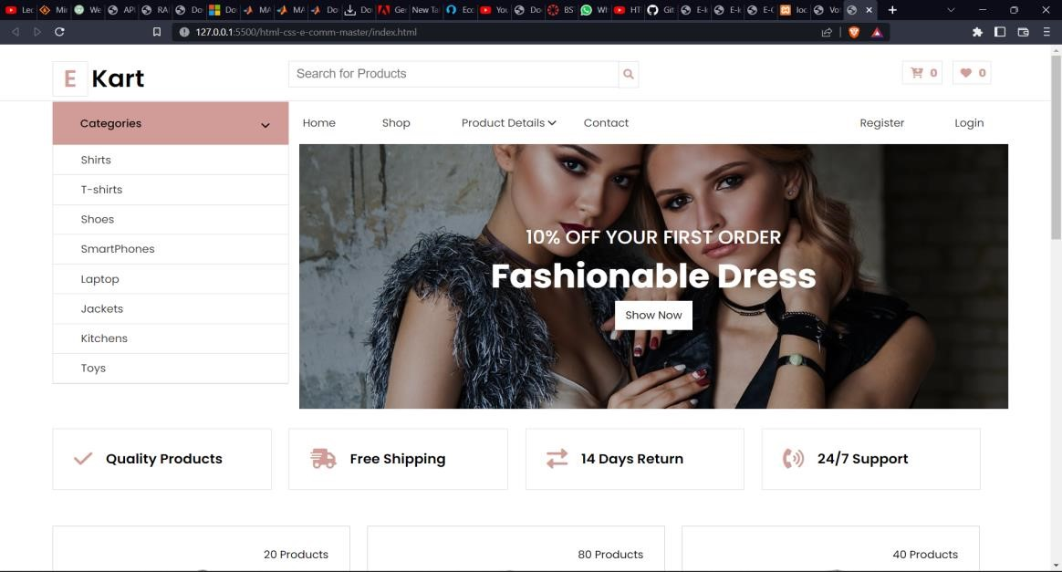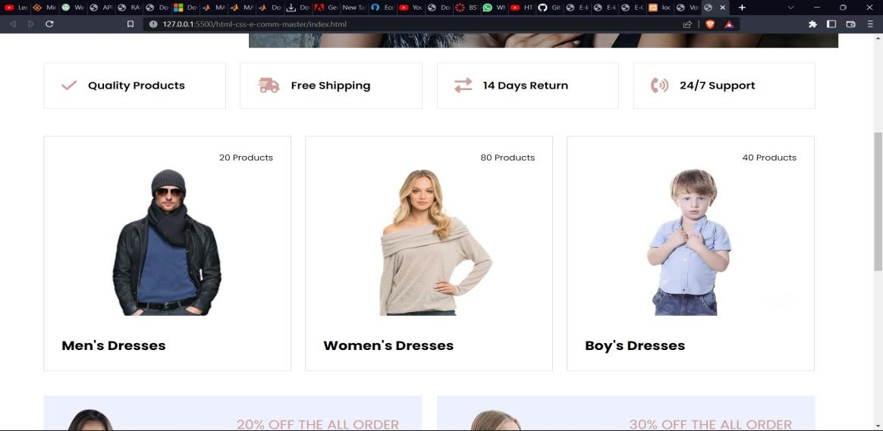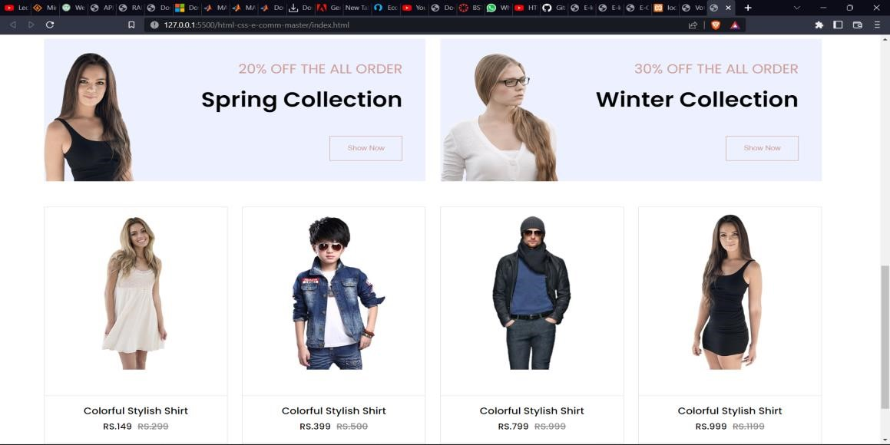

/*Shopping source code*/

<html>

<head>

<title>E-kart Website</title>

<link href="style.css" rel="stylesheet" />

<link href="common.css" rel="stylesheet" />

<link rel="preconnect" href="https://fonts.googleapis.com" />

<link rel="preconnect" href="https://fonts.gstatic.com" crossorigin />

<link

href="https://fonts.googleapis.com/css2?family=Poppins:ital,wght@0,100;0,300;0 ,400;0,500;0,600;0,700;1,100;1,300;1,400&display=swap" rel="stylesheet" />

<link rel="stylesheet" href="https://cdnjs.cloudflare.com/ajax/libs/fontawesome/6.1.1/css/all.min.css" integrity="sha512-

KfkfwYDsLkIlwQp6LFnl8zNdLGxu9YAA1QvwINks4PhcElQSvqcyVLLD9aMh Xd13uQjoXtEKNosOWaZqXgel0g==" crossorigin="anonymous" referrerpolicy="no-referrer"

/>

</head>

<body>

<div class="wrapper">

<div class="header">

<div class="logo arrange-left wid-25">

<h1><span>E</span><span>Kart</span></h1>

</div>

<div class="search-product arrange-left wid-50">

<input type="text" placeholder="Search for Products" />

<button>

<i class="fa-solid fa-magnifying-glass"></i>

</button>

</div>

<div class="selected-product arrange-left wid-25">

<button class="common-btn">

<span>

<i class="fa-solid fa-cart-arrow-down"></i>

0</span

>

</button>

<button class="common-btn">

<span>

<i class="fa-solid fa-heart"></i>

0</span

>

</button>

</div>

</div>

</div>

<div class="full-banner-warapper">

<div class="shop-header">

<h1>Collection</h1>

<h3>- Our Shop -</h3>

</div>

<div class="wrapper next-row">

<div class="sort-options"> <select name="" id="">

<option value="1">By Name</option>

<option value="2">By Rating</option>

<option value="3">By Latest</option>

</select>

</div>

<div class="wid-25 arrange-left">

<h3>Filter By Price</h3>

<div class="custom-control-check">

<input type="checkbox" class="custom-control-input" checked="" id="price-all">

<label class="custom-control-label" for="price-all">All Price</label>

<span class="filter-prod-count">1000</span>

</div>

<div class="custom-control-check">

<input type="checkbox" class="custom-control-input" checked="" id="0-100">

<label class="custom-control-label" for="0-100">RS.0-500</label>

<span class="filter-prod-count">100</span>

</div>

<div class="custom-control-check">

<input type="checkbox" class="custom-control-input" checked="" id="100-200">

<label class="custom-control-label" for="100-200">RS.5001000</label>

<span class="filter-prod-count">150</span>

</div>

<div class="custom-control-check">

<input type="checkbox" class="custom-control-input" checked="" id="200-300">

<label class="custom-control-label" for="200-300">RS.10001500</label>

<span class="filter-prod-count">160</span>

</div>

<div class="custom-control-check">

<input type="checkbox" class="custom-control-input" checked="" id="300-above">

<label class="custom-control-label" for="300-above">RS.1500 above</label>

<span class="filter-prod-count">500</span>

</div>

<h3>Filter By Color</h3>

<div class="custom-control-check">

<input type="checkbox" class="custom-control-input" checked="" id="color-all">

<label class="custom-control-label" for="color-all">All Color</label>

<span class="filter-prod-count">1000</span>

</div>

<div class="custom-control-check">

<input type="checkbox" class="custom-control-input" checked="" id="black">

<label class="custom-control-label" for="black">Black</label>

<span class="filter-prod-count">200</span>

</div>

<div class="custom-control-check">

<input type="checkbox" class="custom-control-input" checked="" id="red">

<label class="custom-control-label" for="Red">Red</label>

<span class="filter-prod-count">150</span>

</div>

<div class="custom-control-check">

<input type="checkbox" class="custom-control-input" checked="" id="yellow">

<label class="custom-control-label" for="yellow">Yellow</label>

<span class="filter-prod-count">360</span>

</div>

<div class="custom-control-check">

<input type="checkbox" class="custom-control-input" checked="" id="white">

<label class="custom-control-label" for="white">White</label>

<span class="filter-prod-count">300</span>

</div>

<h3>Filter By Size</h3>

<div class="custom-control-check">

<input type="checkbox" class="custom-control-input" checked="" id="small">

<label class="custom-control-label" for="small">Small</label>

<span class="filter-prod-count">1000</span>

</div>

<div class="custom-control-check">

<input type="checkbox" class="custom-control-input" checked="" id="m">

<label class="custom-control-label" for="m">Medium</label>

<span class="filter-prod-count">140</span>

</div>

<div class="custom-control-check">

<input type="checkbox" class="custom-control-input" checked="" id="l">

<label class="custom-control-label" for="l">Large</label>

<span class="filter-prod-count">450</span>

</div>

<div class="custom-control-check">

<input type="checkbox" class="custom-control-input" checked="" id="xl">

<label class="custom-control-label" for="xl">Extra Large</label>

<span class="filter-prod-count">130</span>

</div>

<div class="custom-control-check">

<input type="checkbox" class="custom-control-input" checked="" id="xxl">

<label class="custom-control-label" for="xxl">XXL</label>

<span class="filter-prod-count">50</span>

</div>

</div>

<div class="wid-75 arrange-left">

<div class="wid-33 arrange-left">

<div class="cart">

<div>

<img src="./product-1.jpg" alt="" />

</div>

<div class="cart-details">

<h6 class="name-head">Colorful Stylish Shirt</h6>

<div class="cart-price">

<h6 class="current">RS.149</h6>

<h6 class="last">RS.259</h6>

</div>

</div>

<div class="cart-footer">

<a href="#">

<i class="fa-solid fa-eye"></i> View Details

</a>

<a href="#">

<i class="fa-solid fa-cart-arrow-down"></i> Add to Cart

</a>

</div>

</div>

</div>

<div class="wid-33 arrange-left">

<div class="cart">

<div>

<img src="./product-2.jpg" alt="" />

</div>

<div class="cart-details">

<h6 class="name-head">Colorful Stylish Shirt</h6>

<div class="cart-price">

<h6 class="current">RS.159</h6>

<h6 class="last">RS.399</h6>

</div>

</div>

<div class="cart-footer">

<a href="#">

<i class="fa-solid fa-eye"></i> View Details

</a>

<a href="#">

<i class="fa-solid fa-cart-arrow-down"></i> Add to Cart

</a>

</div>

</div>

</div>

<div class="wid-33 arrange-left">

<div class="cart">

<div>

<img src="./product-3.jpg" alt="" />

</div>

<div class="cart-details">

<h6 class="name-head">Colorful Stylish Shirt</h6>

<div class="cart-price">

<h6 class="current">RS.299</h6>

<h6 class="last">RS.599</h6>

</div>

</div>

<div class="cart-footer">

<a href="#">

<i class="fa-solid fa-eye"></i> View Details

</a>

<a href="#">

<i class="fa-solid fa-cart-arrow-down"></i> Add to Cart

</a>

</div>

</div>

</div>

<div class="wid-33 arrange-left">

<div class="cart">

<div>

<img src="./product-4.jpg" alt="" />

</div>

<div class="cart-details">

<h6 class="name-head">Colorful Stylish Shirt</h6>

<div class="cart-price">

<h6 class="current">RS.559</h6>

<h6 class="last">RS.799</h6>

</div>

</div>

<div class="cart-footer">

<a href="#">

<i class="fa-solid fa-eye"></i> View Details

</a>

<a href="#">

<i class="fa-solid fa-cart-arrow-down"></i> Add to Cart

</a>

</div>

</div>

</div>

<div class="wid-33 arrange-left">

<div class="cart">

<div>

<img src="./product-3.jpg" alt="" />

</div>

<div class="cart-details">

<h6 class="name-head">Colorful Stylish Shirt</h6>

<div class="cart-price">

<h6 class="current">RS.599</h6>

<h6 class="last">RS.999</h6>

</div>

</div>

<div class="cart-footer">

<a href="#">

<i class="fa-solid fa-eye"></i> View Details

</a>

<a href="#">

<i class="fa-solid fa-cart-arrow-down"></i> Add to Cart

</a>

</div>

</div>

</div>

<div class="wid-33 arrange-left">

<div class="cart">

<div>

<img src="./product-2.jpg" alt="" />

</div>

<div class="cart-details">

<h6 class="name-head">Colorful Stylish Shirt</h6>

<div class="cart-price">

<h6 class="current">RS.999</h6>

<h6 class="last">RS.1599</h6>

</div>

</div>

<div class="cart-footer">

<a href="#">

<i class="fa-solid fa-eye"></i> View Details

</a>

<a href="#">

<i class="fa-solid fa-cart-arrow-down"></i> Add to Cart

</a>

</div>

</div>

</div>

<div class="wid-33 arrange-left">

<div class="cart">

<div>

<img src="./cat-2.jpg" alt="" />

</div>

<div class="cart-details">

<h6 class="name-head">Colorful Stylish Shirt</h6>

<div class="cart-price">

<h6 class="current">RS.799</h6>

<h6 class="last">RS.1199</h6>

</div>

</div>

<div class="cart-footer">

<a href="#">

<i class="fa-solid fa-eye"></i> View Details

</a>

<a href="#">

<i class="fa-solid fa-cart-arrow-down"></i> Add to Cart

</a>

</div>

</div>

</div>

<div class="wid-33 arrange-left">

<div class="cart">

<div>

<img src="./product-2.jpg" alt="" />

</div>

<div class="cart-details">

<h6 class="name-head">Colorful Stylish Shirt</h6>

<div class="cart-price">

<h6 class="current">RS.499</h6>

<h6 class="last">RS.699</h6>

</div>

</div>

<div class="cart-footer">

<a href="#">

<i class="fa-solid fa-eye"></i> View Details

</a>

<a href="#">

<i class="fa-solid fa-cart-arrow-down"></i> Add to Cart

</a>

</div>

</div>

</div>

<div class="wid-33 arrange-left">

<div class="cart">

<div>

<img src="./product-3.jpg" alt="" />

</div>

<div class="cart-details">

<h6 class="name-head">Colorful Stylish Shirt</h6>

<div class="cart-price">

<h6 class="current">RS.299.00</h6>

<h6 class="last">RS.499</h6>

</div>

</div>

<div class="cart-footer">

<a href="#">

<i class="fa-solid fa-eye"></i> View Details

</a>

<a href="#">

<i class="fa-solid fa-cart-arrow-down"></i> Add to Cart

</a>

</div>

</div>

</div>

</div>

</body>

</html>

Shopping output:

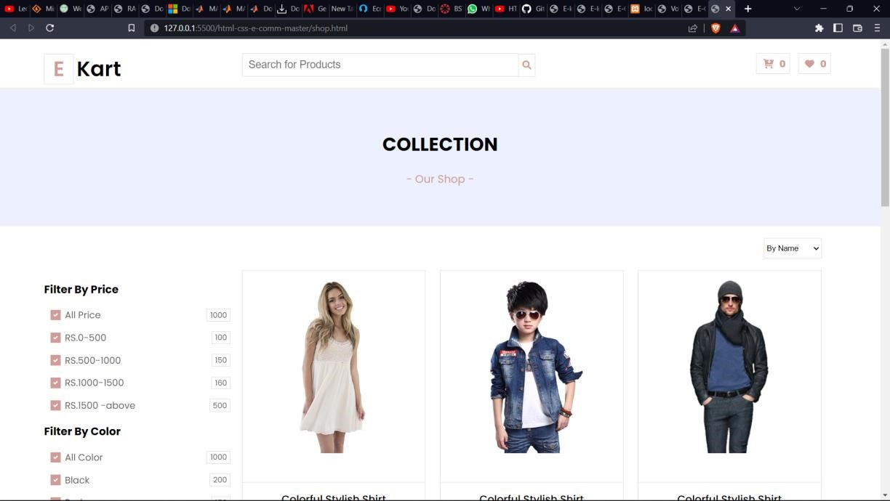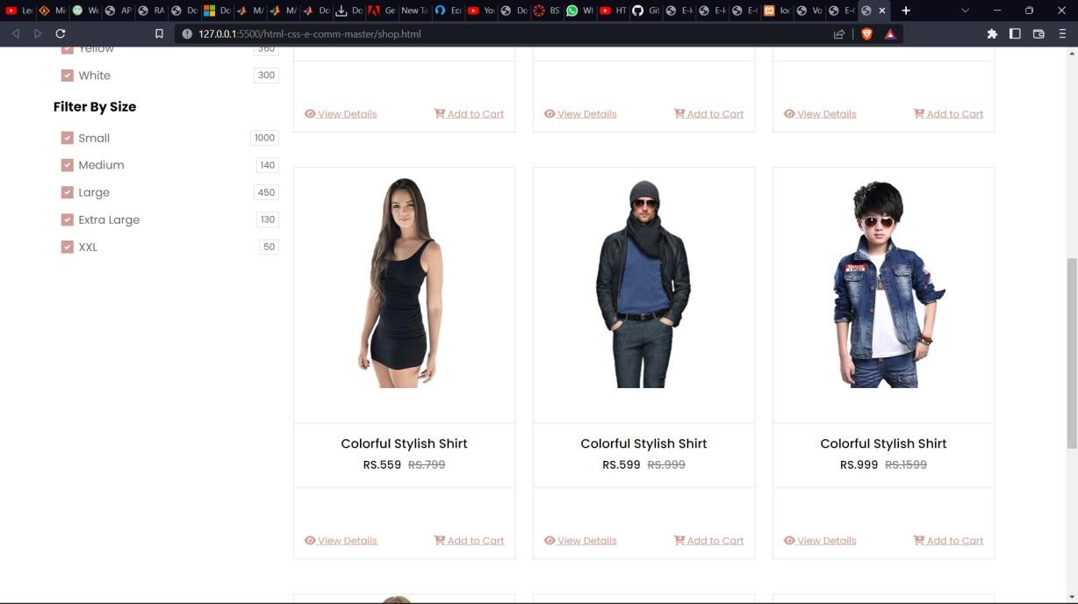

Cart source code:

<html>

<head>

<title>E-kart Website</title>

<link href="style.css" rel="stylesheet" />

<link href="common.css" rel="stylesheet" />

<link rel="preconnect" href="https://fonts.googleapis.com" />

<link rel="preconnect" href="https://fonts.gstatic.com" crossorigin />

<link

href="https://fonts.googleapis.com/css2?family=Poppins:ital,wght@0,100;0,300;0 ,400;0,500;0,600;0,700;1,100;1,300;1,400&display=swap" rel="stylesheet" />

<link rel="stylesheet" href="https://cdnjs.cloudflare.com/ajax/libs/fontawesome/6.1.1/css/all.min.css" integrity="sha512-

KfkfwYDsLkIlwQp6LFnl8zNdLGxu9YAA1QvwINks4PhcElQSvqcyVLLD9aMh Xd13uQjoXtEKNosOWaZqXgel0g==" crossorigin="anonymous" referrerpolicy="no-referrer"

/>

</head>

<body>

<div class="wrapper">

<div class="header">

<div class="logo arrange-left wid-25">

<h1><span>E</span><span>Kart</span></h1>

</div>

<div class="search-product arrange-left wid-50">

<input type="text" placeholder="Search for Products" />

<button>

<i class="fa-solid fa-magnifying-glass"></i>

</button>

</div>

<div class="selected-product arrange-left wid-25">

<button class="common-btn">

<span>

<i class="fa-solid fa-cart-arrow-down"></i>

0</span

>

</button>

<button class="common-btn">

<span>

<i class="fa-solid fa-heart"></i>

0</span

>

</button>

</div>

</div>

</div>

<div class="full-banner-warapper">

<div class="shop-header">

<h1>Your shopping Details</h1>

<h3>- Cart Details -</h3>

</div>

<div class="wrapper next-row">

<div class="wid-75 arrange-left">

<div class="cart-details">

<table>

<thead>

<tr>

<th>Product</th>

<th>Price</th>

<th>Quantity</th>

<th>Total</th>

<th>Remove</th>

</tr>

</thead>

<tbody>

<tr>

<td class="text-with-img">

<img src="./cat-1.jpg" alt="" /><span>Colorful

Shirt</span>

</td>

<td><span>RS.99</span></td>

<td>

<div class="quantity-input">

<button>-</button>

<input type="text" value="1" />

<button>+</button>

</div>

</td>

<td>RS.149</td>

<td>

<i class="fa fa-remove icon custom-delete-button"></i>

</td>

</tr>

<tr>

<td class="text-with-img">

<img src="./cat-2.jpg" alt="" /><span>Shoes</span>

</td>

<td><span>RS.159</span></td>

<td>

<div class="quantity-input">

<button>-</button>

<input type="text" value="2" />

<button>+</button>

</div>

</td>

<td>RS.299</td>

<td>

<i class="fa fa-remove icon custom-delete-button"></i>

</td>

</tr>

<tr>

<td class="text-with-img">

<img src="./cat-3.jpg" alt="" /><span>Colorful

Shirt</span>

</td>

<td><span>RS.559</span></td>

<td>

<div class="quantity-input">

<button>-</button>

<input type="text" value="1" />

<button>+</button>

</div>

</td>

<td>RS.599</td>

<td>

<i class="fa fa-remove icon custom-delete-button"></i>

</td>

</tr>

<tr>

<td class="text-with-img">

<img src="./cat-1.jpg" alt="" /><span>Colorful

Shirt</span>

</td>

<td><span>RS.999</span></td>

<td>

<div class="quantity-input">

<button>-</button>

<input type="text" value="1" />

<button>+</button>

</div>

</td>

<td>RS.799</td>

<td>

<i class="fa fa-remove icon custom-delete-button"></i>

</td>

</tr>

<tr>

<td class="text-with-img">

<img src="./cat-2.jpg" alt="" /><span>Colorful

Shirt</span>

</td>

<td><span>RS.499</span></td>

<td>

<div class="quantity-input">

<button>-</button>

<input type="text" value="1" />

<button>+</button>

</div>

</td>

<td>RS.299</td>

<td>

<i class="fa fa-remove icon custom-delete-button"></i>

</td>

</tr>

</tbody>

</table>

</div>

</div>

<div class="wid-25 arrange-left">

<div class="cart-summary-wrapper">

<div class="coupon-inputs">

<button>Apply Couple</button>

</div>

<div class="cart-summary-body">

<div class="cart-summy-item">

<h6>Sub Total</h6>

<h6>RS.299</h6>

</div>

<div class="cart-summy-item">

<h6>Shipping</h6>

<h6>RS.99</h6>

</div>

</div>

<div class="total-wrapper">

<div class="total-head">

<h4>Total</h4>

<h4>RS.398</h4>

</div>

<div class="proceed-input">

<button>Proceed To Checkout</button>

</div>

</div>

</div>

</div>

</div>

</div>

</body>

</html>

C

art

output:

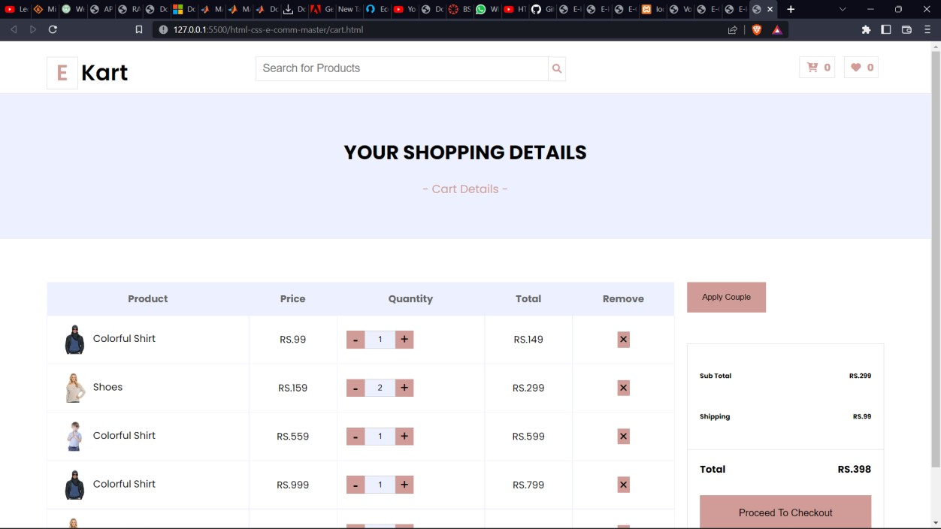

REFERENCES

* [www.google.com](http://www.google.com/)
* [www.youtube.com](http://www.youtube.com/)
* [www.github.com](http://www.github.com/)

1. | P a g e

  