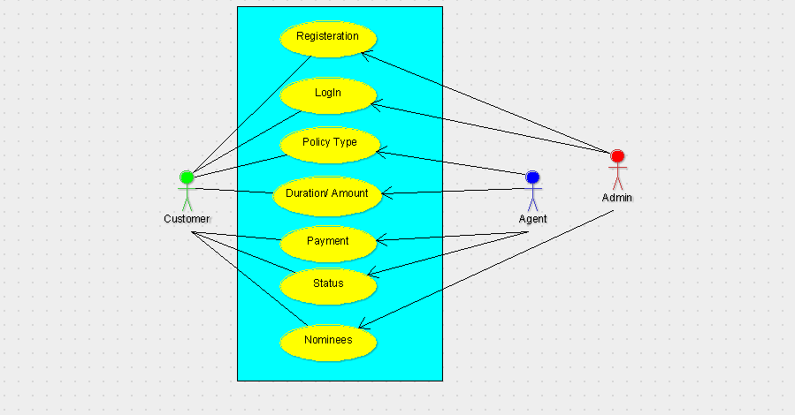

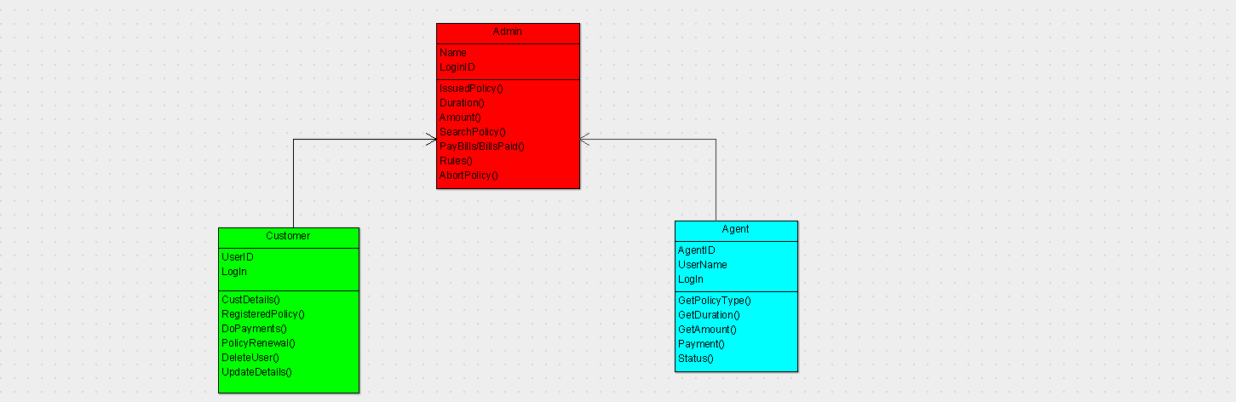

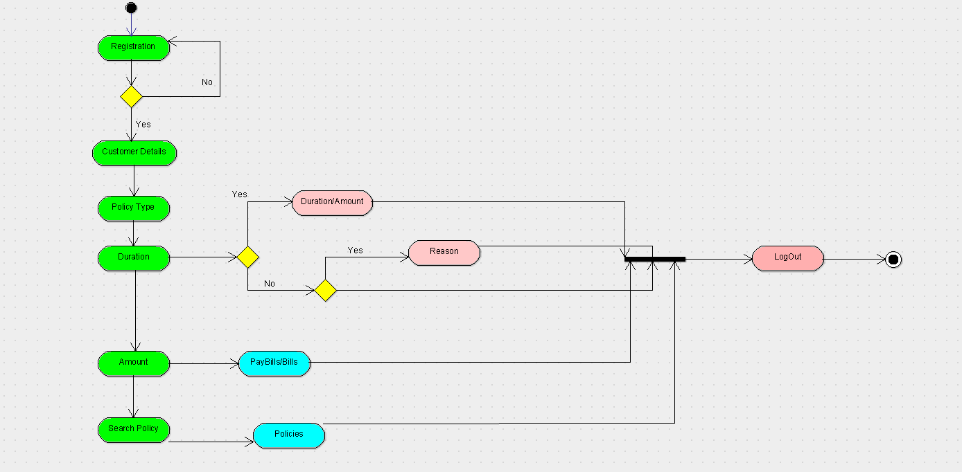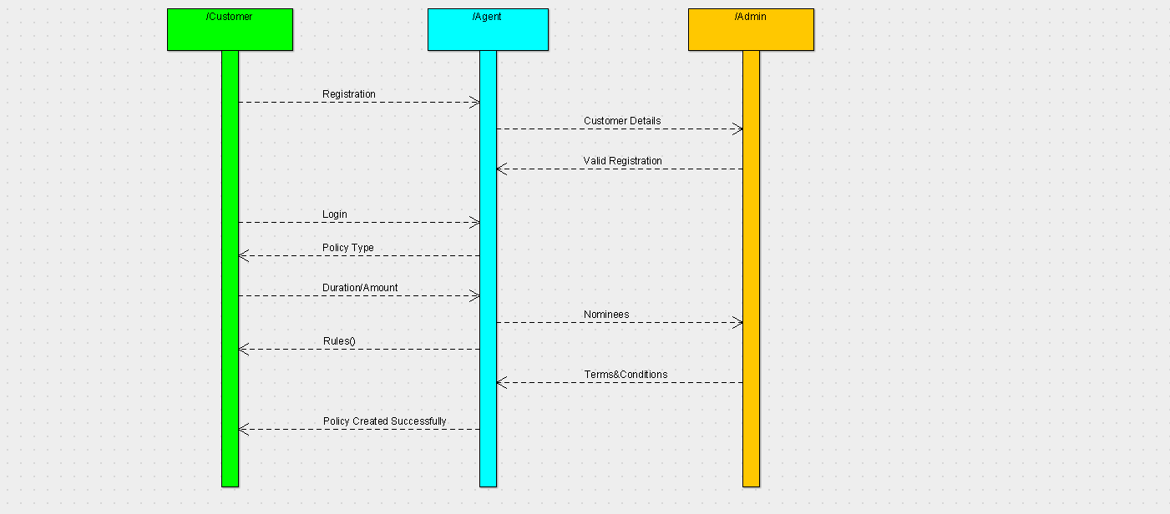

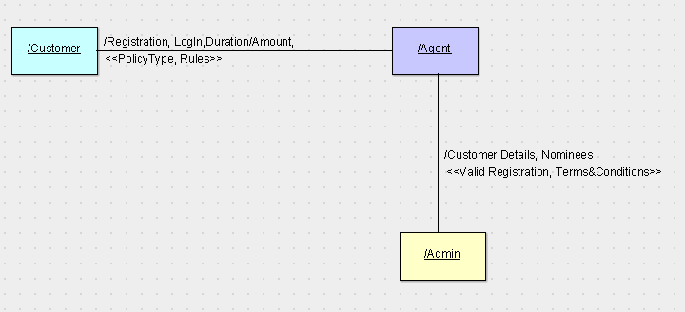

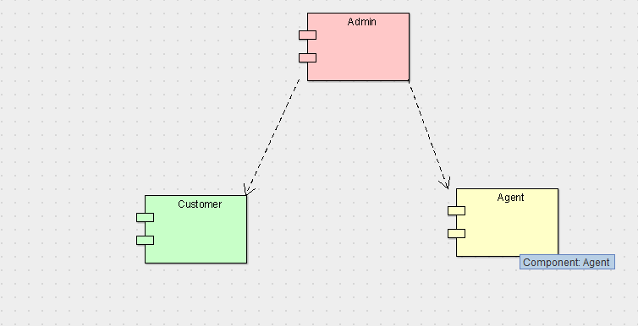

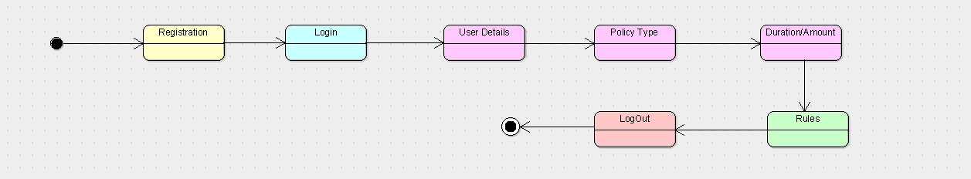

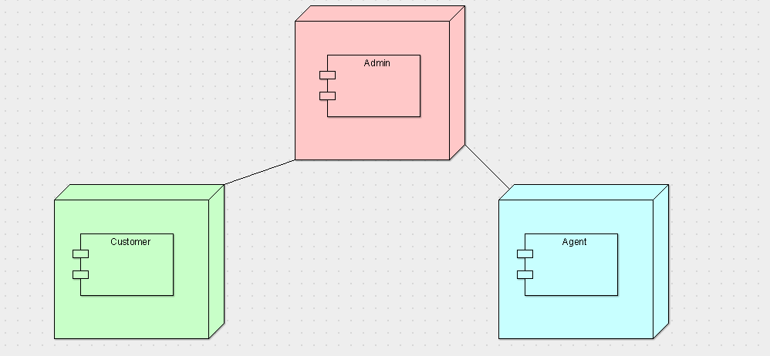

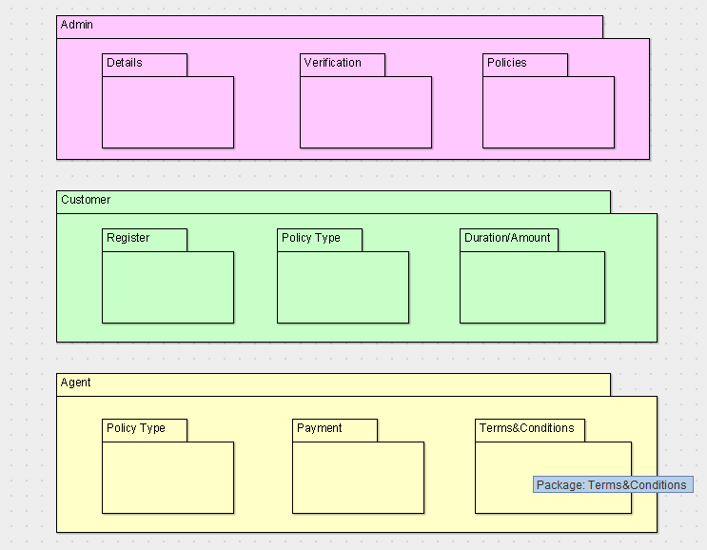

CODE:

ADMIN:

public class Admin {

public Name;

public LoginID;

public void IssuedPolicy() {

}

public void Duration() {

}

public void Amount() {

}

public void SearchPolicy() {

}

public void PayBills/BillsPaid() {

}

public void Rules() {

}

public void AbortPolicy() {

}

}

AGENT:

import java.util.Vector;

public class Agent {

public AgentID;

public UserName;

public LogIn;

public Vector myAdmin;

public void GetPolicyType() {

}

public void GetDuration() {

}

public void GetAmount() {

}

public void Payment() {

}

public void Status() {

}

}

CUSTOMER:

import java.util.Vector;

public class Customer {

public UserID;

public LogIn;

public Vector myAdmin;

public void CustDetails() {

}

public void RegisteredPolicy() {

}

public void DoPayments() {

}

public void PolicyRenewal() {

}

public void DeleteUser() {

}

public void UpdateDetails() {

}

}