Day-5

1.AvgSpeed=78 81 82 74 83 82 77

TotalTime=39 37 36 42 35 36 40

1. Calculate the sd for both
2. Calculate the variance for both

> as=c(78,81,82,74,83,82,77)

> tt=c(39,37,36,42,35,36,40)

> r=sd(as)

> r1=sd(tt)

> r

[1] 3.309438

> r1

[1] 2.544836

> v=var(as)

> v1=var(tt)

> v

[1] 10.95238

> v1

[1] 6.47619

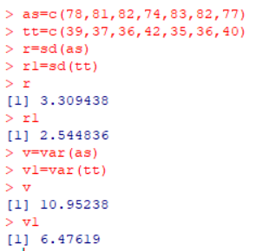

2.Draw- Histogram, Scatterplot and Boxplot

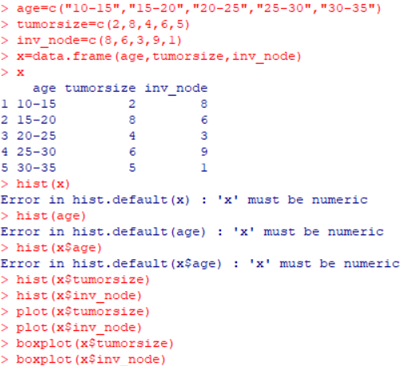

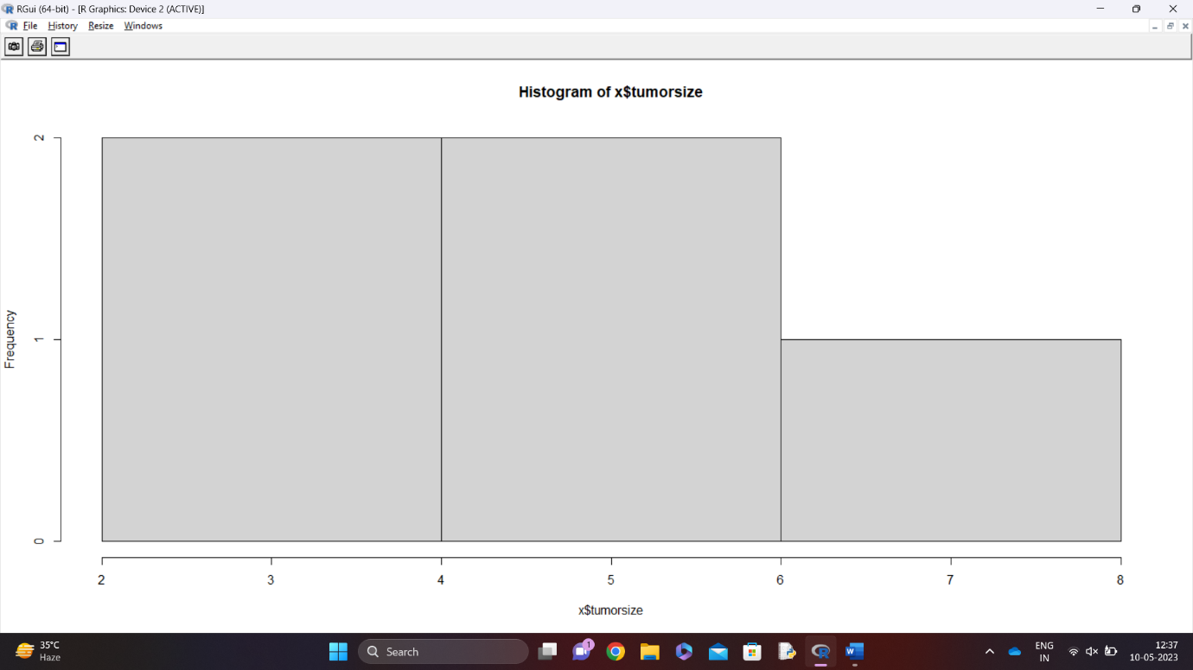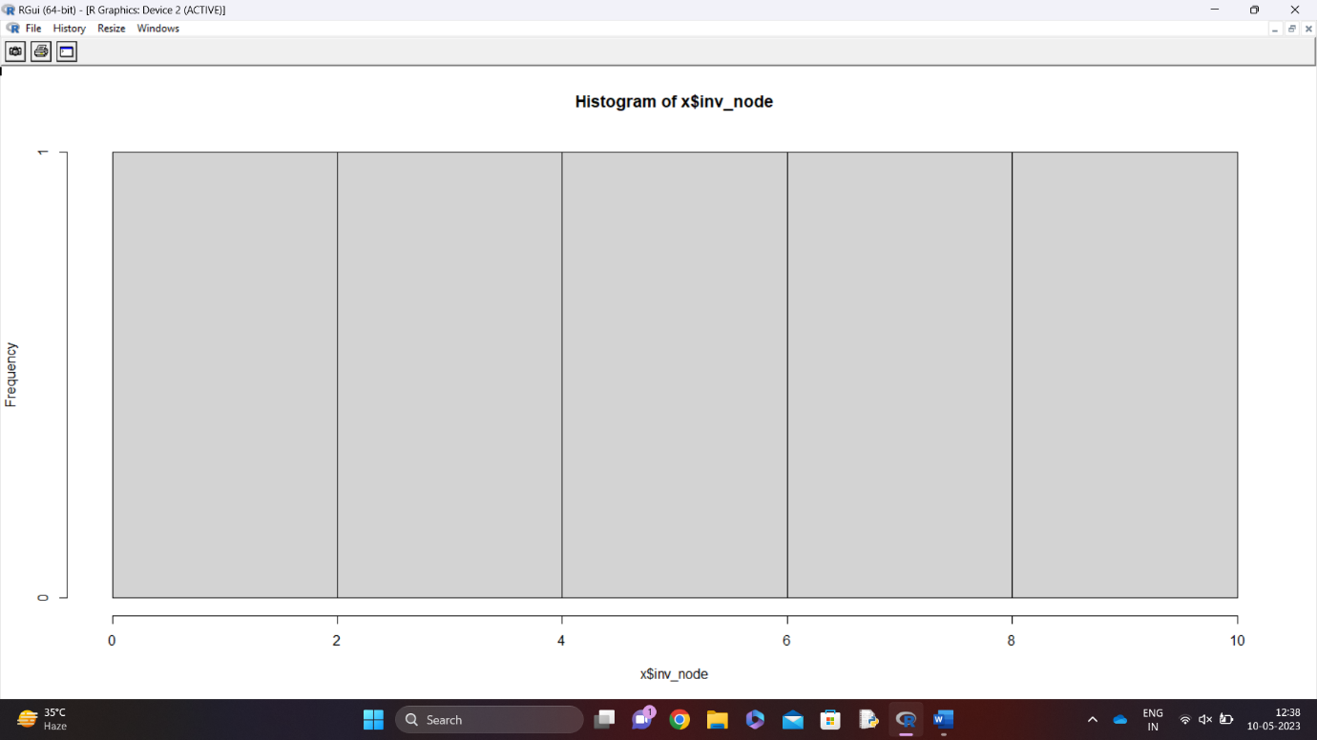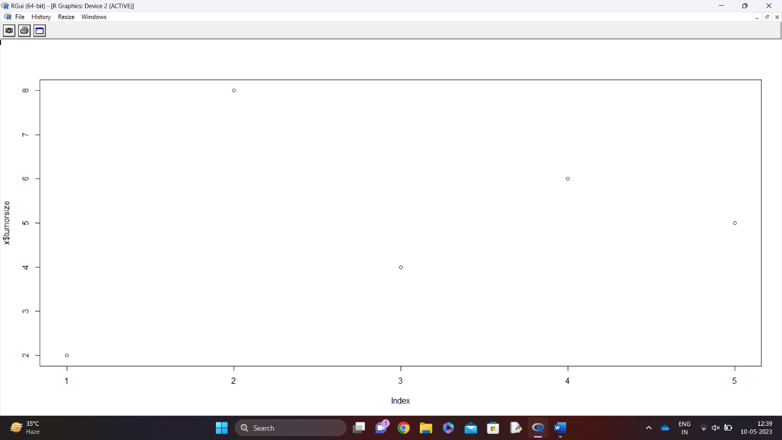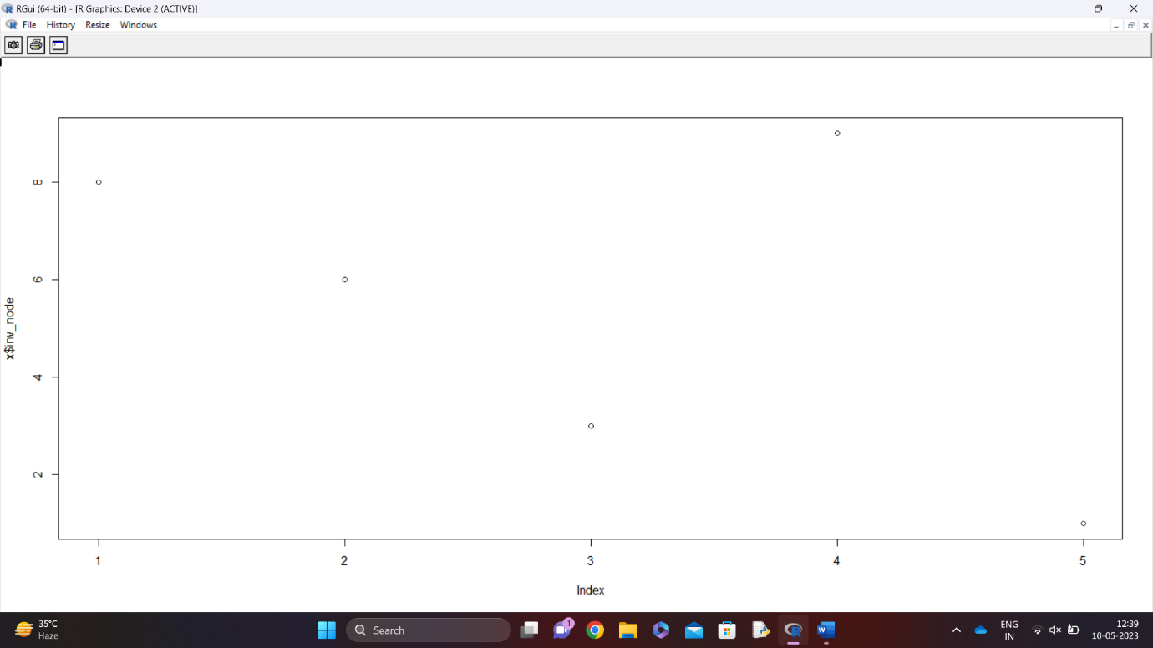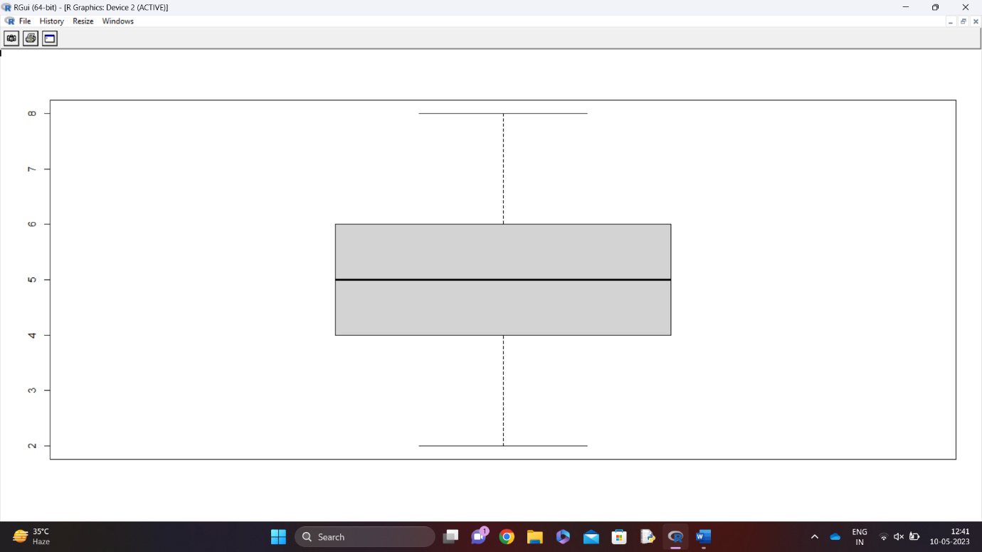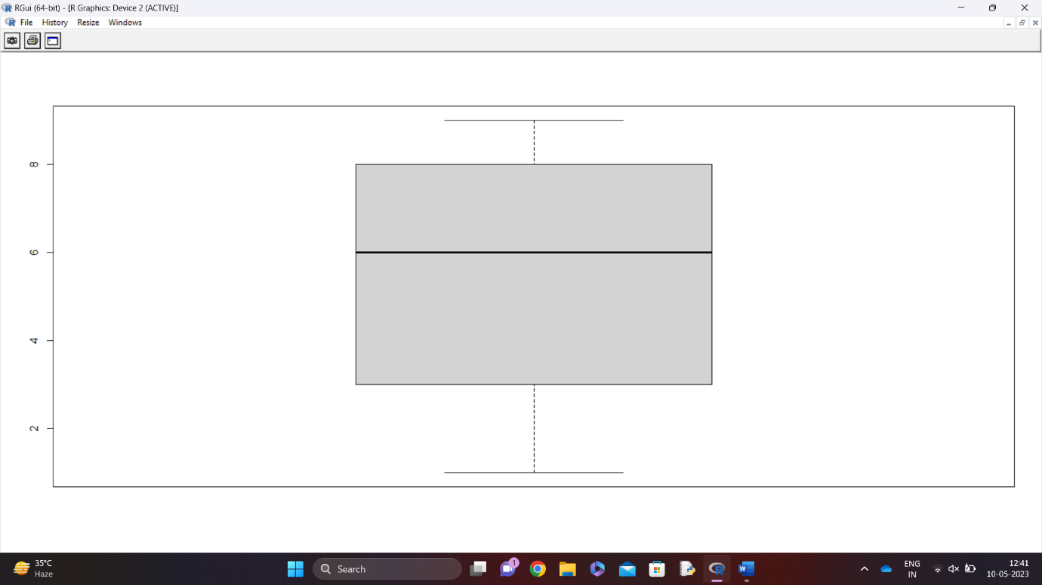

3.

