Note :
* C# is a type safe language
*float f=1.3f; -> use like this same as in java
* There is explixit and implicit type casting in c#
* explicit casting is not possible if we go to type cast double to int

printing with variable
Console.WriteLine($"10 = {a1}, 20 = {a2}, 30 = {a3}");

->also we can do this
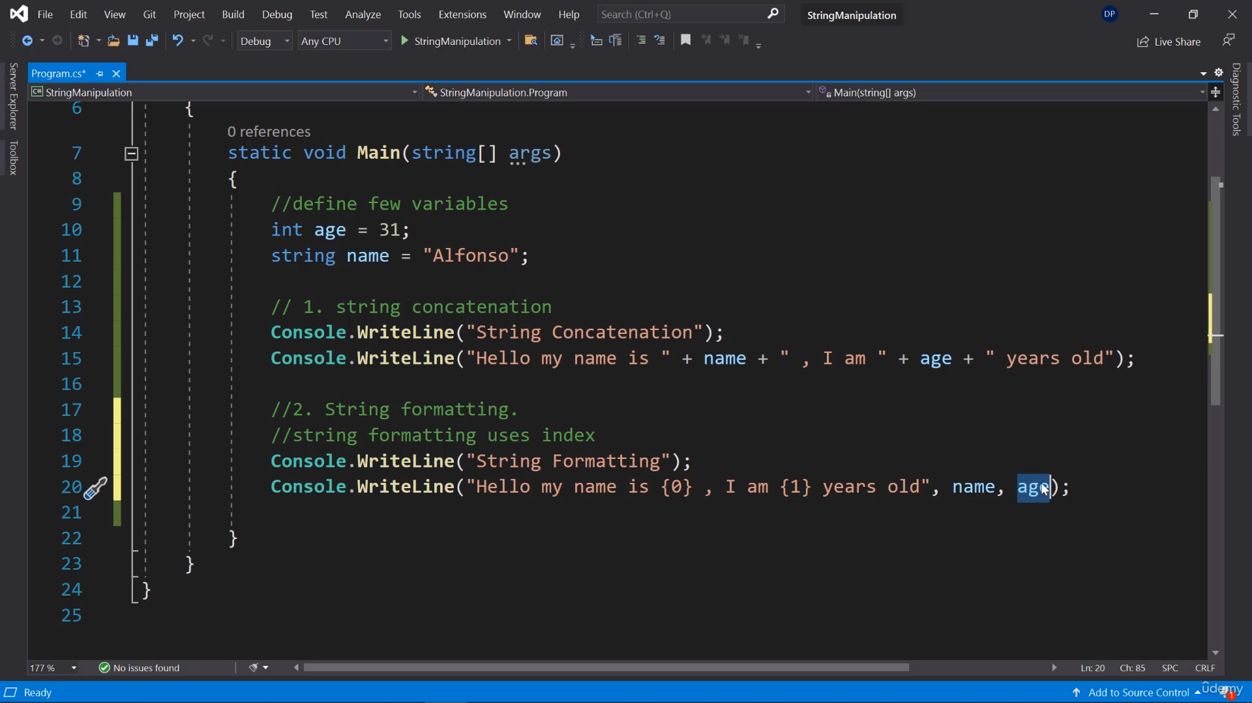

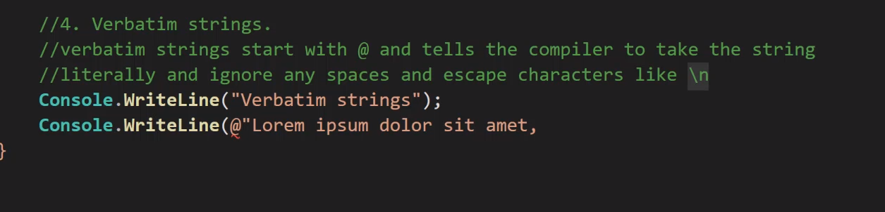

* if for and all the loops are the same as in java
* Decimal is the most presice datatype

Methods

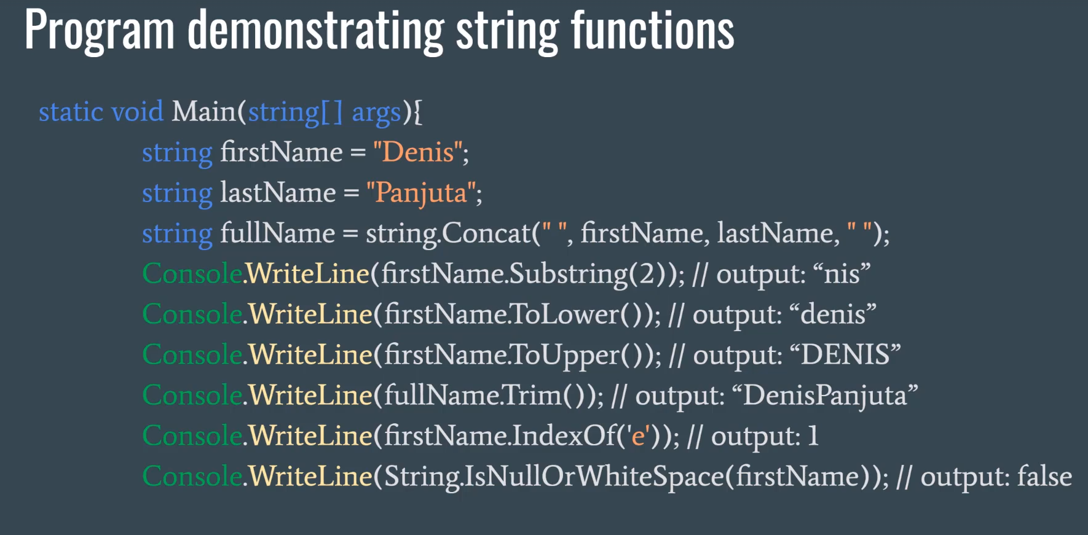
.
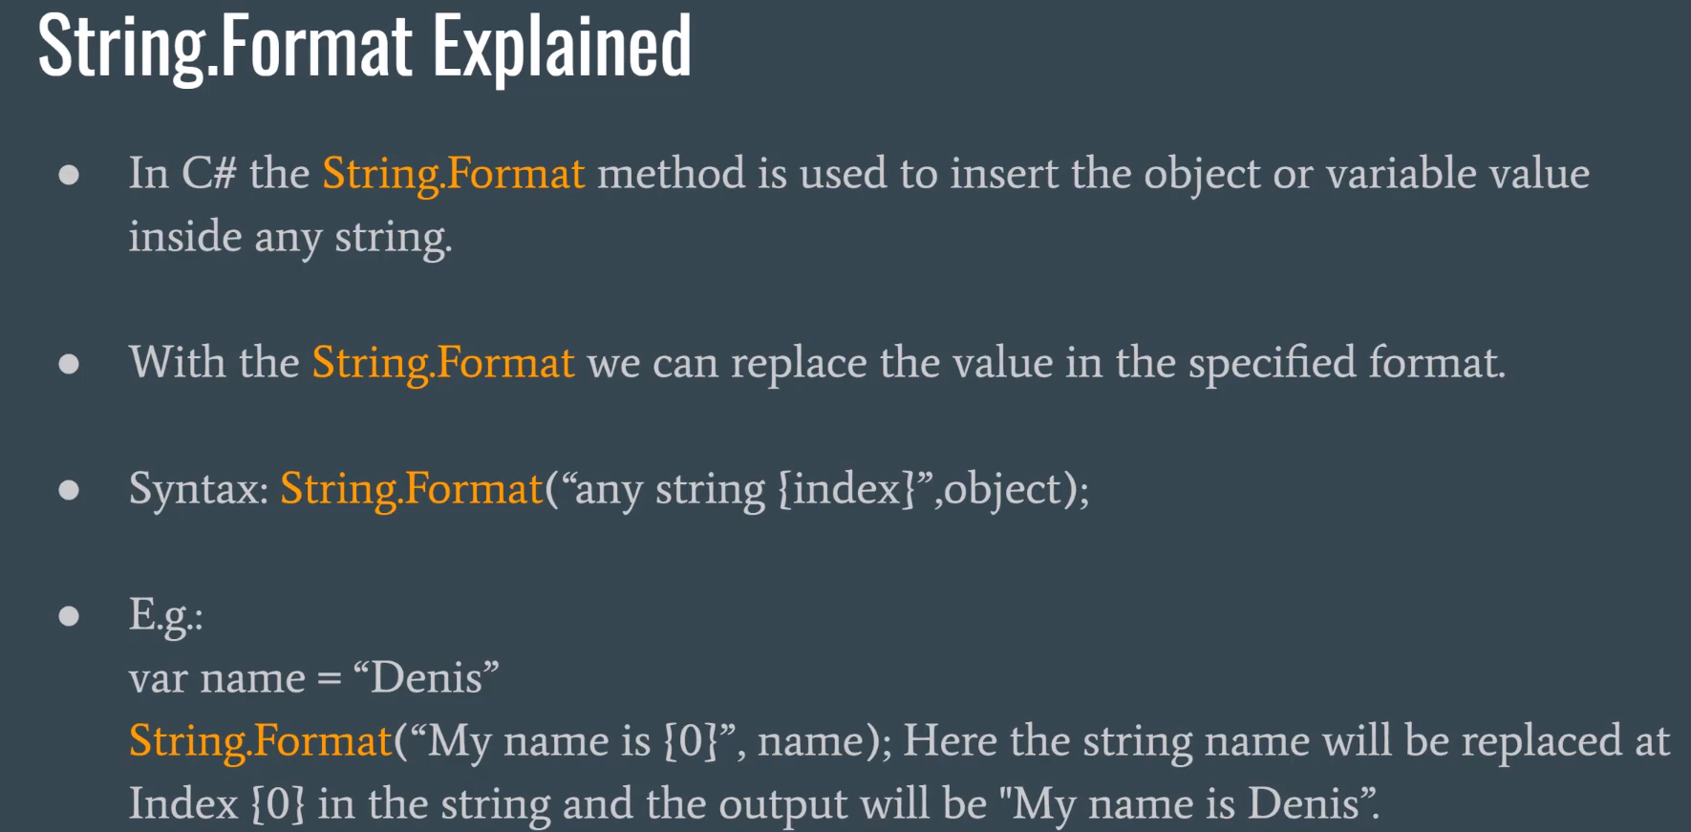
.
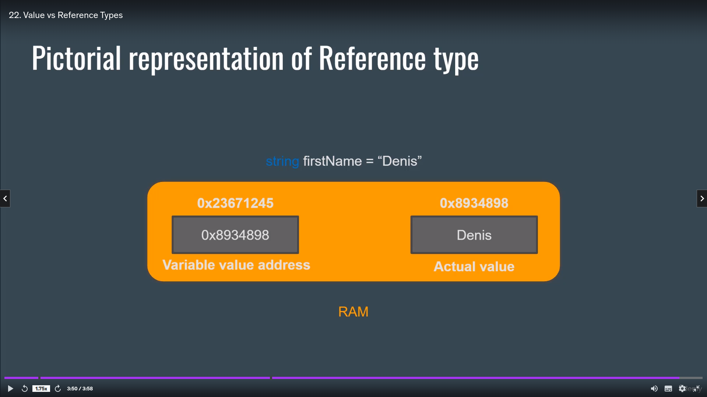
.
convert function
Console.WriteLine("String conveting and adding now = " + (Convert.ToInt32("4") + 4));

Comments
* Single line comments are used while declaring variables
* In if statements
* Multiline comments to explain
* XML Comments
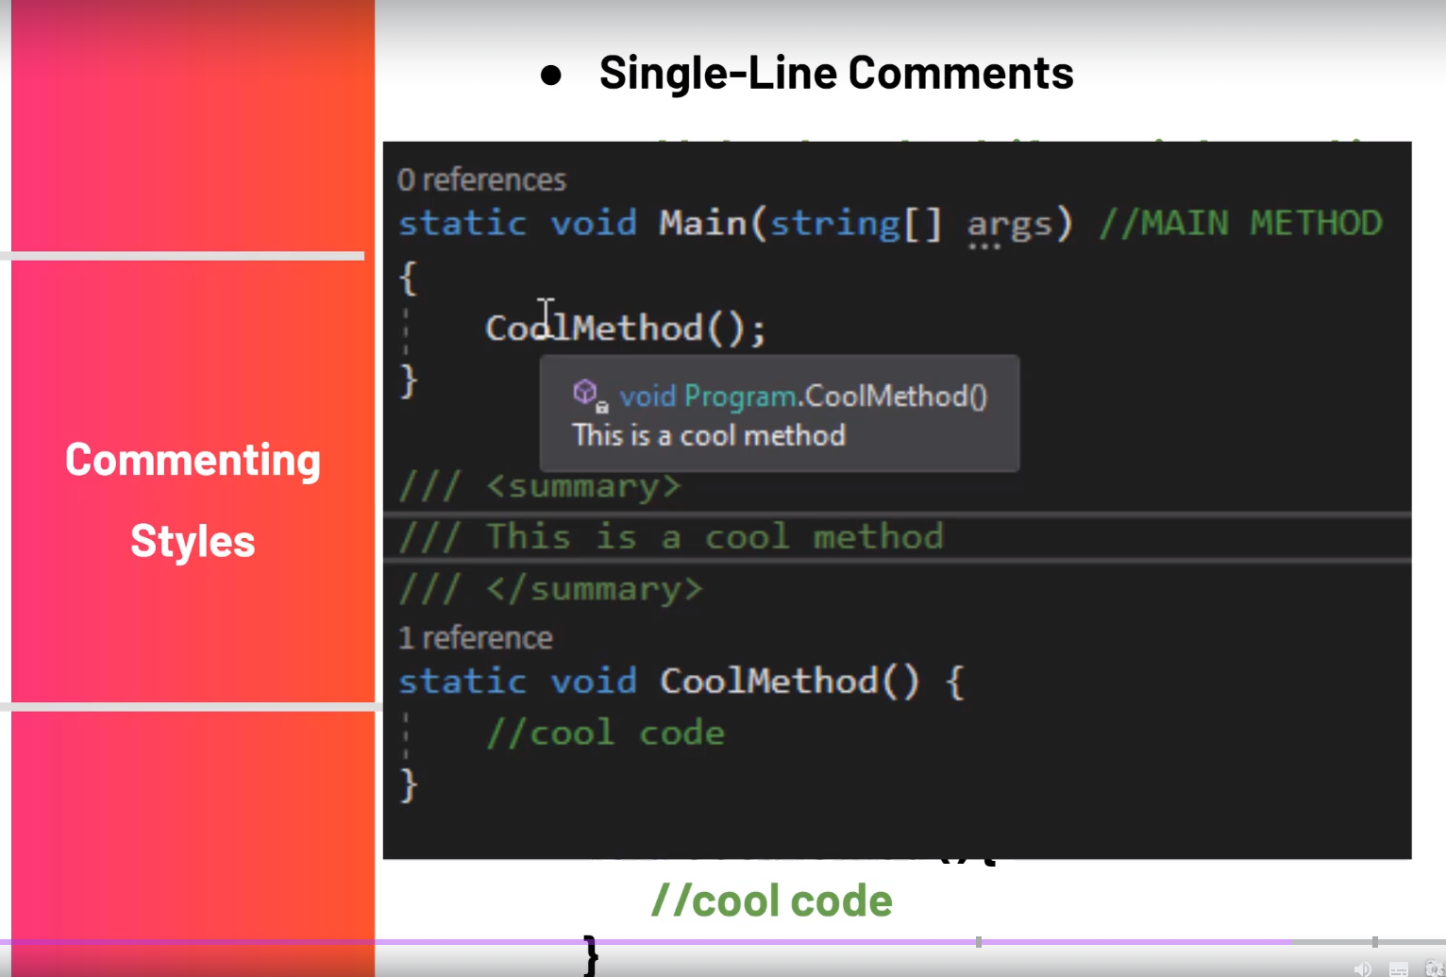

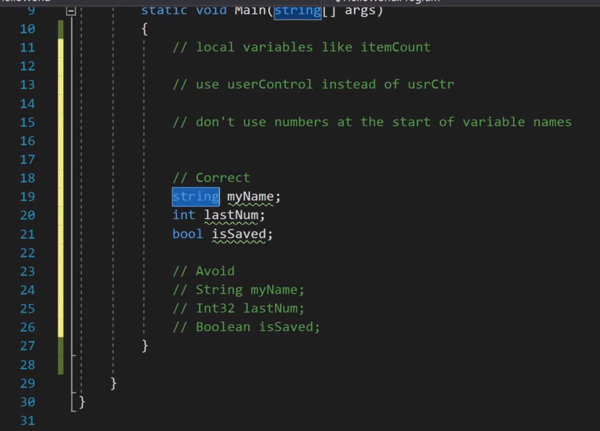
Naming conventions
* Class name and functions are same in this camel starts with capital letter
* for variable starts with a small letters

* Try parse
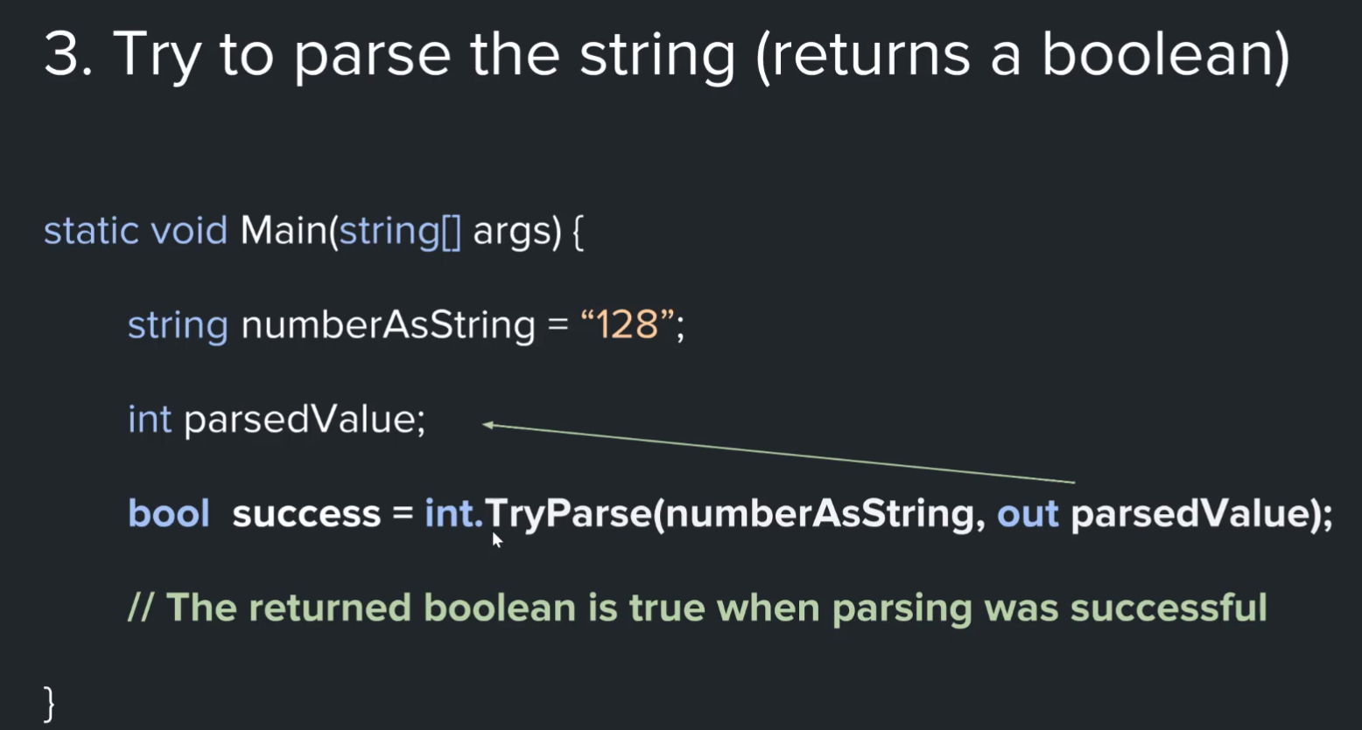

you can directly use it in the if block

If the string is not a number then this try the string instead of throwing the exception
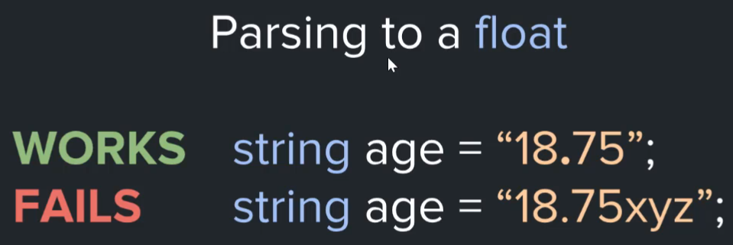

Switch statement:

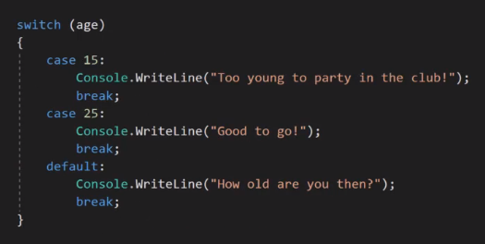
.

Tirnery operator:
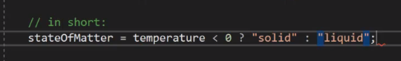

Access modifiers:
Public

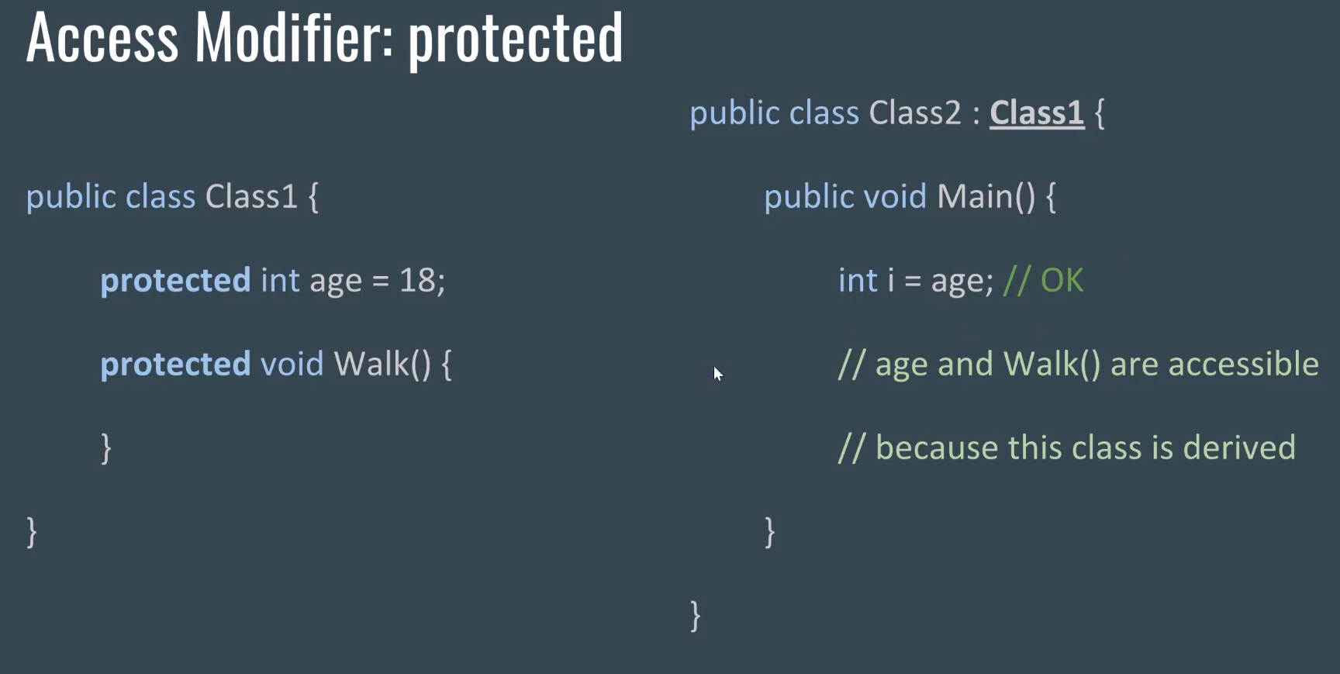

Protected can only accible by itself and the class which inherits that

Getters and setters
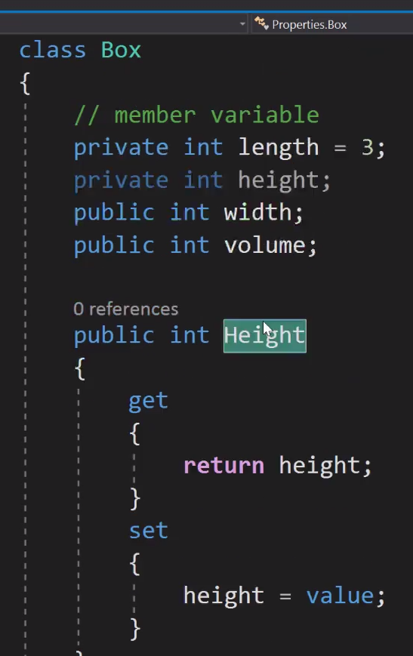

Members Finalizers and destructures
Garbage collection is automatic in c#.

Struct:

similar to class but there is no construct and there are other differences
Nullable

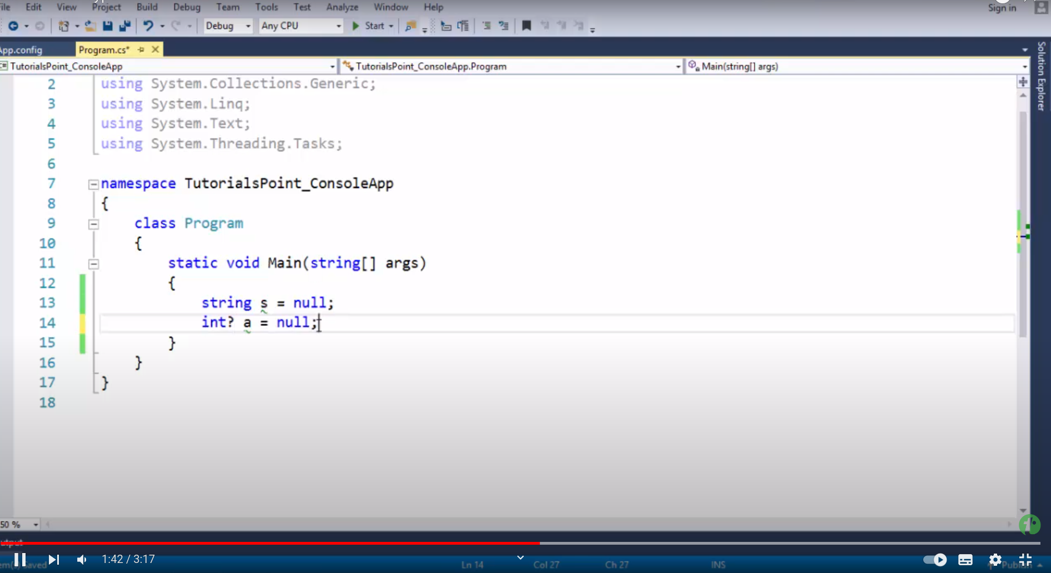
.

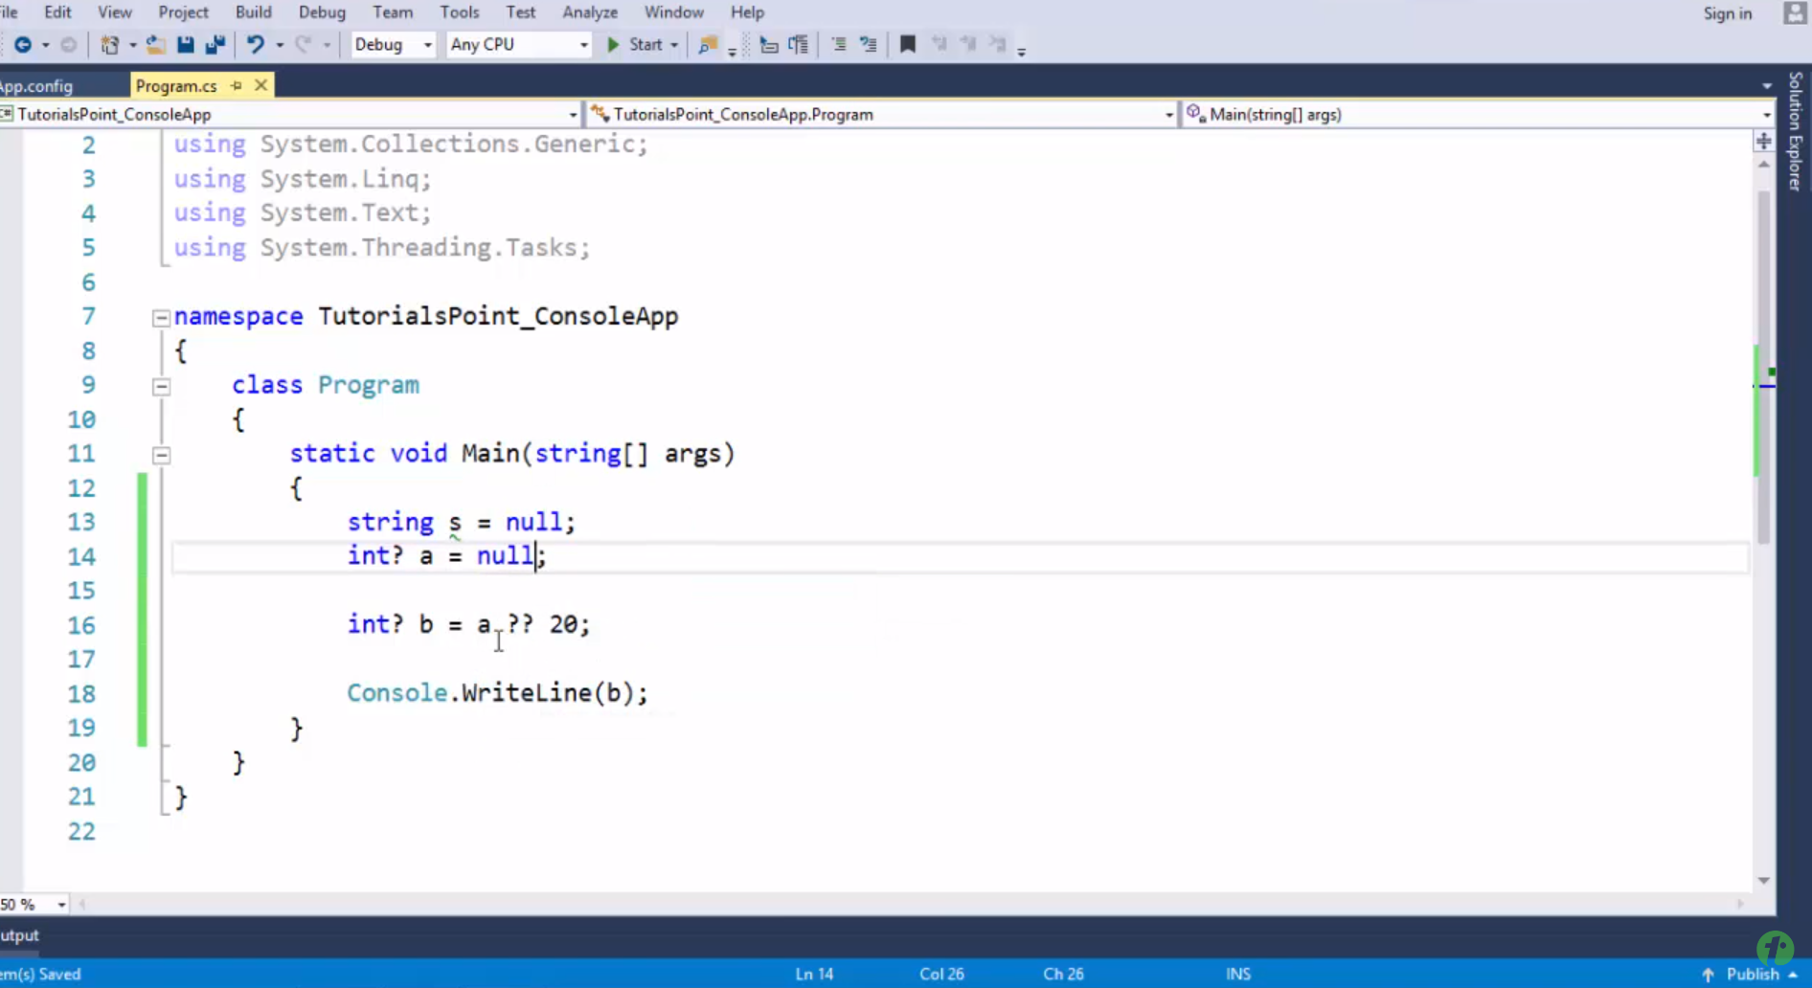
conditional inserting the value according the the value
like i used to do in javascript

var and dynamic in c#
var is in compile time thing
dynamic is a runtime thing

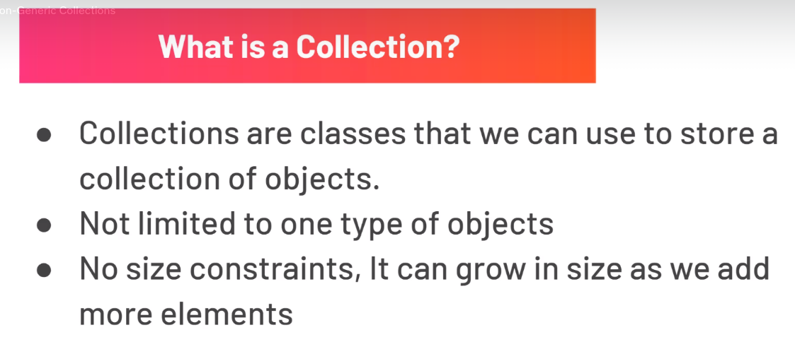

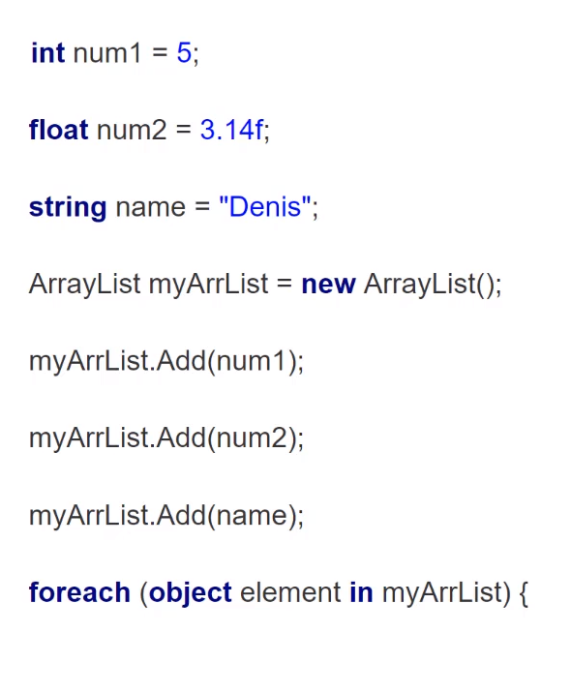

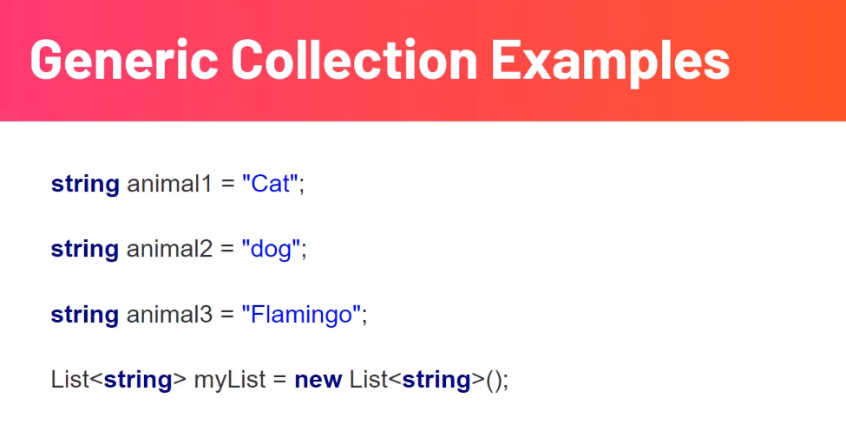

Methods in Collection
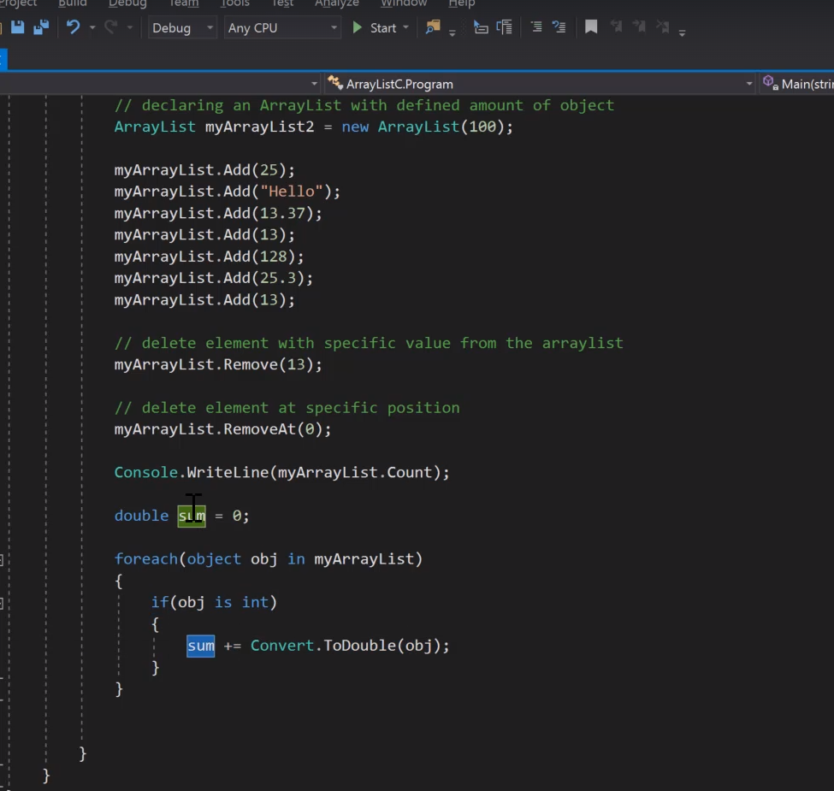
.

Map
HashTable is not generic whereas dictionary is generic
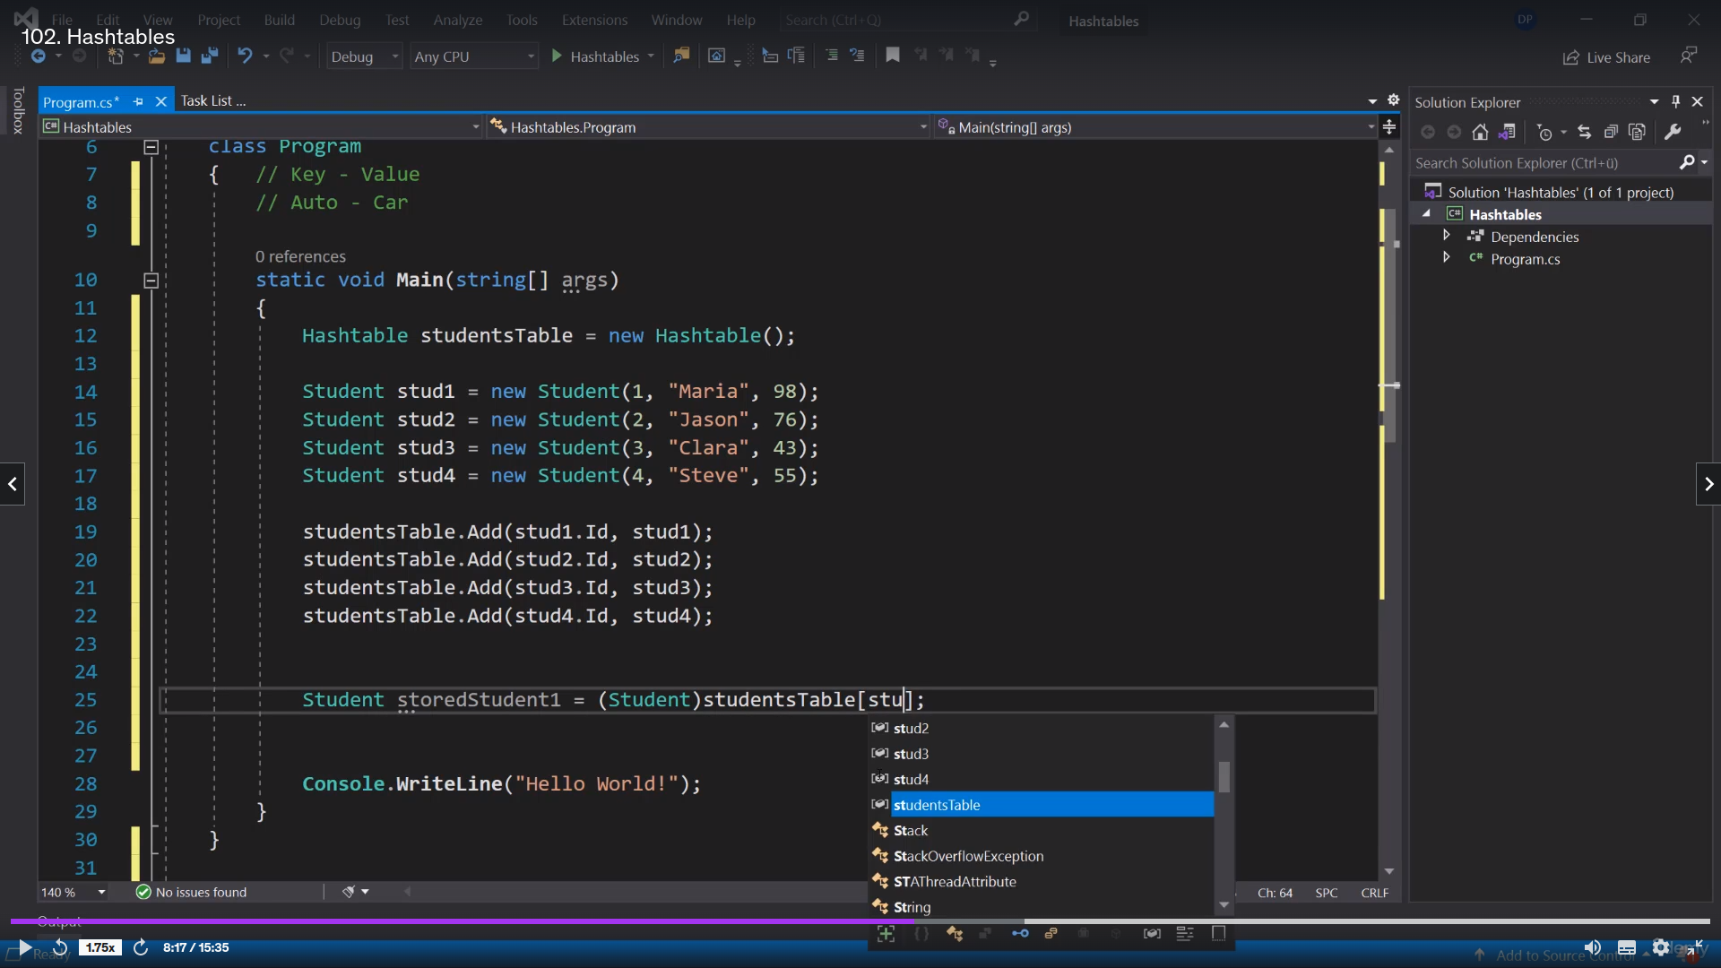
.

similar to the map in c++



