IOT BASED STREET-LAMP SYSTEM FOR A SMART COLLEGE

**ABSTRACT**:

India is a huge country with a lot of energy production as well as consumption. There have been situations where the production does not meet the consumption. To balance this, we might have to use power in a very smart and an efficient way. Providing street lighting is one the most important and expensive responsibilities of a city. Lighting can account for 10–38% of the total energy bill in typical cities worldwide. Over 27 million street lights light up India and consume 20 - 40% of the total energy that we produce that accounts to about 66.86 - 133.72 GW summing to around. Energy consumption due to the street lights needs proper monitoring and control to reduce wastage of power. Conventional street light systems suffer from certain drawbacks as they are manually controlled and are powered through the electrical board power station. This may lead to more power consumption if not monitored properly. In this project, an automatic street light control system is implemented based on IoT. Automated street lights consume power only when it is required by evaluating the conditions of the environment, thus minimizing the consumption. This leads to smart way of consuming power and will save a lot of resources. The project uses Node MCU as the core controller and a few peripherals so as to build the entire system.

**INTRODUCTION:**

Automation systems are being preferred over the manual mode because it reduces the use of energy. These automation systems play an essential role in making our daily life more comfortable and facilitate users from ceiling fans to washing machines and in other applications. Among all exciting applications, street lights play a vital role in our environment and also plays a critical role in providing light for safety for citizens and reducing crimes against women. In this scenario, when the street lights are in working functionality over the whole night that consumes a lot of energy and reduces the lifetime of the electrical equipment such as electric bulb etc. Especially in cities’ streetlights, it is a severe power consuming factor and also the most significant energy expenses for a city. In this regard, an intelligent lighting control system can decrease street lighting costs up to 70% and increase the durability of the equipment.

The traditional lighting system has been limited to two options ON and OFF only, and it is not efficient because this kind of operations meant power loss due to continuing working on maximum voltage. Hence, wastage of power from street lights is one of the noticeable power loss, but with the use of automation, it leads to many new methods of energy and money saving.

This project works over the internet providing the user a flexibility to not only control over the internet but also with the help of sensors. A Light Dependent Resistor (LDR) detects the amount on light in the environment based on which the controller, Node MCU controls the light through a 5V Relay to any light connected to the circuit. A web application has been developed to support the entire system and provide users a friendly and yet attractive Graphical User Interface via scripting languages such as HTML, CSS. The backend web operations are carried out through Herokuapp which acts a cloud, to store and transfer the status of given set of streetlights to our web application. For effective usage, controlling the system through internet is given more priority whereas controlling by LDR is set as default.

**Problem Statement**:

Handling street lights manually via individual switches for each of the street light is a waste of time and energy. Automated lights, that is, smart lighting is the need in order to save energy as well as time.

**Working Principle:**

An IoT based solution that will keep track of which lights are working, and how much electricity they are consuming will work the best in such a scenario. The solution should have either phase wise control or individual light wise control. A single gateway device that can upload this data to the Internet, and operate the lights at the same time, will help the supervisors immensely. A connection backbone of wireless technologies like Wi-Fi will be the most cost-effective solution. Automated ON / OFF control of individual lights will be possible at the end of the completion of the project.

**Components/Applications Used:**

1. **Nodemcu**

NodeMCU is a low-cost open source [IoT](https://en.wikipedia.org/wiki/Internet_of_Things) platform. It initially included [firmware](https://en.wikipedia.org/wiki/Firmware) which runs on the [ESP8266](https://en.wikipedia.org/wiki/ESP8266) [Wi-Fi](https://en.wikipedia.org/wiki/Wi-Fi) [SoC](https://en.wikipedia.org/wiki/System_on_a_chip" \o "System on a chip) from Espressif Systems, and hardware which was based on the ESP-12 module. Since NodeMCU is open source platform, their hardware design is open for edit/modify/build.

NodeMCU Dev Kit/board consist of ESP8266 WIFI enabled chip.

NodeMCU in the project acts as an intermediate between the cloud and the actuator and also controls the cloud.

1. **5v relay**

Commonly used in switching circuits. In current trend of Home Automation projects to switch AC loads, to Control (On/Off) Heavy loads at a pre-determined time/condition. It is also used in safety circuits to disconnect the load from supply in event of failure. In the present case the relay helps in switching the AC source to the destination i.e., streetlight bulb as per the instruction given by the controller, NodeMCU which gets the information either by the LED or the internet, as specified by the user.

1. **LDR**

A **Light Dependent Resistor** (also known as a photoresistor or LDR) is a device whose [resistivity](https://www.electrical4u.com/electrical-resistance-and-laws-of-resistance/) is a function of the incident electromagnetic radiation. Hence, they are light-sensitive devices. They are also called as photoconductors, photoconductive cells or simply photocells. They are made up of [semiconductor](https://www.electrical4u.com/theory-of-semiconductor/) materials that have high resistance. In the current project the LDR is used to detect the light intensity in the environment on the basis of which the microcontroller decides whether the lights should be on or off.

1. **Herokuapp**

Heroku is a cloud platform as a service (PaaS) supporting several programming languages. One of the first cloud platforms, Heroku has been in development since June 2007, when it supported only the Ruby programming language, but now supports Java, Node.js, Scala, Clojure, Python, PHP, and Go. For this reason, Heroku is said to be a polyglot platform as it has features for a developer to build, run and scale applications in a similar manner across most languages. Heroku was acquired by Salesforce.com in 2010 for $212 million. Heroku has been one of the important part of the project rendering a cloud platform for exchange of data from the internet to the microcontroller and vice versa.

**Hardware Support:**

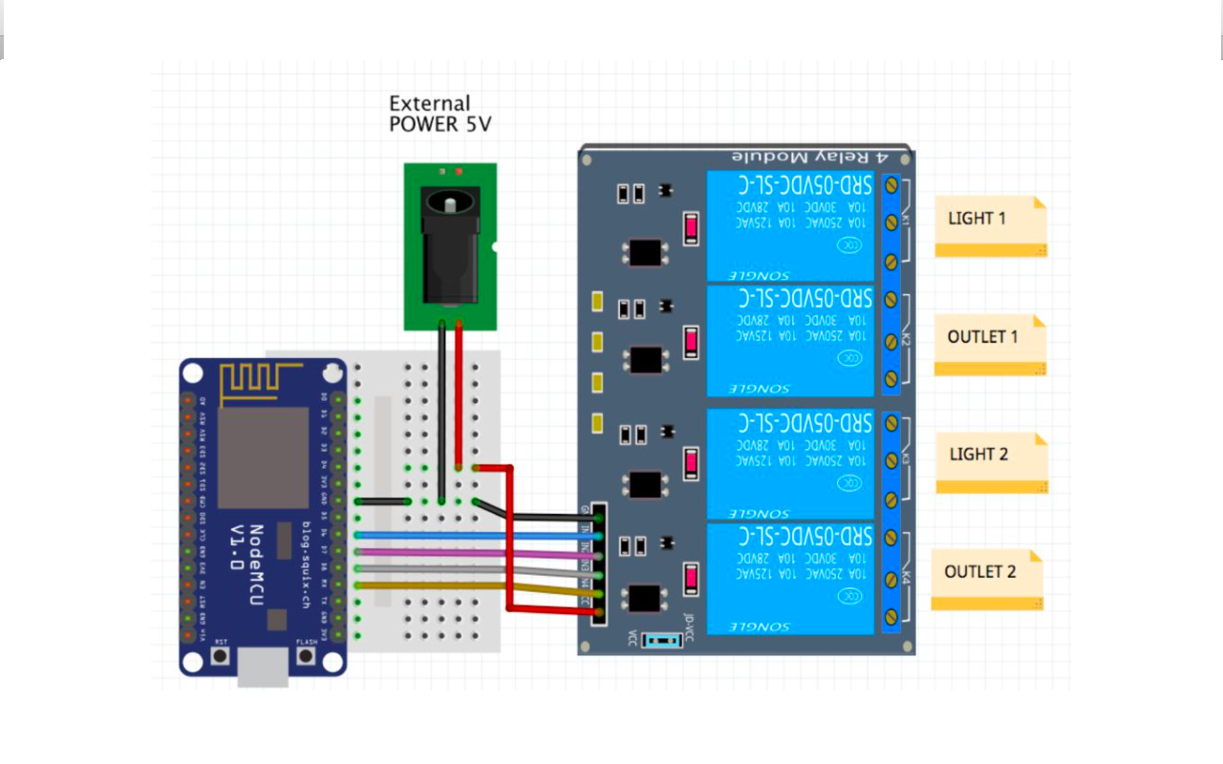

**Software Support:**

A code comprising of both controls, default being the LDR and priority given to the user is written for the smooth running of the functions of the entire system. The code thus used is in the following section.

#include <ESP8266WiFi.h>

#include <ESP8266HTTPClient.h>

const int ldrPin = A0;

const int ledPin = D1;

void setup () {

// char ledStatus = '0';

// char ledStatus = '0';

pinMode(D1,OUTPUT);

pinMode(A0,INPUT);

Serial.begin(9600);

char ssid[] = "Amrutha";

char pass[] = "amrutha1234";

WiFi.begin(ssid,pass);

Serial.println("Connecting..");

while (WiFi.status() != WL_CONNECTED) {

delay(1000);

Serial.println("Connecting..");

}

Serial.println("Connected to WiFi Network");

}

void loop() {

int ldrValue = analogRead(ldrPin);

int bulb;

if (WiFi.status() == WL_CONNECTED) { //Check WiFi connection status

HTTPClient http; //Declare an object of class HTTPClient

http.begin("http://pesce-streetlamp-demo.herokuapp.com/lamp001"); //Specify request destination

int httpCode = http.GET(); //Send the request

//Serial.println(httpCode);

//Serial.println(http.getString());

if (httpCode > 0) { //Check the returning code

String payload =http.getString();

char ledStatus = payload[0];

char ldrStatus = payload[1];

Serial.println();

Serial.println(ledStatus);

Serial.println(ldrStatus);

Serial.println(ldrValue);

if (ldrStatus =='1') {

if ( ledStatus =='0' ) {

bulb=0;

}else{

if(ldrValue<=2 00){

bulb=1;

Serial.println("LDR is DARK, LED is ON");

}

}

}else{

if ( ledStatus =='0' ) {

bulb=0;

}

if ( ledStatus =='1' ) {

bulb=1;

}

}

//Serial.println(payload); //Print the response payload

if(bulb==1)

digitalWrite(D1, HIGH);

else

digitalWrite(D1, LOW);

delay(100);

}else Serial.println("An error ocurred");

http.end(); //Close connection

}

}

**Expected Outcome**:

At the end of this project, the maintenance of the street lights in the college campus should be able to be done automatically rather than being manually operated. An authorized user will have the access to all of the street lights and can be controlled from any corner of the world provided the Microcontroller Unit is connected to an active internet. Also, with the help of the Light Dependent Resistor used in the basic circuitry, a flexibility is provided to the user so that the street lights turn on whenever there is bleak light in the surrounding. Doing this will reduce the user interference to minimum. The internet support for the system is only given to extend flexibility for the user so as to maintain a master-control over the lights.

**References:**

* <https://www.instructables.com/id/IOT-Light-Control-Over-Internet-NodeMCU-ESP8266/>
* <https://www.mapsofindia.com/my-india/government/street-lighting-in-india-and-need-for-energy-efficient-solutionså>
* <https://www.youtube.com/watch?v=v4OM5O3At_k>
* https://www.youtube.com/watch?v=jqHOPSL2MMU