Database System Engineering and Distributed Backend Development
BANK DATABASE — Triggers & Stored Procedures

Name: Sathwika
Roll No: 2520030007
Section: 7

Step 0 — Database & Table Setup (run once, before all questions)
CREATE DATABASE BankDB; USE BankDB;

CREATE TABLE Customer ( Customer_ID INT PRIMARY KEY,
Customer_Name VARCHAR(100) NOT NULL, Phone VARCHAR(15),
Email VARCHAR(100), City VARCHAR(50)
);

CREATE TABLE Account ( Account_No INT PRIMARY KEY, Customer_ID INT, Account_Type VARCHAR(20),
Balance DECIMAL(12,2) DEFAULT 0, Branch VARCHAR(50),
FOREIGN KEY (Customer_ID) REFERENCES Customer(Customer_ID)
);

CREATE TABLE Bank_Transaction (
Transaction_ID INT PRIMARY KEY AUTO_INCREMENT,
Account_No INT, Transaction_Type VARCHAR(20), Amount DECIMAL(12,2),
Transaction_Date DATETIME DEFAULT CURRENT_TIMESTAMP, FOREIGN KEY (Account_No) REFERENCES Account(Account_No)
);

CREATE TABLE Loan (
Loan_ID INT PRIMARY KEY,
Customer_ID INT, Loan_Type VARCHAR(30),

Loan_Amount DECIMAL(12,2),
Interest_Rate DECIMAL(5,2),
FOREIGN KEY (Customer_ID) REFERENCES Customer(Customer_ID)
);
CREATE TABLE Transaction_Audit (
Audit_ID INT PRIMARY KEY AUTO_INCREMENT,
Transaction_ID INT, Account_No INT, Transaction_Type VARCHAR(20), Amount DECIMAL(12,2),
Audit_Date DATETIME DEFAULT CURRENT_TIMESTAMP
);

INSERT INTO Customer (Customer_ID, Customer_Name, Phone, Email, City) VALUES (101, 'Hansika', '9876543210', 'gunapatihansikareddy@klh.edu.in', 'Hyderabad'),
(102, 'Priya Sharma', '9876543211', 'priya@gmail.com', 'Vijayawada'),
(103, 'Arjun Reddy', '9876543212', 'arjun@gmail.com', 'Bangalore'),
(104, 'Sneha Rao', '9876543213', 'sneha@gmail.com', 'Chennai'),
(105, 'Kiran Kumar', '9876543214', 'kiran@gmail.com', 'Hyderabad');

INSERT INTO Account (Account_No, Customer_ID, Account_Type, Balance, Branch) VALUES
INSERT INTO Bank_Transaction (Account_No, Transaction_Type, Amount) VALUES

(10001, | 101, | 'Savings', | 50000, 'Hyderabad'),
(10002, | 102, | 'Savings', | 75000, 'Vijayawada'),
(10003, | 103, | 'Current', | 120000, 'Bangalore'),
(10004, | 104, | 'Savings', | 45000, 'Chennai'),
(10005, | 105, | 'Current', | 90000, 'Hyderabad');

(10001, |  | 'DEPOSIT', 10000),
(10002, |  | 'DEPOSIT', 15000),
(10003, |  | 'WITHDRAW', 20000),
(10004, |  | 'DEPOSIT', 5000),
(10005, |  | 'WITHDRAW', 10000);
INSERT INTO Loan (Loan_ID, Customer_ID, Loan_Type, Loan_Amount, Interest_Rate) VALUES
(501, | 101, |  | 'Home Loan', 5000000, 7.5),
(502, | 102, |  | 'Education Loan', 1000000, 6.5),
(503, | 103, |  | 'Car Loan', 800000, 8.2),
(504, | 104, |  | 'Personal Loan', 500000, 10.5);
Output:

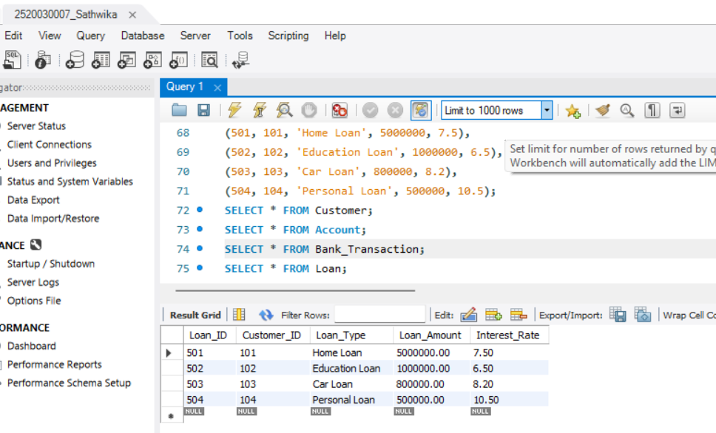

Question 1 — Display all accounts in a particular branch

Query:
DELIMITER //

CREATE PROCEDURE GetBranchAccounts( IN p_Branch VARCHAR(50)
) BEGIN
SELECT * FROM Account WHERE Branch = p_Branch; END //

DELIMITER ;

-- EXECUTION:
CALL GetBranchAccounts('Hyderabad');

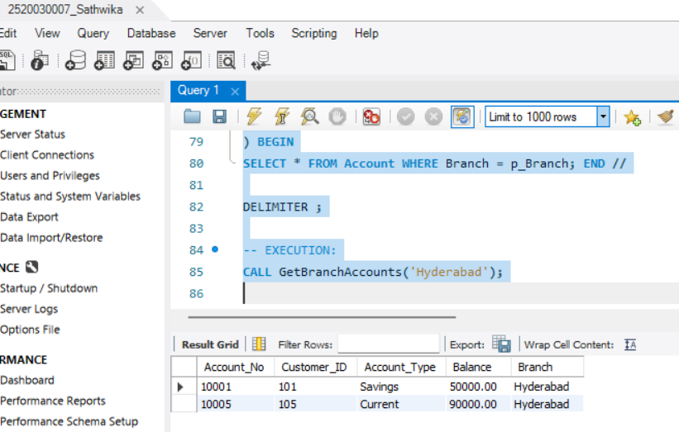

Question 2 — Total balance of all accounts of a customer (OUT parameter)

Query:
DELIMITER //

CREATE PROCEDURE GetTotalBalance( IN p_Customer_ID INT,
OUT p_TotalBalance DECIMAL(12,2)
)

BEGIN
SELECT SUM(Balance) INTO p_TotalBalance FROM Account
WHERE Customer_ID = p_Customer_ID; END //

DELIMITER ;

-- EXECUTION:
CALL GetTotalBalance(101, @Total); SELECT @Total AS Total_Balance;

Output:
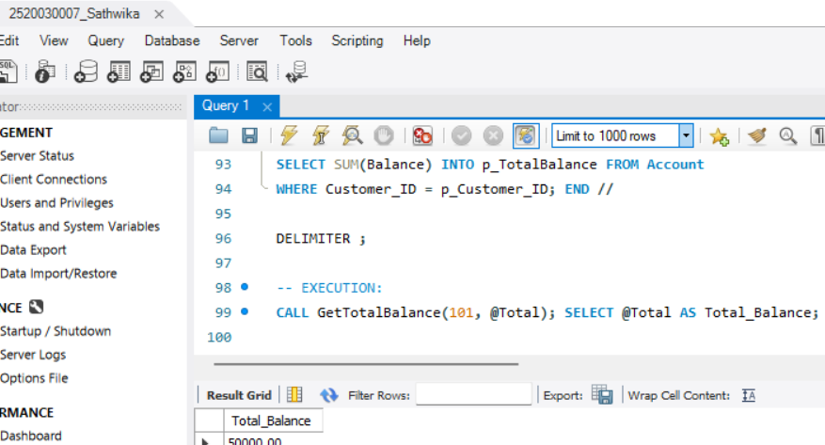

Question 3 — Trigger — prevent account balance from going negative

Query:
DELIMITER //

CREATE TRIGGER PreventNegativeBalance BEFORE UPDATE ON Account
FOR EACH ROW BEGIN
IF NEW.Balance < 0 THEN SIGNAL SQLSTATE '45000'
SET MESSAGE_TEXT = 'Balance cannot go negative'; END IF;
END // DELIMITER ;
-- TEST (should fail): UPDATE Account
SET Balance = Balance - 999999 WHERE Account_No = 10001;

Output:
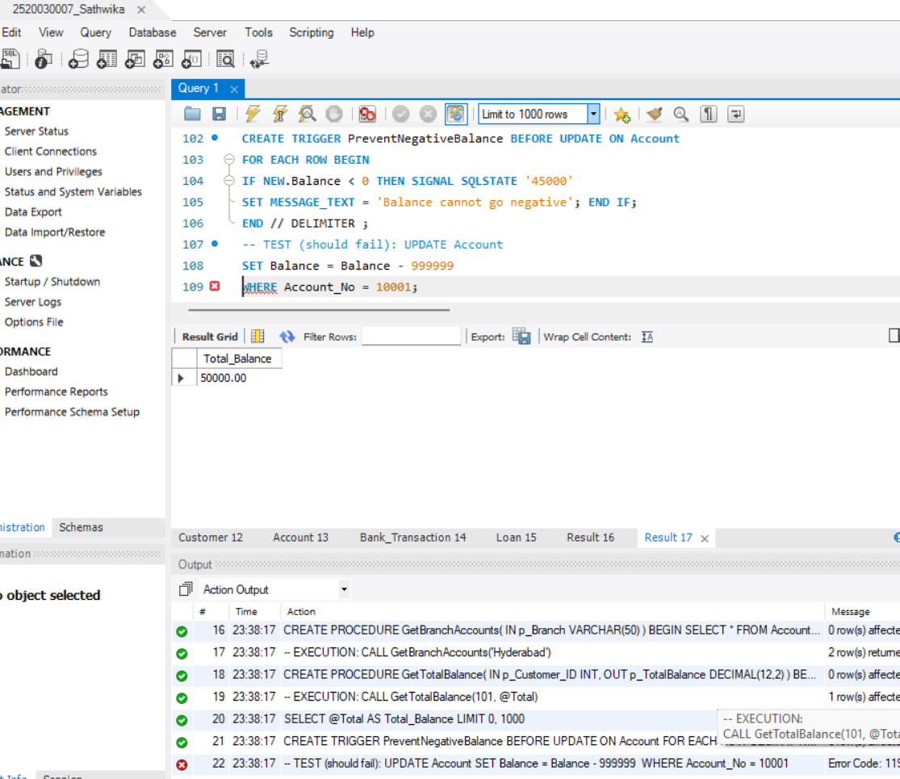

Question 4 — Trigger — auto-record every transaction into Transaction_Audit

Quer
DELIMITER //

CREATE TRIGGER AutoAuditTransaction AFTER INSERT ON Bank_Transaction FOR EACH ROW
BEGIN
INSERT INTO Transaction_Audit
(Transaction_ID, Account_No, Transaction_Type, Amount) VALUES
(NEW.Transaction_ID, NEW.Account_No, NEW.Transaction_Type, NEW.Amount);
END // DELIMITER ;
-- TEST:
INSERT INTO Bank_Transaction (Account_No, Transaction_Type, Amount) VALUES (10002, 'DEPOSIT', 3000);

-- CHECK:
SELECT * FROM Transaction_Audit;
Output:
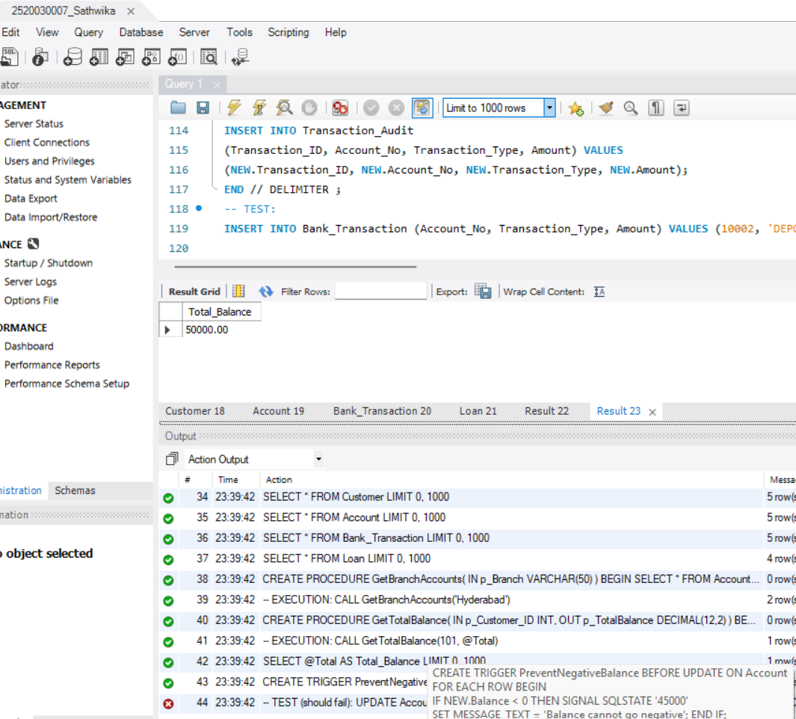

Question 5 — Trigger — auto-increase balance on DEPOSIT

Query
DELIMITER //

CREATE TRIGGER AutoIncreaseBalance AFTER INSERT ON Bank_Transaction FOR EACH ROW
BEGIN
IF NEW.Transaction_Type = 'DEPOSIT' THEN UPDATE Account
SET Balance = Balance + NEW.Amount WHERE Account_No = NEW.Account_No;
END IF;
END // DELIMITER ;
-- TEST:
INSERT INTO Bank_Transaction (Account_No, Transaction_Type, Amount) VALUES (10003, 'DEPOSIT', 4000);

-- CHECK:
SELECT * FROM Account WHERE Account_No = 10003;
Output:
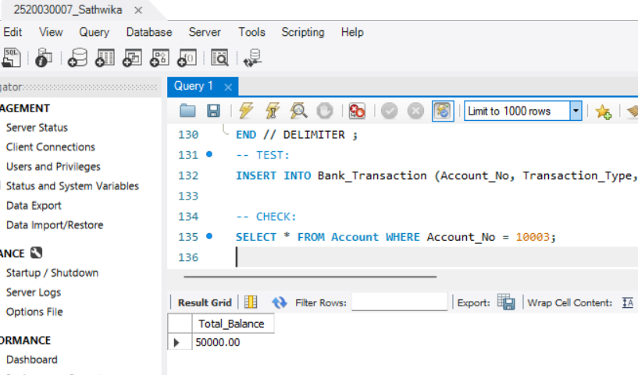

Question 6 — Trigger — auto-decrease balance on WITHDRAW

Query:
DELIMITER //

CREATE TRIGGER AutoDecreaseBalance AFTER INSERT ON Bank_Transaction FOR EACH ROW
BEGIN
IF NEW.Transaction_Type = 'WITHDRAW' THEN UPDATE Account
SET Balance = Balance - NEW.Amount

WHERE Account_No = NEW.Account_No; END IF;
END // DELIMITER ;
-- TEST:
INSERT INTO Bank_Transaction (Account_No, Transaction_Type, Amount) VALUES (10004, 'WITHDRAW', 1000);

-- CHECK:
SELECT * FROM Account WHERE Account_No = 10004;

Output:
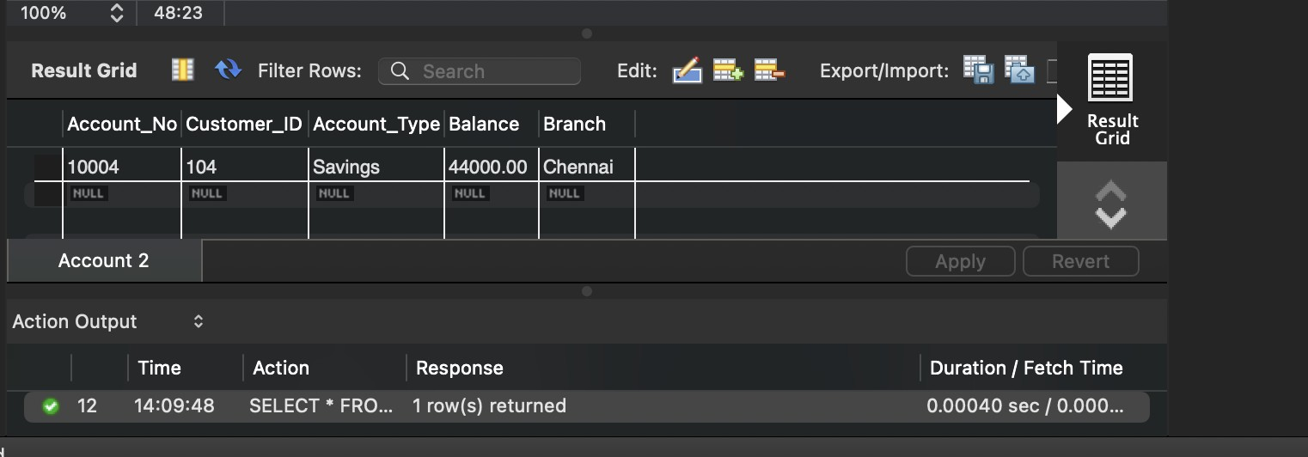

Question 7 — Trigger — prevent withdrawal when balance is insufficient

Query:
DELIMITER //

CREATE TRIGGER PreventInsufficientWithdrawal BEFORE INSERT ON Bank_Transaction
FOR EACH ROW BEGIN
DECLARE CurrentBalance DECIMAL(12,2);

SELECT Balance INTO CurrentBalance FROM Account
WHERE Account_No = NEW.Account_No;

IF NEW.Transaction_Type = 'WITHDRAW' AND NEW.Amount > CurrentBalance THEN SIGNAL SQLSTATE '45000'
SET MESSAGE_TEXT = 'Withdrawal failed: Insufficient balance'; END IF;
END //

DELIMITER ;

-- TEST (should fail):
INSERT INTO Bank_Transaction (Account_No, Transaction_Type, Amount) VALUES (10005, 'WITHDRAW', 5000000);

Output:
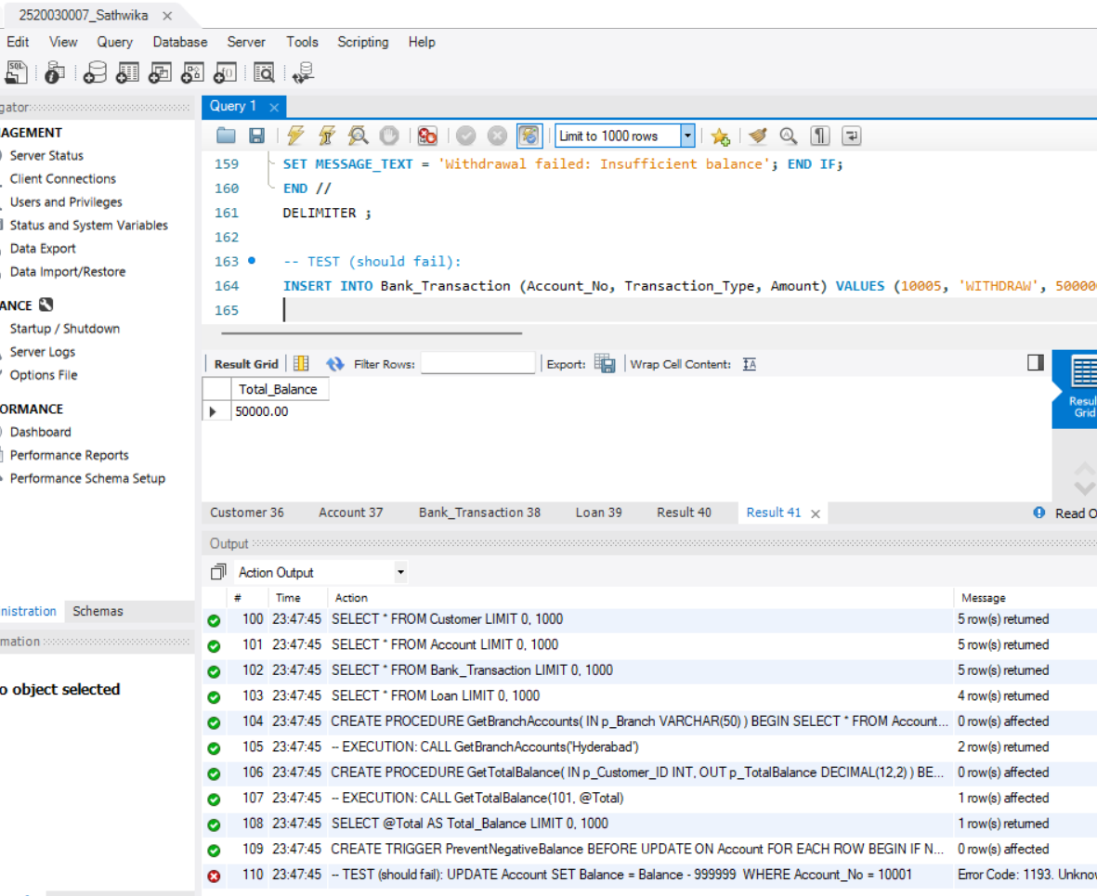

Question 8 — Procedure — transfer money between two accounts (with checks)

Query:
DELIMITER //

CREATE PROCEDURE TransferMoneyFull( IN p_Sender INT,
IN p_Receiver INT,
IN p_Amount DECIMAL(12,2)
) BEGIN

DECLARE v_SenderExists INT DEFAULT 0; DECLARE v_ReceiverExists INT DEFAULT 0; DECLARE v_SenderBalance DECIMAL(12,2);

SELECT COUNT(*) INTO v_SenderExists FROM Account WHERE Account_No = p_Sender; SELECT COUNT(*) INTO v_ReceiverExists FROM Account WHERE Account_No = p_Receiver;

IF v_SenderExists = 0 THEN
SIGNAL SQLSTATE '45000' SET MESSAGE_TEXT = 'Sender account does not exist'; ELSEIF v_ReceiverExists = 0 THEN
SIGNAL SQLSTATE '45000' SET MESSAGE_TEXT = 'Receiver account does not exist'; ELSE
SELECT Balance INTO v_SenderBalance FROM Account WHERE Account_No = p_Sender;

IF v_SenderBalance < p_Amount THEN
SIGNAL SQLSTATE '45000' SET MESSAGE_TEXT = 'Insufficient balance for
transfer';
ELSE
UPDATE Account SET Balance = Balance - p_Amount WHERE Account_No =
p_Sender;
UPDATE Account SET Balance = Balance + p_Amount WHERE Account_No =
p_Receiver;
END IF; END IF;
END // DELIMITER ;
-- EXECUTION:
CALL TransferMoneyFull(10001, 10002, 5000);
-- CHECK:
SELECT * FROM Account WHERE Account_No IN (10001, 10002);

Question 9 — Procedure — calculate loan simple interest

Query:
DELIMITER //

CREATE PROCEDURE CalculateLoanInterest( IN p_LoanAmount DECIMAL(12,2),
IN p_Rate DECIMAL(5,2),
IN p_Years INT,

OUT p_SimpleInterest DECIMAL(12,2), OUT p_TotalAmount DECIMAL(12,2)
) BEGIN
SET p_SimpleInterest = (p_LoanAmount * p_Rate * p_Years) / 100; SET p_TotalAmount = p_LoanAmount + p_SimpleInterest;
END // DELIMITER ;
-- EXECUTION:
CALL CalculateLoanInterest(500000, 7.5, 5, @SI, @Total); SELECT @SI AS Simple_Interest, @Total AS Total_Amount;

Output:
