PRACTICAL – 11
Name: Y.Sathwika
Roll No: 2520030007
Sec: 8

PART 1: MULTITHREADED COUNTER WITH RACE CONDITION

Aim
To develop a multithreaded counter application using POSIX threads (pthread_create() and pthread_join()) and demonstrate race conditions when multiple threads update a shared variable concurrently.

Theory
A thread is an independent execution unit within a process. POSIX threads provide functions such as pthread_create() to create threads and pthread_join() to wait for their completion.
When multiple threads access and modify the same shared variable simultaneously without synchronization, a race condition can occur. The final value may be different from the expected value.

Algorithm
- Start the program.
- Create a shared counter.
- Create multiple threads using pthread_create().
- Allow each thread to increment the shared counter.
- Wait for all threads using pthread_join().
4. Display the final counter value.
7. Observe the race condition.
8. Stop.

C Program – Race Condition
- include <stdio.h>
- include <pthread.h> int counter = 0;
void *increment(void *arg)
{
for (int i = 0; i < 100000; i++)
{
counter++;
}

return NULL;
}

int main()
{
pthread_t t1, t2;

pthread_create(&t1, NULL, increment, NULL); pthread_create(&t2, NULL, increment, NULL);

pthread_join(t1, NULL); pthread_join(t2, NULL);

printf("Final Counter Value: %d\n", counter);

return 0;
}

Compilation
gcc race.c -o race -pthread

Execution
./race

Expected Output
Final Counter Value: 200000
However, due to the race condition, the output may sometimes be less than 200000.

Flow Chart
START
↓
Initialize counter = 0
↓
Create Thread 1
↓
Create Thread 2
↓
Both threads increment counter
↓
Race Condition
↓
pthread_join()
↓
Display Counter

↓
STOP

Observation
Both threads access the shared counter simultaneously without synchronization. Therefore, some increments may be lost due to the race condition.

Output:

Result
The multithreaded counter program was successfully implemented, and the race condition caused by concurrent access to the shared variable was demonstrated.

PART 2: COUNTER USING MUTEX LOCK

Aim
To modify the multithreaded counter program using pthread_mutex_lock() and pthread_mutex_unlock() and compare the output with the race-condition version.

Theory
A mutex (mutual exclusion) allows only one thread at a time to access a critical section.
pthread_mutex_lock(&mutex); counter++; pthread_mutex_unlock(&mutex);
The mutex prevents multiple threads from modifying the shared variable at the same time.

Algorithm
- Start the program.
- Initialize the shared counter.
- Initialize the mutex.
- Create multiple threads.
- Lock the mutex before modifying the counter.
4. Increment the counter.
7. Unlock the mutex.
8. Wait for all threads using pthread_join().
U. Display the final counter value.
- Destroy the mutex.
- Stop.

C Program – Mutex Version
  - include <stdio.h>
  - include <pthread.h> int counter = 0; pthread_mutex_t mutex;
void *increment(void *arg)
{
for (int i = 0; i < 100000; i++)
{
pthread_mutex_lock(&mutex); counter++;
pthread_mutex_unlock(&mutex);
}

return NULL;
}

int main()
{
pthread_t t1, t2; pthread_mutex_init(&mutex, NULL);
pthread_create(&t1, NULL, increment, NULL); pthread_create(&t2, NULL, increment, NULL);

pthread_join(t1, NULL); pthread_join(t2, NULL);

printf("Final Counter Value: %d\n", counter); pthread_mutex_destroy(&mutex);
return 0;
}

Compilation
gcc mutex.c -o mutex -pthread

Execution
./mutex

Output
Final Counter Value: 200000

Comparison
Feature | Race Condition | Mutex
Synchronization | No | Yes
Final value | May be incorrect | Correct
Data safety | Unsafe | Safe
Execution | May be slightly faster | Slight overhead
Shared access | Concurrent | One thread at a time

Flow Chart
START
↓
Initialize counter
↓
Initialize Mutex
↓
Create Threads
↓
Lock Mutex
↓
Increment Counter
↓
Unlock Mutex
↓
More iterations?
↓
pthread_join()
↓
Display Counter
↓
Destroy Mutex
↓
STOP

Observation
Without a mutex, multiple threads can update the counter simultaneously, causing lost updates. With a mutex, only one thread accesses the critical section at a time, so the final value is correct.

Output:

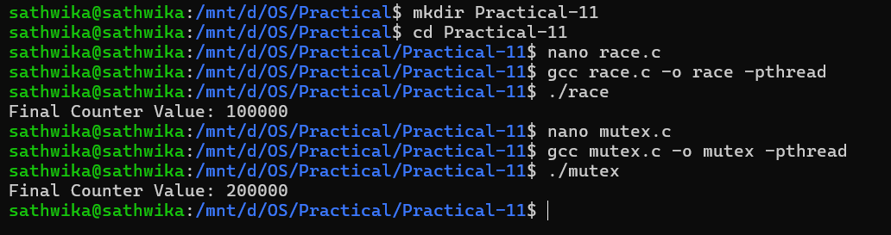

Result
The program was successfully modified using mutex synchronization. The mutex eliminated the race condition and produced the expected counter value, with a small synchronization overhead.

