PRACTICAL – 10
Name: M.Akhila
Roll No: 2520030511
Sec: 8

PART 1: INODE STRUCTURES, HARD LINKS AND SYMBOLIC LINKS

Aim
To investigate inode structures using commands such as ls -i, stat, and find, create hard links and symbolic links, and explain their impact on inode allocation.

Theory
An inode is a data structure in Linux that stores information about a file, such as file size, permissions, owner, timestamps, and location of data blocks.
Each file has an inode number.
- A hard link points to the same inode as the original file.
- A symbolic link has its own inode and stores the path of the original file.
- Creating a hard link does not create a new inode.
- Creating a symbolic link creates a new inode for the symbolic link.

Commands Used
Command | Purpose
ls -i | Displays inode number
stat | Displays detailed file information
find | Searches for files
ln | Creates a hard link
ln -s | Creates a symbolic link

Algorithm
- Start.
- Create a sample file.
- Display its inode using ls -i.
- Display file details using stat.
- Create a hard link using ln.
4. Compare the inode numbers.
7. Create a symbolic link using ln -s.
8. Compare the inode numbers again.
U. Use find to locate the files.

- Observe the inode allocation.
- Stop.

Commands / Program
echo "Hello Linux" > original.txt ls -i original.txt
stat original.txt

ln original.txt hardlink.txt ls -i original.txt hardlink.txt ln -s original.txt symlink.txt
ls -i original.txt hardlink.txt symlink.txt

stat original.txt stat hardlink.txt stat symlink.txt

find . -name "original.txt" -o -name "hardlink.txt" -o -name "symlink.txt"

Expected Observation original.txt → Same inode hardlink.txt → Same inode symlink.txt → Different inode
The hard link and original file share the same inode, while the symbolic link has a separate inode.

Flow Chart
START
↓
Create original.txt
↓
Check inode using ls -i
↓
Check details using stat
↓
Create Hard Link
↓
Compare inode numbers
↓
Create Symbolic Link
↓

Compare inode numbers
↓
Use find command
↓
Observe inode allocation
↓
STOP

Output:

Result
The inode structure was successfully investigated using ls -i, stat, and find. It was observed that hard links share the same inode, while symbolic links have a separate inode.

PART 2: FILE READING AND WRITING USING
mmap()

Aim
To design a program using mmap() to perform file reading and writing and compare memory-mapped I/O with traditional read()/write() operations in terms of efficiency and implementation complexity.

Theory
mmap() maps a file into the process's virtual memory. After mapping, the program can access the file directly through a memory pointer.
Traditional file I/O uses read() and write() system calls to transfer data between the file and a buffer.

Traditional I/O
open() → read() → modify → write() → close()

Memory-Mapped I/O
open() → mmap() → access memory → msync() → munmap() → close() Memory-mapped I/O can be efficient for large files and repeated or random access because the program works directly with memory.

Algorithm
- Start.
- Open the file using open().
- Get the file size using fstat().
- Map the file into memory using mmap().
- Read the file contents through the mapped memory.
4. Modify the contents.
7. Synchronize changes using msync().

8. Unmap the file using munmap().
U. Close the file.
10. Stop.

C Program
- include <stdio.h>
- include <fcntl.h>
- include <unistd.h>
- include <sys/mman.h>
- include <sys/stat.h>
- include <string.h>

int main()
{
int fd;
struct stat st; char *data;
fd = open("mmapfile.txt", O_RDWR); if (fd == -1)
{
perror("Error opening file"); return 1;
}

if (fstat(fd, &st) == -1)
{
perror("Error getting file size"); close(fd);
return 1;
}

data = mmap(NULL, st.st_size, PROT_READ | PROT_WRITE, MAP_SHARED, fd, 0);

if (data == MAP_FAILED)
{
perror("mmap failed"); close(fd);
return 1;
}

printf("Original content:\n%s\n", data);

/* Write data using memory mapping */

if (st.st_size >= 5)
{
memcpy(data, "HELLO", 5);
}

msync(data, st.st_size, MS_SYNC); printf("File modified successfully.\n");
munmap(data, st.st_size); close(fd);

return 0;
}

Compilation
gcc mmap_program.c -o mmap_program

Execution
Create the input file:
echo "Hello Linux World" > mmapfile.txt Run:
./mmap_program Check the file:
cat mmapfile.txt

Sample Output
Original content:
Hello Linux World

File modified successfully. The file becomes:
HELLO Linux World

Comparison: mmap() vs read()/write()
Feature | read()/write() | mmap()
Method | Uses system calls | Maps file into memory
Efficiency | Good for sequential access | Efficient for repeated/ random access
Implementation | Simple | More complex
Data access | Through buffers | Directly through memory
System calls | More read/write calls may be required | Fewer explicit I/O calls after mapping

Suitable for | Simple file operations | Large files and frequent access

Flow Chart START
↓
Open File
↓
Get File Size using fstat()
↓
Map File using mmap()
↓
Read File Through Memory
↓
Modify File Data
↓
msync()
↓
munmap()
↓
close()
↓
STOP

Observation
The file was successfully read and modified using mmap(). Memory-mapped I/ O provides direct memory-based access and can be efficient for large or repeatedly accessed files. However, it is slightly more complex than traditional read() and write() operations.

Output:

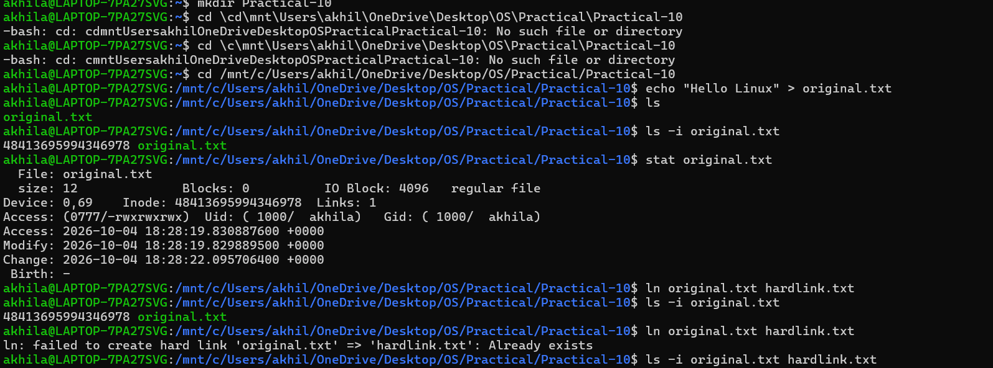
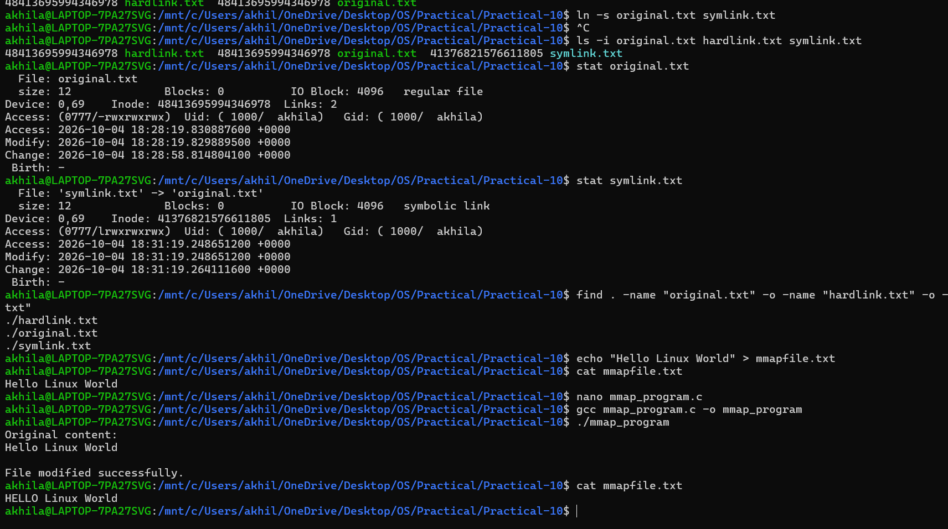

Result
The program successfully performed file reading and writing using mmap(). Memory-mapped I/O was compared with traditional read()/write() operations based on efficiency and implementation complexity.

