Experiment: Practical-02
Course: Operating Systems and Systems Programming (OSSP)
Name: Y.Sathwika
Roll No.: 2520030007
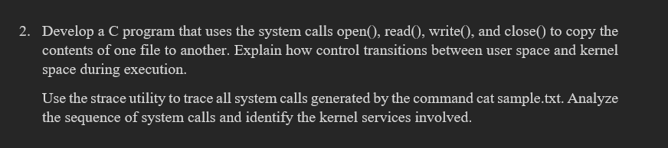
Step 1: Navigate to the Downloads Directory
Command:
Observation: The Downloads directory was successfully opened.

Step 2: Create the Working Directory
Command:
Observation: A new working directory named file_copy_lab was created successfully and opened.

Step 3: Verify the Current Working Directory
Command:
Output:
Observation: The current working directory was successfully verified.
Step 4: Create the Source File
Command:
Observation: A source file named source.txt was created successfully.

Step 5: Display the Source File Contents
Command:
Output:
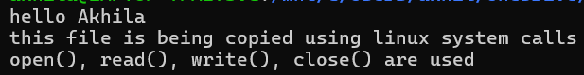
Observation: The contents of the source file were displayed successfully.

Step 6: Create the File Copy Program
Command:
Observation: A C program named filecopy.c was created successfully to copy data from the source file to a destination file using Linux system calls.

Step 7: Compile the File Copy Program
Command:
Observation: The filecopy.c program was compiled successfully and an executable named filecopy was generated.

Step 8: Verify the Generated Files
Command:
Output:
filecopy filecopy.c source.txt
Observation: The source file, C source program, and executable file were successfully present in the working directory.
Step 9: Execute the File Copy Program
Command:
Output:
Observation: The program executed successfully and copied the contents of source.txt to the destination file.

Step 10: Display the Destination File Contents
Command:
Output:
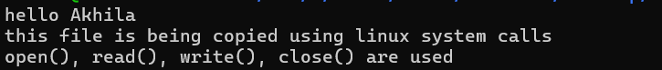
Observation: The destination file contents were displayed successfully and matched the source file contents.

Step 11: Compare the Source and Destination Files
Command:
Observation: The cmp command produced no output, confirming that both files were identical.

Step 12: Check the File Details
Command:
Output:
Observation: Both source and destination files had the same size, confirming that the file contents were copied successfully.

PART-B: System Call Tracing Using strace
Step 13: Create a Sample File for Tracing
Command:
Observation: A sample text file was created successfully for the strace experiment.

Step 14: Display the Sample File Contents
Command:
Output:
Observation: The contents of the sample file were displayed successfully.

Step 15: Verify strace Installation
Command:
Output:
Observation: The strace utility was successfully installed and its version was verified.

Step 16: Trace System Calls of the cat Command
Command:
Observation: The system calls executed while displaying sample.txt were successfully traced. The trace showed important operations including program execution, file opening, reading, writing, and closing.

Step 17: Observe File Opening
System Call Observed:
openat(AT_FDCWD, "sample.txt", O_RDONLY)
Observation: The openat() system call opened sample.txt in read-only mode.

Step 18: Observe File Reading
System Call Observed:
read(3, "This is a sample file for strace"..., 131072) = 88
Observation: The read() system call successfully read the contents of sample.txt.

Step 19: Observe Output Writing
System Call Observed:
write(1, "This is a sample file for strace"..., 88)
Observation: The write() system call successfully displayed the file contents on the terminal.

Step 20: Observe File Closing
System Call Observed:
close(3) = 0
Observation: The close() system call successfully closed the opened file after the reading operation was completed.

Step 21: Verify Program Completion
System Call Observed:
exit_group(0)
+++ exited with 0 +++
Observation: The command completed successfully with exit status 0.

Result
Observation: The file copy program was successfully implemented using Linux file-related system calls. The contents of source.txt were copied successfully to destination.txt, and both files were verified to be identical using the cmp command. The strace utility was also successfully used to observe system calls such as openat(), read(), write(), close(), and program termination during file operations.

