Skill-09
Name: Y.Sathwika
Rollno: 2520030007
Section: 8

Experiment No. 9 (Q9)
Title: Directory Navigation (cd) and Built-in Command Dispatch in a Custom Shell

Aim:
To implement directory navigation functionality (similar to the cd command) that changes directories, validates paths, updates the working directory, handles errors, and maintains the previous directory. To identify shell built-in commands, create a dispatch table, execute built-in commands in-process, handle invalid commands, maintain shell state, and test the dispatch logic.

Objective:

Part 1 – Directory Navigation (cd)
- To change the current working directory using chdir().
- To validate the target path before changing directories.
- To update the working directory after a successful change.
- To handle errors such as invalid or inaccessible paths.
- To maintain the previous directory for use with "cd -".
- To test directory navigation with valid and invalid paths.

Part 2 – Built-in Command Dispatcher
- To identify commands that must be treated as shell built-ins.
- To create a dispatch table mapping command names to handler functions.
- To execute built-in commands in-process (without fork()).
- To handle invalid or unrecognized commands gracefully.
- To maintain shell state such as the command count and current directory.
- To test the dispatch logic with valid and invalid commands.

Theory:

Directory Navigation and the cd Command
Every process has a current working directory associated with it. The cd command changes this directory for the shell process using the chdir() system call. Because cd modifies the shell's own state, it must be implemented as a built-in command rather than an external program — an external program running in a child process cannot change the parent shell's working directory.

chdir()
The chdir() system call changes the calling process's current working directory to the specified path.
int chdir(const char *path);
It returns 0 on success and -1 on failure, setting errno to indicate the cause (e.g. ENOENT for a missing path, ENOTDIR if the path is not a directory).

Path Validation

Before changing directories, the target path is validated using stat(). This confirms that the path exists and that it refers to a directory, preventing chdir() from being called on an invalid or non-directory path.
struct stat st; stat(path, &st);
S_ISDIR(st.st_mode) /* true if path is a directory */

Maintaining the Previous Directory
A well-behaved cd implementation stores the directory the shell was in before the change, similar to the OLDPWD variable in real shells. This allows the special argument "cd -" to return to the previous directory.

Error Handling
If the target directory does not exist, is not a directory, or chdir() fails for any other reason, an appropriate error message is displayed and the current directory remains unchanged.

Shell Built-in Commands
Built-in commands are commands executed directly by the shell process instead of being launched as external programs via fork() and exec(). Examples include cd, pwd, exit and help. They are used for operations that must affect the shell's own state (such as the working directory) or that need to run without the overhead of creating a new process.

Dispatch Table
A dispatch table is an array that maps each built-in command name to a corresponding handler function (a function pointer). When a command is entered, the shell searches the table for a matching name and calls the associated function, avoiding a long chain of if-else statements.
typedef struct { const char *name;
void (*func)(char *);
} DispatchEntry;

In-Process Execution
Because built-in commands run in-process, they execute immediately within the shell and can directly modify shell state (such as currDirectory or prevDirectory) without any inter-process communication.

Handling Invalid Commands
If the entered command name does not match any entry in the dispatch table, the shell reports "command not found" instead of crashing or silently ignoring the input.

Algorithm:

Part 1 – Directory Navigation
- Start the program.
- Record the starting working directory using getcwd().
- Read the target directory argument (or "-" for the previous directory).
- If no argument is given, use the HOME directory.
- Validate the target path using stat() and S_ISDIR().
- If validation fails, display an error and stop.
- Save the current directory into prevDirectory.
- Call chdir() to change to the target directory.
- Update currDirectory using getcwd().
- Display the new working directory.
- Test navigation with a valid path, "cd -", and an invalid path.

Part 2 – Built-in Command Dispatcher
- Start the program.
- Build a dispatch table of {command name, handler function} pairs.
- Read a command and its argument from the user.
- Search the dispatch table for a matching command name.
- If found, increment the command counter and call the handler function.
- If not found, display "command not found".
- Repeat until the exit command is entered.
- Stop the program.

Functions Used:

Function | Purpose
main() | Starting point of the program
chdir() | Changes the current working directory
getcwd() | Retrieves the current working directory
stat() | Retrieves file/directory information for path validation
S_ISDIR() | Checks whether a stat() result refers to a directory
getenv() | Retrieves the HOME environment variable
changeDirectory() | Implements cd, including "cd -" and error handling
updateWorkingDirectory() | Refreshes the stored current directory
isBuiltin() | Checks whether a command exists in the dispatch table
executeBuiltin() | Looks up and calls the handler for a built-in command
builtin_cd() / builtin_pwd() /  builtin_exit() / builtin_help() | Handler functions for built-in commands
fgets() | Reads command input
sscanf() | Splits input into command and argument
printf() | Displays output and messages

Hardware and Operating System Relationship
Hardware consists of physical components such as the CPU, RAM, storage devices, keyboard, mouse and display. The Operating System acts as an interface between application software and hardware. It manages processes, memory, files, devices and system resources.

Relationship
USER
| v
SHELL (this program)
| v
SYSTEM CALLS (chdir, stat, getcwd)
| v
OPERATING SYSTEM
|
+ + + +
v v v CPU RAM FILE SYSTEM
| v
STORAGE DEVICES

How OS Interacts with Hardware
- Process Management – The OS manages the shell process and any commands it runs.
- File Management – The OS resolves paths and verifies directories via the file system.
- Memory Management – The OS manages memory used to store shell state.
- Device Management – The OS controls the terminal used for input and output.
- Security – The OS enforces directory and file access permissions.

Observation
The program successfully changes the current working directory using chdir(), validates paths with stat() before switching, updates and displays the new working directory, and reports clear errors for invalid paths. It also stores the previous directory so that "cd -" correctly returns to it.
The built-in dispatcher correctly identifies recognized commands (cd, pwd, help, exit) using the dispatch table, executes their handler functions in-process, keeps count of the commands dispatched, and reports "command not found" for unrecognized input.

Result
Directory navigation functionality similar to the cd command was successfully implemented, including path validation, working-directory updates, error handling, and maintenance of the previous directory. A built-in command dispatcher was also successfully implemented to identify built-ins, execute them in-process using a dispatch table, handle invalid commands, and maintain shell state.

Design / Flow

Directory Navigation Flow

Read argument
| v
Empty? --Yes--> Use HOME
| No v
"-"? --Yes--> Use prevDirectory
| No v
Validate path (stat + S_ISDIR)
|
+---+---+
Valid Invalid
| |
v v
Save prevDirectory Display error
| v
chdir(target)
| v
updateWorkingDirectory()
| v
Display new directory

Dispatch Logic Flow

Read command + argument
|

v Search dispatch table
|
+ + +
Found Not Found
| |
v v
Increment "command not commandCount found"
| v
Call handler function (builtin_cd / builtin_pwd / builtin_exit / builtin_help)

CODE-
#include <stdio.h> #include <stdlib.h> #include <string.h> #include <unistd.h> #include <sys/stat.h> #include <sys/types.h>

#define MAX 200

char prevDirectory[MAX] = ""; char currDirectory[MAX] = "";

/* ---------- Part 1: Directory Navigation */

int validatePath(const char *path)
{
struct stat st;
if (stat(path, &st) != 0)
{
printf("cd: %s: No such file or directory\n", path); return 0;
}
if (!S_ISDIR(st.st_mode))
{
printf("cd: %s: Not a directory\n", path); return 0;
}
return 1;
}

void updateWorkingDirectory()
{
if (getcwd(currDirectory, sizeof(currDirectory)) == NULL) perror("getcwd");
}

void changeDirectory(const char *arg)
{
char target[MAX];

if (arg == NULL || strlen(arg) == 0)
{
char *home = getenv("HOME"); if (home == NULL)
{
printf("cd: HOME not set\n"); return;
}
strncpy(target, home, MAX);
}

else if (strcmp(arg, "-") == 0)
{
if (strlen(prevDirectory) == 0)
{
printf("cd: OLDPWD not set\n"); return;
}

}
else
{
}
strncpy(target, prevDirectory, MAX); printf("%s\n", target);

strncpy(target, arg, MAX);

if (!validatePath(target)) return;

strncpy(prevDirectory, currDirectory, MAX);

if (chdir(target) != 0)
{
perror("cd"); return;
}

updateWorkingDirectory();
printf("Directory changed to: %s\n", currDirectory);
}

void testNavigation()
{
printf("\n--- Testing Directory Navigation ---\n"); updateWorkingDirectory();
printf("Starting directory: %s\n", currDirectory);

changeDirectory("/tmp"); changeDirectory("-"); changeDirectory("/nonexistent_dir_xyz");
}

/* ---------- Part 2: Built-in Command Dispatcher */

int commandCount = 0;

void builtin_cd(char *arg) { changeDirectory(arg); }

void builtin_pwd(char *arg)
{
(void)arg; updateWorkingDirectory(); printf("%s\n", currDirectory);
}

void builtin_exit(char *arg)
{
(void)arg;
printf("Exiting shell...\n"); exit(0);
}

void builtin_help(char *arg)
{
(void)arg;
printf("Built-in commands: cd, pwd, exit, help\n");
}

typedef struct { const char *name;
void (*func)(char *);

} DispatchEntry;

DispatchEntry dispatchTable[] = {
{"cd", builtin_cd},
{"pwd", builtin_pwd},
{"exit", builtin_exit},
{"help", builtin_help}
};

int dispatchTableSize = sizeof(dispatchTable) / sizeof(DispatchEntry);

int isBuiltin(const char *cmd)
{
for (int i = 0; i < dispatchTableSize; i++)
if (strcmp(cmd, dispatchTable[i].name) == 0) return 1;
return 0;
}

void executeBuiltin(char *cmd, char *arg)
{
commandCount++;
for (int i = 0; i < dispatchTableSize; i++)
{
if (strcmp(cmd, dispatchTable[i].name) == 0)
{
dispatchTable[i].func(arg); return;
}
}
printf("%s: command not found\n", cmd);
}

void testDispatchLogic()
{
printf("\n--- Testing Dispatch Logic ---\n"); executeBuiltin("pwd", NULL); executeBuiltin("cd", "/tmp"); executeBuiltin("help", NULL); executeBuiltin("foo", NULL);
printf("Total commands dispatched: %d\n", commandCount);
}

/* Main */

int main()
{
char line[MAX], cmd[MAX], arg[MAX];

updateWorkingDirectory();

printf("=== Part 1: Directory Navigation ===\n"); testNavigation();

printf("\n=== Part 2: Built-in Command Dispatcher ===\n"); testDispatchLogic();

printf("\n=== Interactive Mode (type 'exit' to quit) ===\n"); while (1)
{
updateWorkingDirectory(); printf("myshell:%s$ ", currDirectory);

if (fgets(line, sizeof(line), stdin) == NULL) break;
line[strcspn(line, "\n")] = '\0'; if (strlen(line) == 0)
continue;

arg[0] = '\0';

sscanf(line, "%s %[^\n]", cmd, arg);

if (isBuiltin(cmd))
executeBuiltin(cmd, arg[0] ? arg : NULL);
else
printf("%s: command not found (external execution not implemented)\n", cmd);
}

return 0;
}

Compilation and Execution

Compile
gcc question9.c -o question9

Execute
./question9

Sample Output

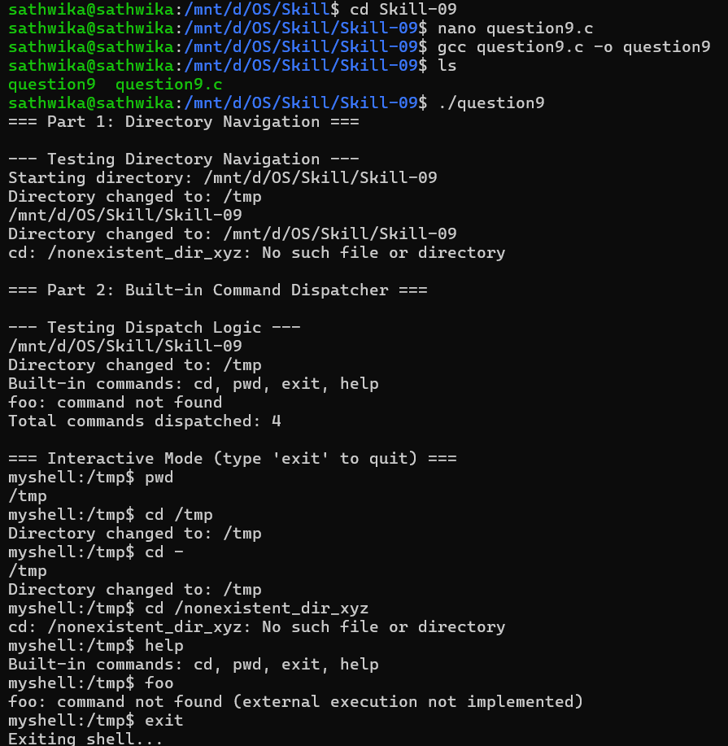

Conclusion
This experiment demonstrates directory navigation using chdir(), including path validation with stat(), working-directory updates, error handling for invalid paths, and maintenance of the previous directory for "cd -". It also demonstrates a built-in command dispatcher built around a table of function pointers, showing how a shell can identify, execute and manage built-in commands in-process while gracefully handling invalid input. Together, these illustrate important Operating System concepts such as the process working directory, system calls for file-system interaction, and command-dispatch design in shell implementation.

