Experiment: Practical-04
Course: Operating Systems and Systems Programming (OSSP)
Name: Y.Sathwika
Roll No.: 2520030007
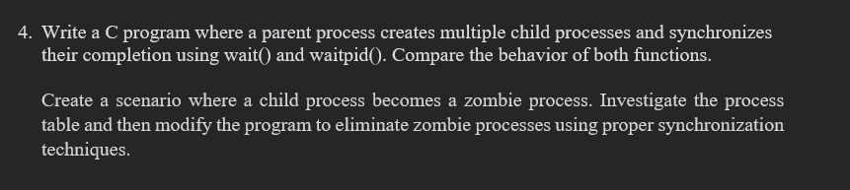
Step 1: Navigate to the Downloads Directory
Command:
Observation: The Downloads directory was successfully opened.

Step 2: Create and Navigate to the Working Directory
Command:
Observation: The process_sync_lab directory was already present. The directory was opened successfully.

Step 3: Verify the Current Working Directory
Command:
Observation: The current working directory was successfully verified.

Step 4: Display the Files in the Working Directory
Command:
Output:
Observation: The programs for demonstrating wait(), waitpid(), and zombie processes were successfully present in the working directory.

Step 5: Execute the wait() Demonstration Program
Command:
Output:
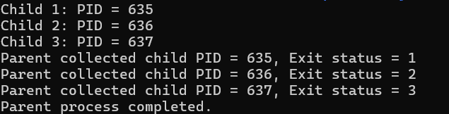
Observation: The parent process successfully created three child processes. The parent used wait() to wait for each child process to complete before finishing its execution.

Step 6: Observe Child Process Completion Using wait()
Observation: Each child process completed its execution and returned a different exit status. The parent process collected the terminated child processes one by one using wait().

PART-B: Process Synchronization Using waitpid()
Step 7: Execute the waitpid() Demonstration Program
Command:
Output:
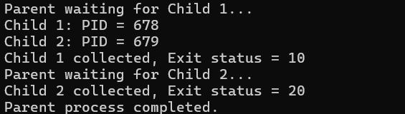
Observation: The parent process successfully used waitpid() to wait for specific child processes and collected their exit statuses individually.

Step 8: Observe Specific Child Process Synchronization
Observation: Unlike wait(), the waitpid() system call allowed the parent process to wait for a particular child process by specifying its PID.

PART-C: Zombie Process Demonstration
Step 9: Execute the Zombie Process Program
Command:
Output:
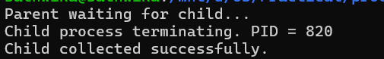
Observation: The child process terminated while the parent process continued sleeping. This situation was used to demonstrate the creation of a zombie process.

Step 10: Check the Zombie Process
Command:
Output:
Observation: The output showed the child process as [zombie] <defunct>, confirming that the child had terminated but had not yet been collected by its parent process.

Step 11: Observe the Zombie Process After Parent Termination
Command:
Observation: After the parent process completed, the zombie process was no longer present in the process list.

Step 12: Monitor Process Information Using ps
Command:
Observation: The ps command was used to monitor the PID, PPID, process state, and command of the active processes.

PART-D: Preventing Zombie Process Using wait()
Step 13: Edit the Zombie Program
Command:
Observation: The zombie process program was modified so that the parent process uses wait() to collect the terminated child process.

Step 14: Compile the Modified Program
Command:
Observation: The modified zombie.c program was compiled successfully without errors.

Step 15: Execute the Modified Zombie Program
Command:
Output:
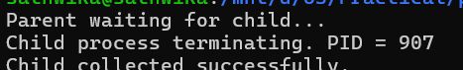
Observation: The parent process successfully used wait() to collect the child process after it terminated. Therefore, no zombie process was created.

Step 16: Verify That No Zombie Process Exists
Command:
Output:
Observation: Only the grep zombie command appeared in the output. No [zombie] <defunct> process was found, confirming that the child process was successfully collected.

Result
Observation: The experiment was successfully performed to demonstrate process synchronization using wait() and waitpid(). The wait() system call was used to collect terminated child processes, while waitpid() was used to wait for specific child processes. A zombie process was also successfully demonstrated when a child terminated before its parent collected its exit status. Finally, the zombie process was prevented by using wait(), which successfully collected the terminated child process.

