Experiment 1: Linux Command Execution Using fork() and exec()
Course: Operating Systems and Systems Programming (OSSP)
Name: M.Akhila
Roll No.: 2520030511
Date: 31/7/2026
1.Develop a C program that demonstrates how a Linux operating system executes a command entered by a user that 1. Accept a Linux command as input. 2. Create a child process using fork(). 3. Execute the command in the child process using an appropriate exec() system call. 4. Allow the parent process to wait for the child using wait (). 5. Display the Process ID (PID) of both parent and child processes.
Using Linux terminal commands (uname, lscpu, lsblk, ps, top), investigate the relationship between hardware resources and operating system services. Prepare a report explaining how the OS abstracts CPU, memory, storage, and I/O devices.

Experiment Steps:

Step 1: Check Whether GCC is Installed
To check if the GNU C Compiler (GCC) was installed, I executed the following command:
gcc --version
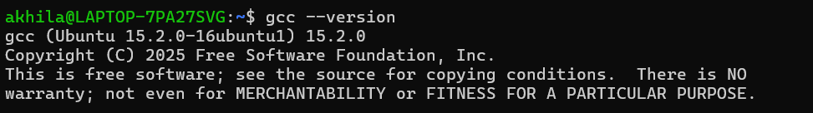

Step 2: Navigate to the Program Directory
The directory containing the C program was opened using:
To verify the file, the following command was executed:
Observation:
The terminal displayed:
This confirmed that the source file was present in the directory.

Step 3: Compile the Program
The C program was compiled using the GCC compiler with the following command:

Step 4: Execute the Program
The compiled program was executed using:
./Practical-01
When prompted:
Enter Linux Command
a Linux command was entered, and the program executed it successfully using the system() function.

Step 5: Execute Different Linux Commands Step
- Ls
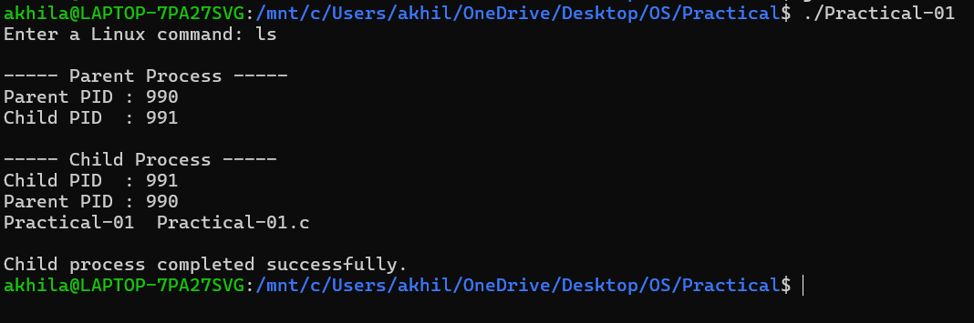
- pwd

- date

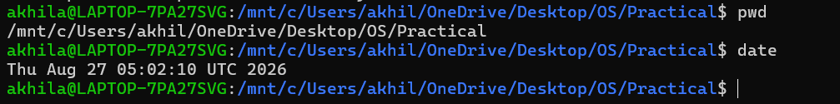
- Uname
- Lscpu

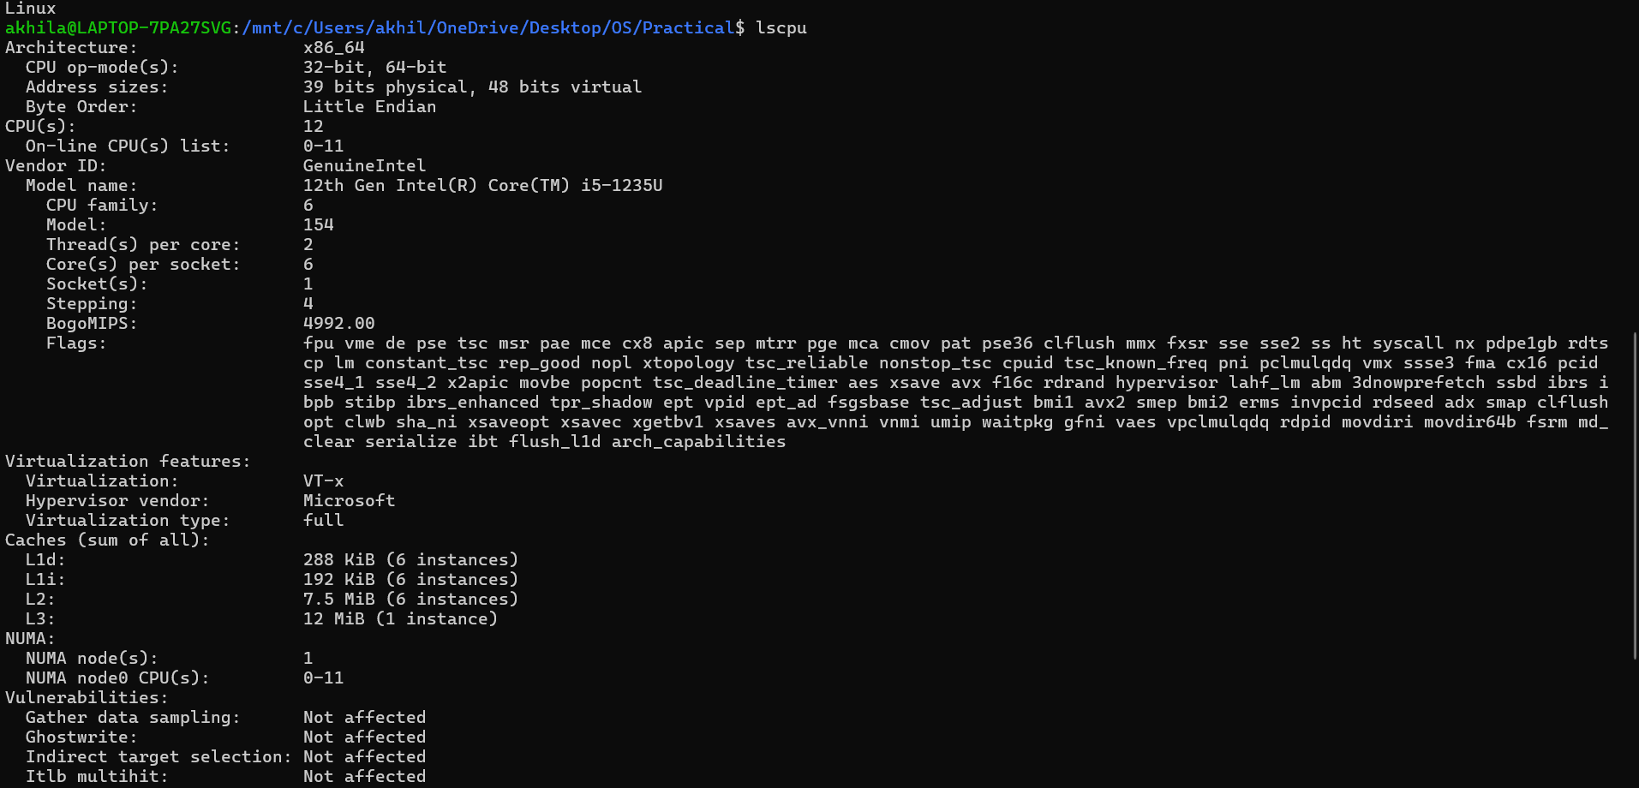
- Lsblk

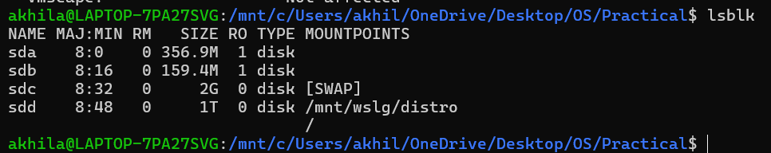
- Ps
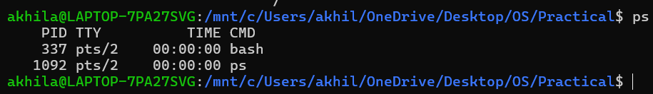
- Top

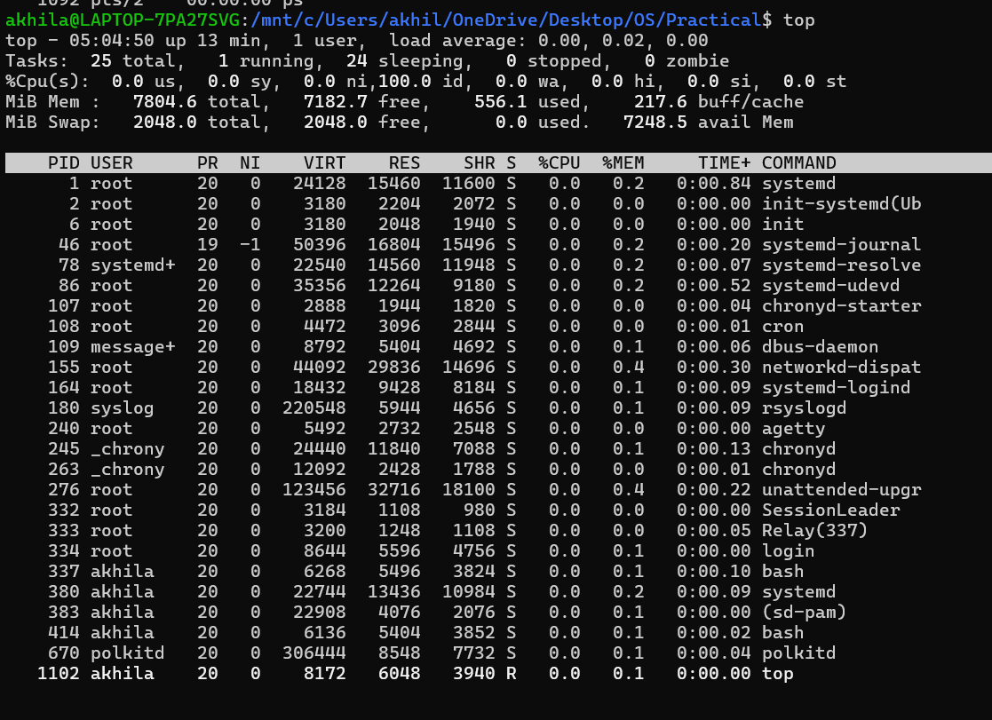

9)whoami

