Course: Operating Systems and Systems Programming (OSSP)
Name: Y.Sathwika
Roll No.: 2520030007
Date: 01/08/2026
Experiment: Skill-03
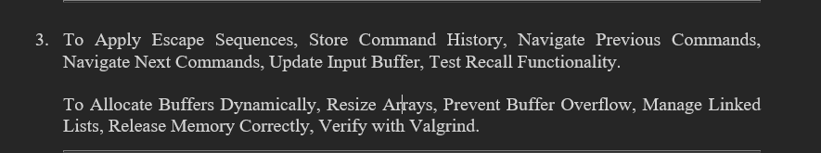
Step 1: Navigate to the Working Directory
Observation: The working directory was successfully opened.

Step 2: Create the C Program
Observation: A C program named memory_demo.c was created successfully to demonstrate dynamic memory allocation and memory management.

Step 3: Verify the Created Program
Observation: The memory_demo.c file was successfully displayed in the working directory.

Step 4: Display the Program Source Code
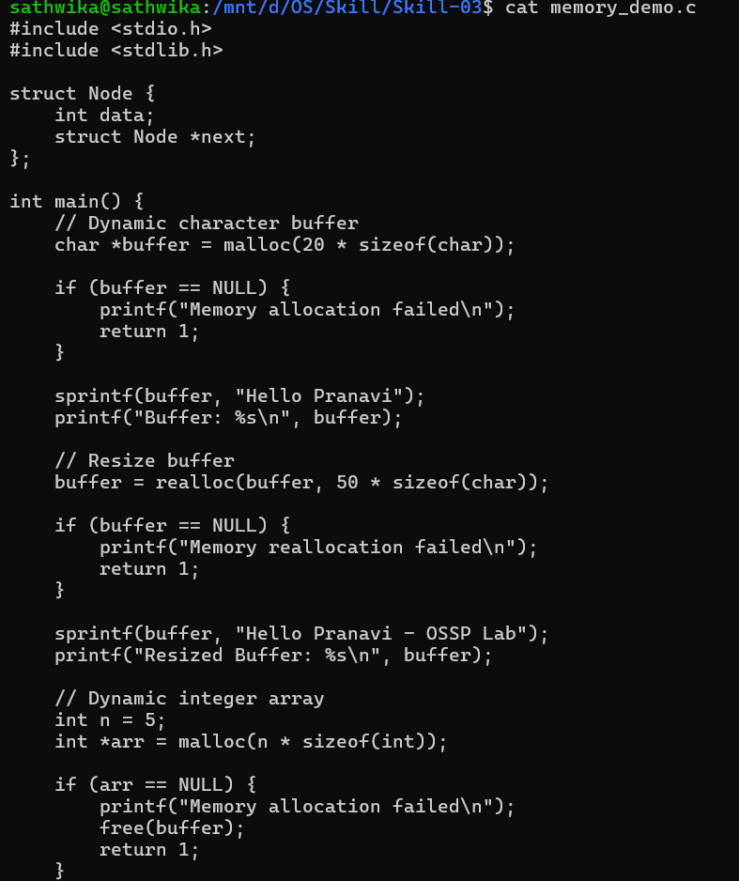

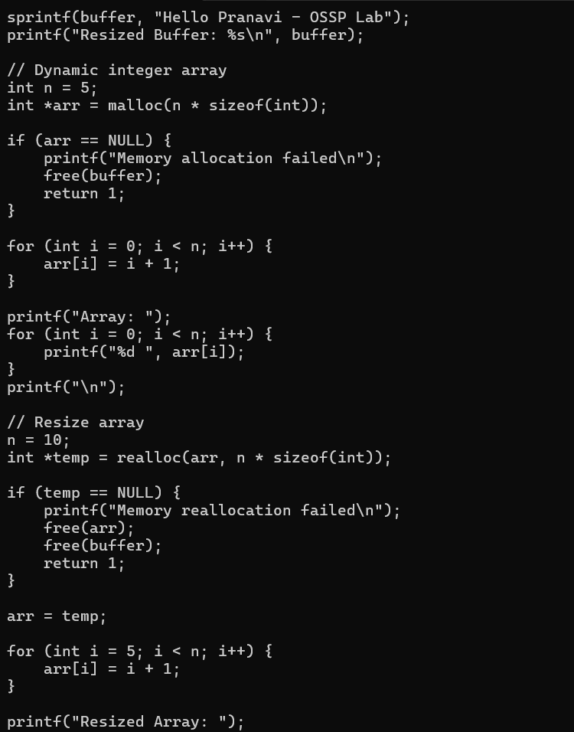

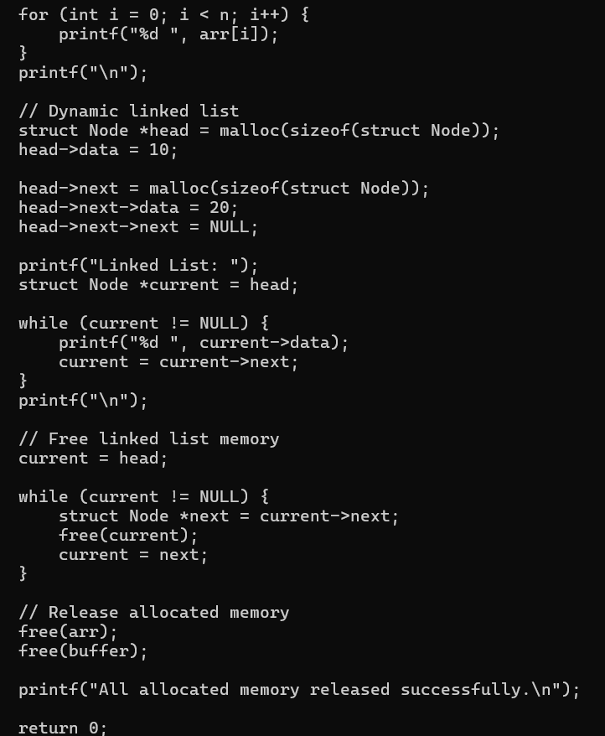
Observation: The complete source code of the memory_demo.c program was displayed successfully.

Step 5: Allocate Memory for a Dynamic Buffer
Program Operation:
char *buffer = malloc(20 * sizeof(char));
Observation: Memory was successfully allocated dynamically for a character buffer using the malloc() function.

Step 6: Resize the Dynamic Buffer
Program Operation:
buffer = realloc(buffer, 50 * sizeof(char));
Observation: The buffer memory was successfully resized using the realloc() function.

Step 7: Create a Dynamic Integer Array
Program Operation:
int *arr = malloc(n * sizeof(int));
Observation: Memory was successfully allocated dynamically for an integer array containing 5 elements.

Step 8: Resize the Dynamic Array
Program Operation:
int *temp = realloc(arr, n * sizeof(int));
Observation: The array size was successfully increased from 5 elements to 10 elements.

Step 9: Create a Dynamic Linked List
Program Operation:
struct Node *head = malloc(sizeof(struct Node));
Observation: Memory was successfully allocated dynamically for the linked-list node.

Step 10: Release the Linked List Memory
Program Operation:
free(current);
Observation: The dynamically allocated memory used by the linked-list nodes was successfully released.

Step 11: Release the Allocated Memory
Program Operation:
free(arr);
free(buffer);
Observation: The memory allocated for the dynamic array and buffer was successfully released.

Step 12: Compile the Program
Observation: The memory_demo.c program was compiled successfully without any errors.

Step 13: Verify the Executable File
Observation: The executable file memory_demo was successfully generated along with the source file memory_demo.c.

Step 14: Execute the Program
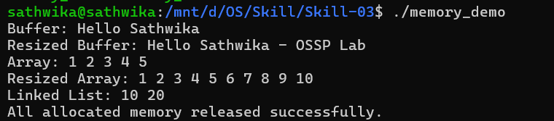
Output:
Buffer: Hello Sathwika
Resized Buffer: Hello Sathwika - OSSP Lab
Array: 1 2 3 4 5
Resized Array: 1 2 3 4 5 6 7 8 9 10
Linked List: 10 20
All allocated memory released successfully.
Observation: The program executed successfully and demonstrated dynamic memory allocation, memory resizing, dynamic arrays, linked lists, and memory deallocation.

Step 15: Check Valgrind Installation
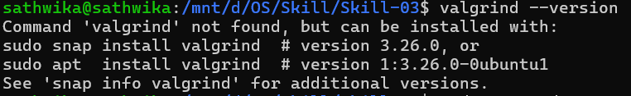
Observation: The system initially showed that Valgrind was not installed.
Step 16: Update the Package List
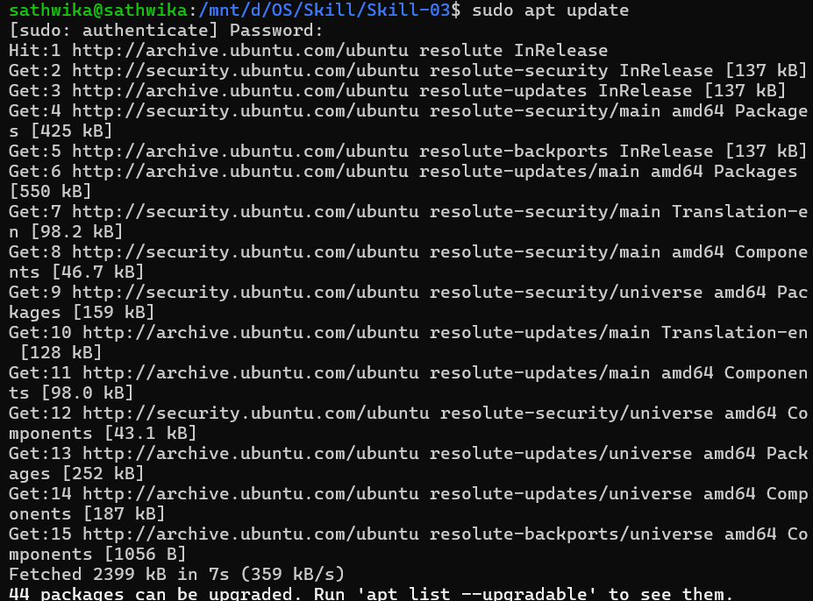Observation: The package information was successfully updated.

Step 17: Install Valgrind
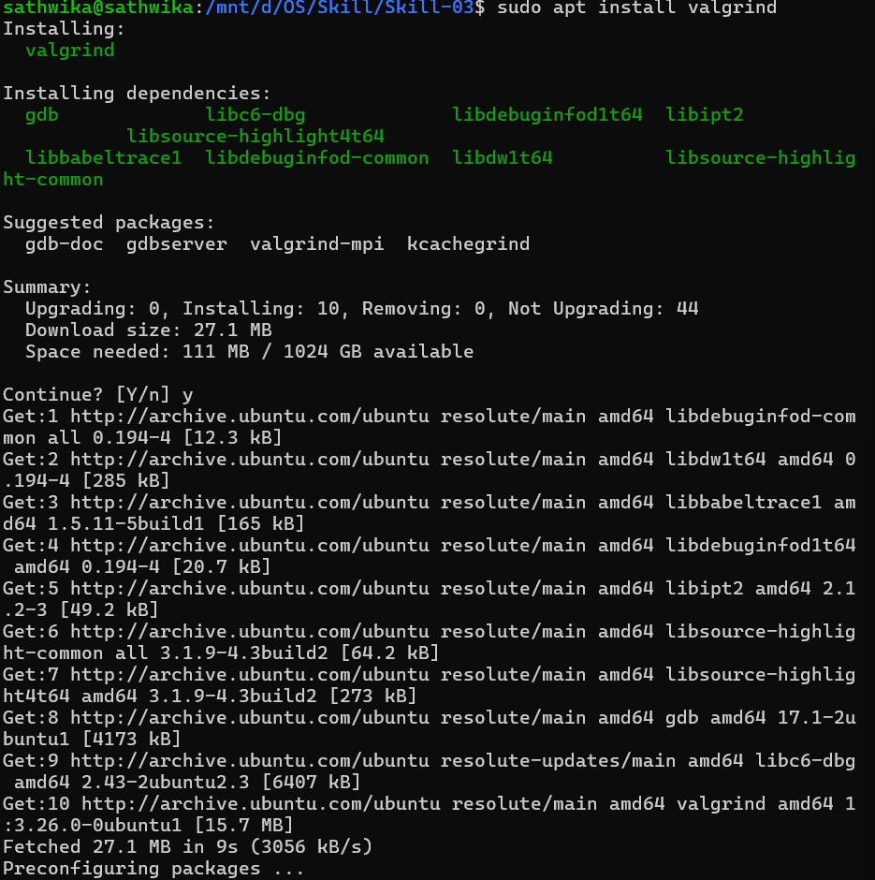Observation: Valgrind and its required packages were installed successfully.

Step 18: Verify Valgrind Version
Output:
valgrind-3.22.0
Observation: Valgrind version 3.22.0 was successfully installed and verified.
Step 19: Check for Memory Leaks
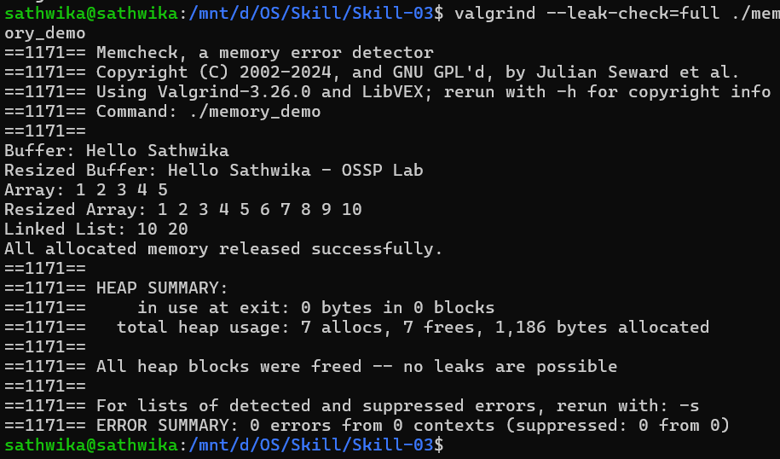
Observation: The memory_demo program was successfully analyzed using Valgrind for memory errors and memory leaks.
Step 20: Verify the Memory Leak Report
Result:
in use at exit: 0 bytes in 0 blocks
total heap usage: 7 allocs, 7 frees
All heap blocks were freed -- no leaks are possible
ERROR SUMMARY: 0 errors
Observation: All dynamically allocated memory was successfully released. Valgrind detected no memory leaks and 0 errors.

