Intelligent Video Surveillance Using Deep Learning

In this project we have used STAE (Spatial Temporal Auto Encoder) deep learning model to predict abnormal behaviour and this model get trained on normal peoples walking videos frames and then test video will be input to this model which will analyse STAE pattern and then return the event and this event will be compared with test frame using Euclidean distance and if this distance crossed normal behaviour threshold then application will display alert message

To implement this project we have used below video frames dataset

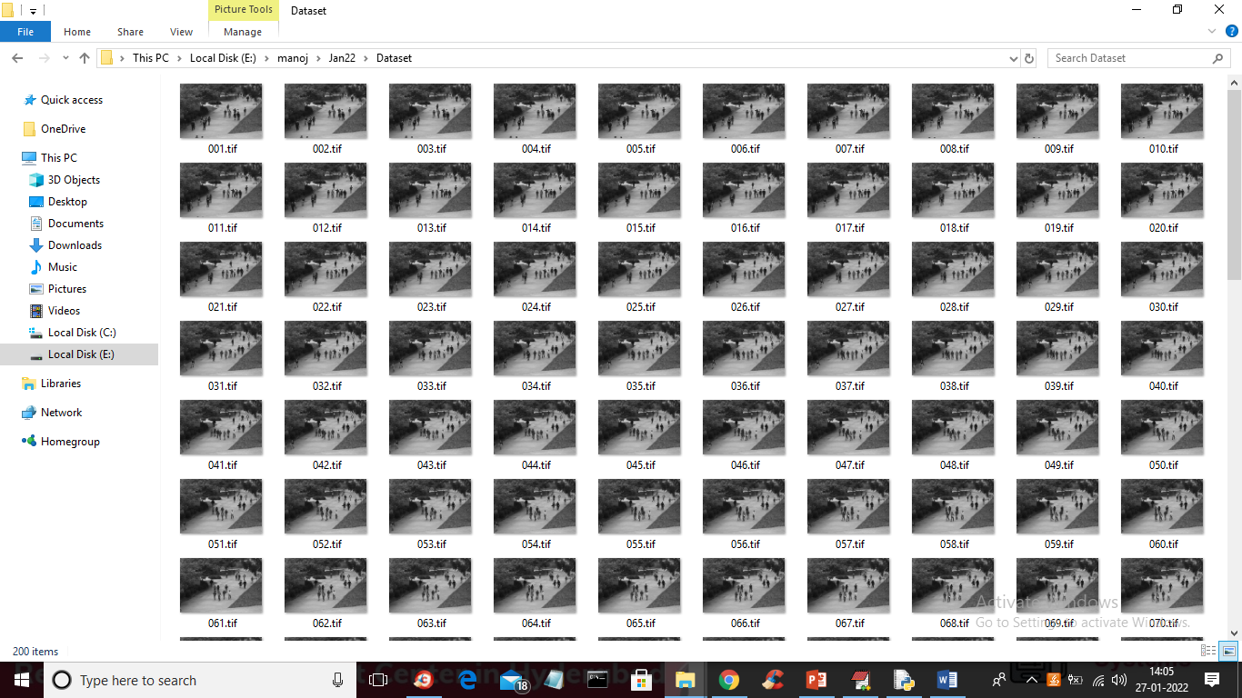

We will use above frames to train STAE model and we have designed following modules to complete this project

1. Upload Video Frames Dataset: using this module we can upload dataset video frames to application
2. Dataset Preprocessing: using this module we will read each image and then extract each pixel and then normalize image pixel values between 0 and 1
3. Train Spatial Temporal AutoEncoder Model: in this module we will input process and normalize images to encoder model to generate STAE model
4. Test Video Surveillance: using this module we will upload test image and then extract each frame from video and then apply STAE model on frame to predict event and this event will be compare with test frame using Euclidean distance and if this distance cross normal behaviour threshold then application will display alert message

SCREEN SHOTS

To run project double click on ‘run.bat’ file to get below screen

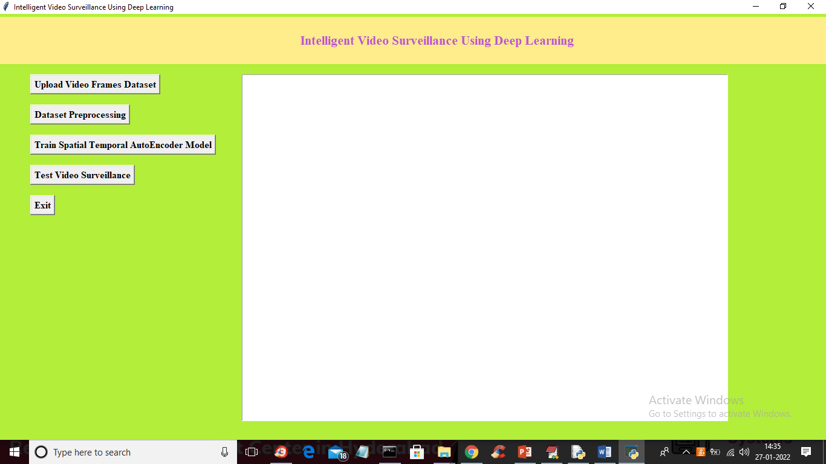

In above screen click on ‘Upload Video Frames Dataset’ button to upload dataset and to get below screen

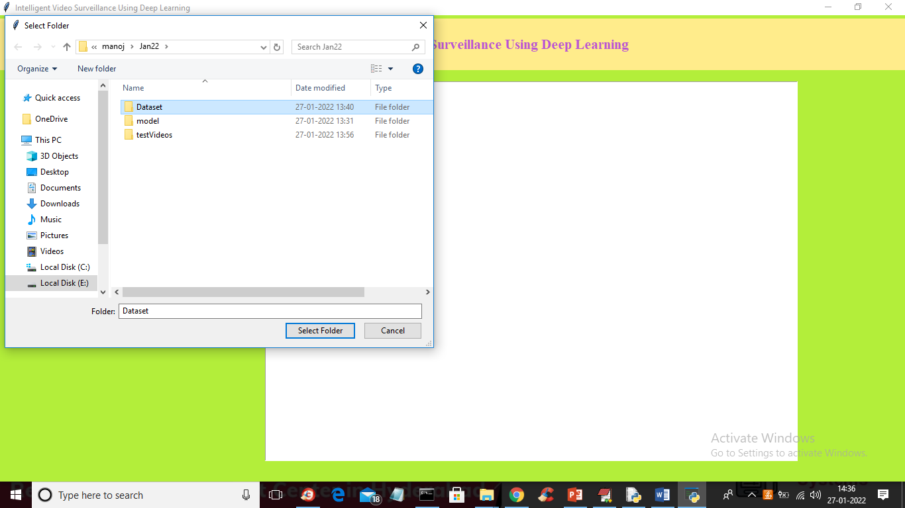

In above screen selecting and uploading ‘Dataset’ folder and then click on ‘Select Folder’ button to load dataset and to get below screen

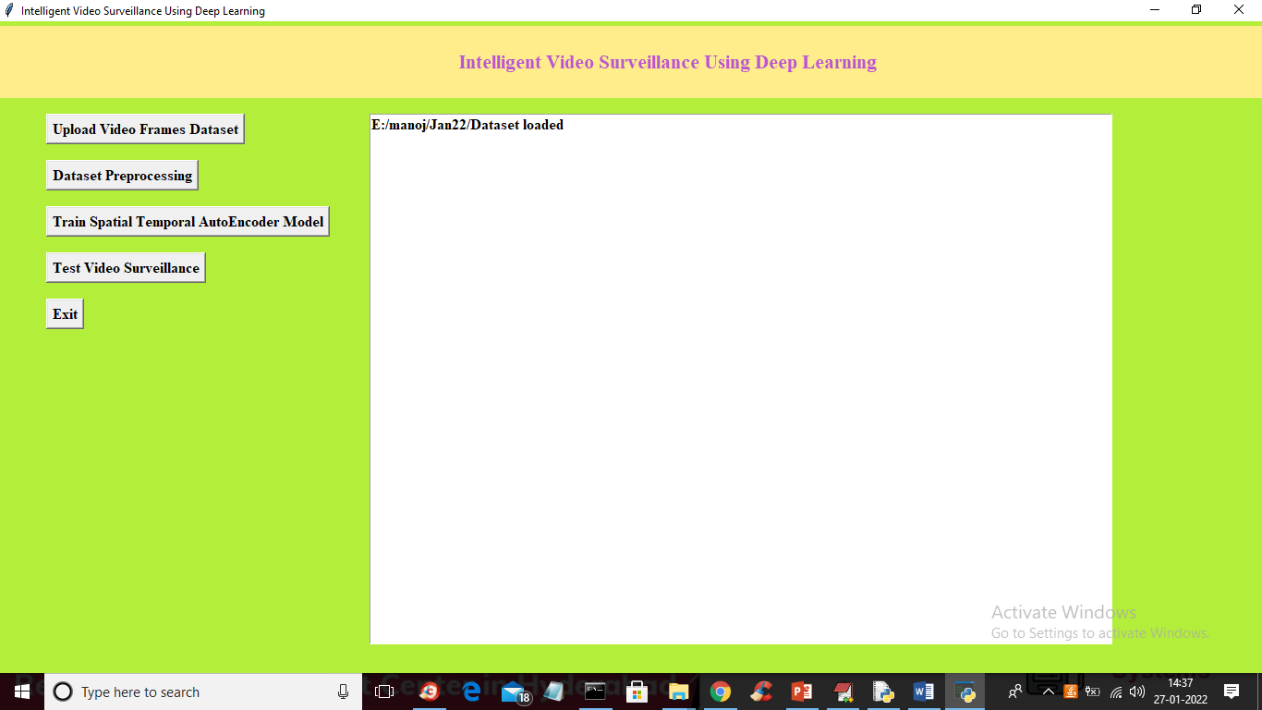

In above screen dataset loaded and now click on ‘Dataset Preprocessing’ button to normalize video frames and to get below screen

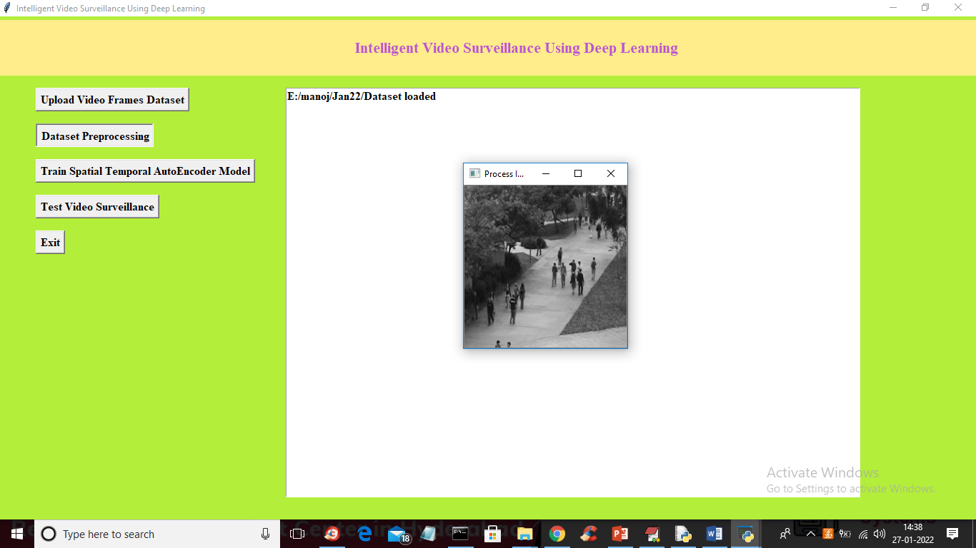

In above screen all images are processed and I am displaying one sample image to see all images are process normally and now closed above image to get below output

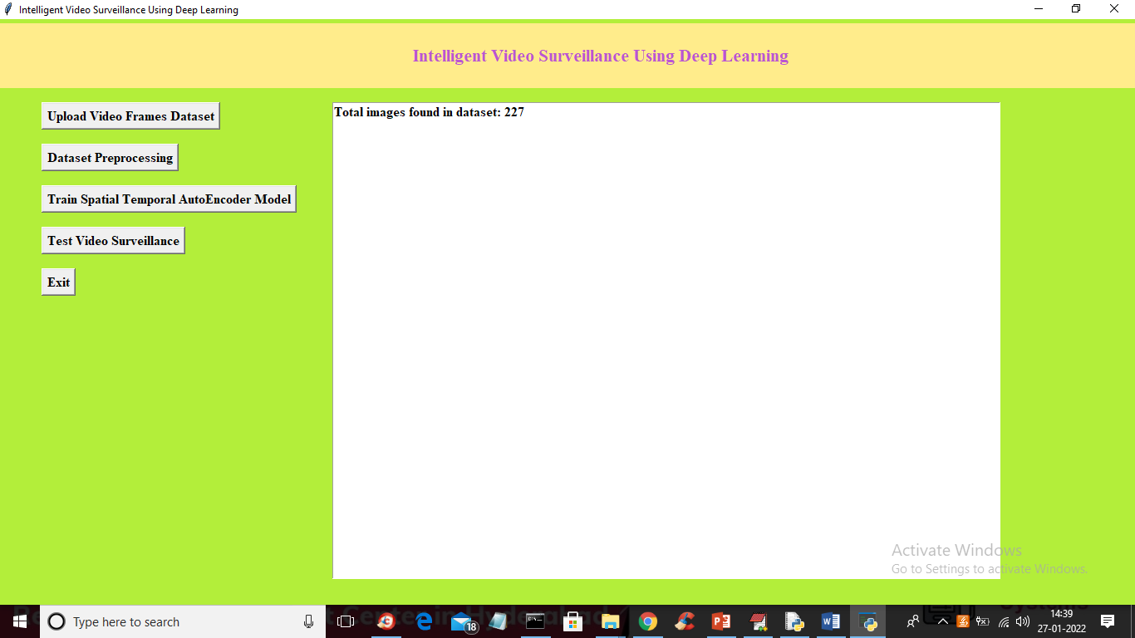

In above screen we can see dataset contains 227 image and all images are processed and now click on ‘Train Spatial Temporal AutoEncoder Model’ button to train STAE model with process images and to get below output

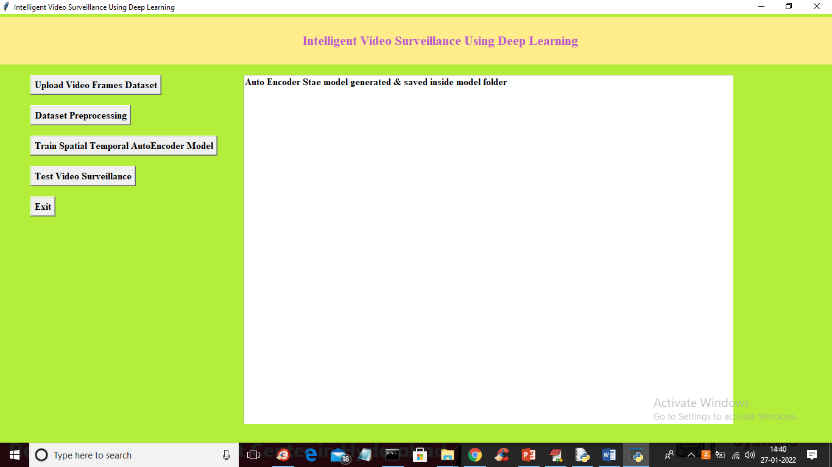

In above screen STAE model generated and now click on ‘Test Video Surveillance’ button to upload test video and to get below output

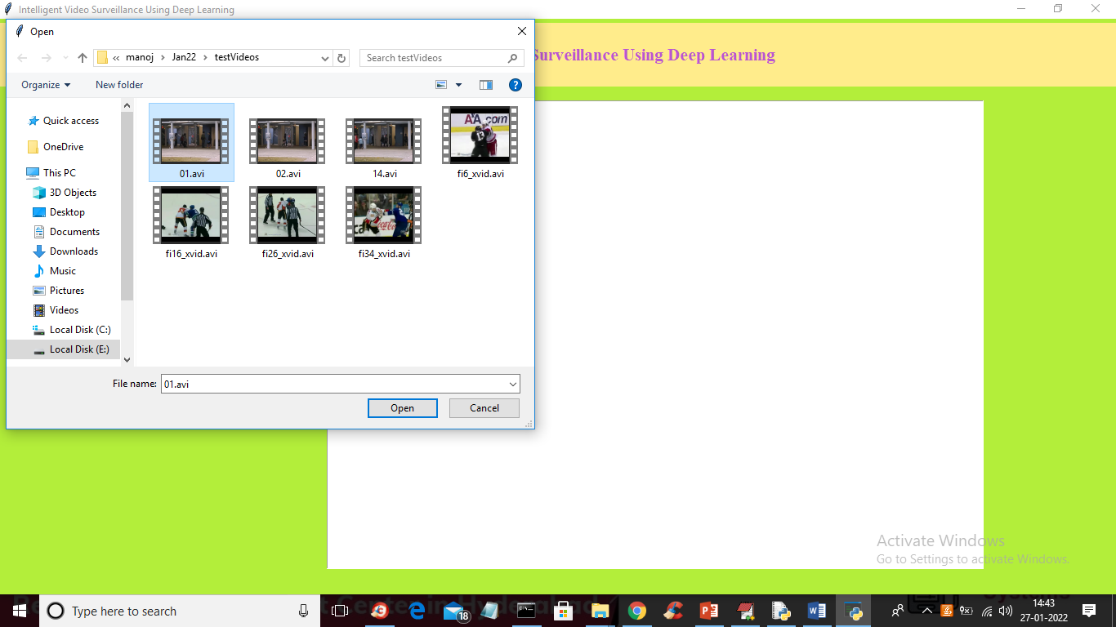

In above screen selecting and uploading ’01.avi’ video file and then click on ‘Open’ button to upload video and to get below output

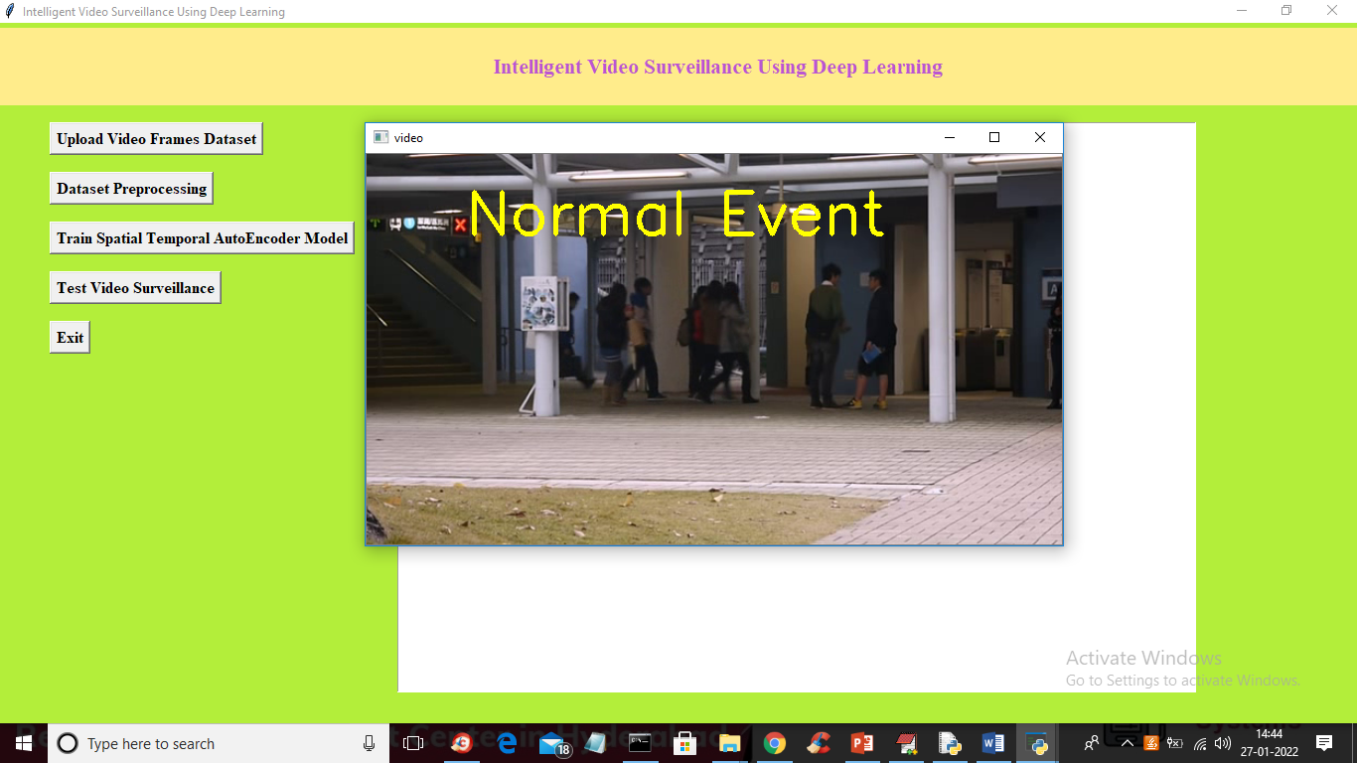

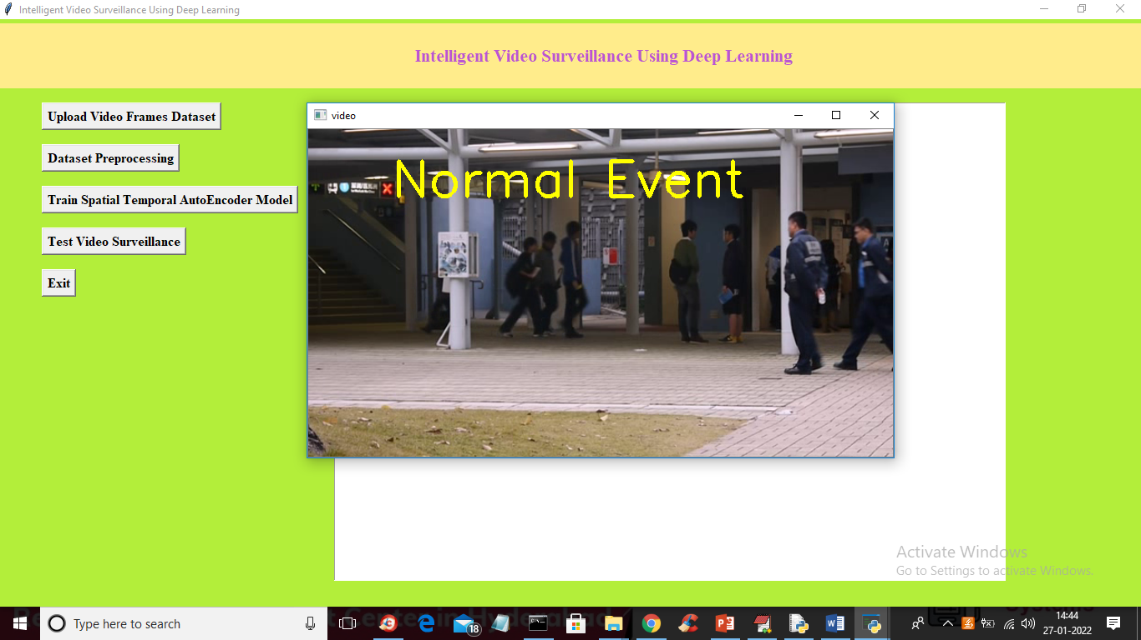

In above screen peoples are just walking so its consider as Normal Event and now press ‘q’ key to close video and upload another video

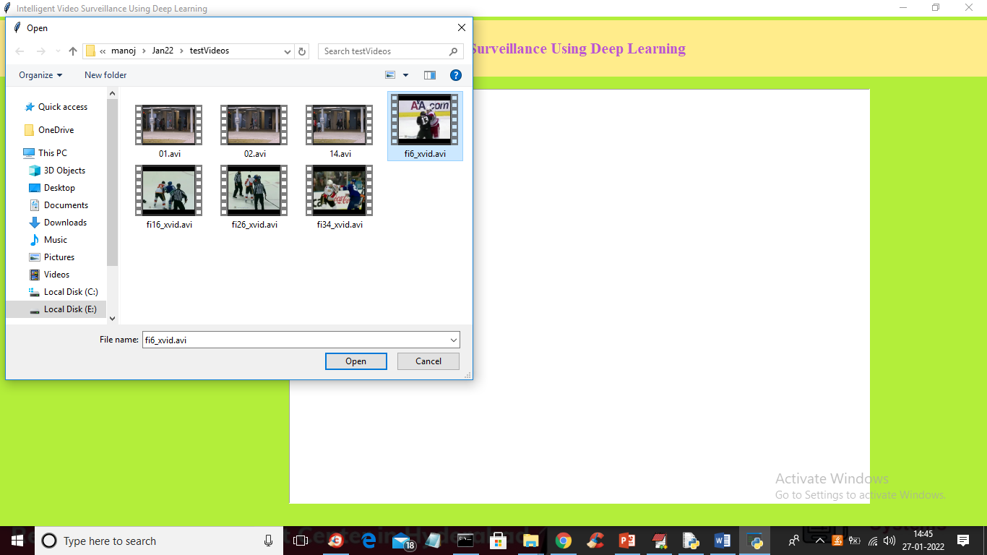

In above screen uploading another video and then click ‘Open’ button to get below output

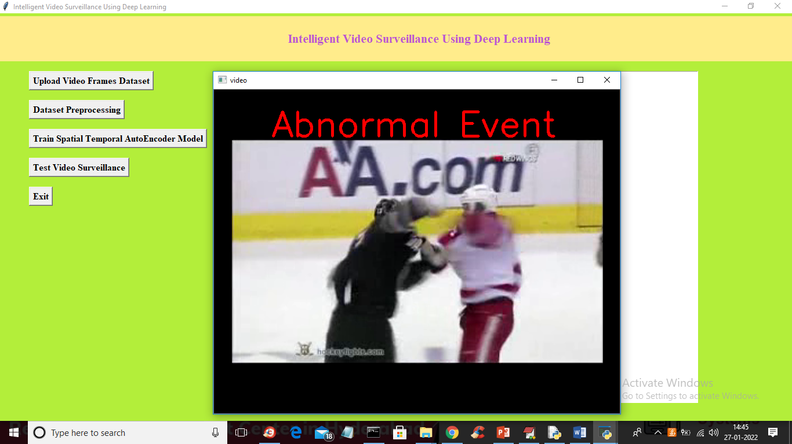

In above screen two peoples are fighting so its not normal walk so displaying alert as abnormal event and below is other output

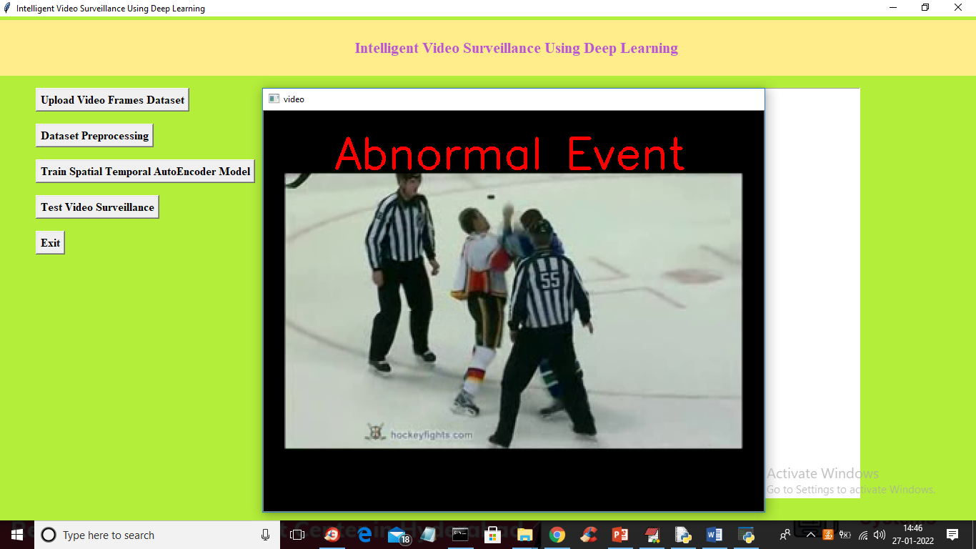

Similarly u can upload any video and test it

