Operating System (lAB-2 Shell Scripting)

1) Write a bash script that takes a user’s name as input and uses the echo command to greet the users with “Hello ,[name]!”.
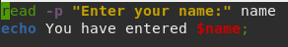

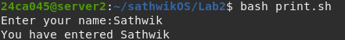

2)Write a Bash script that uses the ls command to list all files and directories in the current directory.

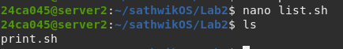

3)Write a Bash script that prompts the user to input a password, and then checks if the password matches a predefined value. If it does, print "Access granted", otherwise print "Access denied".
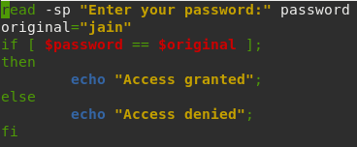

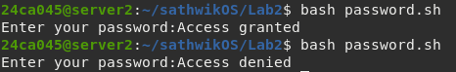

4)Write a Bash script that uses the cat command to concatenate the contents of two text files ("file1.txt" and "file2.txt") and display the result.
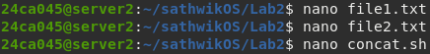

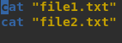

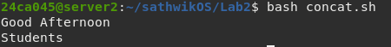

5)Write a Bash script that checks if a given number is even or odd and prints a message accordingly.
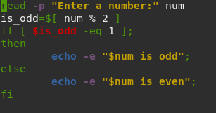

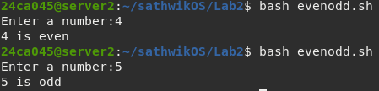

6)Write a Bash script that prompts the user to enter a number and checks if it is positive, negative, or zero, and prints a message accordingly.
