Operating System Lab – 3

Experiment 1: Hello World Script
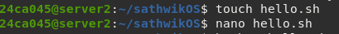

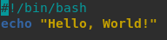

Experiment 2: Basic Calculator
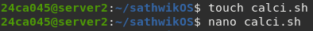

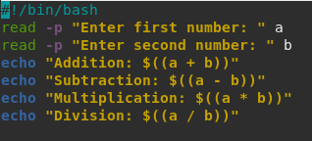

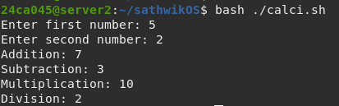

Experiment 3: Odd or Even Checker

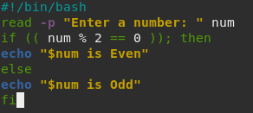

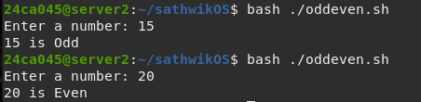

Experiment 4: File Existence Checker

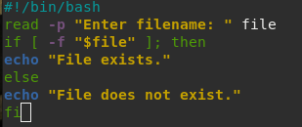

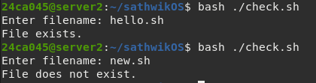

Experiment 5: Current Date and Time

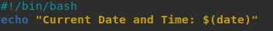

Experiment 6: Directory Size Monitor

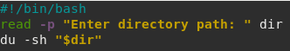

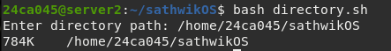

Experiment 7: Backup Script

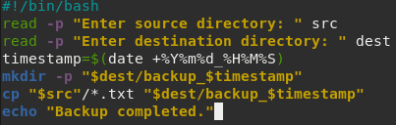

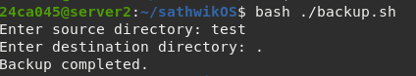

Experiment 8: Simple Login Simulation

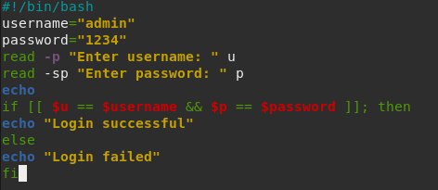

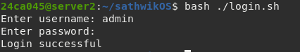

Experiment 9: Countdown Timer

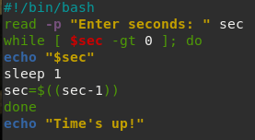

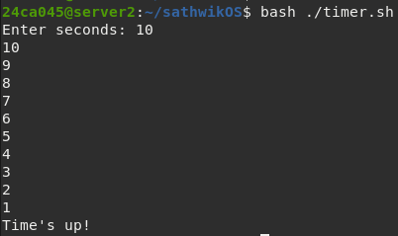

Experiment 10: Batch File Renamer

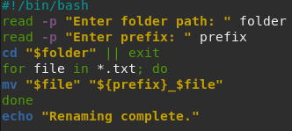

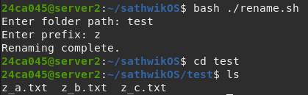

Experiment 11: Word Count Tool

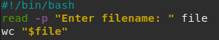

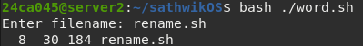

Experiment 12: Search and Replace in Files

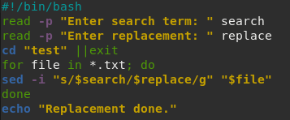

Experiment 13: Log File Filter

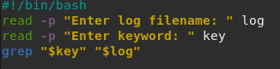

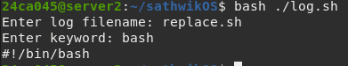

Experiment 14: Remove Duplicate Lines

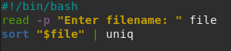

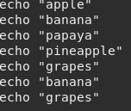

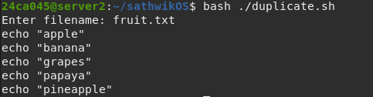

Experiment 15: Merge Multiple files

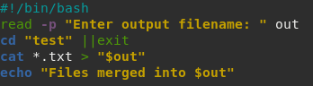

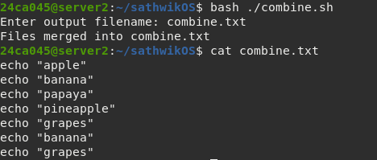

Experiment 16: System Resource Monitor

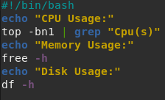

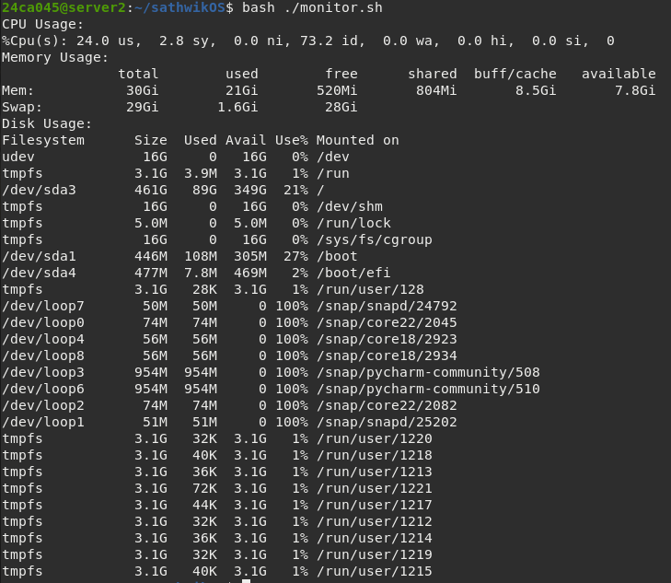

Experiment 17: Website Status Checker

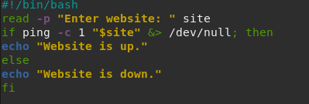

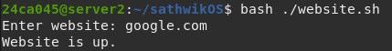

Experiment 18: Automated File Organizer

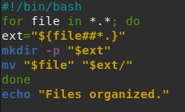

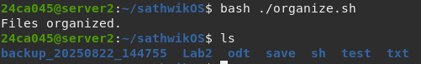

Experiment 19: Cron Job Script

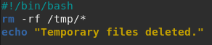

Experiment 20: User Account Report

