


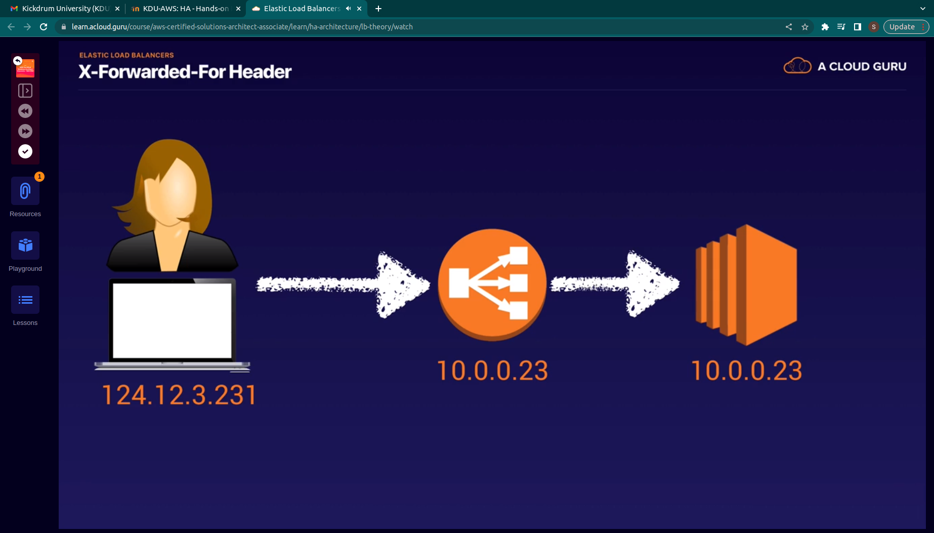
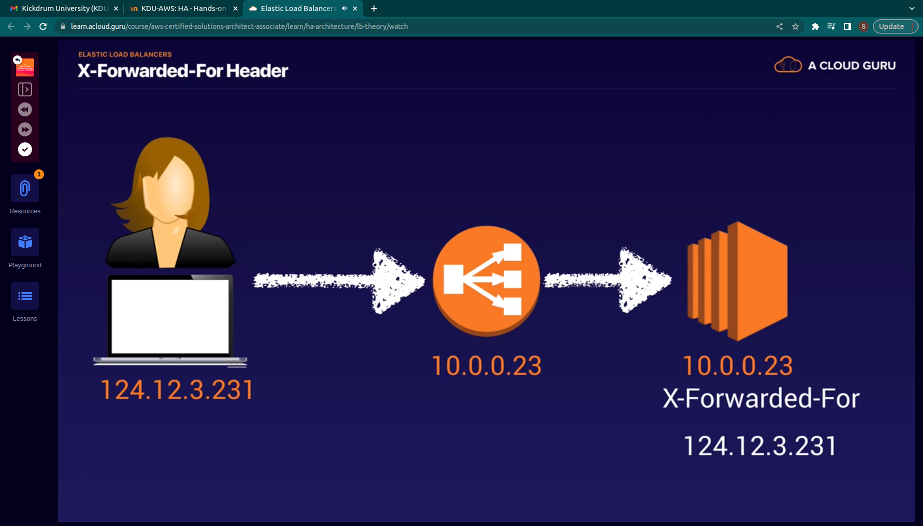
X-Forwar-For
for getting users ip address

Target group:
Targer grop i siwhere the load balancer will route request

we can different group fot different costumer
Target type instances
port is 80
traffic port

AFTER the target group is we need to add isntances


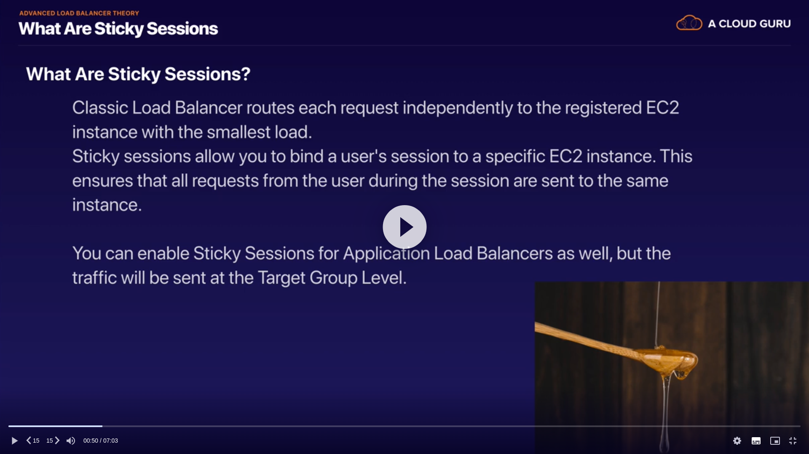
.
When no crcoss laod balancer are used
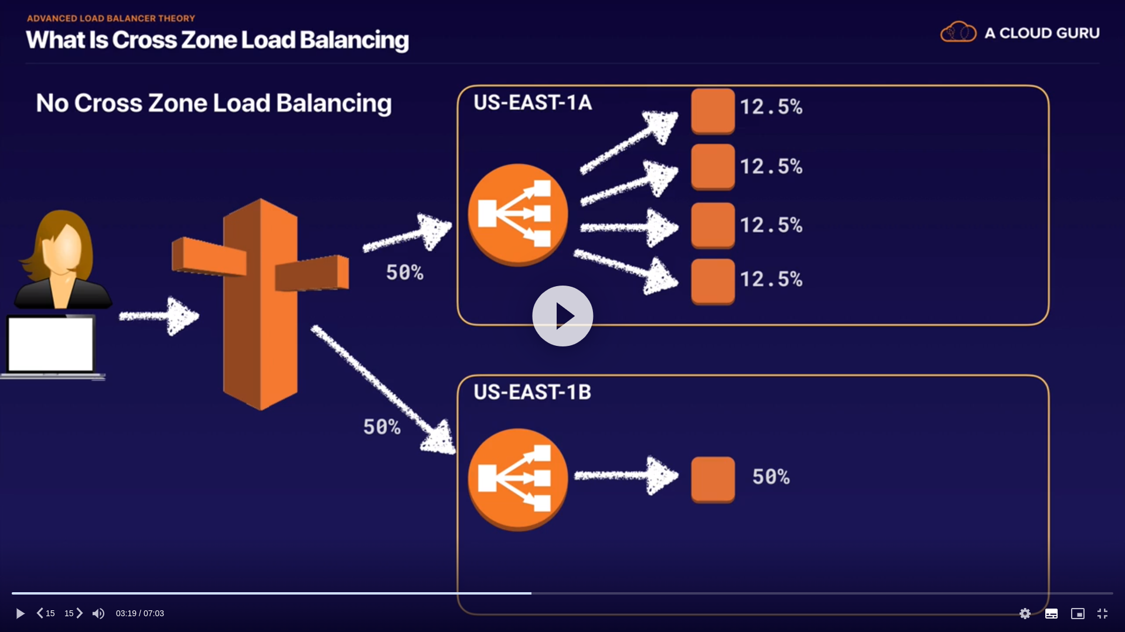
.

when cross load balancing is enabled

Path pattern (seperate file to different ec2 based on the url given)
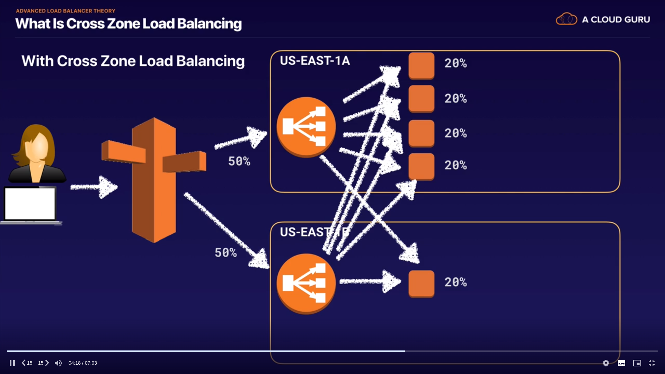
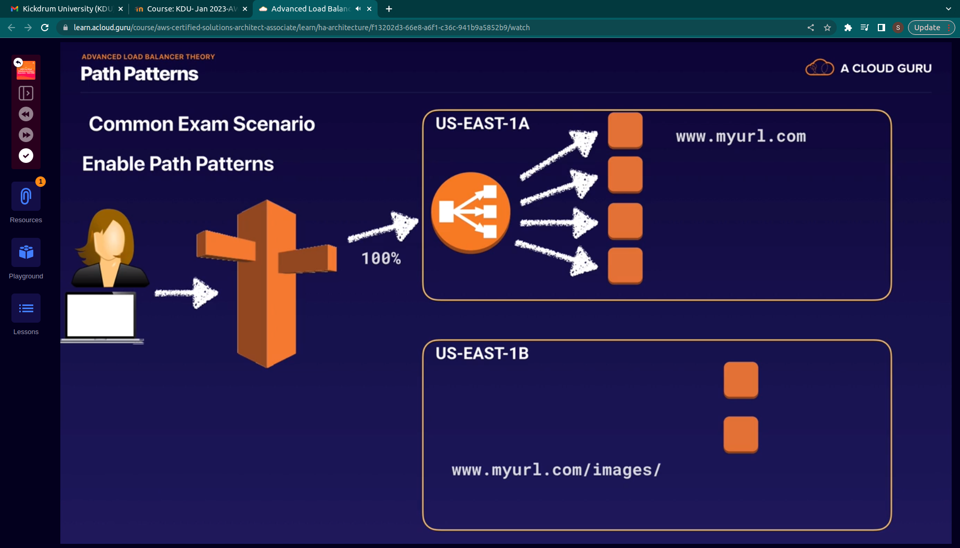
.
Autoscaling group

private instance

meta data instance id

secyrity same

start -> stop -> create image -ami created

ami created

lauch configuration this ami

asks data

network asks give private

launced caufiguration advanced user data --- put bootsrtap script

target group-

assosiated with

autoscaling create
launch temp \
switch to launch confi

max min

add load balancer

put target group

#!/bin/bash
sudo su
yum update -y
yum install -y httpd.x86_64
cd /var/www/html
echo "
<!DOCTYPE html>
<html lang="en">
<head>
<meta charset="UTF-8">
<meta http-equiv="X-UA-Compatible" content="IE=edge">
<meta name="viewport" content="width=device-width, initial-scale=1.0">
<title>Aws-ha</title>
</head>
<body>
<h1>"$(curl http://169.254.169.254/latest/meta-data/instance-type)"<br>"$(curl
http://169.254.169.254/latest/meta-data/instance-id)"<br>"$(curl
http://169.254.169.254/latest/meta-data/mac)"<br>"$(curl
http://169.254.169.254/latest/meta-data/security-groups)"<br>"$(curl
http://169.254.169.254/latest/meta-data/hostname)"</h1>
</body>
</html>" > index.html
service httpd start
chkconfig httpd on

