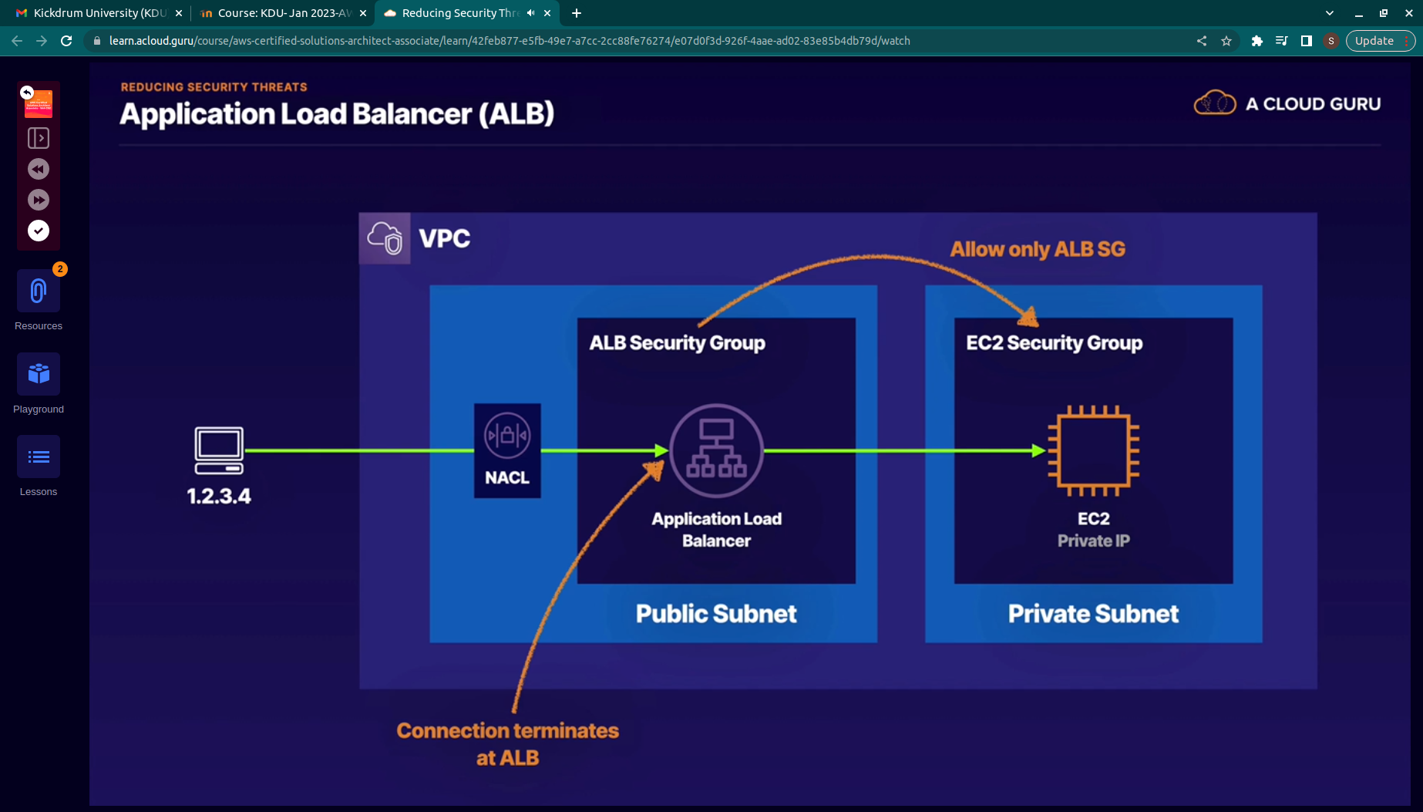
.

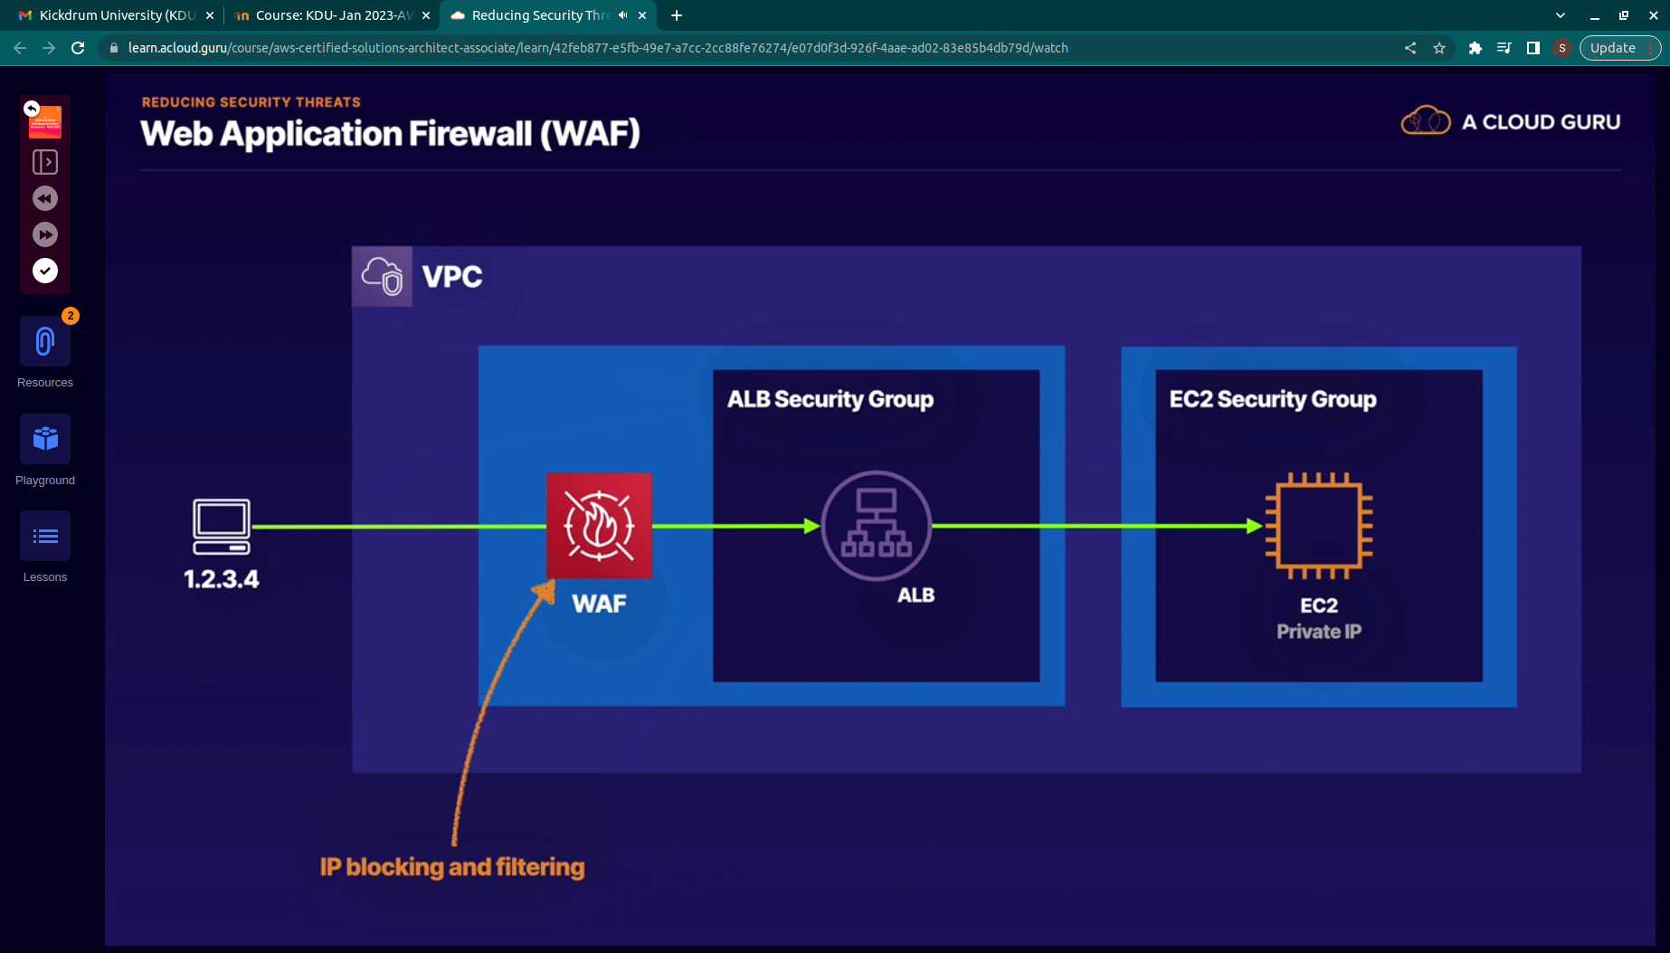
.
we ll use nacl to block certain ip
id the ttcak is going to take place through multiple ips then use waf

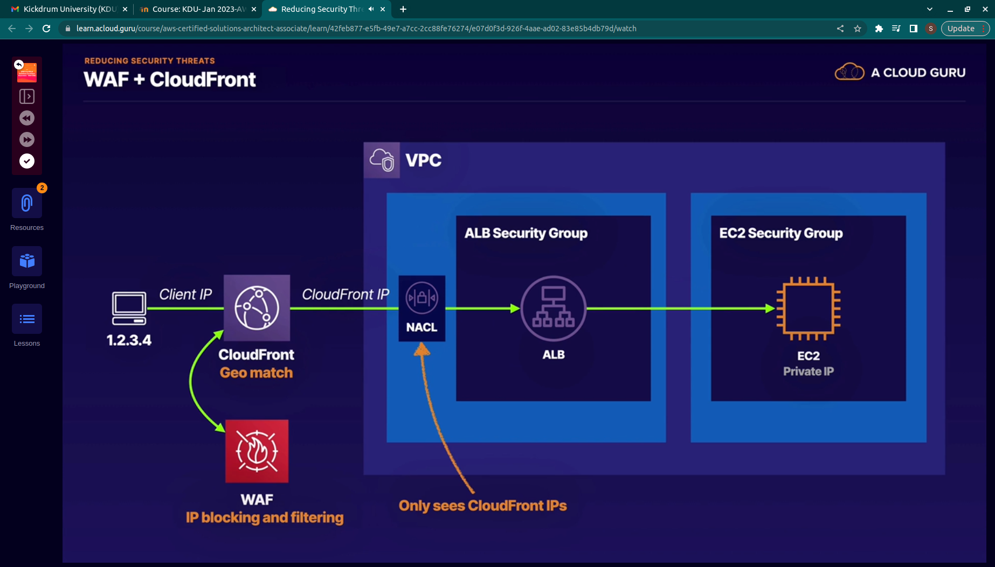
.

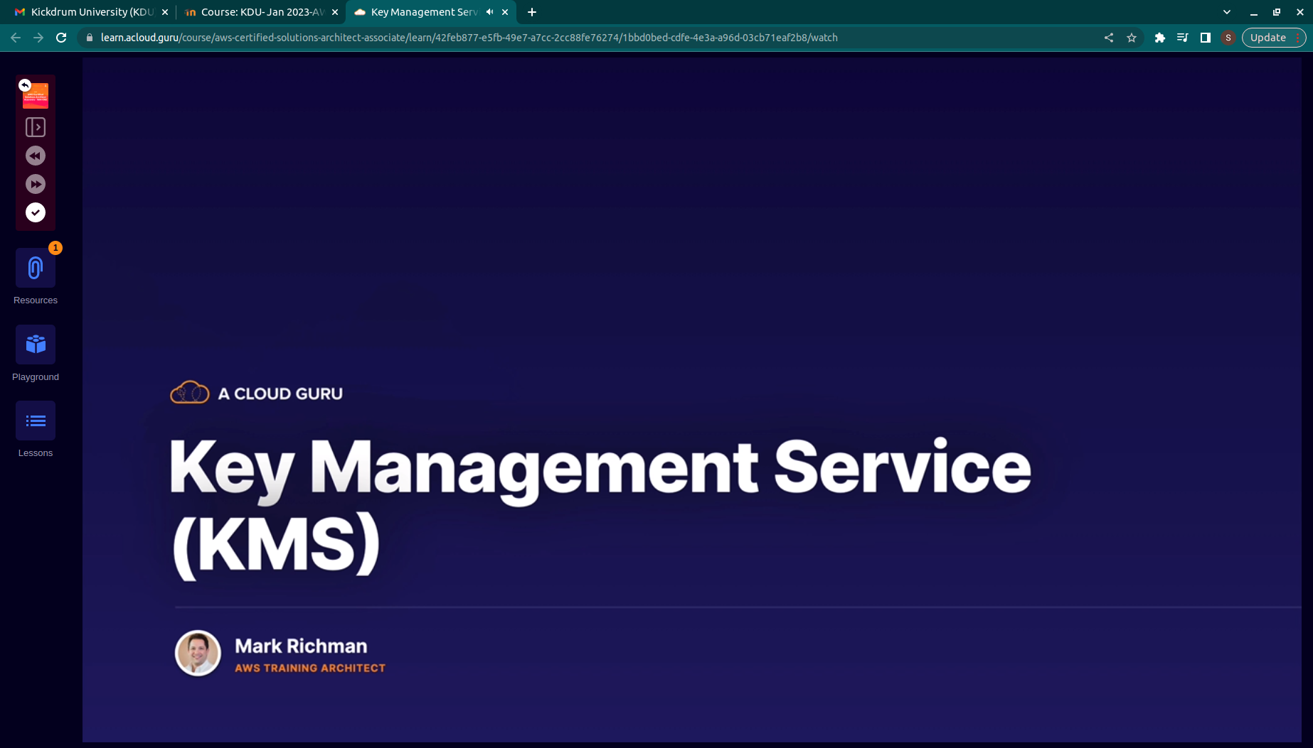
.
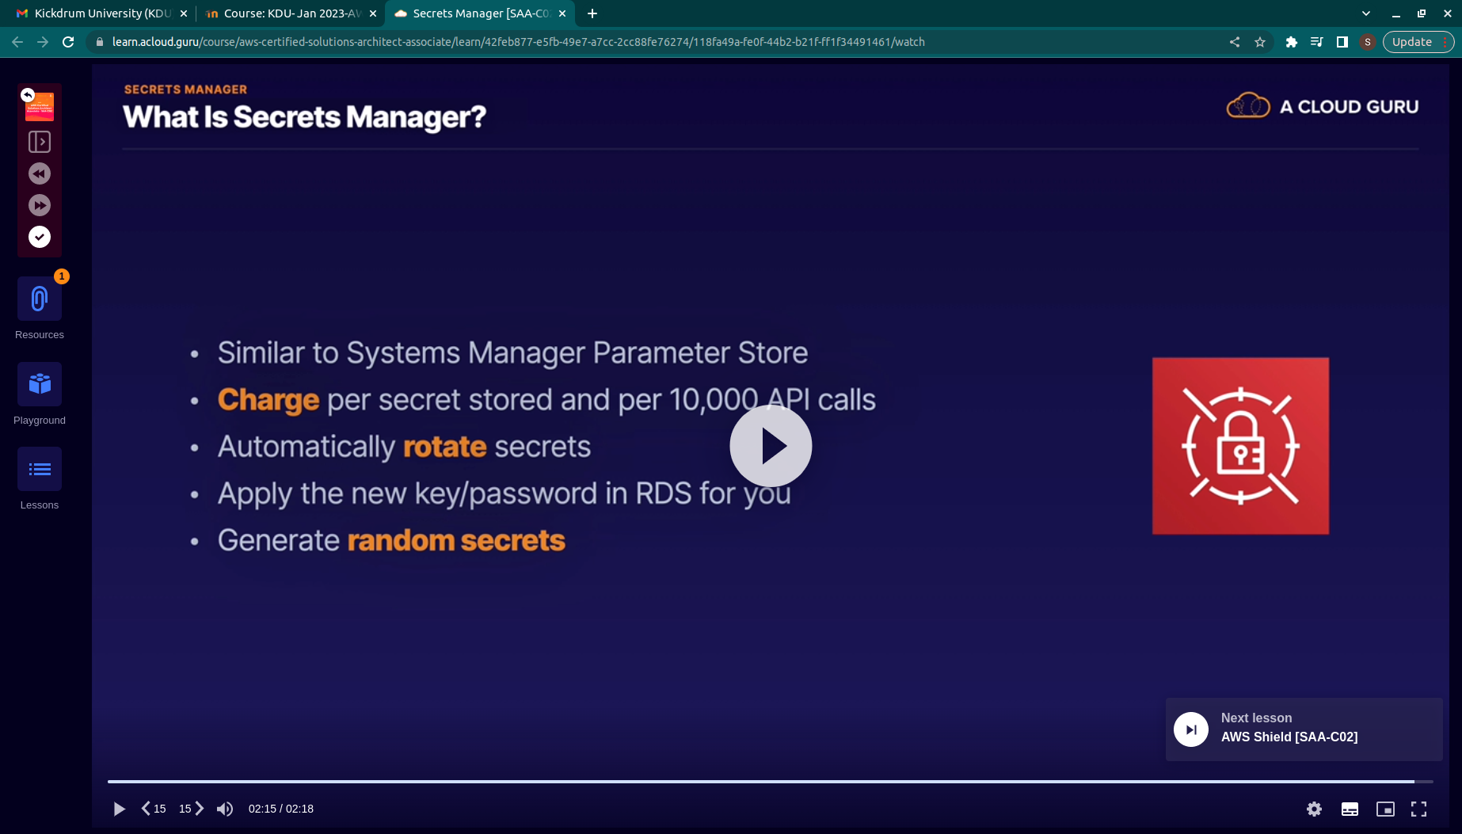
.
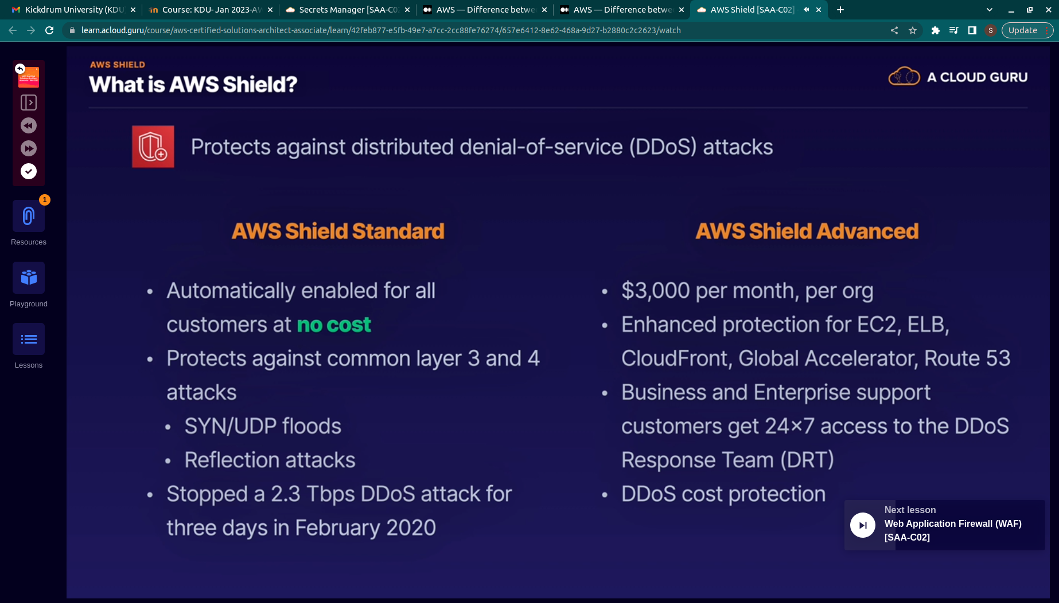
.
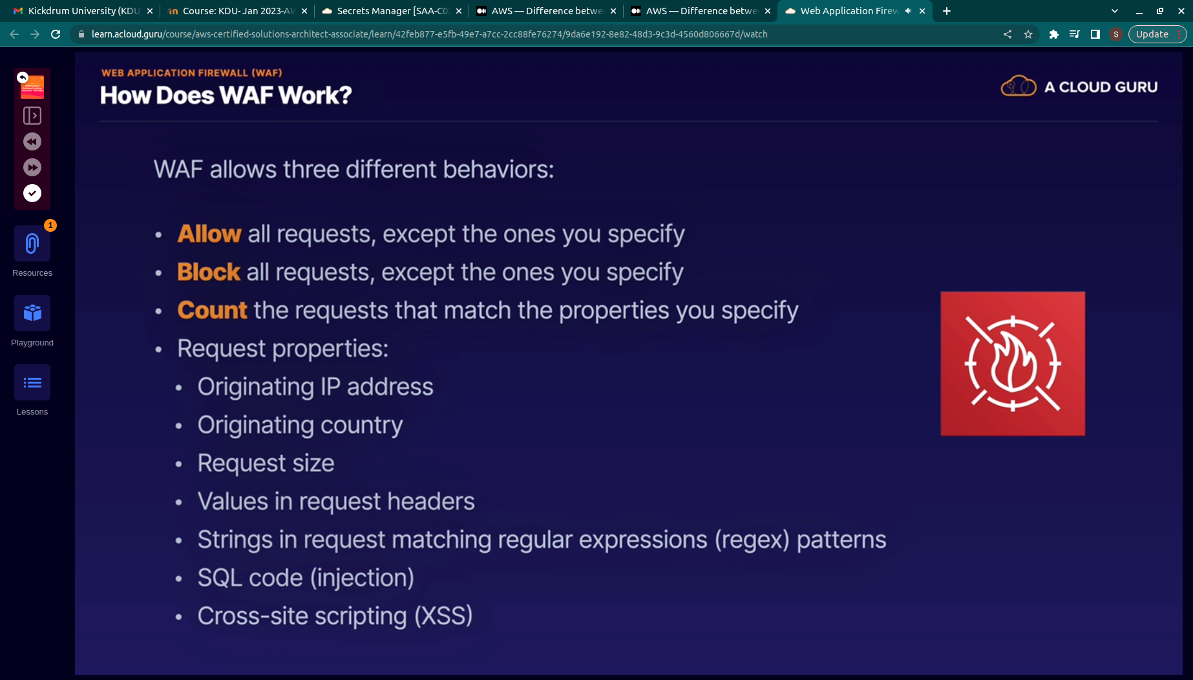
.
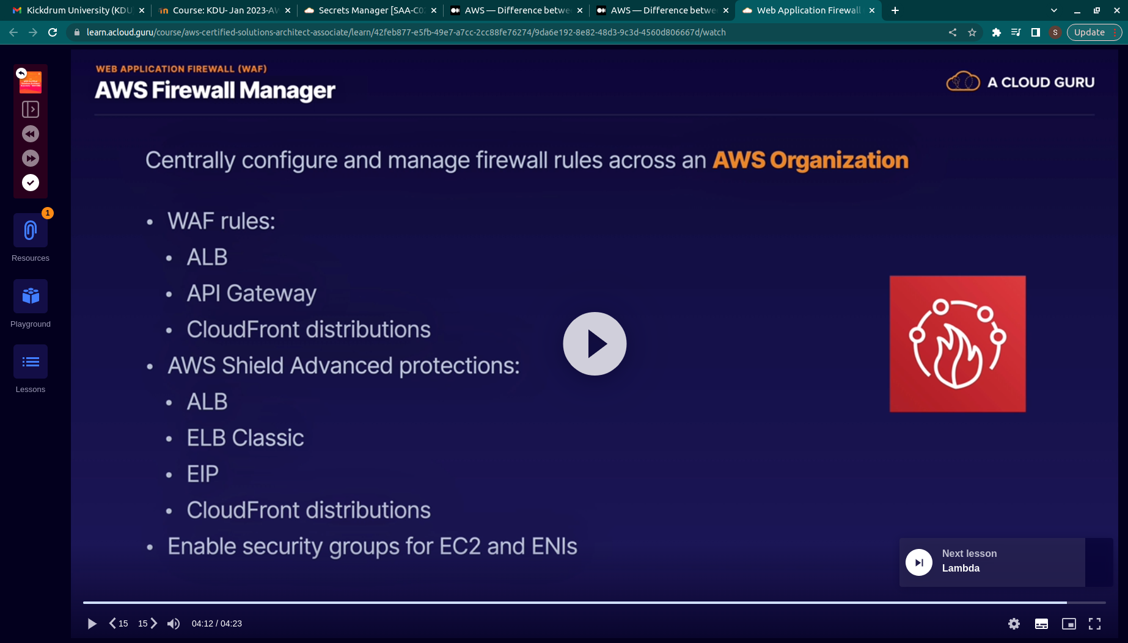
.

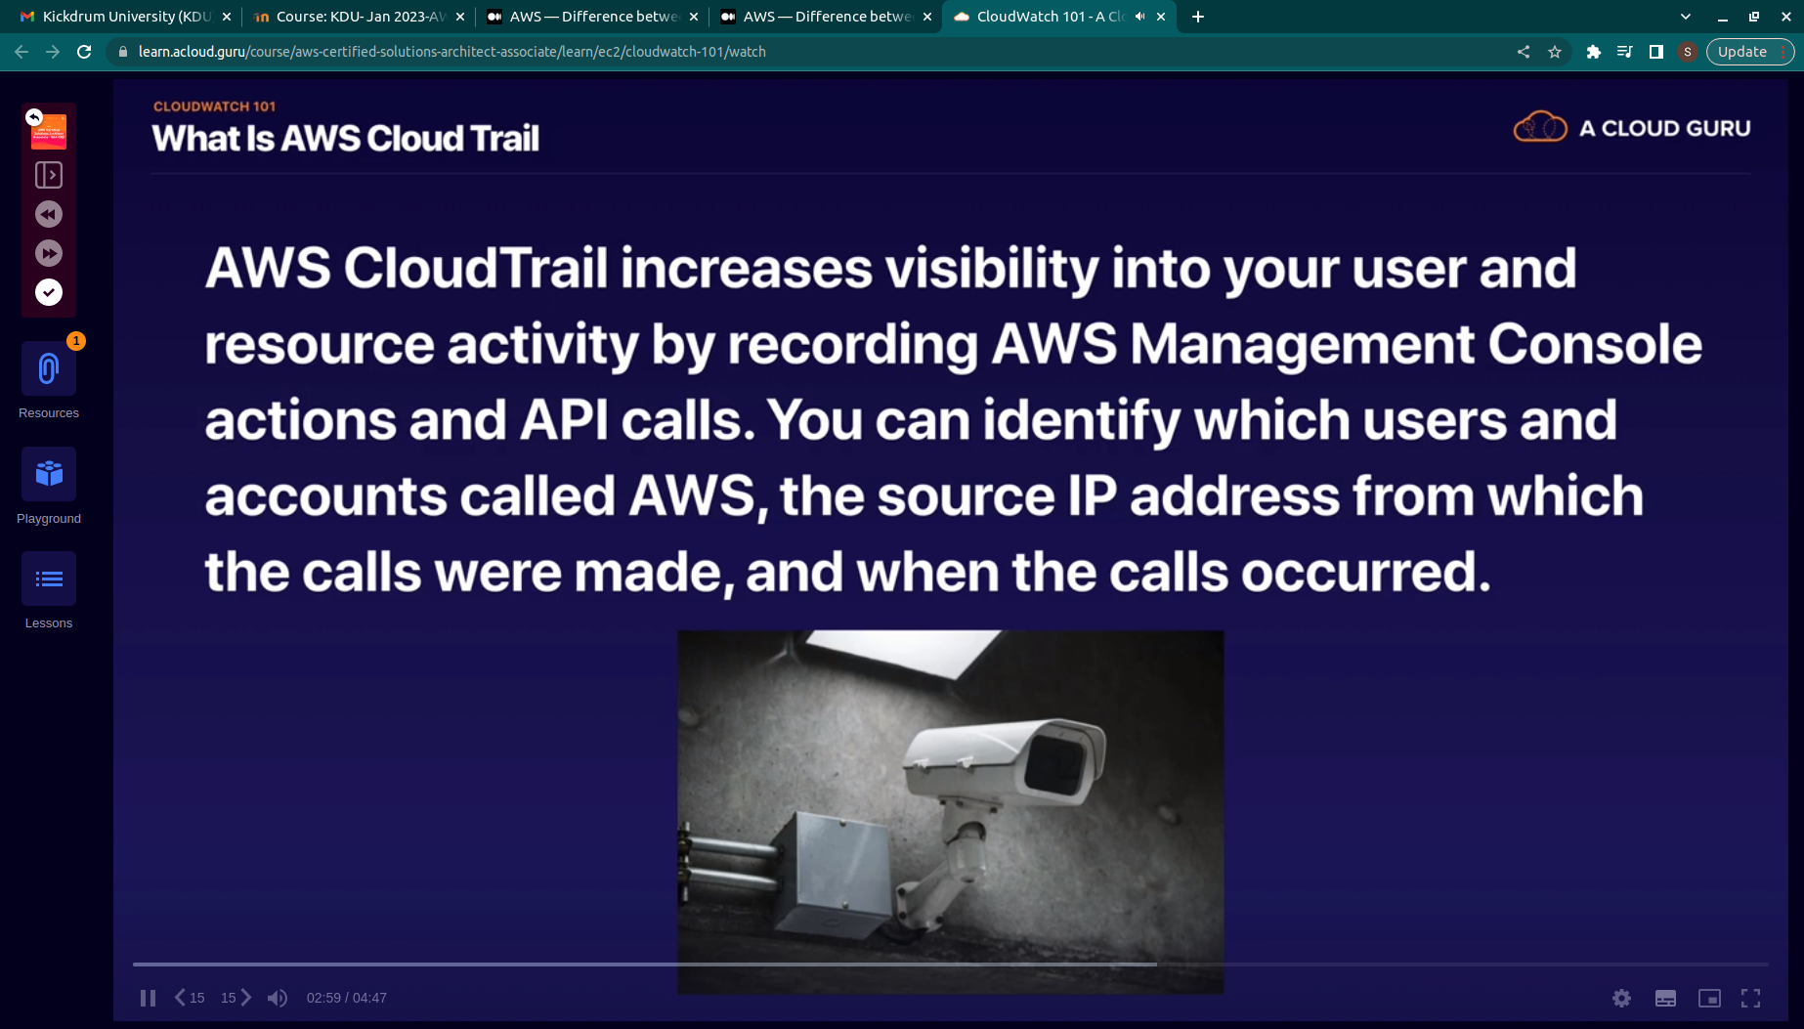
.
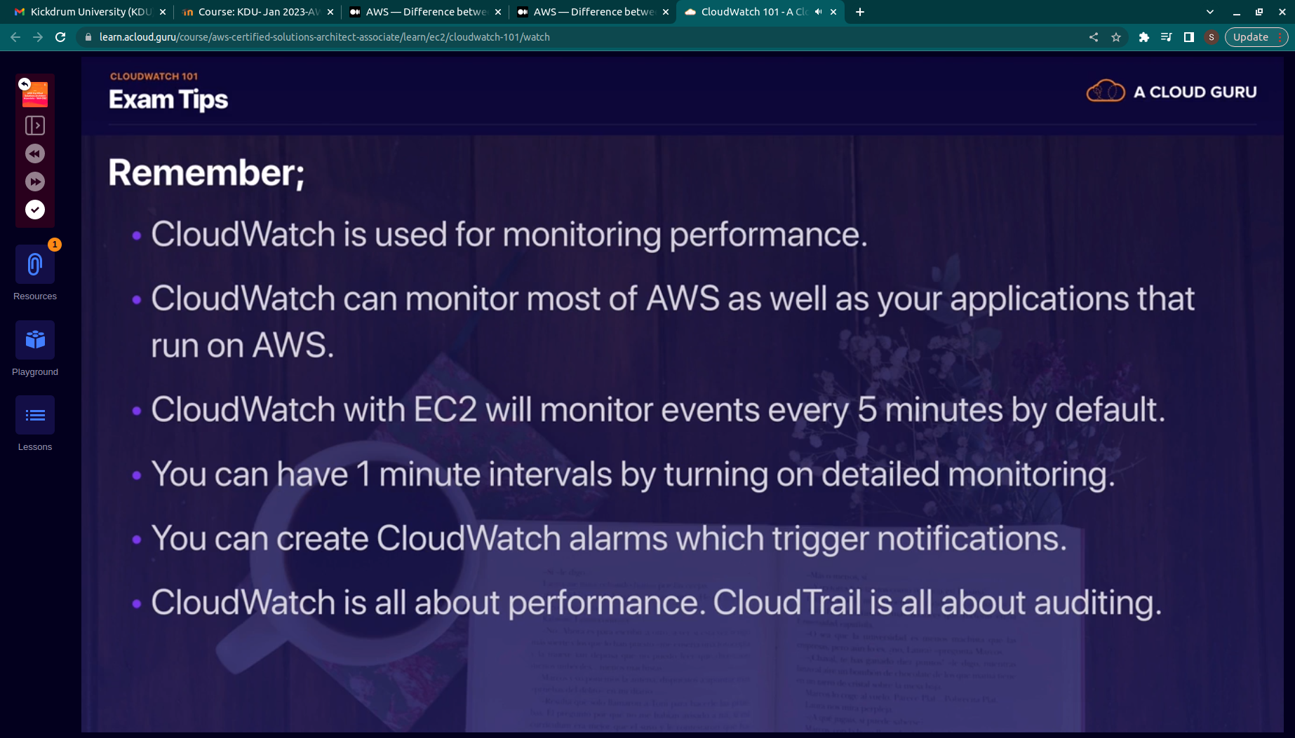
.

cloudwatch
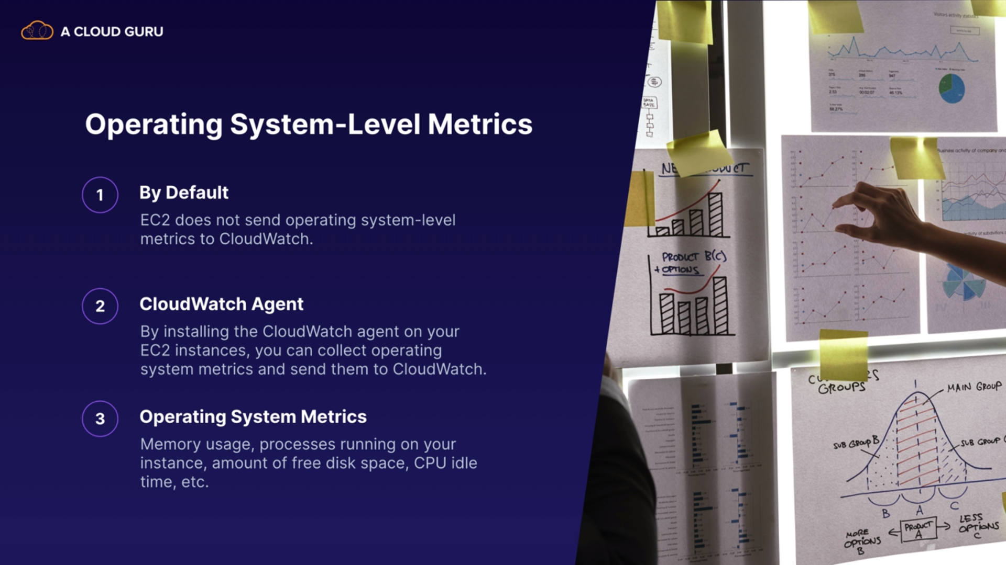
.
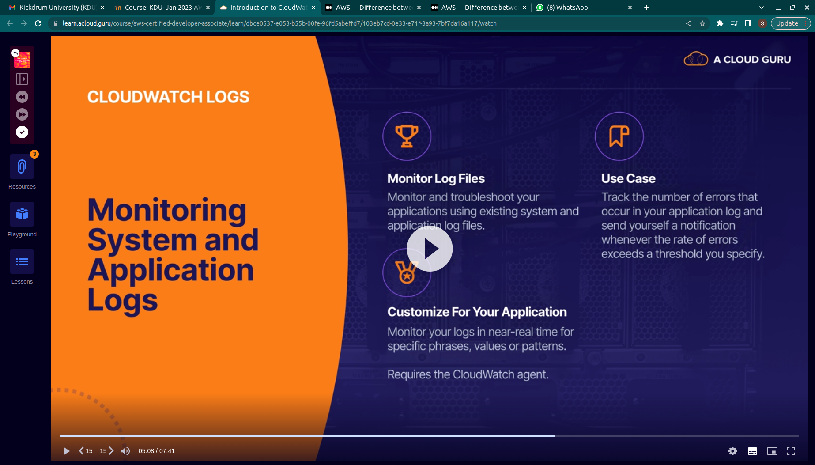
.
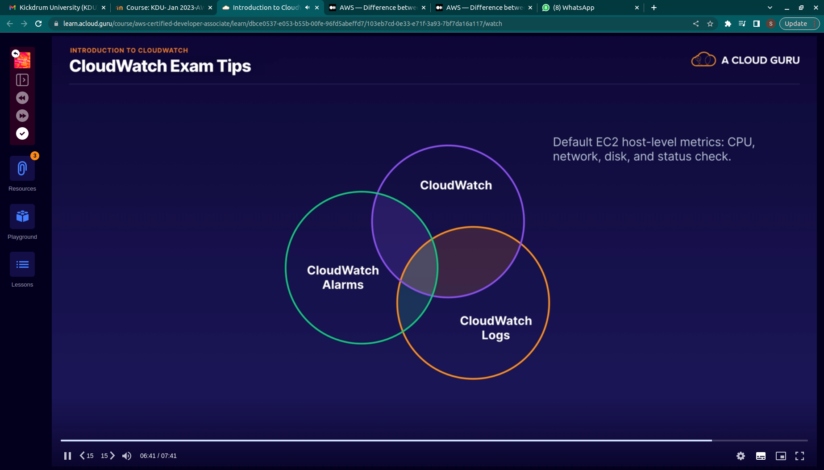
.
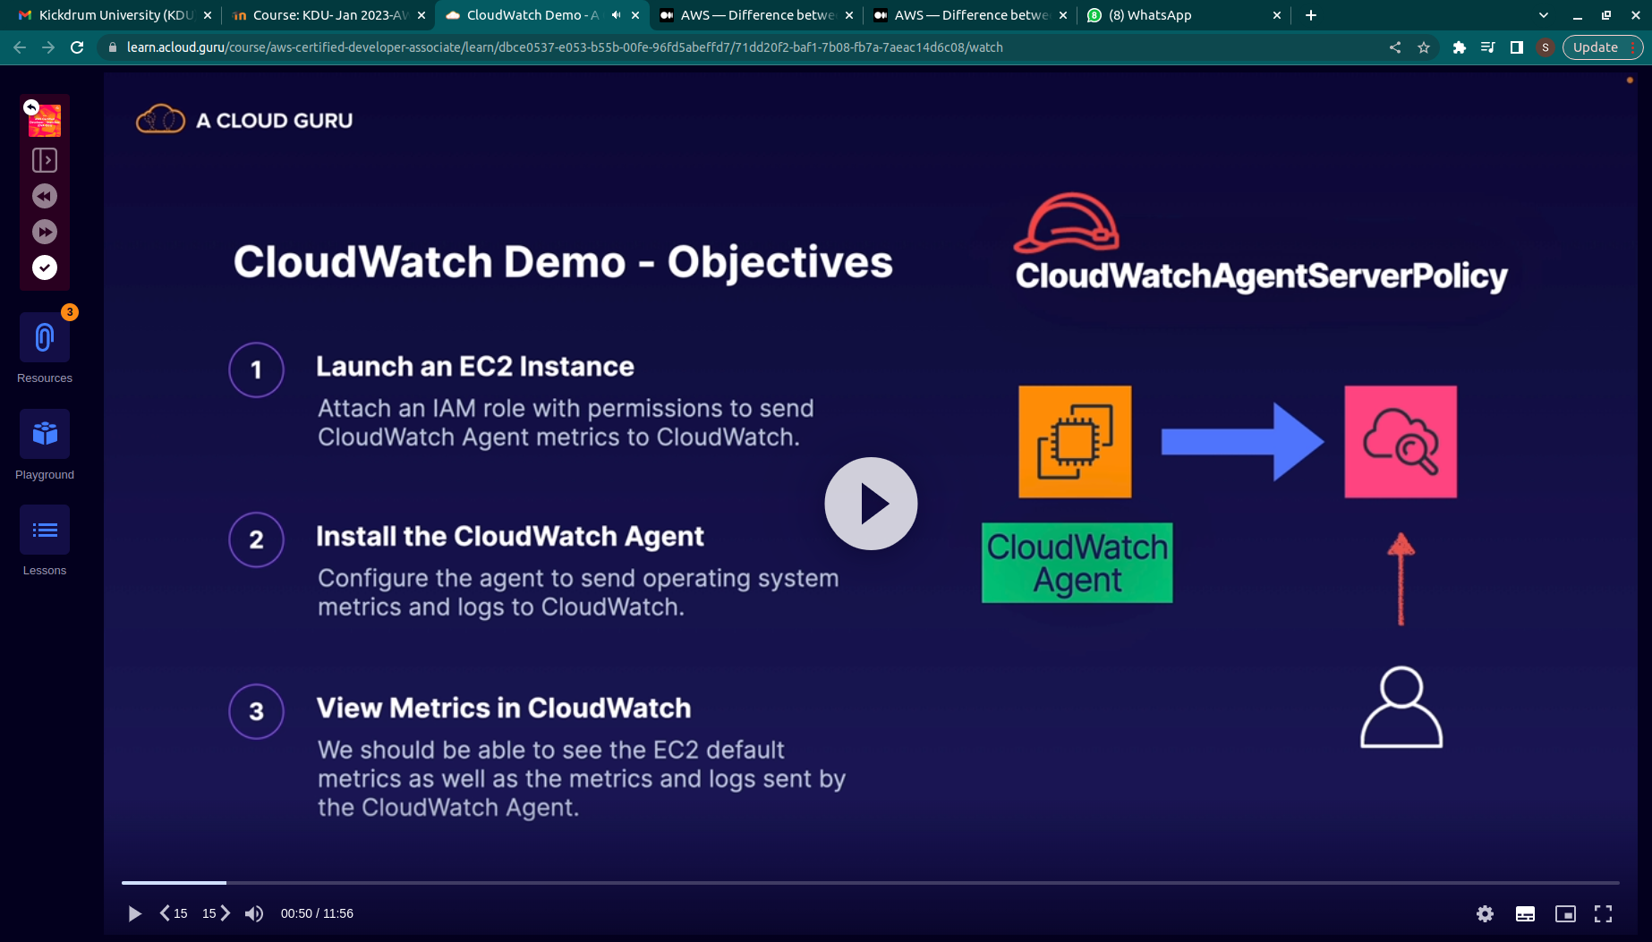
.

Imporatnat concepts
CloudWatch is an essential service in AWS that helps you monitor, troubleshoot, and optimize your applications and infrastructure resources in the AWS environment. Here are some important concepts to know about CloudWatch for the AWS Solutions Architect exam:
- Metrics: Metrics are the fundamental building blocks of CloudWatch. They are numerical data points that measure some aspect of your AWS resources' performance, such as CPU utilization, network traffic, and database queries. You can view, graph, and analyze metrics in CloudWatch to gain insight into your applications' behavior and identify performance bottlenecks.
- Alarms: Alarms enable you to monitor metric data over time and take automated actions based on predefined thresholds. You can create alarms to trigger notifications or automated actions, such as sending an email, invoking an AWS Lambda function, or auto-scaling your resources, when a metric breaches a specified threshold.
- Logs: CloudWatch Logs enables you to monitor, store, and analyze logs generated by your applications and infrastructure resources. You can use CloudWatch Logs to troubleshoot issues, perform root cause analysis, and monitor system events. Logs can be stored in CloudWatch for an indefinite period, and you can search and filter logs using keywords or metrics.
- Events: CloudWatch Events is a service that enables you to respond to changes in your AWS resources by triggering automated actions. You can create rules to detect changes in resource status, such as the creation of a new instance or the deletion of a database, and take actions, such as triggering a Lambda function or sending a notification.
- Dashboards: Dashboards enable you to create custom visualizations of your metrics and logs data in CloudWatch. You can create and share dashboards to monitor key performance indicators, troubleshoot issues, and track progress toward your business objectives.
- Agent: The CloudWatch agent is a software component that you can install on your EC2 instances or on-premises servers to collect and send custom metrics, logs, and events to CloudWatch. The agent enables you to monitor and troubleshoot applications and services that are not natively integrated with CloudWatch.
These are some of the essential concepts you need to know about CloudWatch for the AWS Solutions Architect exam. Make sure you understand how to create and manage metrics, alarms, logs, events, and dashboards using the AWS Management Console, CLI, or SDKs.

