Connected to intsance

Conneting with SSH-look screensot

sudo su(To get root administrator)
public ip address :3.109.203.182
security group name:
ec2-Sathwik G Shetty-first-sg

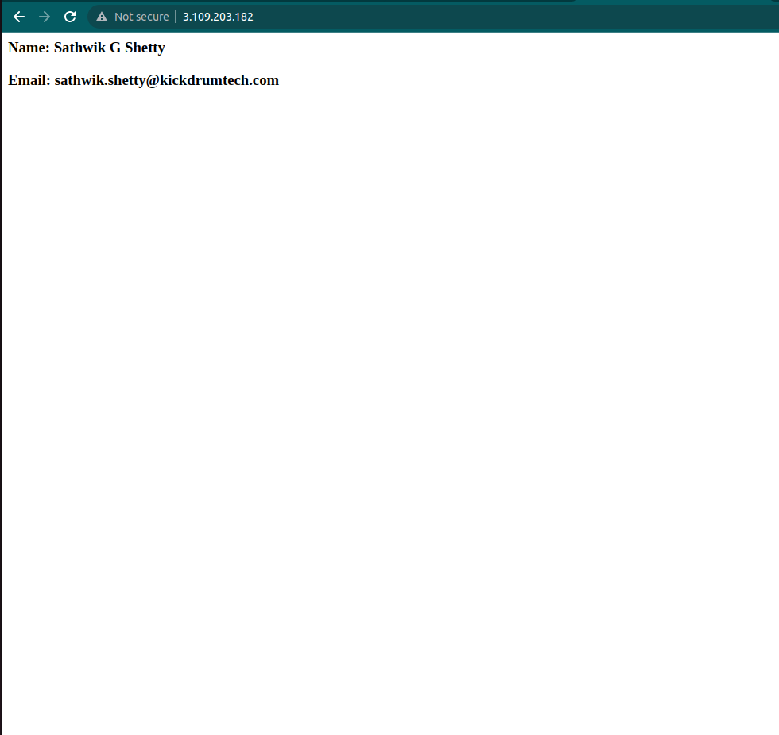
.
We can create an image of our instance which is called as snapshots,
and we need to go to ami and then we can launch an instance

To launch an ec2 instance as encrypted volume:
1.first create an ec2 instace ;
2.cerate a snapshot of that image
3.create an ami and then launch that instance by creating the encrpted volume

Ec2 hebernation:
this actually stores the content in ram to harddisk it make the server quick

bootstrap:
#!/bin/bash
yum update -y
yum install httpd -y
service httpd start
checkconfig httpd on
cd/var/www/html
echo "<html><h1>Hii I am Sathwik</h1></html>"
>index.html
aws s3 mb s3://lasdjasdkasdjhkjasa
aws s3 cp index.html s3://lasdjasdkasdjhkjasa

name
ec2-Sathwik G Shetty-second-sg

VPC-VIRTUAL PRIVATE NETWORK

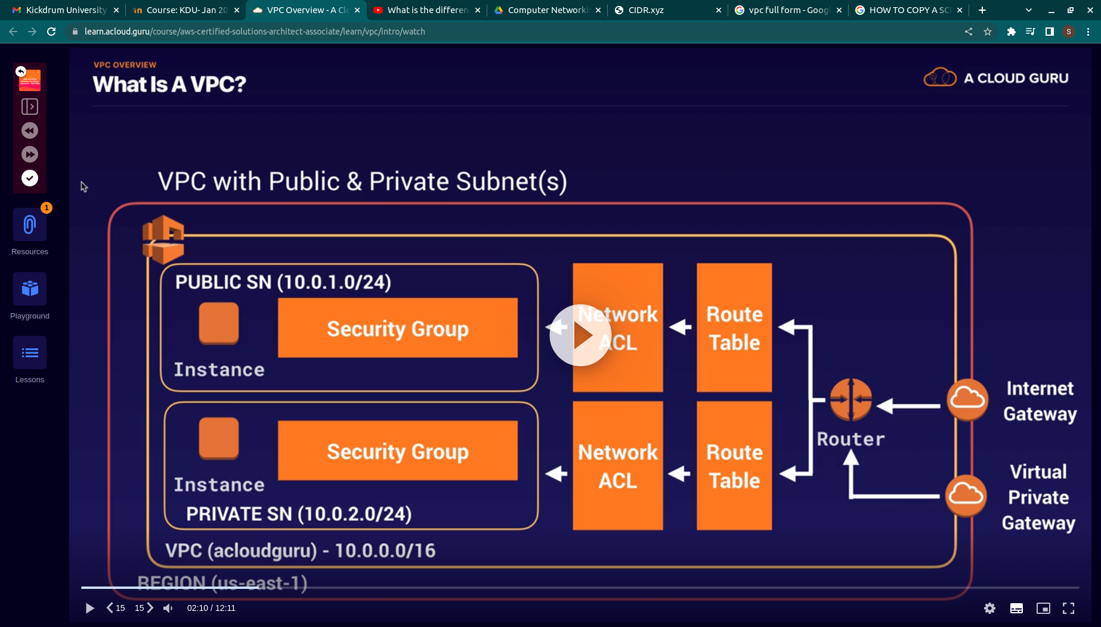
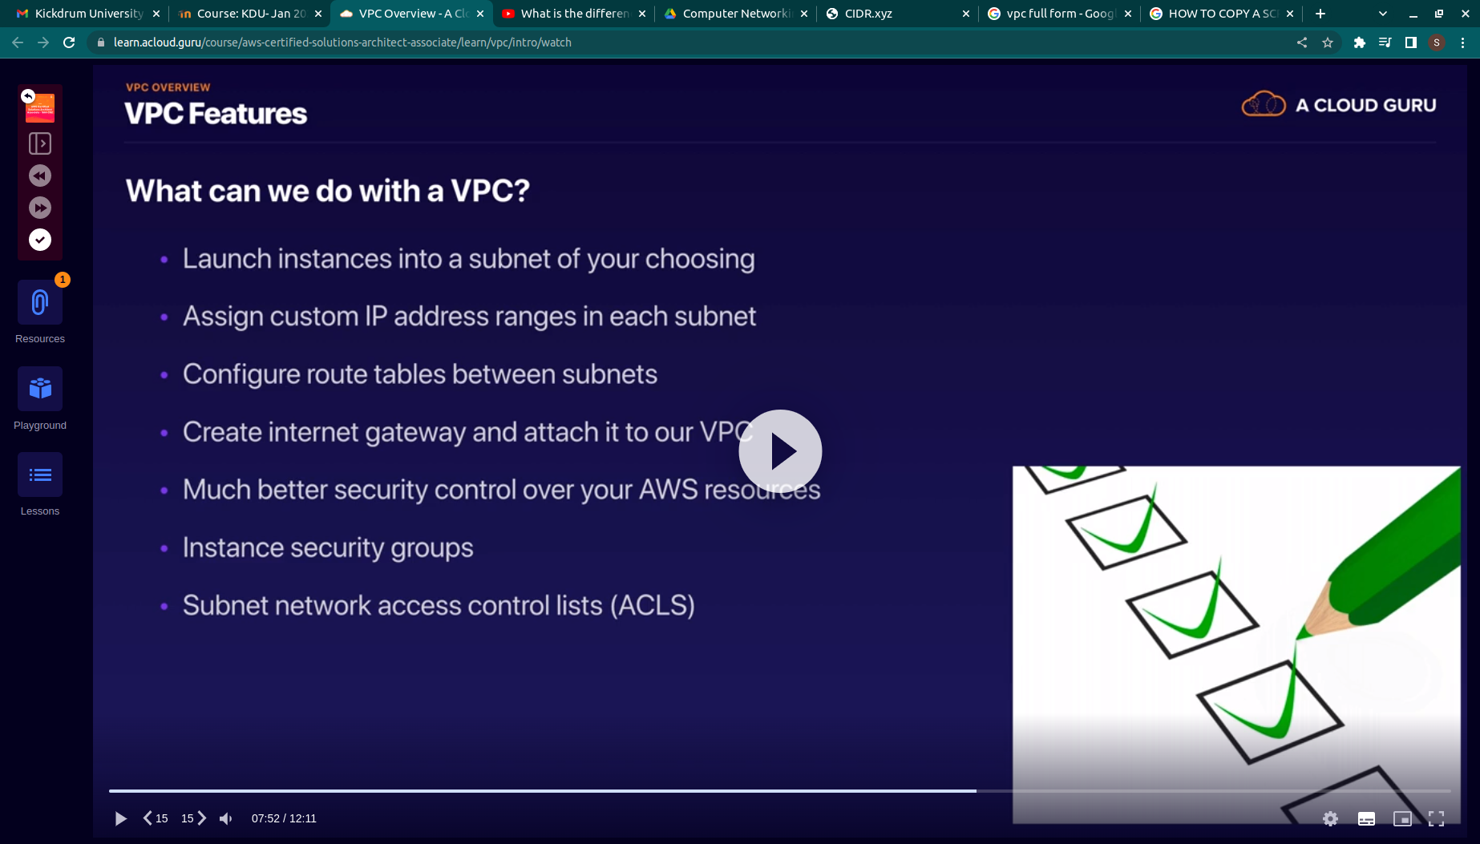
.
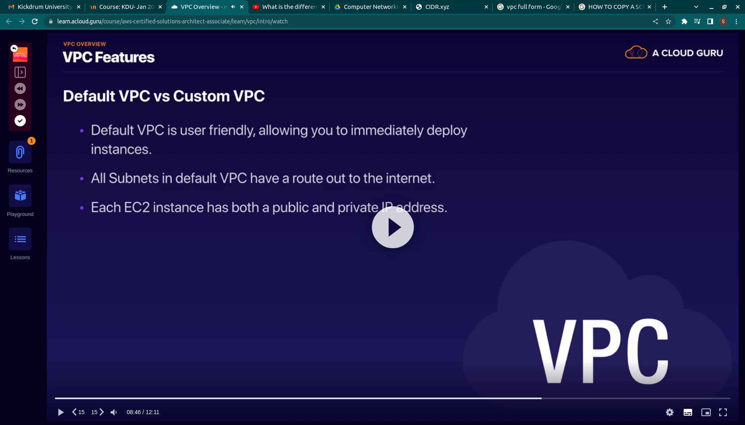
.
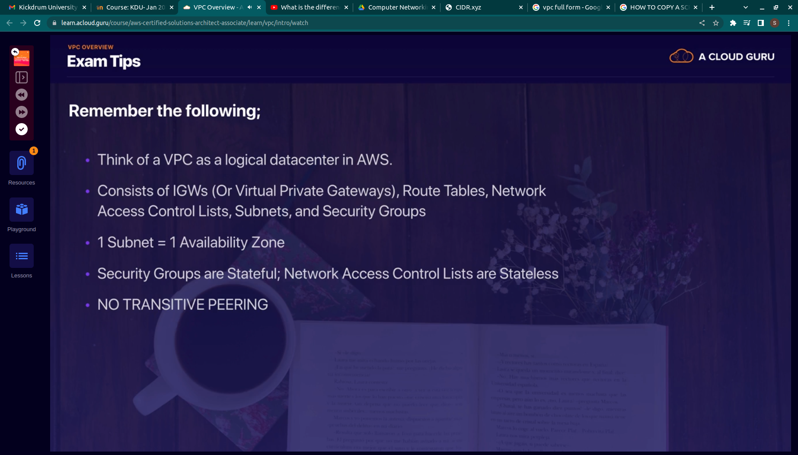
.

When we create a default VPC- Then default network acl is cretaed , and a security group and a route tables

we need to create our own subnet

RESERVER IP ADDESS
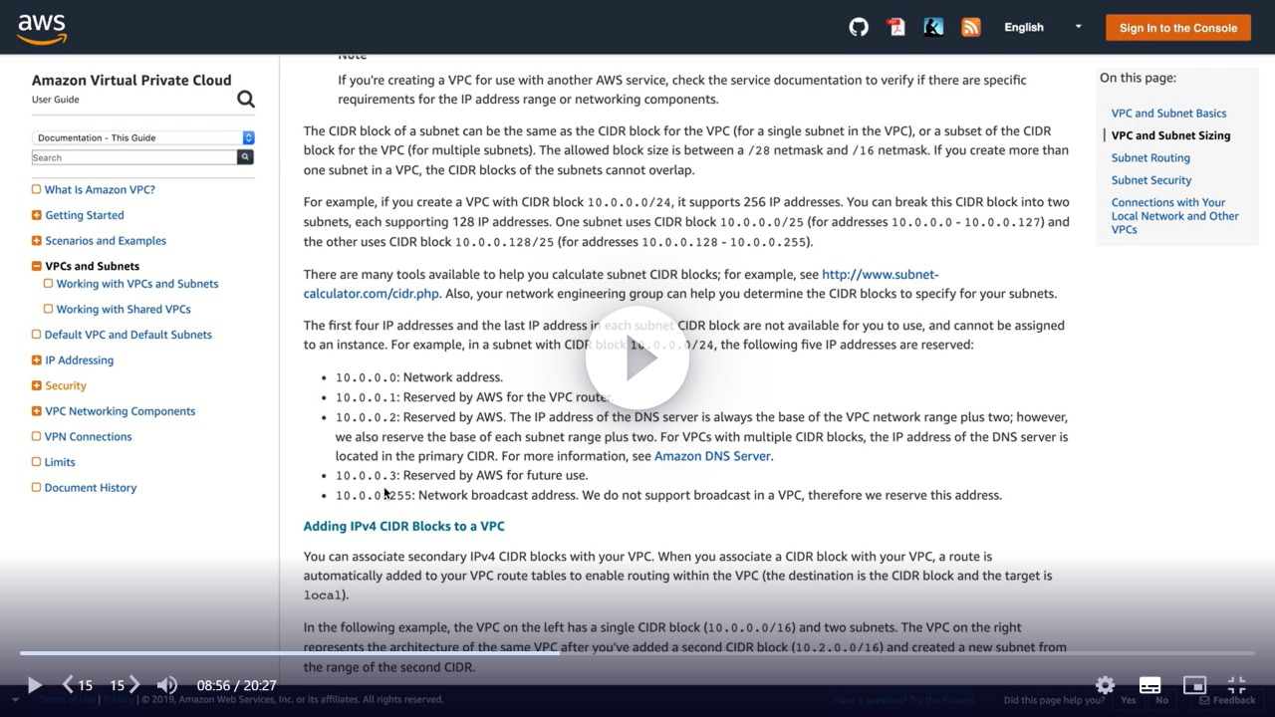
.
We can onlyhave one IGW for a vpc

IGW GIVES A PUBLIC IP ADDRES TO A VPC TO CONNECT TO THE INTERNET
IT NAT TABLE (NETWEOR ADDRESS TRANSLATION)

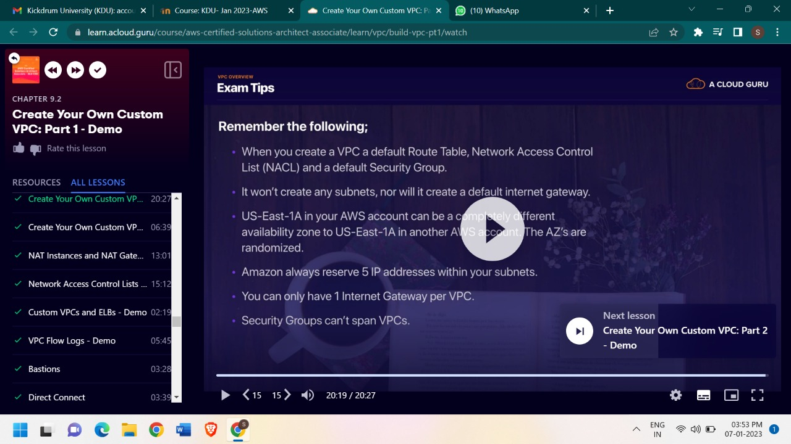
.

FOR PRIVATE SUBNET TO COMMUNICATE WITH INTERNET GATEWAYS WE NEED A NAT

NAT INSTANCE
IT IS A SINGLE INSTAGE

NAT GATEWAT
IT IS A GATEWAY WHICH CAN CONNECT ANY NUMBER OF INSANCE TO INTERNET GATEWAY

Network ACL:
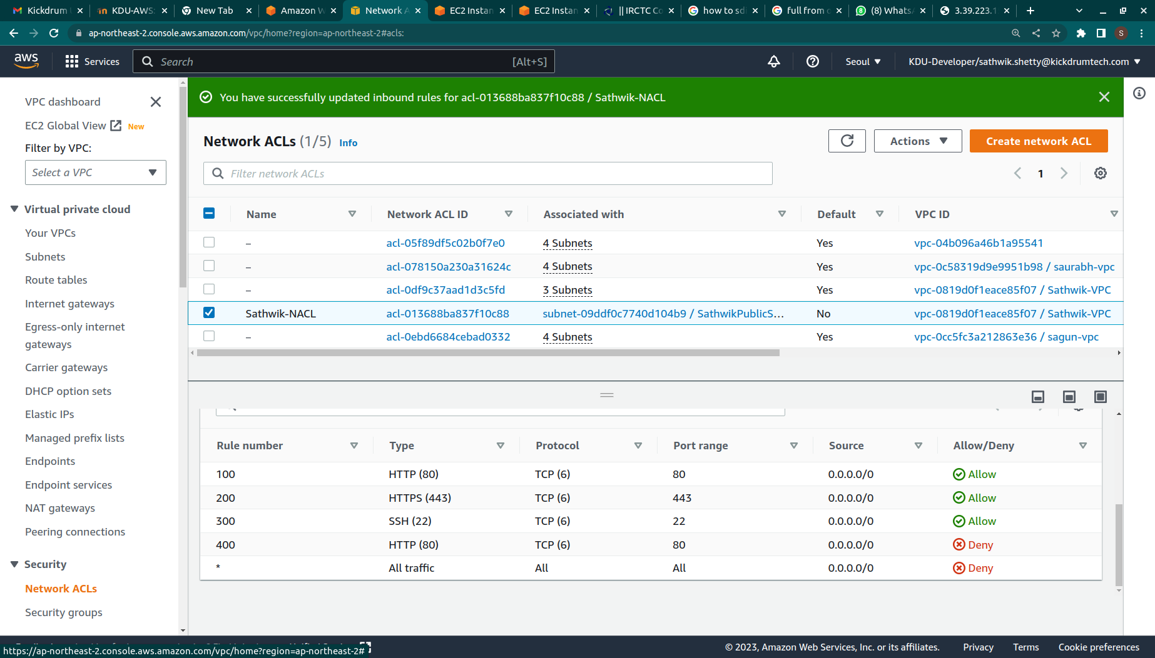
.
RULE 100 IS AHEAD OF RULE 400 SO IT DOES NOT DENY THE HTTP
RULES ARE EVALUATED IN NUMERIC ORDER

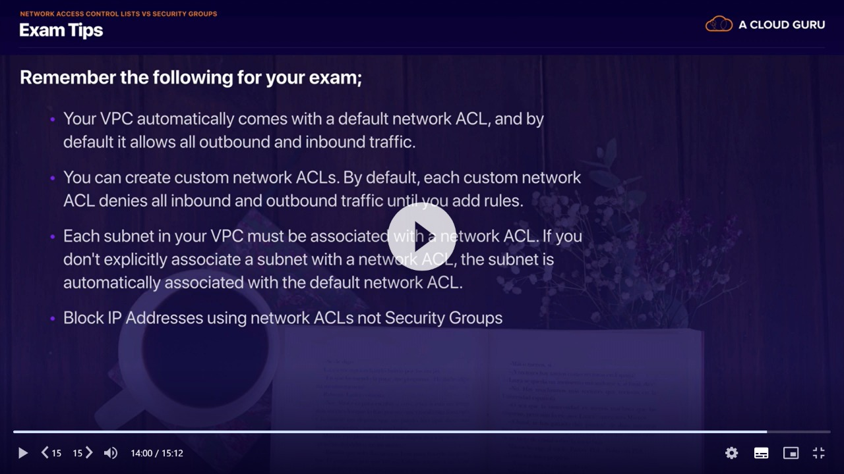
.

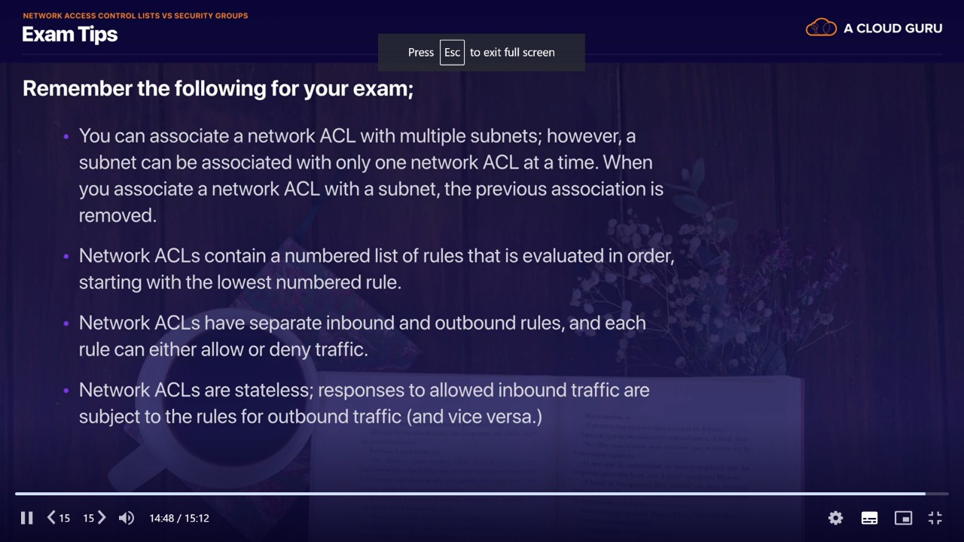
.
S3 provides highly scalable object(files) storage
it is a safe place to store your files

files are stored in bucket
bucket name has to unique

bucket is a folder in the cloud

HTTPS 200 STATUS CODE IF YOU SUCCESSFULLY UPLOAD

1.TIERED STORAGEV
2.LIFECYCLE MANAGEMENT
3.VERSIONING

S3
MINIMUM STORAGE DURATION IS 30 DAYS

GLACIER IS CHEAP

S3-INTELLIGENT TIERING
MOVES DATA BASED ON YOUR USAGE
IT REDUCES THE COST

1.BY DEFAULT ALL BUCKETS CREATED ARE PRIVATE
2.ONLY BUCKET OWNER CAN READ
3.NO PUBLIC ACCESS

WE CAN ENABLE OTER USERS TO READ OUR FILES

BUCKET POLICIES ARE WRITTEN IN JSON

BUCKET ACL(ACCESS CONTROL LISTS)

IT ALSO HAS ACSESS LOG

VERSIONING
Versioning is done so that if we accidentally delete an oject the previous version will still be there

*Each version if we have to make it public then we have to make public individually

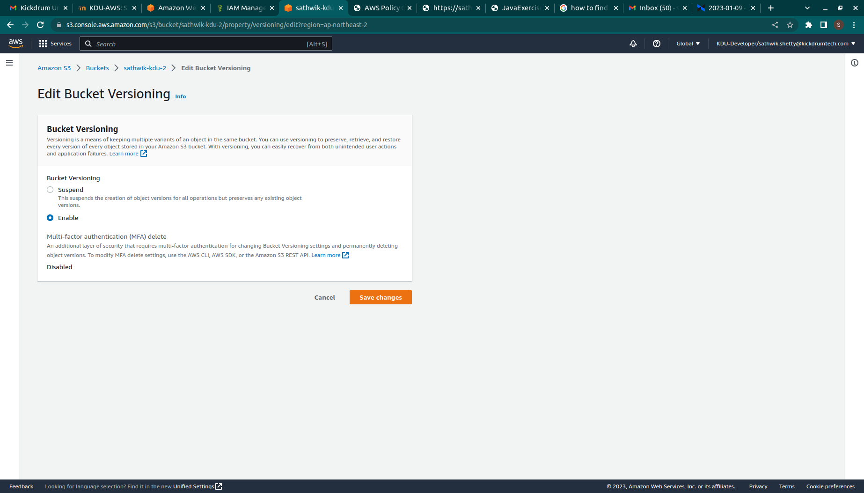
.
we can just suspend bucket versioning not delete it

S3 object lock is used to make others to not access and write to that object

5432

