# Business Forecasting Project

# **Group 3**:

Ajinkyaraje Ghorpade

Darshit Gandhi

Mengqi Luo

Sandeep Ramesh

Sathya Narayanan

Sneha Naik

Zhe Sun

R Programming Code



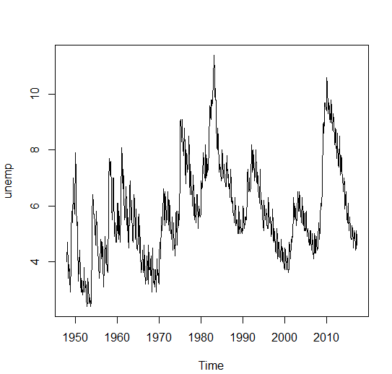



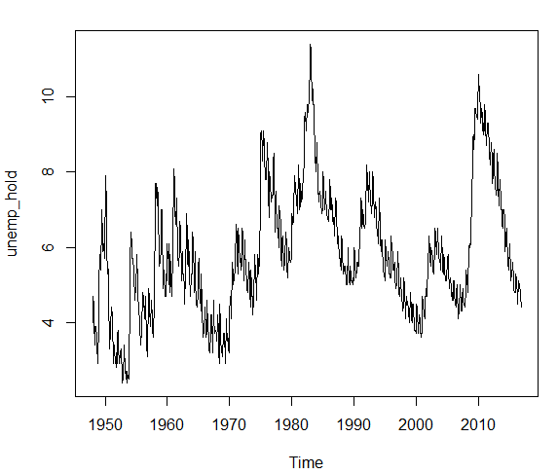

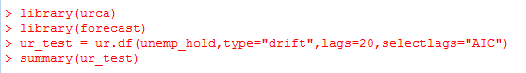

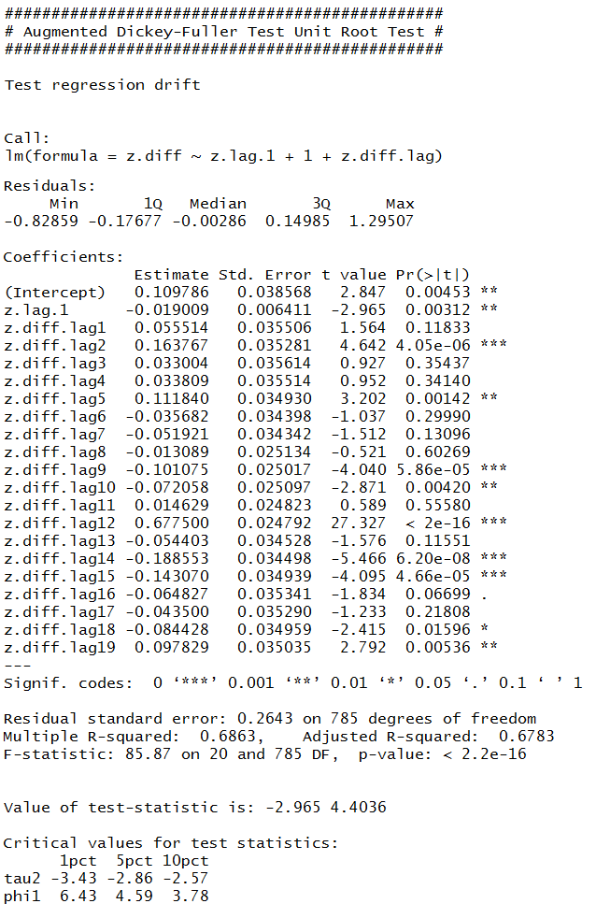





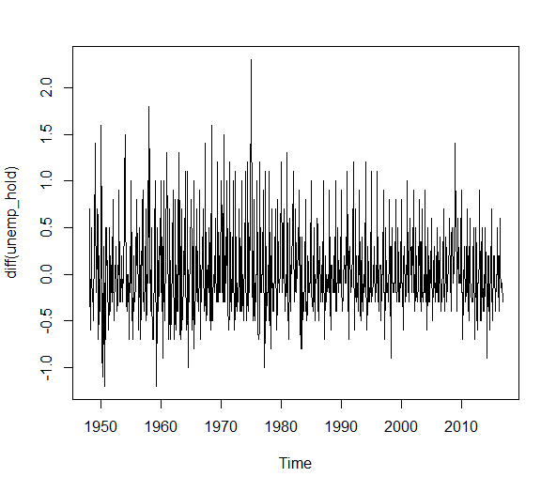



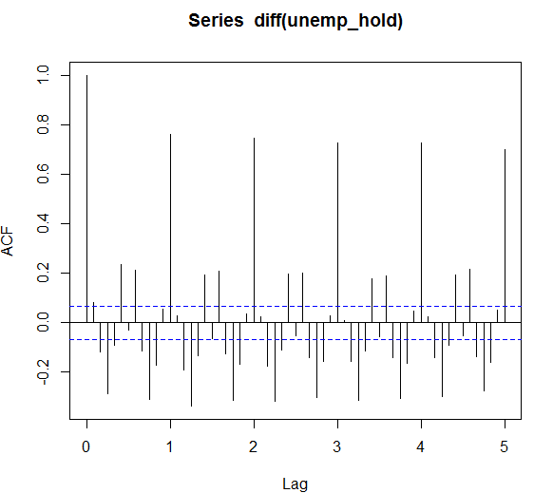



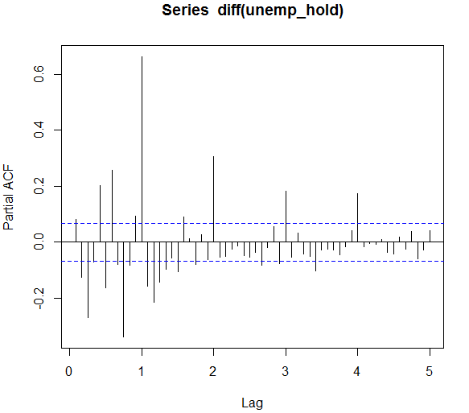

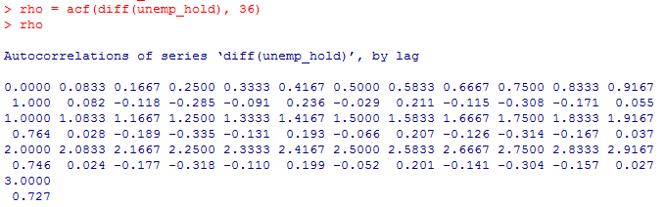

**MODEL GUESSES**

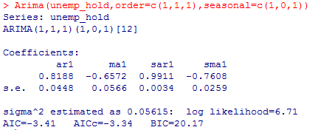

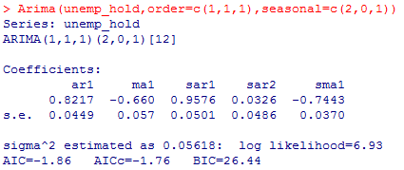

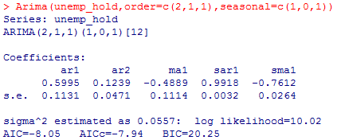

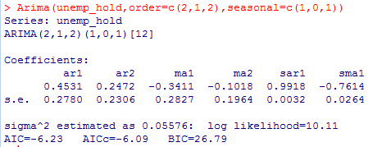

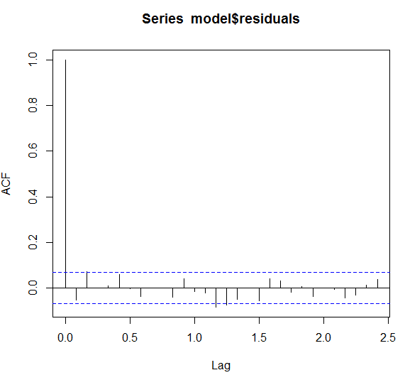

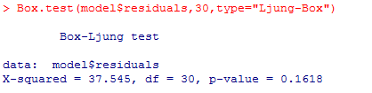

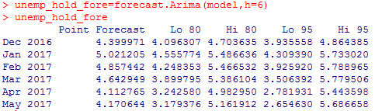



plot(cbind(window(unemp,start=c(2016,3),frequency=12),unemp_hold_fore$mean,upper,lower),plot.type="single",ylab='Forecast',lty=c("solid","solid","dashed","dashed"),col= c("blue","red","green","purple"))

