**Java OOPS**

1. Create a class called "Person" with attributes "name" and "age". Also create a constructor and getter methods for the attributes.

package JavaTask___6;

public class Person {

private String name;

private int age;

// Constructor

public Person(String name, int age) {

this.name = name;

this.age = age;

}

// Getter methods

public String getName() {

return name;

}

public int getAge() {

return age;

}

// Setter methods (if needed)

public void setName(String name) {

this.name = name;

}

public void setAge(int age) {

this.age = age;

}

public static void main(String[] args) {

Person person = new Person("Ameer", 25);

System.*out*.println("Person Name: " + person.getName());

System.*out*.println("Person Age: " + person.getAge());

}

}

**Output:**

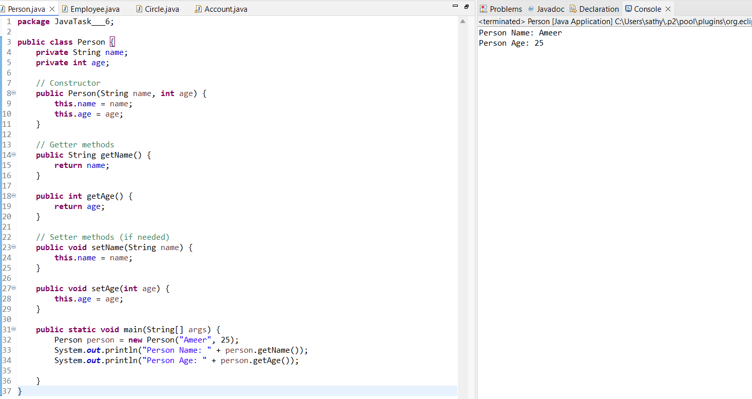

2. From the below image, Create an implementation for a java class named Employee that represents an employee with attributes including ID, name, and salary. The class includes a method called raiseSalary(percent), which updates the salary by a specified percentage.

package JavaTask___6;

public class Employee {

private int id;

private String firstName;

private String lastName;

private int salary;

// Constructor

public Employee(int id, String firstName, String lastName, int salary) {

this.id = id;

this.firstName = firstName;

this.lastName = lastName;

this.salary = salary;

}

// Getter methods

public int getID() {

return id;

}

public String getFirstName() {

return firstName;

}

public String getLastName() {

return lastName;

}

public String getName() {

return firstName + " " + lastName;

}

public int getSalary() {

return salary;

}

// Setter method for salary

public void setSalary(int salary) {

this.salary = salary;

}

// Method to get annual salary

public int getAnnualSalary() {

return salary * 12;

}

// Method to raise salary by percentage

public int raiseSalary(int percent) {

this.salary += (salary * percent) / 100;

return salary;

}

// toString method

@Override

public String toString() {

return "Employee[id=" + id + ", name=" + getName() + ", salary=" + salary + "]";

}

public static void main(String[] args) {

// Test Employee class

Employee employee = new Employee(1, "Anbu", "Selvan", 25000);

System.*out*.println("\nEmployee ID: " + employee.getID());

System.*out*.println("Employee Name: " + employee.getName());

System.*out*.println("Employee Monthly Salary: " + employee.getSalary());

System.*out*.println("Employee Annual Salary: " + employee.getAnnualSalary());

// Raise the salary by 10%

employee.raiseSalary(10);

System.*out*.println("Employee Salary after 10% raise: " + employee.getSalary());

// Print Employee details using toString()

System.*out*.println(employee);

}

}

**Output:**

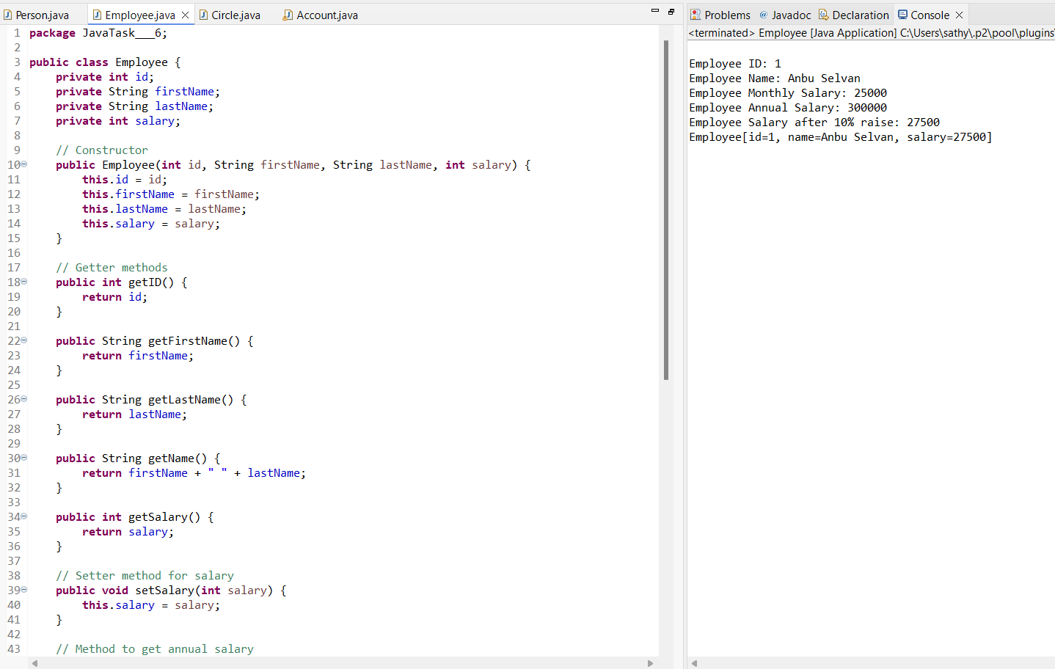

3. Create a class circle class with radius as data member. Create two constructors (no argument, and two arguments) and a method to calculate Circumference.

package JavaTask___6;

public class Circle {

private double radius;

// No-argument constructor

public Circle() {

this.radius = 1.0;

}

// Constructor with one argument

public Circle(double radius) {

this.radius = radius;

}

// Method to calculate circumference

public double getCircumference() {

return 2 * Math.*PI* * radius;

}

// Getter and Setter for radius

public double getRadius() {

return radius;

}

public void setRadius(double radius) {

this.radius = radius;

}

public static void main(String[] args) {

// Test Circle class

Circle circle1 = new Circle();

Circle circle2 = new Circle(5.0);

System.*out*.println("\nCircle 1 Radius: " + circle1.getRadius());

System.*out*.println("Circle 1 Circumference: " + circle1.getCircumference());

System.*out*.println("Circle 2 Radius: " + circle2.getRadius());

System.*out*.println("Circle 2 Circumference: " + circle2.getCircumference());

}

}

**Output:**

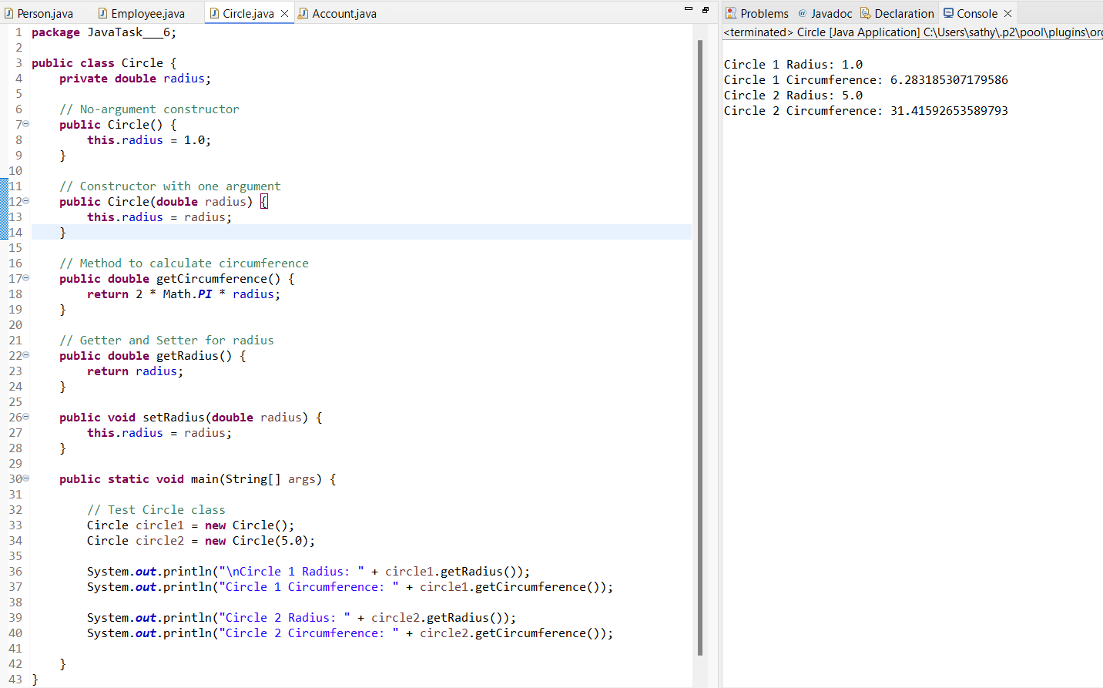

4. Create a class Account class with all necessary parameters as data member. Create two constructors (no argument, and two arguments) and methods to withdraw and deposit balance & check balance.

package JavaTask___6;

public class Account {

private int accountNumber;

private String accountHolderName;

private double balance;

// No-argument constructor

public Account() {

this.accountNumber = 0;

this.accountHolderName = "Unknown";

this.balance = 0.0;

}

// Constructor with two arguments

public Account(int accountNumber, String accountHolderName) {

this.accountNumber = accountNumber;

this.accountHolderName = accountHolderName;

this.balance = 0.0;

}

// Constructor with all arguments

public Account(int accountNumber, String accountHolderName, double balance) {

this.accountNumber = accountNumber;

this.accountHolderName = accountHolderName;

this.balance = balance;

}

// Method to deposit money

public void deposit(double amount) {

if (amount > 0) {

balance += amount;

}

}

// Method to withdraw money

public void withdraw(double amount) {

if (amount > 0 && amount <= balance) {

balance -= amount;

}

}

// Method to check balance

public double checkBalance() {

return balance;

}

public static void main(String[] args) {

// Test Account class

Account account1 = new Account();

Account account2 = new Account(12345, "Ram");

Account account3 = new Account(67890, "Raju", 1000.0);

System.*out*.println("\nAccount 1 Balance: " + account1.checkBalance());

System.*out*.println("Account 2 Balance: " + account2.checkBalance());

System.*out*.println("Account 3 Initial Balance: " + account3.checkBalance());

// Deposit money

account3.deposit(500);

System.*out*.println("Account 3 Balance after deposit: " + account3.checkBalance());

// Withdraw money

account3.withdraw(200);

System.*out*.println("Account 3 Balance after withdrawal: " + account3.checkBalance());

}

}

**Output:**

