**EXPERIMENT-05**

**AIM:** To simulate and synthesis finite state machine using Xilinx ISE.

**APPARATUS REQUIRED**: Xilinx 14.7 Spartan6 FPGA

**PROCEDURE:**

STEP:1 Start the Xilinx navigator, Select and Name the New project.

STEP:2 Select the device family, device, package and speed.

STEP:3 Select new source in the New Project and select Verilog Module as the Source type.

STEP:4 Type the File Name and Click Next and then finish button. Type the code and save it.

STEP:5 Select the Behavioral Simulation in the Source Window and click the check syntax.

STEP:6 Click the simulation to simulate the program and give the inputs and verify the outputs as per the truth table.

STEP:7 Select the Implementation in the Sources Window and select the required file in the Processes Window.

STEP:8 Select Check Syntax from the Synthesize XST Process. Double Click in the Floorplan Area/IO/Logic-Post Synthesis process in the User Constraints process group. UCF(User constraint File) is obtained.

STEP:9 In the Design Object List Window, enter the pin location for each pin in the Loc column Select save from the File menu.

STEP:10 Double click on the Implement Design and double click on the Generate Programming File to create a bitstream of the design.(.v) file is converted into .bit file here.

STEP:11 On the board, by giving required input, the LEDs starts to glow light, indicating the output.

STEP:12 Load the Bit file into the SPARTAN 6 FPGA

**LOGIC DIAGRAM:**

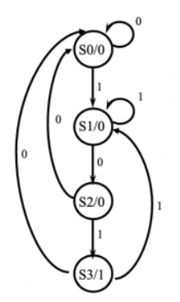

**VERILOG CODE:**

module finitestatic(clk,res,din,dout);

input clk,res,din;

output reg dout;

parameter s0=2'b00,

s1=2'b01,

s2=2'b10,

s3=2'b11;

reg [1:0]state;

always@ (posedge clk or posedge res)

begin

if(res) begin

dout <= 1'b0;

state <= s0;

end

else begin

case(state)

s0:begin

dout <=1'b0;

if(din)

state <=s1;

else

state <=s0;

end

s1:begin

dout <=1'b0;

if(~din)

state <=s2;

else

state <=s1;

end

s2:begin

dout <=1'b0;

if(din)

state <=s3;

else

state <=s0;

end

s3:begin

dout <=1'b1;

if(din)

state <=s1;

else

state <=s0;

end

endcase

end

end

endmodule

**OUTPUT:**

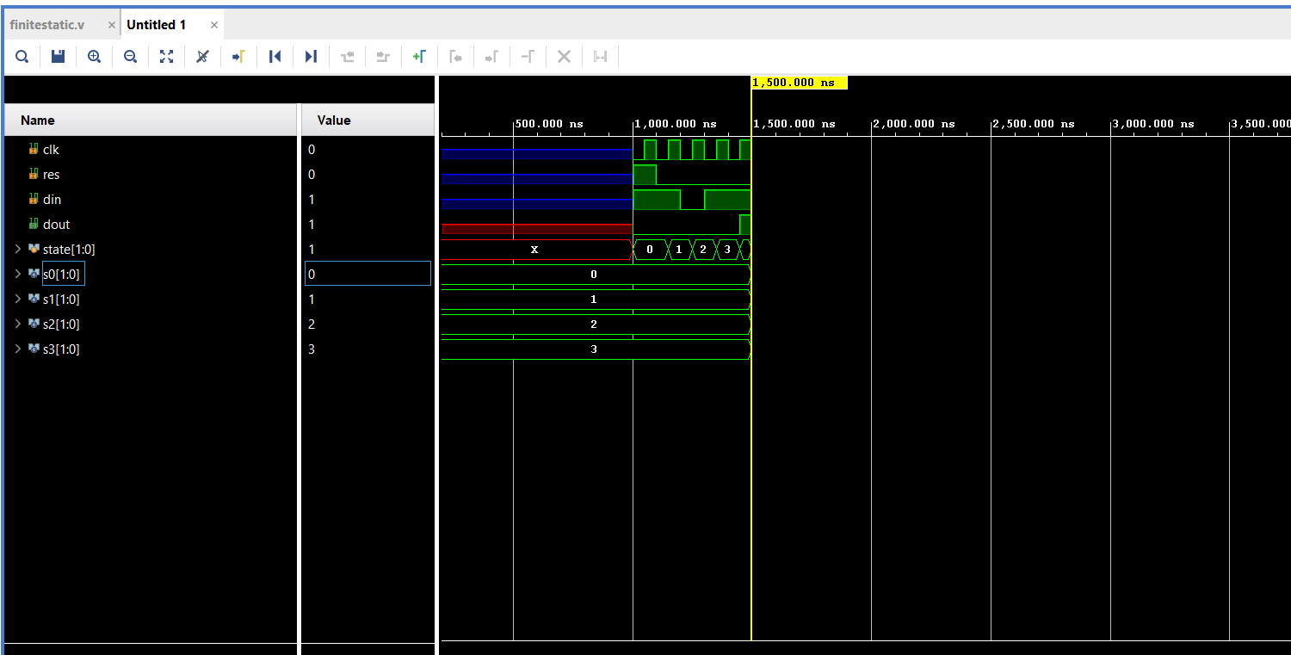

**RESULT:**

Thus ,the given finite state machine are simulated and synthesis are executed successfully.