**Question 3**

**Step 1: Create a feature branch.**

**Step 2: Switch to the new branch.**

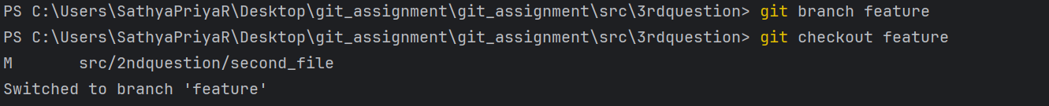

* Create a new branch called feature and switch to the new branch.

**Step 3: open the file and make some changes to it.**

* Open the file in the new branch and make some commits.

**Step 4: Add and commit the changes to the new branch.**

**Step 5: Push the changes to the new feature branch.**

* So after changes made to the file in the local will push the changes to the new feature branch.

**Step 6: Create a pull request.**

* While making some changes to the file it will arise the pull request.

**Step 7: As another user in the master branch make some changes to the same file.**

**Step 8: Add and commit the changes to the master branch.**

**Step 9: Push the changes to the master branch.**

**Note: There will be a conflict in the pull request, how do we resolve it??**

**Hint: git rebase**

* After committing the changes in the main branch it won’t have conflicts in the remopte repository.