embedUR Systems
Campus Training Program – 2026
Wifi Assessment 3 (Module 3)
Name : Sathya Narayanan M College : Thiagarajar College of Engineering

- What are the different 802.11 PHY layer standards? Compare their characteristics.
The PHY (Physical) layer of Wi-Fi defines how data is transmitted over the air (frequency band, modulation, channel width, data rate).
Feature | 11b | 11a/g | 11n | 11ac | 11ax | 11be
Frequency | 2.4 | 2.4/5 | Dual | 5 | 2.4/5/6 | 2.4/5/6
Modulation | DSSS | OFDM | OFDM | OFDM | OFDMA | OFDMA
Channel Width | 20 MHz | 20 MHz | 40 MHz | 80/160 | 160 | 320
MIMO | No | No | Yes | Yes | Yes | Yes
Efficiency | Low | Medium | High | Higher | Very High | Ultra High
Max Speed | 11M | 54M | 600M | 6.9G | 9.6G | 46G
. Evolution Insight
802.11b → DSSS (simple, low speed)
802.11a/g → OFDM (better efficiency)
802.11n → MIMO introduced
802.11ac → wider channels + MU-MIMO
802.11ax → OFDMA + efficiency focus
802.11be → ultra-high speed + multi-link

- What are DSSS and FHSS? How do they work?
DSSS (Direct Sequence Spread Spectrum) and FHSS (Frequency Hopping Spread Spectrum) are the techniques used to make wireless communication more robust against interference and noise by spreading the signal over a wider frequency band.
DSSS (Direct Sequence Spread Spectrum) :
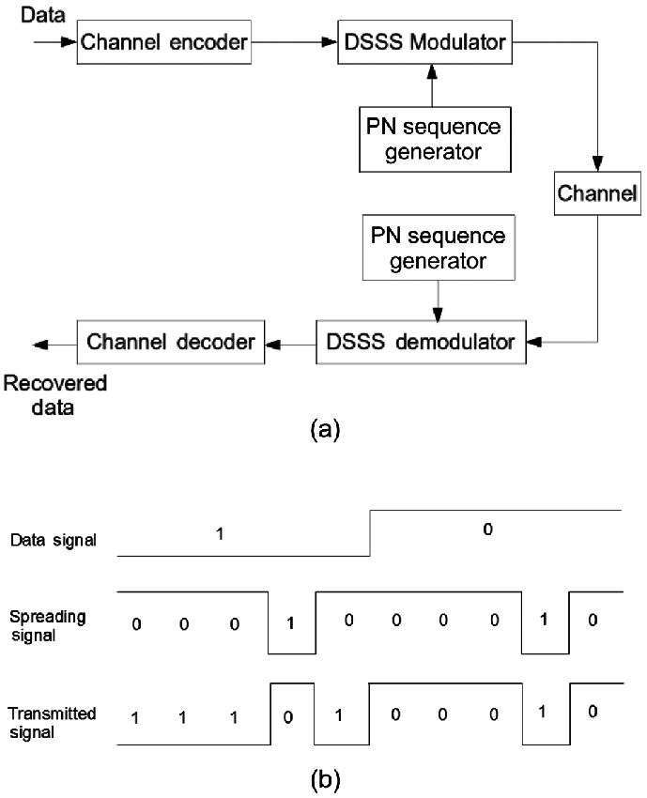
Each data bit is multiplied by a high-rate pseudo-random code (called chips).
This spreads the signal over a wide frequency band.
Used in 802.11b
Works in 2.4 GHz band
More resistant to noise and interference
Requires code synchronization
How it Works :
Original data bit (e.g., 1)
Multiply with spreading code (e.g., 10110101)
Transmit the resulting chip sequence
Receiver uses the same code to despread and recover data
Example :
1 bit → becomes 8 chips
Therefore, Signal becomes wider but more reliable
FHSS (Frequency Hopping Spread Spectrum) :
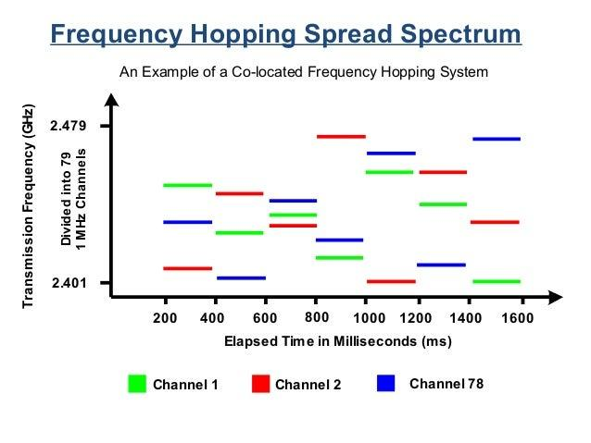
Signal jumps (hops) between different frequencies rapidly
Follows a pseudo-random sequence
Used in early Wi-Fi (802.11 legacy) and Bluetooth
Also operates in 2.4 GHz band
Avoids interference by not staying on one frequency
How it Works :
Data is transmitted on one frequency
After a short time, it hops to another frequency
Receiver follows the same hopping pattern
Data is reconstructed across hops
Example :
Time slot 1 → 2.412 GHz
Time slot 2 → 2.437 GHz
Time slot 3 → 2.462 GHz

- How do modulation schemes work in the PHY layer? Compare different modulation schemes and their performance across various Wi-Fi standards.
The PHY converts bits into a radio waveform by modulating a carrier.
In Wi-Fi (OFDM/OFDMA systems), data is split across many subcarriers, and each subcarrier sends one symbol. A symbol represents multiple bits by choosing a point in a constellation (amplitude + phase).
Steps :
Bits → grouped (e.g., 6 bits per symbol for 64-QAM)
Map groups to constellation points (I/Q values)
Place symbols on OFDM subcarriers
IFFT → time signal → transmit over air
Receiver does FFT, detects constellation points → bits
Key trade-off:
Higher-order modulation ⇒ more bits/symbol (higher rate)
But needs higher SNR (cleaner signal), else errors increase
Common modulation schemes :
Scheme | Bits/Symbol | Robustness | Typical Use
BPSK | 1 | Very high | Very weak signals
QPSK | 2 | High | Low SNR links
16-QAM | 4 | Medium | Moderate SNR
64-QAM | 6 | Lower | Good signal
256-QAM | 8 | Low | Strong signal (Wi-Fi 5)
1024-QAM | 10 | Very low | Very strong signal (Wi-Fi 6)
4096-QAM | 12 | Extremely low | Very clean links (Wi-Fi 7)
How performance changes
1) Data rate (throughput)
Rate ∝ bits/symbol × symbol rate × spatial streams × channel width
Higher QAM ⇒ higher throughput
2) Required SNR (approx idea)
BPSK: ~6–8 dB
QPSK: ~10 dB
16-QAM: ~16 dB
64-QAM: ~22 dB
256-QAM: ~28–30 dB
1024-QAM: ~35 dB+
Higher modulation = needs cleaner signal
3) Error performance
Low-order (BPSK/QPSK) → very reliable
High-order (1024/4096-QAM) → error-prone in noise

Modulation across Wi-Fi standards :
Standard | Modulation | Max Bits/Symbol | Notes
802.11b | DSSS (DBPSK/DQPSK/CCK) | ~1–4 | Robust, low speed
802.11a/g | OFDM (BPSK → 64-QAM) | 6 | First OFDM Wi-Fi
802.11n (Wi-Fi 4) | OFDM (up to 64-QAM) | 6 | + MIMO
802.11ac (Wi-Fi 5) | OFDM (up to 256-QAM) | 8 | Higher speed
802.11ax (Wi-Fi 6) | OFDMA (up to 1024-QAM) | 10 | Better efficiency
802.11be (Wi-Fi 7) | OFDMA (up to 4096-QAM) | 12 | Ultra high throughput

- What is the significance of OFDM in WLAN? How does it improve performance?
OFDM (Orthogonal Frequency Division Multiplexing) is the core PHY technique used in modern Wi-Fi (802.11a/g/n/ac/ax/be). It divides a wide channel into many orthogonal subcarriers, each carrying a portion of the data in parallel.
OFDM Working principle (in WLAN) :
Split high-rate data into multiple low-rate streams
Map each stream to symbols (BPSK/QPSK/QAM)
Assign symbols to subcarriers
Use IFFT to generate time-domain signal
Add Guard Interval (Cyclic Prefix)
Transmit over the air
Receiver performs FFT → recovers symbols → data
Key Components that Improve Performance :
Subcarriers :
Divide channel into many narrowband channels
Each experiences flat fading → easier equalization
Orthogonality :
Subcarriers overlap without interfering
Maximizes bandwidth usage
Cyclic Prefix (Guard Interval) :
Adds small delay buffer
Eliminates ISI caused by reflections
Adaptive Modulation :
Each subcarrier can use different modulation (based on SNR)
Optimizes performance dynamically
- How are frequency bands divided for Wi-Fi? Explain different bands and their channels.
Wi-Fi (IEEE 802.11) operates in unlicensed spectrum. Each band is split into channels (fixed frequency slices). Devices use 20/40/80/160/320 MHz channel widths by bonding adjacent channels.
2.4 GHz Band (~ 2.400–2.4835 GHz) :
Channels :
Numbered 1–13 (India supports 1–13; US uses 1–11)
Spacing: 5 MHz, but each channel is 20 MHz wide → heavy overlap
Practical non-overlapping set
1, 6, 11 (sometimes 1, 5, 9, 13 with careful planning)
Characteristics
Long range, good wall penetration
High interference (Bluetooth, microwaves, many Wi-Fi networks)
Limited usable channels
Typical use
Legacy/IoT devices, wider coverage areas
5 GHz Band (≈ 5.15–5.825 GHz; region dependent) :
Channels :
Many non-overlapping 20 MHz channels
Can bond to 40/80/160 MHz
Sub-bands (UNII)
UNII-1: Ch 36–48
UNII-2/2e (DFS): Ch 52–144 (may require radar detection)
UNII-3: Ch 149–165
Characteristics
Higher throughput, less congestion than 2.4 GHz
More channels → better reuse
Shorter range than 2.4 GHz
DFS channels may pause/move if radar detected
Typical use
Laptops/phones, high-speed indoor networks
6 GHz Band (Wi-Fi 6E/7; ≈ 5.925–7.125 GHz, region dependent) :
Channels
Large contiguous spectrum → many channels:
20 MHz: dozens
40/80/160 MHz: multiple clean blocks
320 MHz (Wi-Fi 7): possible
Characteristics
Very high capacity & speeds (clean spectrum)
Minimal legacy interference
Shortest range (higher frequency)
Device/AP must support Wi-Fi 6E/7
Typical use
Dense environments, high-throughput applications
- What is the role of Guard Intervals in WLAN transmission? How does a short Guard Interval improve efficiency?
A Guard Interval (GI) is a short time gap inserted between consecutive OFDM symbols.
In Wi-Fi, this is implemented as a cyclic prefix (CP)—a copy of the end of the symbol placed at the beginning.
Purpose: protect symbols from overlap due to multipath
Problem: Multipath Propagation
Signals reflect from walls/objects
Multiple delayed copies arrive at receiver
Original signal → arrives first
Reflected signals → arrive later (delayed)
This causes Inter-Symbol Interference (ISI)
Solution: Guard Interval
Adds a buffer time
Delayed signals fall inside GI, not into next symbol
Prevents ISI and preserves data integrity
Role of Guard Interval :
1. Eliminates Inter-Symbol Interference (ISI) - Prevents overlap of symbols
2. Handles Multipath Delay - Absorbs delayed reflections
3. Maintains Orthogonality - Keeps OFDM subcarriers independent
4. Improves Reliability - Reduces packet errors in noisy environments
How Short Guard Interval Improves Efficiency :
GI is overhead (no data transmitted)
Reducing GI → more time for actual data

- Describe the structure of an 802.11 PHY layer frame. What are its key components?
An 802.11 PHY frame (also called PPDU – PLCP Protocol Data Unit) is the format used to transmit data over the air. It consists of three main parts:
Preamble → PHY Header → Data (PSDU)
Key Components
1. Preamble : Helps receiver detect and synchronize with incoming signal
Contains:
Short Training Field (STF) → Signal detection, timing sync
Long Training Field (LTF) → Channel estimation (important for OFDM)
Role:
Aligns transmitter and receiver
Prepares receiver to decode data
2. PHY Header (PLCP Header) : Provides information about the transmission
Contains : Rate (data rate used)
Length (frame size)
Modulation & coding scheme (MCS)
Role:
Tells receiver “How to decode the upcoming data”
3. Data Field (PSDU) : Carries actual payload
Contains: MAC frame (802.11 MAC data)
User data (IP packets, application data)
Role: Main data transmission

- What is the difference between OFDM and OFDMA?
OFDM (Orthogonal Frequency Division Multiplexing) :
Splits channel into many subcarriers
All subcarriers used by ONE user at a time
Entire channel → one user → full bandwidth
OFDMA (Orthogonal Frequency Division Multiple Access)
Extension of OFDM
Divides subcarriers into groups (Resource Units – RUs)
Multiple users share the channel simultaneously
Channel → divided into RUs → multiple users at same time
Feature | OFDM | OFDMA
Users per transmission | One | Multiple
Channel usage | Full channel | Divided into RUs
Efficiency | Lower (idle time) | Higher
Latency | Higher | Lower
Scheduling | Not required | Controlled by AP
Introduced in | 802.11a/g/n/ac | 802.11ax (Wi-Fi 6)

- What is the difference between MIMO and MU-MIMO?
MIMO (Multiple Input Multiple Output)
Uses multiple antennas at transmitter and receiver
Sends multiple spatial streams to ONE device
Also called SU-MIMO (Single User MIMO)
AP → multiple streams → ONE device
MU-MIMO (Multi-User MIMO)
Extension of MIMO
AP sends different streams to MULTIPLE devices at the same time
AP → stream 1 → Device A
AP → stream 2 → Device B
AP → stream 3 → Device C
Feature | MIMO (SU-MIMO) | MU-MIMO
Users served | One at a time | Multiple simultaneously
Efficiency | Lower in multi-user case | Higher
Throughput | High for single user | Shared across users
Latency | Higher (waiting) | Lower
Complexity | Moderate | High (needs scheduling)
Introduced in | 802.11n | 802.11ac (downlink), improved in 802.11ax

- What are PPDU, PLCP, and PMD in the PHY layer?
PHY Layer Structure :
In Wi-Fi (IEEE 802.11), the PHY layer is divided into:
MAC → PLCP → PMD → Wireless Medium
PLCP = adaptation layer
PMD = actual transmission layer
PPDU = the transmitted frame over air
PPDU (PLCP Protocol Data Unit) : The complete PHY frame transmitted over the air
Preamble → PHY Header → Data (PSDU)
Components :
Preamble → synchronization
Header → rate, length
PSDU → actual MAC frame
PPDU = final output of PHY layer
PLCP (Physical Layer Convergence Procedure) : Interface between MAC layer and PMD
Functions :
Takes MAC data (PSDU)
Adds: Preamble, PHY header
Forms PPDU
MAC frame → PLCP → PPDU
PLCP = frame formatter + adapter
PMD (Physical Medium Dependent) : Lowest part of PHY layer
Handles actual transmission over air
Functions :
Modulation (BPSK, QAM)
Coding (error correction)
Signal transmission
Frequency handling
PPDU → PMD → Radio signal
PMD = signal processing + RF transmission
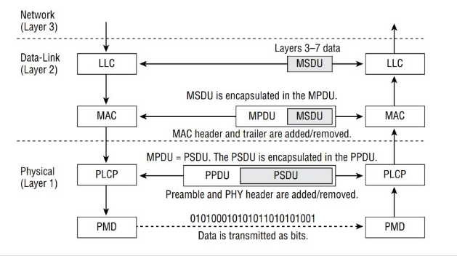
- What are the types of PPDU? Explain the PPDU frame format across different Wi-Fi generations.
PPDU (PLCP Protocol Data Unit) is the complete PHY-layer frame sent over the air:
Preamble + PHY Header + Data (PSDU)
Different Wi-Fi generations define different PPDU formats (preambles/headers).
Types of PPDU (by generation) :
Generation | Standard | PPDU Type
Legacy | 802.11a/b/g | Legacy PPDU
Wi-Fi 4 | 802.11n | HT PPDU
Wi-Fi 5 | 802.11ac | VHT PPDU
Wi-Fi 6/6E | 802.11ax | HE PPDU
Wi-Fi 7 | 802.11be | EHT PPDU
Legacy PPDU (802.11a/g; 11b differs in PHY) :
Fields :
L-STF (Short Training Field): detection, AGC, timing
L-LTF (Long Training Field): channel estimation
L-SIG: rate, length, Parity and Tail
DATA: payload (PSDU)
Features :
OFDM (a/g), basic rates
No MIMO, no multi-user
HT PPDU (Wi-Fi 4 – 802.11n) :
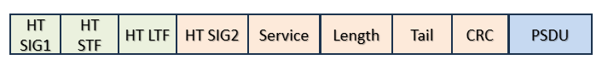
Additions over Legacy :
HT-SIG: MCS, bandwidth (20/40), streams
HT-STF / HT-LTFs: MIMO training
Features :
MIMO (multiple spatial streams)
Channel bonding (40 MHz)
VHT PPDU (Wi-Fi 5 – 802.11ac) :
Additions : VHT-SIG-A/B: user-specific info, bandwidth (80/160 MHz), MU-MIMO params
Features : MU-MIMO (downlink)
Wider channels (80/160 MHz)
Higher QAM (256-QAM)
HE PPDU (Wi-Fi 6/6E – 802.11ax) :
Additions :
RL-SIG (Repeated L-SIG): backward compatibility
HE-SIG-A/B: OFDMA resource units (RUs), multi-user scheduling
Features :
OFDMA (multi-user)
UL/DL MU-MIMO
Better efficiency in dense networks
1024-QAM

- How is the data rate calculated?
The PHY data rate in Wi-Fi depends on how many bits you send per symbol and how fast symbols are sent across all spatial streams.
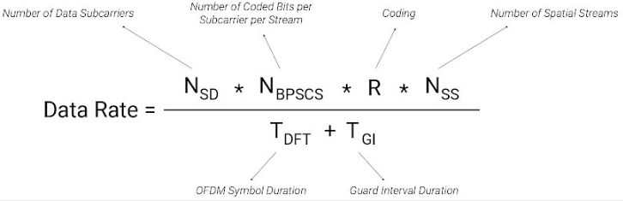

1. Modulation → Nbpsc​ :
Higher modulation = more bits per symbol
Modulation | Bits per subcarrier
BPSK | 1
QPSK | 2
16-QAM | 4
64-QAM | 6
256-QAM | 8
1024-QAM | 10
2. Coding Rate 𝑅
Adds error correction
Typical values: 1/2, 2/3, 3/4, 5/6
Higher rate = more useful data (less redundancy)
3. Subcarriers Nsd :
Depends on channel width
Channel Width | Data Subcarriers (approx)
20 MHz | 52
40 MHz | 108
80 MHz | 234
160 MHz | 468

4. Spatial Streams Nss :
Number of parallel streams (MIMO)
Example:
1×1 → 1 stream
2×2 → 2 streams
5. Symbol Duration Tsym :
Depends on Guard Interval (GI)
Short GI → higher rate

