embedUR Systems
Campus Training Program – 2026
Wifi Assessment 1 (Module 1)
Name : Sathya Narayanan M College : Thiagarajar College of Engineering

- In which OSI layer the Wi-Fi standard/protocol fits.
Wi-Fi (IEEE 802.11) operates in the OSI lower layers :
Layer 1 – Physical (PHY) - Handles Radio transmission
Modulation (BPSK, QPSK, QAM)
Frequency bands (2.4 GHz, 5 GHz, 6 GHz)
Converts bits to/from radio waves
Layer 2 – Data Link
MAC (Medium Access Control) - Controls who transmits and when
CSMA/CA (collision avoidance)
Frame formatting
Retransmissions
LLC (Logical Link Control)
Interface to upper layers (IP)

- Can you share the Wi-Fi devices that you are using in day to day life, share that device's wireless capability/properties after connecting to network. Match your device to corresponding Wi-Fi Generations based on properties.
Wifi devices :
- Smart Phone
- Laptop

Laptop :
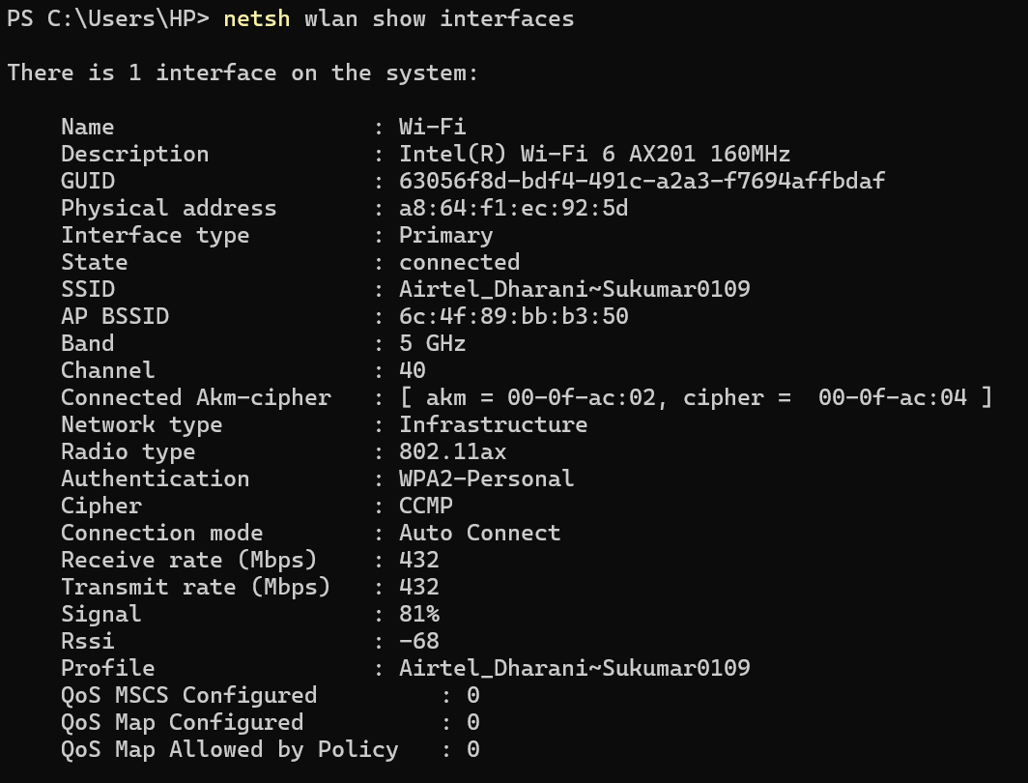
Observed Properties :
Wi-Fi Adapter: Intel Wi-Fi 6 AX201 160MHz
SSID: Airtel_Dharani-Sukumar0109
Band: 5 GHz
Channel: 40
Radio type: 802.11ax
Receive rate: 432 Mbps
Transmit rate: 432 Mbps
Signal strength: 81%
RSSI: -68 dBm
Security: WPA2-Personal (CCMP)

Capability Analysis
Supports Wi-Fi 6 features
Operating in 5 GHz band → high speed
Moderate link speed (432 Mbps):
Likely 2x2 MIMO
Reduced due to:
Channel width (probably 40 MHz)
Signal conditions
Wi-Fi Generation Mapping :
Standard - 802.11ax
Generation - Wi-Fi 6
Phone :
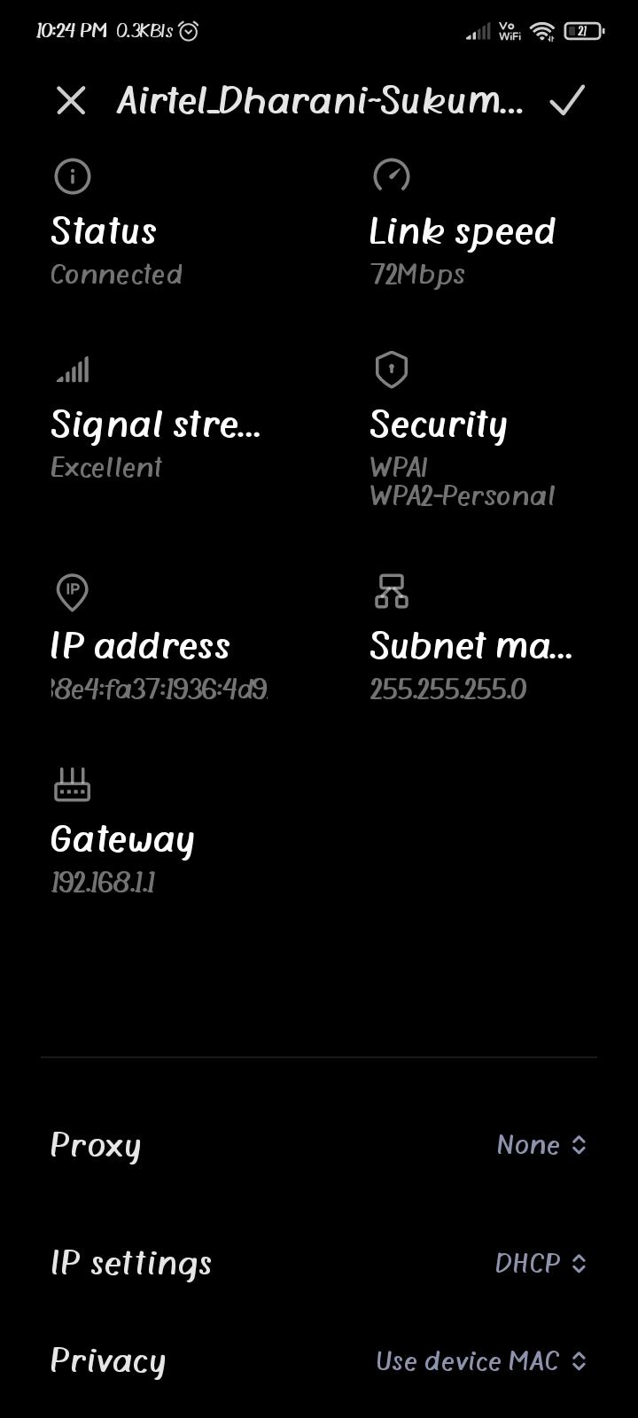

Observed Properties :
Network: Airtel_Dharani-Sukumar0109
Status: Connected
Link speed: 72 Mbps
Band: Likely 2.4 GHz
Security: WPA/WPA2-Personal
Signal strength: Excellent
Capability Analysis :
Low speed (72 Mbps) indicates:
802.11n (Wi-Fi 4)
20 MHz channel
Single spatial stream (1x1 MIMO)
Wi-Fi Generation Mapping
Standard - 802.11n
Generation - Wi-Fi 4

Parameter | Laptop | Smartphone
Standard | 802.11ax | 802.11n
Generation | Wi-Fi 6 | Wi-Fi 4
Band | 5 GHz | 2.4 GHz
Speed | 432 Mbps | 72 Mbps
MIMO | 2x2 (likely) | 1x1
Performance | High | Moderate

The laptop supports 802.11ax (Wi-Fi 6) with 5 GHz and high data rates (approx 432 Mbps), while the smartphone operates on 802.11n (Wi-Fi 4) with 2.4 GHz and lower data rates (approx 72 Mbps), demonstrating the impact of Wi-Fi generation and frequency band on performance.

- What is BSS and ESS?
BSS (Basic Service Set) :
A BSS is the smallest Wi-Fi network unit:
1 Access Point (AP)
Multiple client devices (phones, laptops)
Characteristics :
Single coverage area (cell)
Identified by BSSID (AP’s MAC address)
One channel
Example : Home Wi-Fi router + Devices (like Phone , Laptop …)
ESS (Extended Service Set) :
An ESS is a group of multiple BSSs (multiple APs) connected together.
Characteristics :
Same SSID (Wi-Fi name)
Multiple APs
Larger coverage area
Connected via Distribution System (wired network)
Roaming - Device moves between APs without disconnecting
Example : Office / college campus Wi-Fi

- What are the basic functionalities of Wi-Fi Access Point.
A Wi-Fi Access Point (AP) is a device defined by IEEE 802.11 that connects wireless devices to a wired network and manages communication over the air.
1. Connectivity (Wireless Access)
Allows devices (phones, laptops, IoT) to connect using SSID & password
Acts as the entry point to the network
2. Bridging (Wi-Fi to/from Ethernet)
Converts 802.11 (Wi-Fi frames) into 802.3 (Ethernet frames) and vice versa
Connects wireless clients to the wired LAN/internet
3. Medium Access Control (MAC)
Controls who transmits and when
Uses CSMA/CA to avoid collisions
Manages Channel access , Retransmissions and Frame acknowledgements
4. Security & Authentication
Provides WPA2 / WPA3 encryption
User authentication (password, enterprise login)
Protects network from unauthorized access
5. Coverage & Signal Transmission
Creates a Wi-Fi cell (coverage area)
Handles Signal strength, Channel selection and Frequency bands (2.4 / 5 / 6 GHz)
6. QoS (Quality of Service)
Prioritizes traffic : Voice/video > downloads
Ensures smooth performance for real-time apps
7. Mobility & Roaming Support
Enables devices to move between APs in an ESS
Maintains connection without interruption
8. Network Management
Broadcasts SSID
Handles Association / disassociation, Client management
Power saving features
10. Traffic Forwarding
Forwards data between:
Client (air)to AP (wired)to Router (wired)to Internet

- Difference between Bridge mode and Repeater mode.
Bridge mode connects two separate networks by forwarding data between them, while repeater mode extends the coverage of an existing Wi-Fi network by receiving and retransmitting signals, usually with reduced performance.
Feature | Bridge Mode | Repeater Mode
Purpose | Connect two networks | Extend Wi-Fi coverage
Connection type | Network to Network | AP to Clients
Medium | Wired/Wireless link | Wireless only
SSID for users | Not typically | Yes (same network)
Performance | High | Reduced
Use case | Building connectivity | Home dead-zone fix

Bridge Mode is preferred when :
Two buildings/offices need connection
Long-distance link
Repeater Mode is preferred when :
Weak signal in some rooms
Extend home Wi-Fi

- What are the differences between 802.11a and 802.11b.
Both are early Wi-Fi standards defined by IEEE 802.11 (introduced around 1999), but they differ in frequency, speed, modulation, and behavior.

Feature | 802.11a | 802.11b
Frequency band | 5 GHz | 2.4 GHz
Max data rate | 54 Mbps | 11 Mbps
Modulation | OFDM | DSSS (CCK)
Range | Shorter | Longer
Wall penetration | Poor | Better
Interference | Low (less crowded band) | High (crowded band)
Channel availability | More non-overlapping channels | Fewer channels
Cost | Higher | Lower
Adoption | Less popular initially | Widely adopted

802.11a = fast but short-distance Wi-Fi
802.11b = slow but long-distance Wi-Fi
Therefore, 802.11a operates in the 5 GHz band with higher speed (54 Mbps) using OFDM but has shorter range, whereas 802.11b operates in the 2.4 GHz band with lower speed (11 Mbps) using DSSS but offers better range and penetration.

- Configure your modem/hotspot to operate only in 2.4GHz and connect your laptop/Wi-Fi device, and capture the capability/properties in your Wi-Fi device. Repeat the same in 5GHz and tabulate all the differences you observed during this.
To operate only in 2.4GHz :
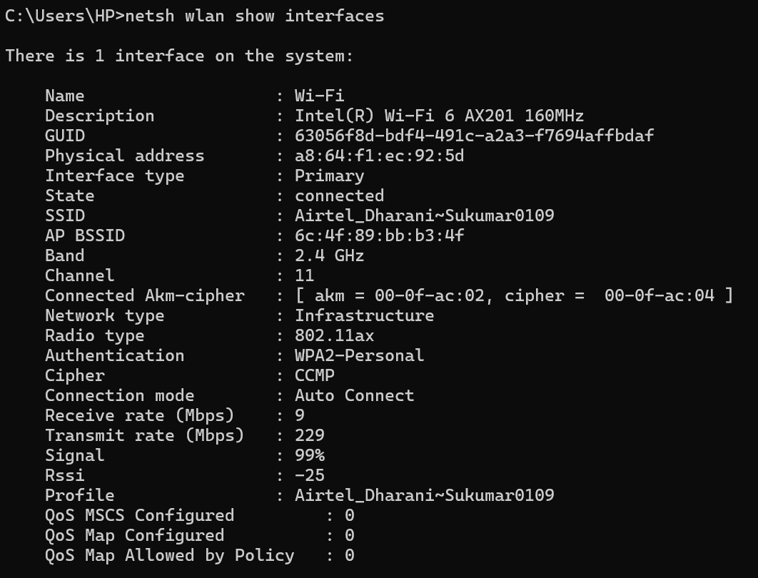
To operate only in 5GHz :
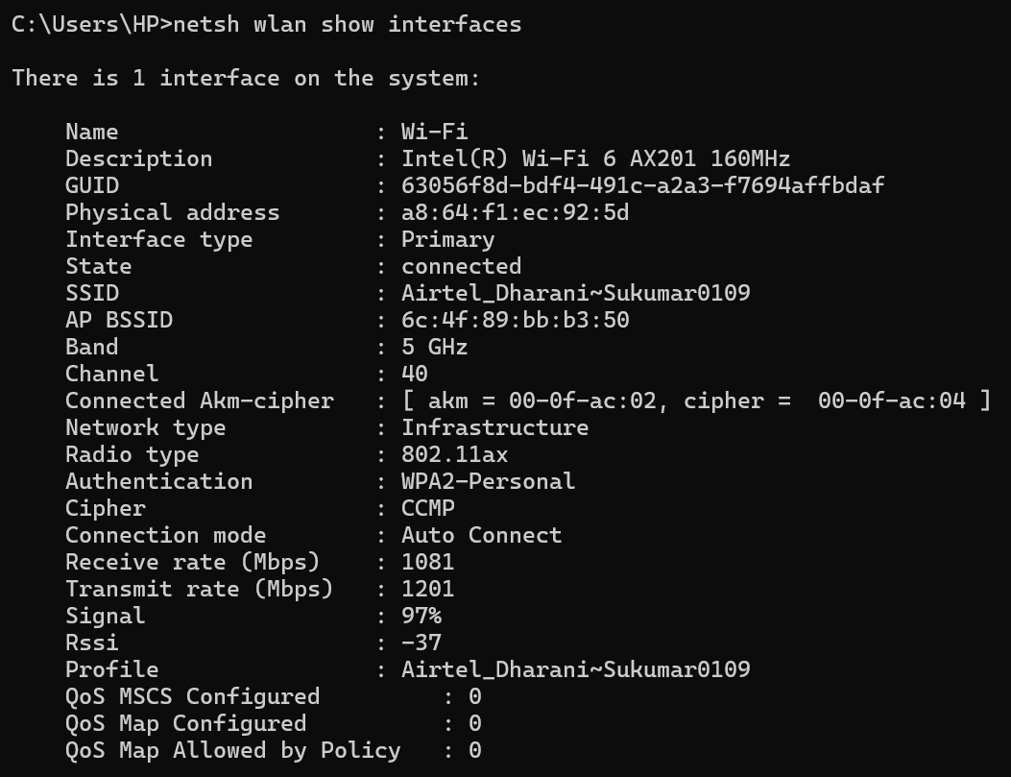

Parameter | 2.4 GHz | 5 GHz | Observation
Band | 2.4 GHz | 5 GHz | Different frequency bands
Channel | (e.g. 6/11 typical) | 40 | 5 GHz has more channel options
Radio Type | 802.11ax | 802.11ax | Same standard (Wi-Fi 6)
Receive Rate | ~229 Mbps | ~1081 Mbps | 5 GHz much faster
Transmit Rate | ~229 Mbps | ~1201 Mbps | 5 GHz higher throughput
Signal Strength | ~95% | ~97% | Both strong (close to router)
RSSI | ~-55 dBm | ~-50 dBm | 5 GHz slightly stronger here
Authentication | WPA2-Personal | WPA2-Personal | Same security
Cipher | CCMP (AES) | CCMP (AES) | Same encryption
Network Type | Infrastructure | Infrastructure | Same
QoS | Not configured | Not configured | Same

- What is the difference between IEEE and WFA.
IEEE (Institute of Electrical and Electronics Engineers)
Creates technical standards.
Example: IEEE 802.11 . It defines :
PHY layer (radio, modulation)
MAC layer (frame format, access rules)
Protocol behavior
WFA (Wi-Fi Alliance)
Certifies devices
Ensures devices from different brands work together
It does :
Testing & certification
Branding Wi-Fi 4, Wi-Fi 5, Wi-Fi 6
Security programs (WPA2, WPA3)

Feature | IEEE | Wi-Fi Alliance (WFA)
Type | Standards body | Industry consortium
Main role | Defines standards | Certifies products
Output | Technical documents | Wi-Fi CERTIFIED logo
Example work | 802.11ax (Wi-Fi 6 spec) | Tests routers/phones
Focus | How Wi-Fi works | Ensures interoperability
Users | Engineers, researchers | Manufacturers, consumers

Work Flow :
- IEEE creates standard (802.11)
- Companies build devices
- WFA tests & certifies devices
- Consumers use reliable Wi-Fi products

- List down the type of Wi-Fi internet connectivity backhaul, share your home/college's wireless internet connectivity backhaul name and its properties.
Backhaul is the connection between Wi-Fi router/AP and the ISP network (internet).
Device ))) Wi-Fi → Router/AP → Backhaul → ISP → Internet
Types of Wi-Fi Backhaul
1. Fiber Optic (FTTH – Fiber to the Home)
Medium: Optical fiber
Speed: Very high (100 Mbps to multi-Gbps)
Latency: Very low
Reliability: Excellent
Most modern homes use this
2. Cable / Coax (DOCSIS)
Medium: TV coaxial cable
Speed: High (up to 1 Gbps)
Latency: Moderate
Used in cable TV networks
3. Cellular (4G / 5G)
Medium: Mobile network (SIM-based)
Speed: Variable (10 Mbps – 1 Gbps)
Portability: High
Used in hotspots, dongles
4. Satellite
Medium: Satellite communication
Speed: Moderate
Latency: High
Used in remote/rural areas
5. DSL (Digital Subscriber Line)
Medium: Telephone copper wires
Speed: Low
Latency: Higher
Mostly outdated
6. Fixed Wireless / Microwave
Medium: Point-to-point wireless link
Used for:
Rural broadband
Campus connectivity
Home wireless internet connectivity backhaul name and its properties :
Provider : Airtel
Backhaul Type : Fiber Optic (FTTH)
Property | Value
Medium | Optical Fiber
Speed | 100 Mbps+ (plan dependent)
Latency | Low (~5–20 ms)
Reliability | High
Interference | Very low
Usage | Home broadband

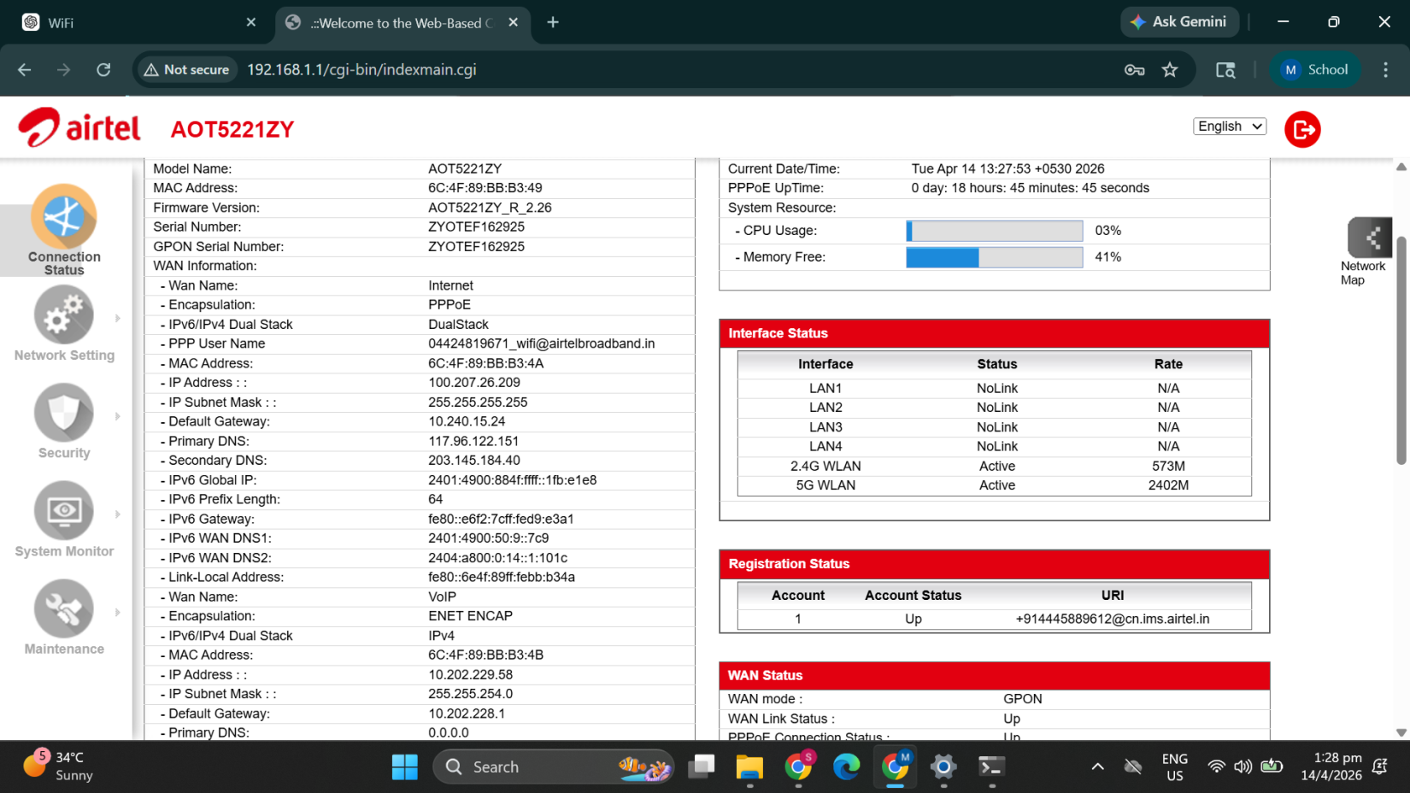
Key fields:
WAN mode: GPON
Encapsulation: PPPoE
PPPoE username: airtelbroadband
IPv4/IPv6 Dual Stack
Public IP address present
These confirm:
Backhaul type is Fiber Optic (FTTH – GPON)

- List down the Wi-Fi topologies and use cases of each one.
Wi-Fi topologies (based on IEEE 802.11) describe how devices and access points are arranged and communicate.
1. Infrastructure Mode (BSS / ESS)
Devices connect to an Access Point (AP)
Most common topology
Types :
BSS → Single AP
ESS → Multiple APs (roaming)
Use cases : Home Wi-Fi, Offices and Colleges
2. Repeater Mode (Range Extender)
Extends coverage of existing Wi-Fi
Receives and retransmits signal
Use cases : Large homes, Areas with weak signal and Dead zone elimination
3. Bridge Mode
Connects two networks wirelessly
Works like a link between LANs
Use cases : Building-to-building connection, Office to/from warehouse and Campus links

4. Mesh Topology
Multiple APs connected together
Self-healing and dynamic routing
Features :
Seamless roaming
No single point of failure
Use cases : Smart homes, Large offices , Hotels, malls
5. Ad-hoc Mode (IBSS)
Devices connect directly (peer-to-peer)
No access point
Use cases : Temporary file sharing, Quick device-to-device communication
6. Mobile Hotspot Mode - Phone acts as Access Point
Use cases : Sharing mobile data, Travel / emergency internet
7. Workgroup Bridge Mode
Connects wired devices to Wi-Fi
One device acts as bridge
Use cases : Printer without Wi-Fi, Old PCs in wireless network
8. IoT Gateway Topology - Gateway connects IoT protocols to Wi-Fi
Use cases : Smart home systems, Industrial IoT

