**Develop a JSP script to retrieve and display the user registration form details on a web page**

**EX-8.**

**display.jsp**

<%@ page language="java" contentType="text/html; charset=UTF-8" pageEncoding="UTF-8"%>

<!DOCTYPE html>

<html>

<head>

<meta charset="UTF-8">

<title>Registration Details</title>

</head>

<body>

<h2>Submitted Registration Details</h2>

<%

String username = request.getParameter("username");

String password = request.getParameter("password");

String name = request.getParameter("name");

String creditcard = request.getParameter("creditcard");

String email = request.getParameter("email");

String phone = request.getParameter("phone");

%>

<p><strong>User Name:</strong> <%= username %></p>

<p><strong>Password:</strong> <%= password %></p>

<p><strong>Name:</strong> <%= name %></p>

<p><strong>Credit Card Number:</strong> <%= creditcard %></p>

<p><strong>Email:</strong> <%= email %></p>

<p><strong>Phone Number:</strong> <%= phone %></p>

<br>

<a href="index.html">Go Back to Registration</a>

</body>

</html>

**Index.html:**

<!DOCTYPE html>

<html lang="en">

<head>

<meta charset="UTF-8">

<title>User Registration Form</title>

</head>

<body>

<h2>User Registration</h2>

<form action="display.jsp" method="post">

  <label for="username">User Name:</label>

  <input type="text" id="username" name="username" required><br><br>

  <label for="password">Password:</label>

  <input type="password" id="password" name="password" required><br><br>

  <label for="name">Name:</label>

  <input type="text" id="name" name="name" required><br><br>

  <label for="creditcard">Credit Card Number:</label>

  <input type="text" id="creditcard" name="creditcard" required pattern="\d{13,16}" title="Enter 13 to 16 digit card number"><br><br>

  <label for="email">Email:</label>

  <input type="email" id="email" name="email" required><br><br>

  <label for="phone">Phone Number:</label>

  <input type="tel" id="phone" name="phone" required pattern="\d{10}" title="Enter 10 digit phone number"><br><br>

  <input type="submit" value="Register">

  <input type="reset" value="Reset">

</form>

</body>

</html>

**OUTPUT:**

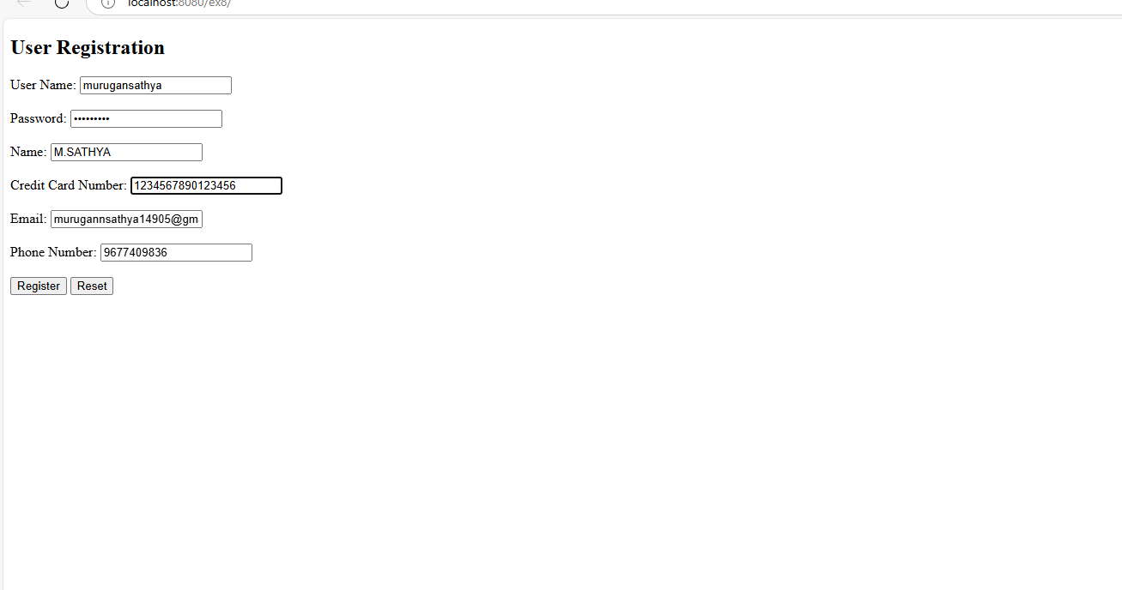

  
  
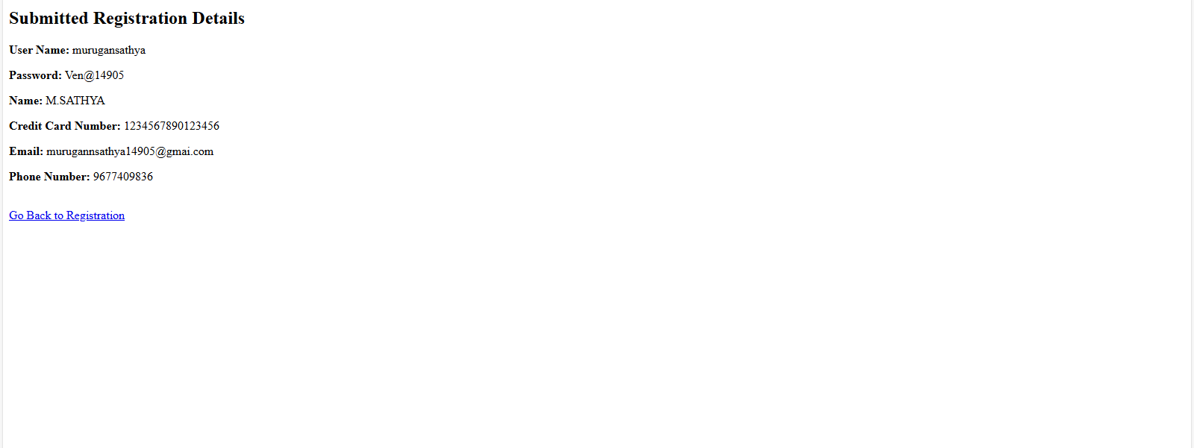

Bottom of Form