TRIP DATA ANALYSIS

**Topics covered:**

1. **Mongo DB Installation**
2. **Python Packages Installation:**
3. **Postman**
4. **Performance metrics**

**Installation Steps:**

**Mongo DB Installation:**

1. Install Mongo DB Community edition. Use below link.

<https://www.mongodb.com/try/download/community>

1. MongoDBCompass will be installed as part of step 1. Launch Mongo Compass and use it.

Here MongoDBCopass is used to interact with MongoDB and query development

Connection string to connect to locally hosted MongoDB - mongodb://localhost:27017

1. Once connection is established create a database. Click on create database and collection

Screenshot (1)

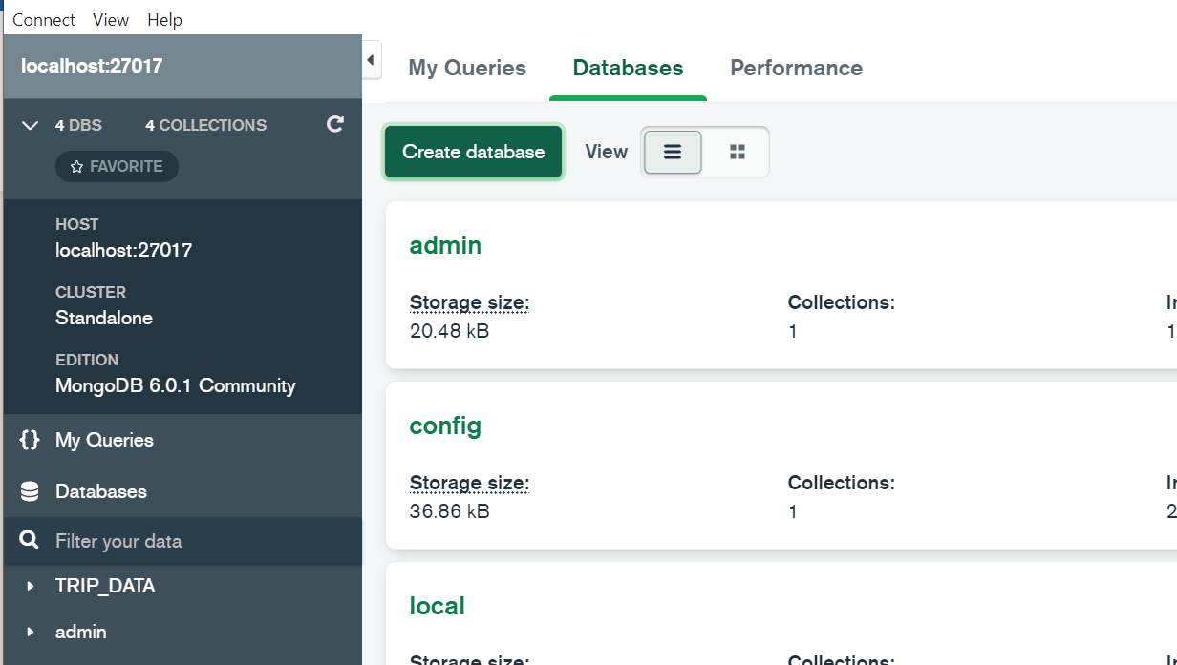

Screenshot (2)

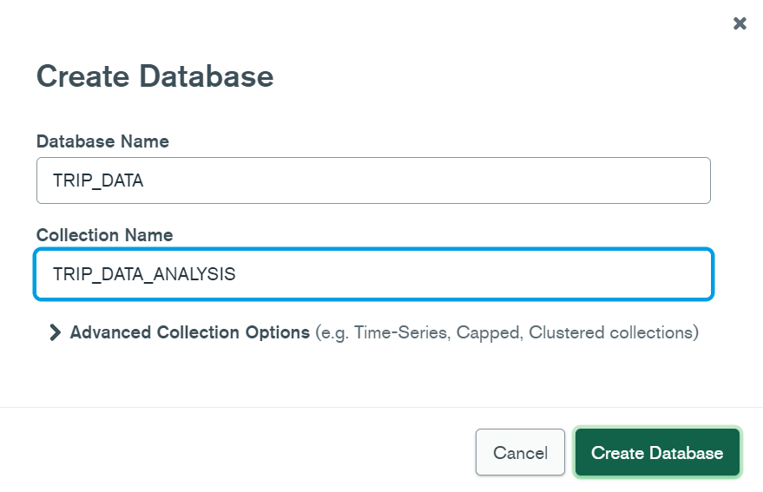

1. Once database & collection is created, insert data to collection.

Click ADD DATA. Then Import File. Browse trip_data.csv file from local and import it.

Please refer below screenshot

**Note:** Please make sure to change datatype of tpep_pickup_datetime to DATE, tip_amount to double, total_amount to DOUBLE datatype. By default everything will be loaded as string datatype

**Python Packages Installation:**

1. Download TripData_Analysis folder.
2. cd TripData_Analysis. pip install -r requirements.txt
3. Once package are installed run trip_data_analysis.py –
4. Now Navigate to code folder. cd code
5. python trip_data_analysis.py

This is the main script. Once script is launched successfully you will see below output.

1. Now application is up and running in port 5051 and it is hosted in local

**Postman:**

In postman use below curl command to hit our application.

curl --location --request POST 'http://127.0.0.1:5051/trip_data_analysis' \  
--header 'Content-Type: application/json' \  
--data-raw '{  
 "DB_NAME": "TRIP_DATA",  
 "COLLECTION_NAME": "TRIP_DATA_ANALYSIS"  
}'

Below is the postman response

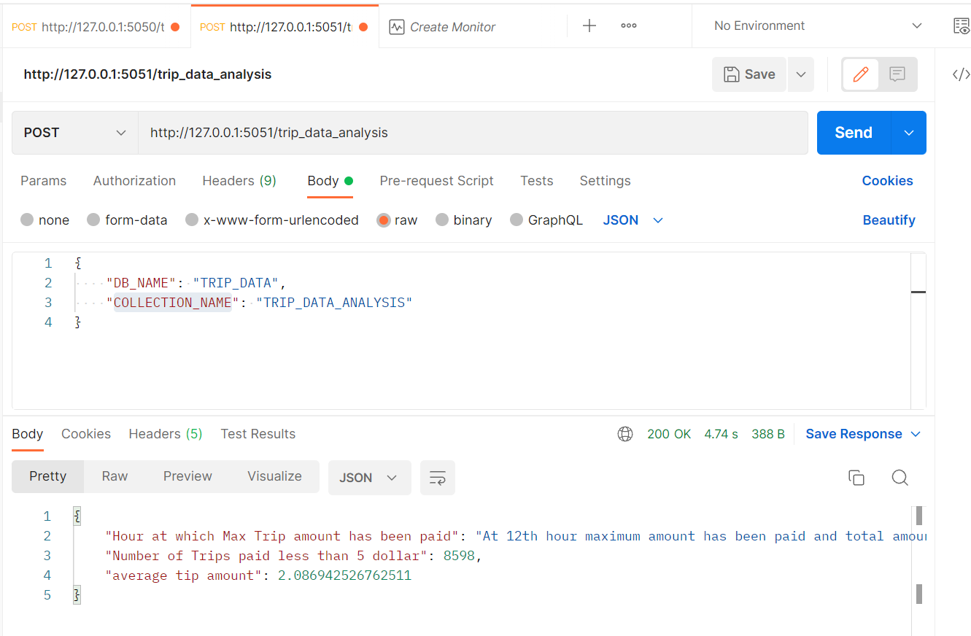

**Performance Metrics:**

Approximately it takes 3.4seconds to query 1million documents and retrieve below response.

|  |  |
| --- | --- |
| Run | Time Taken |
| 1st Run | 4.09 |
| 2nd Run | 2.94 |
| 3rd Run | 4.40 |
| 4th Run | 2.94 |
| 5th Run | 2.91 |

On an average it takes 3.4 seconds to get response