Week 3 Day 1 Assignment
Implement playwright/typescript with vibe coding

Prompt used:
Analyse my entire code base for selenium java (Feature file, Page class, Feature + Page class)
Go step by step
Once up on my approval than proceed with next step
Give me the files in which implementation is done
Proceed with Playwright Typescript implementation
Start in Ask mode
Model: Claude Haiku 4.5
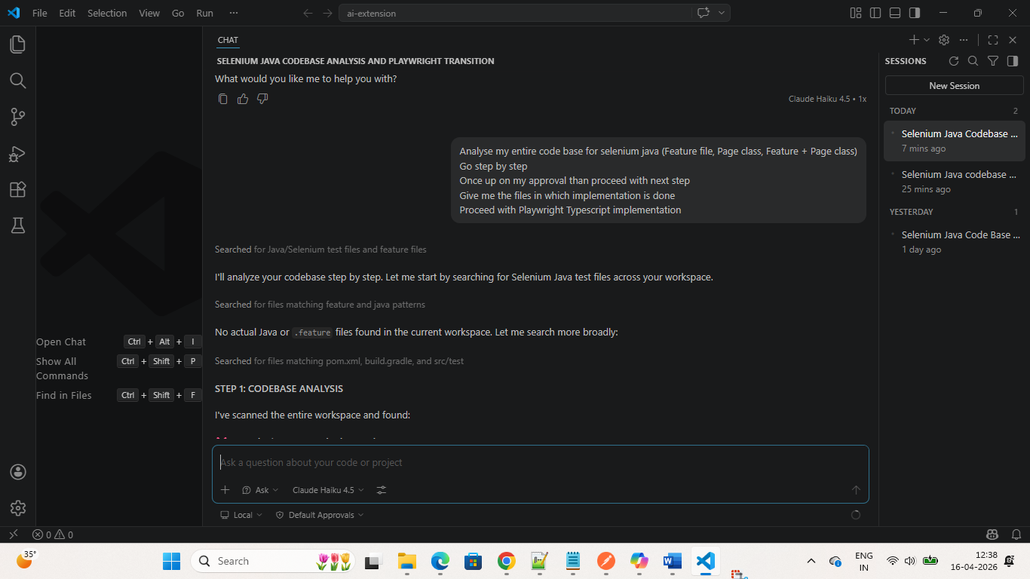

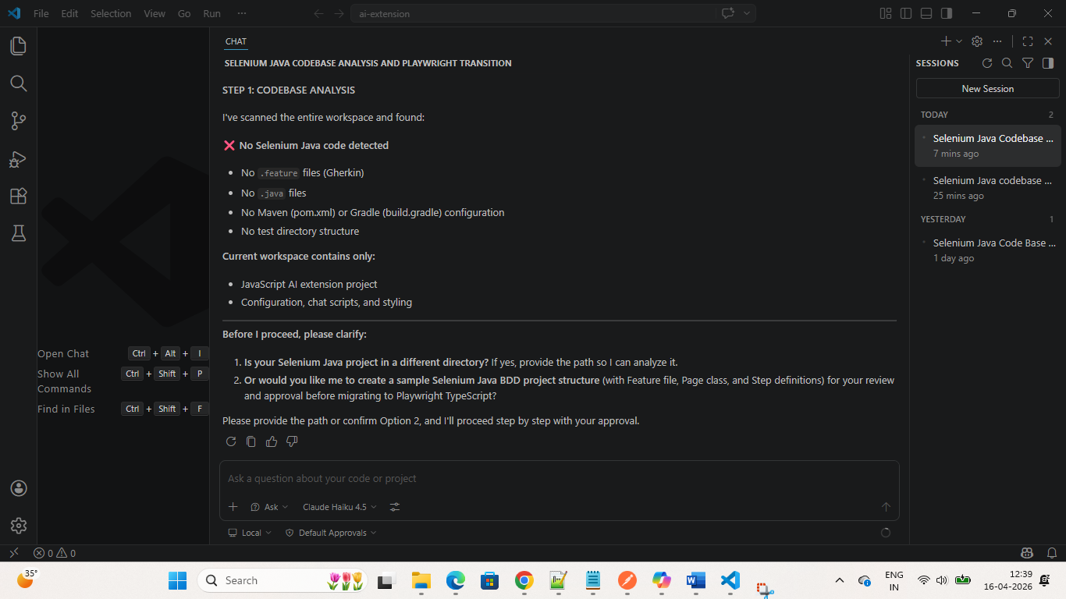
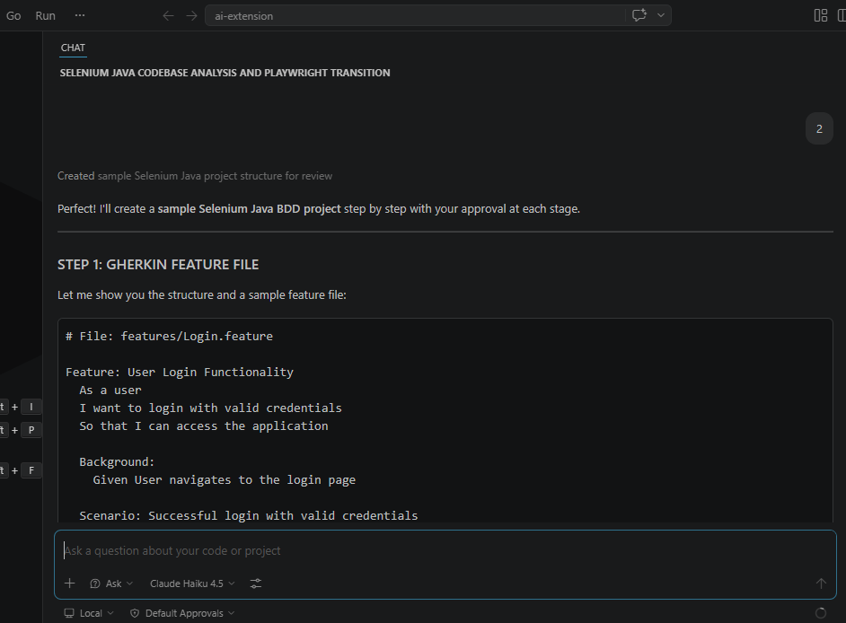
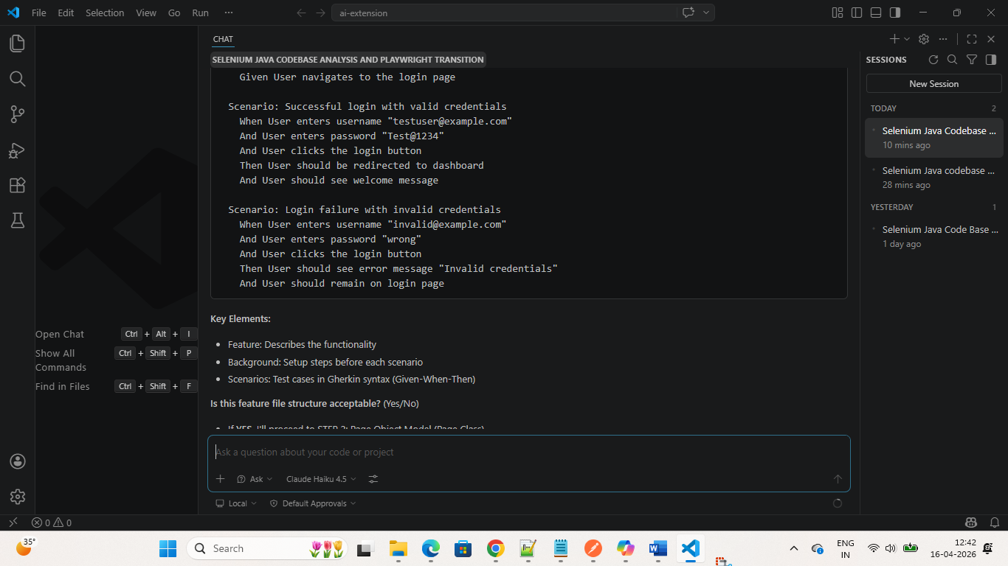
Code Analysis Completed and the code page is below (POM)
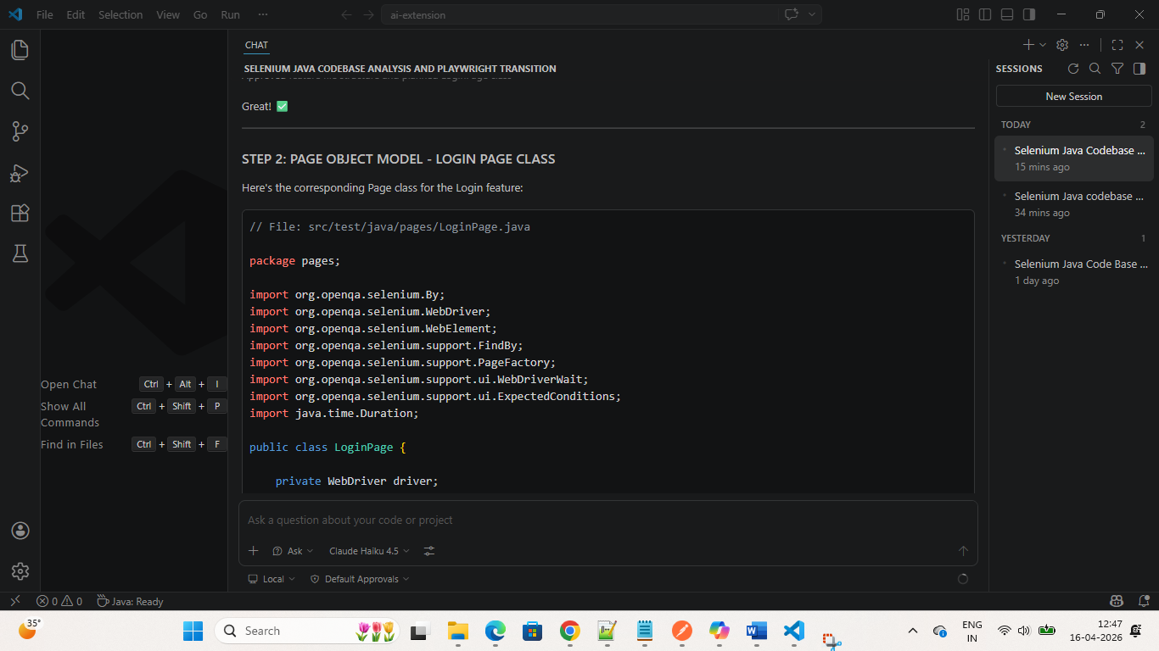
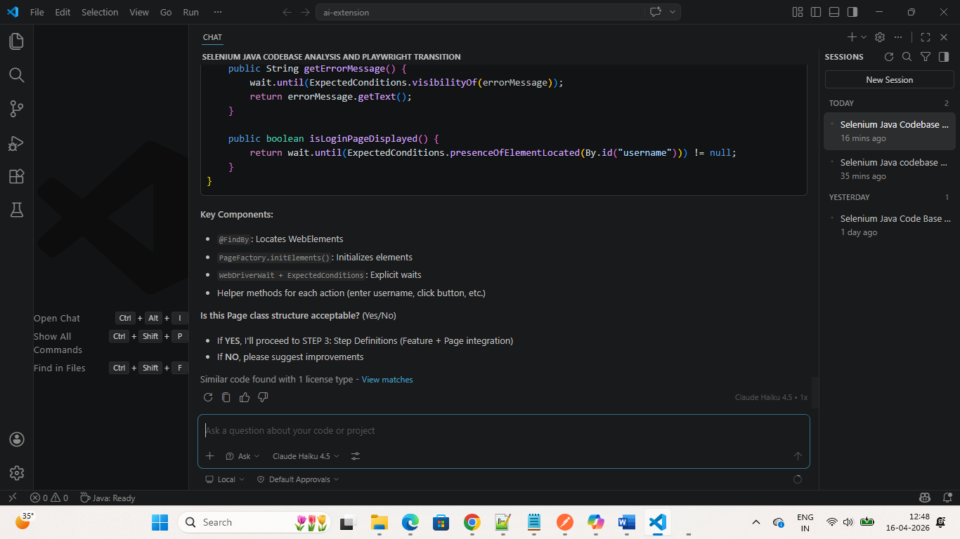
Feature file
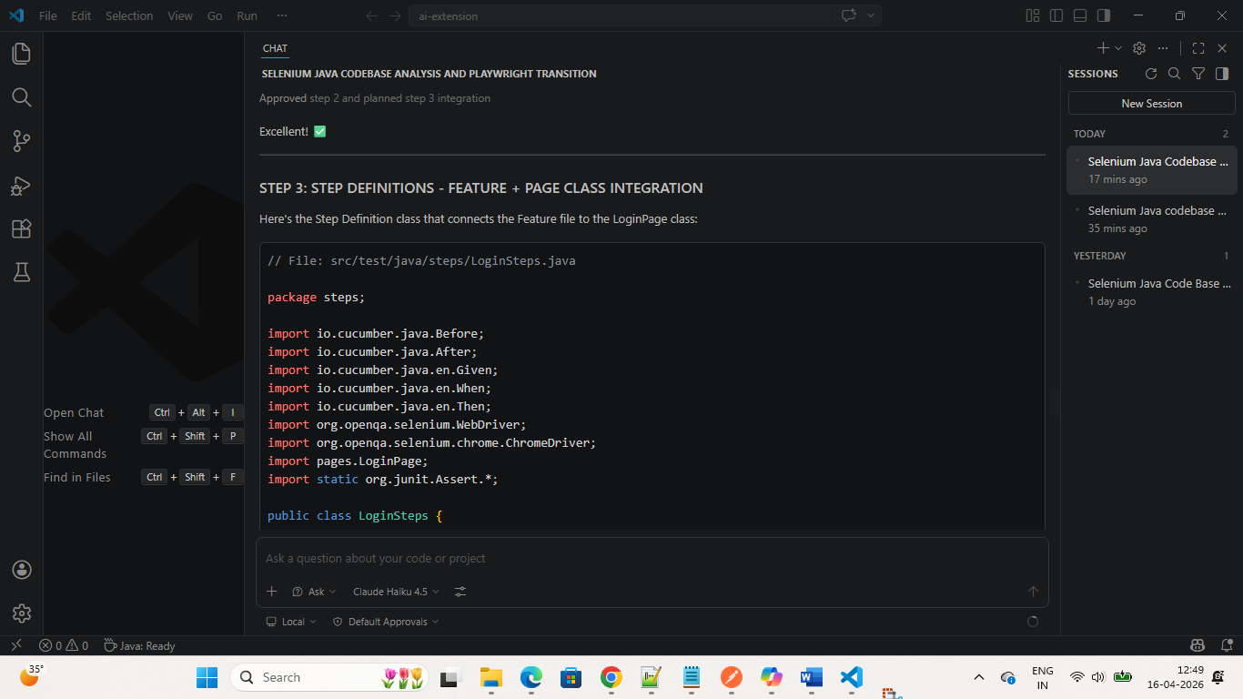
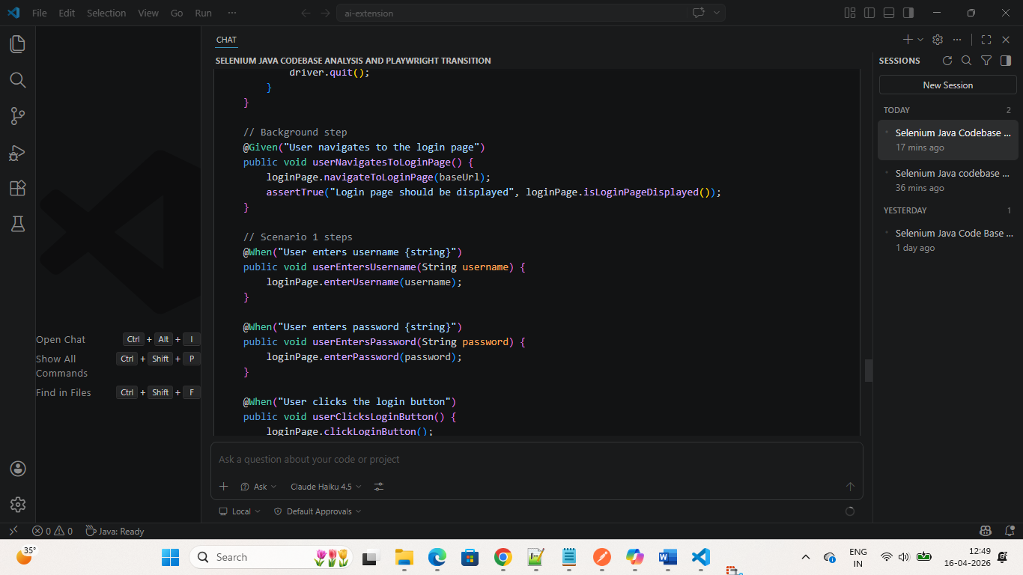
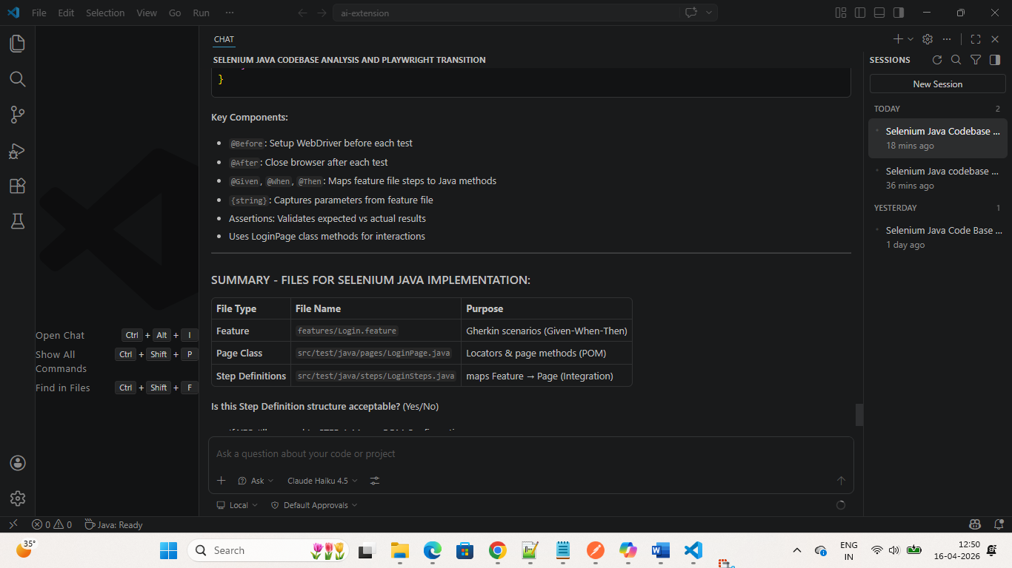
Dependency configuration
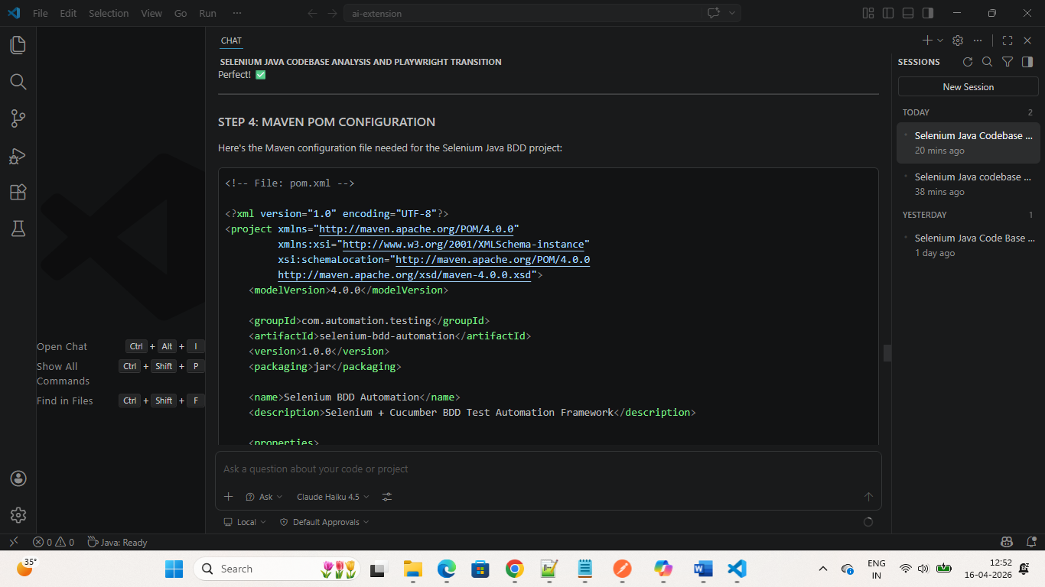
Project Structure:
