Enterprise Knowledge Intelligence Platform with Hybrid Relational, Document, and Vector Data Architecture
A Project Based Learning Report Submitted in partial fulfilment of the requirements for the award of the degree

of

Bachelor of Technology
in The Department of Artificial Intelligence and Data Science
Database Systems Engineering and Distributed Backend Development (25CS1302E)

Submitted by
2510080006: M. Sathya Krishna
2510080001: Yashwanth
2510080005: Aneeq
2510080002: Abhinav

Under the guidance of
Anitha. P



Department of Artificial Intelligence and Data Science
Koneru Lakshmaiah Education Foundation, Aziz Nagar
Aziz Nagar – 500075
OCT - 2026.
Abstract
Organisations keep their knowledge in policies, reports and manuals that are hard to find by keyword alone, and every result must respect who may read it. The Enterprise Knowledge Intelligence Platform (EIP) stores each kind of data in the database that suits it: PostgreSQL holds users, roles, permissions and document metadata in a normalised schema; MongoDB holds document text, chunks and flexible metadata; and Qdrant holds 384-dimensional embeddings of every chunk for search by meaning.
A Spring Boot REST API, secured with JSON Web Tokens and role-based access control, joins the three stores. Users upload PDF, Word, text or Markdown files; the server extracts the text, splits it into chunks, embeds them and writes all three databases, undoing earlier writes if a later one fails. Search fuses a keyword leg that tolerates typing mistakes with a semantic leg, and filters every result by one document-level permission rule.
The system passes 191 backend tests against containerised databases, 148 frontend tests, a 28-check smoke test and a 50-user load test (169 requests per second, no errors). On a 315-document corpus, semantic search found the remote-working policy for “working from home rules”, which shares no keyword with it, and real Word-generated PDF and DOCX files were extracted and made searchable in about two seconds. The platform runs on free hosting: Vercel, Render, Neon, MongoDB Atlas and Qdrant Cloud.
Keywords: polyglot persistence, PostgreSQL, MongoDB, Qdrant, vector search, text extraction, Spring Boot, JWT, role-based access control

List of Figures
Figure 1: Three-tier architecture of the platform 7
Figure 2: Entity-relationship diagram of the PostgreSQL schema (crow’s-foot notation) 8
Figure 3: One demo document (id 44) as stored in PostgreSQL, MongoDB and Qdrant 9
Figure 4: Text extraction: checks, one extractor per format, and the error returned at each step 10
Figure 5: Upload pipeline across the three databases, with compensating actions on failure 10
Figure 6: Authorisation checks on every request, and the response when one fails 11
Figure 7: Hybrid search: two legs, one permission filter, weighted fusion 12
Figure 8: Dashboard with live counts from PostgreSQL and Qdrant (316 documents and 718 vectors, including the uploaded handbook) 15
Figure 9: Hybrid search for “working from home rules”, matched by meaning 16
Figure 10: Upload form with a PDF chosen 16
Figure 11: An uploaded PDF in the viewer: MongoDB text and chunks, extractor pdfbox-3.0 17
Figure 12: User administration (USER_MANAGE only) 18

List of Tables
Table 1: Project modules and their implementation 7
Table 2: PostgreSQL tables 8
Table 3: Roles and their permissions 11
Table 4: Main REST endpoints 11
Table 5: Test results 13
Table 6: Upload checks with real files 13
Table 7: Search results on the 315-document demo corpus 13
Table 8: What each demo user can see 14
Table 9: Performance measurements 14
Table 10: Defects found by testing, and their fixes 14

Table of Contents
1. Introduction 6
2. Methodology 7
a. Requirements and Architecture 7
b. Relational Design in PostgreSQL 8
c. Document Model in MongoDB and Vectors in Qdrant 9
d. Text Extraction for PDF, Word, Text and Markdown 9
e. Keeping Three Databases Consistent 10
f. API and Security 11
g. Hybrid Search 12
h. Frontend and Deployment 12
3. Experiments 12
4. Results 13
5. Conclusion and Future Work 18
References 18

Enterprise Knowledge Intelligence Platform with Hybrid Relational, Document, and Vector Data Architecture

Introduction
Every organisation produces documents its people later need to find: HR policies, finance procedures, engineering runbooks, legal templates and research notes. Usually they sit in shared drives, and finding one depends on remembering its exact words. An employee who asks “what are the rules for working from home?” finds nothing if the policy is titled Hybrid and Remote Working Standard. At the same time, salary guidelines, contracts and security procedures must reach only the right people; even a leaked title in a search result is a breach.
No single database serves all of this well. A relational database [2], [3] is the right home for users, roles, permissions and metadata, where constraints and transactions enforce the rules. Long, variable document text with flexible metadata suits a document database. Finding passages that mean something close to a question needs vector embeddings and approximate nearest-neighbour search [4], [5]. Using several databases, each for what it does best, is polyglot persistence [1]; its cost is keeping the databases consistent without a transaction that spans them.
Problem statement. Build an enterprise knowledge platform that stores, organises and retrieves documents using relational, document and vector databases together; accepts common office formats; finds documents by keyword, approximate spelling and meaning; never shows a user a document they may not read; and keeps the three databases consistent as documents are added and removed.
Approach. The platform gives each database one job and links them through a single key, the PostgreSQL document id. Uploaded files are turned into plain text on the server, split into overlapping chunks and embedded, so a policy can be found by what it says, not only by its title. All writes go through one service that can undo them, and all reads pass one permission rule, so correctness and security do not depend on each endpoint getting the details right.
Objectives.
- Design a normalised (3NF) PostgreSQL schema for identity, roles, permissions, metadata, versions, grants and search history, with constraints and indexes.
- Model document content in MongoDB with schema validation and indexes, linked to PostgreSQL by id.
- Extract text from PDF, Word (.docx), text and Markdown uploads safely.
- Store chunk embeddings in Qdrant and support semantic and hybrid search.
- Secure the REST API with JWT, BCrypt, role permissions and per-document grants, applied on every endpoint.
- Keep the three databases consistent on upload and delete, then containerise, test and deploy on free hosting.
Scope. The project is Project 1 of the course portfolio and covers its five modules: user and role management, the knowledge repository, document and semantic search, REST APIs with authentication, and deployment, testing and documentation. Evaluation uses a demo corpus of 315 English documents in six categories. Section 2 describes the design, Section 3 the experiments and Section 4 the results; Section 5 concludes.

Methodology

Requirements and Architecture
Employees search and read documents they may access; managers can also upload and share their own documents; administrators read everything and manage accounts. Table 1 maps the handbook’s modules to what was built, and Figure 1 shows the three tiers.
Table 1: Project modules and their implementation
Handbook module | Implementation
1. User and role management | Users, roles, permissions and junction tables; admin page to create users, change roles, disable accounts, reset passwords
2. Knowledge repository | Metadata and versions in PostgreSQL, text and chunks in MongoDB; PDF, DOCX, TXT and MD upload; paged, filtered repository; delete
3. Document and semantic search | Hybrid, semantic, keyword and fuzzy modes; MiniLM embeddings in Qdrant; per-user search history
4. REST API and authentication | Spring Boot REST API; JWT sign-in; BCrypt; permission-based access; per-document grants
5. Deployment, testing, documentation | Docker images and Compose; 191 backend and 148 frontend tests; smoke and load tests; live on free hosting

The React frontend is served by Vercel, which also forwards /api to the backend, so the browser talks to one origin. The Spring Boot backend authenticates each request, applies the business rules and talks to PostgreSQL through JPA, to MongoDB through Spring Data and to Qdrant over gRPC. The embedding model runs inside the backend through ONNX Runtime, so no model server is needed.
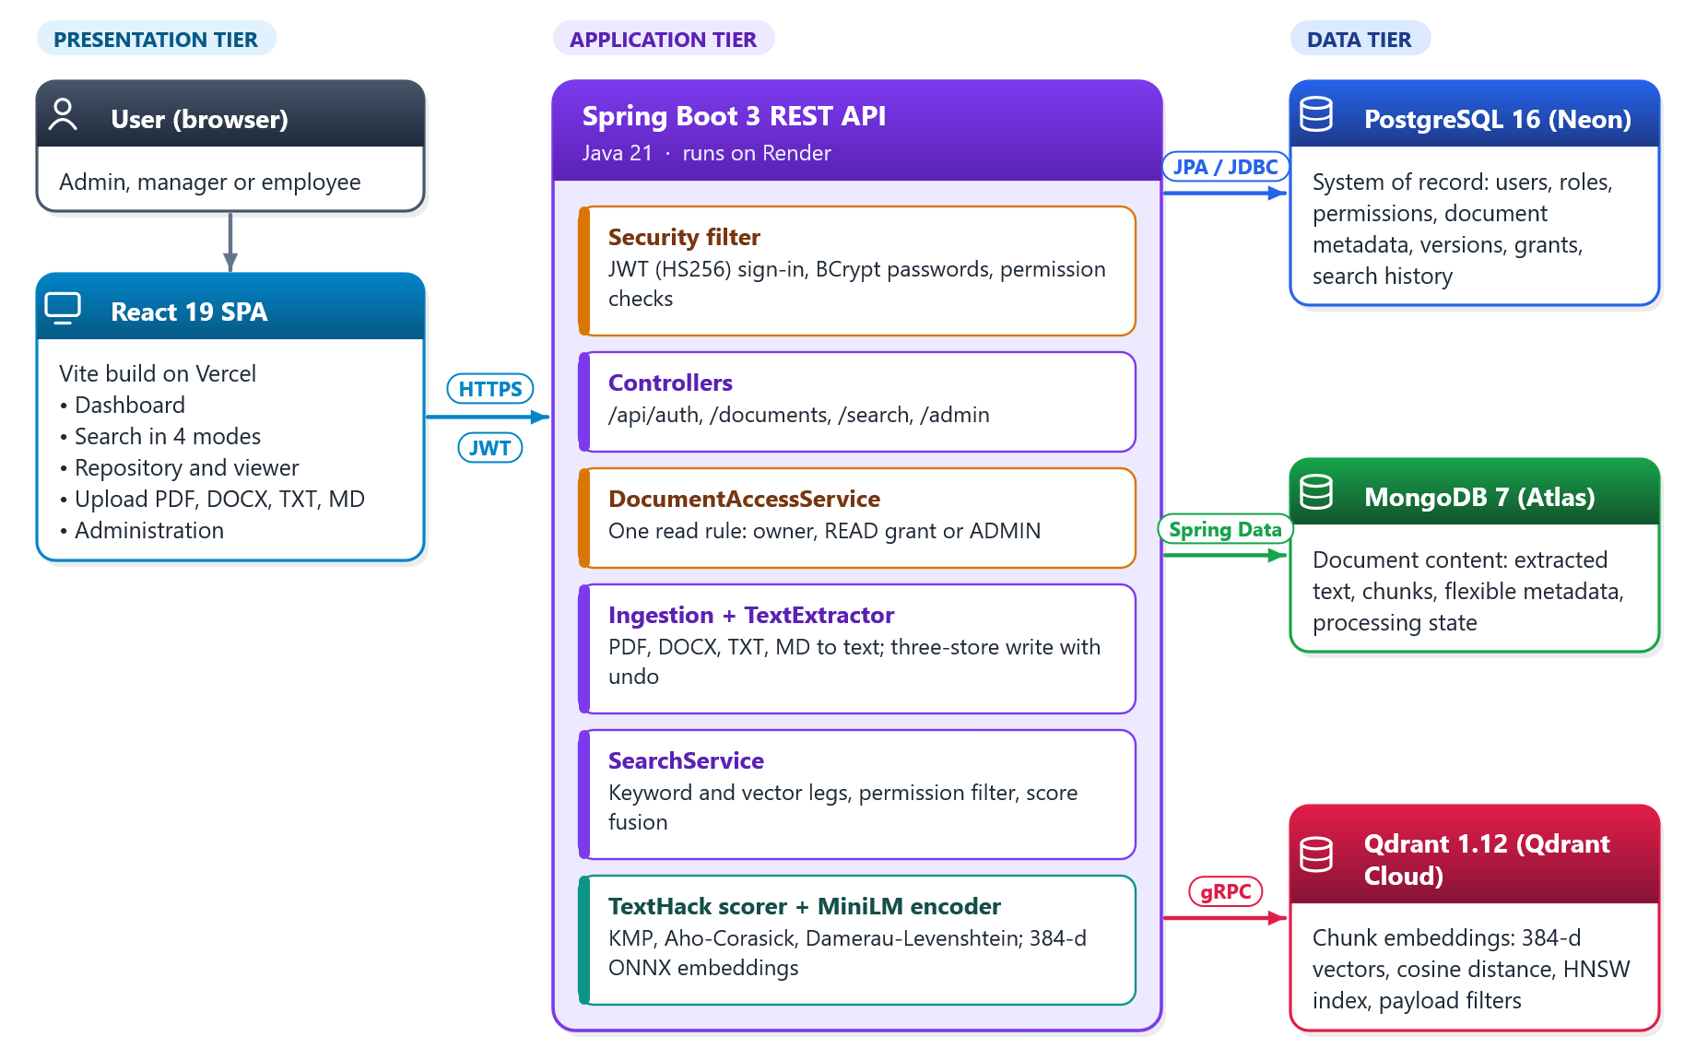
Figure 1: Three-tier architecture of the platform

Relational Design in PostgreSQL
PostgreSQL is the system of record: it decides who exists, what they may do and which documents exist. Its twelve tables (Figure 2, Table 2) resolve the two many-to-many relationships (users–roles, roles–permissions) through junction tables with composite keys, and give each document a category, an owner, versions, tags, grants and search history.
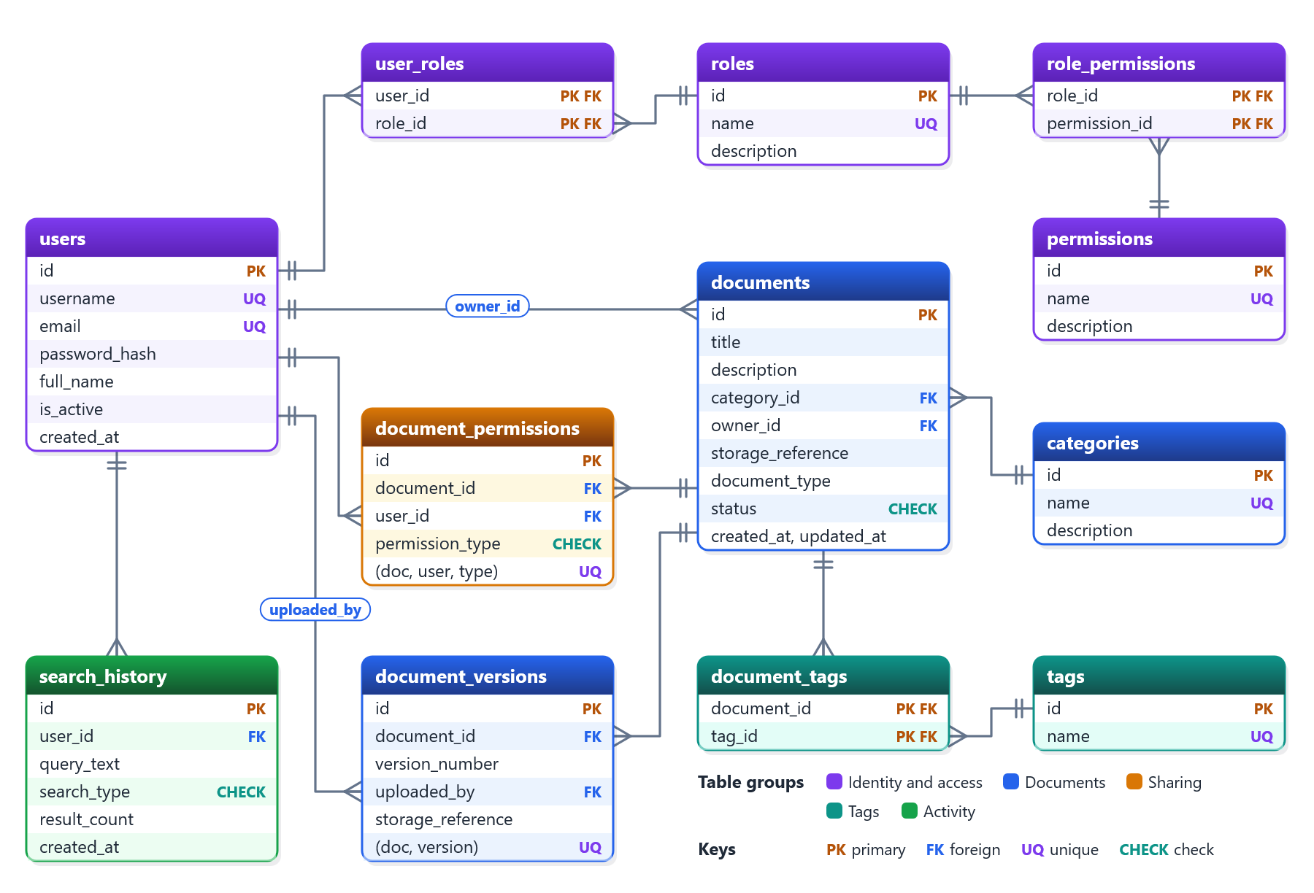
Figure 2: Entity-relationship diagram of the PostgreSQL schema (crow’s-foot notation)
Table 2: PostgreSQL tables
Table | Purpose | Key constraints
users | Accounts | UNIQUE username, email; BCrypt hash; is_active
roles, permissions | ADMIN, MANAGER, EMPLOYEE and permission names | UNIQUE name
user_roles, role_permissions | Many-to-many links | Composite PK; ON DELETE CASCADE
categories | Document categories | UNIQUE name
documents | Metadata and the link to the content | FKs to category and owner (SET NULL); CHECK status
document_versions | Version history | UNIQUE (document, version); CASCADE
tags, document_tags | Labels | UNIQUE name; composite PK
document_permissions | Per-user grants | CHECK type; UNIQUE (document, user, type)
search_history | Each user’s searches | CHECK search_type; CASCADE on user

Normalisation and integrity. Every table is in third normal form: a document stores category_id, not the category name, and roles reach permissions through role_permissions instead of repeating them per user [3], [7]. The database enforces the rules itself: UNIQUE stops duplicate users and grants, CHECK limits statuses, grant types and search modes, and foreign-key actions decide what a deletion does (versions, tags and grants cascade with their document; a deleted owner leaves documents in place). Ten secondary indexes cover the frequent lookups, and schema changes are versioned migrations.

Document Model in MongoDB and Vectors in Qdrant
MongoDB’s knowledge_documents collection holds one document per PostgreSQL row, linked by postgres_document_id [8]. A $jsonSchema validator requires the link, title, content, source, processing and version fields but leaves metadata open. Chunks are embedded in their document because they are always read and written with it. Nine indexes include a unique index on the link and a text index on the title and body.
Qdrant’s knowledge_chunks collection stores one 384-dimensional all-MiniLM-L6-v2 vector [5], [6] per chunk, with cosine distance and an HNSW index (m = 16, ef_construct = 100) [4], [9]. Each point’s payload carries the PostgreSQL id, chunk id, category and status. Figure 3 shows one real document in all three stores.
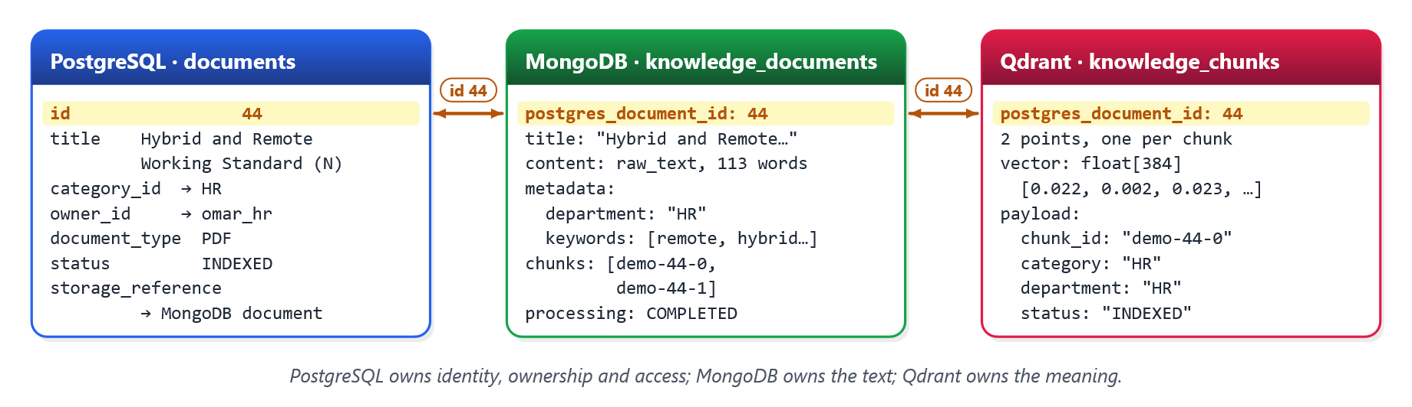
Figure 3: One demo document (id 44) as stored in PostgreSQL, MongoDB and Qdrant

Text Extraction for PDF, Word, Text and Markdown
Uploads accept .pdf, .docx, .txt and .md files of up to 10 MB (Figure 4). PDFs are read with Apache PDFBox in reading order. A .docx file is a zip of XML parts, so the server reads word/document.xml with the JDK’s own zip and StAX parsers, adding no dependency; DTDs and external entities are disabled, so a crafted file cannot make the server fetch or expand anything (XXE), and unzipping stops at 64 MB to defeat zip bombs. Text files must be valid UTF-8. The result is normalised and capped at 1 MB of text. Every failure returns a specific 400 or 413 message, and scanned PDFs, which hold images rather than text, are reported as needing OCR. MongoDB records which extractor produced the text (pdfbox-3.0, docx-xml-1.0 or utf8-text-1.0).
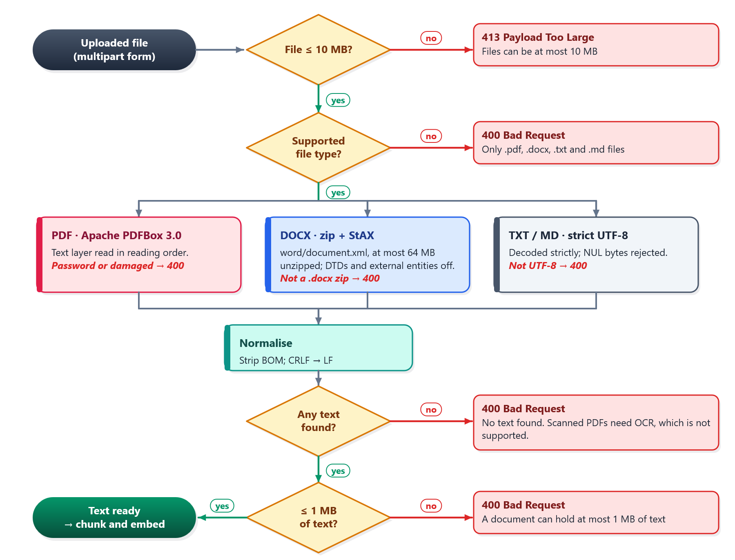
Figure 4: Text extraction: checks, one extractor per format, and the error returned at each step

Keeping Three Databases Consistent
No transaction spans PostgreSQL, MongoDB and Qdrant, so an upload is an ordered series of local writes, each with an undo, in the manner of sagas [10] (Figure 5). PostgreSQL is written first because it issues the id the others reference; the text is cut into 180-word chunks with a 40-word overlap and saved to MongoDB; a version row is added; chunks are embedded and upserted to Qdrant; and the status is set. A failure after step 2 removes the earlier writes in reverse order. Deletion runs Qdrant first, so an unreachable Qdrant fails the request before anything is removed. Under the CAP trade-off [11] search favours availability: without Qdrant it falls back to keyword results and says so.
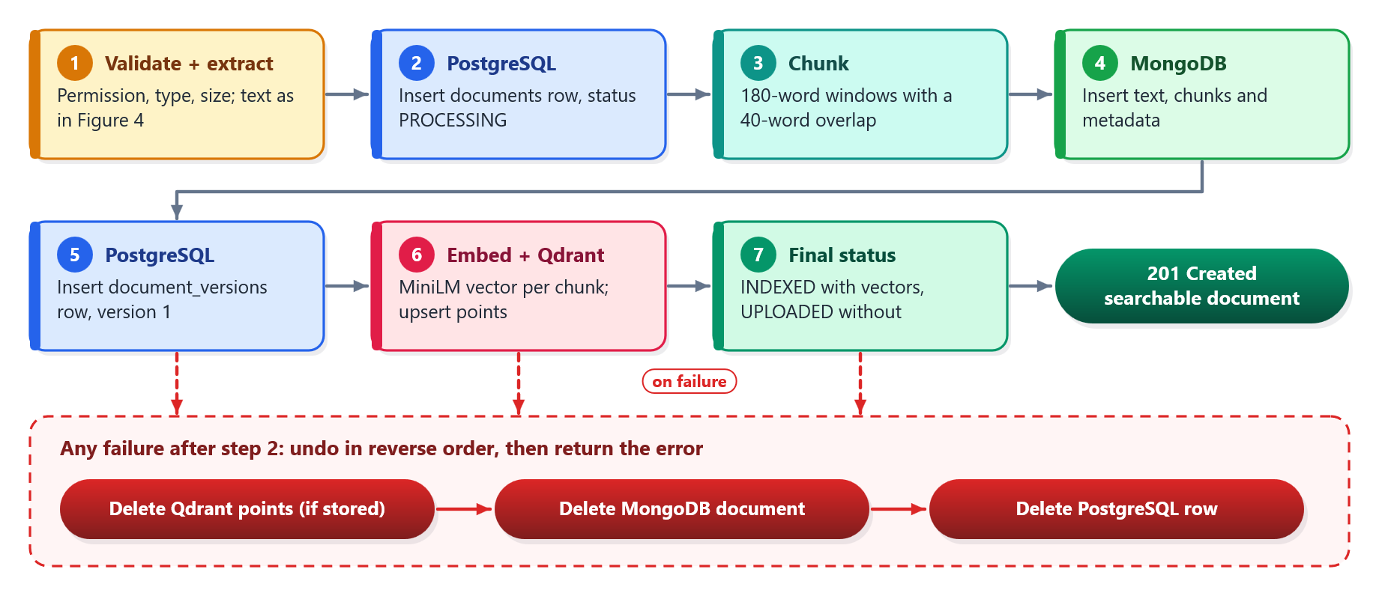
Figure 5: Upload pipeline across the three databases, with compensating actions on failure

API and Security
Controllers, services and Spring Data repositories form the backend layers [12]. Passwords are BCrypt hashes [14]; sign-in returns an HS256 JWT valid for 24 hours [13]. Figure 6 shows the checks on every request. A token is rejected as soon as its account is disabled. Endpoints require permissions, not role names (Table 3), and one rule in DocumentAccessService decides document reads: owner, READ grant or administrator. Search applies it before ranking, so even result counts never reveal hidden documents. Table 4 lists the main endpoints.
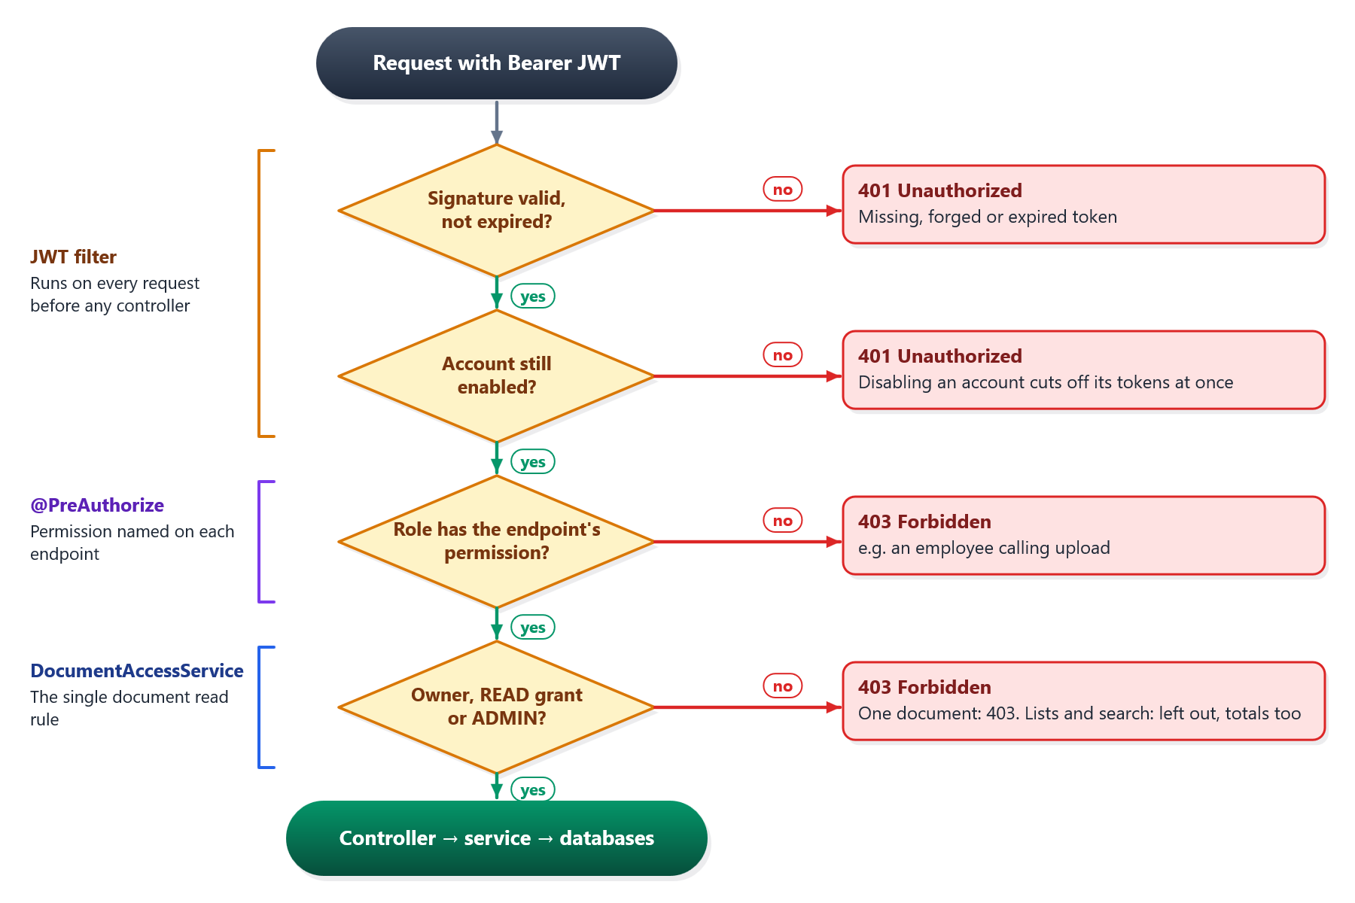
Figure 6: Authorisation checks on every request, and the response when one fails
Table 3: Roles and their permissions
Role | Permissions | Can do
ADMIN | DOCUMENT_CREATE, _READ, _UPDATE, _DELETE, USER_MANAGE, ROLE_MANAGE | Everything; reads every document
MANAGER | DOCUMENT_CREATE, DOCUMENT_READ, DOCUMENT_UPDATE | Upload; read own and shared documents; share own
EMPLOYEE | DOCUMENT_READ | Read own and shared documents

Table 4: Main REST endpoints
Method and path | Purpose | Requires
POST /api/auth/login | Sign in, receive a JWT | Public
GET /api/documents/page | Paged, filtered readable documents | DOCUMENT_READ
GET /api/documents/{id} | PostgreSQL metadata + MongoDB text and chunks | Read access
POST /api/documents | Upload PDF, DOCX, TXT or MD (multipart) | DOCUMENT_CREATE
DELETE /api/documents/{id} | Delete from all three databases | DOCUMENT_DELETE
GET, POST, DELETE /api/documents/{id}/permissions | List, grant, revoke READ access | Owner or USER_MANAGE
POST /api/search | Unified search in four modes | Signed in; filtered
GET, POST, PATCH /api/admin/users | Manage accounts | USER_MANAGE

Hybrid Search
A search names a mode (hybrid, semantic, keyword or fuzzy) and optional filters (Figure 7). The keyword leg scores PostgreSQL candidates with the TextHack scorer from the Data Structures course: Knuth-Morris-Pratt for the whole phrase [15], Aho-Corasick for all terms in one pass [16] and Damerau-Levenshtein distance for typos [17]. The vector leg embeds the query with the same MiniLM model and asks Qdrant for the nearest chunks. After the permission filter, hits are merged per document and scored as score = (0.4 × keyword + 0.6 × (cosine + 1) / 2) ÷ the weights of the legs that ran. Each hit reports how it matched, and every search is saved to the user’s history.
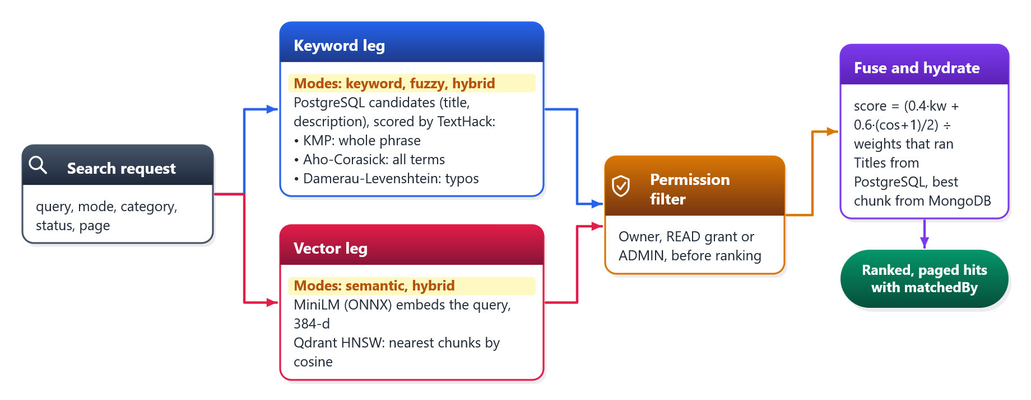
Figure 7: Hybrid search: two legs, one permission filter, weighted fusion

Frontend and Deployment
The React 19 frontend provides the dashboard, search, repository, document viewer, upload and administration pages, and shows only actions the user’s permissions allow; the backend enforces every rule again. Both tiers ship as Docker images [18] and run locally with Compose. In production everything is on free plans: Vercel, Render (512 MB, 0.1 CPU), Neon, MongoDB Atlas and Qdrant Cloud. Fitting the backend and model into 512 MB took a 128 MB heap, one ONNX thread, 16 request threads and 4 database connections.

Experiments
Integration tests run against a pinned, self-seeding stack (PostgreSQL 16.6, MongoDB 7.0.14, Qdrant 1.12.4) whose health checks wait for the seed data. A larger demo stack holds 315 documents in six categories, 705 chunk vectors, 14 users and 60 grants. The backend is tested with JUnit 5, MockMvc and Spring Security test support: unit tests use stubs (fusion, upload rollback, chunking, text extraction, the lexical scorer, embedding parity), and integration tests call the real endpoints on live databases and clean up after themselves. GitHub Actions runs the suite on every backend change. The frontend uses Vitest. On the demo stack, on 6 October 2026, we also ran:
- Upload checks: real files, including a 20-page PDF and DOCX produced by Word, plus damaged, password-protected, image-only and oversized files, sent over HTTP.
- Search checks: the same queries in different modes, including one with no shared words and one with three typos.
- Access checks: short-lived test tokens for eight users, recording what each could list, search and open.
- Smoke and load tests: 28 end-to-end checks through nginx, and 50 users for 30 s with the backend capped at 1 GB; plus a run at Render’s free-tier limits.

Results
Table 5: Test results
Suite | Result
Backend, JUnit 5 (unit + integration on live databases) | 191 passed: 187 in GitHub Actions, plus 4 demo-corpus tests run locally
Frontend, Vitest (16 files) | 148 passed
Smoke test through nginx | 28 / 28 passed
Load test, 50 users for 30 s | 169 requests/s, 0 errors

Uploads (Table 6). Real PDF and Word files were extracted, chunked, embedded and ranked first by semantic search for questions about their content. Every faulty file got the intended message, including the 413 size limit, which only a real HTTP upload can exercise.
Table 6: Upload checks with real files
File | Result
20-page report PDF made by Word, with images and tables (2.2 MB) | 201, INDEXED: 5,005 words, 36 chunks, 2.1 s
The same report as Word .docx (3.1 MB) | 201, INDEXED: 4,913 words, 35 chunks, 1.2 s
Course handbook PDF, 9 pages | 201, INDEXED: 1,768 words, 13 chunks; ranked first (0.79) for “week-wise development schedule”
Image-only (scanned) PDF | 400: no text found; scanned PDFs need OCR
Password-protected PDF | 400: password-protected PDFs cannot be read
PDF renamed to .docx | 400: not a readable Word (.docx) document
9 MB of random bytes named .pdf | 400: not a readable PDF (passes the size limit)
File just over 10 MB | 413: files can be at most 10 MB

Search (Table 7). Each leg covers what the other cannot. Keyword search alone finds nothing for “working from home rules”; hybrid search ranks the remote-working policy first through its vector leg. Fuzzy search recovers three misspelled words. One limit showed: keyword and fuzzy matching cover titles and descriptions only, so “budgt aproval” finds nothing.
Table 7: Search results on the 315-document demo corpus
Query | Mode | Hits | Top result (score, matched by)
working from home rules | Keyword | 0 | —
working from home rules | Hybrid | 152 | Hybrid and Remote Working Standard (0.42, Semantic)
what to do when the production server is down at night | Semantic | 135 | Incident Response and On-Call Runbook (0.63)
remte workng standrd | Fuzzy | 15 | Hybrid and Remote Working Standard (0.63, Keyword + Fuzzy)
budget planning | Keyword | 15 | Departmental Budget Planning Guidelines (1.00)
budgt aproval | Fuzzy | 0 | — (“approval” is in no title)

Access control (Table 8). The administrator sees all 315 documents; everyone else sees only their own and shared documents, their search totals shrink to match, and only the administrator reaches user administration.
Table 8: What each demo user can see
User | Role | Documents | Hits for “remote working” | /api/admin/users
demo_admin | ADMIN | 315 | 137 | 200
priya_fin | MANAGER | 48 | 7 | 403
dana_hr | MANAGER | 46 | 31 | 403
mei_eng | MANAGER | 31 | 18 | 403
ravi_res | MANAGER | 31 | 7 | 403
marcus_legal | MANAGER | 28 | 18 | 403
nils_admin | EMPLOYEE | 30 | 15 | 403
grace_it | EMPLOYEE | 15 | 15 | 403

Performance and defects (Tables 9 and 10). The load test exposed a lock contended by rebuilding the JWT parser per request; building it once raised throughput from 149 to 181 requests/s. At Render’s free limits the tuned image stays under 512 MB and answers semantic search in under a second.
Table 9: Performance measurements
Measurement | Result
Load test, 50 users, 30 s, backend capped at 1 GB | 169 requests/s, 0 errors
Uncapped, before and after the JWT fix | 149 → 181 requests/s
Semantic search at 512 MB / 0.1 CPU | 0.4–0.9 s (6.5–9.4 s before tuning)
Memory after soak, concurrent searches and an upload | 446 MiB steady, 485 MiB peak

Table 10: Defects found by testing, and their fixes
Defect | Fix
Three read endpoints skipped the permission rule and leaked titles and vector hits | All filter through DocumentAccessService; 7 tests
Cosine scores treated as 0–1, so fused scores could go negative | Map with (cos + 1) / 2
Status filter ignored on vector hits | Filter on PostgreSQL status after merging
A disabled user’s token worked for up to 24 hours | Accept tokens only for enabled accounts
JWT parser rebuilt per request, queuing threads | Build it once at start-up

User interface. Figures 8 to 12 show the application on the demo corpus with the real backend.
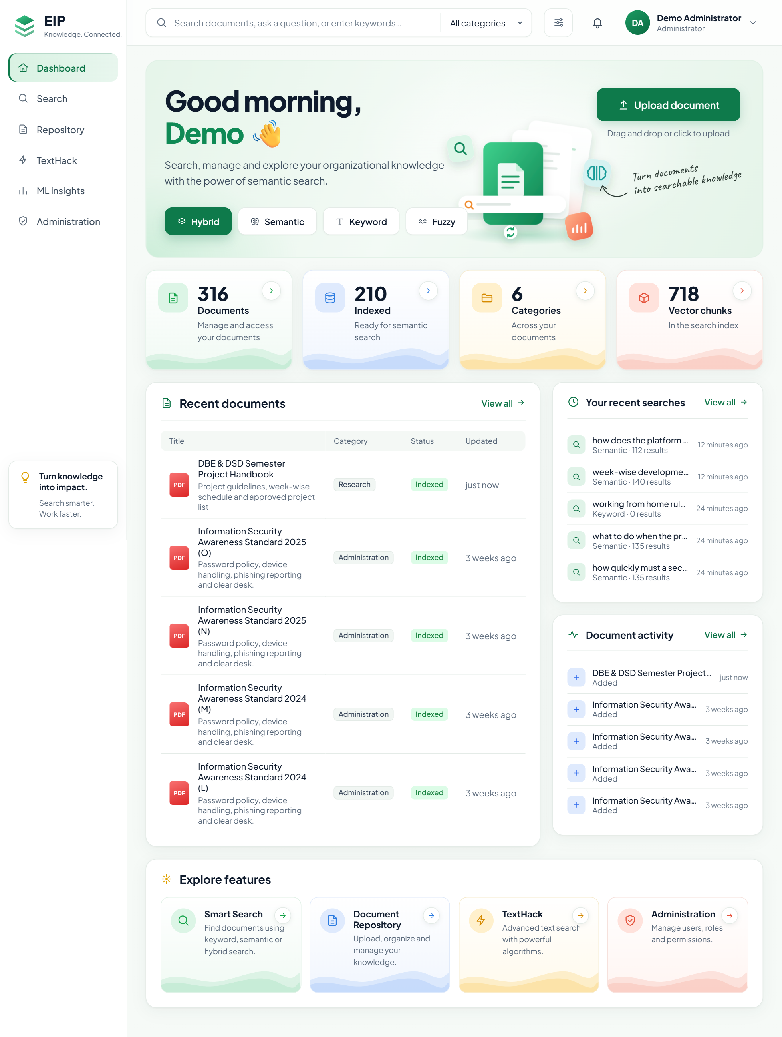
Figure 8: Dashboard with live counts from PostgreSQL and Qdrant (316 documents and 718 vectors, including the uploaded handbook)
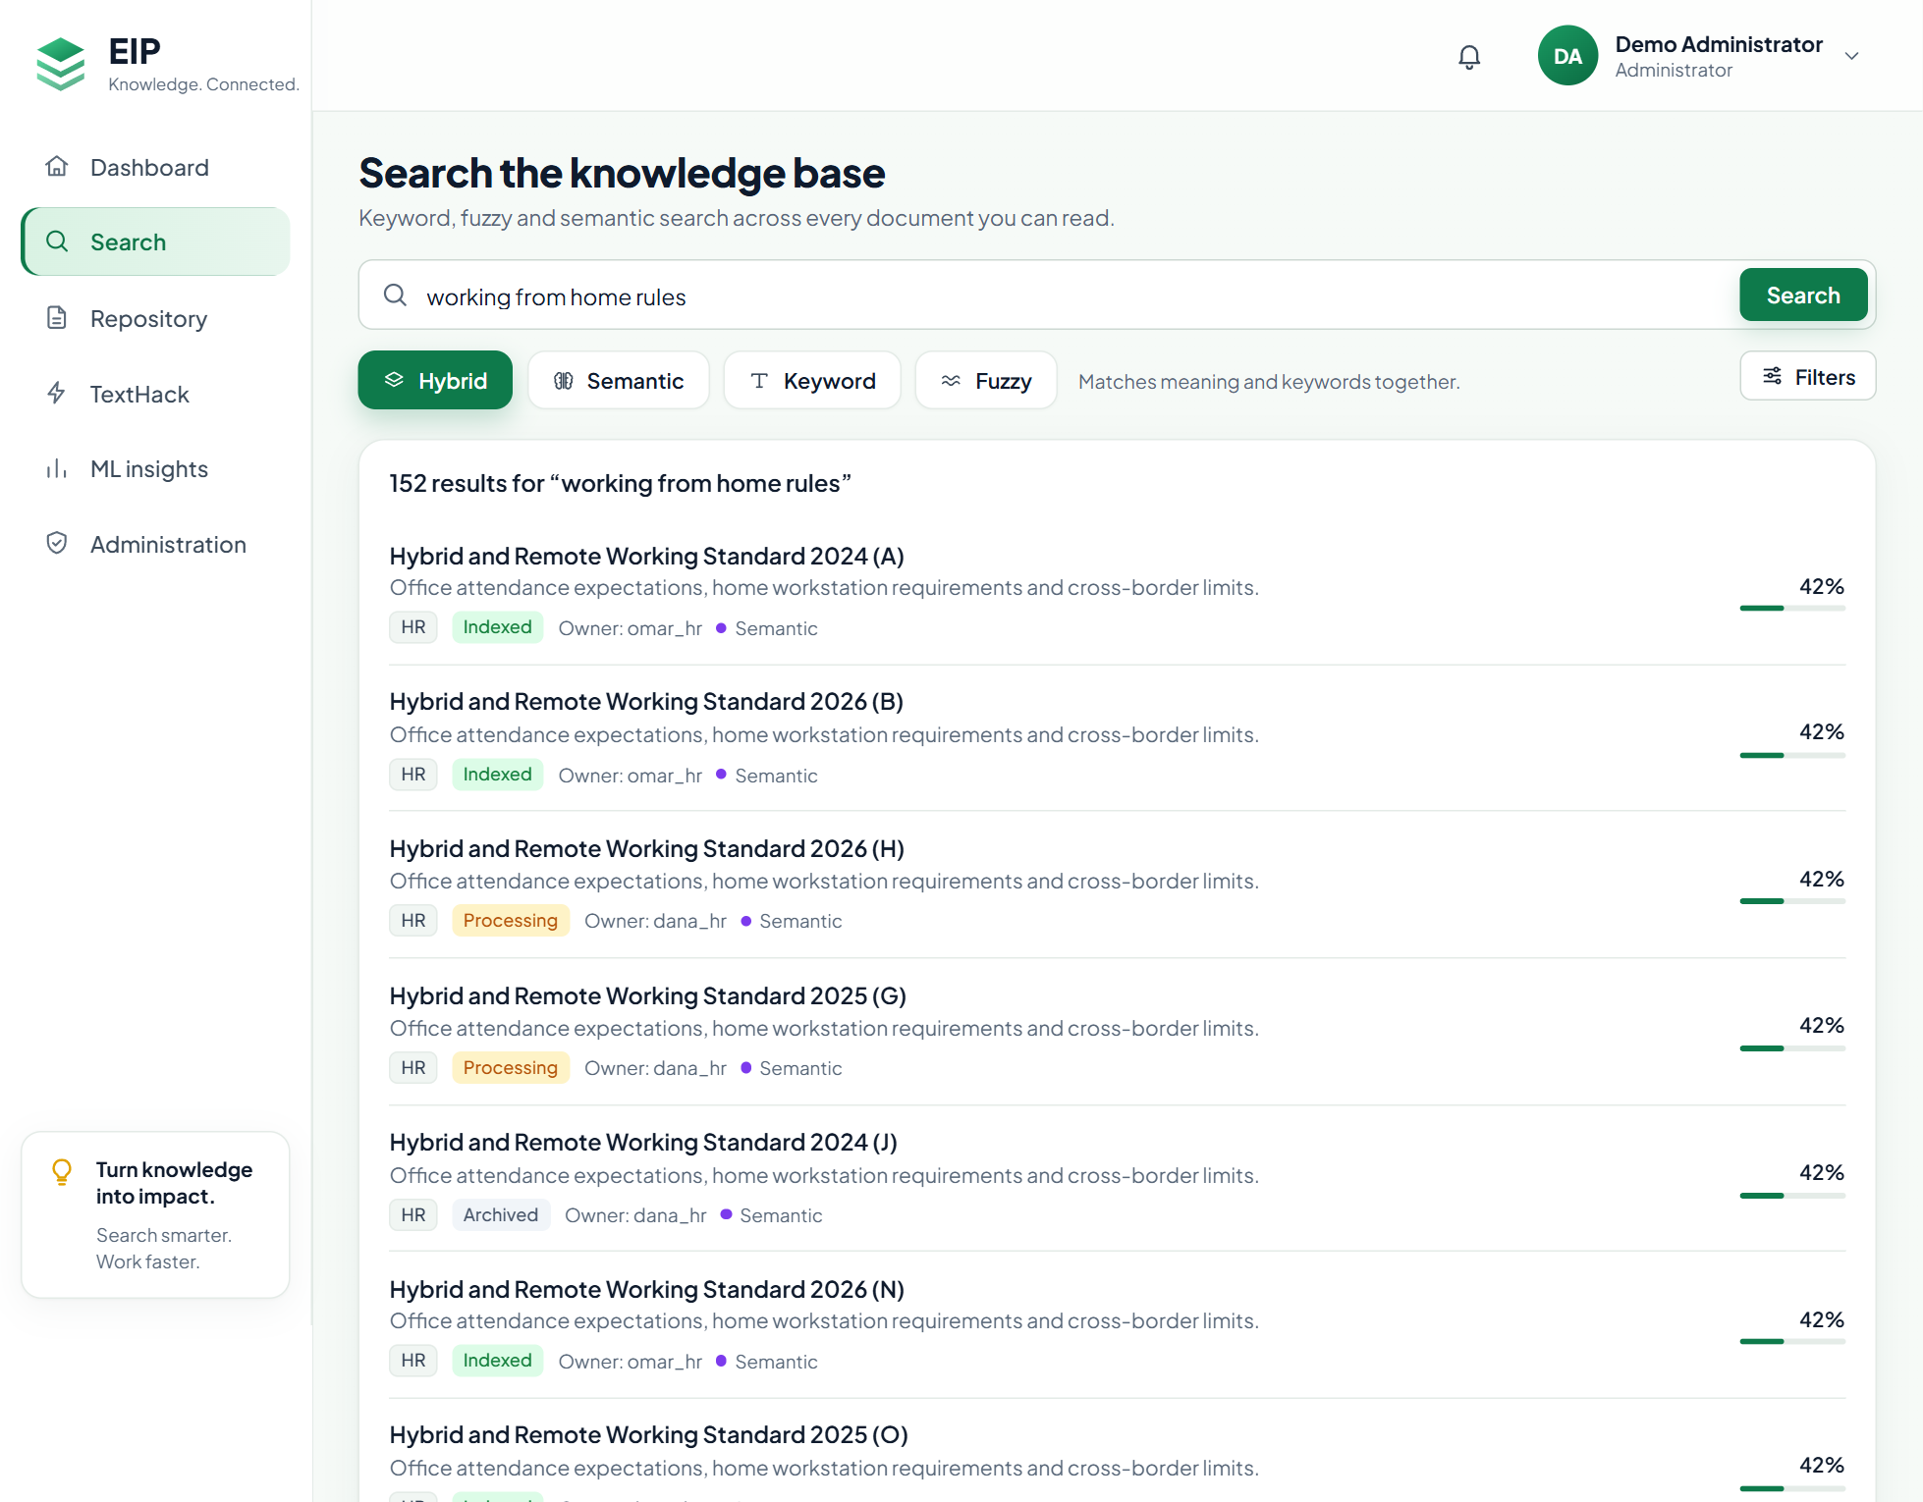
Figure 9: Hybrid search for “working from home rules”, matched by meaning
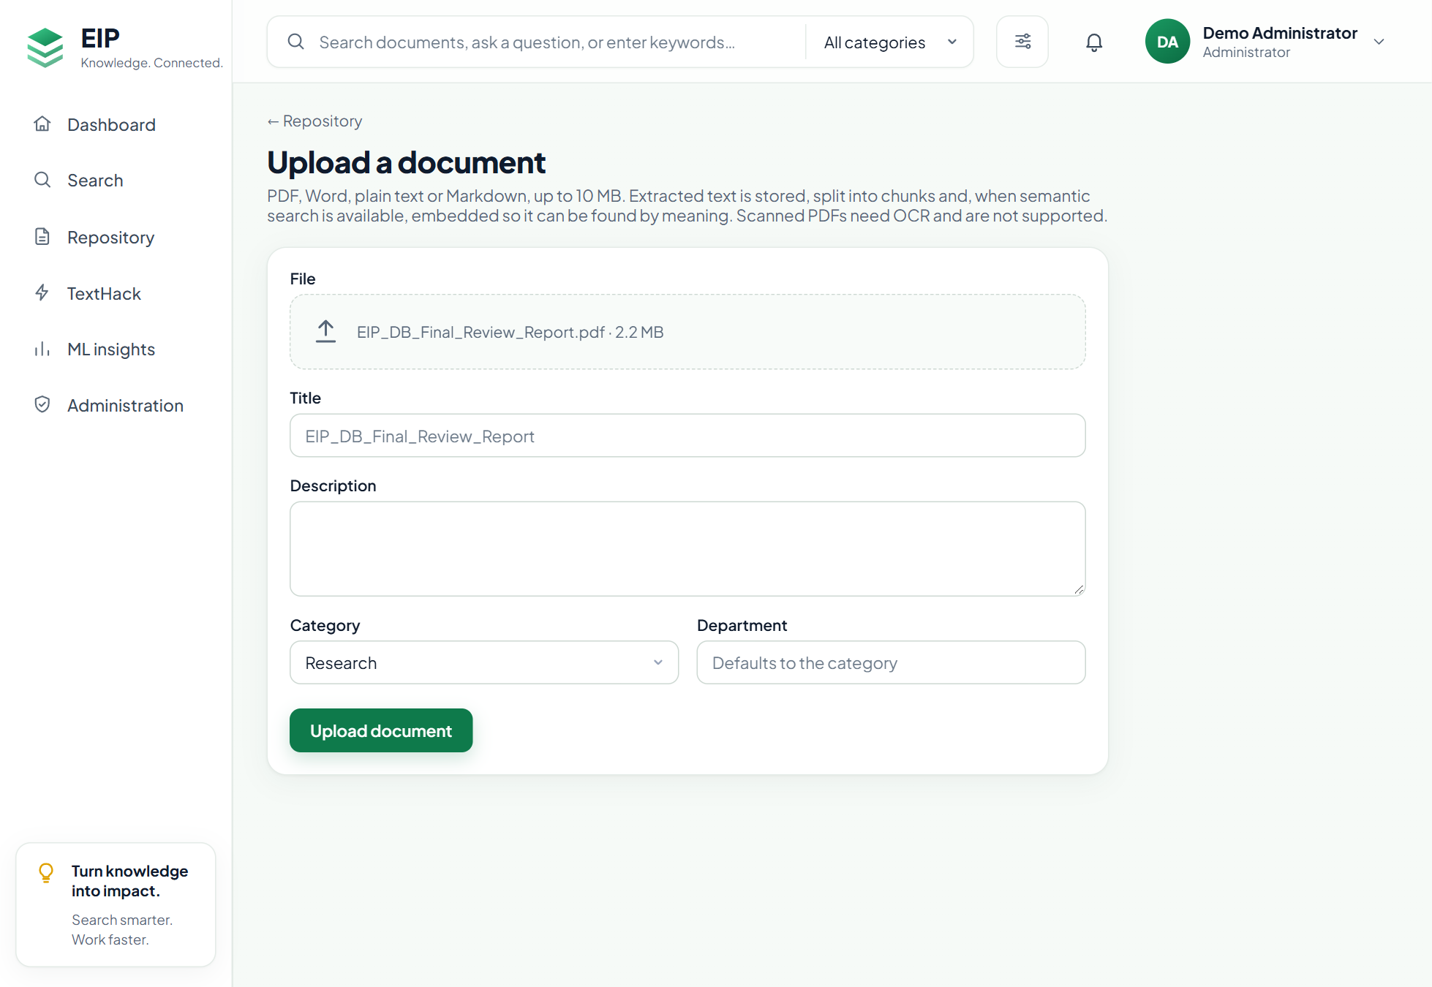
Figure 10: Upload form with a PDF chosen
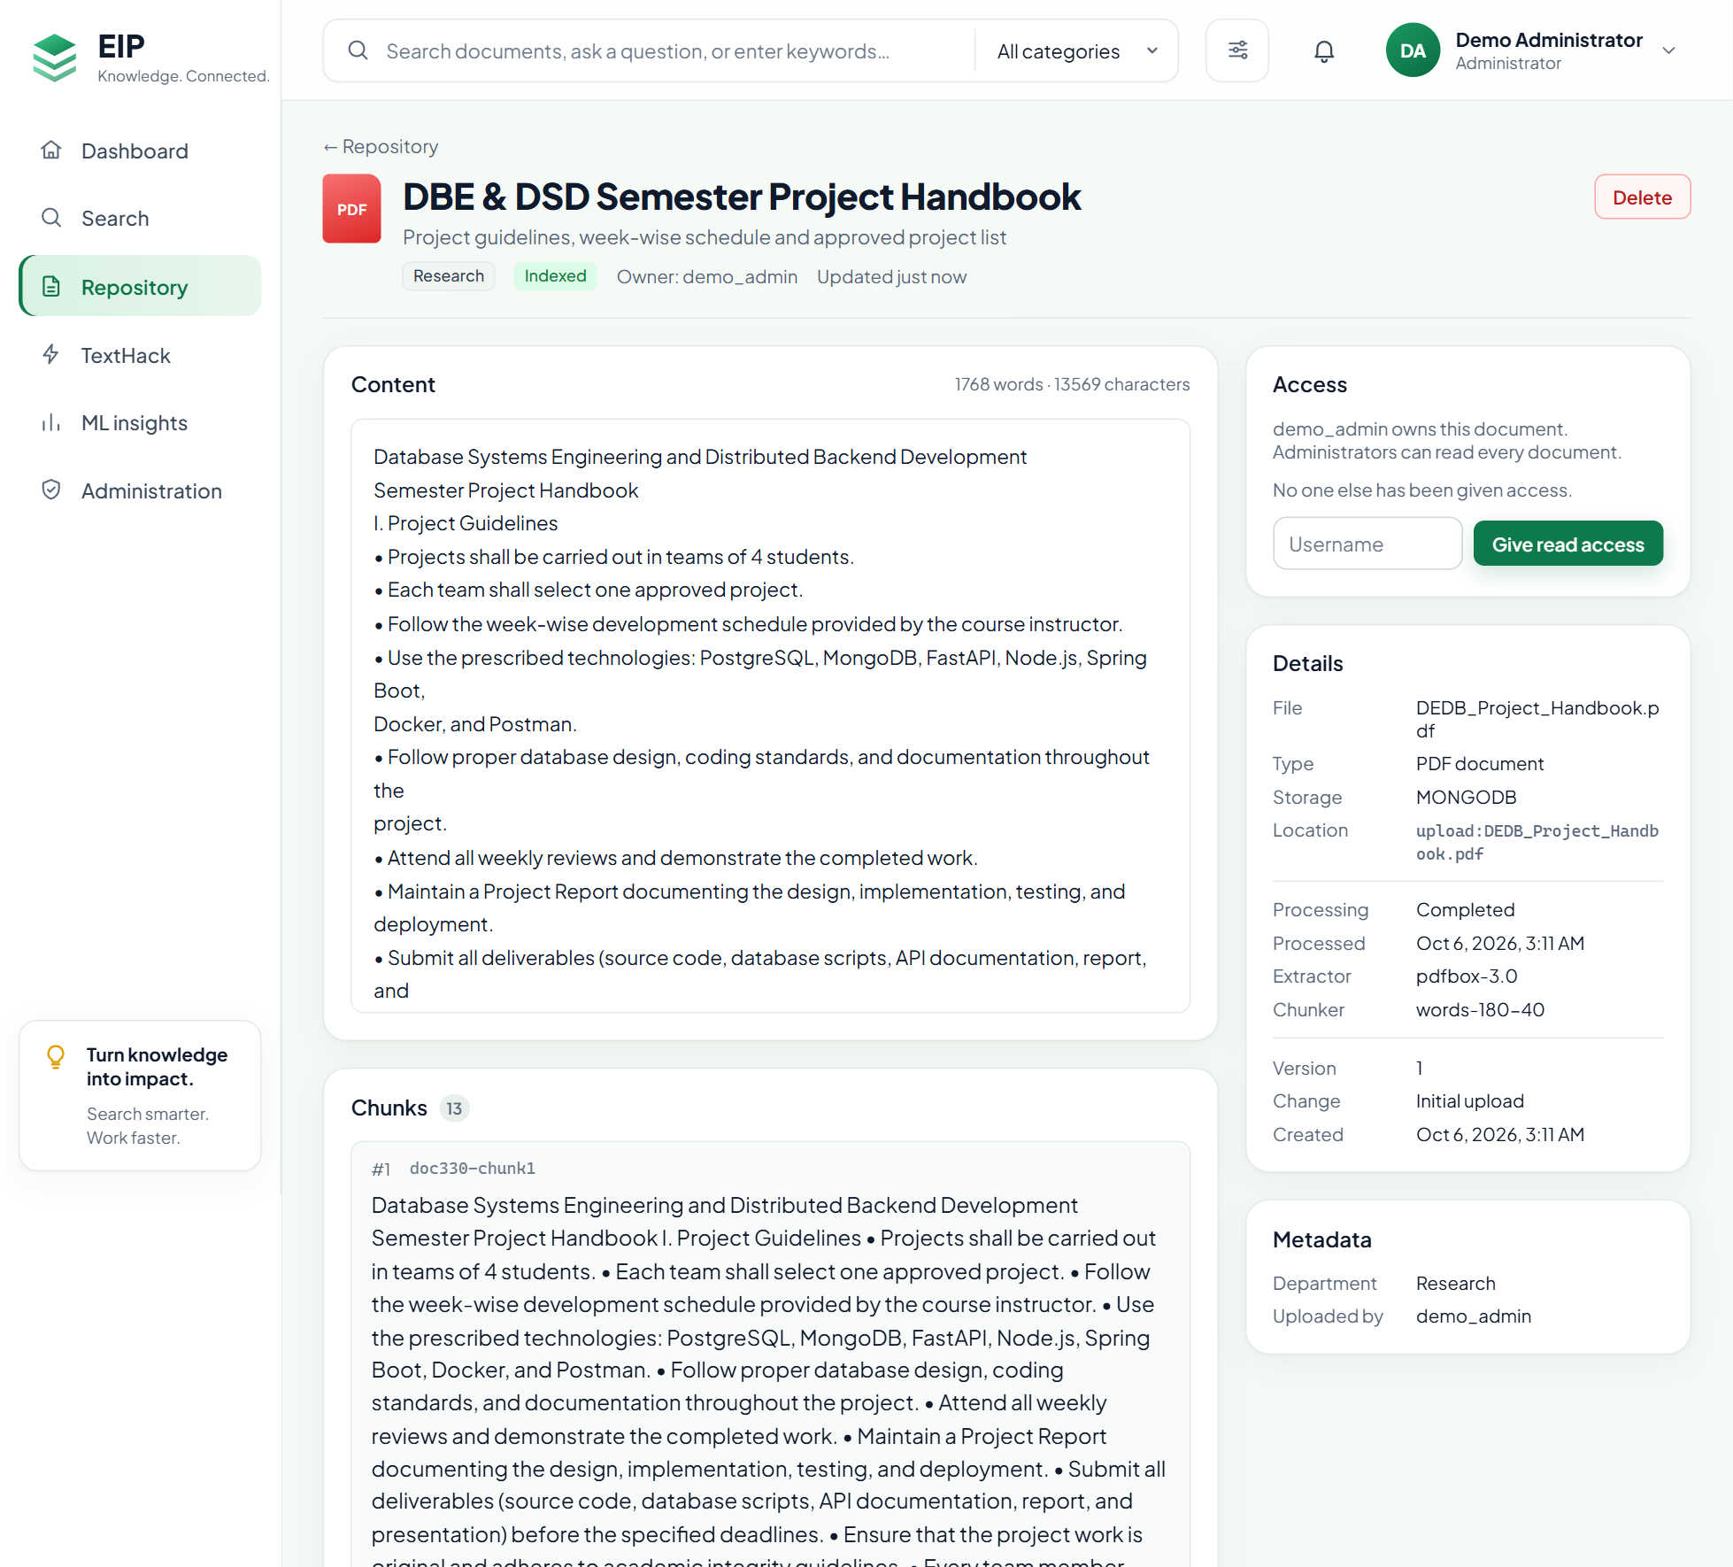
Figure 11: An uploaded PDF in the viewer: MongoDB text and chunks, extractor pdfbox-3.0
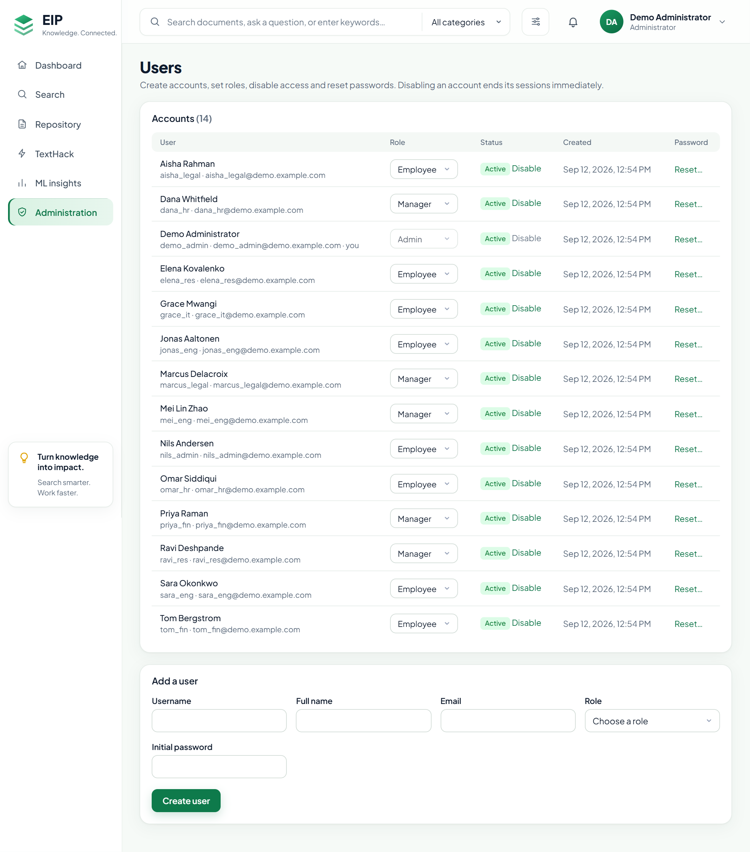
Figure 12: User administration (USER_MANAGE only)

Conclusion and Future Work
Relational, document and vector databases work as one system when each owns a clear part of the data and one key links them. PostgreSQL enforces identity, access and integrity; MongoDB keeps text and chunks in a validated, flexible model; Qdrant makes them searchable by meaning. Safe text extraction brings PDF and Word documents in, ordered writes with compensating actions keep the stores consistent, and one permission rule applied before ranking keeps every result within what the user may read. The tests, the measurements on the demo corpus and the live deployment confirm the design.
Future work.
- OCR for scanned PDFs, and text from Word headers, footers and footnotes.
- Keyword and fuzzy matching over document text, using the MongoDB text index.
- Readable-document filters passed to Qdrant, so restricted users always get a full page of vector hits.
- Background embedding for large uploads.
- Separate search and ingestion services behind an API gateway, with Prometheus and Grafana monitoring [19].

References
- P. J. Sadalage and M. Fowler, NoSQL Distilled: A Brief Guide to the Emerging World of Polyglot Persistence. Addison-Wesley, 2012.
- E. F. Codd, “A relational model of data for large shared data banks,” Communications of the ACM, vol. 13, no. 6, pp. 377–387, 1970.
- R. Ramakrishnan and J. Gehrke, Database Management Systems. McGraw-Hill Education, 2018.
- Y. A. Malkov and D. A. Yashunin, “Efficient and robust approximate nearest neighbor search using hierarchical navigable small world graphs,” IEEE Transactions on Pattern Analysis and Machine Intelligence, vol. 42, no. 4, pp. 824–836, 2020.
- N. Reimers and I. Gurevych, “Sentence-BERT: Sentence embeddings using Siamese BERT-networks,” in Proc. EMNLP-IJCNLP, 2019, pp. 3982–3992.
- W. Wang, F. Wei, L. Dong, H. Bao, N. Yang, and M. Zhou, “MiniLM: Deep self-attention distillation for task-agnostic compression of pre-trained transformers,” in Advances in Neural Information Processing Systems (NeurIPS), 2020.
- L. Ferrari and E. Pirozzi, Learn PostgreSQL, 2nd ed. Packt Publishing, 2024.
- A. Giamas, Mastering MongoDB 4.x, 2nd ed. Packt Publishing, 2019.
- Qdrant, “Qdrant documentation: collections, indexing and payload filtering.” [Online]. Available: https://qdrant.tech/documentation/
- H. Garcia-Molina and K. Salem, “Sagas,” in Proc. ACM SIGMOD International Conference on Management of Data, 1987, pp. 249–259.
- S. Gilbert and N. Lynch, “Brewer’s conjecture and the feasibility of consistent, available, partition-tolerant web services,” ACM SIGACT News, vol. 33, no. 2, pp. 51–59, 2002.
- C. Walls, Spring in Action, 6th ed. Manning Publications, 2022.
- M. Jones, J. Bradley, and N. Sakimura, “JSON Web Token (JWT),” RFC 7519, IETF, May 2015.
- N. Provos and D. Mazières, “A future-adaptable password scheme,” in Proc. USENIX Annual Technical Conference, FREENIX Track, 1999.
- D. E. Knuth, J. H. Morris, and V. R. Pratt, “Fast pattern matching in strings,” SIAM Journal on Computing, vol. 6, no. 2, pp. 323–350, 1977.
- A. V. Aho and M. J. Corasick, “Efficient string matching: An aid to bibliographic search,” Communications of the ACM, vol. 18, no. 6, pp. 333–340, 1975.
- F. J. Damerau, “A technique for computer detection and correction of spelling errors,” Communications of the ACM, vol. 7, no. 3, pp. 171–176, 1964.
- N. Poulton, Docker Deep Dive. Independently published, 2023.
- M. Larsson, Microservices with Spring Boot 3 and Spring Cloud. Packt Publishing, 2023.

