- Do not edit/delete any heading or section with red text.
- Type /paste you answers in relevant sections (below Final Answer (in all questions , Approach (wherever required ) and Charts & tables (wherever required)) of the solution
- Link to submission guidelines
- Please note that submission not following the guidelines will not be accepted

OBJECTIVE QUESTIONS

Question 1: What is the total no. of tables present in the data?

Solution:

Final Answer (if any):
Total number of tables of data would be 2.(excluding pivot tables).
We have considered the original given data table and the derived clean table through cell referencing and formulas only.
Approach (if any):
Excluding pivot tables here.

Question 2: What is the total no. of attributes present in the data?

Solution:

Final Answer (if any):
34 is the count of attributes present in the cleaned data.

Approach (if any):
We have almost about the same number of attributes from the original table (35 columns). Columns with zero variance and which were not of much use in the analysis phase were removed. A few examples of the same are Whitelistuser ,queue and version key column. We have retained a few columns like refund status which have impactful low variance data.

Question 3: The data consists of some inconsistent and missing values so ensure that the data used for further analysis is cleaned.

Solution:

Final Answer (if any):

The given dataset has a few columns with inconsistent data and some missing values. I have used various Excel functions to clean the data and only converted it into a proper format where necessary. Some columns were removed because they had little or no impact on the analysis. A detailed explanation of the data cleaning process is provided below. Also, it's important to note that the data provided is only for the month of January, so the analysis is based on the limited data available.

Approach (if any):

The dataset was cleaned and prepared for analysis using a structured method. Cell referencing was used to keep the original data intact while performing all transformations in a separate working sheet. Here are some examples of the Excel functions I used to standardize and correct inconsistencies:

- TRIM was used to remove extra spaces from text fields for consistency.

PROPER was applied to convert text into proper case (like names) to make it read more clearly.

VALUE was used to turn text-formatted numbers and date-time values into numeric format so they could be used in calculations.

SUBSTITUTE was used to remove unwanted characters (like "T" and "Z" in timestamps) and replace them with suitable separators.

IF was used for conditional cleaning, such as handling negative values, blanks, and organizing data properly.

DATE was used to extract specific parts like date-time values and to apply custom formatting for grouping and analysis.

Helper columns like Day, Month, and Hour were created using date-time functions.

These columns made it easier to break down the data into different time segments and analyse trends over time.

Columns that had no variation (where all values were the same) were removed as they didn't add value to the analysis. Examples include the Whitelist user, queue, and version key columns. However, columns with low variation but possible importance, like refund status, were kept accounting for edge cases.

The data cleaning was done in context:

Financial columns like amount, earnings, and net amount had missing entries replaced with 0 to ensure accurate calculations.

Duration-related columns were left blank where appropriate, because missing data had meaning (e.g., chat data doesn't include call duration and vice versa).

Overall, the cleaning process ensured the dataset stayed accurate and consistent for analysis without over-modifying or changing the original data too much.

Question 4: What is the change in daily call volume day by day and also find the average daily call volume.

Solution:

Final Answer (if any):
Average daily call volume = 250.24(Rounded up to 2 decimals)

Approach (if any):
We go about plotting a pivot table with Month taken in rows and the consultation type in columns filtering out just the calls. We retrieve the Average daily call volume through this table by taking average of the number of calls on each day. In similar manner, we calculate the difference in the call volume between each day and put in a tabular format right beside our pivot table to plot a chart for better understanding.

This is the formula used for average.

Average = AVERAGE (C8:C41) where C cell represents count of call as consultation type.
Change in daily volume= C9-C8 and so on. A separate column has been inserted in the table.

Charts & Tables (if any):

The chart shows daily call volume along with day-on-day changes, highlighting fluctuations and identifying peak and low activity periods.

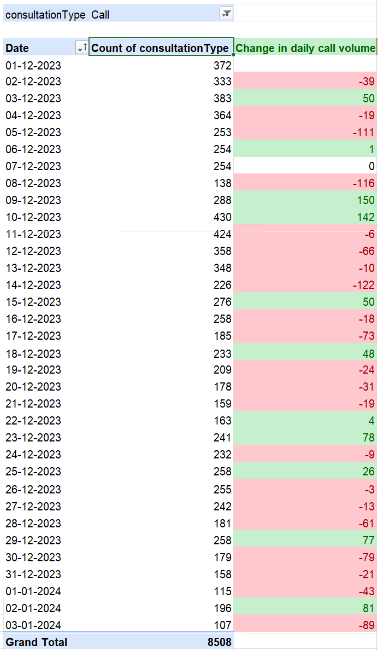

The pivot table represents the change in daily call volume.
We retrieve the Average daily call volume through this table by taking average of the number of calls on each day.

INSIGHT: We conclude that around 250 calls were being received every day on an average, with seeing a sharp rise in calls around 9th Dec 2023 and we see the peak of around 430 calls the following day (10th Dec 2023). There was a noticeable dip on 8th and 14th December which implies major call volume is during the beginning of the month. We see that call volume gradually reduces as the month ends due to Christmas and New Year holidays.

Question 5: Which months experienced the highest and lowest call volumes?

Solution:

Final Answer (if any):
December 2023 received the highest call volume while January 2024 received the lowest.

Approach (if any):
To identify the months with the highest and lowest call volumes, the data was grouped by month and year using a pivot table with the date field. The total number of calls was calculated for each month by aggregating the consultation records. This allowed for easy comparison of monthly call volumes. A chart was then used to visually represent these values, making it easier to identify the peak and lowest performing months based on total call counts.

Charts & Tables (if any):

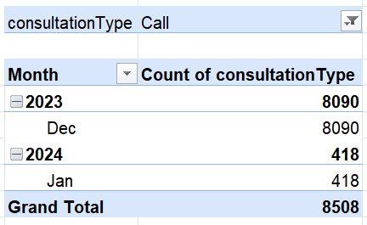

This pivot table was created to analyse average customer ratings by month and year, grouping the data into Dec 2023 and Jan 2024. This helped in identifying trends in customer satisfaction over time. The use of actual date fields ensured correct chronological sorting and accurate aggregation.

A pie chart was used to represent the distribution of total call volumes across different months. Each slice of the chart indicates the proportion of calls handled in a particular month. This visualization makes it easy to compare the contribution of each month to the overall call volume and quickly identify the months with the highest and lowest share of calls. The chart provides a clear overview of how call activity is distributed over time.

Question 6: What is the total operational cost for that month?

Solution:

Final Answer (if any):
December 2023 - 93786.16
January 2024 - 5360.41

Approach (if any):
In our data, Astrologers Earnings reflects the operational cost incurred by the platform in paying the service providers. The total operational cost for the selected month was calculated by summing the astrologers’ earnings for all call records within that month.

Insight: Months with higher call volumes show increased operational costs, highlighting a direct relationship between platform usage and expenses. This suggests that managing call volume efficiently can play a key role in controlling operational costs.

Charts & Tables (if any):

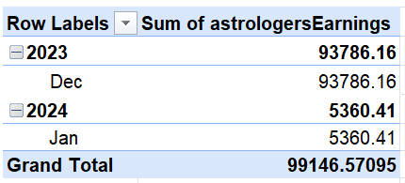

This pivot table was created to analyse The total sum of astrologer earnings by month and year, grouping the data into Dec 2023 and Jan 2024. This helped in identifying trends in operational cost for Astro Sage over time. The use of actual date fields ensured correct chronological sorting and accurate aggregation.

A Stacked column chart was used to represent the distribution of Total Operational cost across different months. Here the main point to notice is that we consider Astrologer’s earnings over the mentioned month as the Operational cost as it is clear from the cleaned data table. The chart provides a clear overview of the OP cost over the mentioned 2 months.

Question 7: What is the average number of calls handled per agent per day?

Solution:

Final Answer (if any):

Average calls per agent in a day is 1.94.

Approach (if any):
First, the total number of calls was calculated using the pivot table and cell referencing to the grand total.

Then, the number of days in the dataset was determined using:
=COUNT (UNIQUE ('Cleaned data'!N:N))

Next, the number of agents handling calls was calculated using:
=COUNTA (E8:E155)
Although the dataset contains 148 total agents, only 129 agents have handled calls (filtered using consultation type = Call). Hence, 129 was considered for the calculation.

Finally, the average was computed using:
=$I$6/($I$7*$I$8)

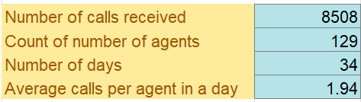

Charts & Tables (if any):

Name of the pivot table is Pivot table 7.

Attached a couple of screenshots of the table(not the entire one).
The pivot table displays the count of calls handled by each agent (guru name), filtered for call consultations. It helps identify active agents and shows how calls are distributed among them.

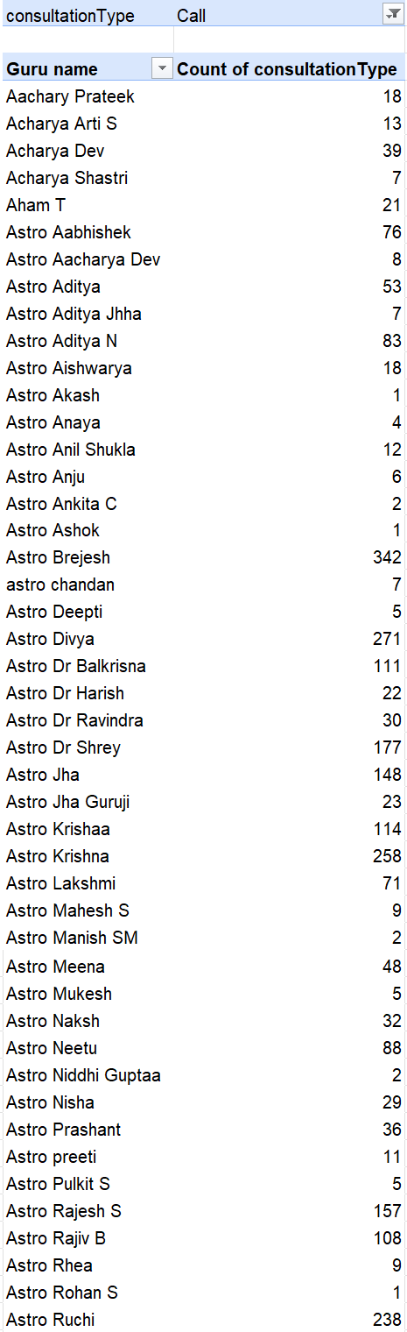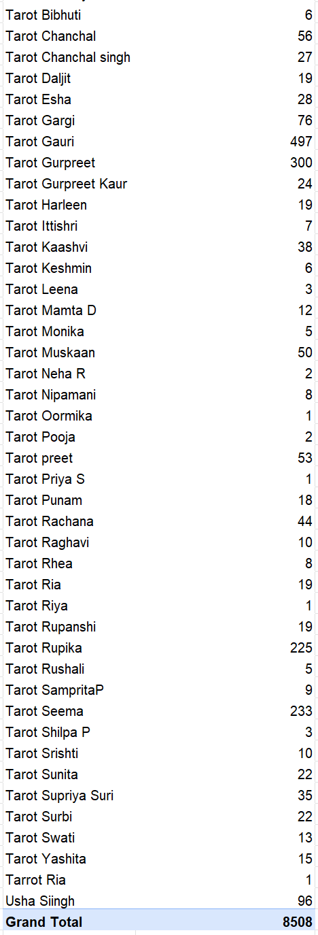

Above is a Line chart plot that represents the number of calls received by all the Gurus who are call agents.

Question 8: How many repeat callers are there, and what percentage of total calls do they represent?

Solution:

Final Answer (if any):
The number of repeat callers is 1277 out of 3629.
The percentage of total calls the repeat callers represent are 57.35%.
Approach (if any):

The Total number of calls received – 8508

Total Number of callers – 3629
We are taking the User ID (uid) column here where we check if the same user has tried to contact the centre multiple times. We use a pivot table to derive the count of consultation type with calls only as a filter. Hence, we get the count of total callers and repeat callers(count>1).

Number of repeat callers – 1277
These are the callers with the count of consultation type>1 from the above-mentioned pivot table.

We can also identify unique callers as the ones who have count of consultation type as 1. Hence, the number of unique callers: 2352

FORMULA USED TO FIND % OF TOTAL CALLS REPEATS CALLERS REPRESENT = (TOTAL NUMBER OF CALLS - TOTAL NUMBER OF CALLERS)/TOTAL NUMBER OF CALLS*100

- 57.35%

Charts & Tables (if any):

PIVOT TABLE 10

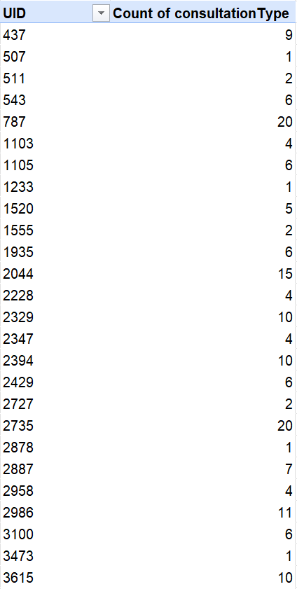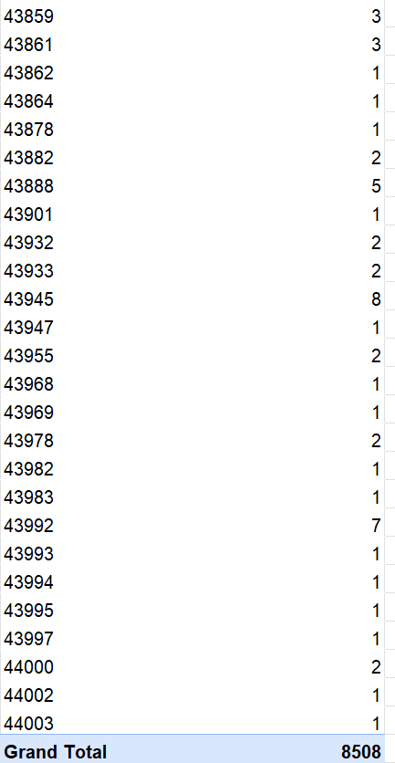

The pivot table represents users against the number of times they have called in.
UID vs Count of consultation type as calls. Here, we get the count of total callers and repeat callers(count>1).

Question 9: What are the total sales generated by the call centre for each product category?

Solution:

Final Answer (if any):
Total sales generated by the call centre in different categories:

CALL: 168520.6183

CHAT: 45494.68333

COMPLEMENTARY: 0

PUBLIC_LIVE_CALL: 50.597

Approach (if any):
Here, the amount column represents total revenue generated from customers. The amount column was used instead of net Amount because it represents the total revenue generated from customers, whereas net Amount reflects only the platform’s earnings after deducting costs. To calculate total sales by product category, a pivot table was created using consultation Type as the row field. The amount column was added to the values section, where Excel automatically aggregated it using the SUM function. This provided the total revenue generated for each category, enabling comparison across different service types.

Charts & Tables (if any):

Pivot table 11

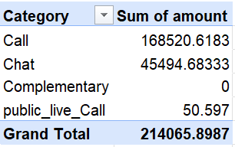

A pivot table was created using consultation Type as the row field and the sum of amount as the values.

The bar chart represents the total revenue generated across different consultation categories. Each bar shows the total amount contributed by Call, Chat, Complementary, and Public Live Call services. This visualization allows for an easy comparison of revenue distribution across categories.

The Call category dominates revenue generation, contributing significantly more than other categories. Chat contributes a moderate share, while Complementary and Public Live Call generate negligible revenue. This indicates that the platform’s primary revenue driver is call-based consultations.

Question 10: How many calls were made for each user ID and guru ID?

Solution:

Final Answer (if any):

The total number of calls made for each user ID and guru ID are 8508.
A pivot table was created with Guru ID (gid) as the primary row field and User ID (uid) as the nested row field. The data was filtered for consultation type = Call. The count of consultationType was used as the value field to calculate the total number of calls made by each user under each guru. This structure helps in understanding the distribution of calls across different users and gurus.

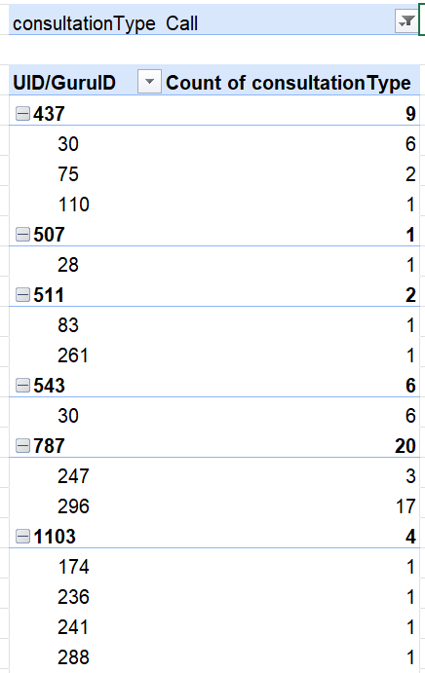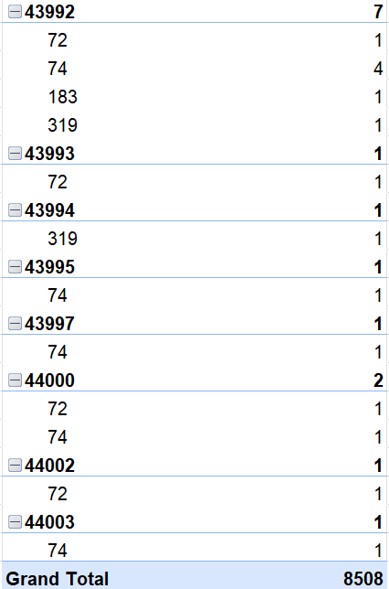

The pivot table displays the number of calls made by each user ID under their respective guru IDs. It provides a hierarchical view, allowing easy identification of call frequency patterns across users and gurus.

Question 11: What is the correlation between call duration and customer satisfaction?

Solution:

Final Answer (if any):
-0.0014

Approach (if any):

The correlation was calculated using filtered data where only valid call records (non-zero duration and non-null ratings) were considered. This ensures that the analysis reflects actual interactions and avoids distortion caused by missing or irrelevant values.

Charts & Tables (if any):
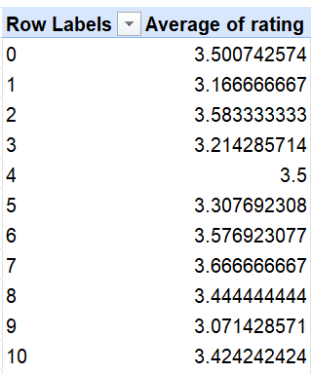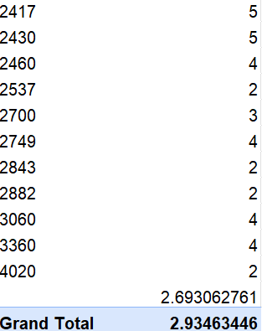

The table shows the average customer rating across different call duration ranges. Each duration value represents a group of calls, along with the corresponding average rating given by customers. The overall average rating is approximately 2.93, providing a benchmark for comparison. A positive correlation would indicate that longer call durations lead to higher customer satisfaction, while a negative correlation would suggest that longer calls reduce satisfaction. However, since the correlation is close to zero, it shows that call duration and customer satisfaction are not significantly related. This implies that factors other than call length play a more important role in influencing customer satisfaction.

Question 12: Which guru has the highest and lowest customer satisfaction scores?

Solution:

Final Answer (if any):

Approach (if any):
A pivot table was created using guruName as the row field and average of rating as the value field. The data was then sorted in descending order of ratings to identify the highest and lowest performing gurus. A bar chart was used to visually represent the variation in customer satisfaction across different gurus.

Charts & Tables (if any):

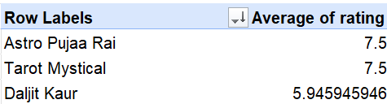

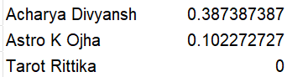

The above snippets are of the pivot table where top 3 and bottom 3 gurus with the best and lowest customer ratings have been displayed.

The chart displays the average customer ratings for gurus based on their ratings, arranged in descending order. This allows easy identification of the highest-rated and lowest-rated gurus based on customer satisfaction scores.

The chart clearly shows a wide variation in customer satisfaction across gurus. A few gurus consistently achieve high ratings (above 7), while some have significantly lower ratings. This indicates differences in service quality and highlights top-performing and underperforming agents.

Question 13: What is the average customer satisfaction score by month?

Solution:

Final Answer (if any):
Dec 2023 – 2.95
Jan 2024 – 2.68

Approach (if any):
We calculate the average customer satisfaction rating here. We take the column rating as values while we have the Years and months grouped as rows.
We must consider the fact that we have limited data for the month of January.

Charts & Tables (if any):

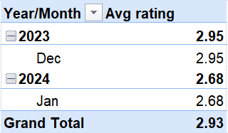

We have taken a pivot table with Years over months as rows and average of ratings as columns.

We have used a 3D stacked column chart here which gives us a better visualisation of how the ratings differ on monthly basis. The changes might be due a lot of factors here. If satisfaction scores tend to drop in certain months, it might indicate issues with service during those times. This could also help track if any changes in service, staff, or workload affect customer satisfaction. This allows for understanding customer satisfaction patterns over time, helping to identify any seasonal trends or areas of concern during certain months. We can enhance overall performance by identifying patterns.

Question 14: How many categorical columns are there in the data? [Search about categorical and continuous data, and try to answer this question]

Solution:

Final Answer (if any):
Categorical data in Excel consists of non-numeric, qualitative values (e.g., categories, labels, types) that can be analysed using Pivot Tables, COUNTIF formulas, bar/pie charts, and filtering.

Continuous data in Excel—measured values like time, weight, or temperature that can take any value within a range.

We have 34 columns in total in the cleaned data table used for analysis.

The Categorical columns present are 24. The list goes like: _id, user, chat Status, guru, guru Name, gid, uid, consultation Type, website, refund Status, free Call, free Chat, created AT, updated At, statementEntryId, chatStartTime, chatEndTime, call Channel, callIvrType, call Status, Call Sid, astrologerCallStatus, region, userCallStatus.

The continuous columns are 10 in number which are chatSeconds, amount, astrologerOnCallDuration, astrologersEarnings, netAmount, userOnCallDuration, rating, Day, HOUR, Month.

SUBJECTIVE QUESTIONS

Question 1: Should the investment be used to hire more agents, improve training programs, or upgrade call center technology?

Solution:

Approach:

We must break down the problem at hand to gain insights into what is happening in the data. To determine the optimal allocation of investment, I assessed three critical factors: capacity, agent performance, and system efficiency. I analyzed call and chat durations alongside customer ratings to evaluate agent effectiveness and identify the need for training. I analyzed the distributions of call and chat statuses to identify failure patterns, such as dropped or incomplete interactions, which indicate underlying technology issues. Finally, I examined interaction volumes and handling times to identify any capacity constraints that might necessitate hiring additional agents. Based on these analyses, investment decisions are prioritized according to the factor that most significantly influences completion rates and customer satisfaction.

Charts & Tables with Insights:

The above chart indicates a pie chart plotted where consultation type are taken as rows and call status are taken as values with calls only filter and here we see that out of the incoming calls, 27% of them are on busy status while the rest 73% were completed. This says that we have calls waiting in the queue. This mainly indicates we need to hire more agents but it depends on the priority.

PIVOT TABLE FOR UPGRADING CALL CENTER TECHNOLOGY

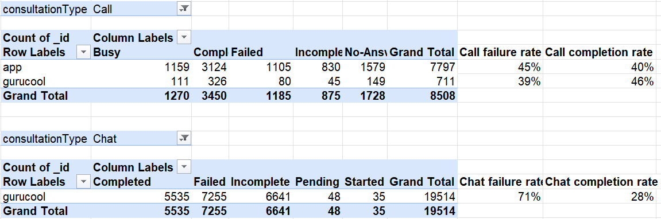

We generated two pivot tables to extract meaningful insights by setting the website as rows, call and chat status as columns, and the count of _id as values. We also applied filters by consultation type to analyze calls and chats separately. Furthermore, we introduced two calculated metrics: the Call Failure Rate, defined as the sum of Failed, Incomplete, and No Answer statuses divided by the total number of calls or chats on the platform, and the Call Completion (Success) Rate, which reflects the proportion of completed interactions. Analysis of calls across platforms reveals a notably low completion rate, especially on the app channel at approximately 40%, accompanied by a high frequency of "No Answer," "Failed," and "Incomplete" statuses. These patterns suggest that a significant number of calls fail to connect or complete, indicating underlying inefficiencies in the technology or platform. A comparable trend emerges in chat analysis, with completion rates hovering around just 28%. In summary, these results indicate that prioritizing investment in advanced technology is essential.

PIVOT TABLE FOR INVESTING IN TRAINING + EFFICIENCY

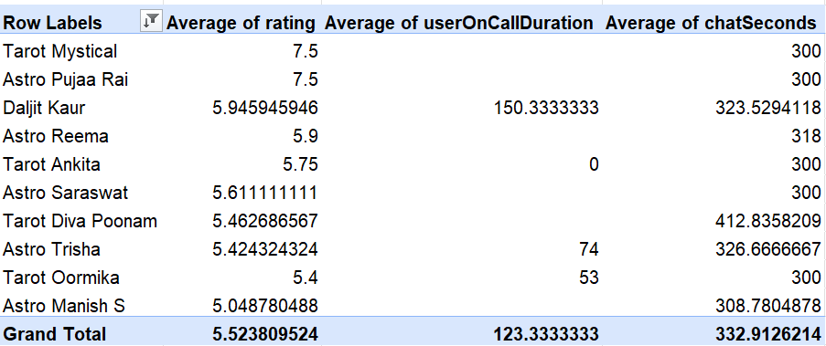

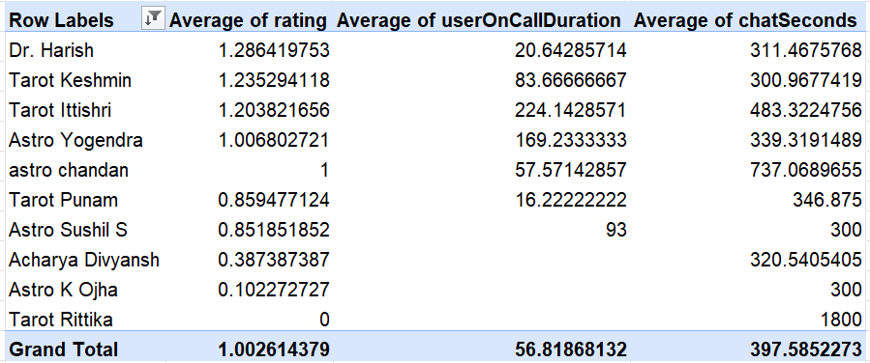

The above tables provide insights into the performance of the top 10 and bottom 10 agents. The pivot tables use guru Name in the rows section, with the average of rating, chat Seconds, and call duration as values to evaluate agent performance.

We can see through the analysis, the top-performing agents spend an average of approximately 332 seconds on chats and around 123 seconds on calls, which is an optimal handling time. On the other hand, the bottom-performing agents tend to spend significantly more time on chats, with an average of around 400 seconds, while spending too little time on calls, averaging only about 57 seconds.

This indicates inefficiencies in handling interactions, such as poor time management and lack of clarity in resolving customer issues. These agents may require targeted training to improve efficiency and deliver better customer outcomes. Addressing this gap is essential for improving overall service quality.

Recommendations:

The analysis recommends upgrading call centre technology, as many interactions fail to complete, revealing systemic inefficiencies. Enhancing platform reliability will yield the greatest improvement in overall performance. Furthermore, part of the investment should be directed toward agent training to resolve inconsistencies in handling time and enhance customer satisfaction. Increasing our agent headcount is not an immediate priority, since the current challenges stem primarily from systemic and efficiency shortcomings rather than a lack of capacity.

Question 2: What are the potential risks of each investment option (hiring, training, technology upgrades), and how can they be mitigated?

Name the chart/spreadsheet function you will use for solving the problem.

Solution:

Approach:

Hiring More Agents

RISK: Adding more agents may raise operational costs without guaranteeing improved performance. If the core issue stems from system inefficiencies or flawed processes, merely adding more personnel may not effectively resolve the problem. Additionally, there is a risk of underutilization if demand fluctuates during overtime periods.
To mitigate this risk, hiring should be conducted gradually and supported by thorough demand analysis. It is also crucial to monitor agent productivity to ensure the expanded workforce is utilized effectively.

Training Programs

While training can enhance performance, the outcomes are not always immediate or guaranteed. If the training is overly generic, it may fail to address the actual performance gaps. Additionally, there is a time commitment required before improvements become apparent.
To mitigate this risk, training efforts should be concentrated on specific problem areas, particularly for lower-performing agents. Tracking performance before and after training while offering continuous feedback helps ensure the training delivers genuine value.

Technology Upgrades

RISK: Upgrading technology typically demands a substantial initial investment and can present implementation hurdles, including system downtime or difficulties for users in adapting to the new system. There may also be resistance from agents accustomed to the current systems.
To mitigate these risks, upgrades should be implemented in phases instead of all at once. Conducting small-scale tests and offering adequate support and training during the transition can facilitate smoother adoption.
To analyse the data and assist with decision-making, a mix of charts and Excel functions is helpful. Charts like stacked bar charts can show how call and chat statuses are spread out, while column charts are great for comparing how different platform perform. Scatter plots can show the link between how long a customer interaction lasts and their satisfaction score and line charts can help see trends over time.

When using Excel functions, COUNTIF and COUNTIFS are useful for counting specific results, while AVERAGE and AVERAGEIF can help measure performance. SUM is used for revenue-related calculations and CORREL helps understand how different variables relate to each other. Pivot tables are important for summarizing and analysing data efficiently.

Recommendations:

Based on the results, the main focus should be on improving the call centre technology to make the system more stable and reduce failure rates for both calls and chats. Fixing these technical issues is likely to have the biggest effect on completion rates and customer experience.

In addition, it is suggested to introduce targeted training programs to help agents become more efficient and follow best practices that top performers use. This will help improve customer satisfaction and make handling times more efficient.

Hiring more agents is not advised at this moment, since the current problems are mostly due to system limitations and inefficiencies rather than a lack of available staff.

Question 3: How does AstroSage's call center performance compare to AstroGuru's average call volume, customer satisfaction, and agent performance?

Will you use any aggregation function or a visualization here to solve the problem?

Solution:

Approach and Insight:

For this question, it's not possible to compare Astro Sage and Astro Guru directly because the dataset only includes information about Astro Sage.
Since there is no data about Astro Guru's call volume, customer satisfaction, or agent performance, it's not possible to make a direct comparison now. Therefore, the analysis focuses on assessing Astro Sage's internal performance and setting up benchmark metrics that can be used for comparison once Astro Guru's data is available.

To understand the overall performance of the call center, a few key metrics that show workload, customer experience, and agent efficiency should be evaluated.

Average Call Volume indicates the number of customer interactions handled within a specific time. This helps to assess demand levels, identify busy times, and determine if the current staffing level is enough. Comparing this metric for both Astro Sage and Astro Guru can help determine which call center handles incoming calls more effectively.

Customer Satisfaction reflects how customers feel about the service they receive, usually measured through ratings or feedback after interactions. It gives insight into service quality and how well customer issues are resolved. This provides a major insight into how the company or organization is performing.

Agent Performance evaluates how effectively agents manage calls and chats while keeping service quality high. Analysing handling time along with customer ratings can help identify high-performing agents and areas where additional training is needed, ensuring a balance between efficiency and positive customer outcomes.

To carry out this analysis, functions like COUNT, AVERAGE, and SUM can be used to calculate key performance indicators, and simple visualizations like bar or column charts can clearly compare these performance metrics.

Recommendation:
To perform a data-driven comparison:
- Collect call volume, CSAT, and agent performance metrics for both companies.
- Benchmark results against industry standards.
- Use visualizations such as bar charts for call volume comparison, column charts for agent performance, and line charts for customer satisfaction trends.

Question 4: How can the call center improve its handling of peak call periods to ensure high customer satisfaction?

Mention the functionality you will use for giving the suggestions, will it be any aggregated function or a visualization?

Solution:

Approach:
To understand how the call center can better handle peak call periods and maintain customer satisfaction, two main aspects were examined:

- Hourly Call Volume Analysis

The first step was to look at how customer demand changes throughout the day. Using the call timestamp, the hour component was extracted and aggregated to find out how many calls were received each hour. This helped identify busy and less busy times and understand when customers are most likely to contact the call center.

Methodology Used

- Extract Hour from call time
- Use Pivot Table to calculate total calls per hour
- Visualize results using a Column Chart (Hourly Call Volume)

- Call Status Distribution During Each Hour

After identifying peak hours, the next step was to assess how well calls were handled during those times. Calls were grouped based on status such as Completed, Busy, Failed, and No Answer. This analysis helps determine whether high demand is impacting service quality or agent availability.

Methodology Used

- Aggregate call counts by Hour + Call Status
- Use Pivot Tables for grouped analysis
- Visualize results using a Stacked Column Chart (Call Distribution Over Hours)

Together, these two charts provide both:

Demand insight (number of incoming calls)
Operational performance insight (how well calls are handled)

Charts & Tables:

This chart represents the total number of incoming calls received during each hour of the day. It highlights workload fluctuations and helps identify peak traffic periods.

This stacked column chart shows how calls were handled each hour, categorized by call status (Completed, Busy, Failed, No-Answer). It reflects agent availability and operational efficiency during different time slots.

A line chart is plotted to give us information about the completion rate of the incoming calls. We have taken hours in rows column while we have taken completed calls over total number of calls in that hour.

Insights:

- We can see that call volume increases gradually in the morning and peaks between 7 AM and 11 AM, with the highest activity around 8 AM.

- During peak hours, although most calls are completed successfully, there is a noticeable increase in Busy, Failed, and No-Answer calls.

- This indicates that customer demand temporarily exceeds available agent capacity.

- One more insight is that evening and late-night hours show significantly lower call volumes, suggesting underused resources during those times.

- The challenge is not poor service quality but managing workload imbalance across the day.

- The call completion rate is alright in the early morning hours but depletes drastically around evening and that is an area of concern.

Recommendations:

Optimize Agent Scheduling: Deploy more agents during identified peak hours (7 AM to 11 AM) and reduce staffing during low-demand periods to improve resource usage.

- Introduce Callback Options for Waiting Customers: Even with more agents, queues may still form during busy hours.
Offering customers a callback option allows them to avoid long waiting times while ensuring their issues are addressed later, improving overall satisfaction.

- Use Continuous Monitoring Through Dashboards: Maintain dashboards using Pivot Tables and visualizations to monitor hourly demand patterns and plan staffing requirements proactively.

- Implement Flexible Shift Management: Adopt staggered or flexible shifts so agent availability naturally aligns with customer demand patterns.

- Improve Peak-Hour Efficiency: Provide agents with knowledge bases, automated responses, or IVR routing for common queries to reduce handling time while maintaining service quality.

Question 5: Based on historical data, what strategic initiatives should be prioritized to improve efficiency and customer satisfaction?

Solution:

Approach:

To identify strategic initiatives, the focus was placed on understanding how agent performance influences both operational efficiency and customer satisfaction.
A Pivot Table was created using agent names as rows and key performance indicators such as average customer rating, chat handling time, and call duration as values. Here, we have filtered the interactions based on website as well as consultation type as performance depends on these factors as well.

The objective of this analysis was to:
- identify performance differences among agents,
- understand how handling behaviour impacts customer experience,
- determine whether efficiency challenges arise from workload issues or performance gaps.
By comparing top and bottom performers, meaningful operational improvement areas can be identified.

Charts & Tables:

The above-mentioned stacked column chart represents the average rating achieved by the top 10 Gurus who have performed well.

The above-mentioned column chart represents the average rating achieved by the Bottom 10 Gurus who have not performed up to their capacity.

Insights:

- Agent effectiveness, not the length of the conversation, is what really makes customers satisfied. Top-performing agents are able to fix problems quickly within a reasonable time frame, showing that having a clear way to solve issues is more important than having long chats.

- The main reason for differences in performance is related to skills, not staffing.
The variations between agents usually come down to things like confidence, how well they understand the work process, and how good they are at handling different types of issues, rather than just having too few people available.

- Customer experience can be very different depending on the website or channel they use. Each site may bring in customers with different expectations and types of questions, which directly affects how much work agents have and how well they perform.

- When agents are handling too many interactions or dealing with complicated traffic on a website at the same time, the quality of service and customer satisfaction start to drop.

- Looking at performance by website helps find specific areas for improvement. Using the website filter can show hidden patterns in performance, allowing leaders to focus training, staffing, and process changes where they will make the biggest difference.

Recommendations:

- Implement focused training programs that target specific skills for agents who are not performing as well, while using top-performing agents as examples to set standards for how to communicate, solve problems, and manage time effectively.

- Use smart ways to assign agents based on how busy the website is and how traffic flows, rather than splitting work equally across all channels, so that experienced agents can handle more complex or busy platforms.

- During busy times, use agents with the best ratings to handle the higher customer demand, which helps avoid delays and keeps customer satisfaction levels high.

- Create rewards and ongoing tracking systems that are based on performance to promote quick and efficient service, keep the quality of support steady, and measure long-term improvements from training.

- Improve the ability to monitor operations throughout the entire customer support process to spot work distribution issues early, prevent agents from being overworked, and ensure a smooth and consistent experience for customers across all websites and communication channels.

Question 6: What can be the key factors contributing to high customer satisfaction scores, and how can these be leveraged to improve overall performance?

What is the basis for the suggestions? And mention how you decided if the satisfaction score affects the ratings.

Solution:

Approach:

To find out what causes high customer satisfaction, the analysis looks at how different operational factors affect customer ratings, which show how satisfied customers are. Customer ratings are the main result we're looking at, and we're checking how agent behaviour and the way interactions go influence these ratings.

The steps we took were:

- Comparing how well agents perform with the ratings they get.
- Checking if the length of the interaction affects how satisfied customers are.
- Looking at differences between platforms or types of consultation to see how they impact the experience.
- Finding patterns between interactions that get high ratings and those that get low ratings.

The advice we give is based on what we actually saw happening between customer ratings and operational factors, not just guesses.

Charts & Tables:

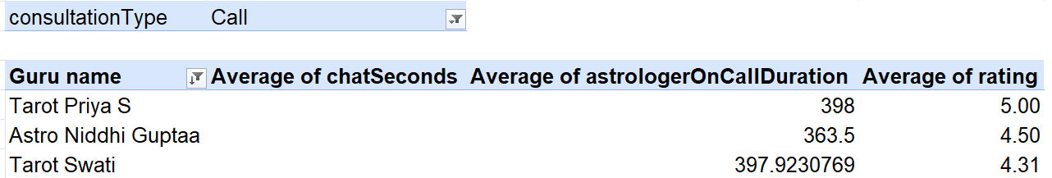

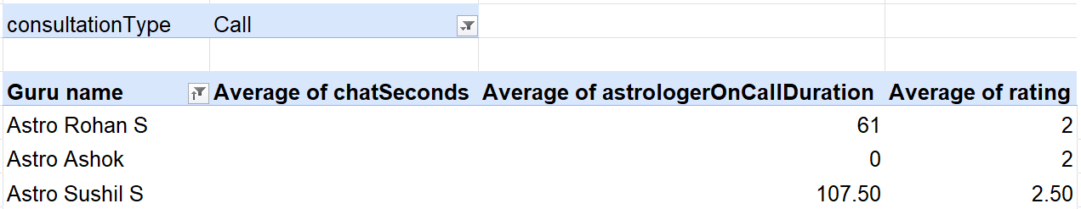

The above tables have guru names as rows, average duration of chat seconds, call duration and ratings as values. It is important to note that we also have consultation_type as a filter and are only on CALLS to get just the names of agents who are on calls and are top and bottom performers respectively.

Average astrologeroncall duration for top 3 agents = 386s

Average astrologeroncall duration for bottom 3 agents = 56s

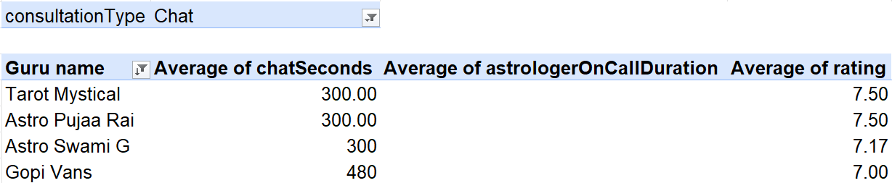

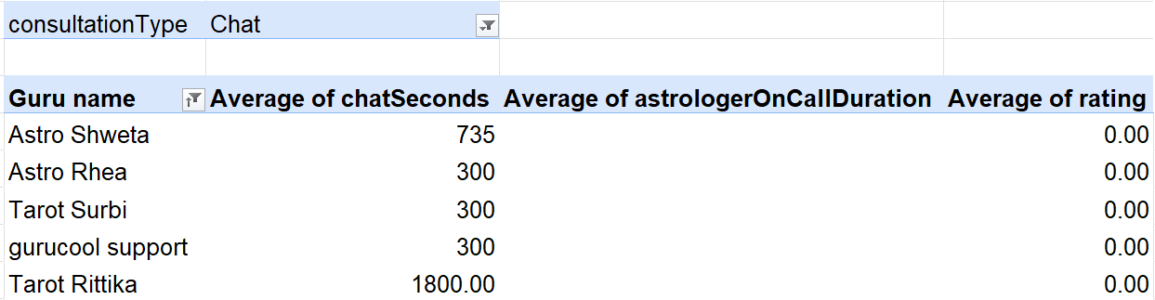

The above tables have guru names as rows, average duration of chat seconds, call duration and ratings as values. It is important to note that we also have consultation_type as a filter and are only on CHATS to get just the names of agents who are on calls and are top and bottom performers respectively.

Average chatseconds duration for top 4 agents = 345s

Average chatseconds duration for Bottom 5 agents = 683s

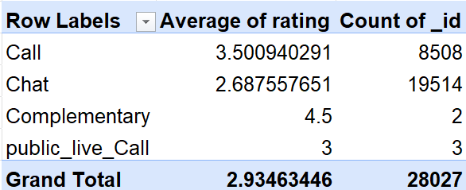

The above table represents a pivot table plotted with consultation_type as rows, average of rating and count of _id as values.

Insights:

- Customers are more satisfied when agents handle their issues in optimal range around 5 mins and thoroughly without making them feel rushed.

- Very long or very short interactions often lead to lower satisfaction, which might mean the customer didn’t fully understand or the problem wasn’t solved properly.

- The best agents communicate clearly and solve problems in an organized way.

- Some platforms or types of customer interactions in this case calls might make the experience smoother, which can boost satisfaction.

- Customer satisfaction is more about how well a problem is solved than how many interactions happen.

Recommendations:

- Create training programs that teach agents how top performers handle calls and chats.

- Set a time frame for how long calls or chats should last and help agents stay within that range.

- Use agents with the best customer ratings during busy times to ensure better service.

- Offer rewards or recognition based on customer feedback to motivate agents to provide excellent service.

- Keep an eye on customer satisfaction trends using dashboards to spot any areas that need improvement.

Question 7: How should the call center balance the workload among agents to ensure optimal performance and avoid burnout?

Mention your approach and spreadsheet function for the answer.

Solution:

Approach:

To understand how work is shared among agents, the analysis looks at how interactions are spread out and how this affects performance and customer satisfaction.

The goal is to find out:

- Agents who are dealing with too much work (which could lead to burnout),
- Agents who aren't being used enough,
- Whether differences in workload influence customer ratings and how efficiently tasks are handled.

A Pivot Table is used to compare how active each agent is, along with performance measures like how long they take to handle tasks and the ratings they receive.
By looking at both how productive agents are and how satisfied customers are, we can figure out the best way to share the work.

Aggregation Functions used:

COUNT – This shows how many calls or chats each agent handles.

AVERAGE – This shows the average rating given by customers to each agent.

Charts & Tables:

This scatter plot helps visualize how an agent's workload relates to customer satisfaction. The X-axis shows the number of interactions each agent handles, which reflects their workload, and the Y-axis displays the average customer rating. Each dot on the graph stands for a single agent, allowing us to see if there's a connection between workload and customer satisfaction, as well as how well each agent is performing overall.

Insights:

- Some agents take on way more interactions than others, which puts them at risk of getting tired and possibly lowering the quality of their service.

- When agents are overloaded, they might become less efficient or customers might be less satisfied over time. The scatter plot proves this that when the workload gets more, agents’ performance dips. These agents require adequate support at peak hours when

- Agents who aren't working as much which can be seen through the scatter plot(the cluster at the bottom) represent unused resources that could help balance the workload better.

- The best performance happens when agents have a balanced number of interactions, along with steady handling times and good ratings.

Recommendations:

  - Spread out the work so that interactions are shared more evenly among agents.

  - Use high-performing agents during busy times and rotate their shifts to avoid burnout.

  - Assign new tasks based on how busy each agent is, sending them to those with lighter workloads.

  - Keep an eye on workload regularly through dashboards to spot signs of overload early.

  - Offer short breaks or flexible hours during busy periods to help agents recover.

  - Use both performance data and workload information to make sure that efficiency doesn't mean sacrificing employee well-being.

Question 8: What new technologies or tools could be implemented to enhance call center operations and customer service?

Solution:

Recommendations:
Key Technologies to Improve Call Center Performance

- AI Chatbots / Voice Bots
Use automated bots to manage routine customer questions like general information and simple problems.
This helps reduce the work agents have to do and lets them concentrate on more difficult issues, making the whole process more efficient.

- Smart Call Routing & Callback System
Set up smart systems that direct customers to the right agent and offer callback options when the lines are busy.
This helps cut down waiting times, lowers the number of calls that are hung up, and makes customers happier.

- Unified Customer Dashboard (CRM Integration)
Give agents one easy place to see a customer’s history, past calls, and preferences. This helps them solve problems quicker and provide a more tailored experience for each customer.

Question 9: What metrics should be included in the final dashboard to comprehensively view call center performance and guide investment decisions?

Solution:

A good call center performance dashboard needs to bring together different types of information like how the center is running, how customers feel about the service, how well agents are doing, and how much money the center is making. This helps leaders make smart choices about where to put their money. The dashboard should start by showing how busy the center is, like the total number of calls, how many calls happen each hour, when the busiest times are, and how many agents are working. This helps in planning how many people to have on duty. Next, it should look at how well the operations are running by checking things like how often calls are resolved the first time, how quickly calls are finished, and how long each call takes. These help find any problems in the process. To understand how happy customers are, the dashboard should include average scores, how the scores are spread out, and whether customers call again or are new. This shows how good the service is and how loyal customers are. Agent performance data should also be included to see how productive each agent is and what training they might need. Finally, the dashboard should show how much money each type of call and each communication channel brings in. This connects how well the center is running to how much money it makes. All these pieces of information together give a full picture, helping leaders make better decisions about hiring, investing in new tools, improving customer service, and using resources wisely for long-term growth.

Question 10: How would you allocate a 1 crore rupee investment to optimize operational efficiency, enhance customer satisfaction, and boost profitability, and what analysis-based recommendations would you offer to support this?

[you have to give bullet pointers to answer this question]

Solution:

The 1 crore investment should be spread out carefully across four main areas that were highlighted in the dashboard to make sure the operations run more smoothly, customers are happier, and the business becomes more profitable.

- ₹35 Lakhs — Workforce Optimization & Agent Enablement
Invest in smarter workforce planning by matching staffing with busy times shown in the dashboard.
Use skill-based routing and flexible schedules to spread out work and stop agents from getting too stressed. Set aside money for training programs that focus on communication skills and quick problem solving to improve First Call Resolution and customer satisfaction ratings.

- ₹30 Lakhs — Automation & Technology Enhancement
Use AI chatbots and IVR systems to handle common questions, which will lighten the agents' workload and cut down wait times.
Set up callback systems for customers when there is a lot of traffic to avoid them hanging up. Improve analytics tools to track performance in real-time and support better, faster decisions.

- ₹20 Lakhs — Customer Experience Improvements
Enhance customer interaction across the app, website, and dashboard.
Add personalized suggestions, quicker routing, and ways to collect feedback after each interaction to build stronger customer relationships and encourage them to use services again.

- ₹15 Lakhs — Performance Analytics & Continuous Improvement
Create detailed dashboards and predictive models to keep an eye on productivity, satisfaction levels, and how much each part of the business contributes to revenue.
Use the data to find top-performing agents, improve processes, and keep refining strategies for long-term success.

This approach of dividing the investment based on percentages makes sure that the money is used in a balanced, data-backed way to solve real problems and support steady growth and better service performance.

