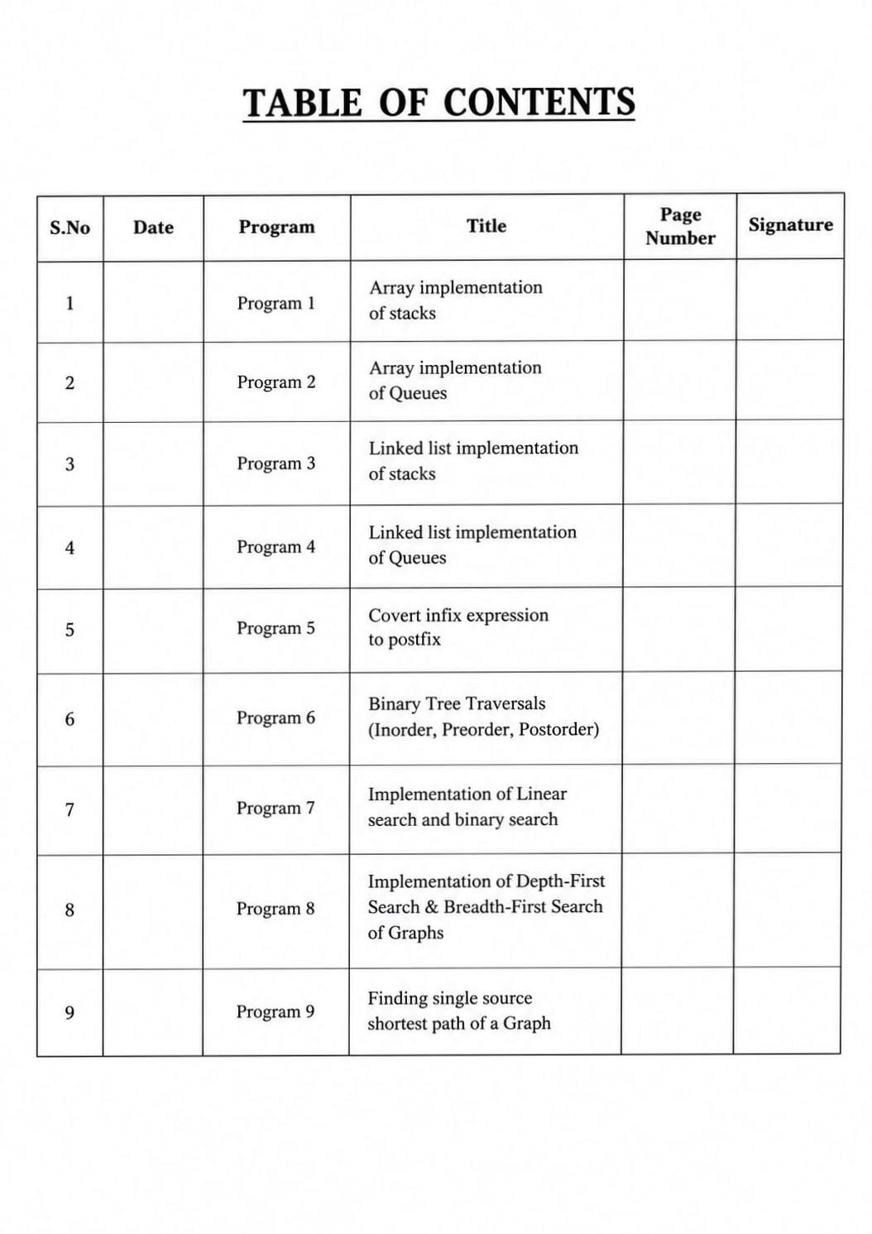


1. Array implementation of stacks
#include <iostream>
using namespace std;

#define MAX 3
class Stack
{
private:
int stack[MAX];
int top;

public:
// Constructor
Stack()
{
top = -1;
}

// Push operation
void push(int value)
{
if (top == MAX - 1)
{
cout << "Stack overflow" << endl;
}
else
{
top++;
stack[top] = value;
cout << value << " pushed into stack" << endl;
}
}

// Pop operation
void pop()
{
if (top == -1)
{
cout << "Stack underflow" << endl;
}
else
{
cout << stack[top] << " popped from stack" << endl;
top--;
}
}

// Display operation
void display()
{
if (top == -1)
{
cout << "Stack is empty" << endl;
}
else
{
cout << "Stack elements are:" << endl;

for (int i = top; i >= 0; i--)
{
cout << stack[i] << endl;
}
}
}
};

int main()
{
Stack s;

s.push(10);
s.push(20);
s.push(30);

s.display();

s.pop();

s.display();

return 0;
}

2. Array implementation of Queues
#include <iostream>
using namespace std;

#define MAX 5

class Queue
{
private:
int queue[MAX];
int front, rear;

public:
Queue()
{
front = -1;
rear = -1;
}

// Enqueue operation
void enqueue(int value)
{
if (rear == MAX - 1)
{
cout << "Queue Overflow" << endl;
}
else
{
if (front == -1)
front = 0;

rear++;
queue[rear] = value;

cout << value << " inserted into queue" << endl;
}
}

// Dequeue operation
void dequeue()
{
if (front == -1 || front > rear)
{
cout << "Queue Underflow" << endl;
}
else
{
cout << queue[front] << " deleted from queue" << endl;
front++;

if (front > rear)
{
front = -1;
rear = -1;
}
}
}

// Display operation
void display()
{
if (front == -1)
{
cout << "Queue is empty" << endl;
}
else
{
cout << "Queue elements are: ";

for (int i = front; i <= rear; i++)
{
cout << queue[i] << " ";
}

cout << endl;
}
}
};

int main()
{
Queue q;

q.enqueue(10);
q.enqueue(20);
q.enqueue(30);

q.display();

q.dequeue();

q.display();

return 0;
}

3.Linked list implementation of stacks

#include <iostream>
using namespace std;

struct Node
{
int data;
Node *next;
};

Node *top = NULL;

void push(int value)
{
Node *newNode = new Node;

newNode->data = value;
newNode->next = top;
top = newNode;

cout << value << " pushed into stack" << endl;
}

void pop()
{
if (top == NULL)
{
cout << "Stack Underflow" << endl;
}
else
{
Node *temp = top;
cout << top->data << " popped from stack" << endl;
top = top->next;
delete temp;
}
}

void display()
{
if (top == NULL)
{
cout << "Stack is Empty" << endl;
}
else
{
Node *temp = top;

cout << "Stack elements are:" << endl;

while (temp != NULL)
{
cout << temp->data << " ";
temp = temp->next;
}

cout << endl;
}
}

int main()
{
push(10);
push(20);
push(30);

display();

pop();

display();

return 0;
}

4. Linked list implementation of Queues

#include <iostream>
using namespace std;

struct Node
{
int data;
Node* next;
};

class Queue
{
private:
Node* front;
Node* rear;

public:
Queue()
{
front = NULL;
rear = NULL;
}

void enqueue(int value)
{
Node* newNode = new Node;

newNode->data = value;
newNode->next = NULL;

if (rear == NULL)
{
front = rear = newNode;
}
else
{
rear->next = newNode;
rear = newNode;
}
}

void dequeue()
{
if (front == NULL)
{
cout << "Queue Underflow" << endl;
}
else
{
Node* temp = front;

cout << "Deleted: " << front->data << endl;

front = front->next;

if (front == NULL)
rear = NULL;

delete temp;
}
}

void display()
{
if (front == NULL)
{
cout << "Queue is Empty" << endl;
}
else
{Node* temp = front;

cout << "Queue elements: ";

while (temp != NULL)
{
cout << temp->data << " ";
temp = temp->next;
}

cout << endl;
}
}
};

int main()
{
Queue q;
q.enqueue(10);
q.enqueue(20);
q.enqueue(30);
q.display();
q.dequeue();
q.display();
return 0;
}
5. Covert infix expression to postfix.
#include <iostream>
#include <stack>
using namespace std;
int p(char c)
{
if(c=='+' || c=='-') return 1;
if(c=='*' || c=='/') return 2;
return 0;
}
int main()
{
string a;
cin >> a;
stack<char> s;
for(char c:a)
{if(isalnum(c))
cout << c;
else {
while(!s.empty() && p(s.top()) >= p(c))
{
cout << s.top();
s.pop();
} s.push(c);
}
} while(!s.empty())
{
cout << s.top();
s.pop();
}
return 0;
}
6. Binary Tree Traversals (Inorder, Preorder, Postorder)

#include <iostream>
using namespace std;

struct Node {
int data;
Node *left, *right;
};
void inorder(Node *p) {
if (p) {
inorder(p->left);
cout << p->data << " ";
inorder(p->right);
}
}
void preorder(Node *p) {
if (p) {
cout << p->data << " ";
preorder(p->left);
preorder(p->right);
}
}
void postorder(Node *p) {
if (p) {
postorder(p->left);
postorder(p->right);
cout << p->data << " ";
}
}
int main() {
Node a{1, NULL, NULL};
Node b{2, NULL, NULL};
Node c{3, NULL, NULL};
a.left = &b;
a.right = &c;
cout << "Inorder: ";
inorder(&a);

cout << "\nPreorder: ";
preorder(&a);

cout << "\nPostorder: ";
postorder(&a);
}

7. Implementation of Linear search and binary search
#include <iostream>
using namespace std;

int main()
{
int a[100], n, key, choice;
int low, high, mid;

cout << "Enter number of elements: ";
cin >> n;

cout << "Enter elements in sorted order: ";
for (int i = 0; i < n; i++)
cin >> a[i];
cout << "\n1. Linear Search";
cout << "\n2. Binary Search";
cout << "\nEnter your choice: ";
cin >> choice;
cout << "Enter element to search: ";
cin >> key;
if (choice == 1)
{
// Linear Search
for (int i = 0; i < n; i++)
{
if (a[i] == key)
{
cout << "Element found at position " << i + 1;
return 0;
}
}
cout << "Element not found";
}
else if (choice == 2)
{
// Binary Search
low = 0;
high = n - 1;

while (low <= high)
{
mid = (low + high) / 2;

if (a[mid] == key)
{
cout << "Element found at position " << mid + 1;
return 0;
}
else if (key < a[mid])
high = mid - 1;
else
low = mid + 1;
}

cout << "Element not found";
}
else
{
cout << "Invalid choice";
}

return 0;
}
8.Implementation of Depth-First Search & Breadth-First Search of Graphs.

#include <iostream>
#include <queue>
using namespace std;

int a[10][10], v[10], n;

void DFS(int x) {
cout << x << " ";
v[x] = 1;
for(int i=0; i<n; i++)
if(a[x][i] && !v[i])
DFS(i);
}

void BFS(int x) {
queue<int> q;
q.push(x);
v[x] = 1;

while(!q.empty()) {
x = q.front();
q.pop();
cout << x << " ";

for(int i=0; i<n; i++)
if(a[x][i] && !v[i])
v[i] = 1, q.push(i);
}
}

int main() {
int s;
cin >> n;

for(int i=0; i<n; i++)
for(int j=0; j<n; j++)
cin >> a[i][j];

cin >> s;

cout << "DFS: ";
DFS(s);

for(int i=0; i<n; i++)
v[i] = 0;

cout << "\nBFS: ";
BFS(s);

return 0;
}

9. Finding single source shortest path of a Graph

#include <iostream>
using namespace std;

int main() {
int n, g[10][10], d[10], s;

cin >> n;

for(int i=0;i<n;i++)
for(int j=0;j<n;j++)
cin >> g[i][j];

cin >> s;

for(int i=0;i<n;i++)
d[i] = 999;

d[s] = 0;

for(int i=0;i<n;i++)
for(int j=0;j<n;j++)
if(g[i][j] && d[j] > d[i] + g[i][j])
d[j] = d[i] + g[i][j];

for(int i=0;i<n;i++)
cout << d[i] << " ";

return 0;
}

Program screenshot
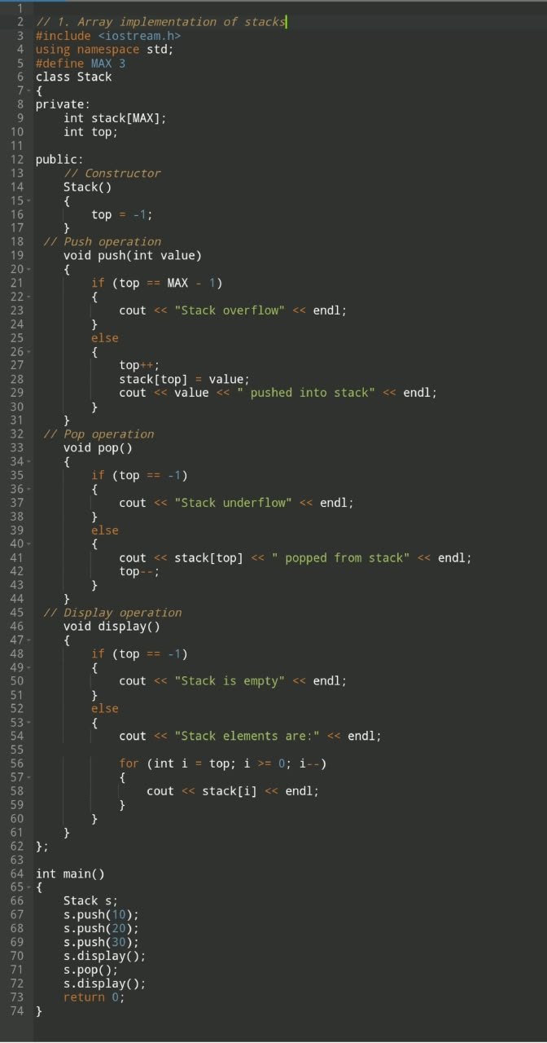

Output screenshot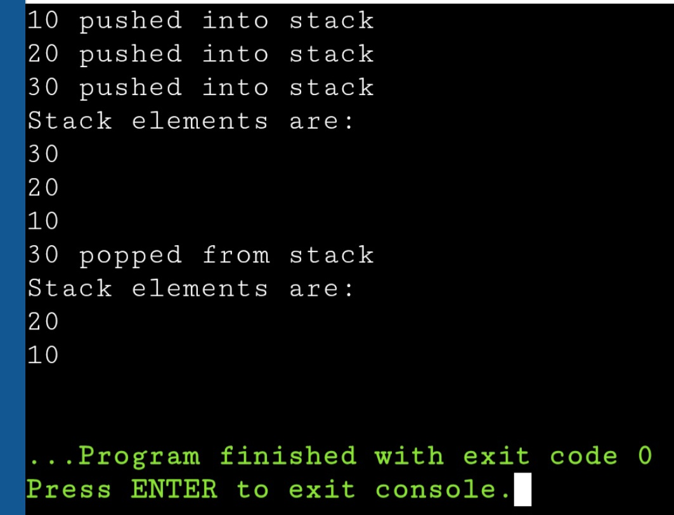

Program screenshot
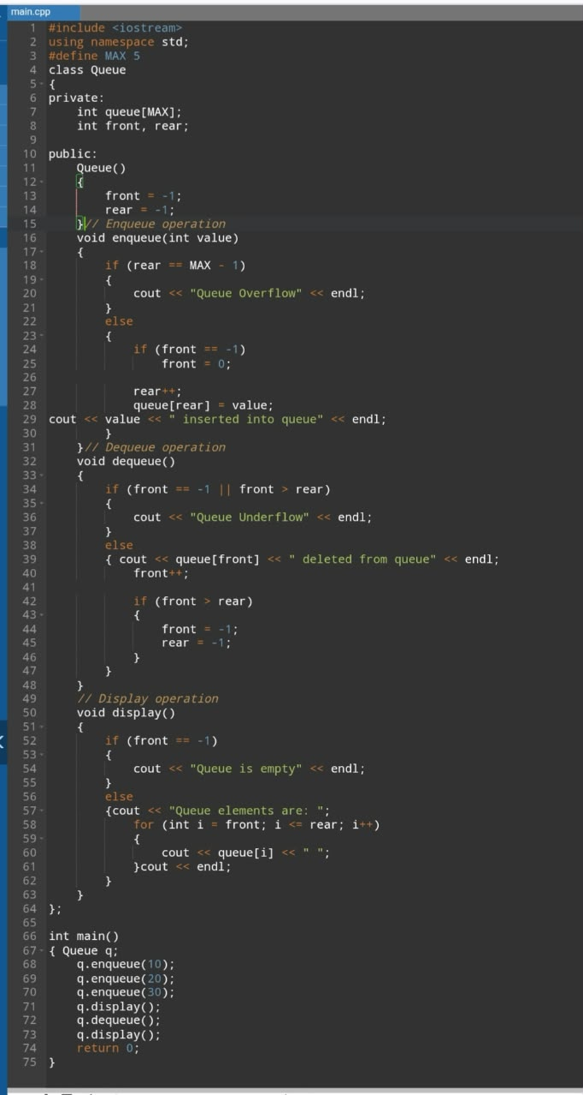

Output Screenshot
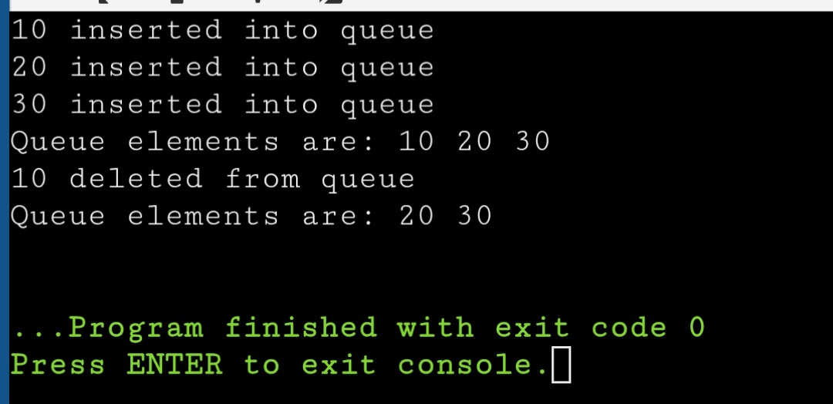

Program screenshot
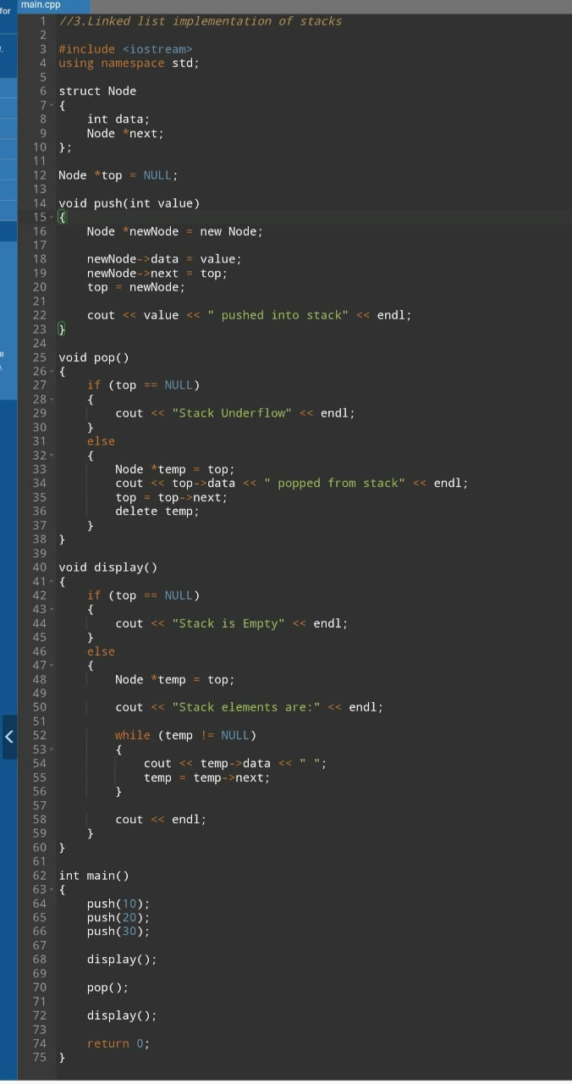

Output screenshot
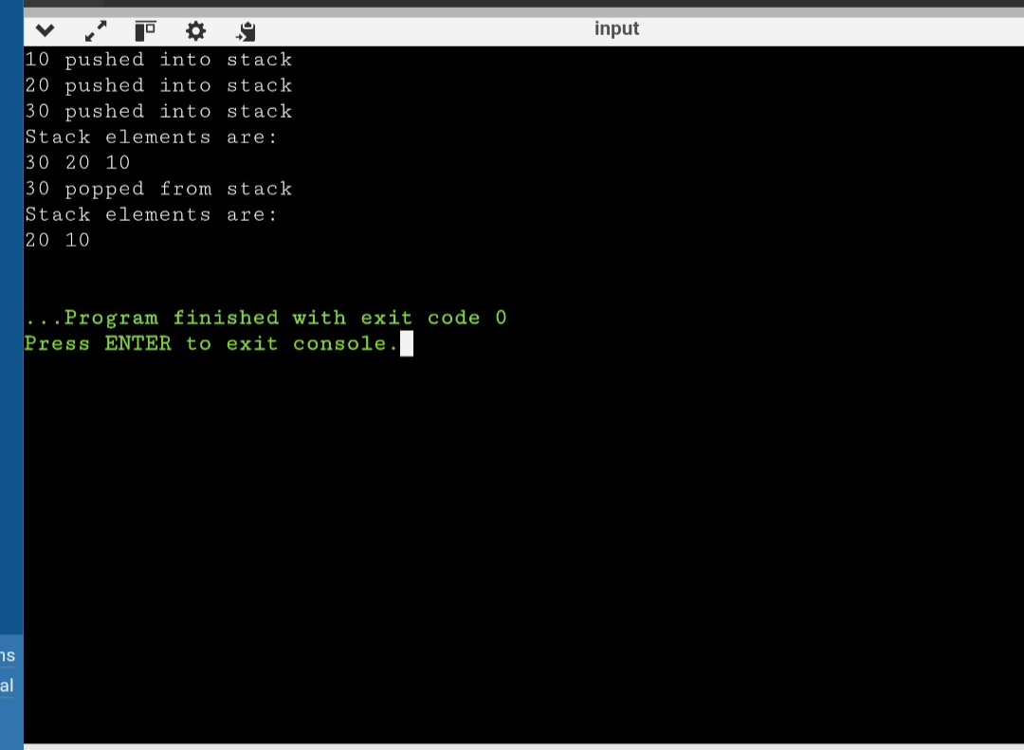

Program Screenshot
