SathyaNarayanan Srinivasan

Sxs142031@utdallas.edu

Abstract

Creating and implementing a library management system

library management

Database Design Programming Project - 1

Table of Contents

Requirements 2

Prerequisites 2

Compiling,Building and Running Instructions 2

For SQL Code 2

For JAVA Code/NetBeans Project 3

Quick Start User Guide 3

Login window 3

Main Options Window 4

Search Window 5

Check-In Window 6

Fine Payment/View Window 6

Checkout Window 7

Add Borrower Window 7

High-Level Architecture 8

Design Decisions 9

Technical Dependencies 10

Learning 10

# Requirements

* **Operating System** – Windows 7 or Higher
* **Product Version :** NetBeans 8.0.2 Patch 2 or higher
* **MySQL –** Version 1.4
* **MySQL Workbench –** [Version 6.3 or higher](https://dev.mysql.com/downloads/file/?id=459898)
* **Java Version –** JDK 1.7 or Higher
* **PDF Processor** – Adobe PDF Reader
* **Word Processor** – Microsoft Word (Higher)
* **Other Dependencies** - mysql-connector-java-5.0.8 and mysql-connector-java-5.1.37

# Prerequisites

* Please ensure that JDK ver. 1.7 is installed properly and working in the machine.
* Please DON’T alter the order of compiling or running instructions.
* Use SQL Workbench to run the create schema and load data commands.

# Compiling,Building and Running Instructions

## For SQL Code

* Open MySQL Workbench.
* Select File then Open MySQL Script
* Navigate to the downloaded project folder and to the SQLCommandsAndData folder
* Make sure all the Data (.csv) are placed in the Uploads folder of the MySQL installation.
* Ensuring proper connectivity is there to the local server, run the SQL Script – CreateAndLoadSchema.SQL
* This creates the schema and loads all the data.

## For JAVA Code/NetBeans Project

* Open NetBeans.
* Select File then Open Project
* Navigate to the downloaded project folder and select Library Management Project
* If dependency issues occur, please resolve dependency problems. The JDBC connectors are provided in the Connectors folder in the project.

# Quick Start User Guide

## Login window

Enter the valid username and password

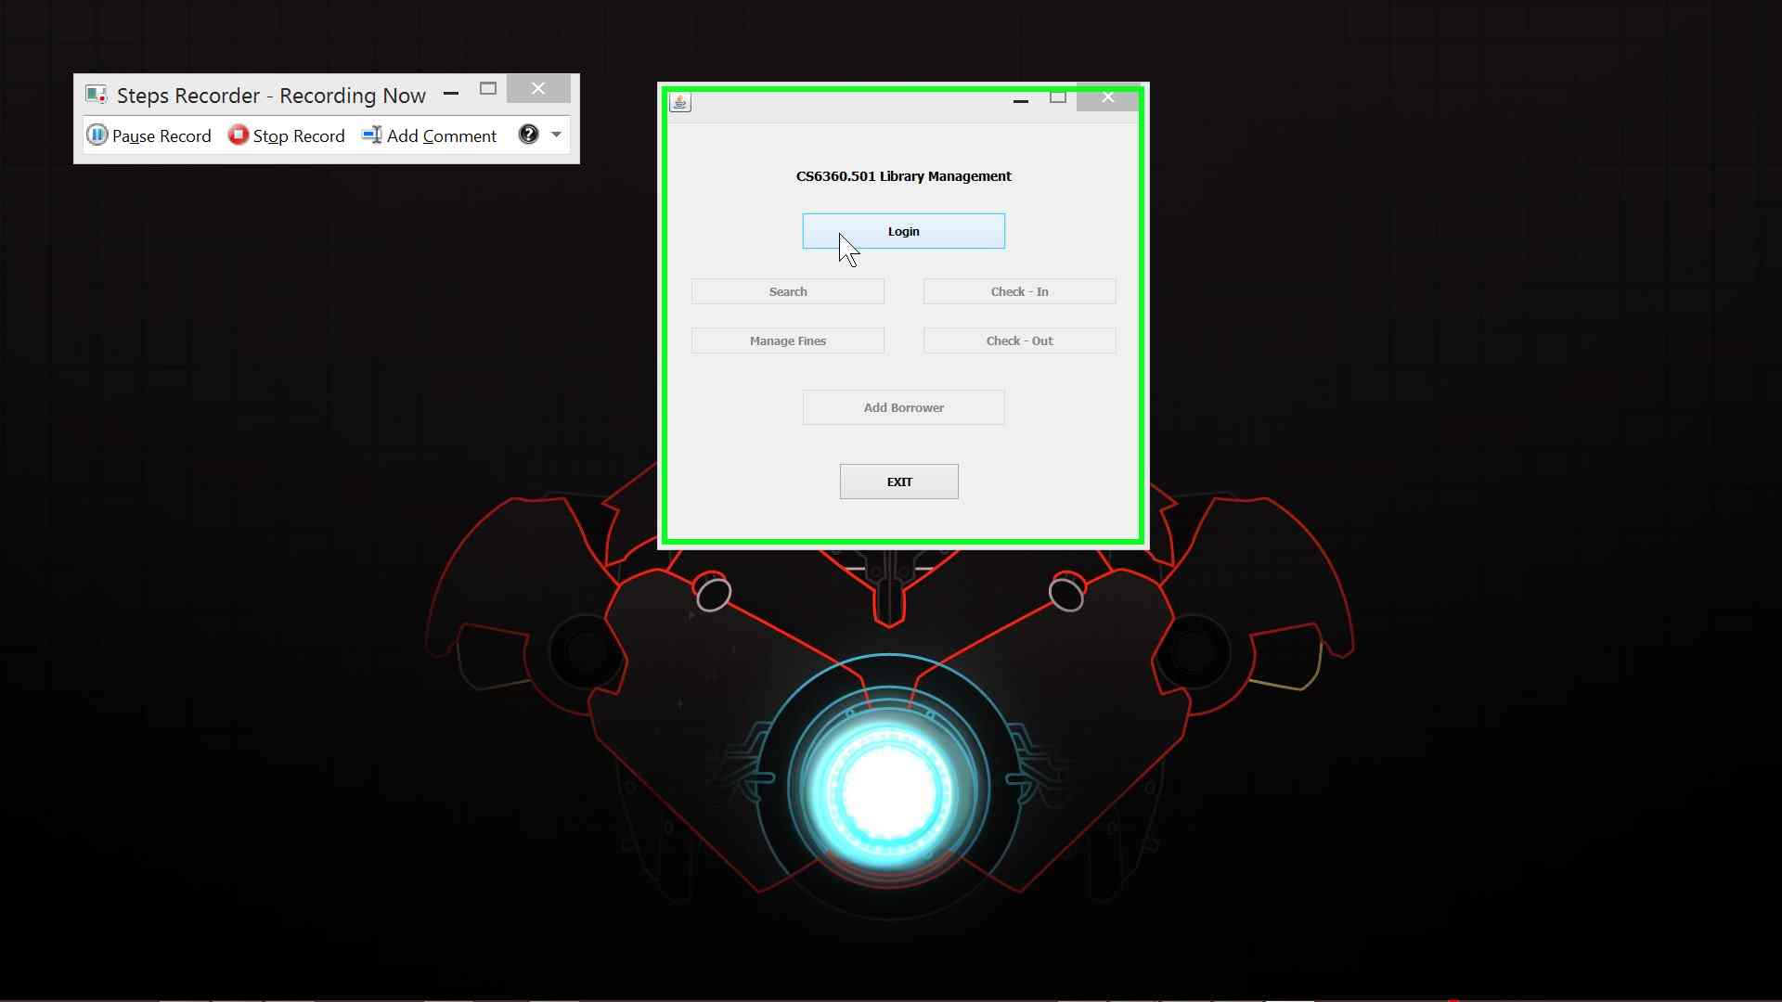

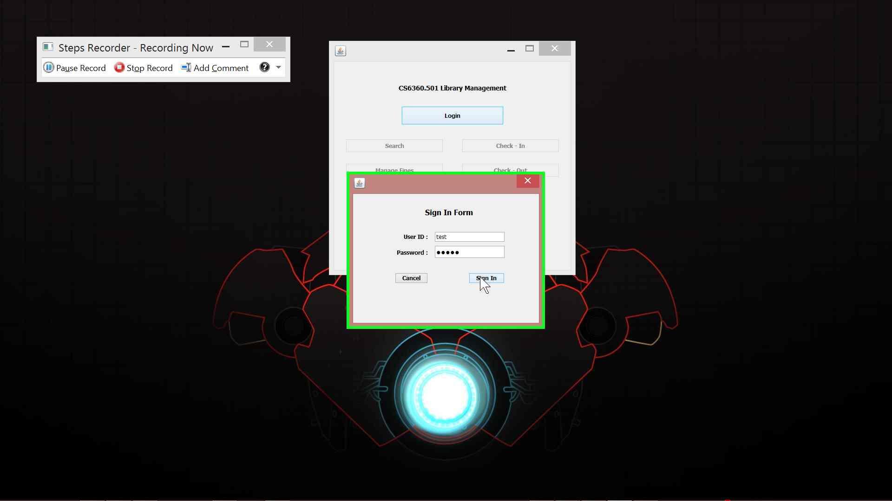

## Main Options Window

Options to Search, Check-In, Check-Out, and Borrower Addition and to Manage fines are given.

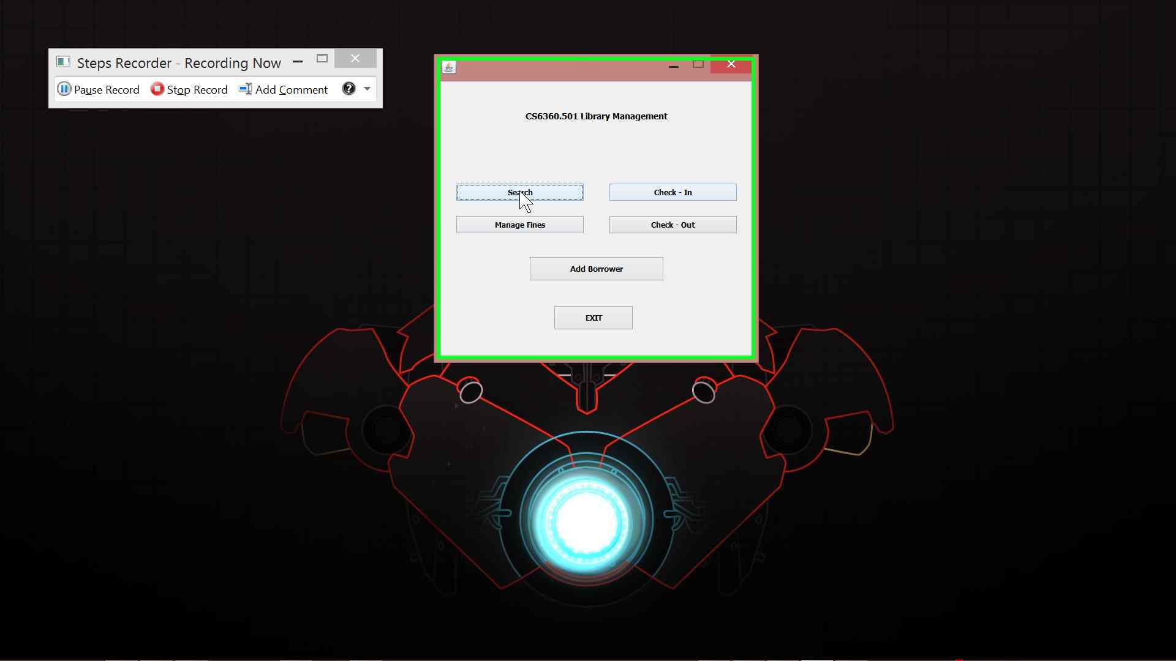

## Search Window

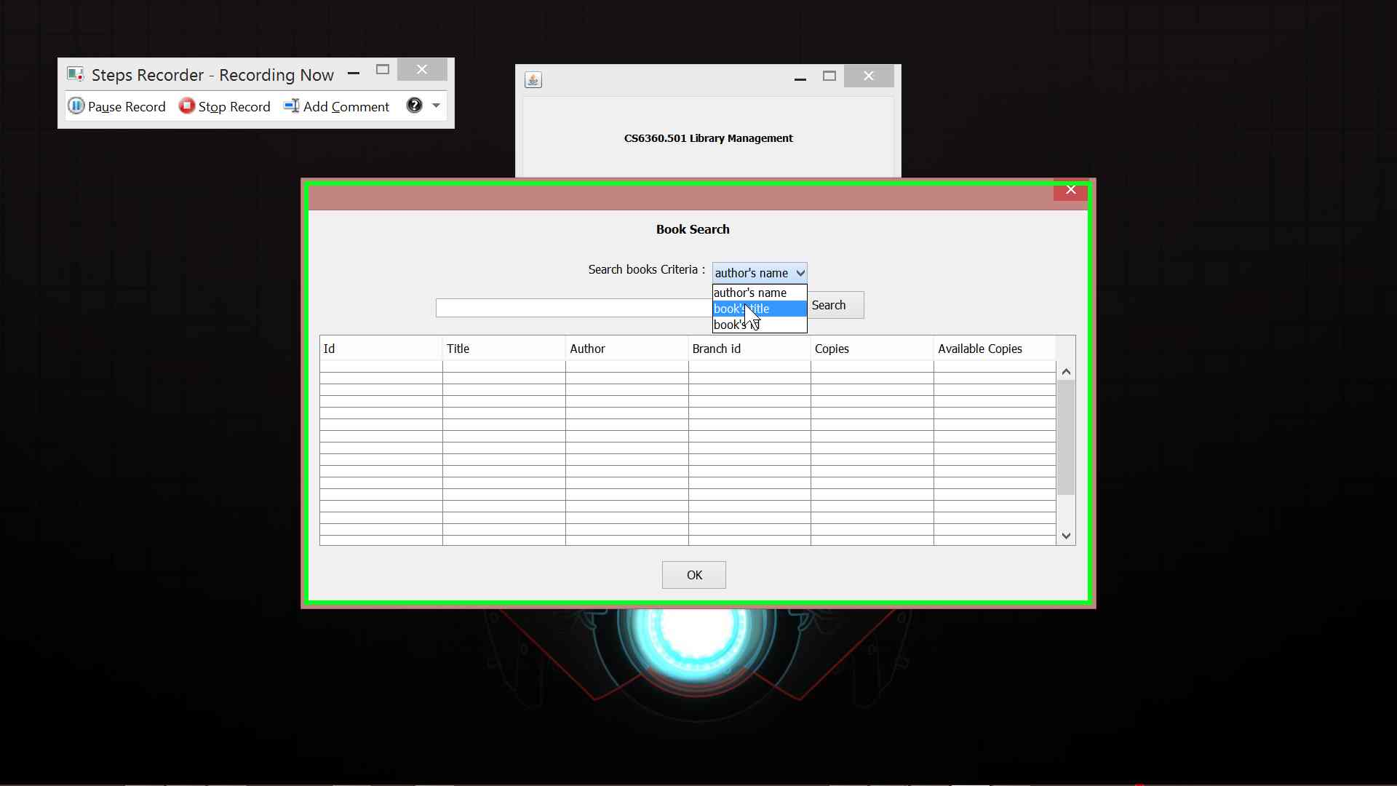Option to search for the book by author’s name, book’s title and book’s id are provided.The search button if hit, lists results on to the table below.

## Check-In Window

Option to Check-In books are provided with a search functionality to search for the books using book id, card number and the borrower’s name and check in as required.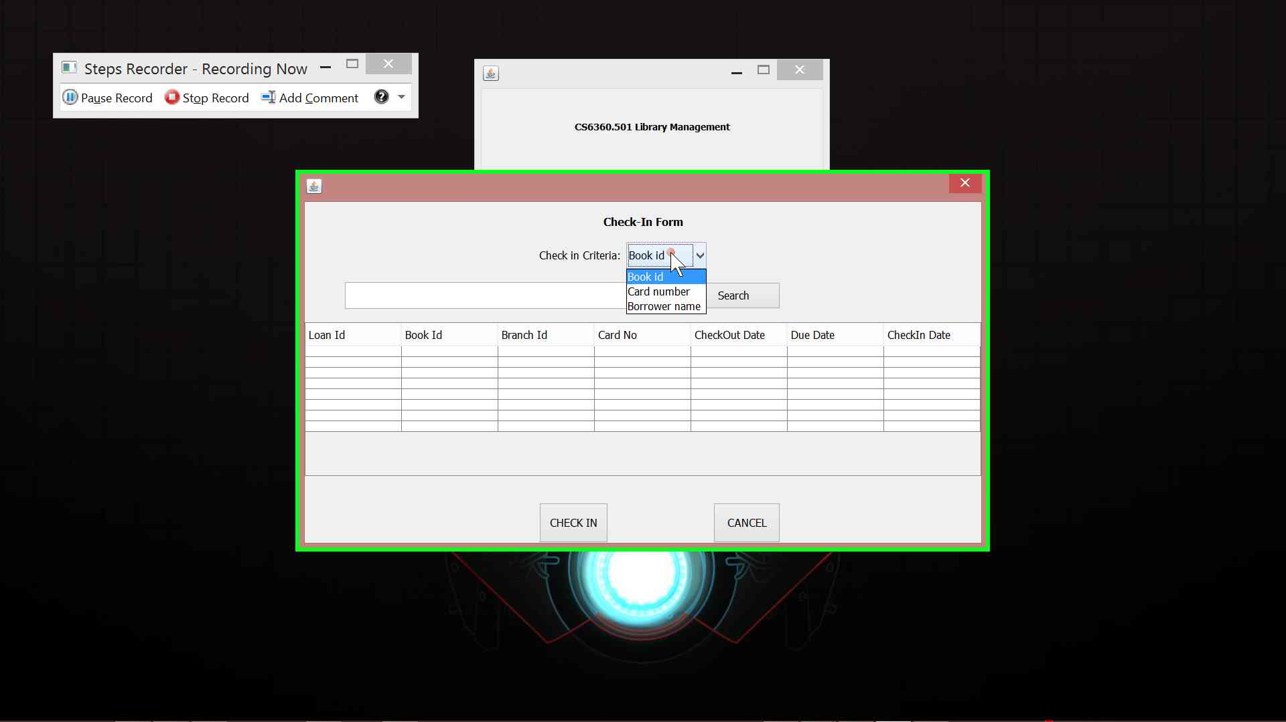

## Fine Payment/View Window

The fine payment window lists all the fines to be paid in the reload button and also, has the capability to pay fines.

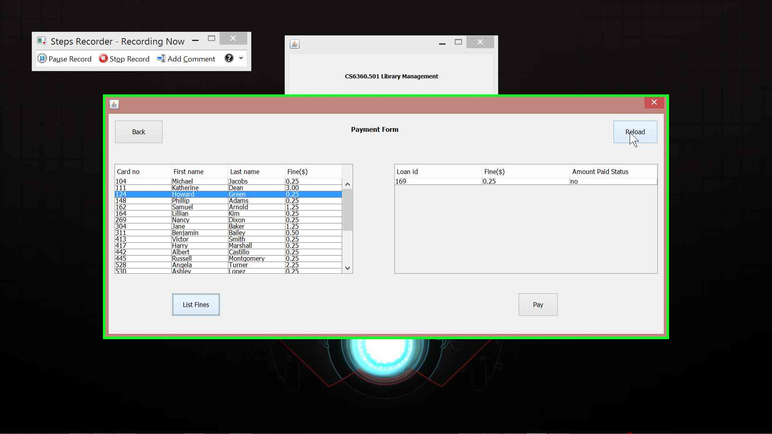

## Checkout Window

The Checkout window has the capability to get the card number, book id and branch id to

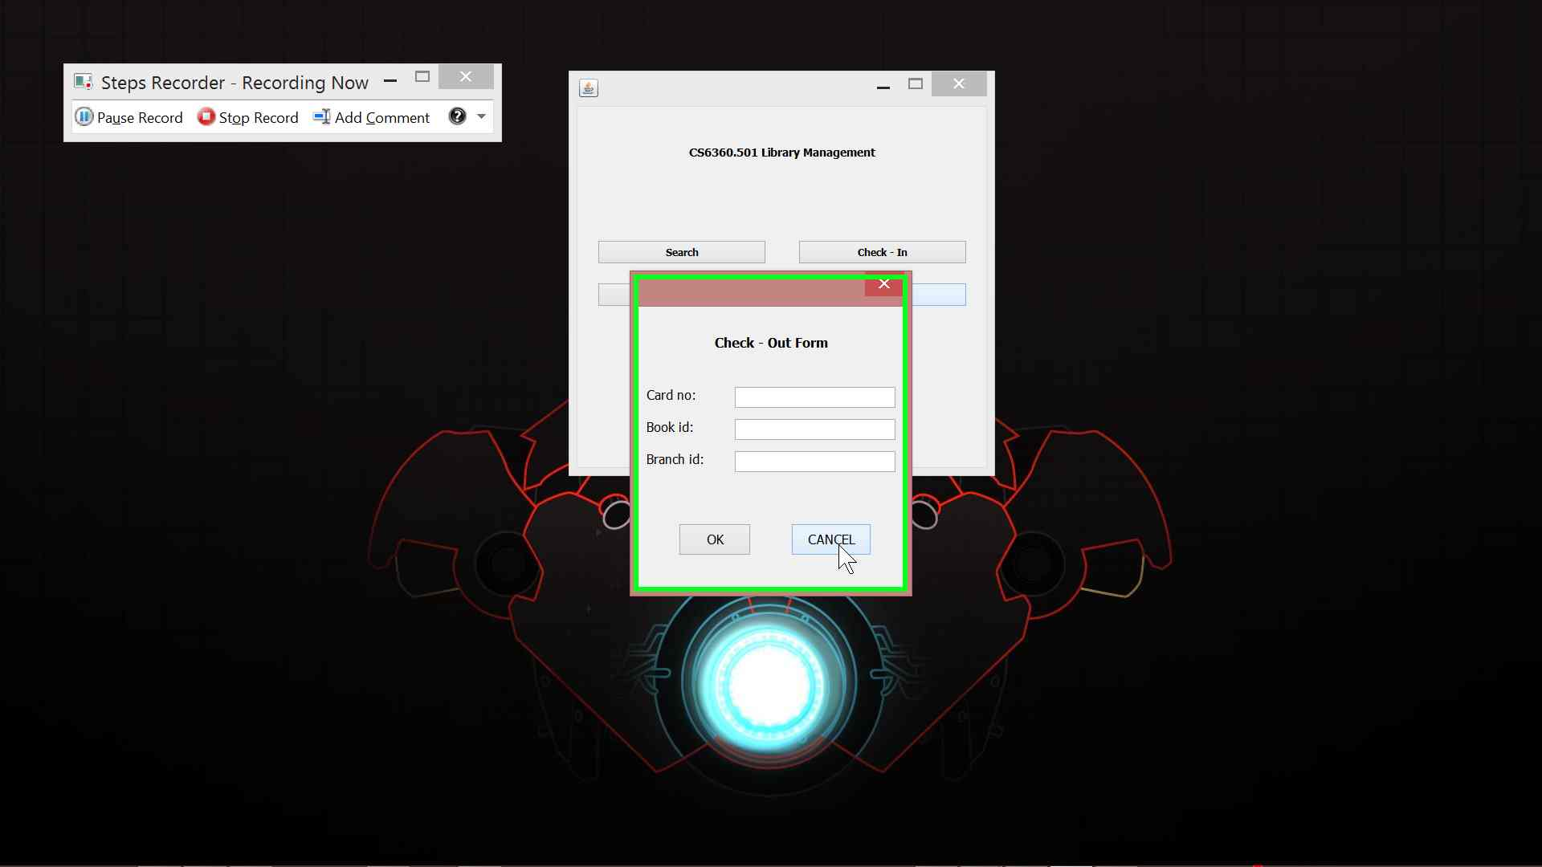Checkout the specific books from specific branches.

## Add Borrower Window

The add borrower window has the ability to add borrowers and generate new card numbers after getting valid inputs from them.

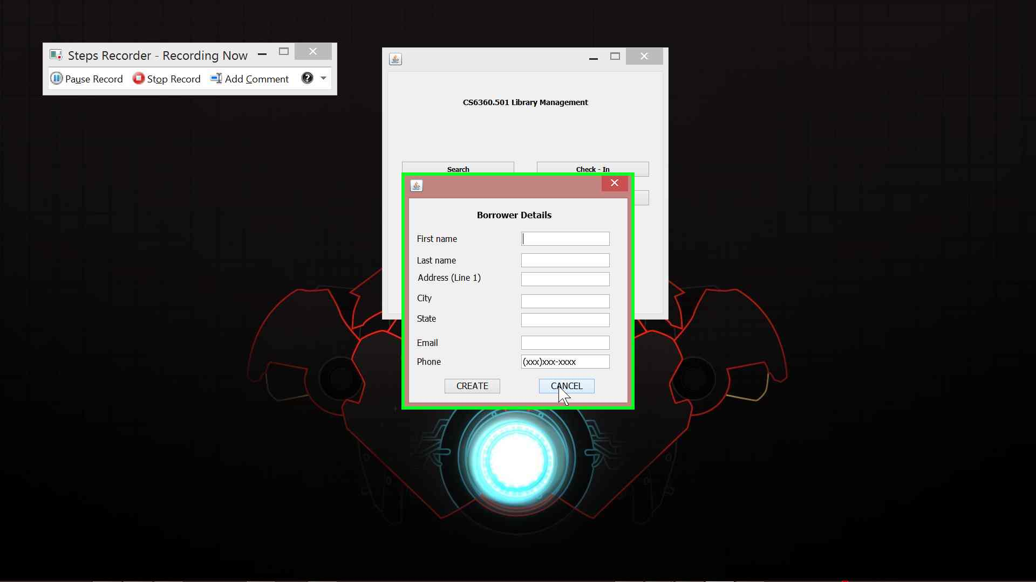

# High-Level Architecture

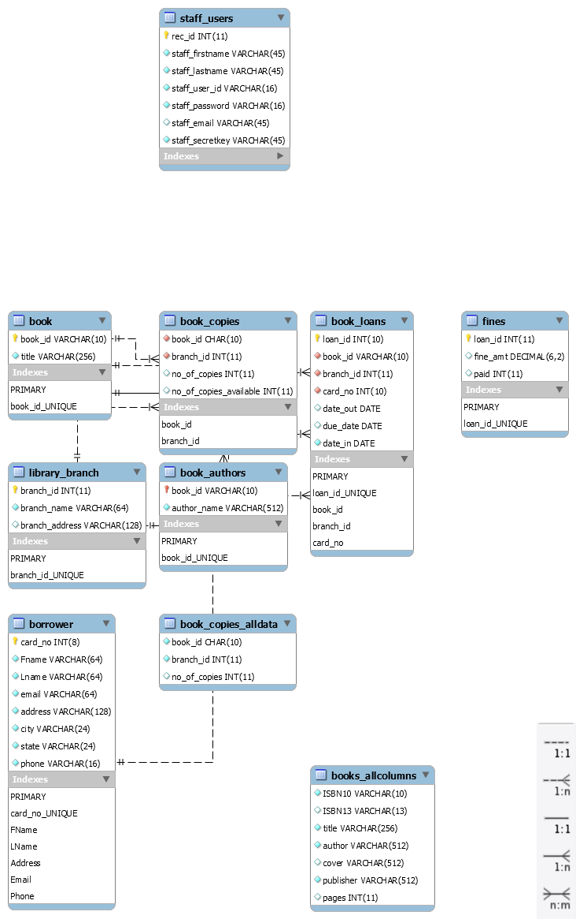The high level architecture can be represented in the form of an EER diagram of the database.

# Design Decisions

The schema given in the diagram is strictly adhered to.

For reference:

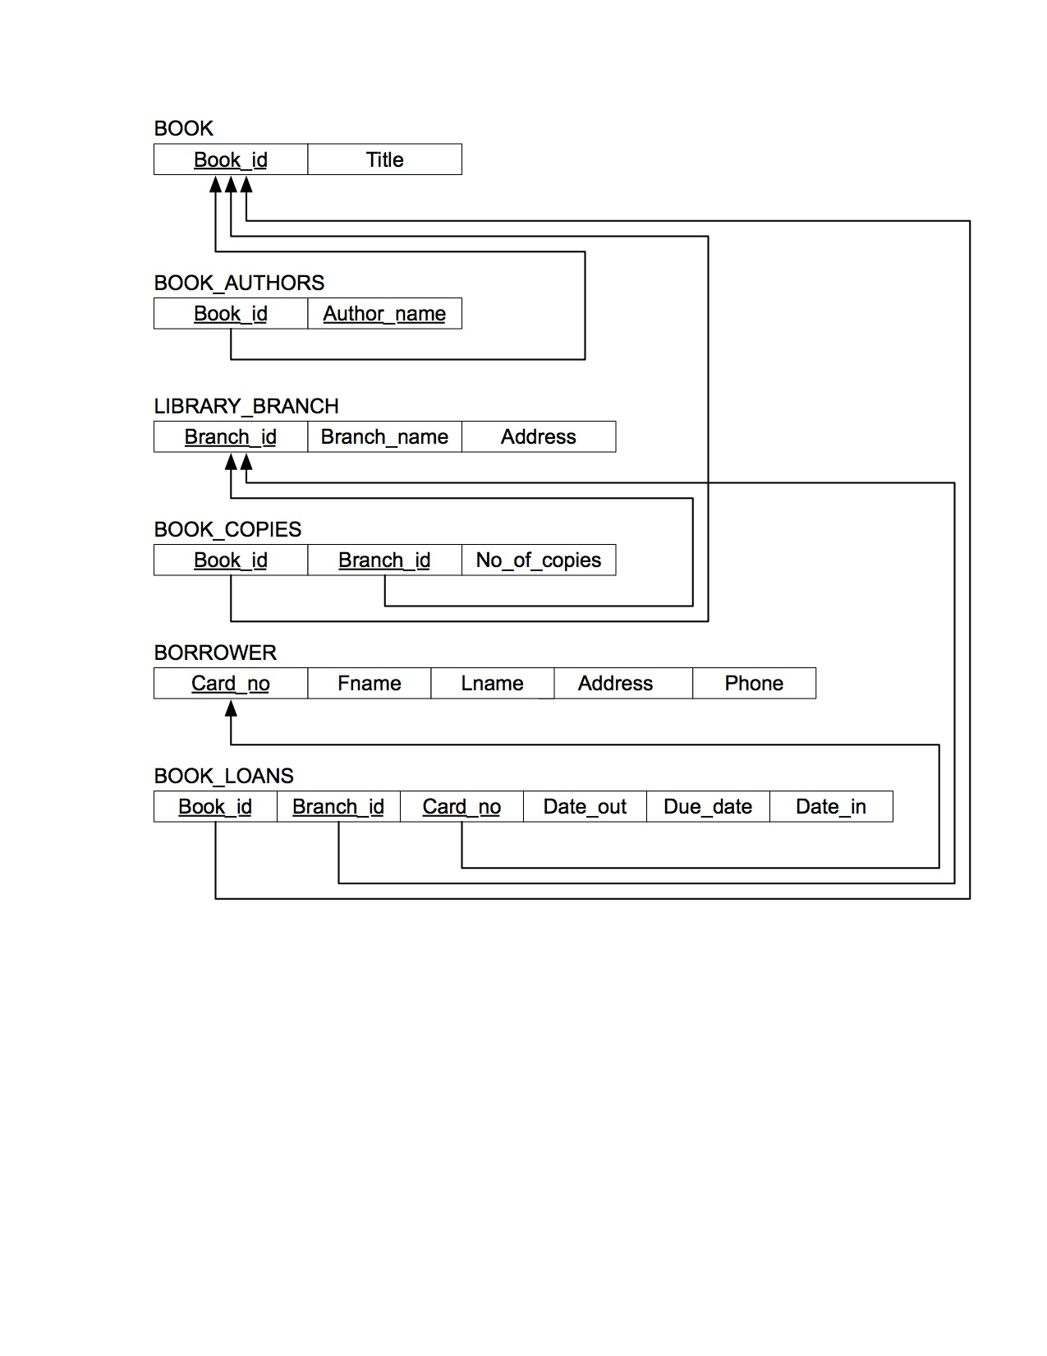

Other major design decisions includes:

* Cleaning up of input data to accommodate nulls, unrecognizable characters and duplicates in the given data to make the number of tuples in books table to be equal to the number of tuples in book_authors table.
* Foreign Keys are added without update/delete criteria as they are not required for this use case.
* The ‘date_in’ field of book_loans is created with a default value of '0000-00-00' in order to accommodate the values given.
* The ‘city ‘and ‘state’ tuples of the ‘borrower’ relations are created with a default ‘unknown’ values.

# Technical Dependencies

The project is implement solely based on MYSQL. It has limitations when the create script is run using a different tool/DBMS.

The create schema and load data scripts are made into one to reduce errors.

# Learning

Although the software is competent with the given requirements. Other essential integrations like intimating the user of a fine if it exceeds a certain threshold automatically could have been implemented.