https://docs.google.com/forms/d/1AyPA1jT3QrYbAr0MexTkQy8B5C8uyk0jTZIkL47CXH0/viewform?edit_requested=true

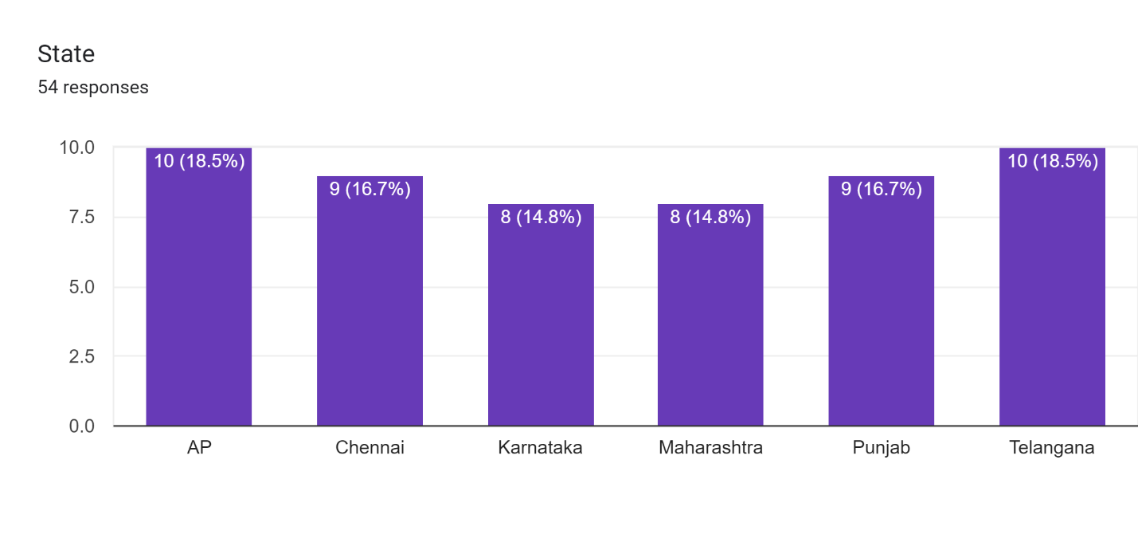Forms response chart. Question title: Gender
. Number of responses: 54 responses.Forms response chart. Question title: Age Group
. Number of responses: 54 responses.Forms response chart. Question title: Daily how many times consumption food
. Number of responses: 54 responses.Forms response chart. Question title: Which type of food preferred
. Number of responses: 54 responses.Forms response chart. Question title: Which type of  food categories  preferred
. Number of responses: 54 responses.Forms response chart. Question title: which  Types of vegetables  preferred
. Number of responses: 54 responses.Forms response chart. Question title: which  Types of Fruits  preferred
. Number of responses: 54 responses.Forms response chart. Question title: Non-vegetarian food  preferred
. Number of responses: 54 responses.Forms response chart. Question title: beverages  preferred
. Number of responses: 54 responses.