SRI CHANDRASEKHARENDRA SARASWATHI VISWA MAHAVIDYALAYA
(Deemed to be University U/S 3 Of The UGC Act 1956) Accredited with “A” Grade by NAAC ENATHUR,KANCHIPURAM – 631 561



DATA STRUCTURES LAB
LABORATORY RECORD

Name : S. SATHYANARAYANAN
Reg. No : 112514027
Class : I B.SC (COMPUTER SCIENCE WITH CYBER SECURITY)

Subject : DATA STRUCTURES LAB
SRI CHANDRASEKHARENDRA SARASWATHI VISWA MAHAVIDYALAYA
(Deemed to be University U/S 3 Of The UGC Act 1956) Accredited with “A” Grade by NAAC ENATHUR,KANCHIPURAM – 631 561



BONAFIDE CERTIFICATE
This is to certify that this is the bonafide record of work done by Mr./Ms. S. SATHYANARAYANAN with Reg.No. 112514027 of First Year B.Sc(Computer Science with Cyber Security) in the UCYF232P60 - Data Structures Lab during the EVEN Semester of the year 2025- 2026.

Staff-in-charge Head of the Department

Submitted for the Practical Examination held on --.

Internal Examiner External Examiner

INDEX

S.No. | Date | Title | Page No. | Signature
1 | 23/01/2026 | Program for implementation of Stack using Array | 1
2 | 30/01/2026 | Program for Implementation of Queue using Array | 5
3 | 11/02/2026 | Program to Implement Circular Queue | 9
4 | 18/02/2026 | Program to Implement Linked list. | 13
5 | 06/03/2026 | Program to Implement Doubly Linked list. | 17
6 | 18/03/2026 | Program To Arrange the list of numbers in ascending order using Bubble Sort | 22
7 | 25/03/2026 | Program to arrange the list of numbers in ascending order using Insertion Sort. | 25
8 | 01/04/2026 | Program to Implement Quick sort. | 28
9 | 08/04/2026 | Program to Implement Linear search | 31
10 | 22/04/2026 | Program to implement Binary Search | 34

Date: 23/01/2026 | 1.Program for implementation of Stack using Array

AIM:
To implement stack operations such as Push, Pop, and Display using arrays.

ALGORITHM:
Step-1: Start the Program. Step-2:Initialize top = -1 Step-3: Push Operation:
- Check if top == n-1, print overflow
- Else increment top and insert element

Step-4: Pop Operation:
- Check if top == -1, print underflow
- Else delete element and decrement top

Step-5: Display Operation:
- If stack empty, print message
- Else display elements from top to 0
Step-6: Stop the program.

SOURCECODE:
#include <iostream> using namespace std;
int Stack[100], n=100, top= -1; //Static declaration of stack void Push(){
int value;
cout<<"Enter a number to insert into the stack: "; cin>>value;
if(top == n-1){
cout<<"Stack Overflow"<<endl; return;
} else {
top++;
Stack[top] = value;
cout<<value<<" is inserted."<<endl;
}
}
void Pop(){
if(top == -1){
cout<<"Stack Underflow"<<endl; return;
} else {
cout<<Stack[top]<<" is deleted."<<endl; top--;
}
}
void Display(){
if(top == -1){
cout<<"Stack is empty"<<endl; return;
} else {
cout<<"Displaying Stack elements: "<<endl; for(int i=top; i>=0; i--){

cout<<Stack[i]<<" ";
}
cout<<endl;
}
}
int main(){
int opt;
cout<<"===== Stack Operations ====="<<endl; cout<<"1. Push \n2. Pop \n3. Display \n4. Exit"<<endl; cout<<"======================="<<endl;
do{
cout<<"Enter your choice: "; cin>>opt;
switch(opt){
case 1: Push(); break; case 2: Pop(); break; case 3: Display(); break;
case 4: cout<<"Exit the program."<<endl; break; default: cout<<"Invalid Choice."<<endl;
}
}while(opt != 4);
return 0;
}

OUTPUT:

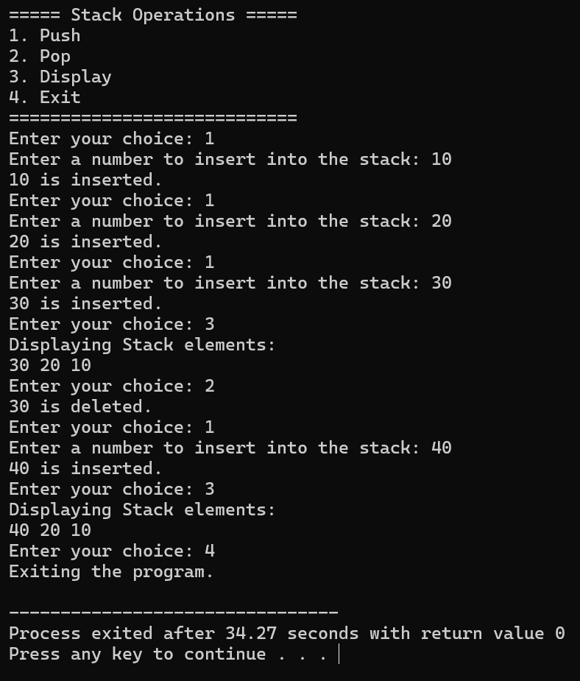

RESULT:

Thus the program is compiled and executed successfully with verified output.

Date: 30/01/2026 | 2.Program for Implementation of Queue using Array

AIM:
To implement queue operations such as Insertion, Deletion, and Display using arrays.

ALGORITHM:
Step-1: Start the program
Step-2: Initialize front = -1, rear = -1

Step-3: Insert()
- Check overflow (rear == n-1)
- If first element, set front = 0
- Increment rear and insert element

Delete()
- Check underflow (front == -1 or front > rear)
- Delete element and increment front

Display()
- Print elements from front to rear
Step-4 :Stop the Program

SOURCE CODE:

#include <iostream> using namespace std;
int Queue[100], n=100, front= -1, rear= -1; // Static declaration of queue int input_values[] = {10,20,30,40,50};
int input_index = 0;
int total_values = sizeof(input_values)/sizeof(input_values[0]); void Insert(){
if(rear == n-1){
cout<<"Queue Overflow"<<endl; return;
} else {
if(front == -1){
front = 0;
}
if(input_index<total_values){
int value = input_values[input_index++]; Queue[++rear] = value;
cout<<"Inserted Value: "<<value<<endl;
} else {
cout<<"No more predefined elements to insert."<<endl; return;
}
}
}
void Delete(){
if(front == -1 || front >rear){ cout<<"Queue Underflow"<<endl; return;
} else {
cout<<"Deleted value: "<<Queue[front++]<<endl;
}
}

void Display(){
if(front == -1 || front >rear){ cout<<"Queue is empty"<<endl; return;
} else {
cout<<"Displaying Queue elements: "; for(int i=front; i<=rear; i++){
cout<<Queue[i]<<" ";
}
cout<<endl;
}
}
int main(){
Insert();
Insert();
Insert();
Display();
Delete();
Insert();
Insert();
Insert(); Display(); Delete(); Display(); return 0;
}

OUTPUT:
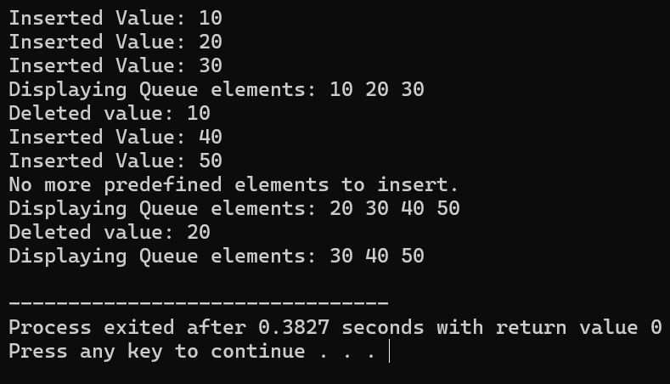

RESULT:

Thus the program is compiled and executed successfully with verified output.

Date: 11/02/2026 | 3.Program to Implement Circular Queue

AIM:

To implement circular queue operations using arrays.

ALGORITHML:
Step-1: Start the program
Step-2:Initializefront = rear = -1
Step-3 : Enqueue:
- Check overflow (rear+1)%MAX == front
- Insert element using circular increment
Step-4:Dequeue:
- Check underflow
- Delete element and update front circularly
Step-5:Display:
Traverse from front to rear circularly
Step-6:Stop the program.

SOURCECODE:

#include <iostream> using namespace std; #define MAX 5
int queue[MAX], front = -1, rear = -1; void enqueue(){
int value;
cout<<"Enter the value to insert into the queue: "; cin>>value;
if((rear+1)%MAX == front){ cout<<"Queue Overflow"<<endl; return;
} else {
if(front == -1){
front = rear = 0;
} else {
rear = (rear+1)%MAX;
}

queue[rear] = value; cout<<value<<" is inserted."<<endl;
}
}
void dequeue(){
if(front == -1){
cout<<"Queue Underflow"<<endl; return;
} else {
cout<<queue[front]<<" is deleted."<<endl;

if(front == rear){
front = rear = -1;
} else {

front = (front+1)%MAX;
}
}
}
void display(){
if(front == -1){
cout<<"Queue is empty"<<endl; return;
} else {
cout<<"Displaying queue elements: "; int i = front;

while(true){
cout<<queue[i]<<" "; if(i == rear){
break;
} else {
i = (i+1)%MAX;
}
}
cout<<endl;
}
}
int main(){
int opt;
cout<<"====== Circular Queue Operations ======"<<endl; cout<<"1. Enqueue \n2. Dequeue \n3. Display Queue \n4. Exit"<<endl; cout<<"================================"<<endl;
do{
cout<<"Enter your choice: "; cin>>opt;
switch(opt){
case 1: enqueue(); break;

case 2: dequeue(); break;
case 3: display(); break;
case 4: cout<<"Exiting from the program."<<endl; break;
default: cout<<"Invalid choice."<<endl;
}
}while(opt != 4);
return 0;
}

OUTPUT:
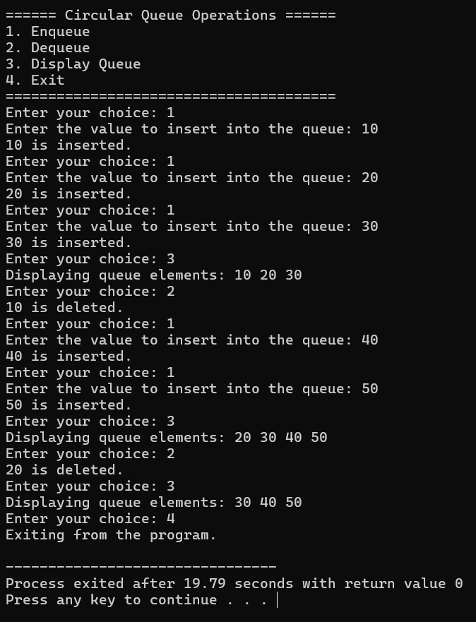

RESULT:

Thus the program is compiled and executed successfully with verified output.

Date: 18/02/2026 | 4.Program to Implement Linked list.

AIM:
To implement insertion, deletion, and display operations in a singly linked list.

ALGORITHM:
Step-1:Start the program.

Step-2:Insert():
- Create new node
- If list empty → assign head
- Else traverse and insert at end

Step-3:Delete():
- Remove first node

Step-4:Display():
- Traverse and print all nodes
Step-5:Stop the program.

SOURCECODE:
#include <iostream> using namespace std; struct Node{
int data;
Node* next;
};
Node* head = NULL; void Insert(){
int value;
cout<<"Enter element: "; cin>>value;
Node* newNode = new Node(); newNode->data = value; newNode->next = NULL; if(head == NULL){
head = newNode;
} else {
Node* temp = head; while(temp->next != NULL){
temp = temp->next;
}
temp->next = newNode;
}
cout<<"Element Inserted!"<<endl;
}
void Delete(){
if(head == NULL){
cout<<"List is empty"<<endl; return;
} else {
Node* temp = head; head = head->next;

cout<<"Deleted element: "<<temp->data<<endl; delete temp;
}
}
void Display(){
Node* temp = head; if(temp == NULL){
cout<<"List is empty!"<<endl; return;
} else {
cout<<"Linked list:"; while(temp != NULL){
cout<<temp->data<<"->"; temp = temp->next;
}
cout<<"NULL"<<endl;
}
}
int main(){
int opt;
cout<<"===== Linked List Operations ====="; cout<<"\n1. Insert\n2. Delete\n3. Display\n4. Exit"<<endl;
cout<<"=================================="<<endl;
do{
cout<<"Enter your choice: "; cin>>opt;
switch(opt){
case 1: Insert(); break; case 2: Delete(); break; case 3: Display(); break;
case 4: cout<<"Exiting from program!"<<endl; break; default: cout<<"Invalid Choice!"<<endl;
}

}while(opt != 4);
return 0;
}

OUTPUT:
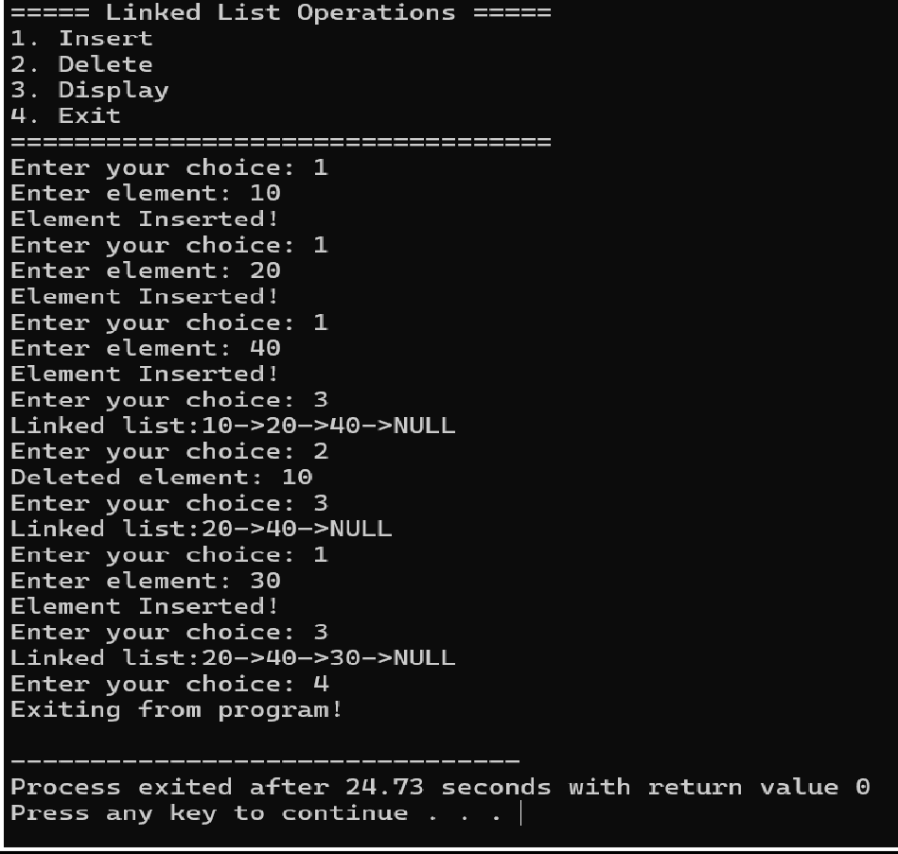

RESULT:

Thus the program is compiled and executed successfully with verified output.

Date: 06/03/2026 | 5.Program to Implement Doubly Linked list.

AIM:
To implement insertion, deletion, and traversal in a doubly linked list.

ALGORITHM:

Step-1:Start the program. Step-2:Insert Beginning:
- Create node and adjust pointers

Step-3:Insert End:
- Traverse and insert at end

Step-4:Delete Beginning/End:
- Adjust pointers accordingly

Step-5:Display Forward & Backward:
- Traverse using next and prev

Step-6: Stop the Program.

SOURCECODE:
#include <iostream> using namespace std; struct Node {
int data;
Node* prev;
Node* next;
};
Node* head = NULL;
void insertBeginning(int value) { Node* newNode = new Node();
newNode->data = value; newNode->prev = NULL; newNode->next = head;
if (head != NULL)
head->prev = newNode; head = newNode;
}
void insertEnd(int value) {
Node* newNode = new Node(); newNode->data = value; newNode->next = NULL;
if (head == NULL) { newNode->prev = NULL;
head = newNode; return;
}
Node* temp = head;
while (temp->next != NULL) temp = temp->next;
temp->next = newNode; newNode->prev = temp;
}
void deleteBeginning() { if (head == NULL) {
cout<< "List is empty!\n"; return;
}
Node* temp = head; head = head->next; if (head != NULL)
head->prev = NULL; delete temp;

}
void deleteEnd() {
if (head == NULL) { cout<< "List is empty!\n";
return;
}
Node* temp = head;
if (temp->next == NULL) { head = NULL;
delete temp; return;
}
while (temp->next != NULL) temp = temp->next;
temp->prev->next = NULL; delete temp;
}
void displayForward() { Node* temp = head; while (temp != NULL) {
cout<< temp->data << " <-> "; temp = temp->next;
}
cout<< "NULL\n";
}
void displayBackward() { Node* temp = head;

if (temp == NULL) return;
while (temp->next != NULL) temp = temp->next;
while (temp != NULL) { cout<< temp->data << " <-> "; temp = temp->prev;
}
cout<< "NULL\n";
}
int main() {
int choice, value;
cout<< "\n--- Doubly Linked List Menu ---\n"; cout<< "1. Insert at Beginning\n";
cout<< "2. Insert at End\n";

cout<< "3. Delete from Beginning\n"; cout<< "4. Delete from End\n"; cout<< "5. Display Forward\n"; cout<< "6. Display Backward\n"; cout<< "7. Exit\n";
cout<< " \n";
do {
cout<< "Enter your choice: "; cin>> choice;
switch (choice) { case 1:
cout<< "Enter value: "; cin>> value;
insert Beginning(value);
break;
case 2:
cout<< "Enter value: "; cin>> value;
insertEnd(value); break;
case 3: deleteBeginning();
break; case 4:
deleteEnd();
break; case 5:
displayForward();
break; case 6:
displayBackward();
break; case 7:
cout<< "Exiting from program"<<endl; break;
default:
cout<< "Invalid choice!"<<endl;
}
} while (choice != 7); return 0;
}

OUTPUT:
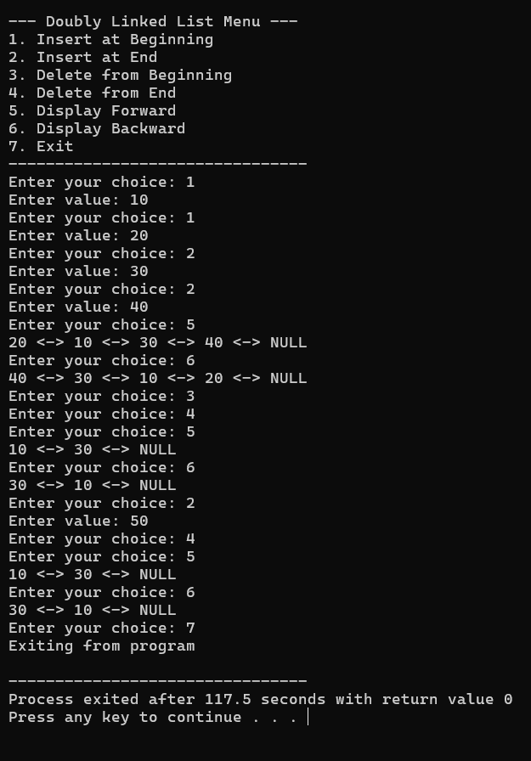

RESULT:

Thus the program is compiled and executed successfully with verified output.

Date: 18/03/2026 | 6.Program To Arrange the list of numbers in ascending order using Bubble Sort

AIM:
To sort elements in ascending order using Bubble Sort.

ALGORITHM:

Step 1: Start the program.

Step 2: Read the number of elements n. Step 3: Input n elements into the array. Step 4: Repeat from i = 0 to n-2:
- Compare adjacent elements in the array.

Step 5: For each i, repeat from j = 0 to n-i-2:

- If arr[j] > arr[j+1], swap the elements.
Step 6: Continue the process until all elements are sorted.

Step 7: Display the sorted array in ascending order.

Step 8: Stop the program.

SOURCECODE:
#include <iostream> using namespace std; int main(){
int n;
cout<<"Enter number of elements: "; cin>>n;
int arr[n];
cout<<"Enter "<<n<<" of elements of the array: "; for(int i=0; i<n; i++)
cin>>arr[i];
//Bubble sort
for(int i=0; i<n-1; i++){
for(int j=0; j<n-i-1; j++){ if(arr[j] >arr[j+1]){
int temp = arr[j]; arr[j] = arr[j+1]; arr[j+1] = temp;
}
}
}
cout<<"Displaying sorted array in ascending order: "; for(int i=0; i<n; i++){
cout<<arr[i]<<" ";
}
return 0;
}

OUTPUT:
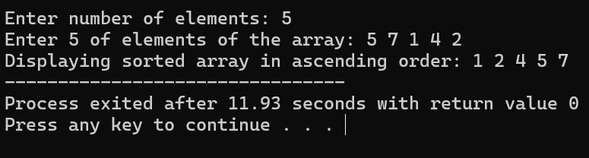

RESULT:

Thus the program is compiled and executed successfully with verified output.

Date: 25/03/2026 | 7.Program to arrange the list of numbers in ascending order using Insertion Sort.

AIM:
Program to sort elements using Insertion Sort.

ALGORITHM:

Step 1: Start the program.

Step 2: Declare variables n, i, j, and key.

Step 3: Prompt the user to enter the number of elements n.

Step 4: Read the value of n.

Step 5: Declare an array arr[n].

Step 6: Prompt the user to enter n elements.

Step 7: Read the elements into the array using a loop from i = 0 to n-1. Step 8: Begin the Insertion Sort process by looping from i = 1 to n-1. Step 9: Assign key = arr[i].
Step 10: Set j = i - 1.

Step 11: Compare key with elements before it:

- While j >= 0 and arr[j] > key, do the following:
  - Shift arr[j] to position arr[j+1]
  - Decrement j by 1

Step 12: Place the key at position arr[j+1].
Step 13: Repeat Steps 9 to 12 until all elements are sorted.

Step 14: Display the sorted array in ascending order using a loop from i = 0 to n-1.
Step 15: Stop the program.

SOURCECODE:

#include <iostream> using namespace std; int main(){
int n;
cout<<"Enter number of elements: "; cin>>n;
int arr[n];
cout<<"Enter "<<n<<" of elements of the array: "; for(int i=0; i<n; i++)
cin>>arr[i];
//Insertion sort
for(int i=1; i<n; i++){
int key = arr[i]; int j = i-1;
while(j >= 0 &&arr[j] >key){ arr[j+1] = arr[j];
j--;
}
arr[j+1] = key;
}
cout<<"Displaying sorted array in ascending order: "; for(int i=0; i<n; i++){
cout<<arr[i]<<" ";
}
return 0;
}

OUTPUT:
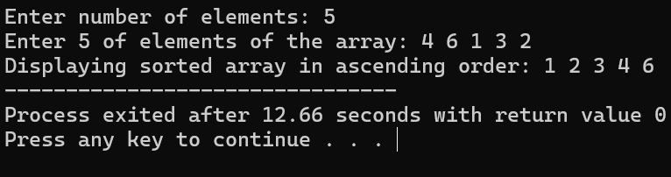

RESULT:

Thus the program is compiled and executed successfully with verified output.

Date: 01/04/2026 | 8.Program to Implement Quick sort.

AIM:
Program to sort elements using Quick Sort (Divide and Conquer).

ALGORITHM:

Step 1: Start the program.

Step 2: Read the number of elements n. Step 3: Input n elements into the array. Step 4: Call quickSort(arr, 0, n-1).
Step 5: In quickSort, check if low < high.

Step 6: Find pivot position using partition() function. Step 7: Sort left part using quickSort(arr, low, pi-1). Step 8: Sort right part using quickSort(arr, pi+1, high). Step 9: In partition, choose last element as pivot.
Step 10: Arrange elements smaller than pivot to left side.

Step 11: Place pivot in correct position.

Step 12: Repeat until array is sorted.

Step 13: Display the sorted array.

Step 14: Stop the program.

SOURCECODE:
#include <iostream> using namespace std;
//Function to partition the array.
int partition(int arr[], int low, int high){
int pivot = arr[high]; // Choose the last element as pivot int i = low-1;
for(int j=low; j<high; j++){ if(arr[j] < pivot){
i++;
//Swap arr[i] and arr[j] int temp = arr[i];
arr[i] = arr[j]; arr[j] = temp;
}
}
//place pivot in correct position int temp = arr[i+1];
arr[i+1] = arr[high]; arr[high] = temp; return (i+1);
}

//Quick sort function
void quickSort(int arr[], int low, int high){ if(low < high){
int pi = partition(arr,low,high); quickSort(arr,low,pi-1); quickSort(arr,pi+1,high);
}
}
//Main Function int main(){
int n;
cout<<"Enter the number of elements of the array: "; cin>>n;
int arr[n];
cout<<"Enter the elements of the array: "; for(int i=0; i<n; i++){
cin>>arr[i];
}
quickSort(arr,0,n-1);
cout<<"Sorted array in ascending order: "; for(int i=0; i<n; i++){
cout<<arr[i]<<" ";
}
return 0;
}

OUTPUT:
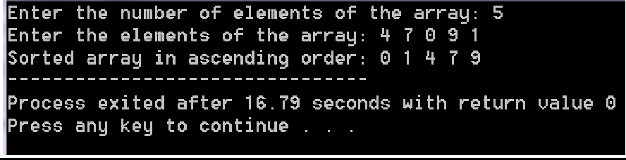

RESULT:

Thus the program is compiled and executed successfully with verified output.

Date: 08/04/2026 | 9.Program to Implement Linear search

AIM:
To write a C++ program to implement Linear search technique.

ALGORITHM:
Step-1: Start the program.
Step-2: Read number of elements n
Step-3: Input array elements
Step-4: Read the element to search (key)
Step-5: Traverse the array from index 0 to n-1 Step-6: If arr[i] == key, display position and stop Step-7: If not found, display “Element not found” Step-8: Stop the program.

SOURCECODE:
#include <iostream> using namespace std; int main(){
int n,i,key,found = 0;
cout<<"Enter the number of elements of the array: "; cin>>n;
int arr[n];
cout<<"Enter the elements of the array: "; for(i=0;i<n;i++)
cin>>arr[i];
cout<<"Enter the element to search: "; cin>>key;
//Linear Search for(i=0; i<n; i++){
if(arr[i] == key){
cout<<"Element found at position: "<<(i+1)<<endl; found = 1;
break;
}
}
if(found == 0)
cout<<"Element is not found in the given array!!"<<endl; return 0;
}

OUTPUT:
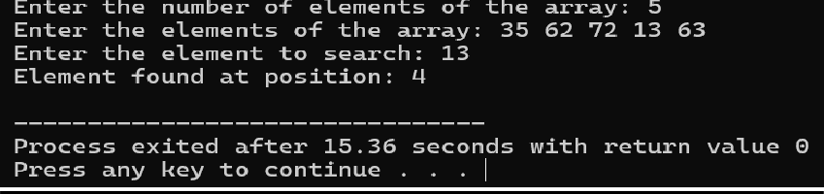

34

RESULT:
Thus the program is compiled and executed successfully with verified output.

34

Date: 22/04/2026 | 10.Program to implement Binary Search

AIM:
To write a C++ program to implement Binary search technique.

ALGORITHM:
Step-1: Start the program.
Step-2: Read number of elements n
Step-3: Input array elements
Step-4: Read the element to search (Key).
Step-5: Set low = 0 and high = n-1
Step-6: Read while low <= high:
- Find mid = (low + high) / 2
- If arr[mid] == key, display position
- If key <arr[mid], set high = mid – 1
- Else, set low = mid + 1
Step-7: If not found, display “Element not found”
Step-8: Stop the program.

35
Source Code:
#include <iostream> using namespace std; int main(){
int n,i,key,low,high,mid,found = 0;
cout<<"Enter the number of elements of the array: "; cin>>n;
int arr[n];
cout<<"Enter the elements of the array: "; for(i=0; i<n; i++){
cin>>arr[i];
}
cout<<"Enter the element to search: "; cin>>key;
low = 0,high = n-1; while(low <= high){
mid = (low +high)/2; if(arr[mid] == key){
cout<<"Element found at position: "<<(mid+1)<<endl; found = 1;
break;
} else if(arr[mid] > key) { high = mid - 1;
} else {
low = mid + 1;
}
}
if(found == 0){
cout<<"Element not found in the given array"<<endl;
}
return 0;
}

36

OUTPUT:

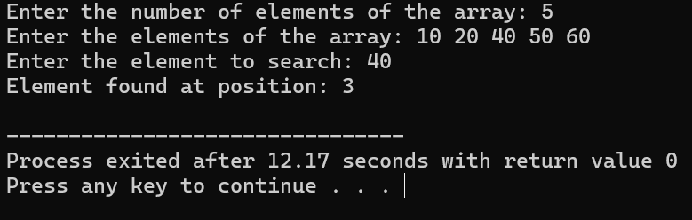

Result:
Thus the program is compiled and executed successfully with verified output.

