BLUESTOCK MUTUAL FUND CAPSTONE PROJECT
  - FINAL DATA ANALYTICS REPORT
Prepared By: KP. Sathya Sai
Role: Data Analysis
Domain: Financial Data Analytics
Project Type: End-to-End Data Analytics (Python+ SQL + Power-BI)

DECLARATION
I hereby declare that this project titled "Bluestock Mutual Fund Capstone Project" is my original work. All analysis, ETL pipeline, and visualization have been completed as part of the capstone requirement.

ACKNOWLEDGEMENT
I would like to express my sincere gratitude to the mentors and team members for their guidance and support throughout this project. Their assistance helped in successfully completing this data analytics project successfully.
TABLE OF CONTENTS
Contents

EXECUTIVE SUMMMARY 4
PROBLEM STATEMENT 5
DATA SOURCES 6
PROJECT ARCHITECTURE & ETL PROCESS 7
DATA CLEANING 8
EXPLORATORY DATA ANALYSIS (EDA) 9
PERFORMANCE METRICS 10
DASHBOARD OVERVIEW 11
KEY INSIGHTS 12
CONCLUSION 13

EXECUTIVE SUMMMARY

This project is an end-to-end data analytics solution focused on mutual fund performance analysis. It involves data ingestion from multiple sources, data cleaning, transformation, and storage in a structured SQLite database.

The objective of this project is to analyze mutual fund schemes, investor transactions, NAV trends, and benchmark performance to generate meaningful insights.

The project uses Python for data processing, SQL for storage, and Power BI for visualization to deliver a complete analytical workflow.

PROBLEM STATEMENT

The objective of this project is to analyze mutual fund datasets to understand performance, risk, and investor behavior.

The project aims to build an end-to-end data pipeline that processes raw financial data into meaningful insights using Python, SQL, and Power BI.

It focuses on evaluating mutual fund schemes based on returns, volatility, and benchmark comparison to support data-driven investment decisions.

DATA SOURCES

The project uses multiple financial datasets to perform end-to-end analysis of mutual fund performance and investor behavior.

The following datasets were used:

- transactions.csv: Contains investor transaction details
- nav_history.csv: Net Asset Value (NAV) history of funds
- scheme_performance.csv: Mutual fund performance metrics
- benchmark_indices.csv: Market benchmark comparison data
- aum_by_fund_house.csv: Assets under management data
- monthly_sip_inflows.csv: SIP investment inflows
- category_inflows.csv: Category-wise fund inflows

PROJECT ARCHITECTURE & ETL PROCESS
The project follows a structured end-to-end data pipeline architecture designed for efficient data processing and analysis.
The workflow consists of the following stages:
1. Data Ingestion:
Raw CSV files are collected from multiple financial sources.
2. Data Cleaning & Transformation:
Missing values are handled, duplicates are removed, and data types are standardized using Python (Pandas).
3. Data Validation:
Data quality checks are performed to ensure accuracy and consistency.
4. Data Storage:
Cleaned data is loaded into a SQLite database for structured storage.
5. Data Analysis:
Exploratory Data Analysis (EDA) is performed to identify trends and patterns.
6. Visualization:
Power BI is used to create interactive dashboards for insights
.
Raw Data

Cleaning

Validation

SQLite DB

Analysis

Dashboard

DATA CLEANING

Data cleaning was performed to ensure the dataset was accurate, consistent, and suitable for analysis.

The following steps were carried out:

- Missing values were identified and handled appropriately
- Duplicate records were removed from datasets
- Date columns were converted into proper datetime format
- Column names were standardized for consistency
- Data types were corrected for numerical and categorical fields
- Outliers were reviewed and handled where necessary

Python Pandas library was used for performing all data cleaning operations efficiently.

Tools Used: Python (Pandas, Numpy)

EXPLORATORY DATA ANALYSIS (EDA)
Exploratory Data Analysis (EDA) was performed to understand patterns, trends, and relationships within the dataset.

The following analyses were conducted:

- Analysis of NAV trends over time to understand fund growth patterns
- Investor transaction behavior analysis to identify investment patterns
- Fund category-wise distribution analysis
- Scheme performance comparison across different mutual funds
- Correlation analysis between risk and return metrics

Various visualization techniques such as line charts, bar charts, and scatter plots were used to derive insights from the data.

Tools used: Python (Matplotlib, seaborn), Power BI

PERFORMANCE METRICS
The performance of mutual funds was evaluated using key financial metrics to assess risk and return characteristics.

The following metrics were used in this project:

- Returns: Measures the profit generated by a mutual fund over a period of time
- Volatility: Indicates the level of risk associated with the fund
- Sharpe Ratio: Measures risk-adjusted returns of the fund
- Alpha: Represents excess returns compared to the benchmark index
- Beta: Measures sensitivity of the fund to market movements

These metrics help in comparing different mutual fund schemes and identifying the best-performing funds based on risk-return balance.

Tools used: Python (Numpy, Pandas), Statistical Analysis

DASHBOARD OVERVIEW
A Power BI dashboard was developed to visualize key insights derived from the mutual fund dataset. The dashboard provides an interactive view of fund performance, risk analysis, and investor behavior.

The dashboard includes the following components:

- NAV Trend Analysis: Visual representation of Net Asset Value over time
- Risk vs Return Analysis: Comparison of mutual funds based on risk and returns
- Fund Performance Ranking: Ranking of schemes based on performance metrics
- Investor Activity Analysis: Visualization of transaction trends and investment patterns
- Category-wise Analysis: Distribution of mutual fund investments across categories
These visualizations help in understanding overall market behavior and support data-driven decision-making.
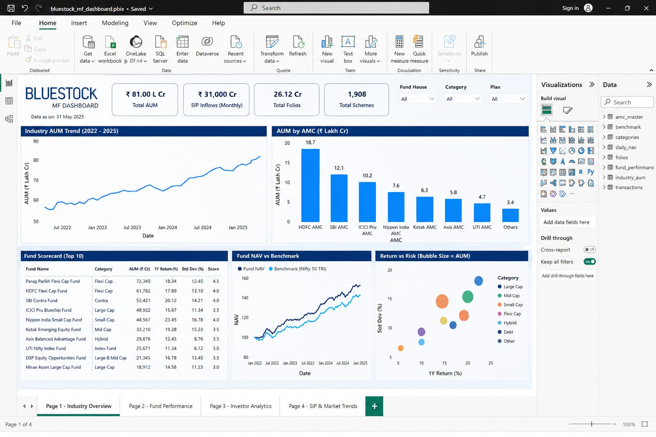

KEY INSIGHTS
The analysis of mutual fund datasets revealed several important insights:

- Equity mutual funds generally provide higher returns but come with higher risk
- Debt funds offer more stability with lower volatility
- SIP investments show consistent and long-term growth patterns
- Fund performance varies significantly based on category and market conditions
- Diversified portfolios tend to perform better during market fluctuations
- Benchmark comparison shows that some funds consistently outperform market indices

These insights help investors make better data-driven investment decisions.

Tools used: Python (Pandas, Matplotlib), Power BI Analysis

CONCLUSION

The Bluestock Mutual Fund Capstone Project successfully demonstrates an end-to-end data analytics workflow using real-world financial datasets.

The project includes data ingestion, cleaning, transformation, storage in a SQLite database, exploratory data analysis, and visualization using Power BI.

The insights generated from the analysis help in understanding mutual fund performance, risk-return behavior, and investor investment patterns.

This project highlights the importance of data-driven decision-making in the financial domain and provides a strong foundation for further advanced analytics and machine learning applications.

