**PAPER** **.** **OPEN** **ACCESS**

A Study on Intelligent Obscured Face Image

Completion System Based on GAN Network To cite this article: Haoxuan Zhu *et* *al*2021 *J.* *Phys.:* *Conf.* *Ser.* 2033 012002

View the [article online](https://doi.org/10.1088/1742-6596/2033/1/012002) for updates and enhancements.

You may also like

- [A Virtual Machine for Low-Level Video](/article/10.1088/1742-6596/1096/1/012044) [Processing in Actor Prolog](/article/10.1088/1742-6596/1096/1/012044)

A A Morozov and O S Sushkova

- [Development of Spreadsheet-Based](/article/10.1088/1742-6596/953/1/012102) [Integrated Transaction Processing](/article/10.1088/1742-6596/953/1/012102) [Systems and Financial Reporting Systems](/article/10.1088/1742-6596/953/1/012102)

I M Ariana and I M Bagiada

- [The Main Ways to Control the Efficiency of](/article/10.1088/1742-6596/2131/5/052021) [Vibration Abrasive Processing](/article/10.1088/1742-6596/2131/5/052021)

Anatoly Prokopets, Vitaly Shenstein, Tatiana Prokopets et al.



This content was downloaded from IP address 84.17.45.179 on 17/05/2023 at 14:23

Journal of Physics: Conference Series **2033** (2021) 012002 doi:10. 1088/1742-6596/2033/1/012002

**A** **Study** **on** **Intelligent** **Obscured** **Face** **Image** **Completion** **System** **Based** **on** **GAN** **Network**

**Haoxuan** **Zhu1,** **\*,** **Kai** **Zhao1,** **Ming** **Yang1,** **Yanxing** **Zhu1,** **Zeyuan** **Wang2**

1Beihang University School of Instrumentation and Optoelectronic Engineering Beijing Haidian 100191

2Beihang University School of Aeronautic Science and Engineering Beijing Haidian

100191

*Corresponding author e-mail: zhuhaoxuan@buaa.edu.cn

**Abstract.** Image recognition and processing is an important part of modern information technology. However, in real life, the face will inevitably be blocked by hats, masks, or face photos are damaged, scratches, and images are added mosaic and other reasons, resulting in face image masking, increasing face information recognition and processing difficulties. Image completion is a kind of technology to restore the missing information of obscured image. By supplementing the information of missing area, it can reduce the difficulty of image recognition and simplify the processing of face information.So it has important research significance for the restoration of shaded image. The traditional image completion technology produces the face of poor natural degree. At present, most of the popular completion methods combine depth learning, and the repair methods based on generating anti-network GAN are the representatives of them.But the stability of the network is poor, so it is difficult to train pictures with large sheltered area or poor image quality.Some methods are not effective in the completion of arbitrary shaded areas. Therefore, this study focuses on the improvement of the stability of the generated adversarial network and the maintenance of the global and local semantic consistency between the completion image and the real image. The main work includes: (1) Sets a special network structure of global discriminator and local discriminator. When the input is arbitrarily shaded, the completion image can maintain the consistency of global and local semantics. (2) The least square loss function is used to improve the stability of the GAN network. So it performs great when the input image has large area masking or low visualization degree. (3) ADAM algorithm is used to accelerate the training of neural network. (4) Based on the completion model, a human-computer interaction software is designed and developed, which includes data set selection, image selection, image completion, result evaluation and so on. The system is applied to the removal of facial structures such as wrinkles and spots. Compared with some existing software, the system can effectively remove the selected facial structures without image distortion. Based on the design of special network structure, the system improves the supervision ability of global and local completion , the stability of GAN network and enhances its training ability in large area masking. The system is intelligent and has strong completion

 Content from this work may be used under the terms of the Creative Commons Attribution 3.0 licence. Any further distribution

 of this work must maintain attribution to the author(s) and the title of the work, journal citation and DOI.

Published under licence by IOP Publishing Ltd 1

Journal of Physics: Conference Series **2033** (2021) 012002 doi:10. 1088/1742-6596/2033/1/012002

ability for arbitrary masking and large area masking. The research results of this paper effectively restore the information loss caused by image masking and prepare favorable conditions for subsequent image recognition and processing.

**Keywords:** machine vision, obscured face image completion system, GAN network, network stability, Adam optimization algorithm, structure removal

**1.** **Introduction**

*1.1.* *Background* *and* *significance* *of* *the* *project*

Face image recognition and extraction are widely used.However,face images will be obscured for various reasons, resulting in lack of information. Sunglasses, hats and so on will mask the face, scratches, creases, breakage on the face picture, the picture may also be artificially added mosaic, these reasons will mask the image, increasing the difficulty of image recognition and the complexity of image processing.

Image completion is widely used.In the field of criminal investigation, suspects wear sunglasses, hats to avoid surveillance cameras.But image completion can restore lost information to help solve cases[1],[2].In the field of historical photo restoration, some of the photos of important historical value have a wide range of information missing because of their old age. Image restoration can restore the appearance of these photos and provide more historical information for researchers.Image masking is everywhere, and image completion, has important practical application requirements.

In order to fully combine the face image completion technology with the actual demand, this paper carries out the research of intelligent completion system to realize the effect of completing the obscured image in the practical application field. It has important academic research and practical application significance.

*1.2.* *Current* *research* *status*

Conventional image repair methods have many types.Patch-Match methods are matched by similar blocks[3].However, the assumption that similar blocks exist in known regions is difficult to guarantee in practical application scenarios. The establishment of search database often requires huge database support, and the matching speed of query is slow, which limits the application of this method. Based on the diffusion fusion method, the obscured area is completed by adding detailed information around the repair area to penetrate into the repair area[4],[5].

Compared with traditional methods, face image completion technology based on depth learning has stronger image generation ability[6].A context-based pixel

prediction algorithm with more natural effect in global structure[7] is proposed by Pathak et al.GAN network was first proposed by Goodfellow et al in 2014, which greatly improved the completion capability of the completion network[8].The content-aware layer is added by Jiahui Yu to the generation network to solve the problem that the large probability of features learned from distant regions is invalid[9].

Cao Qingwen used MATALB to develop image restoration system in the field of image restoration system design[10].An image repair system based on Spark Framework proposed by Ping Wei[11].Lu Liang designed and realized the repair

system of old movies, and achieved ideal results.

Shortcomings in existing repair systems:

Journal of Physics: Conference Series **2033** (2021) 012002 doi:10. 1088/1742-6596/2033/1/012002

Compared with the real image, the obscured image has different global semantics or mismatch of local details. Poor performance in arbitrary shaded areas.GAN is unstable, so the training effect is not ideal when the image masking area is too large.

*1.3.* *Work* *of* *the* *paper*

1. network structure optimization: design the global and local identification network structure, reduce the influence of the shape of the sheltered area on the completion effect, and the effect on any area is ideal.

2. network stability optimization: select the least square loss function to improve the stability of the GAN and complete the completion of large area shaded images.

3. convergence speed improved: Adam algorithm is used to reduce the parameter quantity and algorithm complexity.

4. system design: based on the obscured face completion model, the face masking image is systematically studied and designed, and a human-computer interaction image completion software is developed.

**2.** **Convolutional** **Neural** **Networks** **and** **Generative** **Adversarial** **Networks**

*2.1.* *Artificial* *and* *convolutional* *neural* *networks*

Deep learning network structure is widely used in image completion. By imitating the working principle of human brain neurons, the information is extracted, processed and processed.

Face images have more feature information. Each layer of convolutional neural network contains multiple convolution kernels and each convolution kernel has the ability to extract a certain feature of the image, such as the extraction of single features such as eye shape, layout, hue, etc.

*2.2.* *Generation* *of* *adversarial* *networks*

The core of GAN are generator and discriminator. The function of generator is to complete the input incomplete picture, and deliver the result to the discriminator for effect evaluation,and the discriminator gives the appraisal result.The network parameters are updated according to the result.

**3.** **The** **algorithm** **design** **of** **obscured** **face** **image** **completion**

*3.1.* *Completion* *network* *and* *discrimination* *network*

The size and shape of the obscured area are random.Therefore, on the one hand, the network needs to supervise and feedback the overall layout of the image to ensure the consistency of the global semantics; on the other hand, the network needs to monitor the local details of the image well to ensure the consistency of the local semantics.This system adopts the design of two discriminators, and sets up two discriminators which can supervise the global and local structure. It is helpful to deal with the arbitrariness of shelter.

The network structure is shown in fig 1. The height and width of each cuboid represents the pixel area of the input image. If the input is 256×256 pixel area, the height and width of the first cuboid are all 256 pixel. In this network structure, the height and width of each cuboid are consistent. The depth represents image channel number. The length, width and height of the cuboid constantly change, and the corresponding image features are constantly aggregated and adjusted in this process.

Journal of Physics: Conference Series **2033** (2021) 012002 doi:10. 1088/1742-6596/2033/1/012002

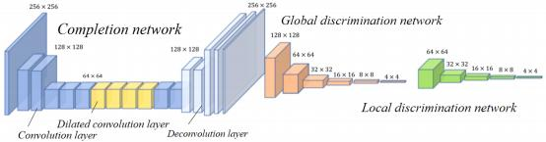

**1Fig.** **1** Completion and discrimination network structure

The completion method in this study has the ability to generate new semantics and can generate image blocks that do not appear in other regions of the image. Also, the network can naturally complete the image with familiar and highly specific structures (such as faces) .

*3.2.* *GAN* *Network* *optimization* *design*

The essence of GAN is to learn an optimal mapping *G:* *Z* → *X* , *Z* is the generated data and *X* is the real data.But the degree of *G(z)* approximation *X* is limited, that is, can not be completely consistent[12]. Tan Hongwei thinks that the instability of gradient update causes network instability[13].Therefore, it is very important to select reasonable loss function and feedback the training results so that the network parameters can be updated continuously.

Masking in large areas contains a large amount of important information.For example, completely masking eyes, without any relevant features to be extracted by the network.When such masking is put in training, the cross-entropy loss function can not continue to update the parameters, so the network can not continue training.But least square loss function can overcome this point, as formula (1)(2).

min *G* *Net* =  *Ex*~*Pdata* [(*D*(*x*) − *b*)2 ] +  *Ez*~*Pz* [(*D*(*G*(*z*)) − *a*)2 ]

min*D* *Net* = *Ez*~*Pz* [(*D*(*G*(*z*)) − *c*)2 ]

( 1)

(2)

*a,b,c* is a constant in the upper formula, take *a* *=0,* *b=c=1.*

Adam design independent learning rate for different parameters, effectively reduce the parameters of network training, and use Adam algorithm to improve the rate of network

convergence.

*3.3.* *Model* *Training* *and* *Testing*

This system selects nine different data sets from *StyleGAN* and *KAGGLE* for training.It basically covers all kinds of possible face images that may appear in real life, including oriental and western face data set, male and female face data set, child,adult and elderly face data set, face with glasses and smiling face data set. The emphasis of training different types of data sets will be different, for example, the face data set containing glasses pays more attention to the structure and style of glasses.

The training lasted 1500 rounds, and 32 pictures of the training set were randomly divided into one group. The image pixel value (0-255) is transformed into [- 1,1] interval by mapping *f* : *a* → *a* / 127.5 − 1 before formal training, which is convenient for subsequent

Journal of Physics: Conference Series **2033** (2021) 012002 doi:10. 1088/1742-6596/2033/1/012002

operation. The 256×256 pixel area images are randomly selected as input, and the rectangular shading of side length in [32,50] pixels is randomly generated within 128 pixels of the image center.

Pre-training of completion network continues 200 rounds. After it, completion network can basically complete part of the shaded image, but the effect needs to be improved.The discrimination network is pre-trained to improve the ability to judge the truth and falsehood of the image. For the real image, its score is close to 1, for the generation of forged images, its score is close to 0.The error of the authentication network is in the form of backward feedback, and the loss is reduced continuously through training, which shows that the ability of the discrimination network to accurately score real images and forged images is constantly enhanced. The process lasted 600 rounds.

In the third stage, completion network and discrimination network participate together,.The update of the network is transformed into the maximum-minimum optimization algorithm.The completion network inputs obscured image and its mask, passes through completion network, finally outputs the completion result.Original image and completed image are passed into the global discrimination network and the obscured and peripheral regions of them are passed into the local discrimination network. The discrimination network judges the similarity between the two and outputs the completion effect score through a full connection layer,as fig 2.

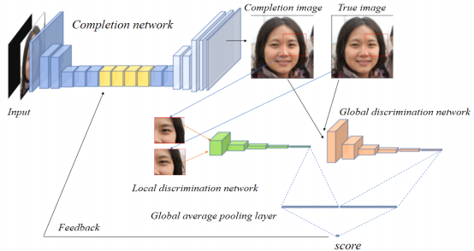

**Fig.** **2** Joint training of completion and discrimination networks

*3.4.* *Results* *analysis* *and* *discussion*

Comparing completion effect with others, the system can complete random obscured face images, with natural effect .Also, the completion image is basically close to the real image, and the evaluation index score is high,as fig 3.

Journal of Physics: Conference Series **2033** (2021) 012002 doi:10. 1088/1742-6596/2033/1/012002

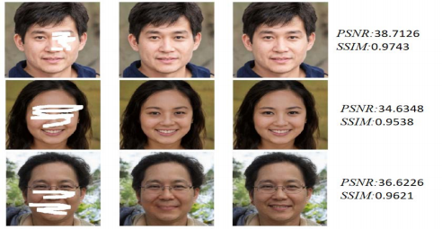

**Fig.** **3** Completion of arbitrary occlusion (input, completion and real images from left to right)

Use square shelter, and increase the area of shelter .When obscured area accounts for 33% of the effective information area,the PSNR value is greater than 30 dB, and SSIM value is greater than 0.92,as fig4.

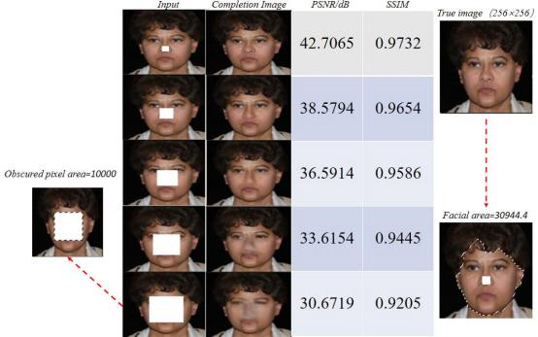

**Fig.** **4** Completion results under different obscured areas

**4.** **Design** **of** **obscured** **face** **completion** **system**

In order to combine with practical application,A software which can complete image completion and support human-computer interaction is developed. There are two ways to add shading, generating rectangular shading randomly or masking any part by dragging the mouse.The performance test indexes include peak signal-to-noise ratio (PSNR) and structural similarity (SSIM).

Journal of Physics: Conference Series **2033** (2021) 012002 doi:10. 1088/1742-6596/2033/1/012002

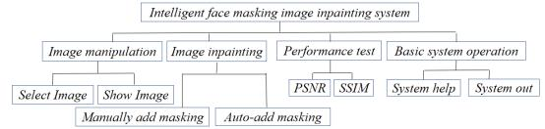

**Fig.** **5** Partition of Face Repair System Module

Firstly, select the data set model, then select the picture to be processed and masking method; the upper right box shows the image selected by operators, and the result is displayed below. The PSNR and SSIM are also displayed,as fig 6.

**5.** **Systematic** **experimental** **study** **——** **removal** **of** **partial** **facial** **structure**

The system is used to remove facial wrinkles. People pay more and more attention to the beautification of photos, all kinds of beautification software came into being.Skin filter and other face image beautification methods have been widely used. An important aspect of face image beautification is the removal of discordant structure of face (such as wrinkles, spots, etc).The face image completion method has the ability to repair the damaged and shaded image. The system successfully removes

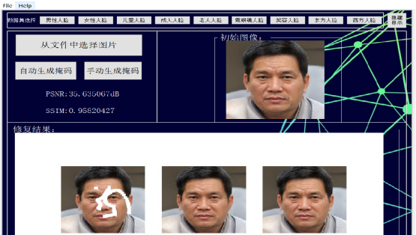

**Fig.** **6** Software interface (left-to-right below:obscured,completion and real images)

the wrinkles on the original image and makes the face more smooth.Repair software can remove wrinkles on the forehead to a certain extent, but the removal effect is not ideal. Filters, skin grinding and other ways damages the nature and harmony of the image. Face structure removal by masking reconstruction will not damage the quality of the image itself.

Journal of Physics: Conference Series **2033** (2021) 012002 doi:10. 1088/1742-6596/2033/1/012002

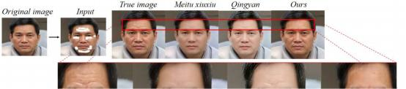

**Fig.** **7** Comparison of some software and ours to remove the forehead wrinkles

**6.** **Conclusion**

Obscured face image completion can reduce the difficulty of image recognition and simplify the complexity of subsequent image processing. It has been widely used in many fields. Existing image methods have two problems, the overall layout and local details of the completion are often not ideal, influencing completion of arbitrary obscured area; GAN is often difficult to train when large obscured area is put in. The actual images usually have a large and arbitrary area of shadowing.

In order to facilitate the application of various image completion scenes in real life, intelligent completion system is studied and designed. The system has strong completion ability for arbitrary masking and large area masking. Through the training of various data sets, the targeted repair of input images can be realized. In order to enhance the ability of the network to completion arbitrary shaded areas, the global discriminator and local discriminator are designed based on the GAN to improve the semantic consistency of the global and local images. To achieve large-area obscured area completion and improve GAN stability, the least squares loss is used as a loss function. It is concluded that the algorithm can complete face images of any shaded area and can still complete the task when the obscured area is quite large. In order to combine with practical application, a software that supports human- computer interaction is developed, with the functions of data set selection, image selection, image completion, performance test and so on. Apply system to the removal of face partial structures (such as wrinkles, spots).Compared with other methods, it is found that the system can effectively remove the selected face structure without image distortion.

The existing image completion system is limited by the shape and area of the obscured area.The completion system proposed in this paper simulates many problems in practical application, broadens the application scope of the existing system, and has great application potential!

**References**

[1] Feng Jie. A Study on the Method of Face Blocking Image Repair Based on the Generation Network [D].Nanning normal University ,2019.

[2] Zhu Dequan. A Study on Face Image Repair Based on Generating Confrontation Network[D]. University of Electronic Science and Technology ,2020.

[3] Barns C,Shechtman E,Finkelstein A,et al.PatchMatch:A randomized correspondence algorithm for structural image editing[J].ACM Transactions on Graphics (ToG),2009,28(3):24

[4] Marcelo Bertalmio,Guillermo Sapiro,Vincent Caselles,and Coloma Ballester.2000.Image Inpainting.In ACM transactions on Graphics (Proceedings of SIGGRAPH). 417-424

[5] Anat Levin,Assaf Zomet,and Yair Weiss.2003.Learning How to Inpaint from Global

Journal of Physics: Conference Series **2033** (2021) 012002 doi:10. 1088/1742-6596/2033/1/012002

Image Statistics.In International Conference on Computer Vision.305-312.

[6] Fan Chunqi, Ren Kun, Meng Lisa, Huang Long. Recent advances in Digital Image repair algorithm based on depth Learning[J].The following advances in digital image repair algorithms Signal processing 36(01):102- 109.

[7] Pathak D,Krahenbuhl P,Donahue J,et al.Context Encoders:Feature Learning by Inpainting [C]//Proceedings of the IEEE Conference on Computer Vision and Pattern Recognition.2016:2536-2544.

[8] Goodfellow I,Pouget-Abadie J,Mirza M,et al.Generative Adversarial Nets [C]//Advances in Neural Information Processing Systems.2014:2672-2680.

[9] J.Yu, Z.Lin, J.Yang, X.Shen, X.Lu and T.S.Huang, "Generative Image Inpainting with Contextual Attention, "IEEE/CVF Conference on Computer Vision and Pattern Recognition,2018 Salt Lake City, UT, 2018, pp.5505-5514, doi:10. 1109/CVPR.2018.00577.

[10] Cao Qingwen.Image Repair Method Based on Apriori Information Learning and Priority Optimization [D]. Northwestern University ,2019.

[11] Pingwei.Design and Implementation of Image Data Complement System Based on Cloud Computing [D].Beijing University of posts and Telecommunications ,2019.

[12] Arjovsky M,Bottou L.Towards principled methods for training generative adversarial networks[C].In Proceedings of the International Conference on Learning Representations,2017.

[13] Tan Hongwei. A Study on Unsupervised Image Generation Based on Generative Confrontation Network [D]. Southwest University ,2020.