# How to Run Automation for pay PLUS SDK APP

# Software Requirements:

|  |  |  |  |
| --- | --- | --- | --- |
| Sl. No. | Softwares | Version | Download Link |
| 1 | AppiumStudio | 11.6 |  |
| 2 | Eclipse IDE 2019-03 | 4.10 |  |
| 3 | payPLUS SDK Demo Apk | Released version |  |

# Hardware Requirements:

|  |  |  |  |
| --- | --- | --- | --- |
| Sl. No. | Hardware | Version | Remarks |
| 1 | Android Device | 4.2 or higher | With USB cable/Connector |
| 2 | iOS Device | 11 or higher | With USB cable/Connector |

# Steps To Set Up Device On Appium Studio:

1. Click on Device -> Add Device -> Android Device  
   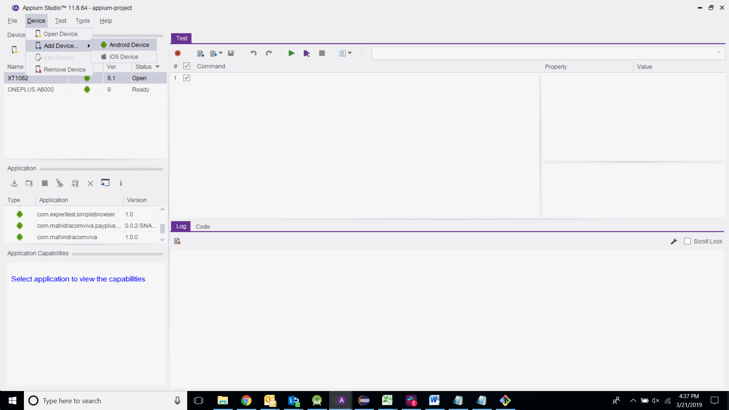
2. Add the device and click on OK.  
   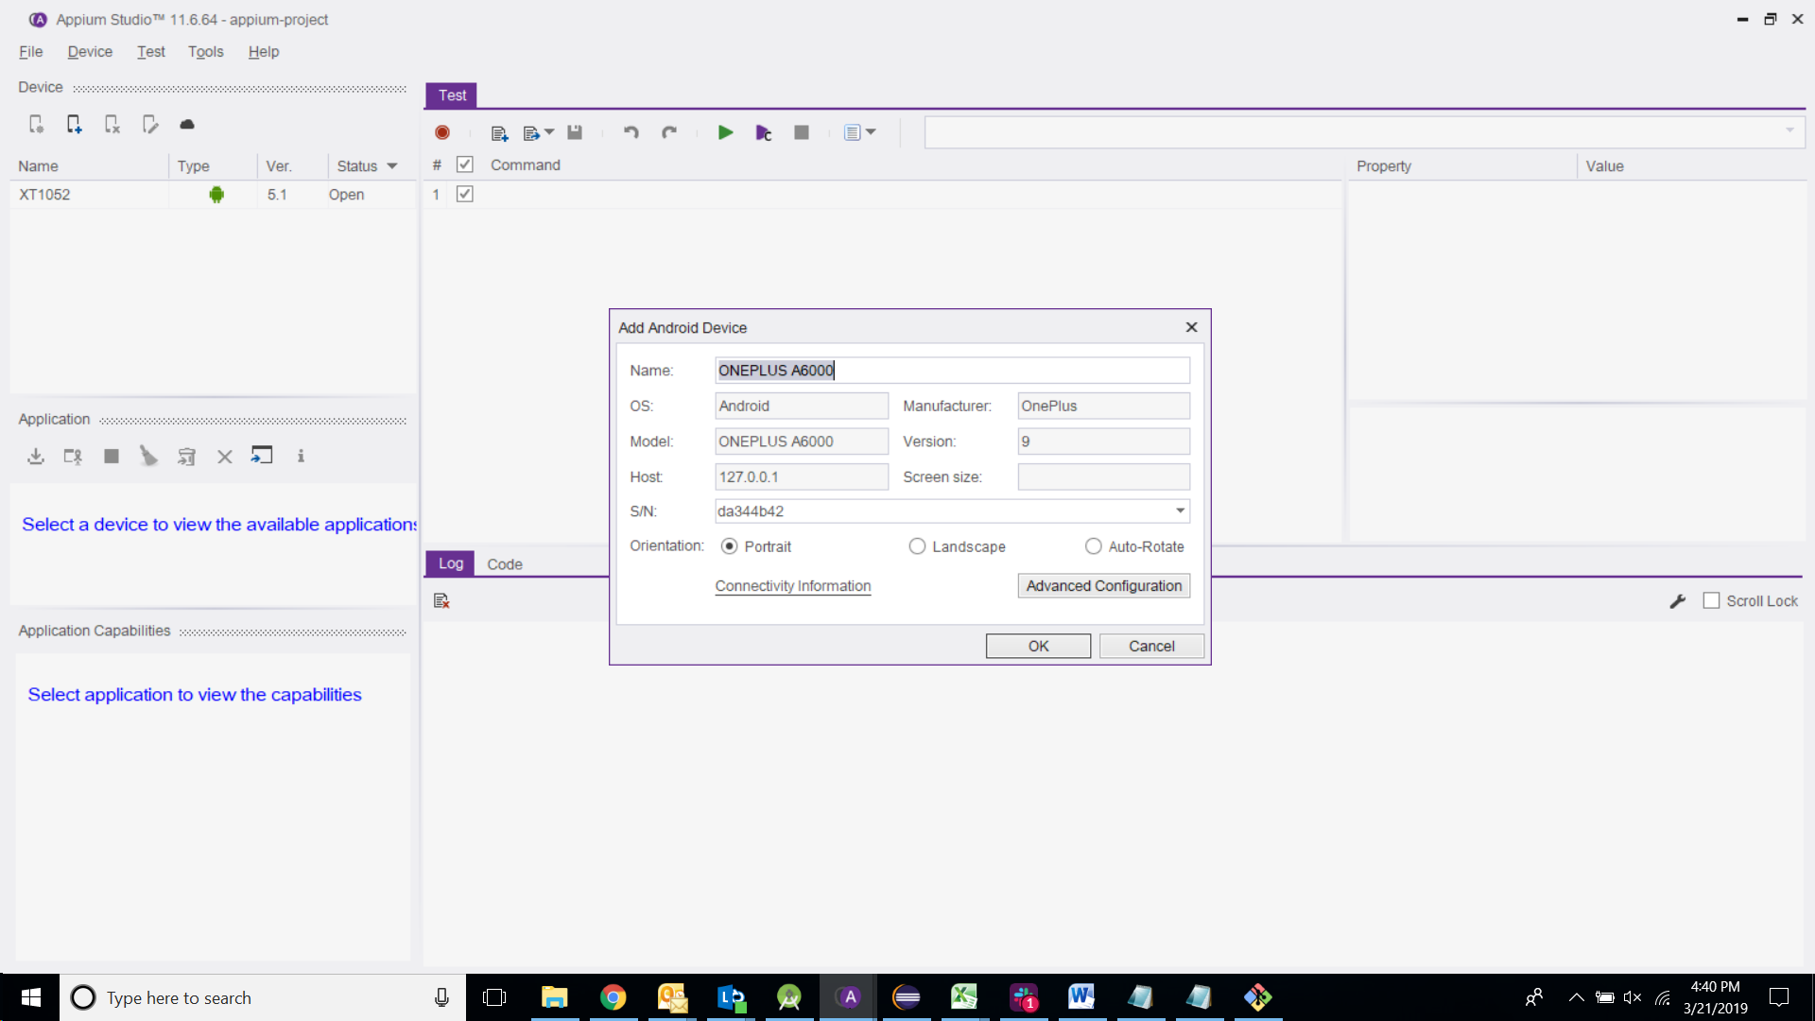
3. Click on “Import the application from local disk” and import and install the apk on the device.  
   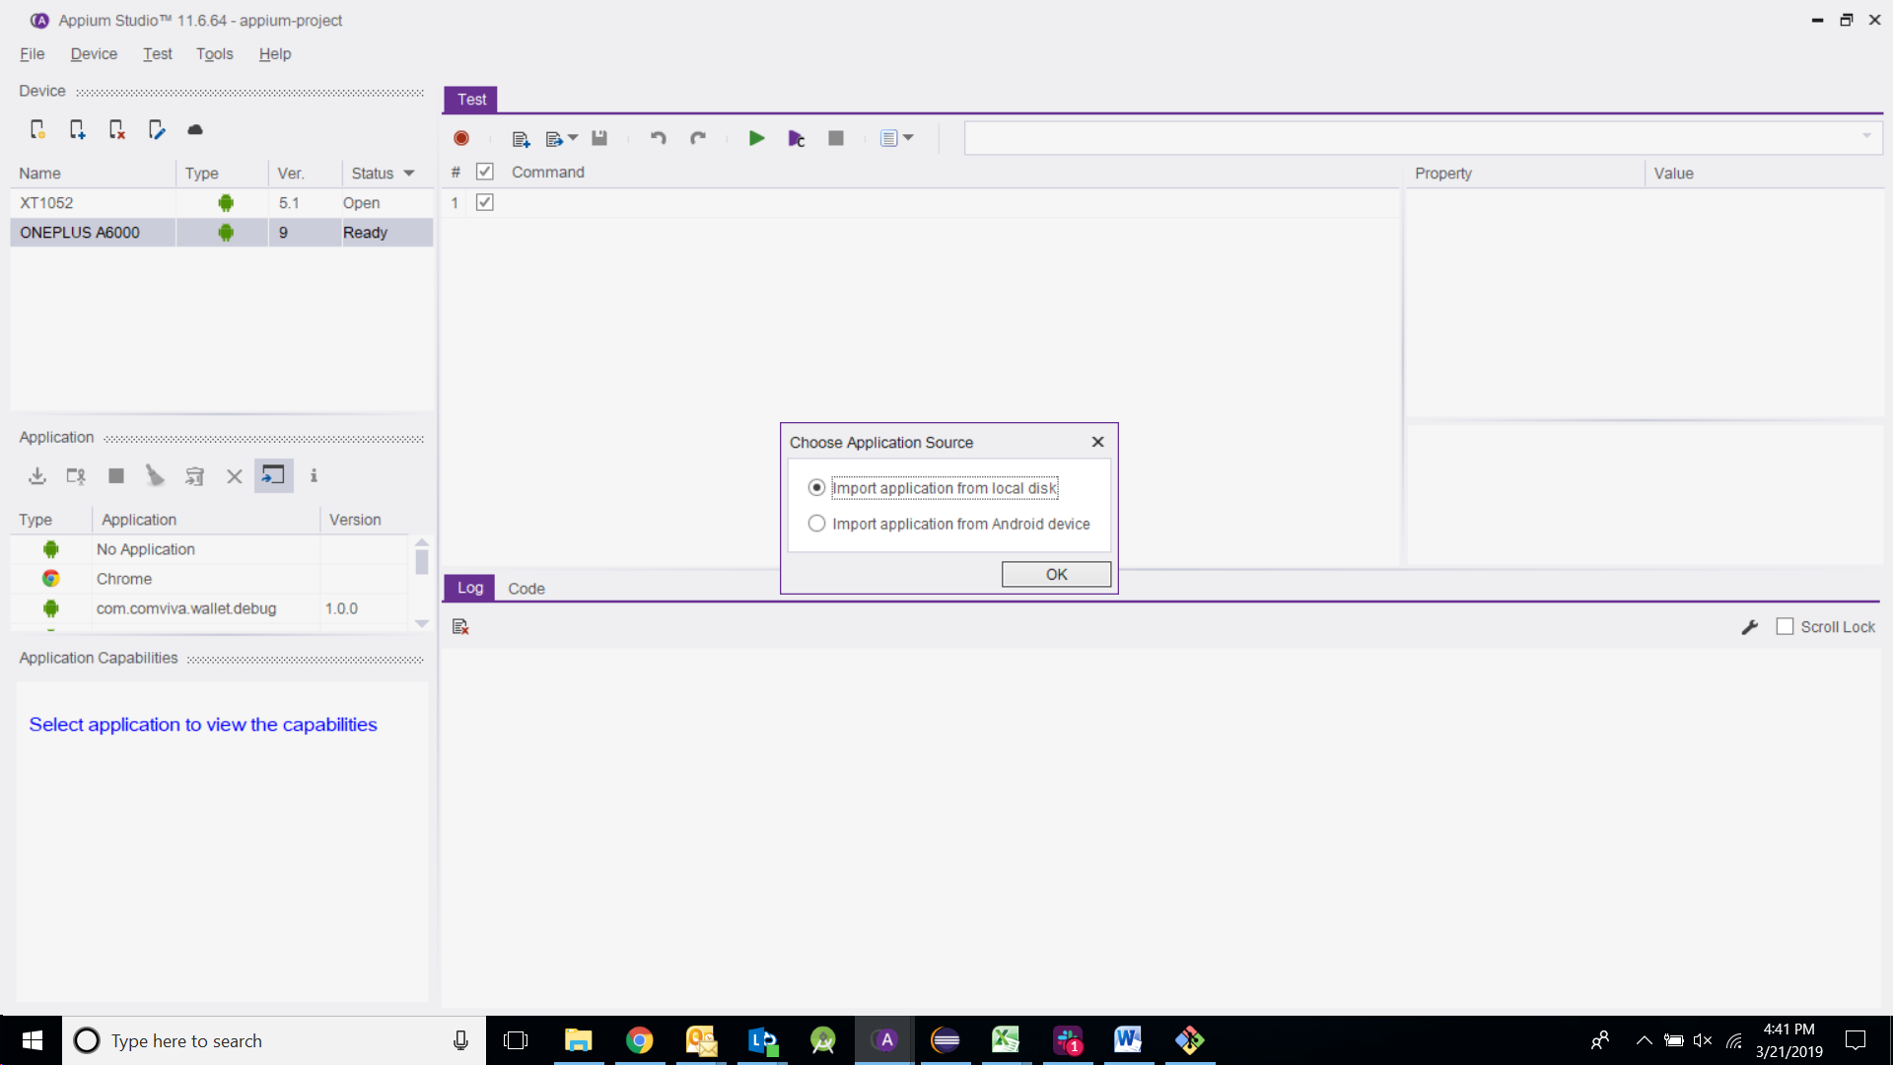

# Steps To Set Up And Run Automation Suite:

## Test Data:

Test Data is maintained in an excel sheet called "PayplusData.xls" in the TestData folder.

## Parameters configurable based on deployment test details

### Device Details

Ensure to update the connected device details in the **“Login”** sub-sheet

Sample Values for Android:

|  |  |
| --- | --- |
| DeviceIdentifier | 8DGAV8S4GYIFAAUS |
| DeviceName | Lenovo A7010a48 |
| DeviceType | Android |

Sample Values for iOS:

|  |  |
| --- | --- |
| DeviceIdentifier | 50004BAC-C0D6-47EA-90B4-70110C81BC58 |
| DeviceName | iPhone 11 |
| DeviceType | iOS |

You can find your device details by referring Step 1 under “Run the automation suite” in this document or by referring the below link<https://appslova.com/find-serial-number-android-phone/>

### Appium URL Details

### Update your local end-point details in the **“Login”** sub-sheet

|  |  |
| --- | --- |
| AppiumURL | http://localhost:4723/wd/hub |

### Merchant Details

Verify and update the merchant details as made available from payPLUS environment for SDK testing on **“InitParameters”** sub-sheet.

|  |
| --- |
| hierarchyCriteria |
| Mid |
| Hid |
| Tid |

### Card Details

Card numbers can be modified in the **“CardPaymentParameters”** sub-sheet for the following cards:

|  |
| --- |
| cardNumberVisa |
| cardNumberMastercard |
| cardNumberAmex |
| cardNumberJcb |
| cardNumberDinersClub |
| cardNumberDiscover |

For sample card numbers, the following link or the default values in the Excel can be used.  
<https://www.easy400.net/js2/regexp/ccnums.html>

## Steps to enable Test Scripts for Amex, JCB, Diners and Discover as required

1. Open Class CardPaymentScreenTest.java
2. Update **enabled=false** to **enabled=true** on respective test methods

The test method names are as below which can be found in mentioned class:

1. verifySuccessfulCardPaymentAmex
2. verifySuccessfulCardPaymentJcb
3. verifySuccessfulCardPaymentDinersClub
4. verifySuccessfulCardPaymentDiscover

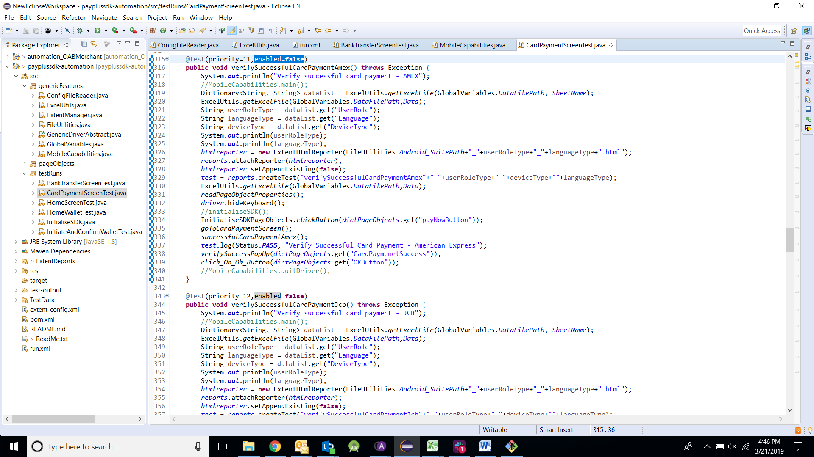

**Reference Screenshot**

## Run the Automation Suite

### Step 1:

Click on the device in Appium Studio and move to the “Code” tab. Copy the device ID.

Eg. dc.setCapability(MobileCapabilityType.UDID, "TA643035FF");

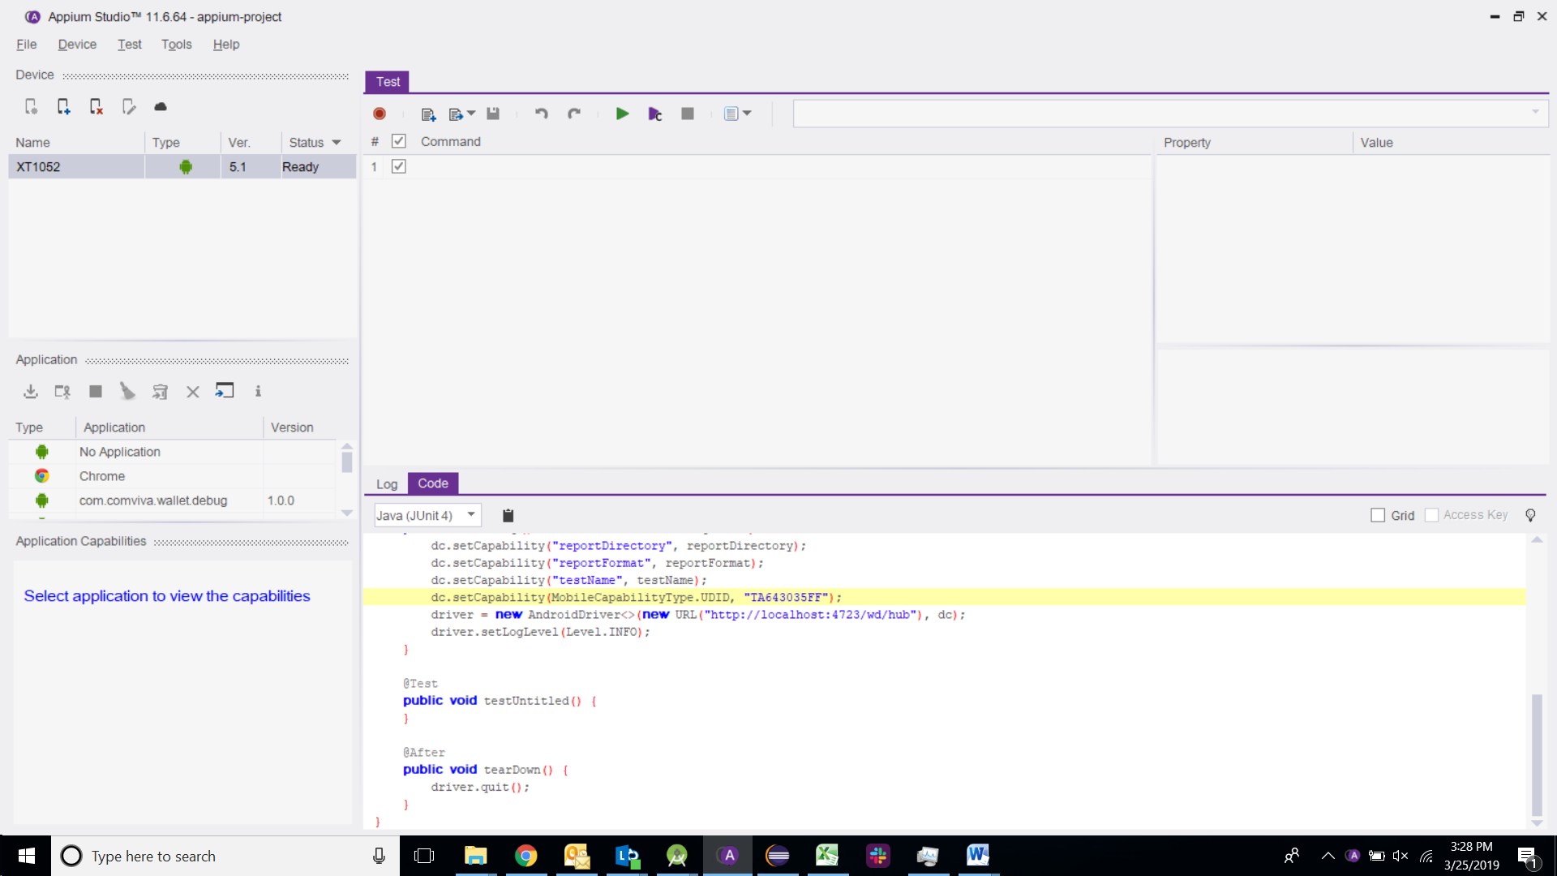

**Update these details (Device Identifier, Device Name and Device Type) in the “Login” sub-sheet.**

### Step 2:

Make sure you have Eclipse (enabled with JEE) and TestNG and Maven installed as well.

Right click pom.xml -> Run as -> Maven Install.

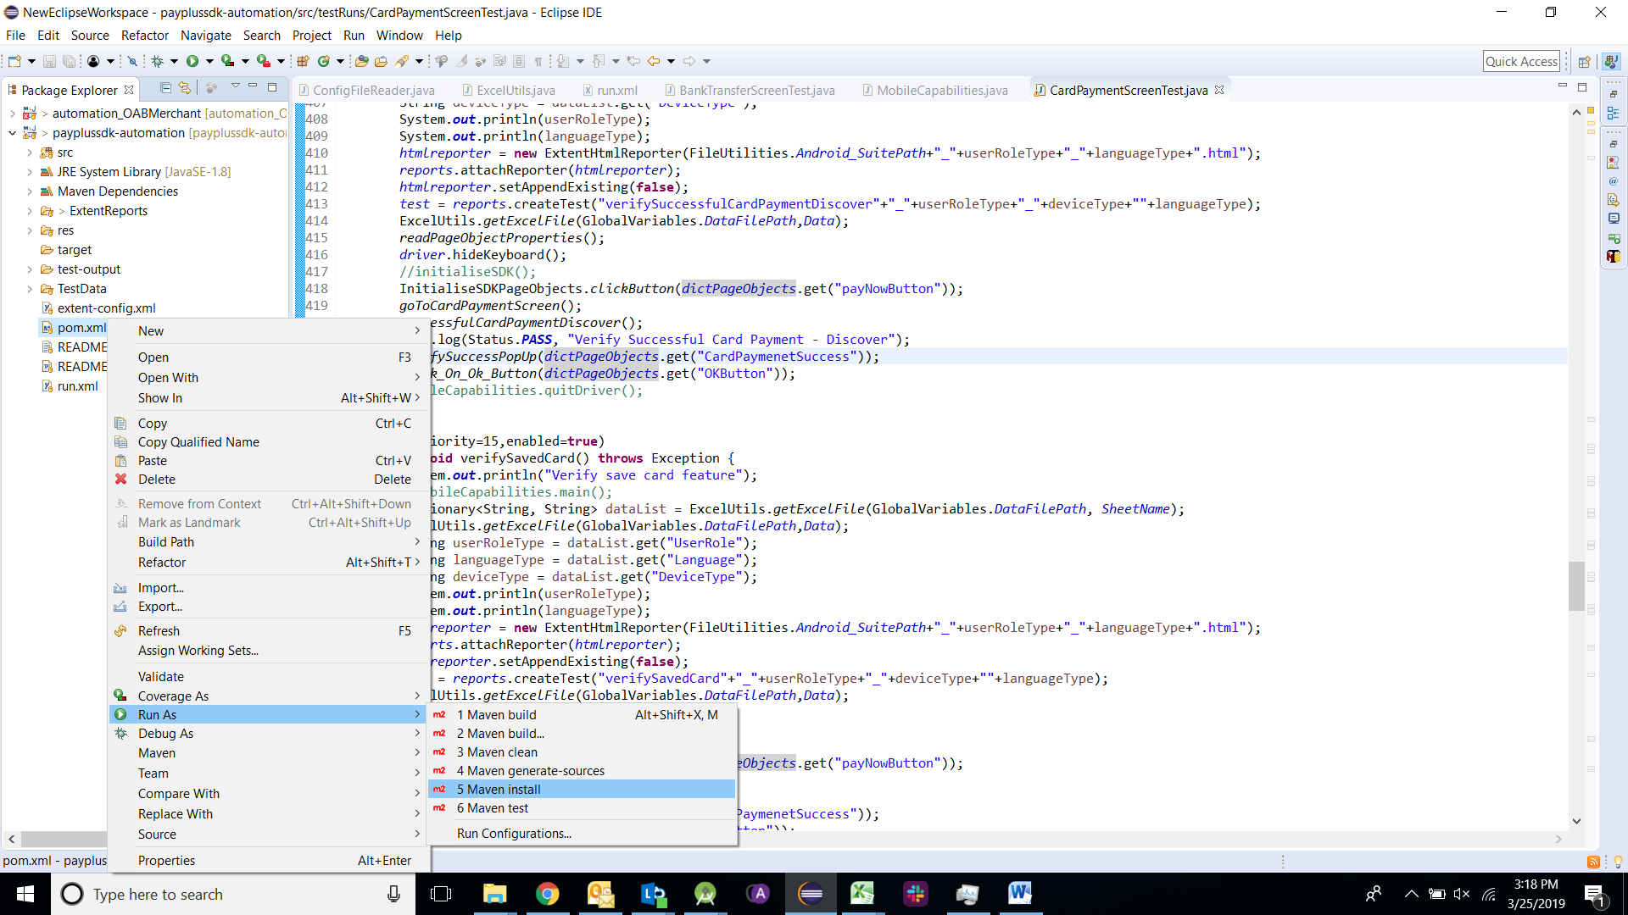

### Step 3:

Locate the file Run.xml in project which contains the names of the test classes along with the order in which we would like to run the test cases.

Right click run.xml -> Run as TestNg.

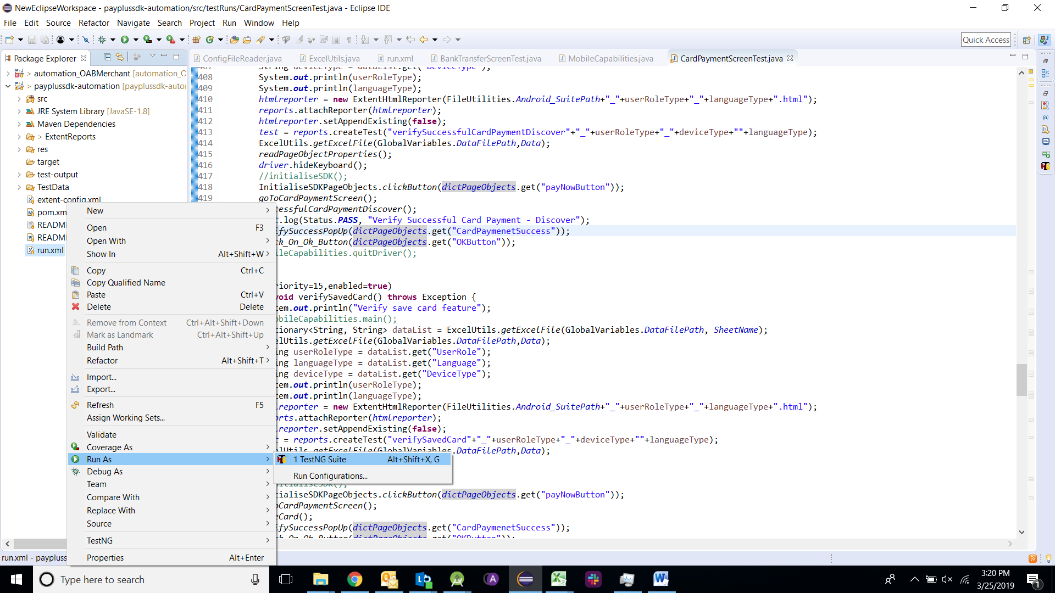

**Note**: Make Sure the Device connected to Appium Studio is installed with application.

In case of abrupt disconnects, re-run the suite from run.xml as mentioned in this section.