Design Document

Group: 7

Members:

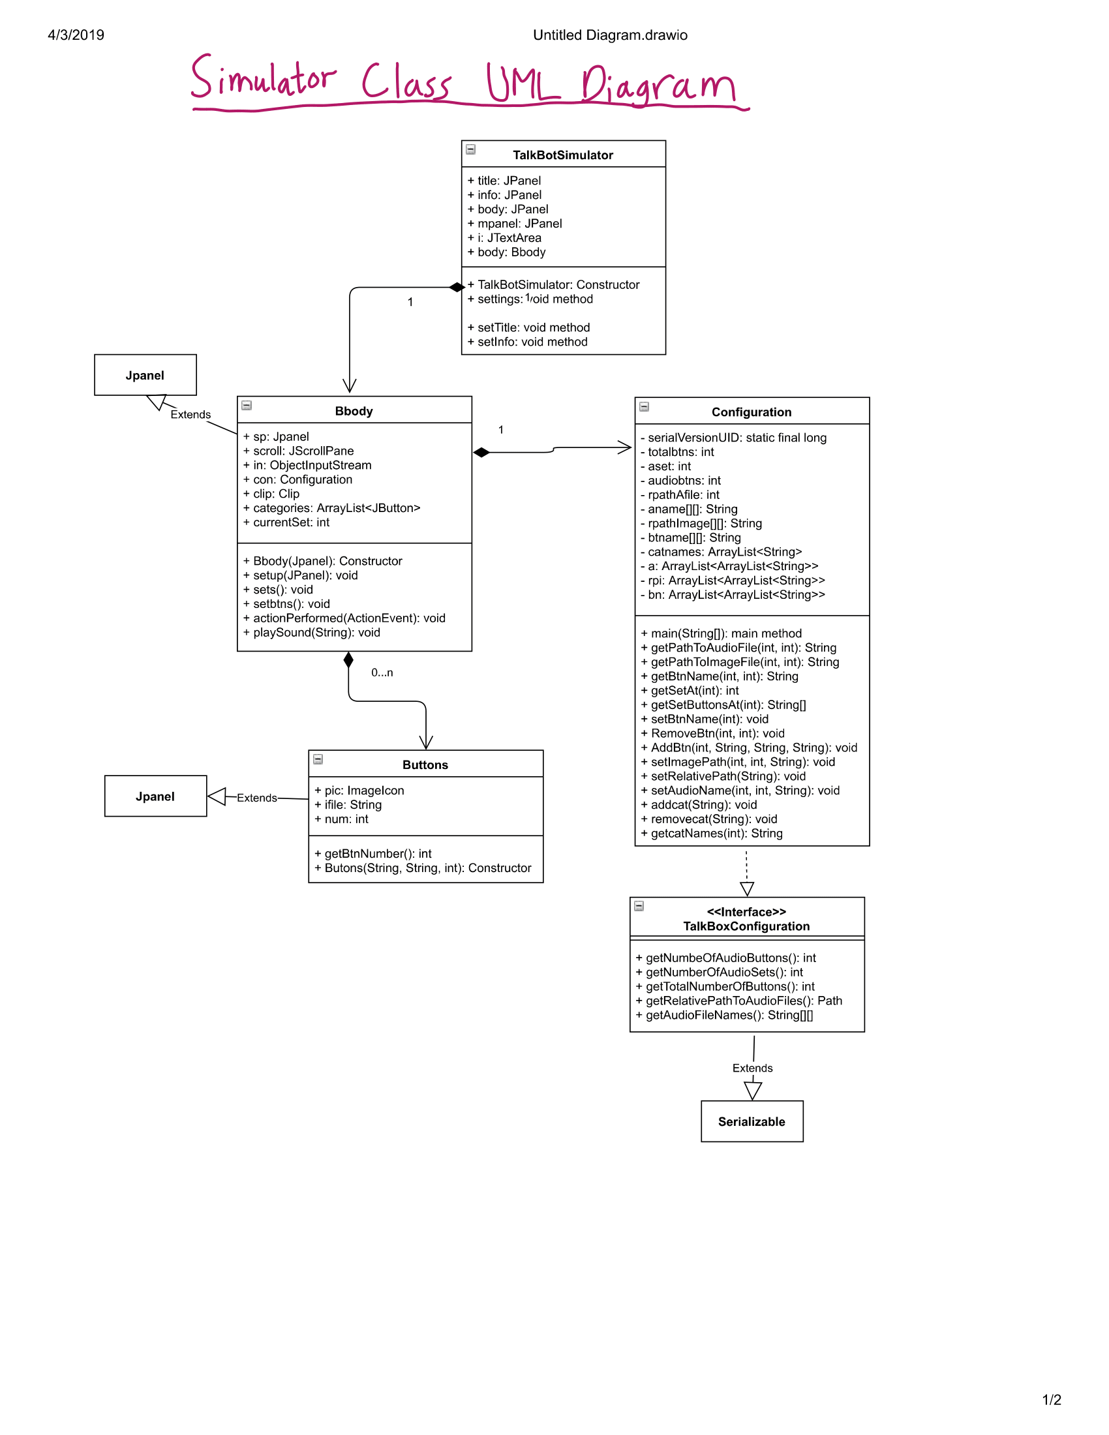

**Sequence Diagram**

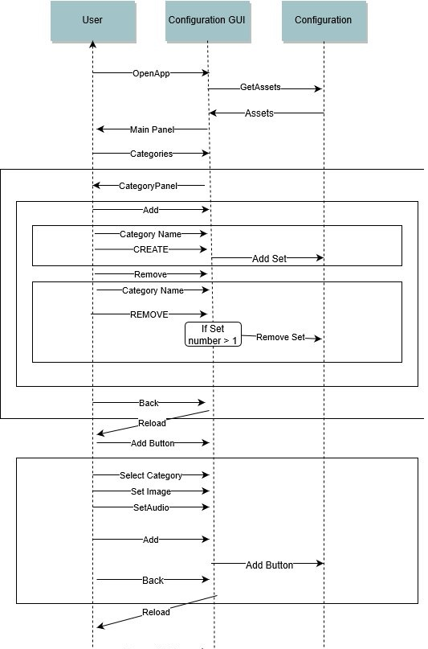

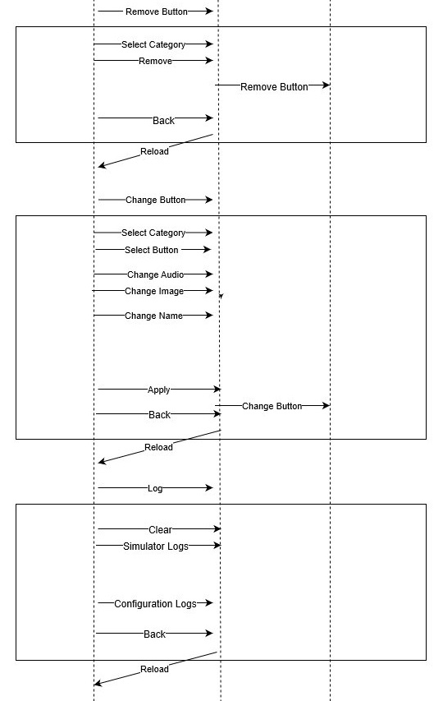

**Buttons**

This is the class that represents the buttons. The buttons are made up of a String name, and ImageIcon, and the paths to an audio file and image file.

**Important methods:**

**int** getbtnNumber()

Given the button object, it returns the button number

**Configuration**

This class controls the application. The accessor methods and mutator methods to the buttons, and the categories are in here.

All the methods are self-explanatory through its name. For example, getPathToAudioFile(int set,int button) returns the path to an audio file given the set its in and the button number.

**TalkBoxConfigurationGUI**

The configurationGUI uses most of the methods from Configuration.java. This is done by using an object named con. Using con, we can access, and modify the arrays holding data for the existing buttons.

**Important methods:**

**String** fileChooser()

This method is accessed by the following JButtons: addImage, addAudio, changeImage, and changeAudio. What fileChooser() does is launch JFileChooser upon call, and returns the path of the file selected as a String. If the user does not pick a file or cancels the action, then NULL is returned.

**void** outputSerial()

This method is called at the end of actions in the configuration to save the changes. By calling outputSerial(), you are writing the changes to “serial/log.bin”.

**void** simulatorLog(), changeButton(), addButton() ,removeButton()

**void** AddNewSet()

By calling AddNewSet, it gets a String name from SetName and creates a new category. This category can store unlimited amount of JButtons.

**void** RemoveOldSet()

This method allows you to remove a selected category. The selected category in JComboBox can be removed by clicking remove button.