**TalkBot**

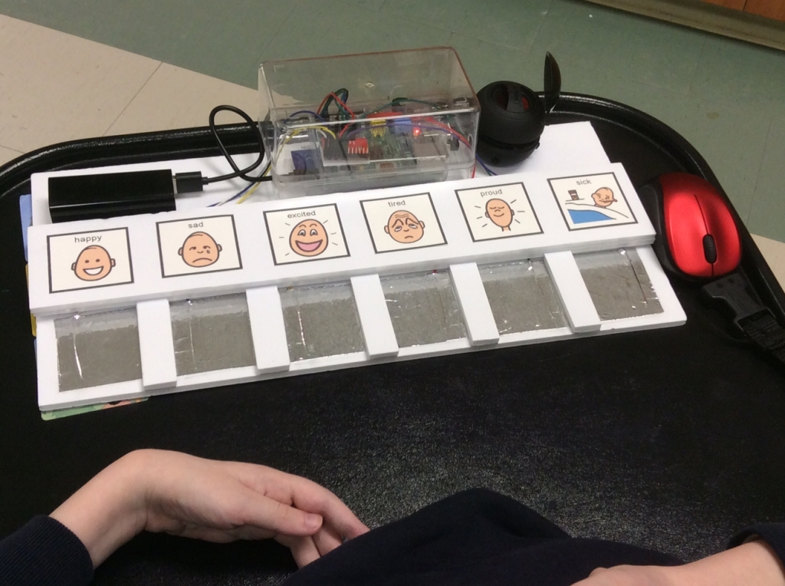**User Manual**

Contents

TalkBox Simulator 3

Simulator Buttons 4

Simulator Scrollbar 5

TalkBox Configurator 6

Configuration GUI 7

Changing Available Buttons 7

Adding Buttons 12

Removing Buttons 15

Adding Categories 16

Removing Categories 18

TalkBox

Run, update, and customize your very own TalkBox

Welcome to the TalkBox user manual and thank you for buying our product. We promise not to disappoint. This user’s manual will guide you through on how to use your TalkBox simulator and configurator.

Should you have any questions not answered by the manual, please talk to one of our representatives by **phone (905-000-000 ext. 416)** or by **email (yorku@simu.ca)**.

# TalkBox Simulator

The very first thing that you should do is open the directory which you downloaded from GitHub labelled 2311Project. From there, double click on TalkBox, and open the VM folder. In this folder you will find TalkBotSimulator.exe. Running this will open the TalkBox simulator, which will emulate a real life TalkBox.

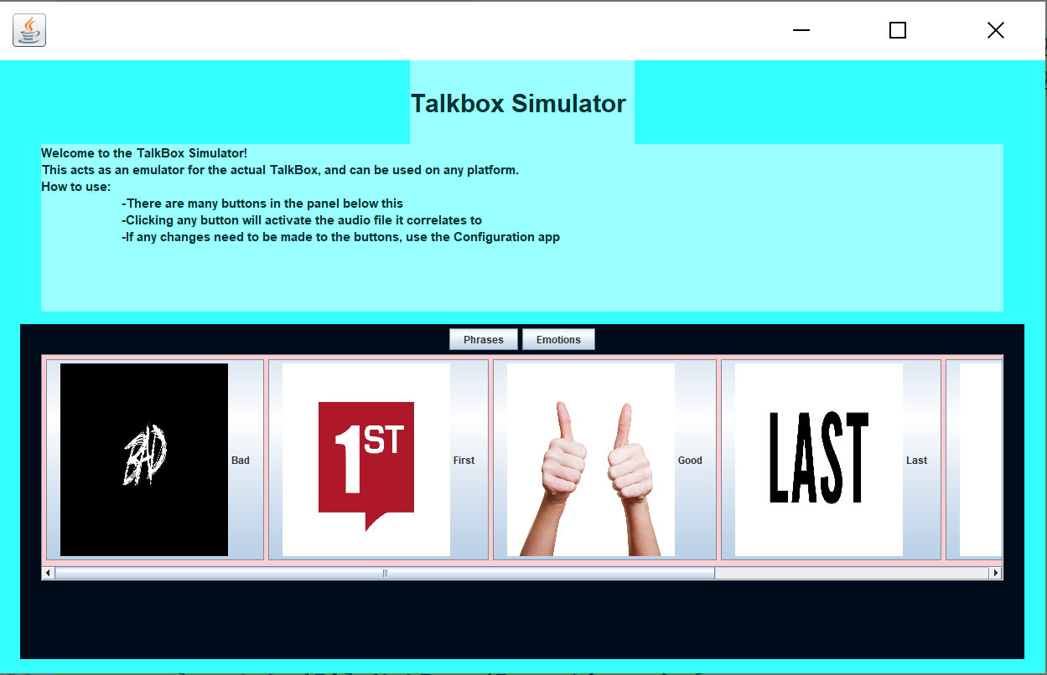

# Simulator Buttons

The simulator, on your very first time running it (after downloading from git) will have a total of 14 buttons (two ‘Category’ buttons and twelve ‘Audio’ buttons).

**Category Buttons:**

**Phrases:** This is the first category; whose buttons are the default ones that appears when you run the simulator. As inferred, the buttons from this category all contain phrases such as ‘Good’, ‘First’, ‘Washroom’ and so on. To play an audio file in this category, simply switch to the phrase’s category (if you’re not already on it) and select one of the large audio buttons.

**Emotions:** This is the second category; whose buttons appear when you click the ‘Emotions’ button. As inferred, the buttons from this category all contain phrases such as ‘Bad’, ‘Angry’, ‘Jealous’ and so on. To play an audio file in this category simply switch to the emotion’s category (if you’re not already on it) and select one of the large audio buttons.

Should you wish to add new buttons or change the audio file of a button within any category, do keep in mind that they should be of the same category type (i.e. ‘Phrases’ and ‘Emotions’).

**Audio Buttons:**

The audio buttons are the large buttons with an image and label on them. As shown below.

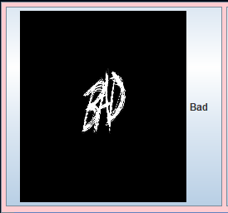

Clicking one of these buttons will play an audio file. Should there not be a proper audio file to display, a default audio will be played which will ask you to choose a proper audio file (.wav) in the configurator. Should there not be a proper image to be displayed, a default image is displayed, and you may change it by choosing a valid ‘.png’ image from the Configurator. When first downloading from GitHub, you will have 12 audio buttons, 6 buttons in each category. Should you make any changes using the Configurator, they will be reflected on the simulator upon opening it again. Do keep in mind that before using the configurator, the simulator should be closed, and before opening the simulator, the configurator should be closed.

# Simulator Scrollbar

As you look at the simulator screen, you will notice a horizontal scroll bar (as seen below highlighted in yellow).

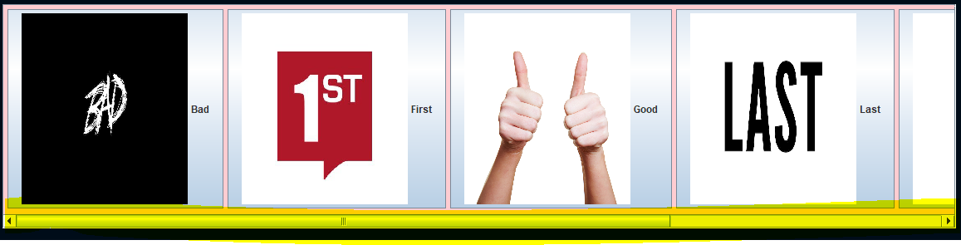

This scroll bar appears whenever there are too many buttons for the panel to fit in horizontally. Should there be space, then the scroll bar will disappear (as seen below).

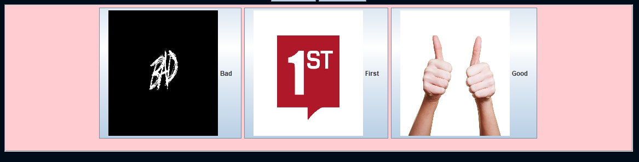

Using the scroll bar, you can navigate to the buttons on the other side of the horizontal panel. Thus, allowing you to fit as many buttons as you wish and properly navigate to them.

If you have added any new buttons, changed the audio or image of an existing button, or removed a button, you will be able to see those changes reflected in the simulator upon opening the simulator again. Your changes will be kept track of, have no worries about that.

# TalkBox Configurator

Now that you have your TalkBox, you may wish to customize, add or remove buttons. This can be done using the TalkBoxConfigurationGUI.exe. To run this, open the folder downloaded from git (2311Project). From there, double click on TalkBox, and open the VM folder. In this folder you will find TalkBotConfigurationGUI.exe. Running this will open the TalkBox configurator which allows you to add/remove and customize your own buttons.

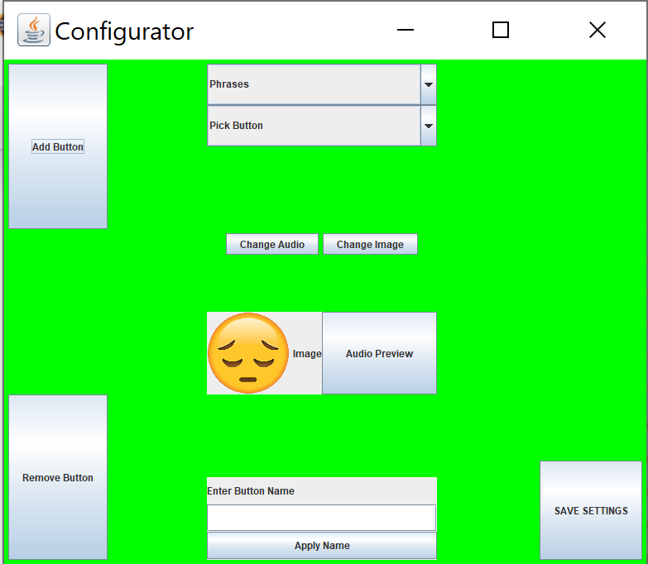

# Configuration GUI

The configuration may look confusing at first, however as you start working with it, the setup become simple to understand and use. Let’s go through the configuration step by step.

# Changing Available Buttons

The first thing we’ll go over is changing the audio, image, and name of a button. This manual will be working under the implication that the default settings have not yet been changed. Thus, when we first run simulator, we have 12 audio buttons in total (6 in phrases and 6 in emotions). When we first run the simulator and click the emotions button, we see that there are six buttons in total.

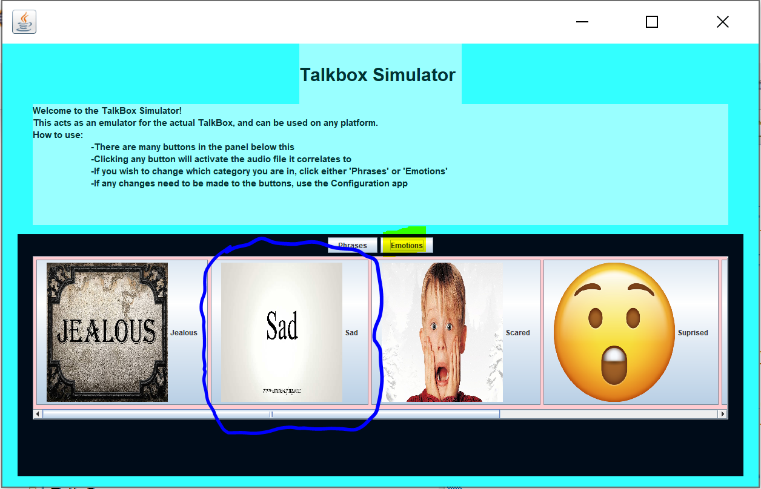

As shown above, there are 6 buttons (the rest are visible when you scroll to them), and we will be focusing on the ‘Sad’ button (the second button in the Emotions category).

We first start off by running the configuration GUI executable file. You will notice that there is a button called ‘Change Button’, this button will be what you click in order to make changes to any existing buttons. In the image below, the circled buttons are what will allow you to choose the set of the button, the number of the button, the audio of the button, the image of the button, and the name of the button respectively.

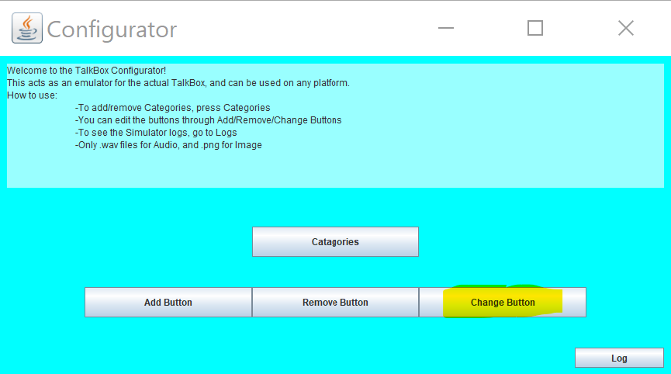

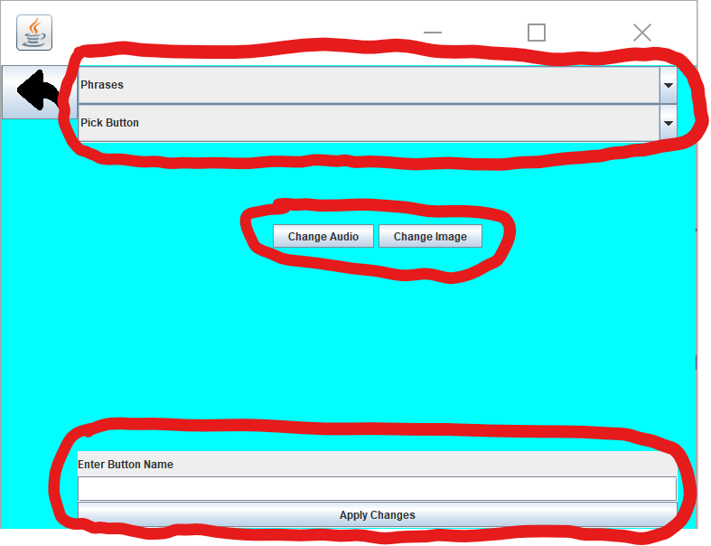

The very first thing we will do is select the category which the button belongs to. The default setting is the Phrases category, however the button which we wish to change is from the ‘Emotions’ category. When you click the area which ‘Phrases’ is enclosed in, you will notice that it is a combo box with two categories, select the ‘Emotions’ category.

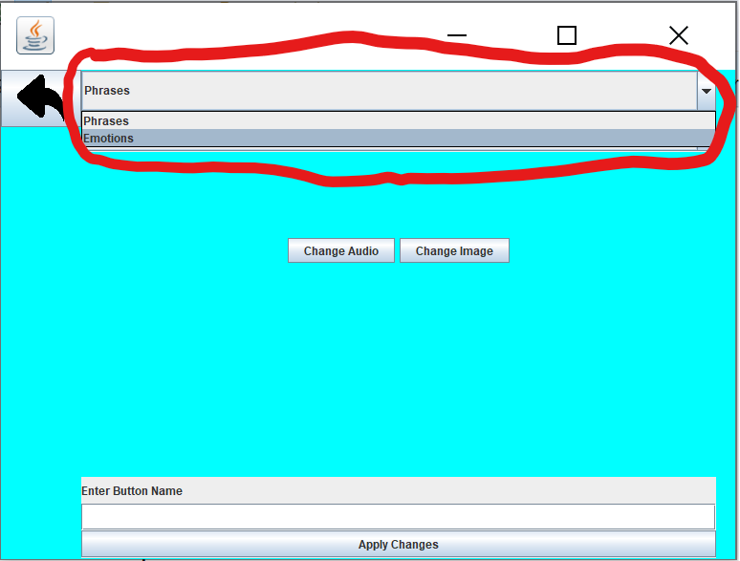

After this, we must select the number of the button we wish to change which in our case is button 2. This will also be a combo box; however, it will show as many buttons which are within the category. Please select 2 from the list.

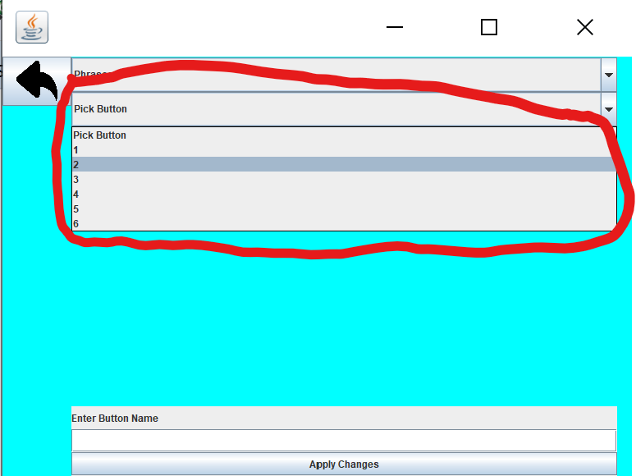

Remember, before changing the audio, image, or name of a button, to *always* select the set and the button which you are changing. Now all that’s left to change the audio, image, and name of the button. Now we change the audio. To do so, we click the ‘Change Audio’ button. Doing so opens a file chooser, where you can navigate through the directories of your computer and select the audio file you wish.

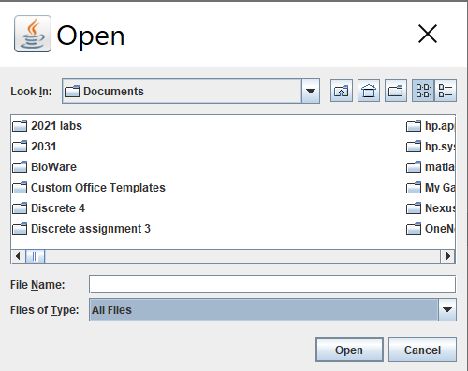

To select the audio file, simply double click on the file in the chooser. The file will automatically be copied into a location where the TalkBox will read the audio files. Remember to make sure that the audio file you choose is of the ‘.wav’ type. If the file is found to be of a different type, the program will not be able to use it, and thus will assign a default audio to the button which request you to select a proper audio file for it in the Configuration.

Now we will select the image we wish for the button to have. To do so, click the ‘Change Image’ button. Doing this, will open another file chooser, where you can once again navigate through the directories of your computer and select the image file you wish by double clicking on that image file. The file will automatically be copied to a location where the TalkBox will read the image files. When selecting the image please ensure that the image is of the ‘.png’ type, otherwise the program will not be able to use it, and thus will assign a default image to the button (image of the default shown below).



Should you see this image, that means your file was not of the correct type (was not ‘.png’) and should be changed in configuration. Now, that we have selected the audio and image of the button we simply need to change the name of the button. To do so, first write in the name of the button within the text field area.

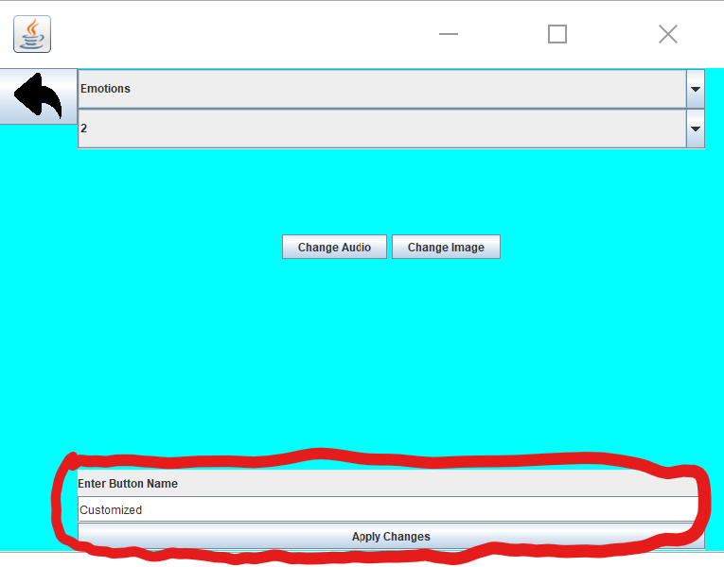

For easy recognition of the button which we have change, we have labelled it ‘Customized’. You may however rename the button to whatever you feel is suitable. After you finish typing the button name, click the ‘Apply Name’ button. Always click this button after you enter the text for the button. The text will disappear and be sent to the files to rename. Now that we have finished with our customization, we must save our settings. Click the button ‘Save Settings’ to do so, and always remember to click this button after customizing a button, otherwise your settings will not be saved and thus will not be reflected in the simulator. To make sure that the button was changed, close the configurator, and open the simulator. If you look at the second button in the ‘Emotions’ category, you will notice that the button image and label has been changed. Furthermore, when you try to click the button, you will notice that the audio has also been changed to the one which was specified during configuration.

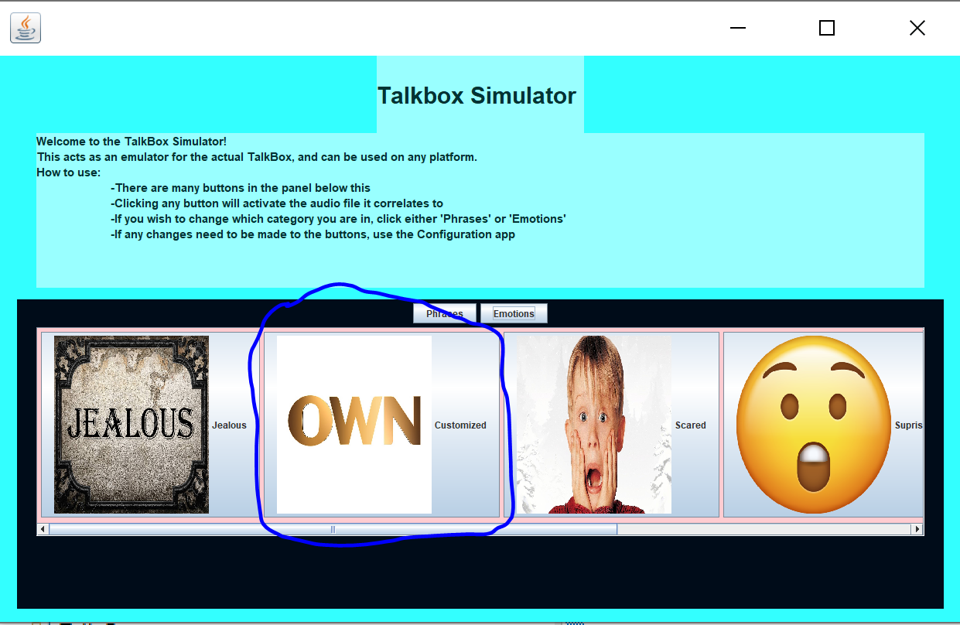

Although we showed you how to change the audio, image, and name of a button, you do not have to change all of them to customize a button. You may simply wish to update the audio of a button to something more specific or to your liking, which in that case you simply need to select the set, button, and click ‘Change Audio’, choose the audio file and then click ‘Save Settings’. Or perhaps you want to update the image of a specific button to one that is more to your liking as well? You can

# Adding Buttons

Now let us try adding buttons. Close the simulator (if you have it open) and open the configuration. To add a button, we must click the ‘Add Button’ button in configuration (as seen below).

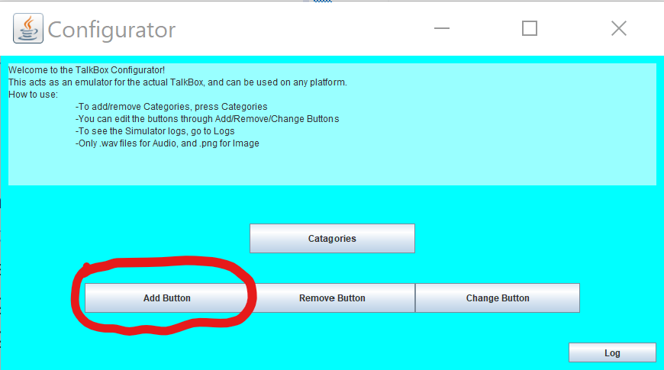

Clicking this button pops open another frame which can be seen below.

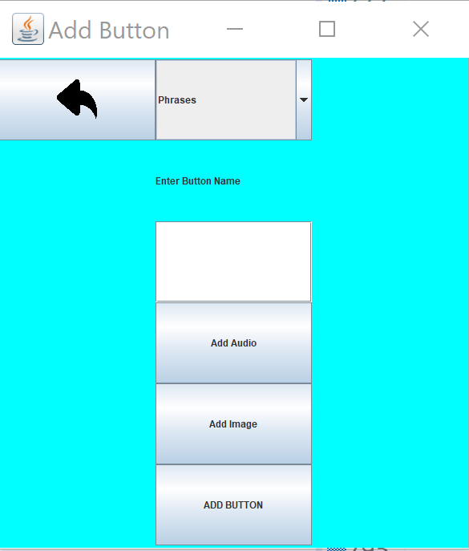

Now, you must select the which category you wish to add your new button to. The default category is ‘Phrases’, you may however change it to ‘Emotions’ if you so wish by clicking the combo box and selecting emotions from the list. For this case, let’s add the new button to the ‘Phrases’ category. Now, we enter the button name within the text field area, for this case we will be labelling the button as ‘New Btn’. After this, we select the audio file we wish to have for this button, do this by clicking ‘Add Audio’. This will open a file chooser, and we use it to navigate our computers directories to select an audio file (selected by double clicking on the file). Remember that the audio file must be of the ‘.wav’ type, otherwise the program will assign a default audio to the button. Now we select the image file we wish to have this button display. To do so, click the ‘Add Image’ button, which will open a file choose, and we use it to navigate our computers directories to select an audio file (selected by double clicking on the file). Remember that the image file must be of the ‘.png’ type, otherwise the program will assign a default image to the button. Now that we have selected and filled out all the button requirements, we can click the ‘Add Button’ button, which will save your changes. Remember to click this button before exiting the frame, otherwise your button will not be added. Close the frame as well as the configuration window and open the simulator. If you scroll to the very right, you will notice that there is a new 7th button in the ‘Phrases’ category.

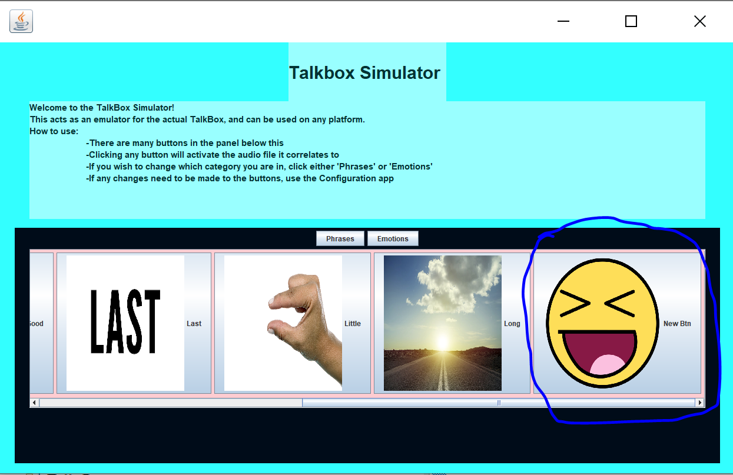

This feature is useful in case you ever feel like the TalkBox needs more buttons, or if there is not a button which fits your needs then you can simply add one that does, while keeping all your other buttons! One thing to keep in mind is that whenever we add a button, it is always added to the end of the set.

# Removing Buttons

Now let us try removing buttons. Close the simulator (if you have it open) and open the configuration. To remove a button, we must click the ‘Remove Button’ button in configuration (as seen below).

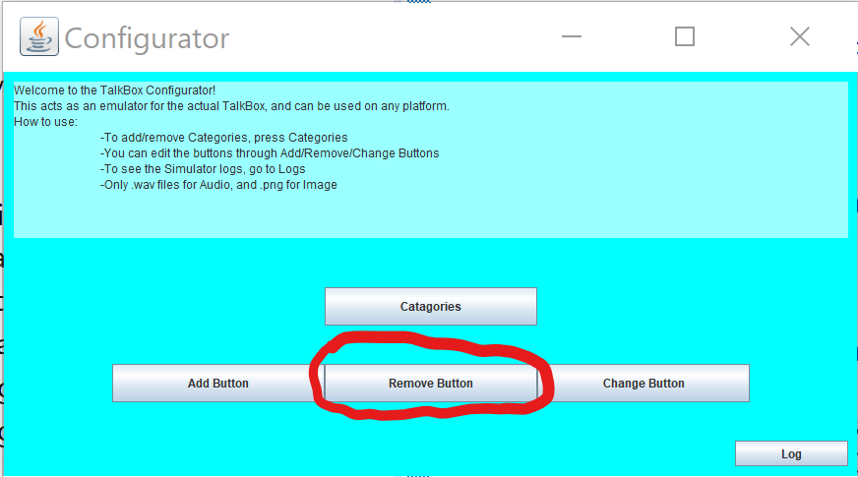

Clicking this will pop open another frame as seen below.

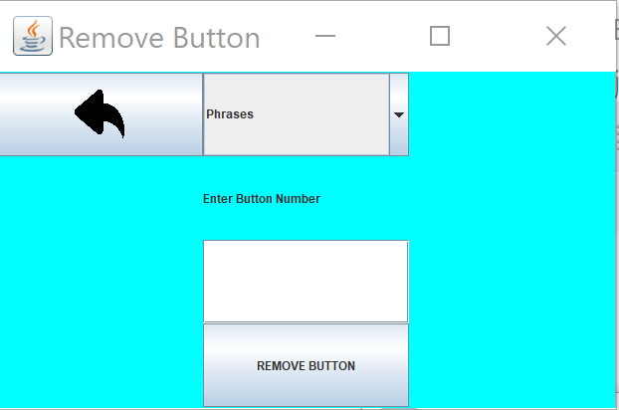

Now, you must select the which category you wish to remove your new button from. The default category is ‘Phrases’, you may however change it to ‘Emotions’ if you so wish by clicking the combo box and selecting emotions from the list. For this case, let’s remove the button we previously added to the ‘Phrases’ category. This would be button 7. Enter in the button number into the text field area, and simply click the ‘Remove Button’ button, then voila! The button will be gone from the program. If you end up choosing a button which does not actually exist within the category (i.e. button 0 or button 10) it will simply remove the first button within that set. To see the changes made, close the frame and the configurator window, and open the simulator. You will notice that the button which you previously added is gone! This feature is useful when you no longer need a button, or feel as if you have too many buttons, and instead of tolerating those buttons, you can simply remove them.

# Adding Categories

Now let us try adding categories. A category (e.g. “phrases”, “Emotions”, etc.) is a group which contains buttons related to it’s description. Close the simulator (if you have it open) and open the configuration. Now click the ‘Categories’ button, this will open up a window with 2 buttons ‘Add Set’ and ‘Remove Set’. To add a category, we must click the ‘Add Set’ button in configuration (as seen below).

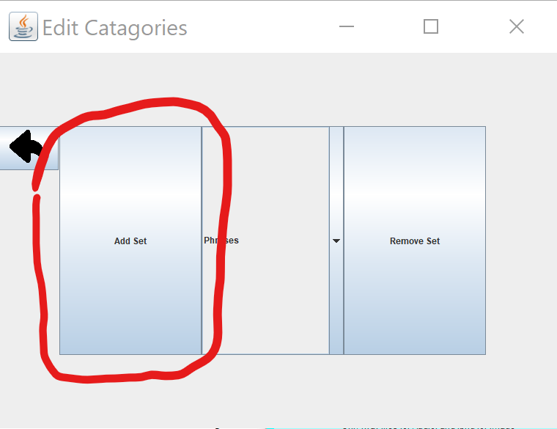

This will open a new frame as shown below. In the text field, enter the name of your new category and then click the ‘Create’ button. For this case, the new set will be labelled ‘Test’. This will add in the new category, which you can see when you open the simulator.

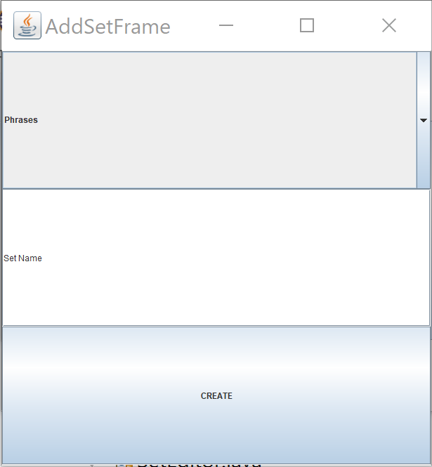

As you can see below, the new category appears, and when you click it, there are no buttons. This is because although we have created a new category, we did no add any buttons to the new category, a problem which can easily be fixed by adding them.

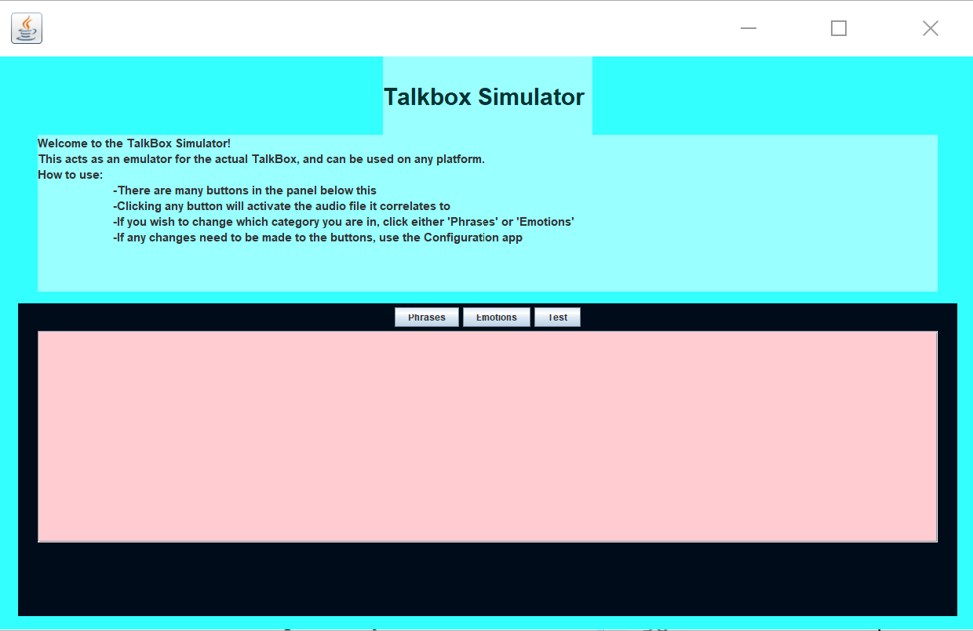

This feature is useful in case you ever feel like the TalkBox needs more categories, or if there is not a category which fits your needs then you can simply add one that does, while keeping all your other categories and their corresponding buttons! One thing to keep in mind is that whenever we add a category, it is always added to the end of the category list.

# Removing Categories

Now let us try removing categories. Close the simulator (if you have it open) and open the configuration. Now click the ‘Categories’ button, this will open up a window with 2 buttons ‘Add Set’ and ‘Remove Set’. To remove a category, we must click the ‘Remove Set’ button in configuration (as seen below).

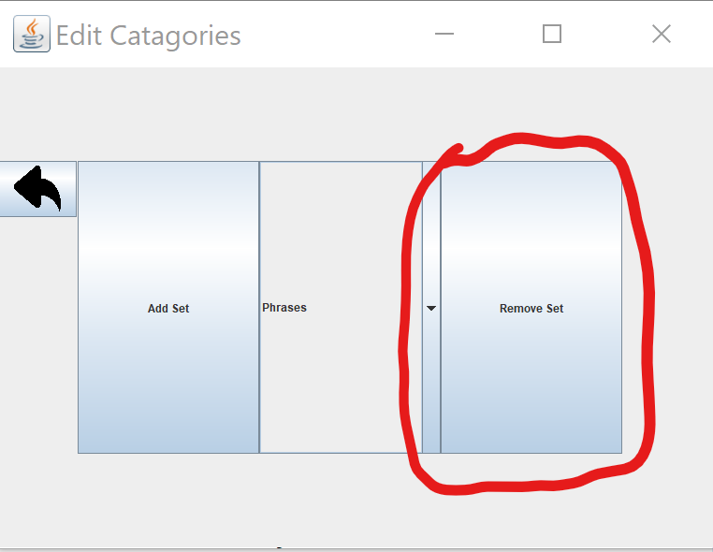

This will open a new frame, as shown below. Now from the ComboBox, select the category which you wish to remove, and then click the ‘Remove’ button. This will remove that category, and to notice this change, please close the configurator and open the simulator. For the purpose of this example, we will be removing the ‘Emotions’ category. The default category is the first category, thus if you click remove, in our case it would remove the ‘Phrases’ category.

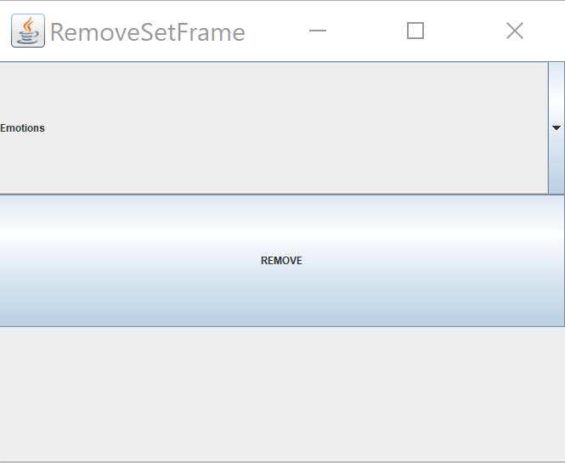

As you can see below, the ‘Emotions’ category and all it’s corresponding buttons have been removed, just like magic! This feature is useful when you no longer need a category, or feel as if you have too many categories, and instead of tolerating those categories, you can simply remove them. Now that we’ve gone through how to use the Configuration and Simulator.

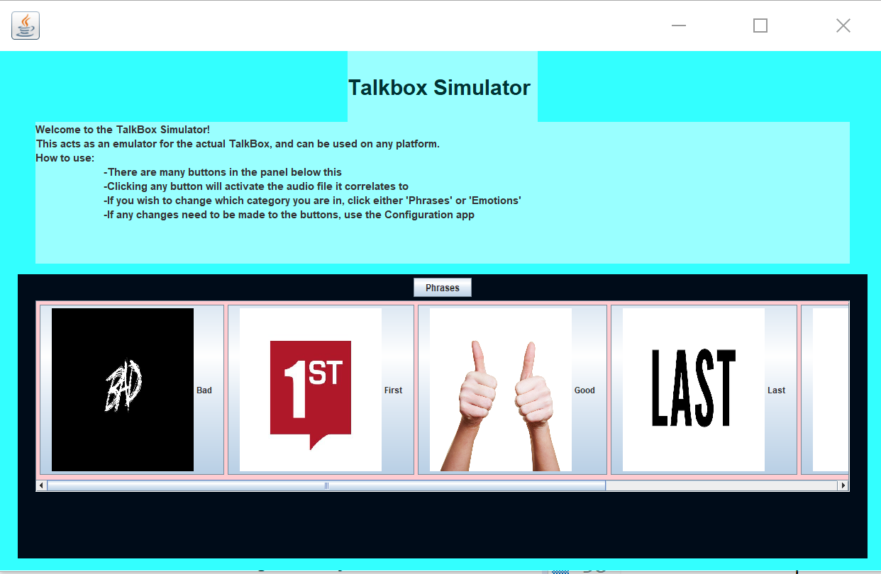

We hope that you feel comfortable with our product. If you have any questions or concerns, please do not hesitate to call or email us using the information provided near the top of this manual. Thank you for buying our product, and we hope you enjoy using it as much we did making it!