**PROFILE OF FACULTY MEMBERS**

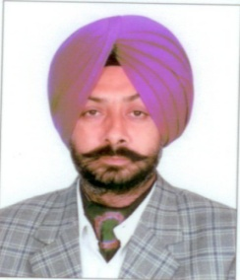

|  |  |  |  |
| --- | --- | --- | --- |
| 1. | Name | : | JASMANINDER SINGH GREWAL |
| 2. | Father’s Name | : | S. Gurbir Singh Grewal |
| 3. | Date of Birth | : | May 23, 1969 |
| 4. | Permanent Address with Pincode, Telephone No. & E-mail) | : | 317, Model Gram, Ludhiana  Pin-141 002, Ph. 98153-23023, 95920- 23023,0161-2402110 [jsgrewal_2000@yahoo.com](mailto:jsgrewal_2000@yahoo.com) |

**Educational Qualification**

|  |  |  |
| --- | --- | --- |
| **S.No.** | **Qualifications** | **Year of Passing** |
| 1. | Ph.D. (PTU, Jalandhar) | August, 2014 |
| 2. | M.E. (PU, Chandigarh) | December, 1999 |
| 3. | B.E. (PU, Chandigarh) | June, 1991 |

**Work Experience**

Teaching : 22 Years

Research : 14 Years

Industry : 1 Year

**Present Designation** : Associate Professor and Head, Department of Production Engineering and Workshops, GNDEC, Ludhiana

**Additional Duties:** :Head Workshops

Chairman Students Grievance Committee

Office-Incharge, M.Tech.

Additional Public Information Officer

Chairman, Board of Studies (Production Engineering)

Co-Chairman, Board of Studies Postgraduate (Production and Industrial Engineering)

**Areas of Specialization** : Manufacturing processes, Tribology, Surface Engineering, Mechanics of Materials, Materials and Metallurgy and Engineering Drawing

**Subjects Taught** : Engineering Drawing and Graphics, Strength of Materials, Metal Forming, Manufacturing Processes I and II, Industrial Tribology

**Memberships Technical Bodies:**

* Life Member of ISTE (Membership No. LM 29210)
* Life Member of ISME (Membership No. L 240)
* Life Member of IIIE [Membership No. SMIIE 10389 (99)]
* Life Member of IAENG

**Research Guidance :**

|  |  |  |  |
| --- | --- | --- | --- |
| **S.No.** | **Name of the Student** | **Title** | **Year of Submission** |
| 1. | Nripjit | Implementation of Inventory control using material requirement planning(MRP-I) system(A case Study) | April 2000 |
| 2. | Rupinder Singh | Environmental Management System Design Implementation in cement industry | March 2001 |
| 3. | Anil Kumar | Comparative Study of the process output parameters of Die steels EN-24 and HcHCr using Aluminium and Copper electrodes | Feb 2002 |
| 4. | Kuldip Rai | Study on Weld properties of Aluminium welded by MIG Welding process | May 2002 |
| 5. | Darshan Kumar | Study of Wire Electric Discharge Machining (WEDM) output parameters on EN-24,EN-31 and HcHCr Steels | Aug 2002 |
| 6. | Gurmeet Kaur | An experiment study of Bead Geometry in Gas metal Arc Welding | March 2004 |
| 7. | Naib Singh | Optimization of Spot Welding control parameters for Low Carbon Steel by Taguchi Technique | July 2004 |
| 8. | Vaishali Goyal | Influence of Welding parameters on Tensile shear strength and Nusset diameter of resistance spot wells on Cold rolled sheet of low Carbon steel | July 2004 |
| 9. | Sanjeev Kumar | Tig Welding of Aluminium Boffler plates for Head-Ex Changer | Dec 2005 |
| 10. | Munish Chhabra | Weldability study of Austenitic Stainless Steel(AIAI-304) with pulse GMAW | Sept 2006 |
| 11. | Ravinderpal Singh | Protection of Boiler Tubes against Hot Corrosion using HVOF sprayed Ni-Al Coatings | Dec 2006 |
| 12. | Tarik Moyerro | Comparative study of the performance of Cryo-treated and Nano coated drills in dry drilling | May 2009 |
| 13. | Arunesh Mangla | To study the effect of varying composition of Chromium(0.6%-35%) in Hard facing Alloys on wear, hardness and microstructure | March 2010 |
| 14. | Jwala P. Singla | To study the effect of thermally sprayed coatings on wear rate of Grey Cast Irons | March 2010 |
| 15. | Rakesh Goyal | Enhancement of wear resistance of Carbon Steel with the application of Thermal spray coatings | March 2010 |
| 16. | Gaurav Prashar | High Temperature Erosion of Aluminium oxide coated Boiler tubes in Simulated coal fired boiles’s conditions | August 2010 |
| 17 | Harmesh Lal | Application of FEM for crack analysis of railway wheel. | July 2011 |
| 18 | Preetkanwal Singh | To study the effect of wear resistant coatings on wear rate of bearing steel. | September 2011 |
| 19 | Amardeep Singh Kang | To study the behaviour of wear resistant coating on high tensile steels applicable on rotavator blades. | September 2011 |
| 20 | Shivali Singla | Performance evaluation of hardfaced exacavator bucket teeth against wear. | January 2012 |
| 21 | Lakhwinder Singh | Erosion-corrosion study of D-gun sprayed coatings on ASTM-SA-210-Grade A-1 boiler steel. | June-2012 |
| 22 | Shehbaaz Singh Brar | To study the behaviour of erosion-corrosion resistant detonation gun sprayed coatings onT-22steel. | June 2012 |
| 23 | Birdawinder Singh | Design and fabrication of cavitation erosion test rig and checking its capabilities by testing different pump materials. | June 2012 |
| 24 | Vinod Pandita | Work related musculoskeletal disorders among workers –A case study. | September 2012 |
| 25 | Pawandeep Singh Grewal | Characterization and hot corrosion behavior of D-gun sprayed coatings on ASTM-SA 210 grade A-1 boiler steel. | November 2012 |
| 26 | Daljinder Singh | Effect of filler wire composition on performance of Gas Tungsten Arc Welded (GTAW) stainless steel. | November 2012 |
| 27 | Jagtar Singh | Behaviour of friction stir welded brass plate joints. | December 2012 |
| 28 | Deepak Kumar Sharma | Fabrication of cavitation erosion test rig and comparison of cavitation erosion of cast iron by injecting water inwater and air in water. | January 2013 |
| 29 | Navjot Singh | To study the behavior of wear resistant coatings on cast iron applicable on lathe machine beds and slides. | April 2013 |
| 30 | Gurkamalnain Singh | To study high temperature erosion-corrosion of detonation gun sprayed Al2O3 coating on ASTM-SA213-grde T-91 boiler steel. | April 2013 |
| 31 | Atam Parkash Papreja | Comparative analysis of eco-friendly vegetable, petroleum and synthetic oil based cutting fluids. | April 2013 |
| 32 | Ranjit Singh | To study the behavior of wear resistant coatings on high tensile steels applicable on lawn mower blades. | April 2013 |
| 33 | Satjot Singh Dhillon | Experimental investigation of high temperature corrosion behavior of gun sprayed Al2O3..xTiO 2 coatings on T-22 boiler steel. | April 2013 |
| 34 | Tejinder Kaur | Synthesis and characterization of sol gel derived pure and titania composite HAP thin film coatings on Ti-6Al-4V for biomedical applications. | June 2013 |
| 35 | Jaswinder Singh | Performance of hardfaced stainless steels subjected to erosion under controlled conditions. | June 2013 |
| 36 | Rupinder Singh | To study the performance of hardfaced high tensile steels with respect to wear applicable on the blades of rotavator. | June 2013 |
| 37 | Naveen Bansal | To study the behavior of thermal spray coatings on erosive wear of boiler steels. | June-2013 |
| 38 | Jimmy Mehta | Comparative analysis of detonation gun and high velocity oxy fuel sprayed coatings with respect to wear of high tensile steel applicable to concrete mixer shovels. | September 2013 |
| 39 | Arshpreet Kaur Pandher | Comparative studyof thermal spraying bydetonation gun and high velocity oxy fuel on AISI-310 Boiler steel with respect to erosion. | December 2013 |
| 40 | Satinder Singh | Evaluation of erosion resistance of detonation gun sprayed and hardfaced AISI-314 boiler steel. | December 2013 |
| 41 | Ravinder Kaur | Development and evaluation of vegetable based cutting fluid for grinding process. | January 2014 |
| 42 | Tajinder Singh | Performance of wear resistant coatings deposited on C-70 high carbon steel applicable to rotary cutter blades. | July 2014 |
| 43 | Vipal Kumar Garg | Wear behavior of D-gun sprayed coatings deposited on brick crusher steel plates. | July 2014 |
| 44 | Harkamal Singh | Experimental investigation of D-gun sprayed coatings on E-15B steel applicable to harvester combine blades with respect to wear. | July 2014 |
| 45 | Manminder Singh | Performance of thermal sprayed coatings on EN-8 steel applicable to oil expeller screw with respect to wear. | July 2014 |
| 46 | Vivek Kumar | Analysis of microstructure and mechanical properties obtained by GTAW welded duplex stainless steel applying Taguchi method. | August 2014 |
| 47 | Bhupesh Walia | Protective thermal spray coatings for 316L stainless steel implant materials | Pursuing |
| 48 | Navneet Gupta | To evaluate mechanical properties and wear characteristics of electroless Ni-P coatings on mild steel. | Pursuing |
| 49 | Jagtar Singh | Slurry erosion behavior of hardfaced stainless steel. | Pursuing |
| 50 | Maninder Singh | Hot corrosion behavior of D-gun sprayed coatings on AISI 310 boiler steel. | Pursuing |

**Research Publications :**

**National**

1. Seehra, R.S., Bains, H.S. and Grewal, J.S., “Shortpeening as Surface Corrective Process”, 9th ISME Conference on Mechanical Engineering at University of Roorkee, Roorkee on 10-11 Nov., 1994.
2. Tayal, N., Tayal, S.P. and Grewal, J.S., “Quality Improvement in technical Institutions to meet the challenges of the industry”, National Conference on TQM in Technical Institutions, MACT (REC) Bhopal on 20-21 Dec. 1996.
3. Grewal, J.S., Sharma, N.D. and Singh Jasdeep, “Optimization of Machining Parameters using geometric Programming”, 16th National Conference of Mechanical Engineers and All India Seminar on Future Trends in mechanical Engineering”, at University of Roorkee, Roorkee on 29-30 Sept., 2000.
4. Grewal, J.S., Nripjit and Bhullar, R.S., “Designing the Element of Material Requirement Planning (MRP 1) System in a Make to Order Company”, National Conference at Coimbatore on 14-15 May, 2001.
5. Grewal, J.S. and Kaur Gurmeet, “Some studies on back bead geometry of mild steel using automatic GMAW process”, National Conference at SLIET, Longowal on 18-19 Jan., 2004.
6. Grewal, J.S. and Singh Rupinder, “Spot Welding Optimization of Low Carbon Steel using Taguchi Technique,”2nd National conference on recent development in Mechanical Engineering at TIET Patiala on 10-11 Nov.,2006.
7. Grewal, J.S. and Grewal, C.S., “Nanotechnology: The Way for Novelty in Every Stream of Technology”, National Conference on Nanotechnology at Bhai Maha Singh College of Engineering, Muktsar on 23-24 Feb., 2007.
8. Grewal, J.S., Singh Sehijpal, Chawla, Vikas and Mangla, A.K., “Improvement in abrasive wear resistance by hard facing – A review”, National Conference on Advancements and Futuristic Trendsin Mechanical and Material Engineering, Feb. 19-20, 2010, Yadwindra College of Engineering, Punjabi University, Talwandi Sabbo
9. Grewal, J.S., Chawla, Vikas and Singla, J.P., “A survey of detonation gun sprayed wear resistant coatings” National Conference on Advancements and Futuristic Trendsin Mechanical and Material Engineering, Feb. 19-20, 2010, Yadwindra College of Engineering, Punjabi University, Talwandi Sabbo.
10. Singla Shivali, Goyal Rakesh and Grewal, J.S., “A review paper on wear and hard facing”, 14th Punjab Science Congress held on Feb. 7, 2011 at SLIET, Longowal
11. Singh Birdevinder, Grewal, H.S., Sehgal R. and Grewal, J.S.,”Cavitation erosion of metals – A review”, National Conference on Recent Trends in Mechanical and Automobile Engineering.

**International Conferences:**

1. Singh, Rupinder, Khamba, J.S. and Grewal, J.S., “Machining characteristics optimization using Taguchi technique in ultrasonic drilling of titanium alloys”. International Conference on Emerging Technique Technologies and Control (EISCO 2005), 5-7 Jan. 2005, Coimbatore.
2. Goyal Rakesh, Sidhu Buta Singh and Grewal, J.S., “An innovation in manufacturing – detonation gun sprayed wear resistant coatings”. International Conference on Engineering Innovations: A Fillip to Economic Development, 18-20 Feb. 2010 at Continental Group of Institutes
3. Effect of filler wire composition on joining properties of GTAW stainless steel 202, pp. 191-200. International Conference on Research and Innovations in Mechanical Engineering, ICRIME 2013.
4. Mechanical and microstructural properties of nano-structured and conventional TiAlN coatings deposited on AISI-316 boiler steel, International Conference on Research and Innovations in Mechanical Engineering, ICRIME 2013.

**International Journals:**

1. Goyal Rakesh, Sidhu Buta Singh and Grewal, J.S., “Surface engineering and detonation gun spray coatings”. International Journal of Engineering Studies, Vol. 2, No. 3, 2010, pp. 351-357
2. Dhillon, Satjot Singh, Chawla, Vikas and Grewal, Jasmaninder Singh, “Hot corrosion and its preventive measures – A review”. Journal of the Australian Ceramic Society, Vol. 47 (2), 2011, pp. 1-7.
3. Grewal, Pawandeep Singh, Chawla, Vikas and Grewal, Jasmaninder Singh, High velocity oxy-fuel sprayed coatings – A review. Journal of The Australian Ceramic Society, Vol. 47 (2), 2011, pp. 30-36.
4. Singla, Shivali, Shibe Vineet and Grewal, J.S., “Comparative study of hard faced excavator bucket teeth against abrasive wear using MMAW process”. International Journal of Material s Science and Engineering, Vol. 2, No. 1-2, Jan.-Dec. 2011, pp. 5-8.
5. Singla, Shivali, Shibe Vineet and Grewal, J.S., “Performance evaluation of hard faced excavator bucket teeth against abrasive wear using MMAW process”. International Journal of Mechanical Applications Research, Vol. 2, Issue 2, Aug-Sept. 2011
6. Kang, Amardeep Singh, Jain Deepak, Kang Shivani and Grewal Jasmaninder Singh, “Wear behaviour of thermal; spray coatings on rotavator blades” Journal of Thermal Spray Technology, Vol. 21, No.2, 2012
7. Singh, Lakhwinder, Chawla, Vikas and Grewal, J.S., “A review on detonation gun sprayed coatings”. Journal of Minerals and Materials Characterization and Engineering, Vol. 2, No. 3, pp. 243-265, 2012
8. Singla Shivali, Kang Amardeep Singh and Grewal Jasmaninder Singh, “Enhancing wear resistance of low alloy steels applicable on excavator bucket teeth via hard facing”. Asian Review of Mechanical Engineering and International Peer Reviewed Journal on Mechanical Engineering, Vol, 1, No. 2, July-Dec. 2012
9. Grewal Jasmaninder Singh, Sidhu Buta Singh and Prakash Satya, “High Temperature erosion performance of nanostructured and conventional TiAlN coatings on AISI-3014 boiler steel substrate”. International Journal of Transactions of Indian Institute of Metals IIM, 2014
10. Singla Shivali, Kang Amardeep Singh, Cheema Gurmeet Singh and Grewal Jasmaninder Singh, “Wear behaviour of weld overlays on excavator bucket teeth”, Procedia Maetrial Science (5), pp. 256-266, 2014.

**Books/Monographs Published:**

1. Wear Behaviour:Some detonation gun sprayed coatings on grey cast iron
2. Behaviour of wear resistant coatings : Enhancing wear resistance of high tensile steel applicable on rotavator blades
3. Wear behaviour of hard facings: Excavator bucket teeth wear resistance enhancement via hard facing
4. Material degradation at high temperature: erosion corrosion study of detonation gun sprayed coatings on Gr. A1 boiler tube steels

**Books Reviewed:**

1. Engineering Drawing by Basant Aggarwal and C.M. Aggarwal, Publisher McGraw-Hill Education India Pvt. Ltd.
2. Theory of Lubrications, Publisher McGraw-Hill Education India Pvt. Ltd.

**Courses Attended:**

|  |  |  |  |
| --- | --- | --- | --- |
| **Name of the Course/ Summer School** | **Place** | **Duration** | **Sponsoring Agency** |
| MICROCONTROLLERS AND THEIR INDUSTRIAL APPLICATIONS | GNDEC, Ludhiana | One Week  31 Dec, 1999 | AICTE |
| An integrated approach to flexible Automated Manufacturing | College of Technology and Agriculture Engg. Udaipur | Two weeks, 01 July to 14 July 2000 | ISTE/AICTE |
| Mechatronics: Application ;Motion control and process control | GNDEC, Ludhiana | Two weeks, 17 to 28 July 2000 | ISTE/AICTE |
| A workshop o system Modeling and SIMULATION | Sant Longowal Institute of Engg. And Tech, Sangrur | Two Week  31 July to 11 Aug. 2000 | ISTE/AICTE |
| Productivity enhancement through resource waste reduction | Thapar Institute of Engg. And Tech, Patiala | Two Week  (Dec. 18-29, 2000) | ISTE |
| Intellectual property rights and Patents systems in India | NITTR, Chd. | One Week  (Dec. 18-20, 2006) | MHRD, Govt. of India |
| EDUCATIONAL AUDITING AND FEEDBACK SYSTEMS FOR EXCELLENCE IN TECHNICAL INSTITUTIONS | GNDEC, Ludhiana | One Week 12 January, 2009 to 16 January, 2009. | MHRD, Govt. of India |
| FUNDAMENTALS OF RESEARCH METHODOLOGY | GNDEC, Ludhiana | One Week 11-15 July 2011 | PTU, Jalandhar |
| RECENT ADVANCEMENTS IN MANUFACTURING TECHNOLOGY | GNDEC, Ludhiana | Two Weeks 10-21 June, 2013 | TEQIP- II |
| MANAGEMENT CAPACITY ENHANCEMENT PROGRAMME FOR ADMINISTRATORS | IIM, Lucknow (Noida Campus) | One Week 23-27 Sept, 2013 | TEQIP- II |
| FINITE ELEMENTAL METHOD AND ITS APPLICATION | GNDEC, Ludhiana | Two weeks 31 Oct. to 13 Nov., 2013 | AICTE |
| RESIDENTIAL TRAINING PROGRAMME ON AFFECTIVE OFFICE ADMINISTRATION AND MANAGEMENT | Port Blair, A & N Islands | One Week 11-15 Feb, 2014 | TEQIP- II |
| MICRO/NANO MATERIAL REMOVAL AND ADDITIVE TECHNOLOGIES IN ADVANCE MANUFACTURING | GNDEC, Ludhiana | One Week 28 July –1 August, 2014 | TEQIP- II |

**Additional Information:**

* Approx. 23 yrs. Teaching experience at GNDEC Ldh.
* During my tenure of Dean Training and Placement from June 2002 to June 2006 GNDEC Ldh. Ranked 19th at national level including IIT’s mainly based upon placements.
* During my tenure of President Sports from 30th May,2008 to 31st Dec.2012 rain water guns are installed in grounds, gymnasium renovated and the college bagged overall sports trophy most of the times.
* In 1992, I initiated inter-professional colleges hockey tournament i.e. Pilot Officer M.S. Gill Memorial Hockey Tournament in the memory of our 90 passed out student Mukhpal Singh Gill.
* During my tenure of Head Worshops with effect from May 28,2008 to till date CNC yard has been established and the purchasing of CNC is in process.
* Being chairman of student grievance committee the problems of students has been redressed effectively in consultation with the chair.
* As per the long pending demand of students regarding canteens, Nescafe and Lipton are brought in campus in consultation with the chair and Director Trust.
* Also performing the duty of APIO with effect from Dec.20, 2012 to till date.
* Being chairman board of studies of Production Engg. the courses has been upgraded according to the industry need.
* Being officer incharge and co-chairman of board of studies of M.Tech. Production and Industrial Engg.the programme education objectives are being achieved and the courses has been upgraded as and when required.
* Convener of Hostels inspection committee from last six yrs.
* Member of PTU flying squad team
* Session Chaired in International Conference on Research and Innovations in Mechanical Engineering (ICRIME 2013).

**(Jasmaninder Singh Grewal)**

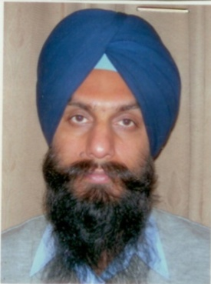

Name : Ranjit Singh

Date of Birth : 10-6-1971

Designation : Asstt. Prof. (Workshops)

Experience : Teaching : 16 years

Industry : 7 years

Other : worked as O.I/c. electrical

maintenance for 8 years

along with teaching.

Qualifications : M.Tech. (Electrical Engineering)

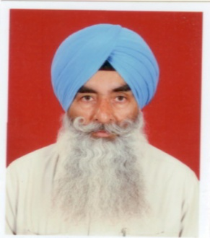

Name : Avtar Singh Grewal

Date of Birth : 21/09/1955

Designation : Sr.Instructor

Experience : 1.Instructor(16.7.1979 to till date)

2.Machinest Pearl Mech.Engg.&Foundry Works,Ldh(1976-1978)

Qualifications : 1.C.T.I.(1979)

2.I.T.I.(1976)

3.Matric(1973)

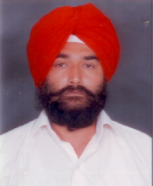

Name : Jasbir Singh

Date of Birth : 01-06-1966

Designation : Sr.Instructor

Experience : 1.Instructor(18.10.1992 to till date)

2.Supdervisor at Indian Decorator 366,Janta

Nagar(1986-1992)

Qualifications : 1.Diploma(1985)

2.Matric(1982)

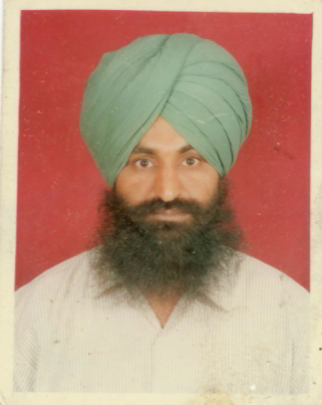

Name : Rampartap Singh

Date of Birth : 26-02-1966

Designation : Sr.Instructor

Experience : 1.Instructor(G.N.D.E.C.)(01.10.1992 to

31.12.1992 & 23.4.1993 to till date)

2.Industrial Expereince(1986-1992)

Qualifications : 1.I.T.I.Moulder(1986)

2.Matric(1982)

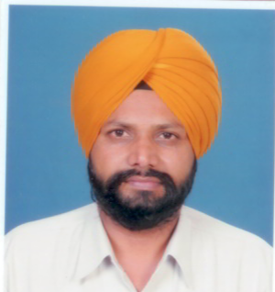

Name : Hakam Singh

Date of Birth : 18-02-1966

Designation : Sr.Instructor

Experience :1. Instructor(G.N.D.E.C.)(April 1994 to

Till date)

2.CDRT G.N.D.Poly.Ldh. (1990-1994)

Qualifications : 1.Post Diploma in Automobile & Tractor

Engg.(1991)

2.Diploma(1990)

3.Matric(1984)

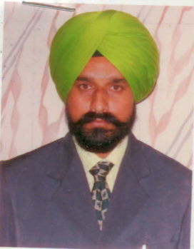

Name : Charanjit Singh

Date of Birth : 20-11-1963

Designation : Instructor

Experience : 1.Instructor(G.N.D.E.C.)(1994 to till date)

Qualifications : 1.Diploma(1990)

2.I.T.I.Electrician(1982)

3.Matric(1980)

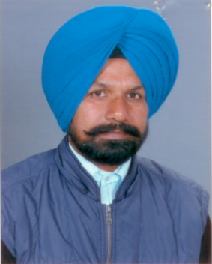

Name : Gurmeet Singh

Date of Birth : 01-04-1966

Designation : Instructor

Experience : 1.About 12 years in Auto Lab.

2.Instructor(G.N.D.E.C.)(1994 to till date)

Qualifications : 1.Diploma in Mech. (1993)

2.Matric (1982)

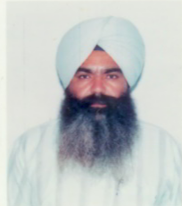

Name : Jasgur Singh

Date of Birth : 01-06-1969

Designation : Sr.Instructor

Experience : 1.Instructor(1994 to till date)

Qualifications : 1.C.T.I.(Fitter)(1991)

2.I.T.I.(Fitter)(1987)

3.Matric(1985)

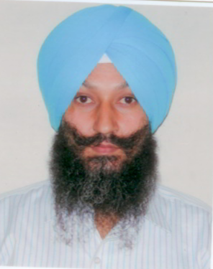

Name : Sukhpal Singh

Date of Birth : 07-09-1972

Designation : Instructor

Experience : 1.Instructor(G.N.D.E.C)(2002 to till date)

Qualifications : 1.Diploma(1992)

2.Matric(1988)



Name : Amritpal Singh

Date of Birth : 20-07-1975

Designation : Instructor

Experience : 1.Instructor(G.N.D.EC.)(20.12.2002 to

till date)

2.Instructor(G.N.D.E.C.)(2001-2002)

3.Industrial Exp.(1997-2001)

Qualifications : 1.1 yr.Diploma in Comp.Aided & Tool

Design(2001)

2.Post diploma in Automobile & Tractor

Engg.(1997)

3.Diploma(1996)

4.Matric(1991)

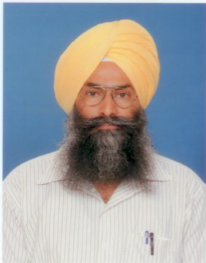

Name : Varinder Singh

Date of Birth : 31-5-1960

Designation : Instructor

Experience : 1.Instructor(G.N.D.E.C.)(2002 to till date)

2.Tech.officer at STEP(G.N.D.E.C.)

(1995-2002)

3.Maint.Engg./Incharge Tool Room at

G.N.A.Goraya(1989-1995)

4.Engg.at J.S.Mech.Works,Krishna Nagar,

Ldh.(1987-1989)

5.Auto Genns(India)38-R,IAB,LDH

(1981-1987)

Qualifications : 1.Diploma Mech.(1987)

2.Matric(1977)

3.Advance Trg.in Latest Welding Techniques.

From L & T,New Delhi.

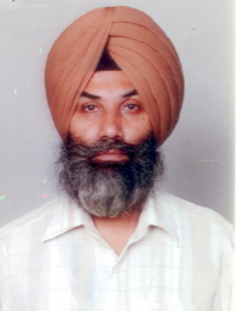

Name : Rajinder Singh

Date of Birth : 15-10-1960

Designation : Instructor

Experience : 1.Instructor(G.N.D.EC.)(2003 to

till date)

2.Instructor(Sukhmani Inst.)(2000-2003)

3.Indian Air Force.(1979-1999)

Qualifications : 1.B.A.(1999)

2.Diploma(1986)

3.Matric(1977)

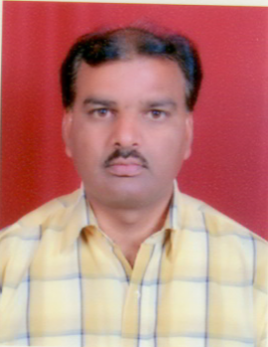

Name : Balwant Raj

Date of Birth : 30-03-1969

Designation : Instructor

Experience : 1.Instructor(G.N.D.EC.)(2003 to

till date)

2.Industrial experience(1988-2003)

In G.N.A.Udyog Ltd.Jalandhar

3.Auto CAD-2D and 3D

Qualifications : 1.Diploma(1988)(3 yr.diploma Mech.Engg.)

3.Matric(1985)

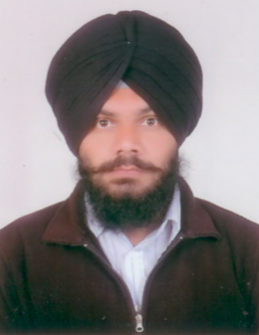

Name : Kuljit Singh

Date of Birth : 17-10-1983

Designation : Instructor

Experience : 1.Instructor(G.N.D.EC.)(2008 to

till date)

Qualifications : 1.Diploma in Electronics & Communication

Engg.(2004)

2.10+2 Arts(2002)

3.Matric(2000)

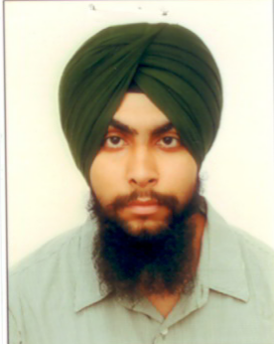

Name : Paviter Singh Grewal

Date of Birth : 28-09-1988

Designation : Instructor

Experience : 1.Instructor(G.N.D.EC.)(since 2nd Aug.2010 )

2.Instructor(Bhutta College of engg.& Tech.)

(July 2009 to July 2010)

3.Industrial exp.July 2008 to June 2009)

Qualifications : 1.Diploma in Mech.Engg.(2005-08)

2.Matric(2005))

Name : Jantinder Singh 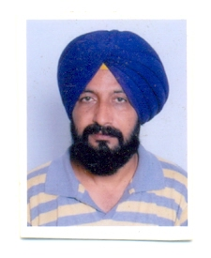

Date of Birth : 21-03-1963

Designation : Instructor

Experience : 1. M/s Dhillon Enterprises( 1986-1990)

2.M/s Sakshi International

3.Generator Operator-cum-Mechanic

(26- 11-2009 to 31-07-12)

4. Instr.01-08-12 till date GNDEC,Ldh.

Qualifications : 1.Diploma in Mech.Engg.(1990)

2.Short term Diploma-Heat Treatment

3.Short term Diploma Matrology&Inspection

4.Matric(1986)