Once timesheet is filled and submitted for entire month for each developer then all the ToDos tasks needs to be closed for each user story as mentioned below.

Execute 🡪User Stories 🡪 Click on one user story (This task needs to perform for each user story ) 🡪 ToDos 🡪 Select all and click on close

The status must be shown as “Closed”.

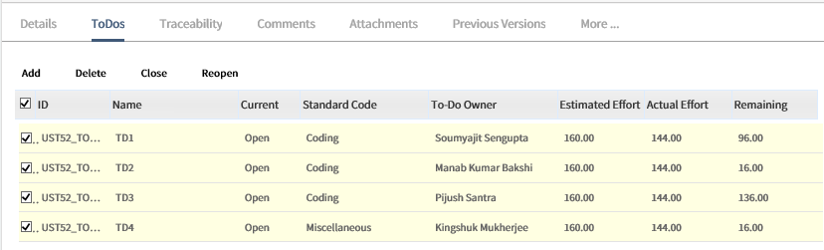

Go to Execute ----🡪 Execution board -🡪 Click on Board Filter and filter by Sprint name under which the user stories are created for that particular month.

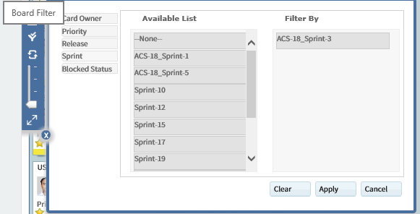

Drag each user story from “Planned” to “In-Progress” to “Validate” to “Completed”.

Once the above activity is completed the status for the user story will be shown as “Completed” under Execute--🡪User Stories section.

Now click on each user story and change the **State** as “Accepted” and click on “Save”. Now status for the user story will be shown as “Accepted” under Execute--🡪User Stories section.

Now go to Plan --- Sprints ---- Select the sprint which is created for the month. ----- change the status as “Completed” and Save. This will change the Sprint as “Completed” under Plan --- Sprints.

Finally, once all these activities are done then contact one of the DE team member (256572 Somdatta Banerjee) and ask for metrics submission for the sprint created.