RED CROSS BLOOD BANK

*INDIAN RCD* CJIOSS 5OCf£TY

West Godavari District Branch, Eluru

ELURU - 534 006, W.G.Dist., (A.P.) Ph : 08812 - 224722

BLOOD DONOR CERTWICATE

DONATE BLOOD

Reg. No. ... '..I?. ...... Date .\*It..\.3.\.@b...

*His / Her Blood Group is .* We *are* fhon£jiz/

*for the donation of Blood and contribution to the Blood* Donafion *movement.*

DONATE BLOOD & SAVE .LIVES

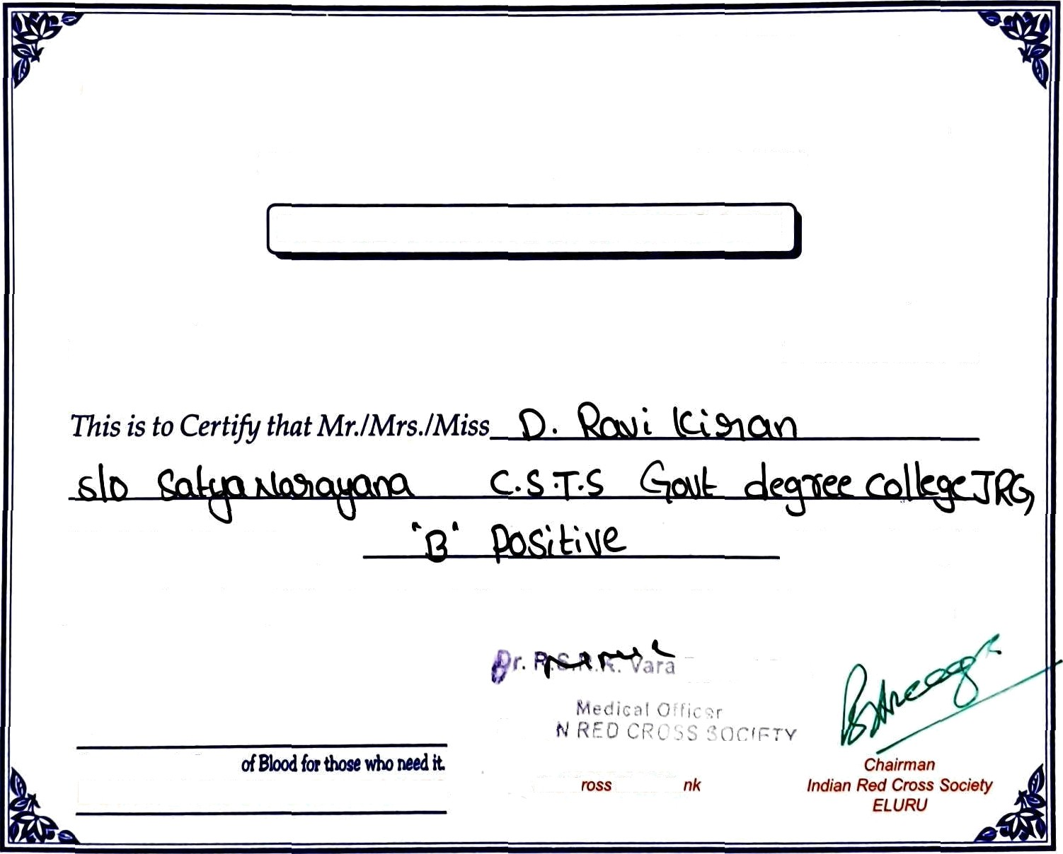

°v\*s’ \*\‹tâ6›a/‹4/• ”i ! ' ""’

Red C. 8/ood 8a