# EV Market in India

Name: - Satish Maurya

GitHub Link: -

1. Problem Statement:The main task is to analyze the EV market in India using segmentation analysis and come up with a feasible strategy to enter the market for a startup company.
2. Data sources: -
   * Public government data: - <https://data.gov.in/keywords/Electric>
   * Kaggle: - <https://www.kaggle.com/datasets>
3. Data Glimpse: -
   * Two-wheeler EVs review data:

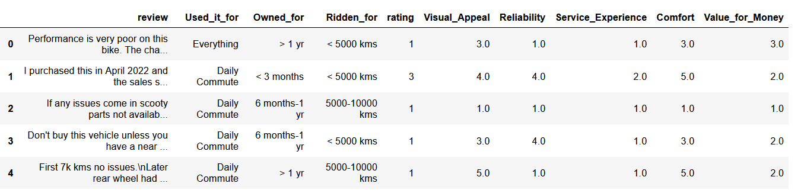

* Geographical data (Statewise proportion of registered EVs):

* Ev Sales/Trend data yearwies:

1. Data preprocessing: -

Two-wheeler EVs review data: -

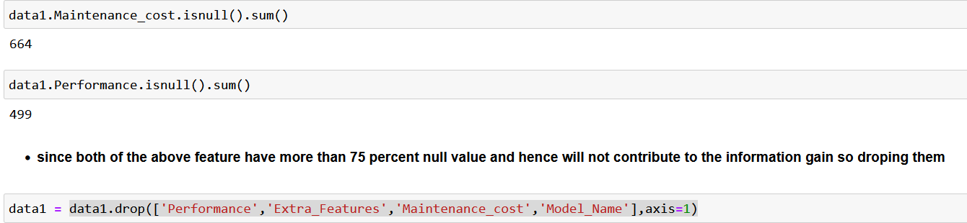

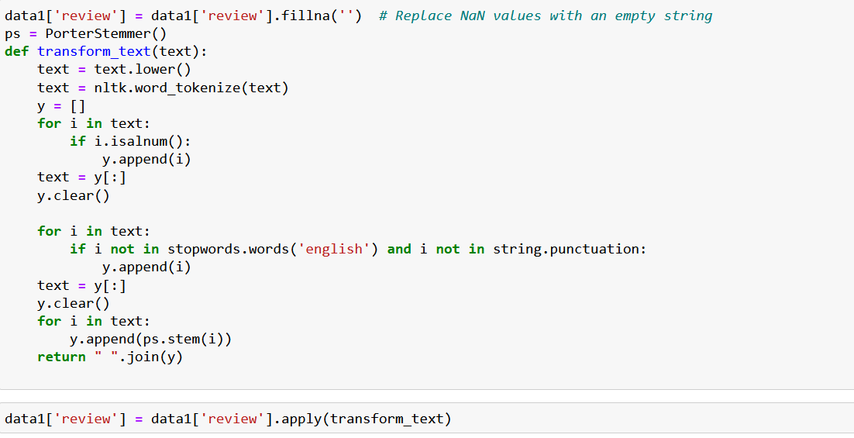 Used some NLP techniques for processing review column: -

Libraries Used:-

* + Pandaas
  + Nltk
  + String
  + stopwords,
  + PortStemmer

Note:- Other two datasets did not need to be processed.

1. Psychographic segmentation: -  
   After conducting a thorough analysis of the data, several key psychographic segments emerged:

* **Value-Conscious Consumers:**
  + A distinct segment of consumers highly values the affordability aspect of electric vehicles. They prioritize getting the most out of their investment and are drawn to EVs that offer excellent value for money, as indicated by their overwhelmingly positive ratings (4 & 5) for this attribute.
  + Below is the plot to show the above: -

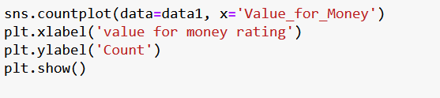

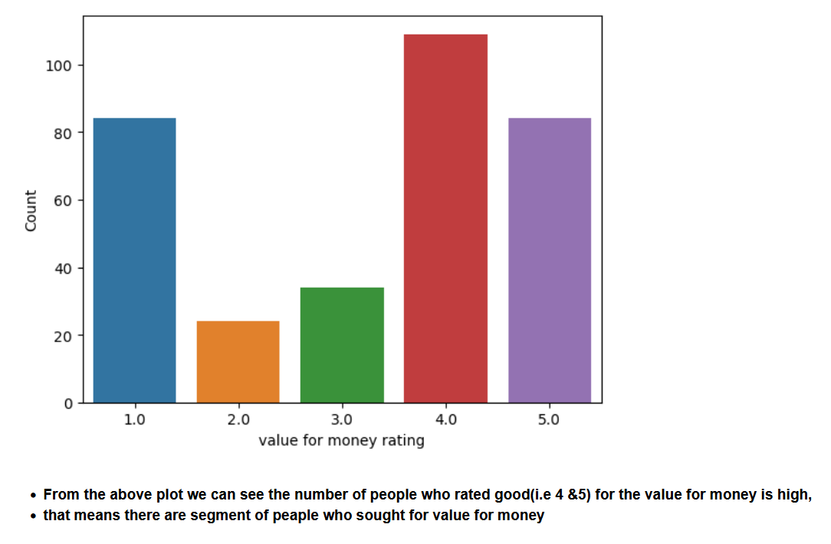

* **Comfort-First Enthusiasts:**
  + This segment places a premium on comfort and convenience in their electric vehicle choices. They prioritize features that enhance comfort during their daily commute and other activities, as reflected in their high ratings (4 & 5) for comfort-related factors.
  + Below is the plot for supporting the above segment: -

* **Comfort-Driven Value Seekers:**  
  + This segment prioritizes both comfort and value for money when selecting an electric vehicle. They seek a balance between luxury and affordability, as evidenced by their preference for EVs that offer both comfort and good value.
  + 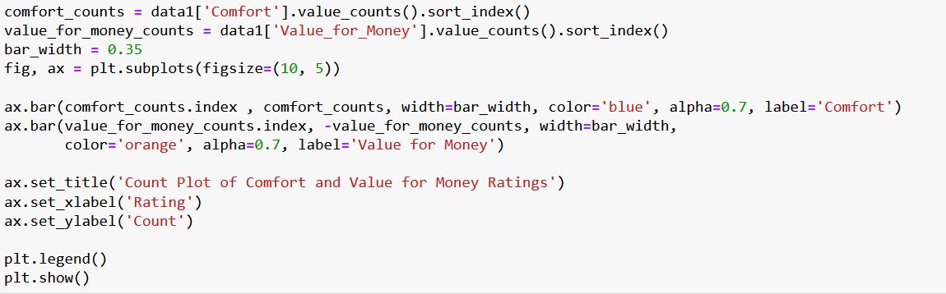Below is the plot: -

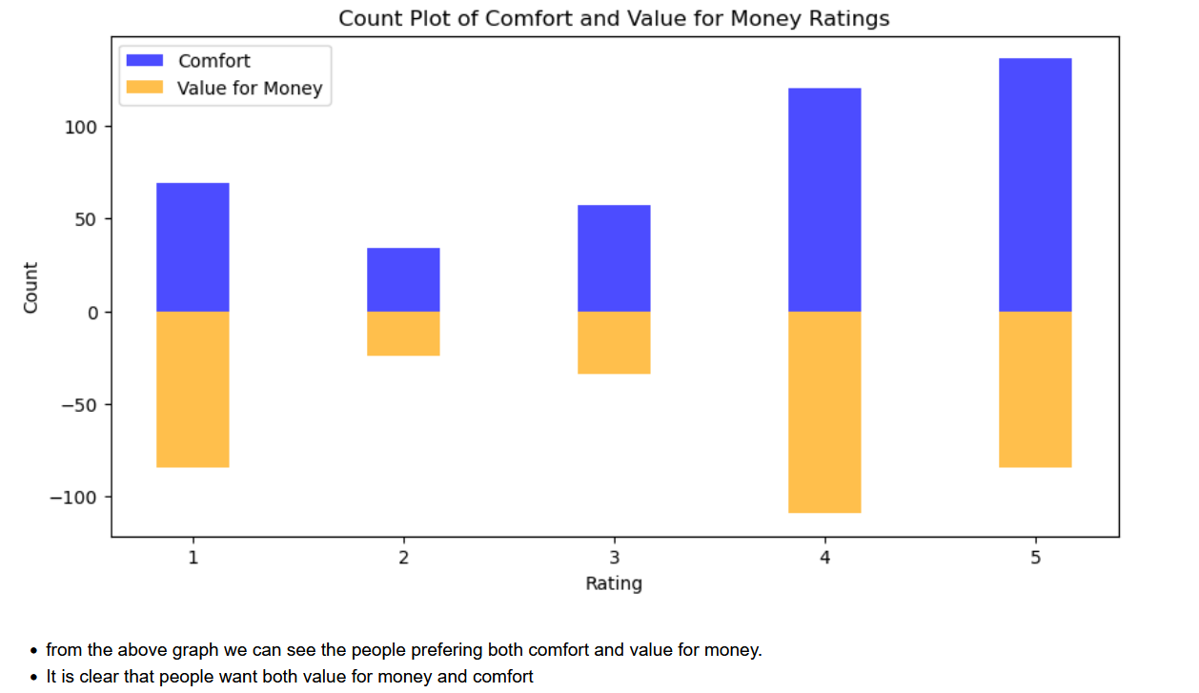

* **Utility-Focused Users:**
  + Another segment of consumers primarily sees electric vehicles as practical solutions for everyday needs. They prioritize functionality and utility, opting for EVs that are well-suited for daily commuting and versatile enough to serve various daily purposes.
  + Below is the code and the plot for supporting the above statement: -

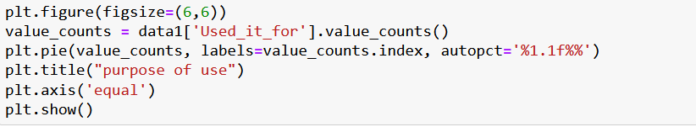

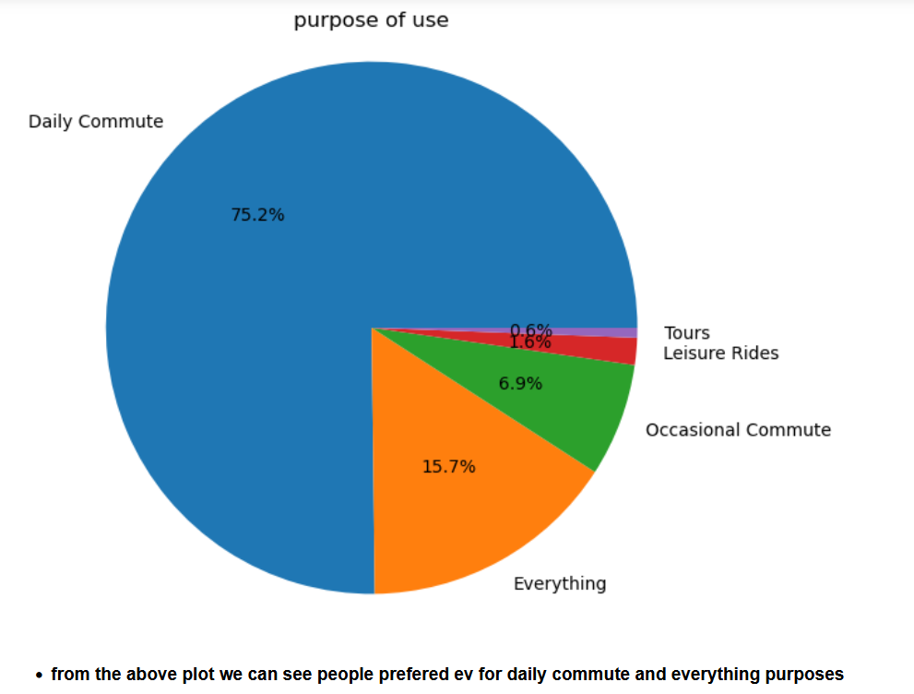

* **Most frequent words used: -**
  + Below plot shows some frequently used words in the customer’s review.

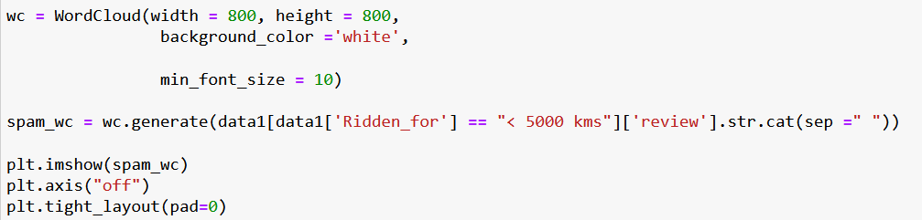

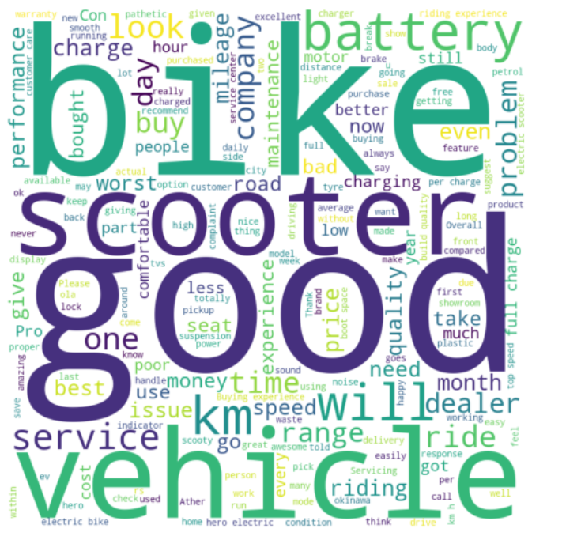

* + Some of the words are good, charge, service, battery, km, speed.
    - **Charge:** The word "charge" appearing frequently indicates that customers are discussing the charging process or perhaps the vehicle's battery charging capabilities, including factors like charging speed, convenience of charging stations, or range per charge.
    - **Service:** Mentions of "service" could relate to customers' experiences with after-sales service, maintenance, or customer support, reflecting their satisfaction or dissatisfaction with the support provided by the manufacturer or service centers.
    - **Battery:** Discussions about the "battery" likely revolve around its performance, longevity, reliability, and overall effectiveness in powering the vehicle.
    - **Km:** References to "km" may indicate discussions about the vehicle's range per charge or its efficiency in terms of kilometers per unit of battery charge, which is a critical factor for electric vehicle owners.
    - **Speed:** The inclusion of "speed" suggests that customers are discussing the vehicle's performance in terms of acceleration, top speed, or general driving dynamics.

1. Geographical Analysis: -
   * 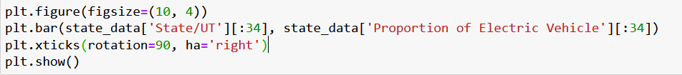Below is the plot for the analysis of proportion of the EVs in each state.

* We can see from the above graph there are some state where proportion of EVs is very less.
* So, for a startup it will be easy where the ratio is less.
* So, the startup company can start spreading the value of the EV adoption in those states.
* And the next step is to study the purpose of the EVs in those state and build customized EV based on the study.

1. EVs trend over the year: -
   * Below is the plot of sales trend of different EVs over the year:

1. Extracting Segments: -
   * Used k-means for clustering data to extract segments.
     1. Used elbow method to decide the number of clusters.

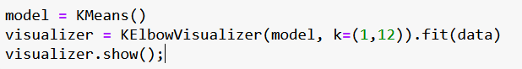

From the above plot the number of clusters should be 3.

* Applying k-means for clustering the data.

* Below is the visualization of the clusters after running the above code.

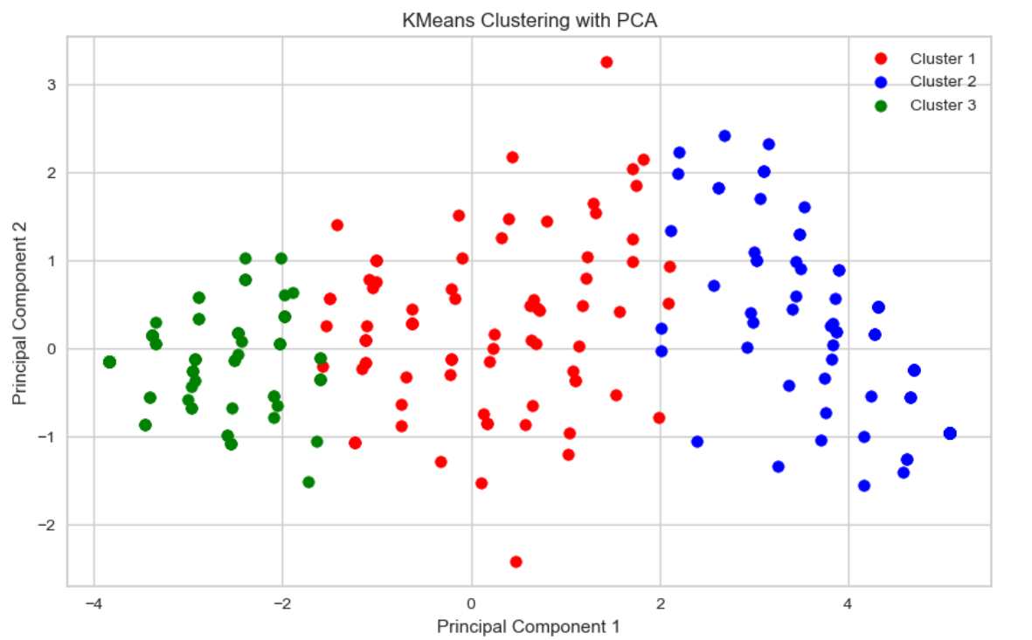

* From the above plot it’s clear that data exist in three segments based on features- Visual appeal, Reliability, Service experience, Comfort, and value for money.
* That clear that there are three strong segments in the data.
  + Using PCA method to analyse the segments.

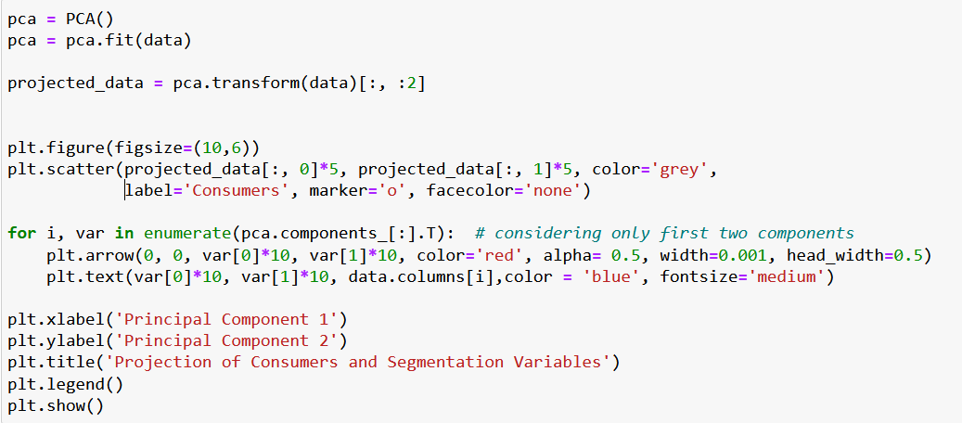

The above plot indicates that there some of the attributes are strongly related to one another.

1. 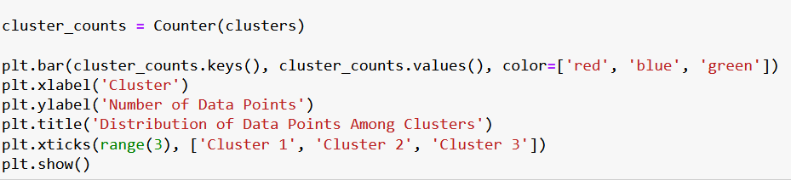Segment Profiling: -

1. Selection of target market: -
   * From the above analyses and representations, the selection of market segment should be on the following basis:
     1. **EVs proportion**: As we can see from the state wise data representation that some of the states having very low proportion of EVs. So, the focus of the startup should be in those states.
     2. **Purpose of use:** From the above analysis, we can interpret that the EV bikes are mostly used for the daily commute. So, the main market will be there where people are used to travel daily for their daily commute.
     3. **E-Rickshaws:** Startups can focus on manufacturing electric auto-rickshaws. As the above representation trend suggests there is rise in the 3w EVs. This market is very profitable as in many rural areas it is observed reduction in the salas of other auto rickshaws which runs on fossils.
     4. **Charging Stations:** The startup compony should plan to put their feet in EV market where the electricity is available continuously.
     5. **Last-Mile Delivery Vehicles: We can see these days a huge rise in online delivery and cab booking. So, the startup should produce electric cargo bikes** vans, or three-wheelers designed specifically for delivery purposes, offering businesses a cost-effective and sustainable alternative to traditional delivery vehicles.
2. Conclusion:
   * From thorough analysis of the data, I have come to the following conclusions and strategies for the startups to take to put their feet in the EV market:
     1. The startups should focus on the optimization of the present EVs that exist in market for stepping their feet in this competitive market.
     2. The startups should teach the people about use of sustainable energy and benefits of EVs over the vehicles which are runs on the fossil fuel.
     3. There are customer segments that exist which want good, visual appealing EVs. SO, the startup focusses on optimizing the existing EVs, which run in the market.
     4. There exists a distinct segment which wants the value for money. The startup should manufacture EVs which are more affordable than the existing EVs.
     5. From the above PCA analysis we can see there are two strong segments clustered with different features, like the first one having features like visual appeal and comfort, and the second one is reliability, service, and value for money. The startup should take these points into consideration.
     6. The startup should study the different segments reviews and make more customized EVs than their competitors.
     7. The startup should build their market where the existing EV proportion I very low and that market is not occupied by the giant companies.