Collection sheet Contents
Q1. Collections Introduction: 1
Q2. difference between ArrayList and linkelist and why we are using it its benefits and disadvantages 3
Q3. difference between vector and stack with example in java 5
Q4. difference between linkedlist and Vector 7
Q5. all methods of collections interface in java 9
SET 11
Q6. difference between Hashset and LinkedHashSet 11
Q7. difference between and LinkedHashSet and TreeSet 12
MAP 13
Q8. difference between HashMap, LikedHashMap, treeMap,HashTable 13
Q9. internal working of HashMap 14
Q10. interview questions for map interface. 18
Q11. questions with answers. 21

Q1. Collections Introduction:
In Java, a collection is a framework that provides a set of classes and interfaces for storing and manipulating groups of objects. Collections are an essential part of Java's standard library, and they offer a convenient way to work with data structures like lists, sets, and maps. Collections provide a consistent and powerful way to manage, store, and manipulate data in Java applications.

Key interfaces and classes in the Java Collections Framework include:

1. Collection Interface:------------------
The root interface for all collections. It defines the basic operations that all collection classes must support, including add, remove, contains, and size.
2. List Interface:-----------------
An ordered collection that allows duplicate elements. Common implementations include ArrayList, LinkedList, and Vector.
Example:
List<String> names = new ArrayList<>();
names.add("Alice");
names.add("Bob");
names.add("Charlie");
3. Set Interface:--------------------

An unordered collection that does not allow duplicate elements. Common implementations include HashSet, LinkedHashSet, and TreeSet.
Example:
Set<Integer> numbers = new HashSet<>();
numbers.add(1);
numbers.add(2);
numbers.add(3);

4. Map Interface:--------------------------------
A collection of key-value pairs. Each key is associated with a single value. Common implementations include HashMap, LinkedHashMap, and TreeMap.
Example:
Map<String, Integer> scores = new HashMap<>();
scores.put("Alice", 95);
scores.put("Bob", 87);
scores.put("Charlie", 92);

5. Queue Interface:--------------------------------
A collection for managing elements in a first-in, first-out (FIFO) order. Common implementations include LinkedList and PriorityQueue.
6. Deque Interface:--------------------------------
A collection for managing elements in a double-ended queue, allowing operations at both ends. Common implementations include ArrayDeque and LinkedList.
7. Collections Class:--------------------------------
A utility class that provides various static methods for working with collections. It includes methods for sorting, searching, and synchronizing collections.
Example:
List<Integer> numbers = new ArrayList<>();
numbers.add(3);
numbers.add(1);
numbers.add(2);
Collections.sort(numbers); // Sort the list

8. Iterators:--------------------------------
Collections also provide iterators for traversing elements. Iterators allow you to loop through a collection's elements sequentially.
Example using an iterator to loop through a list:

java
Copy code
List<String> names = new ArrayList<>();
// Add names to the list
Iterator<String> iterator = names.iterator();
while (iterator.hasNext()) {
String name = iterator.next();
// Process the name
}
Collections are a fundamental part of Java programming, and they make it easier to work with data in various applications. They are versatile and can be used for a wide range of tasks, from managing simple lists to implementing complex data structures like maps and queues.

Q2. difference between ArrayList and linkelist and why we are using it its benefits and disadvantages
Ans :
ArrayList and LinkedList are two commonly used implementations of the List interface in Java, and they have different characteristics that make them suitable for different use cases. Below, I'll explain the differences between them and when to use each:

1. ArrayList:
Implementation: ArrayList uses a dynamically resizable array to store elements. It's an array-based list.
Benefits:
Fast random access: Accessing elements by index is efficient because it uses an array.
Good for read-heavy operations: Ideal for scenarios where you frequently read elements.
Disadvantages:
Slower insertion and deletion: Insertions and deletions in the middle of the list can be slow because elements may need to be shifted.
High memory overhead: ArrayList typically consumes more memory than LinkedList due to the underlying array.
Use Cases:
Use ArrayList when you need efficient random access, mostly read operations, and don't perform frequent insertions or deletions in the middle of the list.
2. LinkedList:

Implementation: LinkedList uses a doubly-linked list to store elements. It's a node-based list.
Benefits:
Fast insertions and deletions: Insertions and deletions are efficient because you only need to update references.
Low memory overhead: LinkedList consumes less memory than ArrayList because it only needs to store values and references.
Disadvantages:
Slower random access: Accessing elements by index is slower because you need to traverse the list from the beginning or end.
Less efficient for read-heavy operations: Not ideal for scenarios where you frequently read elements without modifying the list.
Use Cases:
Use LinkedList when you need efficient insertions and deletions, mostly write operations, and don't perform frequent random access.
Use Cases and Considerations:

If your use case involves a mix of read and write operations with a bias towards reads, and you need random access or indexing, ArrayList may be more suitable.
If your use case involves frequent insertions and deletions in the middle of the list, or memory consumption is a concern, LinkedList may be a better choice.
Keep in mind that there is a trade-off between the two. The choice depends on the specific requirements of your application. Additionally, you can use the List interface in your code, and the choice between ArrayList and LinkedList can be easily changed without affecting the rest of your program. This flexibility allows you to optimize your code based on changing requirements or performance considerations.

Q3. difference between vector and stack with example in java
Ans :
Vectors are analogous to arrays in a way that both of them are used to store data, but unlike an array, vectors are not homogeneous and don’t have a fixed size. They can be referred to as growable arrays that can alter their size accordingly. It is relatively a memory-efficient way of handling lists whose size could change drastically.
It is found in “java.util” package and implements the List interface as displayed in the figure below
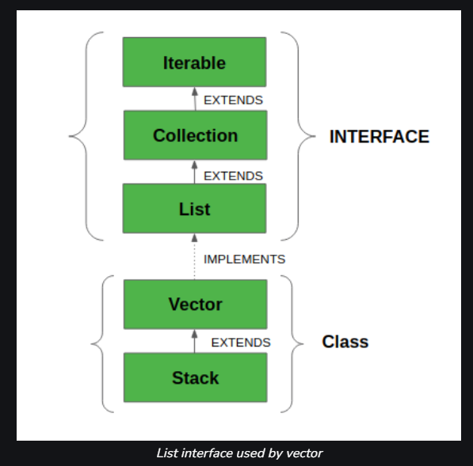
1. Inheritance:

Vector is a general-purpose, dynamic array that extends the AbstractList class and implements the List interface. It is part of the Java Collections Framework.
Stack is a specialized class that extends the Vector class and provides a last-in, first-out (LIFO) data structure for storing objects. It is designed specifically for stack operations.
2. Usage:

Vector is a flexible, resizable array that can be used as a list to store and manage elements.
Stack is designed for stack-like operations, where you typically push elements onto the top of the stack and pop them from the top. It follows the LIFO principle.
3. Stack Operations:

Stack provides stack-specific methods like push() to add elements to the top of the stack and pop() to remove and return the top element.
Vector does not provide specific stack operations but offers a more general set of list operations.

Example :
import java.util.Vector;

public class VectorExample {
public static void main(String[] args) {
Vector<String> vector = new Vector<>();
vector.add("Apple");
vector.add("Banana");
vector.add("Cherry");

System.out.println("Vector: " + vector);
}
}

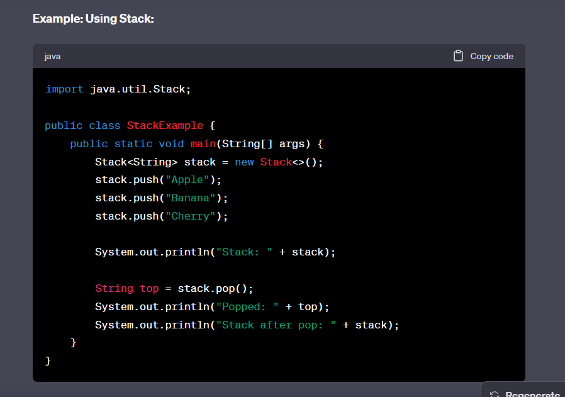
Use Cases:
- Use Vector when you need a resizable list with various list operations and are not concerned about the specific characteristics of a stack.
- Use Stack when you specifically need a stack data structure for LIFO operations, such as tracking program execution flow or managing undo/redo functionality.
Note: It's worth mentioning that Vector and Stack are older classes, and in modern Java programming, it's often recommended to use ArrayList or LinkedList for general-purpose collections and a Deque (e.g., ArrayDeque or LinkedList) for stack-like operations due to their improved performance and flexibility.

Q4. difference between linkedlist and Vector
Ans :
LinkedList and Vector are both classes in Java that provide a way to work with ordered collections of objects, but they have different characteristics and use cases. Here are the key differences between LinkedList and Vector:

1. Implementation:

LinkedList is implemented as a doubly-linked list, where each element is a node containing a value and references to the previous and next nodes. It is not synchronized.
Vector is implemented as a dynamically resizable array. It is synchronized, which means that it is thread-safe by default.
2. Synchronization:

LinkedList is not synchronized, so it is not thread-safe. If you need thread safety, you must manually synchronize access to it.
Vector is synchronized, which means that it is designed to be thread-safe. Multiple threads can safely access and modify a Vector without additional synchronization.
3. Performance:

LinkedList provides efficient insertions and deletions in the middle of the list, but random access to elements by index can be slower because it requires traversal from the beginning or end of the list.
Vector offers efficient random access to elements by index because it is array-based. However, insertions and deletions in the middle of the list can be slower due to the need to shift elements.
4. Memory Overhead:

LinkedList typically consumes less memory compared to Vector because it only needs to store values and references.
Vector generally consumes more memory because it uses an underlying array, which may be larger than the number of elements in the list.
5. Use Cases:

Use LinkedList when you need efficient insertions and deletions, and you do not require thread safety. It is suitable for scenarios where you have frequent list modifications and do not rely heavily on random access.
Use Vector when you need thread safety or if you require fast random access to elements, even though insertions and deletions may be slower. It is suitable for situations where multiple threads access the same list.
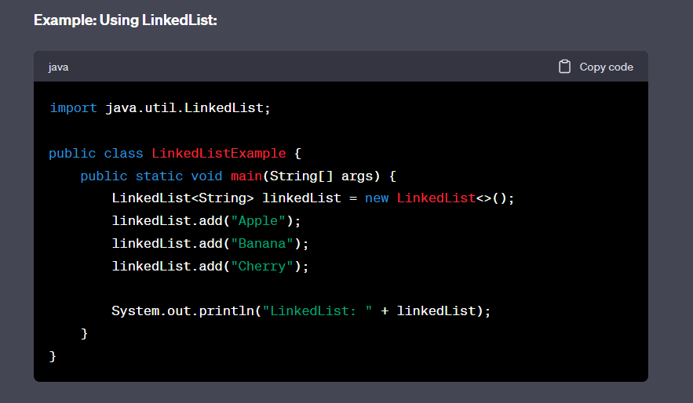
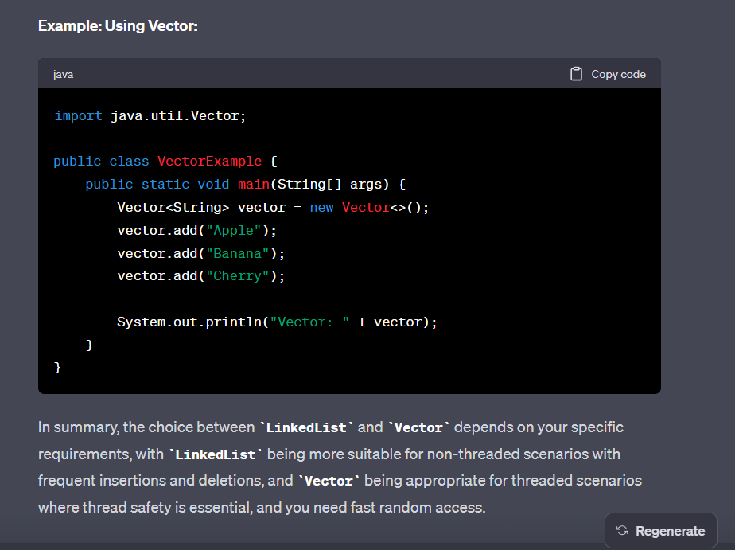

Q5. all methods of collections interface in java
Ans :
The java.util.Collection interface is one of the fundamental interfaces in the Java Collections Framework. It defines a common set of methods that all collection classes, such as lists, sets, and queues, must implement. Here are the key methods of the Collection interface:

add(E e): Adds the specified element to the collection if it is not already present. Returns true if the collection changes as a result of the call.

addAll(Collection<? extends E> c): Adds all elements in the specified collection to this collection.

clear(): Removes all elements from the collection, leaving it empty.

contains(Object o): Returns true if the collection contains the specified element.

containsAll(Collection<?> c): Returns true if the collection contains all the elements in the specified collection.

isEmpty(): Returns true if the collection contains no elements.

iterator(): Returns an iterator over the elements in the collection.

remove(Object o): Removes a single instance of the specified element from the collection, if present.

removeAll(Collection<?> c): Removes all elements in the specified collection from this collection.

removeIf(Predicate<? super E> filter): Removes all elements of the collection that match the given predicate.

retainAll(Collection<?> c): Retains only the elements in this collection that are also in the specified collection.

size(): Returns the number of elements in the collection.

toArray(): Returns an array containing all of the elements in this collection.

toArray(T[] a): Returns an array containing all of the elements in this collection, where the runtime type of the returned array is that of the specified array.

equals(Object o): Compares the specified object with this collection for equality.

hashCode(): Returns the hash code value for the collection.

stream(): Returns a stream of elements in the collection for use in stream operations introduced in Java 8.

parallelStream(): Returns a parallel stream of elements in the collection for parallel processing.

These methods are part of the core functionality provided by the Collection interface. Implementing classes, such as ArrayList, LinkedList, HashSet, and more, provide their own specific implementations of these methods to work with their underlying data structures. The choice of collection class depends on the specific requirements of your application.

SET

Q6. difference between Hashset and LinkedHashSet
Ans :
HashSet and LinkedHashSet are both implementations of the Set interface in Java, but they have different characteristics when it comes to ordering and performance. Here's the key difference between HashSet and LinkedHashSet:

1. Ordering:

HashSet does not maintain any specific order of the elements. Elements are stored in a way that allows for efficient searching and retrieval but does not guarantee any particular order.
LinkedHashSet, on the other hand, maintains the order of elements based on the order of insertion. It behaves like a combination of a HashSet and a linked list, ensuring that elements are stored in the order in which they were added.
2. Performance:

HashSet offers slightly better performance for typical set operations like add, remove, and contains. It is generally faster for these operations compared to LinkedHashSet.
LinkedHashSet is slightly slower than HashSet for basic set operations because it has the added overhead of maintaining the insertion order.
Use Cases:

Use HashSet when you need a set for fast set operations like adding, removing, and checking for containment, and you do not care about the order of elements.
Use LinkedHashSet when you need a set that maintains the order of insertion and still provides reasonably fast set operations. It is useful when you need to iterate through elements in the order they were added or when order matters.
In summary, the choice between HashSet and LinkedHashSet depends on whether you need to maintain insertion order. If you don't need to maintain order, HashSet is more efficient. If order matters, then LinkedHashSet is the better choice.

Q7. difference between and LinkedHashSet and TreeSet
Ans :
LinkedHashSet and TreeSet are both implementations of the Set interface in Java, but they have different characteristics when it comes to ordering and performance. Here's the key difference between LinkedHashSet and TreeSet:

1. Ordering:

LinkedHashSet maintains the order of elements based on the order of insertion, which means it preserves the order in which elements were added to the set.
TreeSet stores elements in a sorted order, specifically in ascending order as defined by their natural order (if the elements are Comparable) or a custom comparator (if provided during TreeSet creation).
2. Performance:

LinkedHashSet is efficient for basic set operations like add, remove, and contains. These operations have a time complexity of O(1) on average.
TreeSet is efficient for set operations as well, but it is designed for maintaining elements in a sorted order. Basic operations also have a time complexity of O(log n) on average, where "n" is the number of elements in the set.
3. Elements' Comparison:

LinkedHashSet does not require elements to have a natural order or be Comparable, as it only preserves the insertion order.
TreeSet requires elements to either implement the Comparable interface or be provided with a custom Comparator during TreeSet creation to define their order.
Use Cases:

Use LinkedHashSet when you need a set that maintains the order of insertion and you don't require sorting of elements. It is useful when you need to iterate through elements in the order they were added or when order matters.
Use TreeSet when you need a set that stores elements in a sorted order. It is suitable for situations where you need to retrieve elements in ascending or descending order and when you want to take advantage of its sorted properties.
In summary, the choice between LinkedHashSet and TreeSet depends on whether you need to maintain insertion order (LinkedHashSet) or store elements in a sorted order (TreeSet). Your choice should align with your specific requirements for ordering and performance.

MAP

Q8. difference between HashMap, LikedHashMap, treeMap,HashTable
Ans:
HashMap, LinkedHashMap, TreeMap, and HashTable are all implementations of the Map interface in Java, which is a part of the Java Collections Framework. They are used to store key-value pairs, but they have some differences in terms of performance, ordering, and synchronization.

HashMap:

It does not guarantee any specific order of the elements.
It allows one null key and multiple null values.
It is not synchronized, so it is not thread-safe. If multiple threads access a hash map concurrently, and at least one of the threads modifies the map structurally, it must be synchronized externally.
LinkedHashMap:

It maintains the order of the elements based on the order they were inserted into the map.
It allows one null key and multiple null values.
It is not synchronized by default, but you can create a synchronized version using Collections.synchronizedMap(LinkedHashMap).
TreeMap:

It maintains the natural ordering of the elements or allows you to provide a custom comparator to define the order.
It does not allow null keys (throws NullPointerException) but allows multiple null values.
It is not synchronized by default, but you can create a synchronized version using Collections.synchronizedMap(TreeMap).
HashTable:

It is the older version of a map in Java and has been largely replaced by HashMap. However, it is synchronized, which means it is thread-safe.
It does not allow null keys or values (throws NullPointerException).
It is considered less efficient than HashMap for most use cases, as the entire table is locked during write operations.
In summary:

Use HashMap when you don't need to maintain any order and want better performance.
Use LinkedHashMap when insertion order needs to be maintained.
Use TreeMap when you need elements sorted in a specific order.
Use HashTable when you need a synchronized (thread-safe) map, although ConcurrentHashMap is often preferred for this purpose in modern Java programming.

Q9. internal working of HashMap
Ans:
The internal working of HashMap in Java involves hashing, buckets, and linked lists (or, starting from Java 8, balanced trees). Here's a brief overview:

Hashing:

The key objects in a HashMap are stored in an array, which is often referred to as the "table."
The hashCode() method of the keys is used to determine the index where the key-value pair should be stored in the array.
Buckets:

Each index in the array is called a "bucket." Multiple key-value pairs may end up in the same bucket if they have the same hash code (collision).
To handle collisions, each bucket doesn't store just one entry; it stores a linked list (or a tree in Java 8 and later versions) of entries with the same hash code.
In Java 8 and later, if a bucket's linked list becomes too long, it gets converted into a balanced tree to improve the search time (reducing worst-case time complexity from O(n) to O(log n)).
Entry (Node):

Each element in the linked list or tree is an "entry" or "node" containing a key-value pair.
The hashCode() of the key is used to locate the bucket, and then the equals() method is used to find the exact node within the bucket.
Load Factor and Rehashing:

HashMap has a load factor, which is a measure of how full the hash table is allowed to get before its capacity is automatically increased.
When the load factor exceeds a certain threshold, the HashMap is resized, and the entries are redistributed to new buckets to maintain performance.
This process is known as "rehashing."
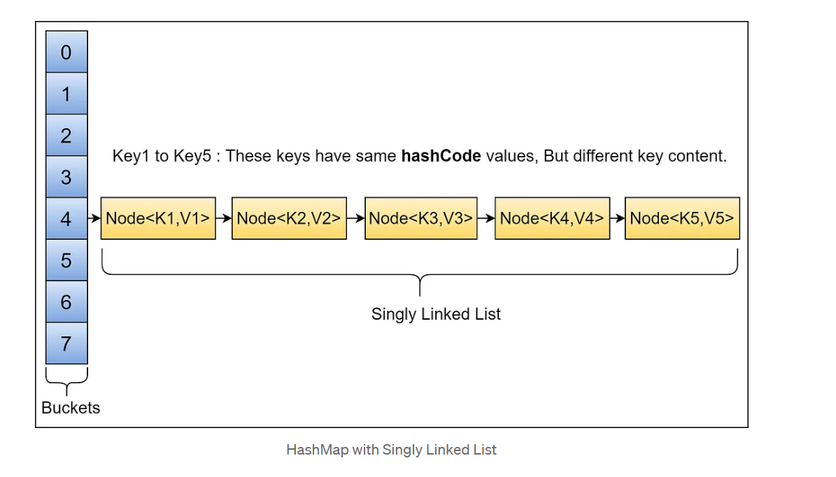
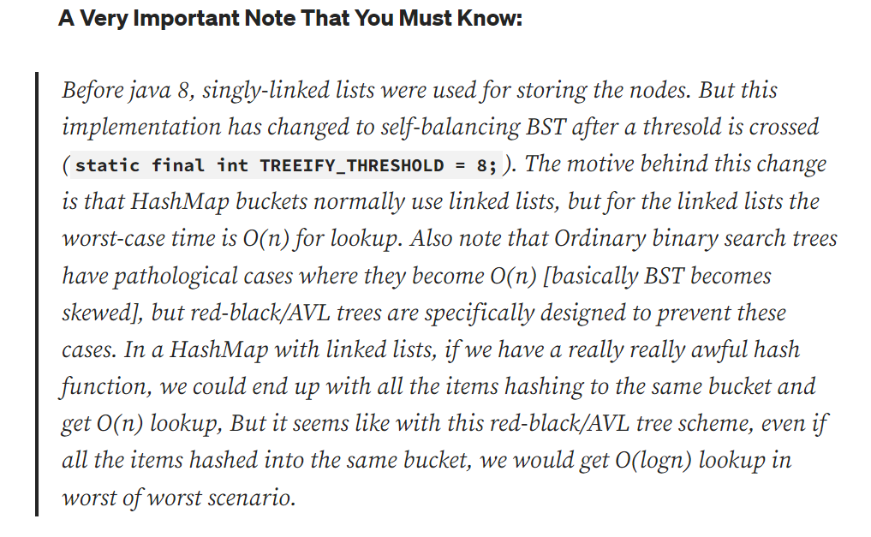
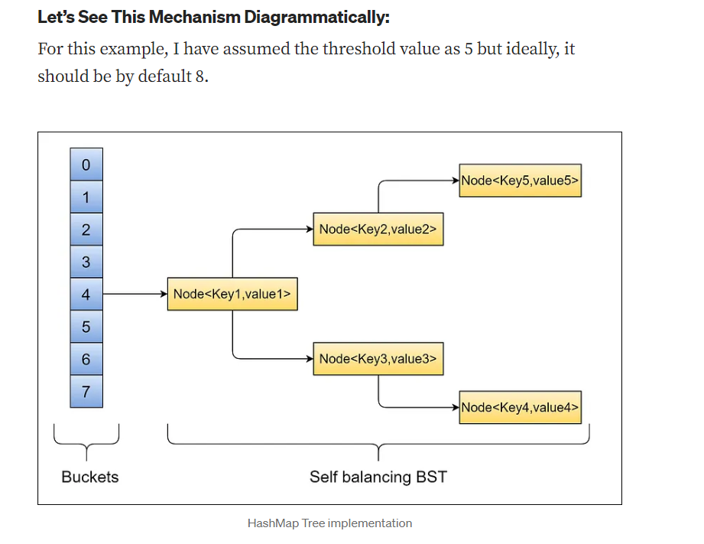
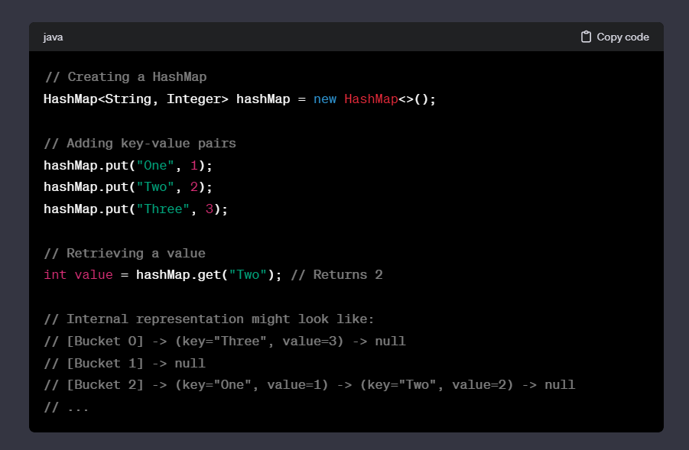

In this example, the keys "One" and "Two" might end up in the same bucket due to collisions, and a linked list is used to manage multiple entries in the same bucket. The get operation follows the same process to locate the bucket and then find the exact entry within the linked list.

Q10. interview questions for map interface.
Ans:
Certainly! Here are some interview questions related to the Map interface in Java:

Basic Understanding:

- What is the purpose of the Map interface in Java Collections?
- How does the Map interface differ from other collection interfaces like List and Set?

Implementations:
- Can you name some commonly used implementations of the Map interface in Java?
- Explain the differences between HashMap, LinkedHashMap, TreeMap, and HashTable.
- When would you choose one implementation over another?
Hashing and Equality:

- How does the HashMap use the hashCode() and equals() methods of keys?
Ans:
In a HashMap, the hashCode() and equals() methods of keys play a crucial role in determining the storage and retrieval of key-value pairs. Here's how HashMap uses these methods:

hashCode() Method:

When you insert a key-value pair into a HashMap, the hashCode() method of the key is called to calculate a hash code.
The hash code is an integer value that represents the key.
The purpose of the hash code is to determine the index (or bucket) in the underlying array where the key-value pair will be stored.
The hash code is then modified to ensure that it falls within the range of valid indices.
Finding the Bucket:

The modified hash code is used to find the appropriate bucket in the array.
If two keys have the same hash code (a collision), they will end up in the same bucket.
equals() Method:

If there is more than one key in a bucket (due to hash code collisions), the equals() method of the keys is used to determine the exact key-value pair.
equals() is used to compare the keys for equality within the same bucket.
It is essential for the equals() method to be consistent with the hashCode() method. If two keys are equal (according to equals()), their hash codes must be the same.
Retrieval:

When you try to retrieve a value from the HashMap using a key, the same process is repeated.
The key's hashCode() is calculated, the bucket is determined, and then the equals() method is used to find the exact key-value pair within the bucket.
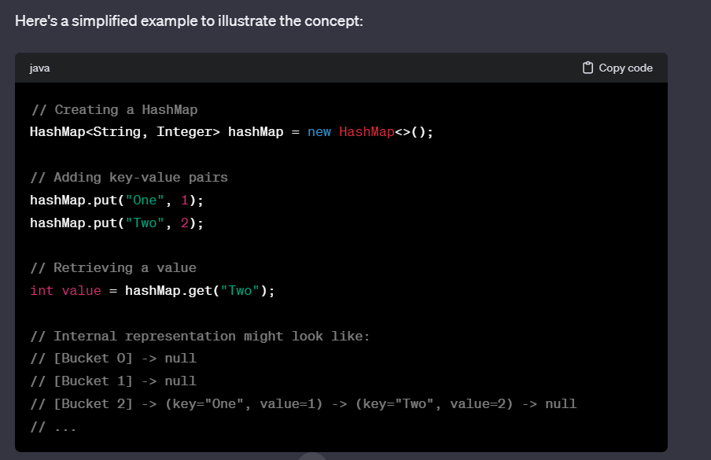
- Why is it important for key objects to provide proper implementations of hashCode() and equals()?

Ordering:

- How is the ordering of elements maintained in a LinkedHashMap?
- In a TreeMap, how is the order of elements determined?
Null Keys:

- Can a HashMap or HashTable contain null keys? What about null values?
Synchronization:

- Is HashMap thread-safe? How can you make it thread-safe? =>No
- Compare HashTable and ConcurrentHashMap in terms of synchronization.
Performance and Complexity:

- What is the time complexity of key lookup in a HashMap?
- How does the time complexity of key lookup in a TreeMap compare to that of a HashMap?

Load Factor and Rehashing:

- Explain the concepts of load factor and rehashing in a HashMap.
- How does adjusting the load factor affect the performance of a HashMap?
Concurrent Collections:

- What are some thread-safe alternatives to HashMap? =>HashTable & ConcurrentHashMap
- How does ConcurrentHashMap achieve thread-safety?
Iterating over Map Entries:

- How can you iterate over the entries of a Map?
Ans :
In Java, you can iterate over the entries of a Map using various methods. Here are a few common ways to iterate over the entries:

1. Using forEach and Lambda Expression (Java 8 and later):
java
Copy code
import java.util.HashMap;
import java.util.Map;

public class MapIterationExample {
public static void main(String[] args) {
Map<String, Integer> map = new HashMap<>();
map.put("One", 1);
map.put("Two", 2);
map.put("Three", 3);

// Using forEach and Lambda Expression
map.forEach((key, value) -> System.out.println(key + ": " + value));
}
}
2. Using entrySet() and Enhanced for Loop:
java
Copy code
import java.util.HashMap;
import java.util.Map;

public class MapIterationExample {
public static void main(String[] args) {
Map<String, Integer> map = new HashMap<>();
map.put("One", 1);
map.put("Two", 2);
map.put("Three", 3);

// Using entrySet() and Enhanced for Loop
for (Map.Entry<String, Integer> entry : map.entrySet()) {
System.out.println(entry.getKey() + ": " + entry.getValue());
}
}
}
3. Using Iterator:
java
Copy code
import java.util.HashMap;
import java.util.Iterator;
import java.util.Map;

public class MapIterationExample {
public static void main(String[] args) {
Map<String, Integer> map = new HashMap<>();
map.put("One", 1);
map.put("Two", 2);
map.put("Three", 3);

// Using Iterator
Iterator<Map.Entry<String, Integer>> iterator = map.entrySet().iterator();
while (iterator.hasNext()) {
Map.Entry<String, Integer> entry = iterator.next();
System.out.println(entry.getKey() + ": " + entry.getValue());
}
}
}
4. Using Streams (Java 8 and later):
java
Copy code
import java.util.HashMap;
import java.util.Map;

public class MapIterationExample {
public static void main(String[] args) {
Map<String, Integer> map = new HashMap<>();
map.put("One", 1);
map.put("Two", 2);
map.put("Three", 3);

// Using Streams
map.entrySet().stream()
.forEach(entry -> System.out.println(entry.getKey() + ": " + entry.getValue()));
}
}
These methods allow you to iterate over the entries of a Map and perform operations on the keys and values. Choose the method that best fits your requirements and the version of Java you are using. The enhanced for loop and iterator methods are available in all versions of Java, while lambda expressions and streams are available starting from Java 8.

- Explain the difference between keySet(), values(), and entrySet() methods.
Ans :
In Java, keySet(), values(), and entrySet() are methods provided by the Map interface to access different aspects of a map's content. Here's an explanation of each:

keySet() Method:

The keySet() method returns a Set containing all the keys in the map.

If you need to iterate over the keys of a map or perform operations specifically on the keys, using keySet() is a convenient choice.

Example:

java
Copy code
Map<String, Integer> map = new HashMap<>();
// Add entries to the map

Set<String> keys = map.keySet();
for (String key : keys) {
System.out.println("Key: " + key);
}
values() Method:

The values() method returns a Collection containing all the values in the map.

If you need to iterate over the values of a map or perform operations specifically on the values, using values() is a convenient choice.

Example:

java
Copy code
Map<String, Integer> map = new HashMap<>();
// Add entries to the map

Collection<Integer> values = map.values();
for (Integer value : values) {
System.out.println("Value: " + value);
}
entrySet() Method:

The entrySet() method returns a Set of Map.Entry objects, where each entry represents a key-value pair in the map.

If you need to iterate over both keys and values or perform operations on key-value pairs, using entrySet() is a convenient choice. This method is often more efficient than separately iterating over keys and values.

Example:

java
Copy code
Map<String, Integer> map = new HashMap<>();
// Add entries to the map

Set<Map.Entry<String, Integer>> entrySet = map.entrySet();
for (Map.Entry<String, Integer> entry : entrySet) {
System.out.println("Key: " + entry.getKey() + ", Value: " + entry.getValue());
}
Key Differences:
keySet():

Provides a set of keys.
Suitable when you need to operate specifically on the keys.
If you only need to access keys and not values, this method can be more efficient.
values():

Provides a collection of values.
Suitable when you need to operate specifically on the values.
If you only need to access values and not keys, this method can be more efficient.
entrySet():

Provides a set of Map.Entry objects representing key-value pairs.
Suitable when you need to operate on both keys and values.
Can be more efficient than separately iterating over keys and values.
- Removing Elements:

- How can you remove an entry from a Map?
- What is the difference between remove(Object key) and remove(Object key, Object value)?
Performance Considerations:

- In what scenarios would you choose a HashMap over a TreeMap or vice versa, considering performance implications?
These questions cover a range of topics related to the Map interface in Java, including different implementations, internal workings, performance considerations, and synchronization aspects. Depending on the depth of the role, you may encounter questions that delve more deeply into specific implementation details or scenarios.

Q11. questions with answers.
Ans:
Implementations:
Commonly Used Implementations:

Common implementations of the Map interface in Java include HashMap, LinkedHashMap, TreeMap, and HashTable.
Differences Between HashMap, LinkedHashMap, TreeMap, and HashTable:

HashMap: No order guarantee, allows null keys and values, not synchronized.
LinkedHashMap: Maintains insertion order, allows null keys and values, not synchronized.
TreeMap: Orders elements based on natural order or a custom comparator, does not allow null keys (values are allowed), not synchronized.
HashTable: Older version, synchronized, does not allow null keys or values.
Choosing an Implementation:

- Use HashMap for general-purpose use where order is not important.
- Use LinkedHashMap when insertion order matters.
- Use TreeMap when elements need to be sorted.
- Use HashTable when thread safety is a concern (consider ConcurrentHashMap for modern thread safety).
Hashing and Equality:
HashMap and Key Methods:

- HashMap uses the hashCode() method to calculate the hash code of keys and the equals() method to compare keys for equality.
Importance of Proper Implementations:

- Proper implementations of hashCode() and equals() are crucial for correct functioning of HashMap. Inconsistent implementations may lead to incorrect retrieval and storage of key-value pairs.
Ordering:
Ordering in LinkedHashMap:

- LinkedHashMap maintains the order of elements based on the order of insertion.
Order in TreeMap:

- TreeMap orders elements based on natural order or a custom comparator provided at the time of creation.
Null Keys:
- Nulls in HashMap and HashTable:
- HashMap allows one null key and multiple null values.
- HashTable does not allow null keys or values (throws NullPointerException).
Synchronization:
HashMap Thread Safety:

- HashMap is not thread-safe.
- To make it thread-safe, you can use Collections.synchronizedMap() or use ConcurrentHashMap.
Comparison Between HashTable and ConcurrentHashMap:

- Both are synchronized, but ConcurrentHashMap is preferred for better scalability as it uses finer-grained locking.
Performance and Complexity:
HashMap Time Complexity:

- The average time complexity for key lookup in a HashMap is O(1), but it can degrade to O(n) in the worst case due to collisions.
TreeMap vs. HashMap Time Complexity:

The time complexity for key lookup in a TreeMap is O(log n), making it generally slower than HashMap for large datasets.
Load Factor and Rehashing:
Load Factor and Rehashing:

- The load factor is a measure of how full the HashMap is allowed to get before it is resized.
- Rehashing occurs when the load factor exceeds a certain threshold, and the capacity is increased, redistributing the entries to new buckets.
Adjusting Load Factor:

- A higher load factor reduces space overhead but increases the likelihood of collisions.
- A lower load factor increases space overhead but reduces the likelihood of collisions.
Concurrent Collections:
Thread-Safe Alternatives to HashMap:

- ConcurrentHashMap is a thread-safe alternative to HashMap.
ConcurrentHashMap Thread-Safety:

- ConcurrentHashMap achieves thread-safety through a combination of partitioning and lock striping, allowing multiple threads to read and write concurrently.
Iterating over Map Entries:
Iterating Over Entries:

- You can iterate over the entries of a Map using an iterator or enhanced for loop along with the entrySet() method.
Difference Between keySet(), values(), and entrySet():

- keySet(): Returns a set of keys.
- values(): Returns a collection of values.
- entrySet(): Returns a set of map entries (key-value pairs).
Removing Elements:
Removing an Entry:

- You can remove an entry from a Map using the remove(Object key) method.
Difference Between remove(Object key) and remove(Object key, Object value):

- remove(Object key): Removes the entry with the specified key.
- remove(Object key, Object value): Removes the entry only if the key is associated with the specified value.
Performance Considerations:
Choosing HashMap or TreeMap:
- Use HashMap when order doesn't matter, and constant-time lookups are crucial.
- Use TreeMap when elements need to be sorted, and you're willing to sacrifice some performance for ordered retrieval.

