Trend:

1 – Maximum purchase was done by male players i.e. 84%

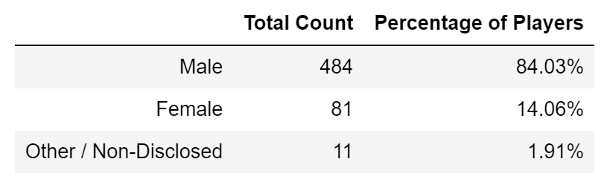

2- Around 44% was purchased by age group 20-24:

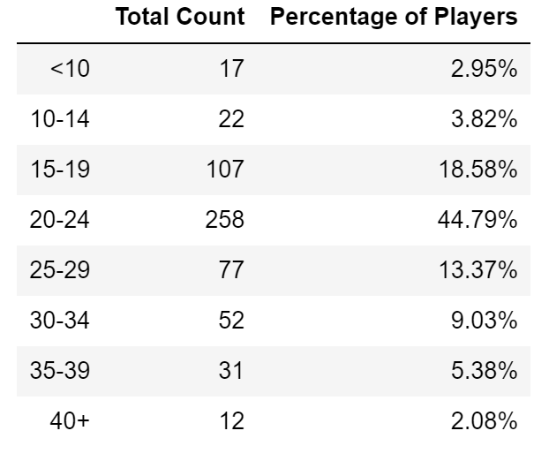

3-Minimum purchase was done by 40+ age group

