Task 3 — Authentication & Protected Routes (JWT)

Objective
Add a signup/login flow with hashed passwords and JWT-based
protected endpoints and client routes. Only authenticated users
should be able to create, update or delete products.

Technologies Used
bcryptjs → Password hashing
jsonwebtoken → JWT token generation & verification
MongoDB → Store user data
Express.js → Auth API endpoints
React.js → Login/Signup forms + protected routes

What is Authentication?
Authentication is the process of verifying WHO a user is,
typically through email and password, before granting access
to protected resources.
Without Auth:
→ Anyone can create/edit/delete products

With Auth:
→ Only logged-in users can modify data
→ Public users can only VIEW products

Core Security Concepts Learned
1. Password Hashing (bcrypt)
Plain password is NEVER stored in database.
Instead, it's converted to an irreversible hash.

"mypassword123" → bcrypt.hash() → "$2a$10$N9qo8uLOickgx2..."
2. JWT (JSON Web Token)
A secure token issued after successful login that
proves a user's identity on future requests, without
needing to send password again and again.

Structure: HEADER.PAYLOAD.SIGNATURE
3. Protected Routes
Backend: Middleware checks JWT before allowing
access to certain API endpoints.

Frontend: React checks if user is logged in before
showing certain pages/buttons.

Authentication Flow Diagram
SIGNUP:
User Form → Password Hashed → Saved in MongoDB

LOGIN:
User Form → Password Verified → JWT Token Created → Sent to Client

PROTECTED ACTION (e.g. Add Product):
Client sends JWT in request header
↓
Server verifies JWT
↓
Valid? → Allow action
Invalid? → Reject with 401 Unauthorized

Step 1 — User Model with Password Hashing
Created a User schema with automatic password hashing using
bcrypt's pre-save hook, ensuring passwords are never stored
in plain text.
Installation:
npm install bcryptjs jsonwebtoken
Key concepts:
- bcrypt.genSalt() → generates random salt for hashing
- bcrypt.hash() → converts plain password to secure hash
- pre('save') → Mongoose middleware runs before saving document
- matchPassword() → custom schema method to verify login password
- select: false → excludes password from query results by default
User Schema Fields:
name → String, required
email → String, required, unique, validated format
password → String, required, min 6 characters, hashed
Security Note:
Even if the database is compromised, hashed passwords cannot
be reversed back to the original password, protecting user
credentials from exposure.
User.js model file in VS Code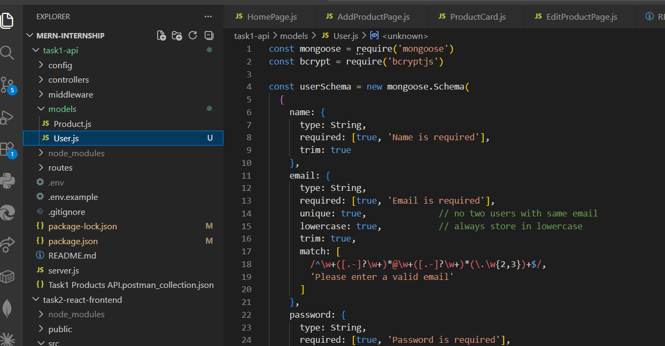
npm install bcryptjs jsonwebtoken in terminal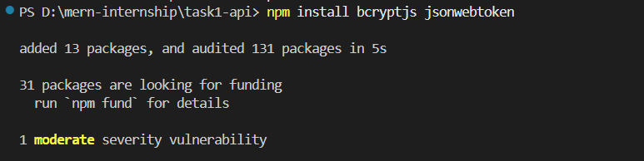

Step 2 — Signup & Login API
Built authentication controller with signup and login endpoints.
JWT tokens are generated on successful signup/login and sent
back to client for future authenticated requests.
New endpoints:
POST /api/auth/signup → Register new user
POST /api/auth/login → Authenticate user
GET /api/auth/me → Get logged-in user (protected)
Key concepts:
- jwt.sign() → creates a signed token containing user ID
- JWT_SECRET → server-only secret key to sign/verify tokens
- .select('+password') → explicitly fetch password field for verification
- matchPassword() → bcrypt compare during login
📸 [Screenshot: authController.js file]
📸 [Screenshot: .env file showing JWT_SECRET (blur the actual secret!)]

Step 3 — Auth Middleware & Protected Routes
Built JWT verification middleware that runs before protected
routes to verify if user is logged in.
Key concepts:
- Authorization: Bearer <token> → standard JWT header format
- jwt.verify() → validates token using secret key
- req.user → attaches logged-in user to every request
- Middleware runs IN ORDER before route handler
Protected vs Public Routes:
PUBLIC (no token needed):
GET /products → anyone can view
GET /products/:id → anyone can view

PROTECTED (JWT token required):
POST /products → only logged-in users
PUT /products/:id → only logged-in users
PATCH /products/:id → only logged-in users
DELETE /products/:id → only logged-in users
Issue Fixed:
Mongoose 6+ async pre-save hooks don't need next() parameter.
Removing it fixed the "next is not a function" 500 error.

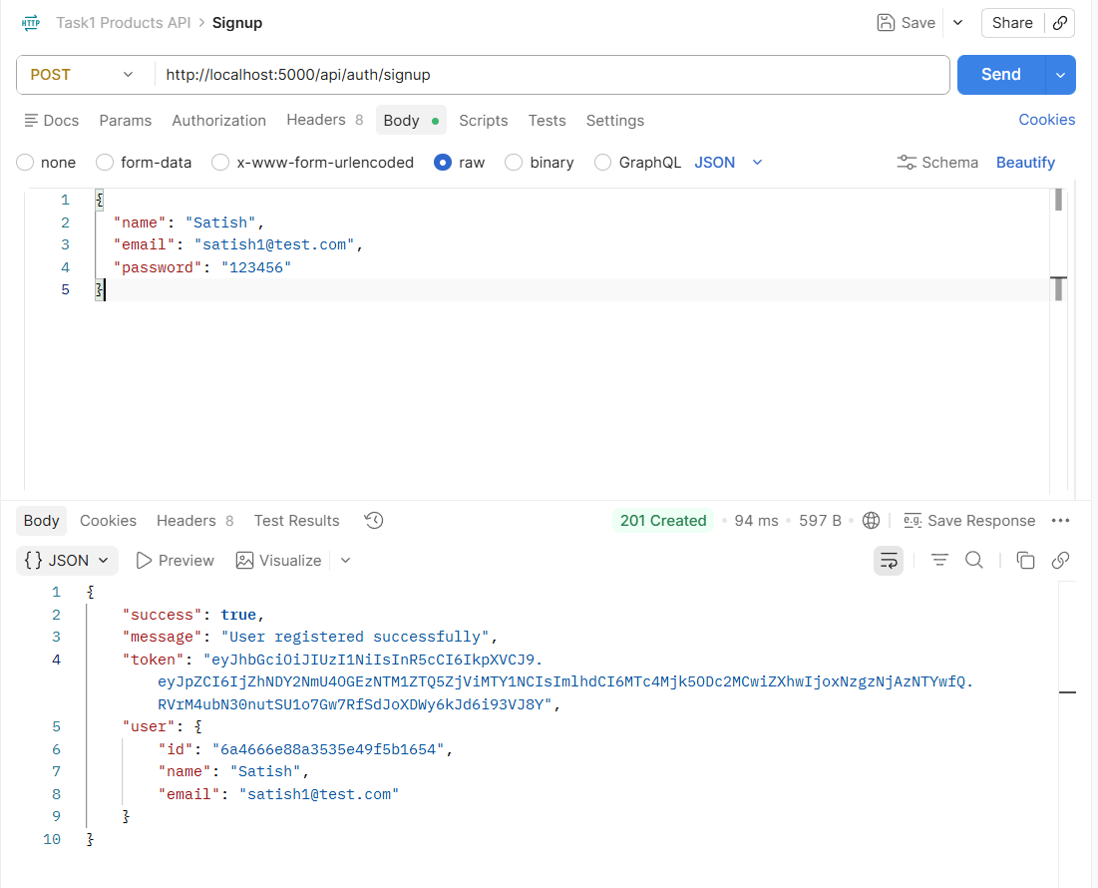
Signup success with token
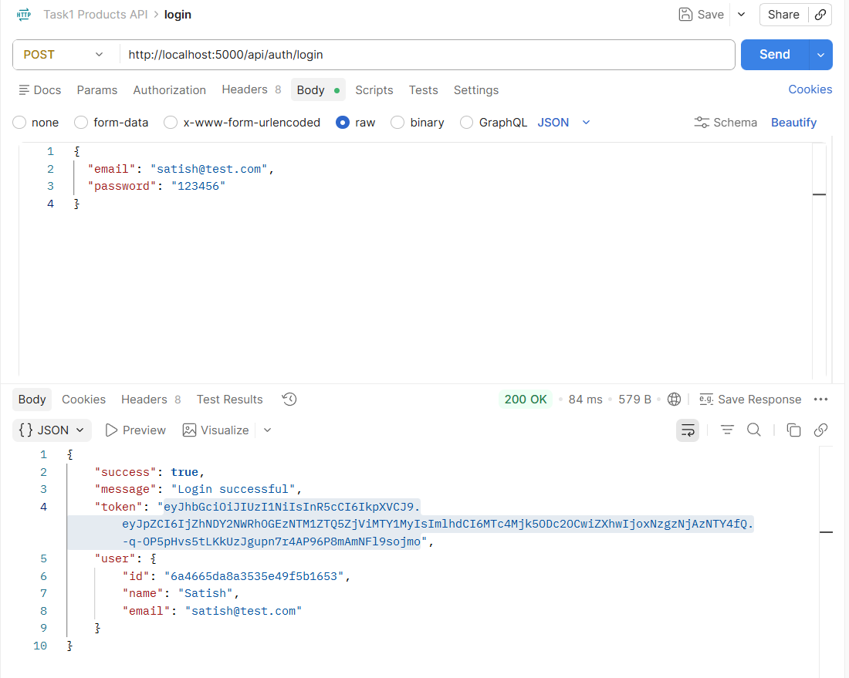
Login success with token
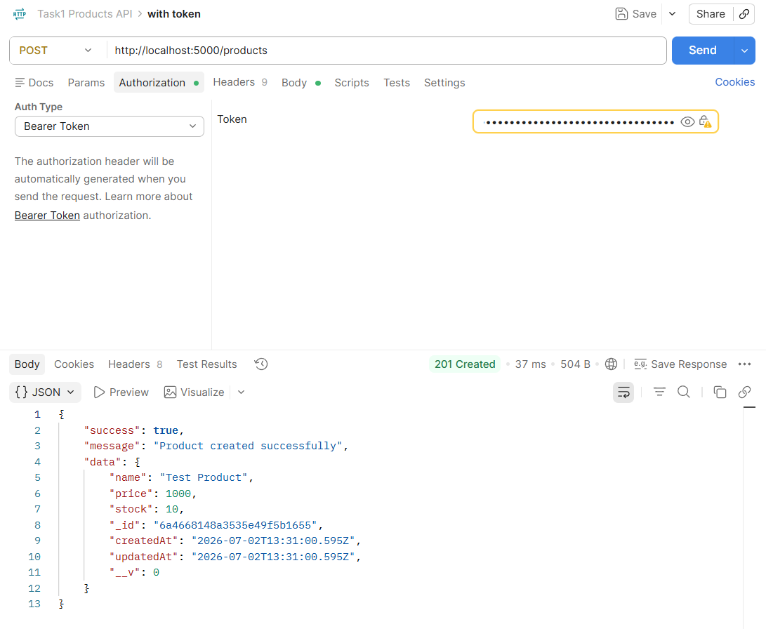
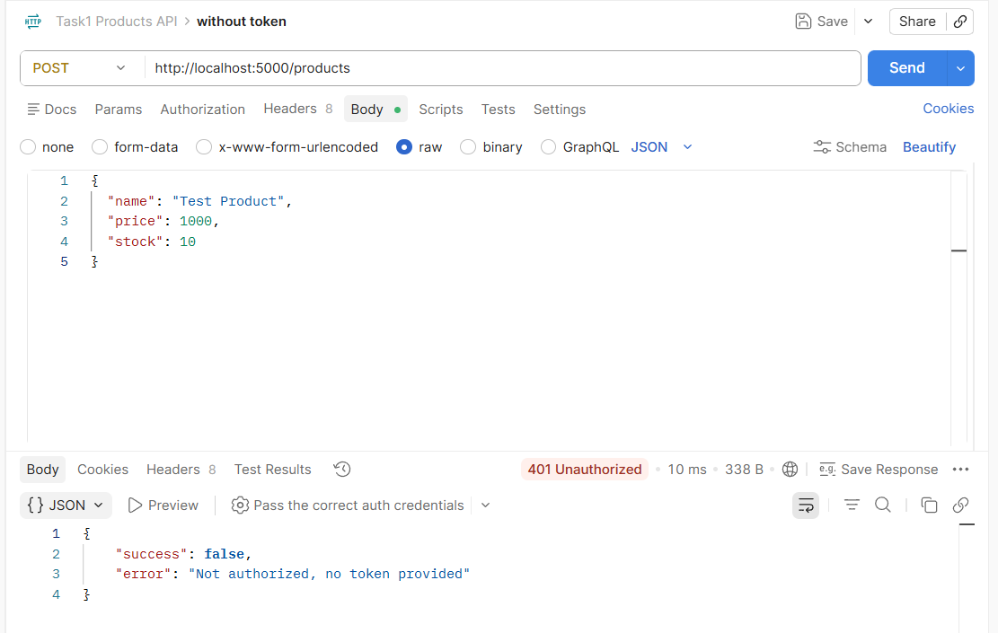
POST without token → 401 error
POST with token → success

Step 4 — React Login Page + Auth Context
Built Auth Context to manage login state globally across
all components. Created Login page that stores JWT token
in localStorage after successful authentication.
Key concepts:
- React Context API → shares state across all components
- localStorage → persists token even after page refresh
- useAuth() → custom hook to access auth state anywhere
- Navbar conditionally shows Login or Logout based on auth state
Login page
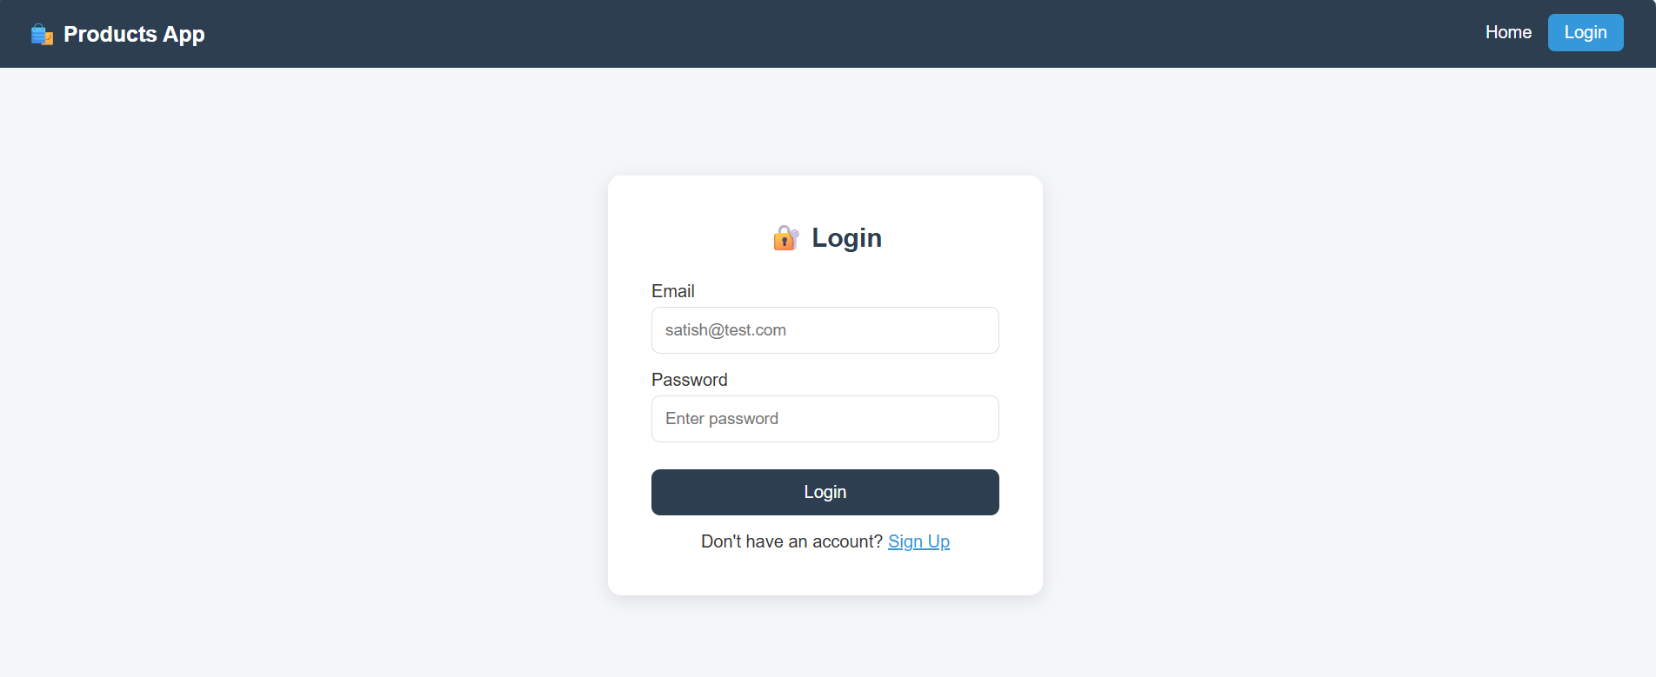
Navbar after login showing username

