Task 1 — Building a RESTful API
Tech Used: Node.js, Express.js, MongoDB

Step 1 — Project Setup
I initialized a Node.js project using npm init -y which created a package.json file. This file acts as the project's identity card storing the project name, version and all dependencies.
Command used:
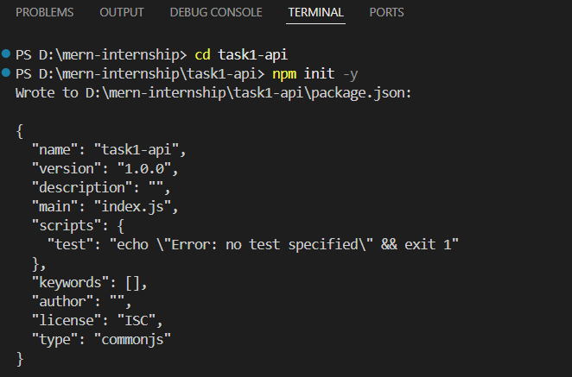
npm init -y

Step 2 — First Node.js Program
I created server.js and ran a basic JavaScript program using Node.js without a browser.
Command used:
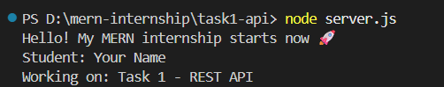
node server.js
Step 3 — First HTTP Server
I built a basic HTTP server using Node.js built-in http module. The server listens on port 5000 and responds with a message when accessed from the browser.
Key concepts learned:
- req = request from browser
- res = response we send back
- localhost:5000 = our computer at door number 5000
- HTTP 200 = success status code
Command used:
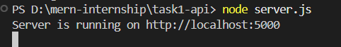
node server.js
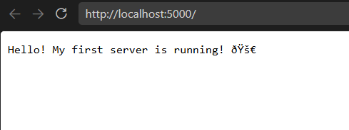

Step 4 — Setting Up Express.js
Plain Node.js HTTP module becomes complex with multiple routes. Express.js is a framework built on Node.js that simplifies server creation and route management.
Installation:
npm install express
Key concepts learned:
- require('express') → imports the Express package
- app.get('/path') → handles GET requests on that path
- req → request from client (browser/Postman)
- res → response we send back
- app.listen(5000) → starts server on port 5000
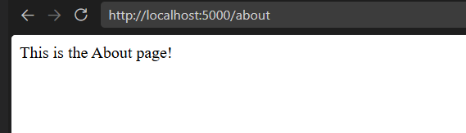
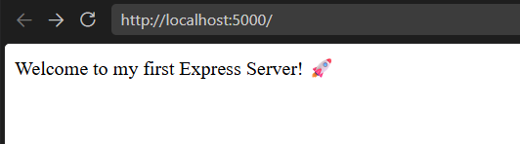
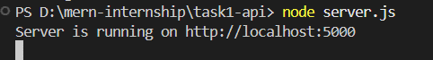
- express.json() → middleware to read JSON data

REST API — Core Concepts
API is a middleman between client and server. REST is a set of rules for designing clean APIs.
HTTP Methods:
- GET — Read data
- POST — Create data
- PUT — Update data
- DELETE — Delete data
Status Codes:
- 200 — OK
- 201 — Created
- 404 — Not Found
- 500 — Server Error
URL Structure for Products Resource:
GET /products → all products
GET /products/:id → single product
POST /products → create product
PUT /products/:id → update product
DELETE /products/:id → delete product
Step 5 — REST API Routes
Built 5 REST API endpoints for Products resource using Express Router. Separated concerns into routes and controller’s folders.
Project Structure:
routes/productRoutes.js → URL definitions
controllers/productController.js → Business logic
server.js → Server entry point
Endpoints built:
GET /products → returns all products
GET /products/:id → returns single product
POST /products → creates new product
PUT /products/:id → updates product
DELETE /products/:id → deletes product

Step 6 — MongoDB Local Setup & Connection
Installed MongoDB Community Edition locally on Windows. Used Mongoose to connect Express app to local MongoDB instance.
Connection string used:
mongodb://localhost:27017/shopDB
Key concepts:
- .env file stores sensitive config variables
- dotenv package reads .env into process.env
- mongoose.connect() establishes database connection
- async/await handles the connection promise
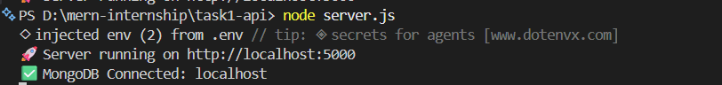
- process.exit(1) stops app if DB connection fails

Step 7 — Error Handling Middleware
Built a centralized error handling system so all errors are managed in one place consistently.
Types of errors handled:
- CastError → Invalid MongoDB ID in URL
- Code 11000 → Duplicate field value
- ValidationError → Missing required fields
Also added PATCH endpoint:
- PUT replaces entire document
- PATCH updates only fields that are sent
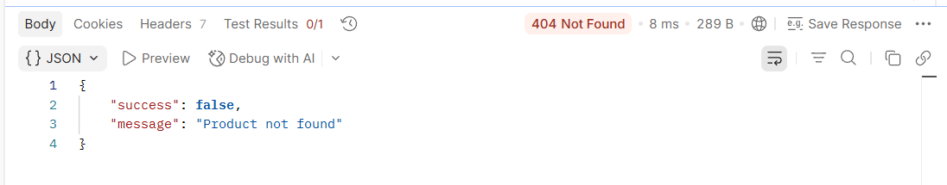
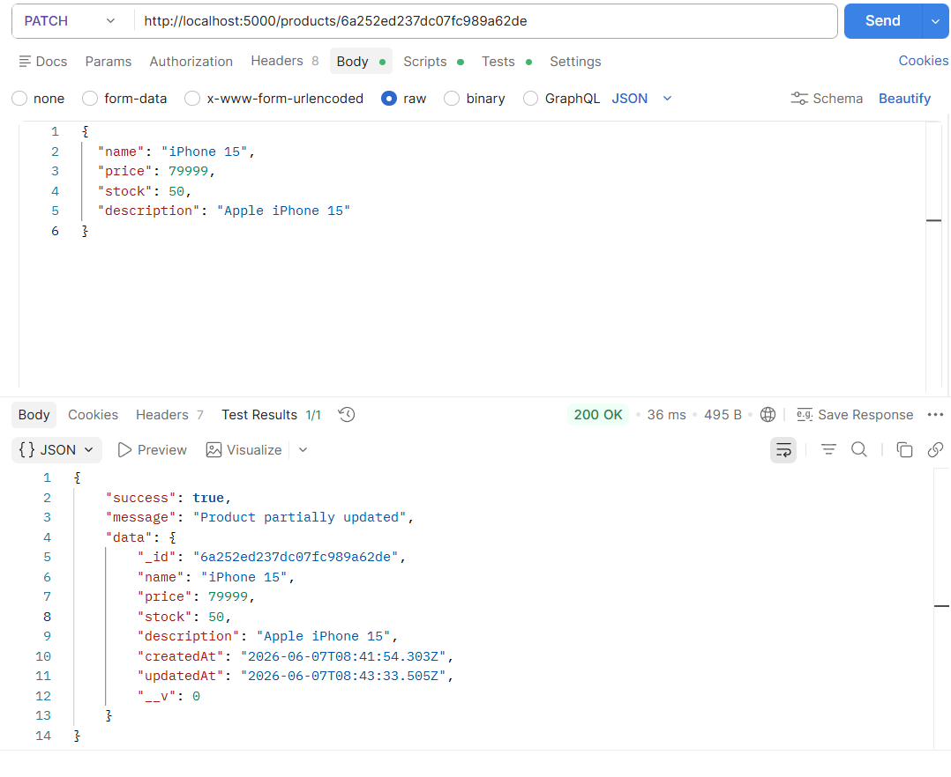
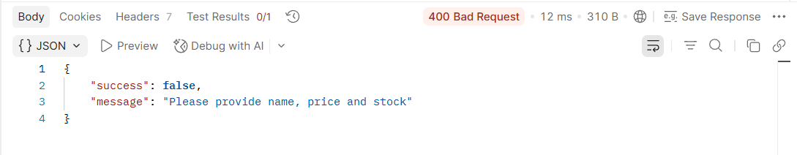

Step 8 — Morgan Request Logging
Installed Morgan middleware to log every API request automatically in terminal.
Installation:
npm install morgan
Log format (dev mode):
METHOD /route StatusCode ResponseTime
GET /products 200 45ms
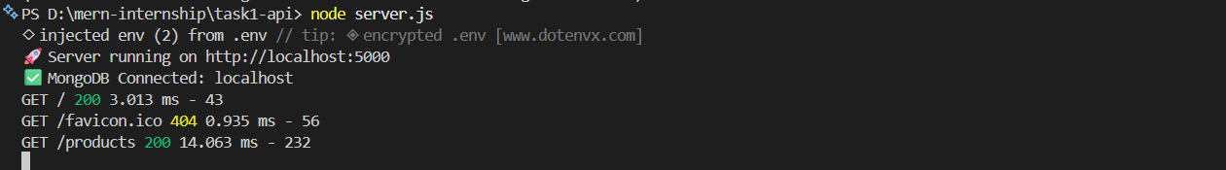

Step 9 — Postman Collection
Saved and exported all API requests as a Postman Collection for easy testing and submission.
Requests included:
GET → All Products
GET → Single Product
POST → Create Product
PUT → Update Product
PATCH → Partial Update
DELETE → Delete Product
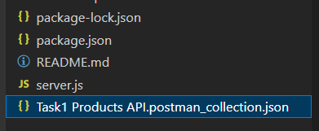
GET → Invalid ID (Error handling test)

Step 10 — README.md
Created a detailed README.md explaining project setup, all API endpoints, sample requests and responses, error handling and environment variables.
README includes:
- Project structure
- Setup instructions
- All API endpoints table
- Sample requests and responses
- Error handling examples
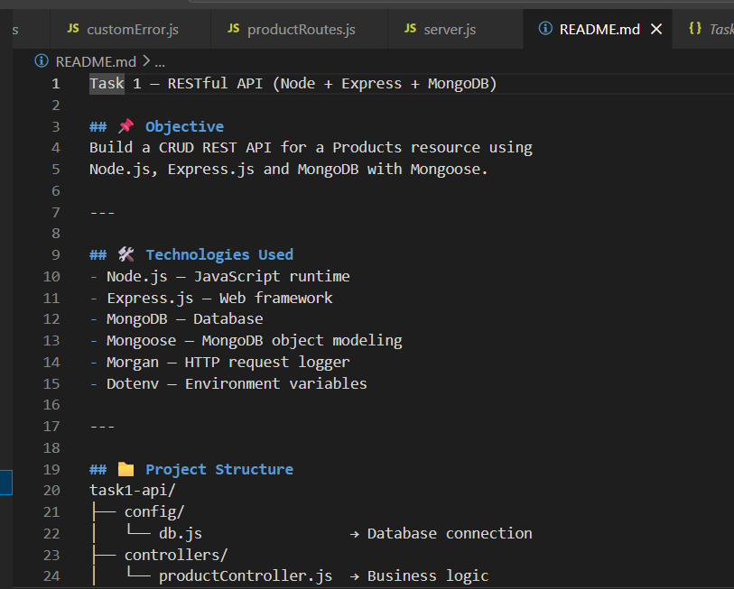
- Environment variables guide

