Task 2 — React Frontend
What is React?
React is a JavaScript library for building user
interfaces using reusable components.
Key Concepts:
- Components → reusable UI pieces
- useState → stores and watches data
- useEffect → runs code on events
- React Router → navigation without page reload
Setup Command:
npx create-react-app task2-react-frontend
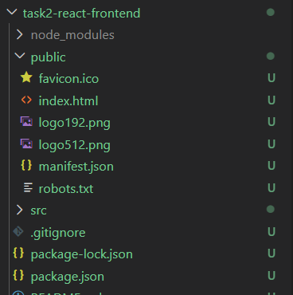
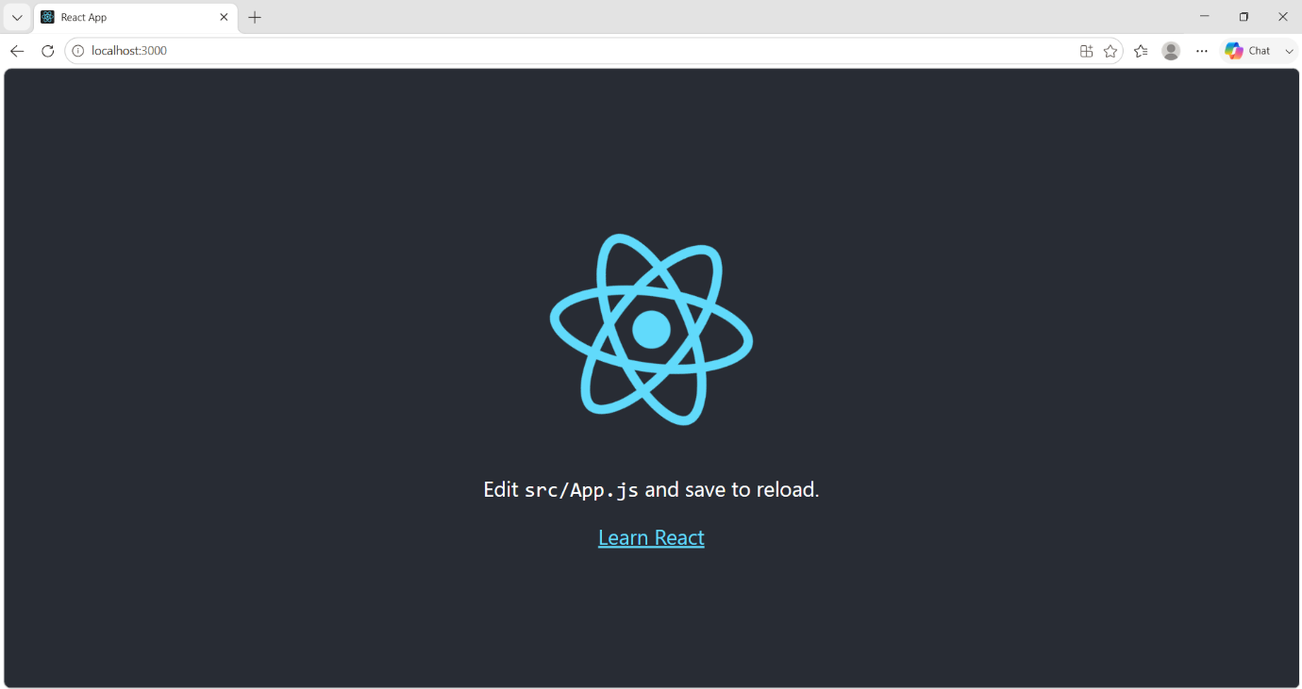
npm start

Step 2 — Project Setup & Structure
Created React app using create-react-app and organized
into proper folder structure.
Folder Structure:
components/ → reusable UI pieces
pages/ → full page components
services/ → API communication
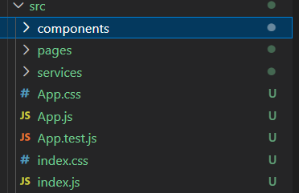
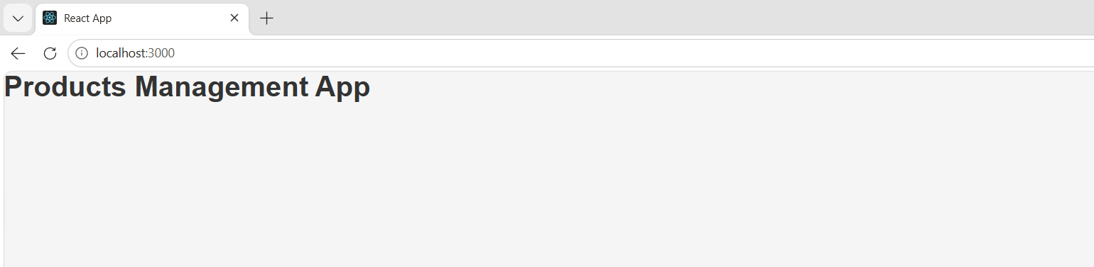

Step 3 — React Router Setup
Installed React Router for navigation and Axios
for API calls.
Installation:
npm install react-router-dom axios
Routing Structure:
/ → HomePage (all products)

/add → AddProductPage (add form)
/edit/:id → EditProductPage (edit form)
Key concepts:
- BrowserRouter → enables routing
- Routes → container for routes
- Route → single URL to component mapping
- Link → navigation without page reload
Navbar showing on homepage
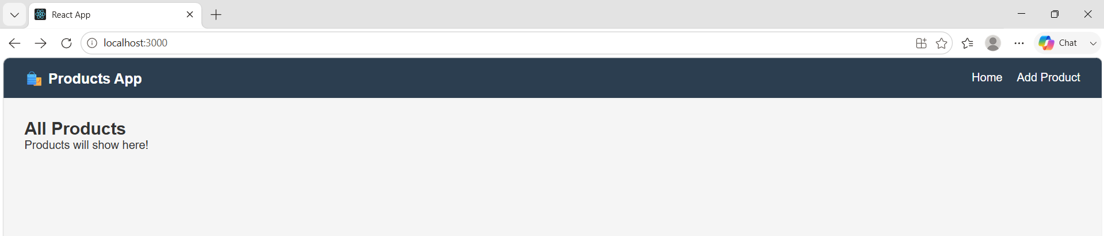
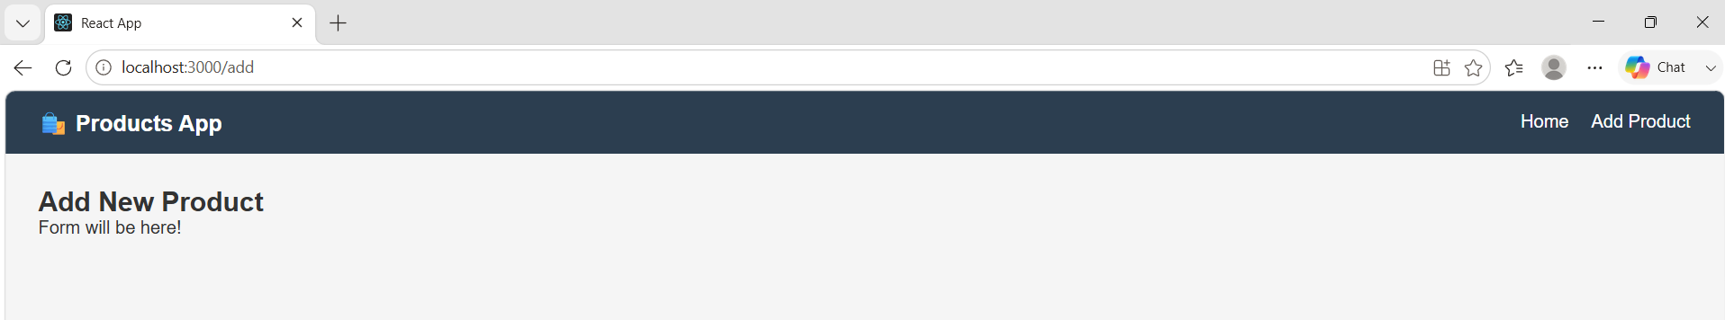

Step 4 — Connecting React to Task 1 API
Created a service file to handle all API calls using Axios.
Built HomePage to fetch and display real products from MongoDB.
Key concepts:
- useState → stores products, loading, error states
- useEffect → fetches data when page loads
- axios.get() → calls Task 1 API
- CORS enabled on backend for cross-origin requests

Service file structure:
javascript
getAllProducts() → GET all products
getProductById(id) → GET single product
createProduct(data) → POST new product
updateProduct(id) → PUT update product
deleteProduct(id) → DELETE product

Step 4 — Connecting React to Task 1 API
Created productService.js to handle all API calls using Axios.
Built HomePage to fetch and display real products from MongoDB
using useState and useEffect hooks.
Issue faced: CORS error blocked requests from React (port 3000)
to Express API (port 5000).
Fix applied: Installed cors package in Task 1 backend and
added app.use(cors()) middleware.
npm install cors
Real products showing on HomePage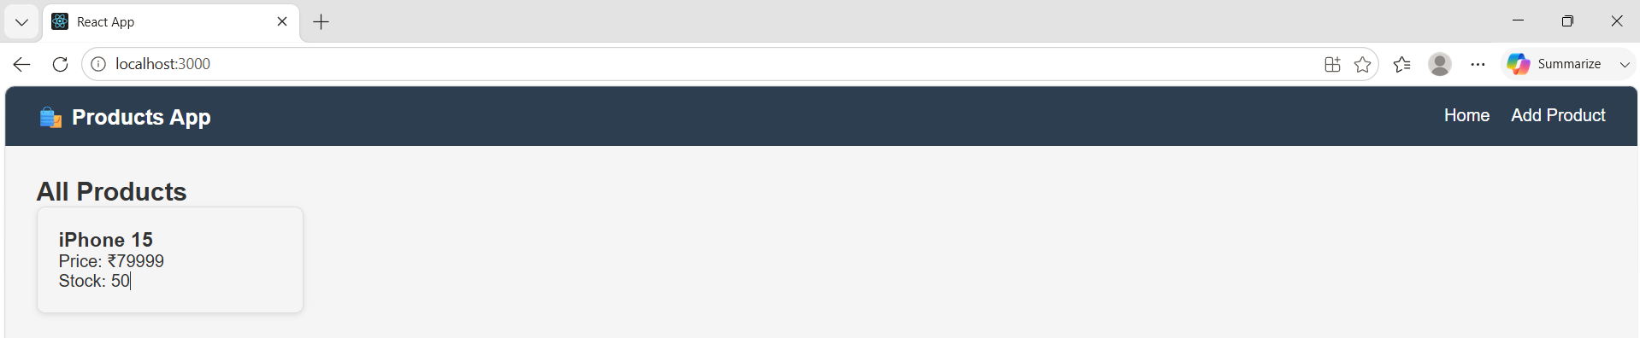
Console error before fix
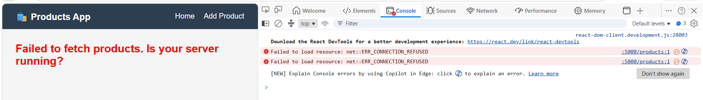

Step 5 — Add Product Form
Built a controlled form using React state to add new products.
Form data is sent to Task 1 API via POST request, and user is
redirected to Home page on success.
Key concepts:
- Controlled inputs — React tracks every field value
- Single state object for entire form
- handleChange — one function updates any field dynamically
- e.preventDefault() — stops page refresh on submit
- useNavigate() — redirects after successful submission
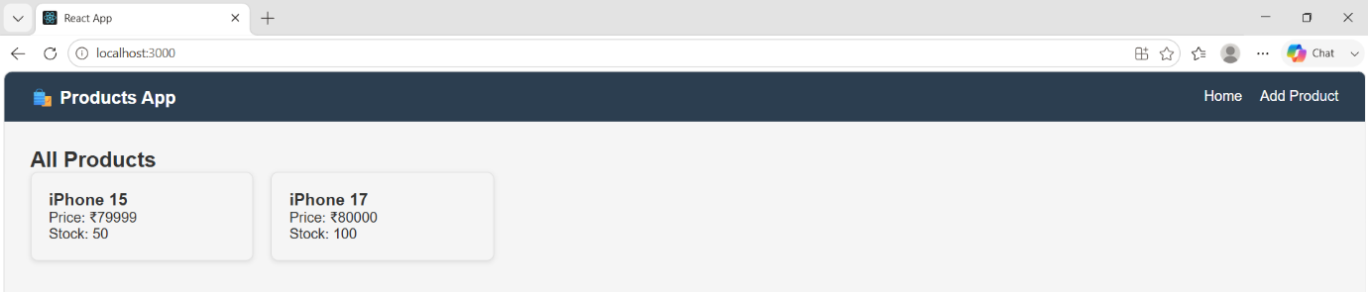
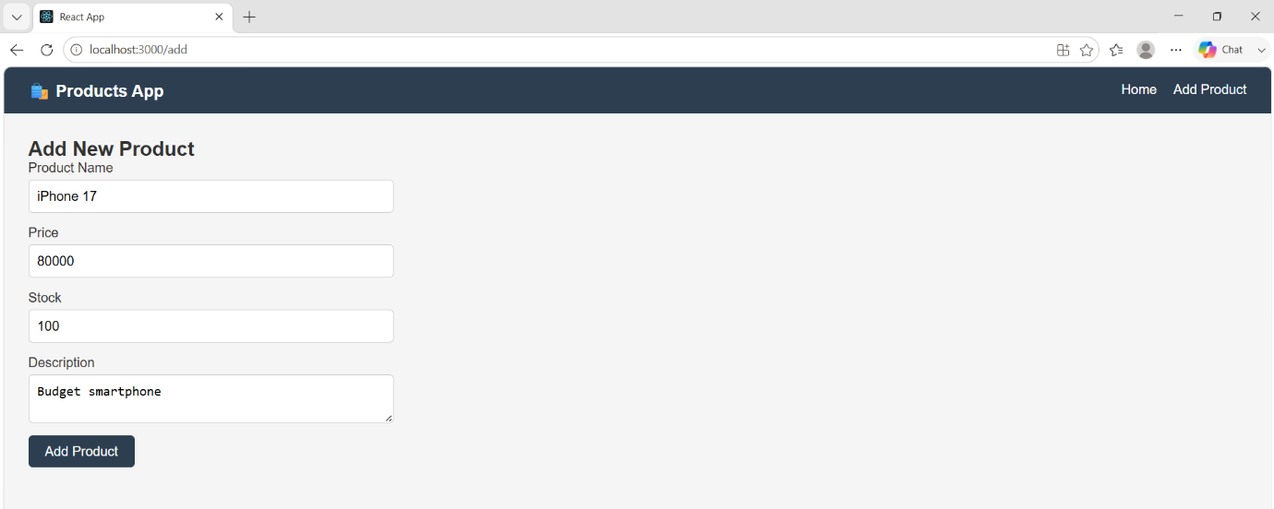
Add product form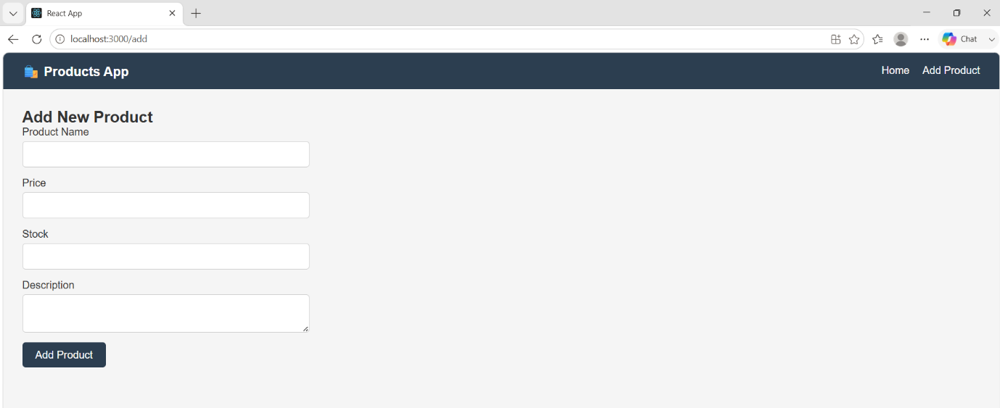
New product appearing in product list

Step 6 — Edit & Delete Functionality
Built Edit form that pre-fills with existing product data using
useParams() to get product ID from URL. Added Delete functionality
with confirmation popup using window.confirm().
Key concepts:
- useParams() → extracts :id from URL
- Pre-filling form with getProductById() response
- updateProduct() → sends PUT request
- Optimistic UI update after delete (no refetch needed)
Edit form with pre-filled data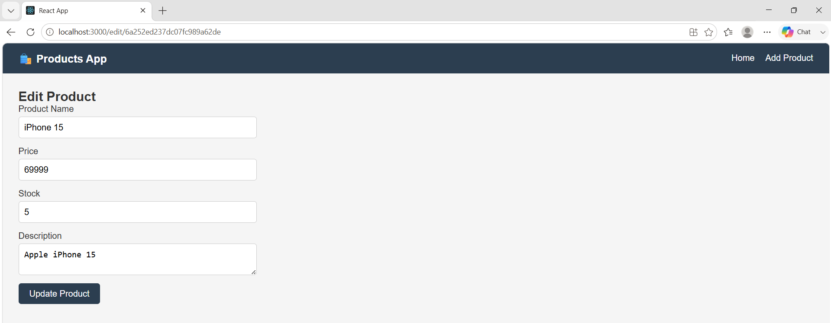 Successfully updated product and : Delete confirmation and removal 