
MINI CHATBOT — ASSIGNMENT SUBMISSION

Name | Pasupuleti Satish
Reg No | 99230040716
Notebook | Mini_Chatbot.ipynb
Platform | Google Colab
Language | Python 3

NoteBook Screenshots with the Implemenation:

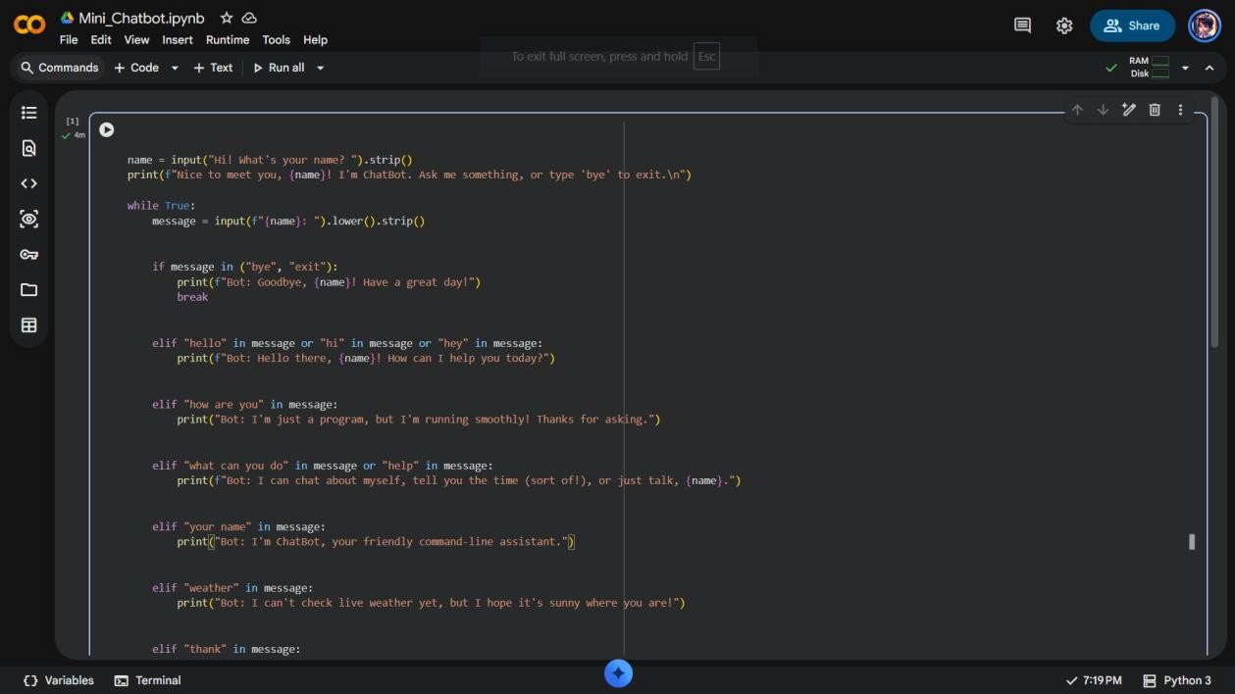
Figure 1: Beginning of the chatbot code — input handling, greeting, and farewell logic.
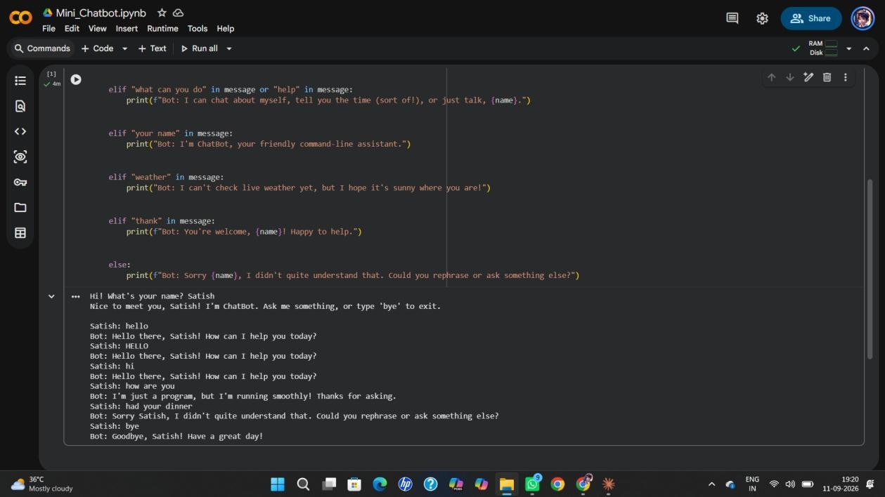
Figure 2: Remaining response branches and a sample conversation output.

