

**Tribhuvan University**

**Faculty of Humanities and Social Sciences**

**“GizmoGrove: Laptop and Accessories Selling E-commerce Website”**

**A PROJECT REPORT**

**Submitted to**

**Department of Bachelor in Computer Application**

**Kathmandu Business Campus**

***In partial fulfillment of the requirements for the Bachelors in Computer Application***

Submitted by

Reejan Chhetri Kelvin Maharjan

BCA 4th Semester BCA 4th Semester

University SN:6-2-1219-20-2021 University SN: 6-2-1219-12-2021

Roll No:20 Roll No: 12

Under the Supervision of

**Sulav Nepal**



**Tribhuvan University**

**Faculty of Humanities and Social Sciences**

**Kathmandu Business Campus**

**Banasthali , Balaju**

**Supervisor’s Recommendation**

I hereby recommend that this project prepared under my supervision by **Reejan Chhetri( reg no:6-2-1219-20-2021)** and **Kelvin Maharjan(reg no:6-2-1219-12-2021)** entitled **“GizmoGrove: Laptop & Accessories Selling E-commerce Website”** in the Partial Fulfillment of requirement for the degree of Bachelor in Computer Application is recommended for that final evaluation.

Sulav Nepal

Project Supervisor

BCA Department

Kathmandu Business Campus



**Tribhuvan University**

**Faculty of Humanities and Social Sciences**

**Kathmandu College of Technology**

**LETTER OF APPROVAL**

This is to certify that this project prepared by **Kelvin Maharjan** and **Reejan Chhetri** entitled “**GizmoGrove: Laptop & Accessories Selling E-commerce Website”** in partial fulfillment of the requirements for the degree of Bachelor in Computer Application has been evaluated. In our opinion it is satisfactory in the scope and quality as a project for the required degree.

Sulav Nepal Ram Prasad Subedi

Supervisor Program Coordinator

BCA Department Kathmandu Business Campus

Kathmandu Business Campus

Internal Examiner External Examiner

**ABSTRACT**

The proposed system is an e-commerce platform designed to facilitate online shopping for users. It aims to provide a user-friendly interface for browsing, selecting, and purchasing products from a diverse range of categories. The system incorporates features such as user registration, product catalog management, shopping cart functionality, and secure payment processing.

Through a comprehensive system analysis and design process, the project identified key requirements and constraints, leading to the development of a robust and scalable solution. The system's architecture was carefully designed to ensure scalability, reliability, and performance, utilizing modern technologies and best practices.

Overall, the e-commerce platform offers an intuitive and seamless shopping experience for users while providing administrators with efficient management tools for maintaining the product catalog. With future recommendations and lessons learned, the system aims to continuously evolve and improve to meet the dynamic needs of online shoppers and businesses.

**ACKNOWLEDGEMENT**

We would like to express our special thanks of gratitude to our supervisor Mr. Sulav Nepal who gave us the golden opportunity to do this wonderful project on the topic of ‘**GizmoGrove: Laptop & Accessories Selling E-commerce Website’**, which also helped us in doing a lot of research and we came to know about so many new tools and technologies.

I would like to express my special gratitude and thanks to our BCA Program Coordinator Mr. Ram Prasad Subedi for his support and help for our personnel development and mainly for the completion of this Project

I am highly indebted to Kathmandu Business Campus for their guidance and constant supervision as well as for providing necessary information regarding the Project and support in the completion.

We would also like to express my gratitude towards library and member of Kathmandu Business Campus for their kind co-operation and encouragement which help me in completion of this Project.

We would also like to thank our parents and friends who helped us a lot in finalizing this project within the limited time frame.

In the end, we would also like to thank Tribhuvan University for giving us this opportunity via the course of Computer Application to help us understand the project ethics at this early stage and helped us to evaluate my knowledge and expand it a little more.

Yours sincerely,

Reejan Chhetri

Kelvin Maharjan

**LIST OF ABBREVIATIONS**

HTML Hyper Text Markup Language

CSS Cascading Style Sheet

ERD Entity Relationship Diagram

DFD Data Flow Diagram

CRUD Create, Read, Update and Delete

JS Java Script

MySQL Microsoft Server Structured Query Language

PHP Hypertext Preprocessor

# TABLE OF CONTENTS

Contents

Supervisor’s recommendation i

Letter of approval ii

Abstract iii

Acknowledgement iv

List of abbreviations v

List of figures  vi

List of tables vii

TABLE OF CONTENTS 0

CHAPTER: 1 1

INTRODUCTION 1

1.1 Introduction 1

1.2 Problem Statement 2

1.3 Objectives 2

1.4 Scope and limitation 2

1.5 Report Organization 3

CHAPTER: 2 4

BACKGROUND STUDY AND LITERATURE REVIEW 4

2.1 Study of existing systems 4

2.2 Literature review 5

CHAPTER: 3 6

SYSTEM ANALYSIS AND DESIGN 6

3.1 System Analysis 6

3.1.1 Requirement Identification 7

3.1.2 Feasibility Study 8

i Technical feasibility 8

ii Operational feasibility 8

iii Schedule feasibility 8

3.1.3 Data Modeling(ER-diagram) 9

3.1.4 Process Modeling (DFD) 10

3.2 System Design 12

3.2.1 Architectural Design 12

3.2.2 System flowchart 12

3.2.3 Database schema design 16

3.2.4 Interface Design (UI Interface) 16

CHAPTER: 4 22

4.1 Implementation 22

4.1.1 Tools Used (CASE tools, Programming language, Database platforms) 22

4.1.2 Implementation Details of Modules 23

# LIST OF FIGURES

Figure 3.1: Waterfall model for e-commerce website. 6

Figure 3.2: Use case diagram for e-commerce website. 7

Figure 3.3: Gantt chart for e-commerce website 9

Figure 3.4: Entity Relational Diagram for e-commerce website 10

Figure 3.5: level 0 DFD for e-commerce website 11

Figure 3. 6: Level 1 DFD for E-commerce website 11

Figure 3.7: Architectural Design of E-commerce website 12

Figure 3.8: Flow chart of E-commerce website for user 13

Figure 3.9: Flow chart of E-commerce website for admin 14

Figure 3.10: Database Schema Design of E-commerce website 15

Figure 3.11: Login page of GizmoGrove. 16

Figure 3.12: Registration page of E-commerce website 16

Figure 3.13: Landing page of E-commerce website 17

Figure 3.14: Product Section of E-commerce website 17

Figure 3.15: Product Description Page of E-commerce website 18

Figure 3.16: Admin panel Page of E-commerce website 18

Figure 3.17: Admin user management page of E-commerce website 19

Figure 3.18: Admin add product page of E-commerce website 19

Figure 3.19: Admin update product page of E-commerce website 20

# LIST OF TABLES

Table 3.1: Gantt chart Table for E-commerce website…………...9

# CHAPTER: 1

# INTRODUCTION

## Introduction

Introducing **“GizmoGrove: Laptop & Accessories Selling E-Commerce Website”**. An innovative and user-friendly e-commerce website specializing in the sale of laptops and accessories. This platform aims to provide a seamless and efficient online shopping experience for customers looking to purchase laptops and accessories.

GizmoGrove is a simple website where one can find their dream laptops. It is a place where you can find latest laptop and accessories at the best price.

Our project is aimed at general public who are looking for a suitable and trusted online laptop and accessories store where one can search through available laptops, accessories, check its description, read reviews of previous people who purchased the product and order it directly through the website.

We hope to provide a safe and easy place to view and purchase branded laptops and accessories and help people to acquire there best fitted laptops and accessories. GizmoGrove offers various filters which helps people to find a laptop and accessories with their Specification.

## In summary, GizmoGrove is a simple but effective website with its user-friendly interface and straightforward design, it's the perfect place to look for one’s specific laptop and accessories

## Problem Statement

## In the rapidly evolving landscape of e-commerce, businesses face the challenge of adapting to changing consumer preferences and technological advancements. With the proliferation of online shopping platforms, consumers now expect seamless and engaging experiences across all touchpoints. To address this demand, our project focuses on developing a comprehensive e-commerce platform that prioritizes user experience, efficient product management, scalability, and mobile accessibility. By addressing these key areas, our platform aims to bridge the gap between traditional retail and digital commerce, offering businesses a competitive edge in the online marketplace. Through innovative features and intuitive design, we seek to enhance user engagement, drive conversions, and foster long-term customer loyalty. Our goal is to create a platform that not only meets the current needs of businesses and consumers but also anticipates and adapts to future trends in e-commerce, ensuring sustained growth and success in an ever-changing market.

## 1.3 Objectives

Our objective is:

* + - To provide wide variety of filter options.
    - To provide product management method.
    - To provide user interaction and feedback method.

## Scope and limitation

## 1.4.1 Scope

* + - Diverse Product Range.
    - Comprehensive Product Information.
    - Admin dashboard
    - Cart functionalities.

**1.4.2 Limitation**

* + - * Limited Physical Interaction
      * Inability to Experience Performance
      * Logistical Challenges.

## Report Organization

**Introduction**

The E-commerce Website project aims to create a user-friendly platform for seamless online shopping and efficient management. It prioritizes enhancing user experience, streamlining administrative tasks, ensuring scalability and security, and adapting to market demands. Despite potential constraints like technology limitations and market competition, the project is driven by the need to meet consumer demand, capitalize on business opportunities, and achieve efficiency through innovation. Ultimately, it aims to deliver a competitive solution that fosters growth in the digital marketplace.

**Background Study and Literature Review**

The chapter reviews recent advancements in data mining, emphasizing its role in enhancing E-commerce platforms. It also discusses key features of existing employee leave management systems and popular E-commerce platforms, offering insights for the project's development.

**System Analysis and Design**

This chapter analyzes system requirements, feasibility, and architecture. It visualizes the system's structure through diagrams and outlines database schema design and user interface considerations.

**Implementation and Testing**

This chapter details the tools and technologies used in system development, implementation steps, and testing procedures. It focuses on ensuring system robustness, reliability, and functionality through comprehensive testing.

**Conclusion and Future Recommendation**

# The chapter summarizes project outcomes, lessons learned, and future prospects. It provides recommendations for system enhancement and explores potential research directions in the E-commerce domain.

# CHAPTER: 2

# BACKGROUND STUDY AND LITERATURE REVIEW

## Study of existing systems

In this section, an examination of existing e-commerce systems provides insights into established practices, features, and challenges. By analyzing various platforms, such as Amazon, eBay, and Shopify, valuable lessons can be learned to inform the development of our own e-commerce solution.

Amazon, as a global leader in e-commerce, offers a vast array of products, streamlined shopping experiences, and efficient logistics. Its personalized recommendations, user reviews, and robust seller ecosystem contribute to its success. However, challenges such as counterfeit products, seller fraud, and complex navigation highlight areas for improvement.

eBay, known for its auction-style marketplace, emphasizes user-to-user transactions and a wide range of product categories. Its bidding system fosters competition and engagement among users. Yet, issues related to seller credibility, shipping delays, and disputes underscore the importance of effective dispute resolution mechanisms.

Shopify stands out for its user-friendly interface and comprehensive suite of e-commerce tools, making it an attractive option for businesses of all sizes. Its customizable themes, integrated payment gateways, and extensive app ecosystem enable merchants to create and manage online stores efficiently. Nevertheless, concerns regarding platform fees, limited scalability, and dependency on third-party apps warrant consideration.

By studying these and other e-commerce platforms, we aim to identify best practices, innovative features, and areas for improvement to inform the design and development of our own system. This analysis will guide our efforts in creating a competitive and user-centric e-commerce solution tailored to the needs of our target audience.

## Literature review

The literature review examines existing research and publications related to e-commerce systems. It focuses on understanding user behavior, technological advancements, and business strategies within the e-commerce domain. By reviewing relevant literature, we aim to gain insights into best practices, challenges, and opportunities in the field of online commerce.

Several studies have explored consumer preferences and behaviors in e-commerce environments, highlighting the importance of user experience, convenience, and trust in driving online sales. Additionally, research has investigated the impact of emerging technologies such as social media and mobile commerce on e-commerce trends, emphasizing the need for businesses to adapt to changing consumer habits and preferences.

Furthermore, scholarly works have addressed security concerns and privacy issues in e-commerce transactions, emphasizing the importance of implementing robust security measures to protect user data and build trust with customers. Additionally, literature on e-commerce business models and revenue strategies provides valuable insights into monetization approaches and digital marketing techniques for maximizing online revenue.

Overall, the literature review serves as a foundation for understanding key concepts and trends in e-commerce, informing the development and strategic planning of our project to ensure its alignment with industry standards and best practices.

# CHAPTER: 3

# SYSTEM ANALYSIS AND DESIGN

## System Analysis

System analysis is the most important phase in the development of GizmoGrove: Laptop & Accessories selling E-commerce website. It plays a fundamental role in understanding the requirements, functionalities, and components of the system. Thus, it helps in ensuring its successful design and implementation of a system.

## 

This system is designed with the series of processes starting with requirement analysis, design, implementation, testing and deployment. During requirement analysis, all the functional and nonfunctional requirement are analyzed and system is developed according to the requirement then designing of the system is carried out. After the design process, coding and development part is started then after integrating the system there is testing of the system. After testing is positive then system is moved on to deployment phase.

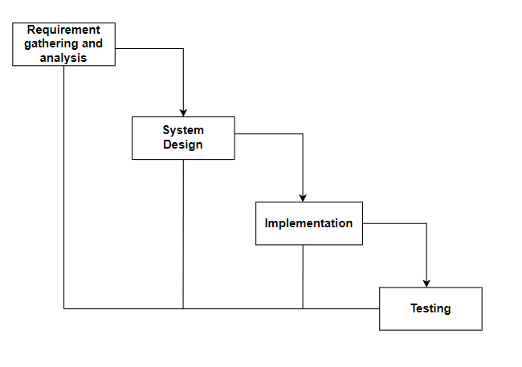

**Fig: Waterfall model for e-commerce website.**

## Requirement Identification

Requirement identification is a critical step in the development of an GizmoGrove: Laptop & Accessories selling E-commerce website. This process involves identifying the functional and non-functional requirements of the system to ensure that it meets the needs of the organization and its customers.

1. **Functional requirement**
   * + - 1. Users can login into the website.
         2. Customers can search, view products and add to cart.
         3. Admin can login into the website.
         4. Admin can manage users and products.

**USECASE DIAGRAM**

In GizmoGrove, there are two actors such admin and customer where admin can login, logout, manage customer and products from the website. Likewise, customers can register, login, Search Products, View Products, Add to Cart, checkout and logout from the website.

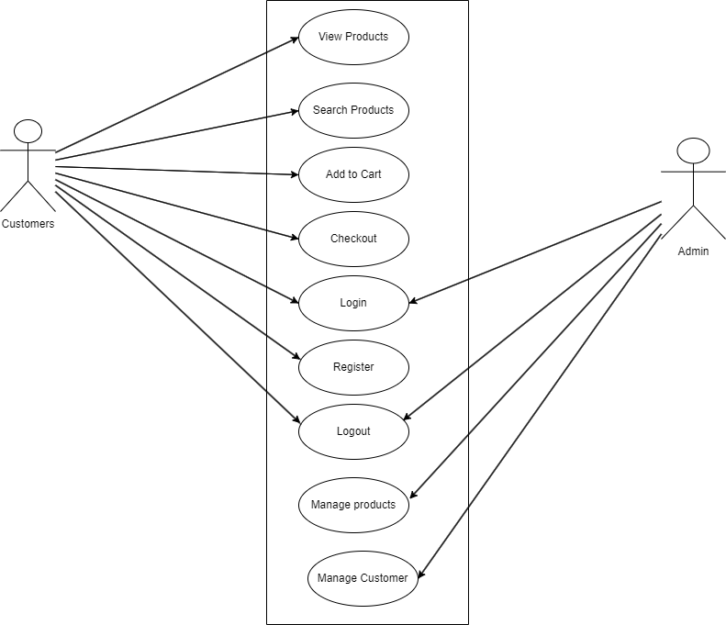

**Fig: Use case diagram for e-commerce website.**

1. **Non-functional requirement**
2. **Security**

We have not saved the user password into the database, only the hashed password is saved.

1. **Performance**

This system will be designed for better performance of users and admin.

1. **Reliability**

This system will be reliable for both the user and admin

1. **Usability**

This system will be easy to use and navigate, with user-friendly interface.

## Feasibility Study

A feasibility study is a preliminary assessment of a proposed project, plan, or idea to determine whether it is practical, feasible, and economically viable. The purpose of a feasibility study is to identify potential risks, challenges, and opportunities associated with the project.

Following feasibility were studied before building the system to see if the system could be built with exact requirement in required time.

### Technical feasibility

This system uses existing technologies, software and hardware so there is no technological hurdle to build this system.

### Operational feasibility

This system uses simple technologies to design so it is easy to use and understand and it is user-friendly.

### Schedule feasibility

The system is completed within scheduled time and do not exceed the scheduled time.

## Data Modeling (ER-diagram)

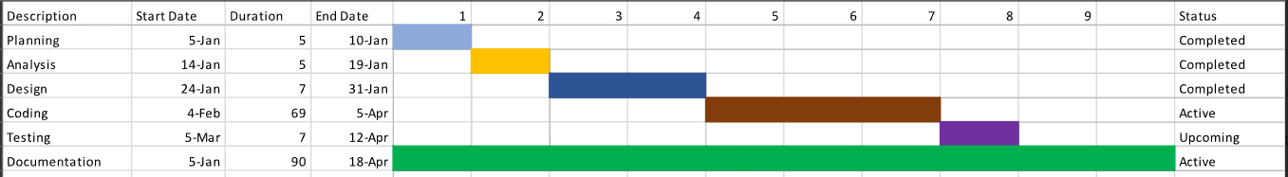In Entity-Relationship diagram there are 7 entities named website, laptops, shopping cart, customer, customer order and shipping. Laptop has attributes such as name, brand, id, price. Like-wise customer has name, contact, email. Customer has attributes like customer id and product id. Admin can delete user manage products whereas user can view produvts buy them or add to cart.

**Fig: Gantt chart for e-commerce website.**

**Table: Gantt chart Table for GizmoGrove**

|  |  |
| --- | --- |
| **Task name** | **Duration** |
| Planning | 1 week |
| Analysis | 1 week |
| Design | 2 week |
| Coding | 12 week |
| Testing | 1 week |
| Deployment | 1 week |

**Fig: Gantt chart for e-commerce website.**

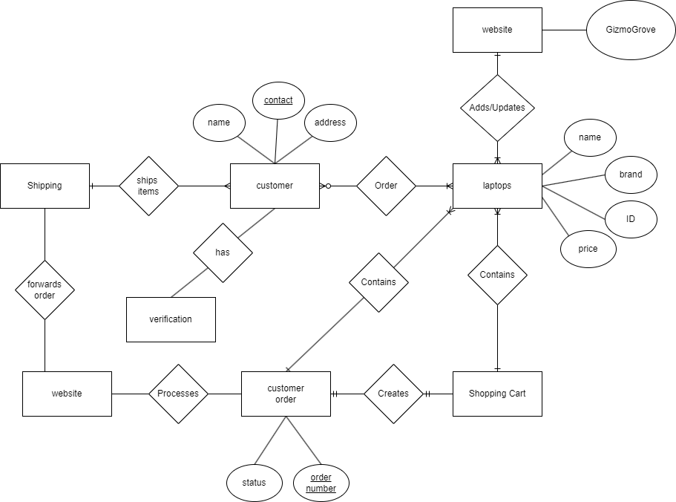

**Fig: Entity Relationship diagram for e-commerce website.**

## Process Modeling (DFD)

Data Flow Diagram of GizmoGrove: An e-commerce website consists of two levels of DFD context diagram and level one DFD. Both these levels are used for making data flow diagram of GizmoGrove: An e-commerce website.

In context diagram, the user can view and search products add them to cart or buy them. The admin can manage products and users get order details and update the delivery details.

Then the customer can get the delivery details.

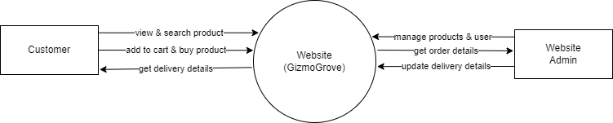

**Fig: level 0 DFD for E-commerce website**

In level 1 DFD, there are four processer responsible for all the work, process 1.1 is responsible, for managing customer information, process 1.2 is responsible for managing product information, 1.3 is responsible for payment management and 1.4 is responsible for managing transactions.

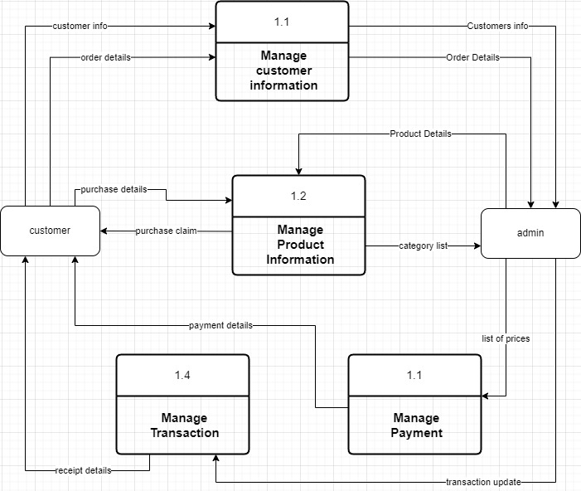

**Fig: level 1 DFD for e-commerce website**

## System Design

To realize the different functional requirement of the system in graphical form, different design diagram of the system has been prepared which are as follows:

### Architectural Design

For this system, three tier architecture is used which includes user interface, web server and database. In architectural design, basic structure of the system is show.

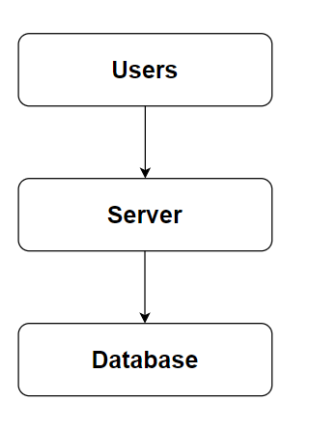

**Fig: Architecture Design of e-commerce website**

### System flowchart

The flowchart for the E-commerce Website begins with the start of the process. Users are prompted with a question asking if they have an account. If they do, they proceed to the login stage where the validity of their credentials is checked. Upon successful validation, they are directed to the landing page where they can view and buy products, as well as add them to their cart. After selecting their desired items, users proceed to checkout before the process concludes.

For the admin, the process begins with the start followed by login. The system then verifies the validity of the admin's credentials. Upon successful authentication, the admin is directed to the dashboard where they can manage users and products. After completing their tasks, the admin can choose to logout before the process ends.

**For Employees**

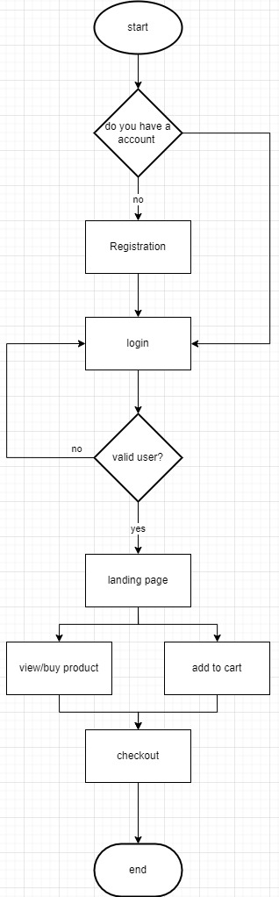

**Fig: Flowchart of e-commerce website for user**

**For Admin**

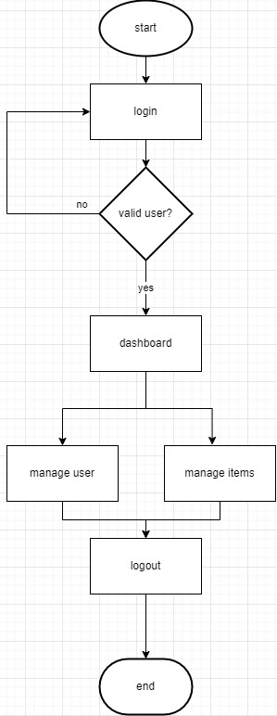

**Fig: Flowchart of e-commerce website for admin**

### Database schema design

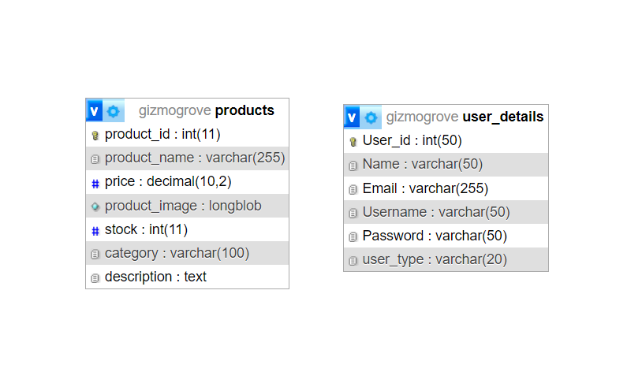The figure below is the database schema design of e-commerce website. Database schema design is used to show basic structure of the system. In the e-commerce website there are two tables in the databases each of them have their own fields where their id is primary key and if that id is used in another table it becomes foreign key.

**Fig: Database Schema Design**

### Interface Design (UI Interface)

Interface design is used to design how the e-commerce website looks like and this design is shown to user that how the website will look. And after finalizing the system development starts. The UI design of login page, registration page, landing page, laptops section, accessories section, product description page, dashboard page, add product page, edit product page add user page and manag6e user page of GizmoGrove: A e-commerce website are shown below:

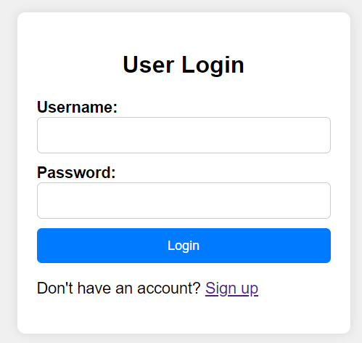

**Fig: Login page of GizmoGrove.**

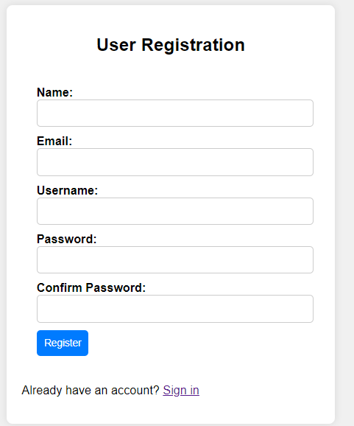

**Fig: registration page of GizmoGrove.**

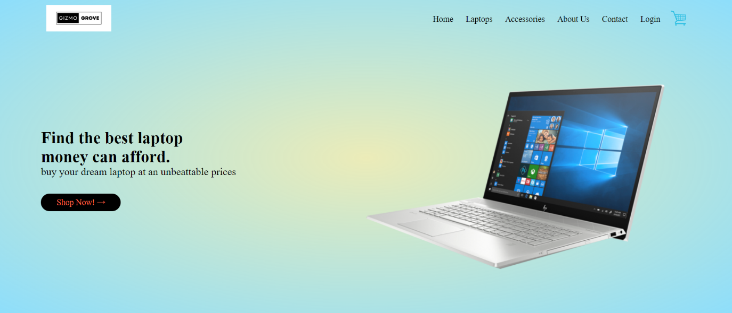

**Fig: landing page of GizmoGrove**

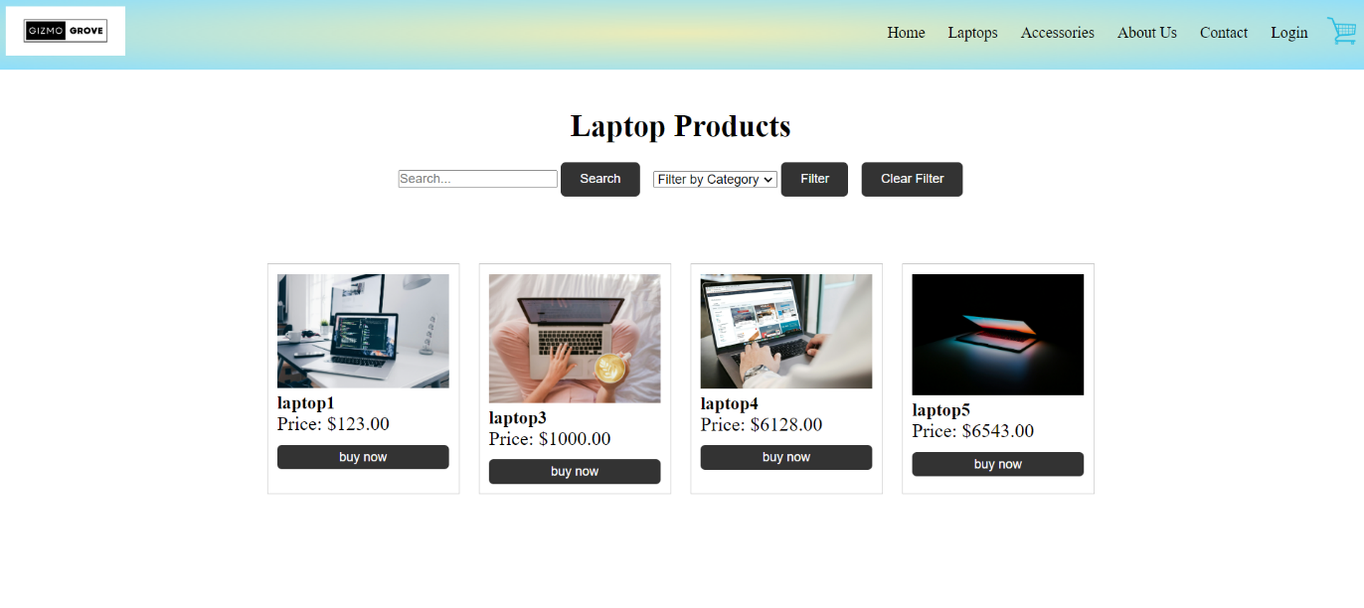

**Fig: product section of GizmoGrove**

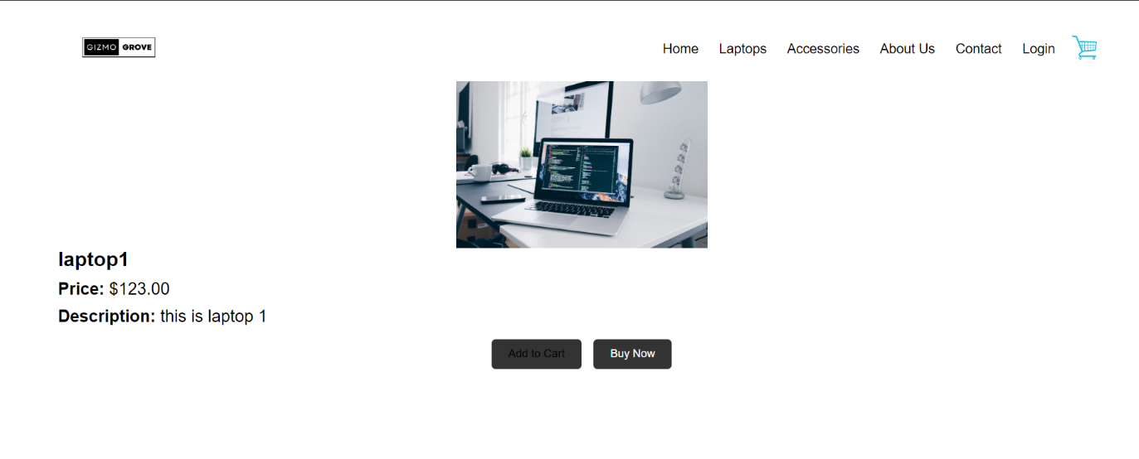

**Fig: Product description page of GizmoGrove**

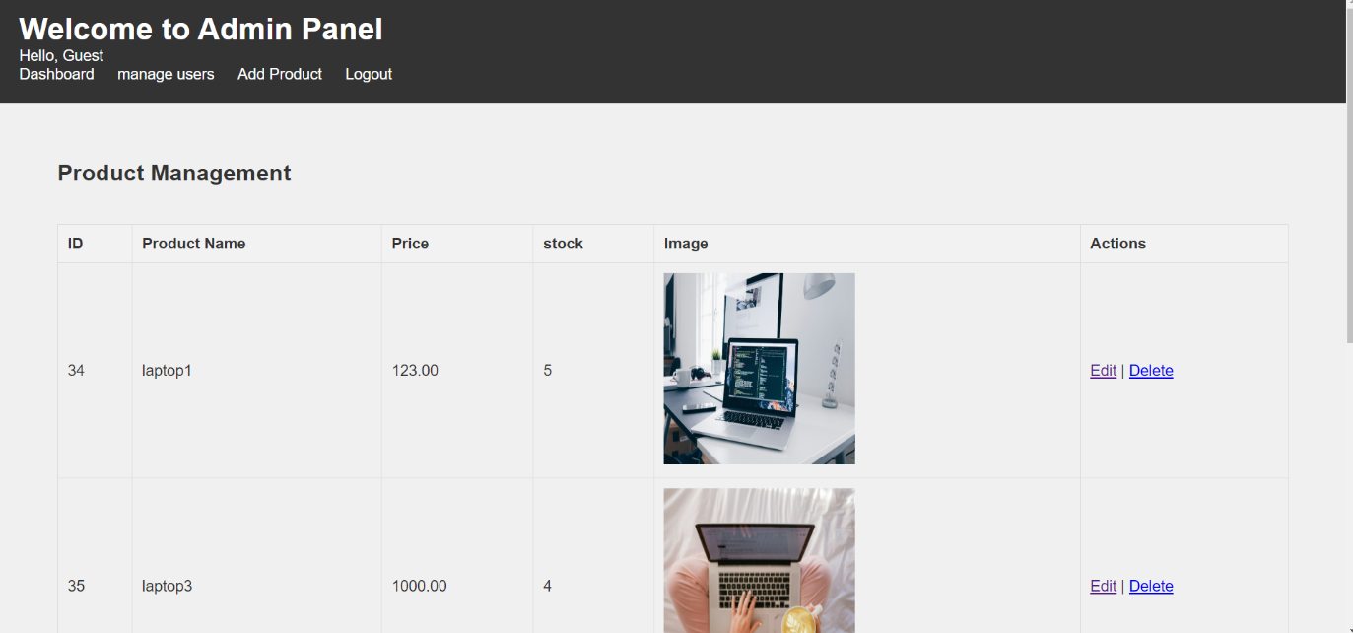

**Fig: Admin panel page of GizmoGrove.**

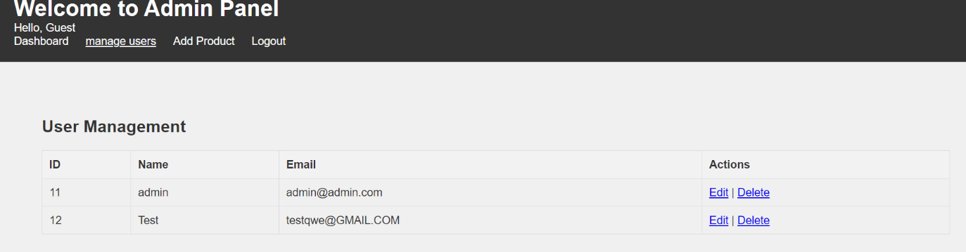

**Fig: User management page of GizmoGrove.**

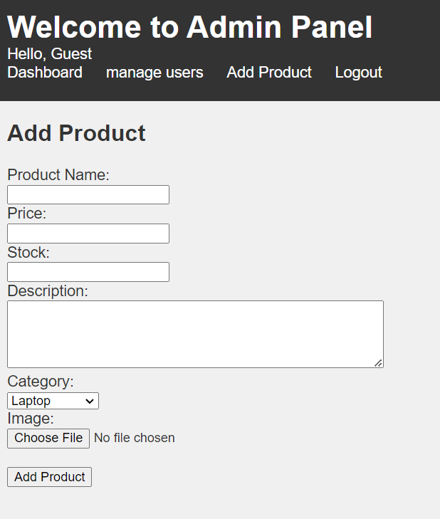

**Fig: Add product page of GizmoGrove.**

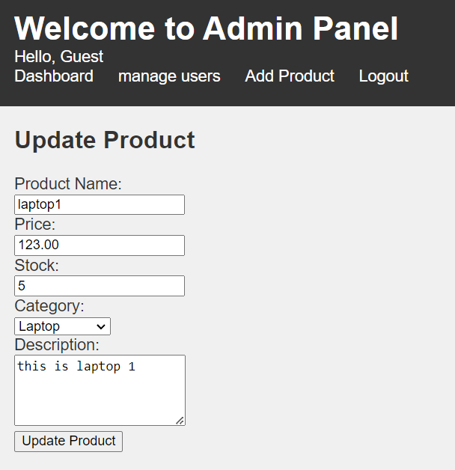

**Fig: Update products page of GizmoGrove.**

# CHAPTER: 4

**IMPLEMENTATION**

## Implementation

### Tools Used (CASE tools, Programming language, Database platforms)

Following are the tools and framework used for the accomplishment of this project:

* **Front end**
  + **Html:** HTML, which stands for Hyper Text Markup Language, is the standard markup language. It provides a structure and syntax for organizing and presenting content on the Internet. HTML uses a series of elements and tags to define the structure and formatting of a web document. Html is used for creating different webpage and sites. It is used to create and structure sections, headings, links, paragraphs using various tags and elements.
  + **CSS:** CSS, which stands for Cascading Style Sheets, is a styling language used to describe the presentation and appearance of a document written in HTML or XML. By using css, we can control the text color, font style, the spacing between paragraphs, sizing of columns, layout designs, and many more.
  + **JavaScript:** JavaScript is a high-level programming language primarily used for adding interactivity and dynamic behavior to websites. JavaScript is used for client-side validation and to make dynamic, interactive and responsive web pages. It is used to add dynamic behavior to the webpage and add special effects to the webpage.
* **Back end**
  + **PHP:** PHP is extensively used in website development due to its versatility and powerful features. PHP allows you to generate dynamic content on web pages based on user inputs, database queries, or other external data sources. It is used for server side scripting purpose to add connectivity to the database and also used to encrypt the data, validate the user data, confirm user to go to certain pages, login pages.
* **Server**
  + - **APACHE SERVER:** In employee leave management system, apache server is used to run php files and creating fast and dynamic web pages.
* **Database**
  + **MYSQL:** MySQL is a popular open-source relational database management system (RDBMS) that is commonly used in website design and development. It provides a reliable and scalable solution for storing, managing, and retrieving data for websites.MySQL allows you to create and manage databases to store website data efficiently. It is used for performing CRUD operation such as create, delete and update data from the database as requested by the user.
* **Documentation Tools** 
  + - **MS Office**: This is used for writing and editing the documentation of employee leave management system.
    - **Draw.io:** This is used to generate diagrams for system analysis and design of employee leave management system. Diagrams were created using this tool in order to save time since all components are available with drag and drop functions.

### Implementation Details of Modules

Different modules of this system are described as below:

**Admin module:**

* **Admin manage user module.**

In this module, an admin can check the list of users their details and delete them if needed.

* **Admin manage product module.**

This module enables an Admin to add product and edit products.

**User module:**

* **User view module.**

Enables the user to view various dynamically loaded product listing.

* **User buy module.**

Users are able to click on the buy button to proceed to check out.

* **User add to cart module.**

Users are able to add their preferred items in cart.

**Login module:**

In login module, we have implemented two modules which takes the admin login into admin panel and user login into landing page.